Paul Pennings - When and Where did the Great Recession Erode the Support of Democracy

* Online appendix 1. Variations in satisfaction with democracy within the regions

TEMPORARY.
sel if year eq 2012.
crosstables cntry by stfdem01/cell row.

Case Processing Summary
 | Cases
 | Valid |  | Missing |  | Total
 | N | Percent | N | Percent | N | Percent
Country * stfdem01 | 38573 | 97,0% | 1211,737 | 3,0% | 39784,737 | 100,0%

Country * stfdem01 Crosstabulation
% within Country
 |  | stfdem01 |  | Total
 |  | ,00 | 1,00 | Total
Country | Belgium | 37,8% | 62,2% | 100,0%
Country | Bulgaria | 88,7% | 11,3% | 100,0%
Country | Switzerland | 13,7% | 86,3% | 100,0%
Country | Czech Republic | 56,1% | 43,9% | 100,0%
Country | Germany | 34,6% | 65,4% | 100,0%
Country | Denmark | 16,7% | 83,3% | 100,0%
Country | Estonia | 59,8% | 40,2% | 100,0%
Country | Spain | 73,3% | 26,7% | 100,0%
Country | Finland | 18,8% | 81,2% | 100,0%
Country | France | 56,4% | 43,6% | 100,0%
Country | United Kingdom | 47,2% | 52,8% | 100,0%
Country | Hungary | 65,4% | 34,6% | 100,0%
Country | Ireland | 49,9% | 50,1% | 100,0%
Country | Italy | 72,5% | 27,5% | 100,0%
Country | Lithuania | 59,0% | 41,0% | 100,0%
Country | Netherlands | 25,5% | 74,5% | 100,0%
Country | Norway | 14,9% | 85,1% | 100,0%
Country | Poland | 60,1% | 39,9% | 100,0%
Country | Portugal | 77,3% | 22,7% | 100,0%
Country | Sweden | 19,9% | 80,1% | 100,0%
Country | Slovenia | 79,4% | 20,6% | 100,0%
Country | Slovakia | 55,8% | 44,2% | 100,0%
Total |  | 52,3% | 47,7% | 100,0%

TEMPORARY.
sel if year eq 2006.
crosstables cntry by stfdem01/cell row.

Case Processing Summary
 | Cases
 | Valid |  | Missing |  | Total
 | N | Percent | N | Percent | N | Percent
Country * stfdem01 | 31820 | 96,5% | 1149,388 | 3,5% | 32969,388 | 100,0%

Country * stfdem01 Crosstabulation
% within Country
 |  | stfdem01 |  | Total
 |  | ,00 | 1,00 | Total
Country | Austria | 39,5% | 60,5% | 100,0%
Country | Belgium | 45,4% | 54,6% | 100,0%
Country | Bulgaria | 89,9% | 10,1% | 100,0%
Country | Switzerland | 22,0% | 78,0% | 100,0%
Country | Germany | 51,8% | 48,2% | 100,0%
Country | Denmark | 15,5% | 84,5% | 100,0%
Country | Estonia | 61,8% | 38,2% | 100,0%
Country | Spain | 41,8% | 58,2% | 100,0%
Country | Finland | 22,4% | 77,6% | 100,0%
Country | France | 63,8% | 36,2% | 100,0%
Country | United Kingdom | 60,8% | 39,2% | 100,0%
Country | Hungary | 80,4% | 19,6% | 100,0%
Country | Ireland | 42,0% | 58,0% | 100,0%
Country | Netherlands | 30,9% | 69,1% | 100,0%
Country | Norway | 27,1% | 72,9% | 100,0%
Country | Poland | 71,5% | 28,5% | 100,0%
Country | Portugal | 75,5% | 24,5% | 100,0%
Country | Sweden | 33,1% | 66,9% | 100,0%
Country | Slovenia | 66,9% | 33,1% | 100,0%
Country | Slovakia | 62,4% | 37,6% | 100,0%
Total |  | 54,5% | 45,5% | 100,0%

TEMPORARY.
sel if year eq 2012.
crosstables cntry by stfgov01/cell row.

Case Processing Summary
 | Cases
 | Valid |  | Missing |  | Total
 | N | Percent | N | Percent | N | Percent
Country * stfgov01 | 38734 | 97,4% | 1050,737 | 2,6% | 39784,737 | 100,0%

Country * stfgov01 Crosstabulation
% within Country
 |  | stfgov01 |  | Total
 |  | ,00 | 1,00 | Total
Country | Belgium | 32,0% | 68,0% | 100,0%
Country | Bulgaria | 76,9% | 23,1% | 100,0%
Country | Switzerland | 10,7% | 89,3% | 100,0%
Country | Czech Republic | 62,4% | 37,6% | 100,0%
Country | Germany | 38,3% | 61,7% | 100,0%
Country | Denmark | 42,8% | 57,2% | 100,0%
Country | Estonia | 57,7% | 42,3% | 100,0%
Country | Spain | 76,2% | 23,8% | 100,0%
Country | Finland | 22,2% | 77,8% | 100,0%
Country | France | 63,0% | 37,0% | 100,0%
Country | United Kingdom | 54,9% | 45,1% | 100,0%
Country | Hungary | 62,6% | 37,4% | 100,0%
Country | Ireland | 67,0% | 33,0% | 100,0%
Country | Italy | 73,2% | 26,8% | 100,0%
Country | Lithuania | 51,4% | 48,6% | 100,0%
Country | Netherlands | 31,8% | 68,2% | 100,0%
Country | Norway | 23,1% | 76,9% | 100,0%
Country | Poland | 65,6% | 34,4% | 100,0%
Country | Portugal | 85,3% | 14,7% | 100,0%
Country | Sweden | 28,1% | 71,9% | 100,0%
Country | Slovenia | 77,9% | 22,1% | 100,0%
Country | Slovakia | 58,4% | 41,6% | 100,0%
Total |  | 56,6% | 43,4% | 100,0%

TEMPORARY.
sel if year eq 2006.
crosstables cntry by stfgov01/cell row.

Case Processing Summary
 | Cases
 | Valid |  | Missing |  | Total
 | N | Percent | N | Percent | N | Percent
Country * stfgov01 | 31862 | 96,6% | 1107,388 | 3,4% | 32969,388 | 100,0%

Country * stfgov01 Crosstabulation
% within Country
 |  | stfgov01 |  | Total
 |  | ,00 | 1,00 | Total
Country | Austria | 53,6% | 46,4% | 100,0%
Country | Belgium | 31,8% | 68,2% | 100,0%
Country | Bulgaria | 75,3% | 24,7% | 100,0%
Country | Switzerland | 18,9% | 81,1% | 100,0%
Country | Germany | 62,8% | 37,2% | 100,0%
Country | Denmark | 30,0% | 70,0% | 100,0%
Country | Estonia | 42,9% | 57,1% | 100,0%
Country | Spain | 39,5% | 60,5% | 100,0%
Country | Finland | 14,8% | 85,2% | 100,0%
Country | France | 59,2% | 40,8% | 100,0%
Country | United Kingdom | 55,7% | 44,3% | 100,0%
Country | Hungary | 76,4% | 23,6% | 100,0%
Country | Ireland | 34,9% | 65,1% | 100,0%
Country | Netherlands | 26,2% | 73,8% | 100,0%
Country | Norway | 42,2% | 57,8% | 100,0%
Country | Poland | 75,6% | 24,4% | 100,0%
Country | Portugal | 61,8% | 38,2% | 100,0%
Country | Sweden | 34,1% | 65,9% | 100,0%
Country | Slovenia | 48,5% | 51,5% | 100,0%
Country | Slovakia | 39,5% | 60,5% | 100,0%
Total |  | 54,3% | 45,7% | 100,0%

TEMPORARY.
sel if year eq 2012.
crosstables cntry by trust01/cell row.

Case Processing Summary
 | Cases
 | Valid |  | Missing |  | Total
 | N | Percent | N | Percent | N | Percent
Country * trust01 | 38293 | 96,3% | 1491,737 | 3,7% | 39784,737 | 100,0%

Country * trust01 Crosstabulation
% within Country
 |  | trust01 |  | Total
 |  | ,00 | 1,00 | Total
Country | Belgium | 41,3% | 58,7% | 100,0%
Country | Bulgaria | 87,9% | 12,1% | 100,0%
Country | Switzerland | 18,8% | 81,2% | 100,0%
Country | Czech Republic | 68,1% | 31,9% | 100,0%
Country | Germany | 31,2% | 68,8% | 100,0%
Country | Denmark | 10,5% | 89,5% | 100,0%
Country | Estonia | 53,3% | 46,7% | 100,0%
Country | Spain | 65,2% | 34,8% | 100,0%
Country | Finland | 12,3% | 87,7% | 100,0%
Country | France | 50,2% | 49,8% | 100,0%
Country | United Kingdom | 40,4% | 59,6% | 100,0%
Country | Hungary | 60,2% | 39,8% | 100,0%
Country | Ireland | 48,8% | 51,2% | 100,0%
Country | Italy | 55,1% | 44,9% | 100,0%
Country | Lithuania | 67,9% | 32,1% | 100,0%
Country | Netherlands | 26,8% | 73,2% | 100,0%
Country | Norway | 13,8% | 86,3% | 100,0%
Country | Poland | 73,4% | 26,6% | 100,0%
Country | Portugal | 77,7% | 22,3% | 100,0%
Country | Sweden | 24,7% | 75,3% | 100,0%
Country | Slovenia | 71,9% | 28,1% | 100,0%
Country | Slovakia | 79,7% | 20,3% | 100,0%
Total |  | 48,5% | 51,5% | 100,0%

TEMPORARY.
sel if year eq 2006.
crosstables cntry by trust01/cell row.

Case Processing Summary
 | Cases
 | Valid |  | Missing |  | Total
 | N | Percent | N | Percent | N | Percent
Country * trust01 | 31526 | 95,6% | 1443,388 | 4,4% | 32969,388 | 100,0%

Country * trust01 Crosstabulation
% within Country
 |  | trust01 |  | Total
 |  | ,00 | 1,00 | Total
Country | Austria | 36,6% | 63,4% | 100,0%
Country | Belgium | 43,2% | 56,8% | 100,0%
Country | Bulgaria | 83,8% | 16,2% | 100,0%
Country | Switzerland | 23,1% | 76,9% | 100,0%
Country | Germany | 40,4% | 59,6% | 100,0%
Country | Denmark | 10,3% | 89,7% | 100,0%
Country | Estonia | 52,0% | 48,0% | 100,0%
Country | Spain | 43,2% | 56,8% | 100,0%
Country | Finland | 13,1% | 86,9% | 100,0%
Country | France | 51,8% | 48,2% | 100,0%
Country | United Kingdom | 49,3% | 50,7% | 100,0%
Country | Hungary | 66,5% | 33,5% | 100,0%
Country | Ireland | 44,7% | 55,3% | 100,0%
Country | Netherlands | 30,2% | 69,8% | 100,0%
Country | Norway | 20,2% | 79,8% | 100,0%
Country | Poland | 75,6% | 24,4% | 100,0%
Country | Portugal | 66,1% | 33,9% | 100,0%
Country | Sweden | 28,7% | 71,3% | 100,0%
Country | Slovenia | 63,5% | 36,5% | 100,0%
Country | Slovakia | 66,5% | 33,5% | 100,0%
Total |  | 47,8% | 52,2% | 100,0%

Online Appendix 2. Trust

COMPUTE TOTWEIGHT=DWEIGHT*PWEIGHT.
weight by totweight.
*recode eisced (1,2=1)(3,4=2)(5,6,7=3) into edlev3.
*var labels edlev3 'Education in three levels from eisced'.
*value labels edlev3 1 'Primary' 2 'Secondary' 3 'Tertiary'.
*compute edlev2=edlev3.
*recode edlev2 (1,2=0)(3=1).
*value labels edlev2 0 'Education low' 1 'Education high'.

temp.
select if welstate eq 1.
GRAPH /title 'Nordic' /BAR(GROUPED)=MEAN(meantrust) BY year BY edlev2.

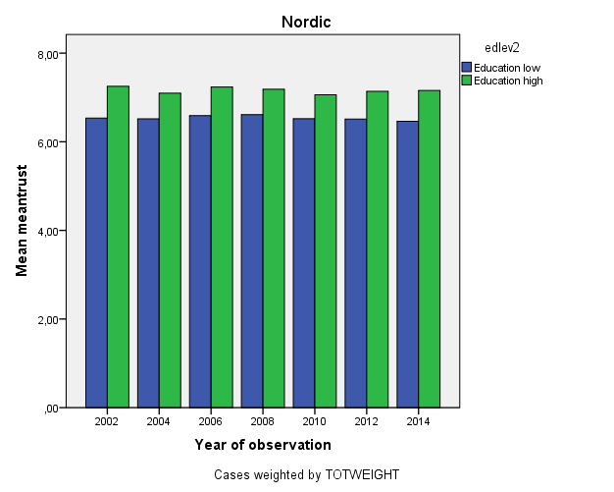

temp.
select if welstate eq 2.
GRAPH /title 'Liberal' /BAR(GROUPED)=MEAN(meantrust) BY year BY edlev2.

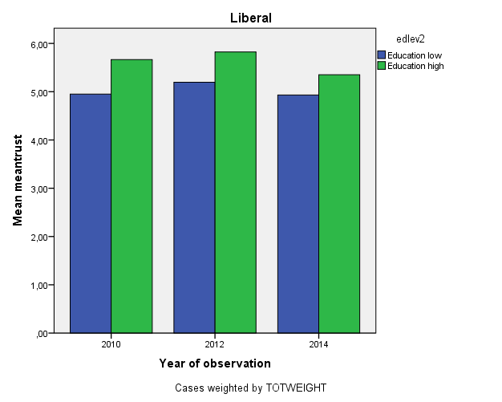

temp.
select if welstate eq 3.
GRAPH /title 'Continental' /BAR(GROUPED)=MEAN(meantrust) BY year BY edlev2.

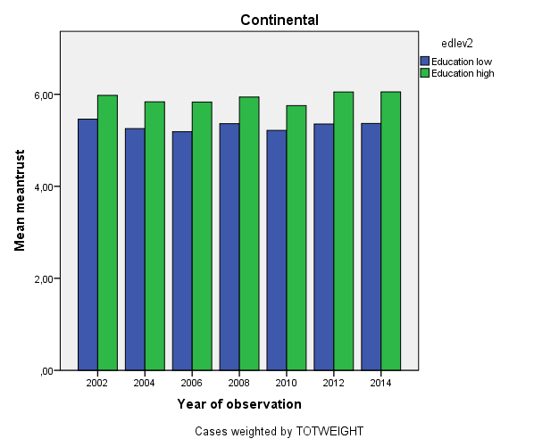

temp.
select if welstate eq 4.
GRAPH /title 'Southern' /BAR(GROUPED)=MEAN(meantrust) BY year BY edlev2.

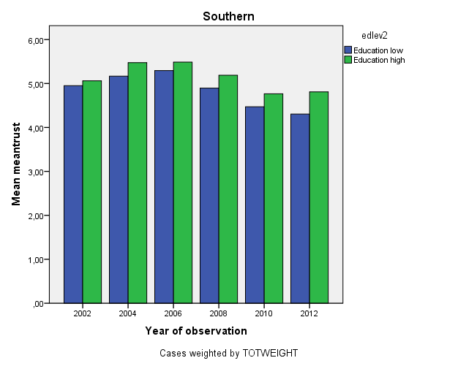

temp.
select if welstate eq 5.
GRAPH /title 'Eastern' /BAR(GROUPED)=MEAN(meantrust) BY year BY edlev2.

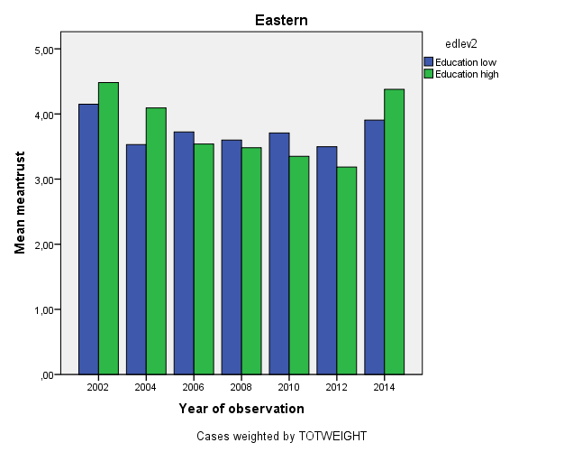

Online Appendix 3. Trends

GET FILE='h:\Documents\oz\ESS\ESS1-7_cumulative_e01.sav'.
sort cas by welstate.
split file by welstate.
GRAPH /title 'Trust and Satisfaction with government and democracy across Europe'
/BAR(GROUPED)= PGT(4)(stfdem) PGT(4)(stfgov) PGT(5)(meantrust) BY year
/MISSING=LISTWISE.

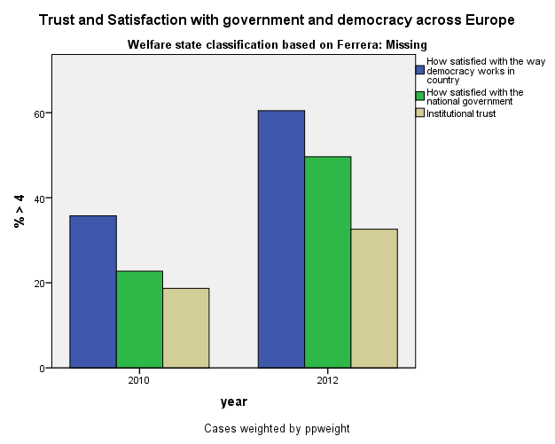

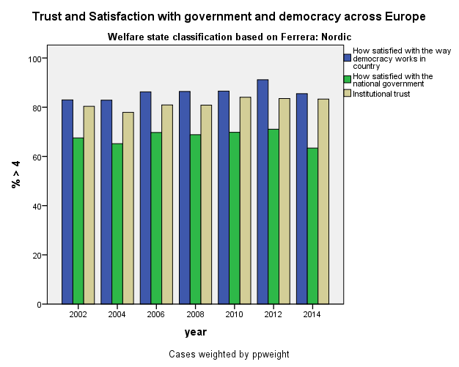

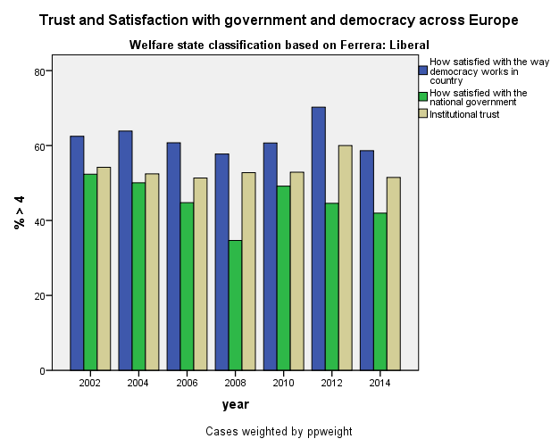

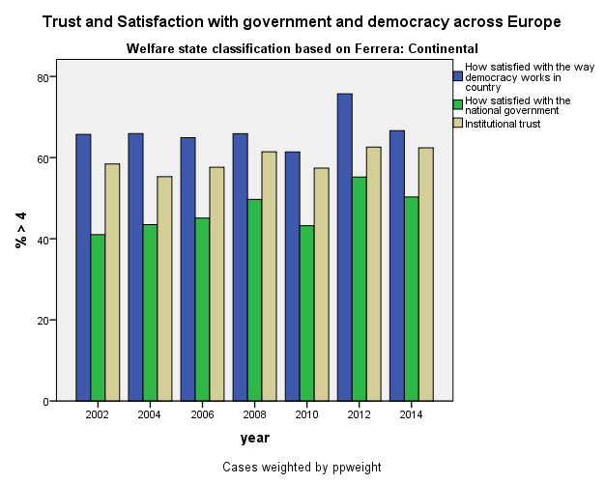

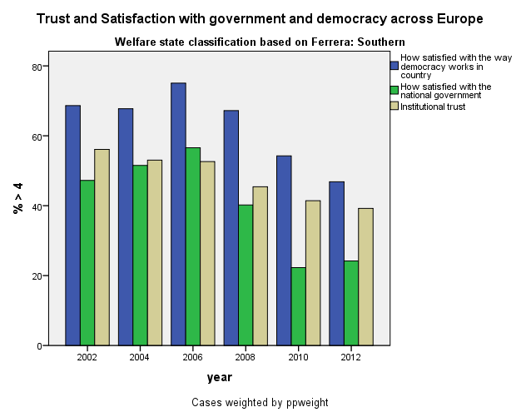

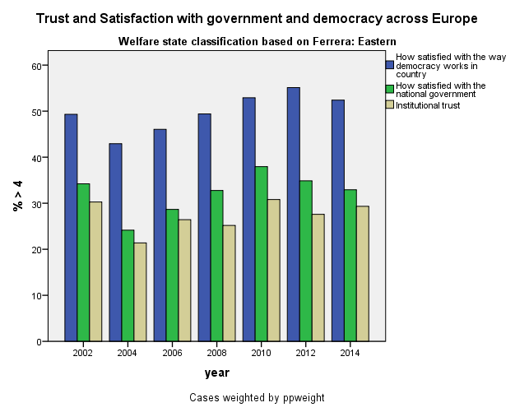

split file off.

Online Appendix 4. Poverty and Income Inequality

GET FILE='h:\documents\oz\ESS\ESS6e02_1.sav'.

temp.
sel if region01 eq 1.
cross stfgov2 by gvctzpv2/cell row.

Case Processing Summary
 | Cases
 | Valid |  | Missing |  | Total
 | N | Percent | N | Percent | N | Percent
stfgov2 * The government protects all citizens against poverty | 21325 | 97,8% | 473 | 2,2% | 21798 | 100,0%

stfgov2 * The government protects all citizens against poverty Crosstabulation
% within stfgov2
 |  | The government protects all citizens against poverty |  | Total
 |  | Less important | Extremely important | Total
stfgov2 | Not satisfied | 52,7% | 47,3% | 100,0%
stfgov2 | Satisfied | 60,7% | 39,3% | 100,0%
Total |  | 57,5% | 42,5% | 100,0%

temp.
sel if region01 eq 0.
cross stfgov2 by gvctzpv2/cell row.

Case Processing Summary
 | Cases
 | Valid |  | Missing |  | Total
 | N | Percent | N | Percent | N | Percent
stfgov2 * The government protects all citizens against poverty | 17427 | 97,1% | 521 | 2,9% | 17948 | 100,0%

stfgov2 * The government protects all citizens against poverty Crosstabulation
% within stfgov2
 |  | The government protects all citizens against poverty |  | Total
 |  | Less important | Extremely important | Total
stfgov2 | Not satisfied | 38,9% | 61,1% | 100,0%
stfgov2 | Satisfied | 52,3% | 47,7% | 100,0%
Total |  | 43,0% | 57,0% | 100,0%

temp.
sel if region01 eq 1.
cross stfdem2 by gvctzpv2/cell row.

Case Processing Summary
 | Cases
 | Valid |  | Missing |  | Total
 | N | Percent | N | Percent | N | Percent
stfdem2 * The government protects all citizens against poverty | 21573 | 99,0% | 225 | 1,0% | 21798 | 100,0%

stfdem2 * The government protects all citizens against poverty Crosstabulation
% within stfdem2
 |  | The government protects all citizens against poverty |  | Total
 |  | Less important | Extremely important | Total
stfdem2 | Not satisfied | 50,1% | 49,9% | 100,0%
stfdem2 | Satisfied | 59,1% | 40,9% | 100,0%
Total |  | 57,4% | 42,6% | 100,0%

temp.
sel if region01 eq 0.
cross stfdem2 by gvctzpv2/cell row.

Crosstabs

Case Processing Summary
 | Cases
 | Valid |  | Missing |  | Total
 | N | Percent | N | Percent | N | Percent
stfdem2 * The government protects all citizens against poverty | 17689 | 98,6% | 259 | 1,4% | 17948 | 100,0%

stfdem2 * The government protects all citizens against poverty Crosstabulation
% within stfdem2
 |  | The government protects all citizens against poverty |  | Total
 |  | Less important | Extremely important | Total
stfdem2 | Not satisfied | 37,5% | 62,5% | 100,0%
stfdem2 | Satisfied | 48,6% | 51,4% | 100,0%
Total |  | 43,0% | 57,0% | 100,0%

* Income.
temp.
sel if region01 eq 1.
cross stfgov2 by grdfinc2/cell row.

Case Processing Summary
 | Cases
 | Valid |  | Missing |  | Total
 | N | Percent | N | Percent | N | Percent
stfgov2 * grdfinc2 | 21206 | 97,3% | 592 | 2,7% | 21798 | 100,0%

stfgov2 * grdfinc2 Crosstabulation
% within stfgov2
 |  | grdfinc2 |  | Total
 |  | Less important | Extremely important | Total
stfgov2 | Not satisfied | 52,7% | 47,3% | 100,0%
stfgov2 | Satisfied | 60,4% | 39,6% | 100,0%
Total |  | 57,4% | 42,6% | 100,0%

temp.
sel if region01 eq 0.
cross stfgov2 by grdfinc2/cell row.

Case Processing Summary
 | Cases
 | Valid |  | Missing |  | Total
 | N | Percent | N | Percent | N | Percent
stfgov2 * grdfinc2 | 17326 | 96,5% | 622 | 3,5% | 17948 | 100,0%

stfgov2 * grdfinc2 Crosstabulation
% within stfgov2
 |  | grdfinc2 |  | Total
 |  | Less important | Extremely important | Total
stfgov2 | Not satisfied | 32,4% | 67,6% | 100,0%
stfgov2 | Satisfied | 45,0% | 55,0% | 100,0%
Total |  | 36,3% | 63,7% | 100,0%

temp.
sel if region01 eq 1.
cross stfdem2 by grdfinc2/cell row.

Case Processing Summary
 | Cases
 | Valid |  | Missing |  | Total
 | N | Percent | N | Percent | N | Percent
stfdem2 * grdfinc2 | 21443 | 98,4% | 355 | 1,6% | 21798 | 100,0%

stfdem2 * grdfinc2 Crosstabulation
% within stfdem2
 |  | grdfinc2 |  | Total
 |  | Less important | Extremely important | Total
stfdem2 | Not satisfied | 49,3% | 50,7% | 100,0%
stfdem2 | Satisfied | 59,2% | 40,8% | 100,0%
Total |  | 57,3% | 42,7% | 100,0%

temp.
sel if region01 eq 0.
cross stfdem2 by grdfinc2/cell row.

Case Processing Summary
 | Cases
 | Valid |  | Missing |  | Total
 | N | Percent | N | Percent | N | Percent
stfdem2 * grdfinc2 | 17573 | 97,9% | 375 | 2,1% | 17948 | 100,0%

stfdem2 * grdfinc2 Crosstabulation
% within stfdem2
 |  | grdfinc2 |  | Total
 |  | Less important | Extremely important | Total
stfdem2 | Not satisfied | 31,1% | 68,9% | 100,0%
stfdem2 | Satisfied | 41,6% | 58,4% | 100,0%
Total |  | 36,3% | 63,7% | 100,0%

