Supplementary information
Table S1. The list of primers used in the junction sites analysis. *Names in brackets indicate expected product sizes for particular analyzed line.
Name | Sequence | Expected product size [bp]*
Primers specific for vector (confirming presence of vector backbone)
Tha_B_F | CTCTTCGTTCGTCTGGAAGG | 219
Tha_B_R | CGGGCAGGATAGGTGAAGTA | 219
Tha_A_F | GGAGTGAAAGAGCCTGATGC | 230
Tha_A_R | GCCGGTATAAAGGGACCACC | 230
Tha_A_F | GGAGTGAAAGAGCCTGATGC | 3306 (B10); 6934 (212);  7909 (224); 8190 (225)
Tha_B_R | CGGGCAGGATAGGTGAAGTA | 3306 (B10); 6934 (212);  7909 (224); 8190 (225)
Primers specific for insertion site in 212 line
1FL_F | TTGTAGGACGGTGTTGACGG | 2988 (B10)  6616 (212)
1FL_R | TCCCCGACCCCAACTCTTTA | 2988 (B10)  6616 (212)
Tha_1R_F | CTCAACTCGGGAGAGTCCTG | 2105 (212)
1FL_F | TTGTAGGACGGTGTTGACGG | 2105 (212)
1FL_R | TCCCCGACCCCAACTCTTTA | 1551 (212)
Tha_1L_R | CTCGTCCTGCAGTTCATTCA | 1551 (212)
Primers specific for insertion site in 224 line
2FL_F | TTGTGGCATTGATTGCTTTC | 931 (B10)  5534 (224)
2FL_R | CAAAGGCTCCCTCTTCTCCT | 931 (B10)  5534 (224)
2FL_F | TTGTGGCATTGATTGCTTTC | 2548 (224)
Tha_2L_R | ACAAAAGGGCGACATTCAAC | 2548 (224)
Tha_2R_F | CTCAACTCGGGAGAGTCCTG | 1846 (224)
2FL_R | CAAAGGCTCCCTCTTCTCCT | 1846 (224)
Primers specific for insertion site in 225 line
3FL_F | TCTATTAAGGGGTCAGGGGCA | 1469 (B10)
3FL_R | ATCGGCCAACTGCCAACAAT | 1469 (B10)
3FL_F | TCTATTAAGGGGTCAGGGGCA | 5895 (225)
Tha_3L_R | TGATATTCGGCAAGCAGGCA | 5895 (225)
Tha_3R_F | TCGAGAAGGCATCAGCTTGG | 2122 (225)
3FL_R | ATCGGCCAACTGCCAACAAT | 2122 (225)

Table S2. The list of primers used in the verification of predicted polymorphisms.
Name | Sequence | Product length [bp]
C138 | CGAGAAGCAAGAATGAGTAGCA | 288
C139 | TTTTGAAAATCATTTCTAATCCAAA | 288
C140 | GCCGGTAACGATCATTAAACA | 296
C141 | AGTCCACTAGCCCTTGATTTC | 296
C142 | TTCCTTATTCAAATTATATCGGTTAGA | 352
C143 | AAAGAATTGTGTGCTCATTCCA | 352
C144 | CATCGCTTTTCTTTGTTTCAA | 400
C145 | TCCAATCATGTGGGTGATCTT | 400
C146 | TCCAATTTTTCTTCATTTGTGG | 295
C147 | CATAGCACAAACCCTGGCTA | 295
C148 | TTTTAGAAAACGTGAGAGAGAAAAA | 297
C149 | CGTATGCCTGAATACCTCCAA | 297
C150 | GGAAACTTCATAGTCATCCTCCA | 300
C151 | TCTTTTCATTACCCGCAAAT | 300
C152 | GGGTTATCCCTCCATAATGC | 285
C153 | TAATCGGAAATGCCACAACA | 285
C154 | CGGTGGCTAACTGATAAAGTGA | 400
C155 | TCTTCTTTCATTTTCCGTTTCT | 400
C156 | CAGAAAACAAATAATGTGGAAACAA | 290
C157 | TTCAGTTGCAGCTTATGCTAGAG | 290
C158 | GAAGAAAAAGAAATCAGCAGCAA | 292
C159 | GCACCTCGTAATATTCTTTAGGC | 292
C160 | TGAAGATCCGAAGGAAATGG | 325
C161 | GCCAAAATATGAGCCTAAAGGT | 325
C162 | TGGGAAGAAACCCAAACAAA | 367
C163 | AAAATGTTCCTTTATTGGTTTATGA | 367
C164 | CGAAGGTTATGGAACGGGTTA | 343
C165 | TGAAAACCATTTGACACCTCA | 343
C166 | CGTGAAATTTTCTGATCCTTCA | 379
C167 | GGCCTTAAAAAGTGGGAGCA | 379
C168 | GAGATCAAGACATTAGAATACGAAAA | 369
C169 | TCAAAATTCTTGGAATTGGATTT | 369
C170 | CATGGTGAGACGAAAAGTAAATTG | 300
C171 | AACCAATATTTTTGCATCCAAGT | 300
C172 | TGGAATTCTGCCAGGATGAT | 295
C173 | ACTTGAACATGCAACATAGGC | 295
C174 | AAAGGCGGTCCTCTTTGAG | 300
C175 | TTCAGCCATCTGTCTTTTGAA | 300
C176 | GGCAGATGGATAATGGGTTG | 287
C177 | CTCCAACAGTTCGCTGCATA | 287
C178 | TTTTCAGTAAAGGTTTAATTTTGCTAT | 593
C179 | TTCTCGAGTTTTCAAAATGTACC | 593
C180 | TTTTTAAAATTCATGCTTGTTTCTTC | 281
C181 | ACAAATTGTTCTGGTTGCTTTT | 281
C182 | TCGCTTCCCTCAATTCTTTC | 298
C183 | TCTTCCAAACCAGACACGAG | 298
C184 | AAAAACACCCTAAAATGGACTGA | 268
C185 | TTCCGCTGTGCATGACTTAG | 268
C186 | CACCCATATGAAACCACAACA | 361
C187 | GCTACCTAAGTCATCAATAAACGAAA | 361
C188 | TTCAAGTGAGAAGGGCAAAAA | 393
C189 | TTGATGAAAAGGTTCAGCATAAAA | 393
C190 | GCCTCTCACACACACACACA | 297
C191 | AGGACGTGCAACAAATTGGA | 297
C192 | TTGTGTTTCCTTTCCAGAATTG | 432
C193 | TTCGGTTAAATCCATTCTCTCA | 432
C194 | GAGATGTCCATTTCTTTTTCTCTCA | 358
C195 | TCCAAACCATAACTGCGAAA | 358
C196 | TCATTGATCCCTATCAAACCCTA | 492
C197 | GAGCCTTGGAAGCAACCTTT | 492

Table S3. Summary of mapping statistics of three analyzed somaclonal lines.
 | 212 | 224 | 225
Total number of reads | 126 867 816 | 126 887 524 | 126 664 932
Sequencing depth (coverage) | 34.57× | 34.57× | 34.51×
Total number of filtered reads | 122 859 014 | 122 741 194 | 123 375 564
Filtered reads (%) | 96.84% | 96.73% | 97.40%
Total number of reads mapped | 105 848 881 | 102 882 010 | 110 413 095
Total number of reads mapped (%) | 86.15% | 83.82% | 89.49%
Read mapped uniquely | 100 674 281 | 97 796 006 | 106 213 817
Read mapped uniquely (%) | 95.11% | 95.06% | 96.20%

Table S4. Density of variants predicted in thaumatin lines in reference to the entire genome length.
 | Number of SNPs + MNPs |  | Number of insertions |  | Number of deletions
 | In total | Per Mb | In total | Per Mb | In total | Per Mb
212 | 1355 | 4 | 344 | 1 | 2847 | 8
224 | 1170 | 3 | 275 | 1 | 2428 | 7
225 | 1228 | 3 | 300 | 1 | 2775 | 8

Table S5. Density of variants counted per 1 Mb of particular regions of the genomic sequence.
 | Number of variants per 1 Mb of
 | UTR | exons | introns | upstream | downstream | intergenic
212 | 16 | 12 | 20 | 18 | 18 | 37
224 | 14 | 10 | 18 | 15 | 15 | 31
225 | 14 | 10 | 17 | 16 | 17 | 36
average | 14 | 11 | 18 | 16 | 17 | 34

Table S6. Percentages of variants having high, moderate, low, or modifier effect on the genome according to SnpEff analysis.
Effect | 212 | 224 | 225
High | 1.86% | 1.84% | 1.56%
Moderate | 0.39% | 0.36% | 0.23%
Low | 0.43% | 0.38% | 0.32%
Modifier | 97.32% | 97.42% | 97.89%
Table S7. Number of high-impact (HI) variants and number of genes with HI variants within their structure.
 | Total number of HI variants | Number of genes with HI variants | Number of genes encoding proteins | Number of genes with more than one HI variants
212 | 109 | 105 | 105 | 4
224 | 92 | 89 | 89 | 3
225 | 87 | 85 | 85 | 2

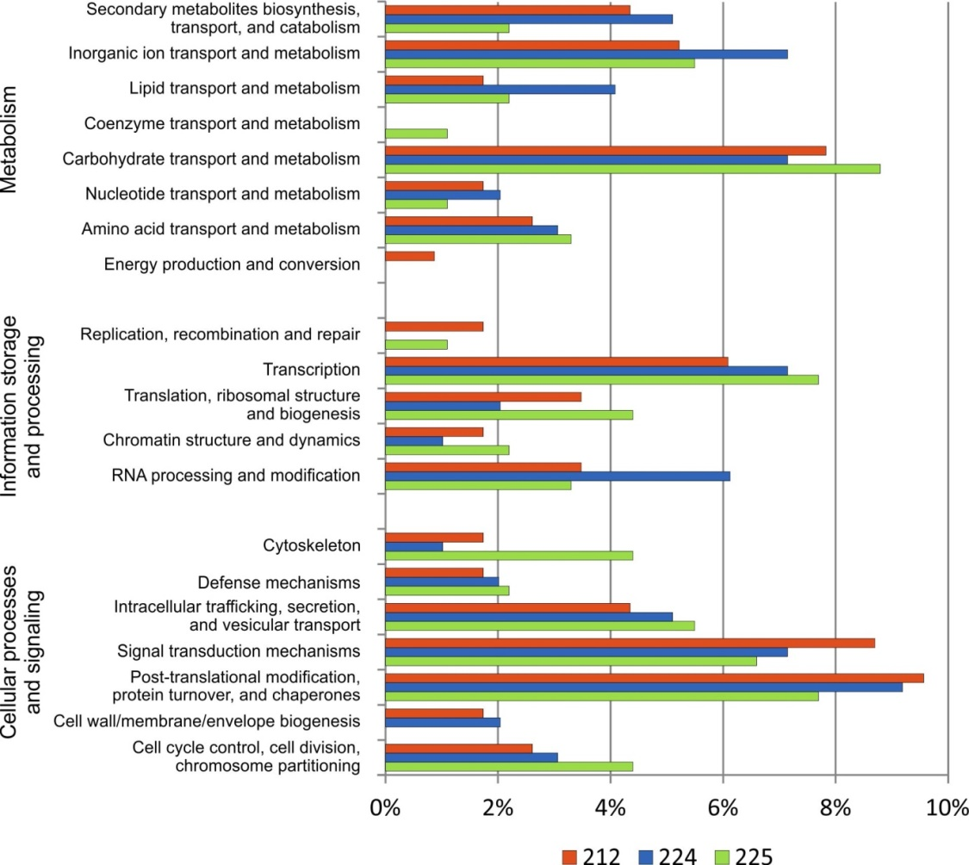
Figure S1. Functional KOG classification of genes identified as having HI polymorphisms.

Table S8. Number of genes located on ctg1556 with predicted variants inside their structure and number of variants within the genes.
 |  | 212 | 224 | 225
Number of genes | with variant in their structure | 35 | 34 | 29
Number of genes | with variants in exons | 20 | 21 | 20
Number of variants | in genes | 633 | 608 | 557
Number of variants | in exons | 65 | 64 | 53

