Supplementary Information
Table S1. Primers Used in Constructs for Generating Transgenic Plants
Primers | Sequence (5’ to 3’)
For overexpressing of Ugp1 in rice
Ugp1-Ox-F | ATGGCGGTCACCGCCGAC
Ugp1-Ox-R | TCAAAGATCCTCCGGAC
For identification of the Ugp1-OX plants
Ugp1-Ox-q-F | GGAGCAGATCGAGTGGAGTAAGA
Ugp1-Ox-q-R | GAGCGTGTCGTAGGGAACCA

Table S2. Primers Used for RT-qPCR Analysis
Primers | Sequence (5’ to 3’)
Actin_qRT_F | GAGTCTGGCCCATCCATTGT
Actin_qRT_R | AGCATTCTTGGGTCCGAAGA
Ugp1-qRT_F | GGCTGCTCACGGAAACCTT
Ugp1-qRT_R | GCCGAATGCACACGACAAT
PHT1;1_qRT_F | CGCTTCCGTACGAGTGGTAGT
PHT1;1_qRT_R | GGTTCTTTCAAATCCAGGGAAA
PHT1;3_qRT_F | TGCGACTGCTGTATTCAGTACGT
PHT1;3_qRT_R | ACAAATGCCATCAAATATGAACAGA
PHT1;6_qRT_F | TATAACTGATCGATCGAGACCAGAG
PHT1;6_qRT_R | TGGATAGCCAGGCCAGTTATATATC
PHT1;8_qRT_F | AGAAGGCAAAAGAAATGTGTGTTAAAT
PHT1;8_qRT_R | AAAATGTATTCGTGCCAAATTGCT
IPS1_qRT_F | TTGGCAATTATTCGGTGGAT
IPS1_qRT_R | ACCATTTCACCATCCTCTTTATG

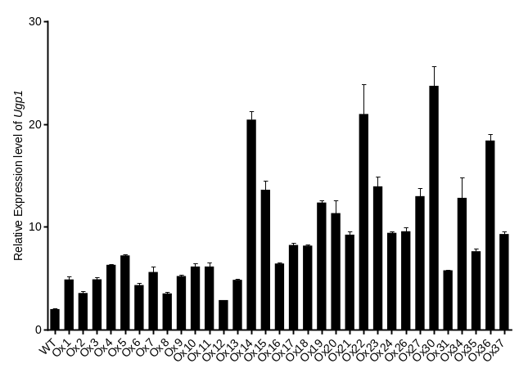
Figure S1 Relative Expression Level of Ugp1 in Transgenic Overexpression T0 Plants

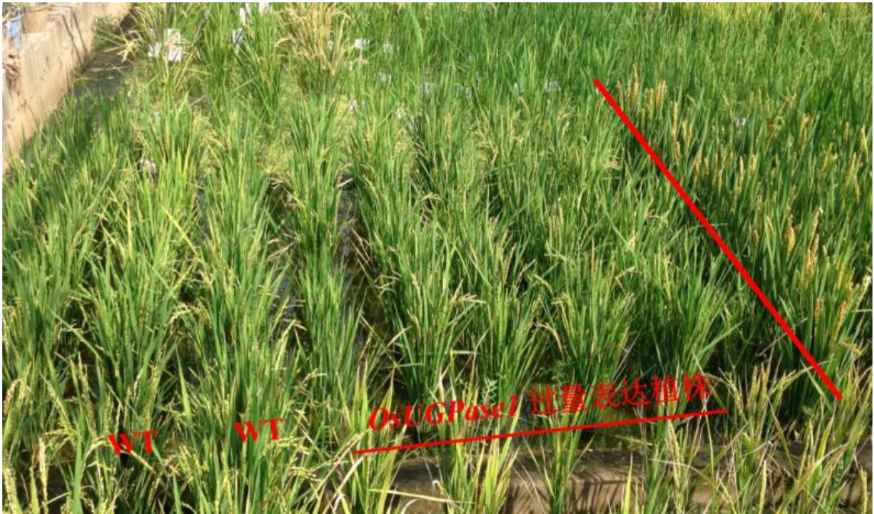
Figure S2 Phonotype of Ugp1-OX Plants in Field
The two rows on the left are wild type; the five columns on the right are Ugp1-OX plants.

