Tables
Table S1. Chemical taxonomy of metabolites identified from NMR spectra of Al-sensitive Golia-99 and Al-tolerant Demir-2000 roots.
Metabolite | Super class | Main class | Sub class
Maltose | Carbohydrates | Disaccharides | Disaccharides
Sucrose | Carbohydrates | Disaccharides | Disaccharides
Trehalose | Carbohydrates | Disaccharides | Disaccharides
Fructose | Carbohydrates | Monosaccharides | Hexoses
Galactose | Carbohydrates | Monosaccharides | Hexoses
Glucose | Carbohydrates | Monosaccharides | Hexoses
Mannose | Carbohydrates | Monosaccharides | Hexoses
Ribose | Carbohydrates | Monosaccharides | Pentoses
4-aminobutyrate | Fatty Acyls | Fatty acids | Amino FA
5-aminolevulinate | Fatty Acyls | Fatty acids | Amino FA
Glucarate | Fatty Acyls | Fatty acids | Dicarboxylic acids
Acetate | Fatty Acyls | Fatty acids | Saturated FA
Caprate | Fatty Acyls | Fatty acids | Saturated FA
Cadaverine | Fatty Acyls | Fatty amines | Monoalkylamines
Putrescine | Fatty Acyls | Fatty amines | Monoalkylamines
Guanosine | Nucleic acids | Purines | Purine ribonucleosides
Uracil | Nucleic acids | Pyrimidines | Other pyrimidines
Uridine | Nucleic acids | Pyrimidines | Pyrimidine ribonucleosides
Alanine | Organic acids | Amino acids and peptides | Amino acids
Arginine | Organic acids | Amino acids and peptides | Amino acids
Asparagine | Organic acids | Amino acids and peptides | Amino acids
Aspartate | Organic acids | Amino acids and peptides | Amino acids
Betaine | Organic acids | Amino acids and peptides | Amino acids
Cysteine | Organic acids | Amino acids and peptides | Amino acids
Glutamate | Organic acids | Amino acids and peptides | Amino acids
Glutamine | Organic acids | Amino acids and peptides | Amino acids
Glycine | Organic acids | Amino acids and peptides | Amino acids
Histidine | Organic acids | Amino acids and peptides | Amino acids
Isoleucine | Organic acids | Amino acids and peptides | Amino acids
Leucine | Organic acids | Amino acids and peptides | Amino acids
Lysine | Organic acids | Amino acids and peptides | Amino acids
Methionine | Organic acids | Amino acids and peptides | Amino acids
Phenylalanine | Organic acids | Amino acids and peptides | Amino acids
Proline | Organic acids | Amino acids and peptides | Amino acids
Pyroglutamate | Organic acids | Amino acids and peptides | Amino acids
Serine | Organic acids | Amino acids and peptides | Amino acids
Threonine | Organic acids | Amino acids and peptides | Amino acids
Tyrosine | Organic acids | Amino acids and peptides | Amino acids
Valine | Organic acids | Amino acids and peptides | Amino acids
Formate | Organic acids | Carboxylic acids | Carboxylic acids
Lactate | Organic acids | Short-chain acids | Short-chain acids
Pyruvate | Organic acids | Short-chain acids | Short-chain acids
cis-Aconitate | Organic acids | TCA acids | TCA acids
Citrate | Organic acids | TCA acids | TCA acids
Fumarate | Organic acids | TCA acids | TCA acids
Isocitrate | Organic acids | TCA acids | TCA acids
Malate | Organic acids | TCA acids | TCA acids
Succinate | Organic acids | TCA acids | TCA acids
Ethanolamine | Organic nitrogen compounds | Amines | 1,2-aminoalcohols
Carnitine | Organic nitrogen compounds | Carnitines | Carnitines
Choline | Organic nitrogen compounds | Cholines | Cholines
Glycerol | Organic oxygen compounds | Alcohols and polyols | 1,2-diols
Ethanol | Organic oxygen compounds | Primary alcohols | Primary alcohols
Methanol | Organic oxygen compounds | Primary alcohols | Primary alcohols

Table S2. The results of quantitative pathway analysis for Al-tolerant Demir-2000 roots treated with 10 µM AlCl₃.6H₂O. FDR indicates that p-values were adjusted using the false discovery rate. The impact of pathways was estimated by topology analysis.
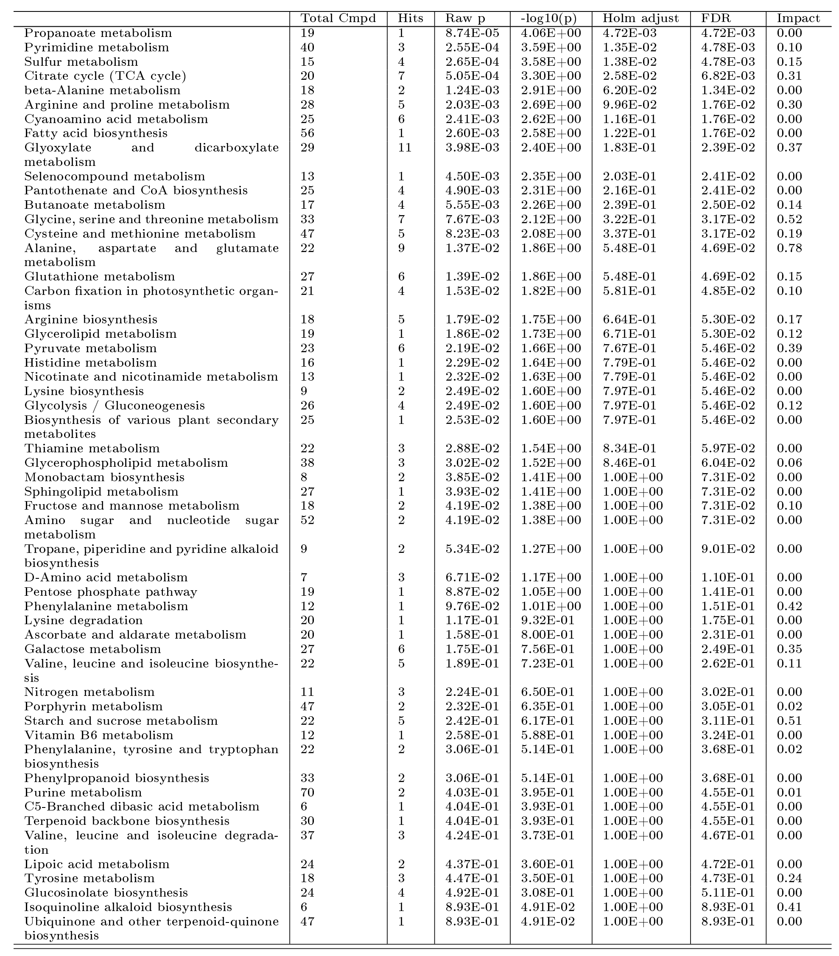

Table S3. The results of quantitative pathway analysis for Al-tolerant Demir-2000 roots treated with 30 µM AlCl₃.6H₂O. FDR indicates that p-values were adjusted using the false discovery rate. The impact of pathways was estimated by topology analysis.
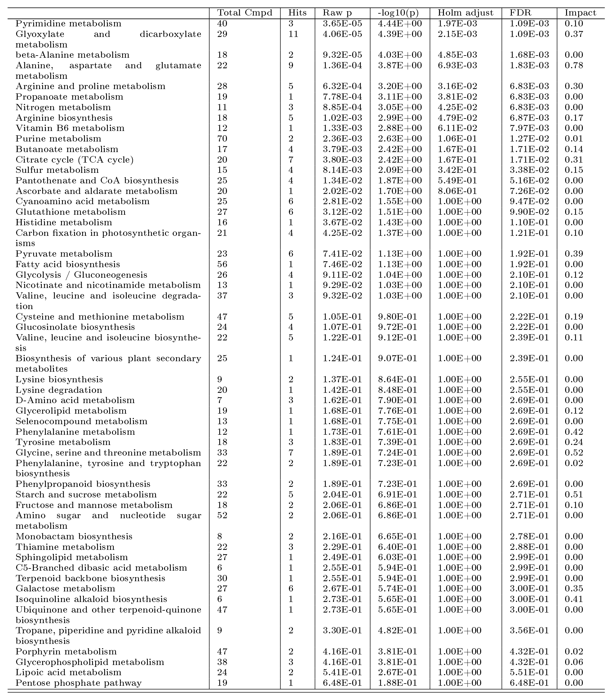

Table S4. The results of quantitative pathway analysis for Al-sensitive Golia-99 roots treated with 10 µM AlCl₃.6H₂O. FDR indicates that p-values were adjusted using the false discovery rate. The impact of pathways was estimated by topology analysis.
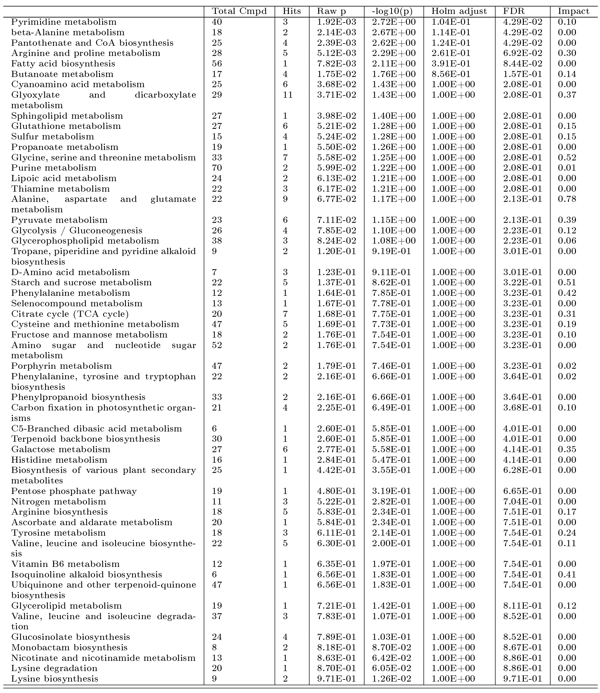

Table S5. The results of quantitative pathway analysis for Al-sensitive Golia-99 roots treated with 30 µM AlCl₃.6H₂O. FDR indicates that p-values were adjusted using the false discovery rate. The impact of pathways was estimated by topology analysis.
