- Supplemental Data

  - Supplemental Figures
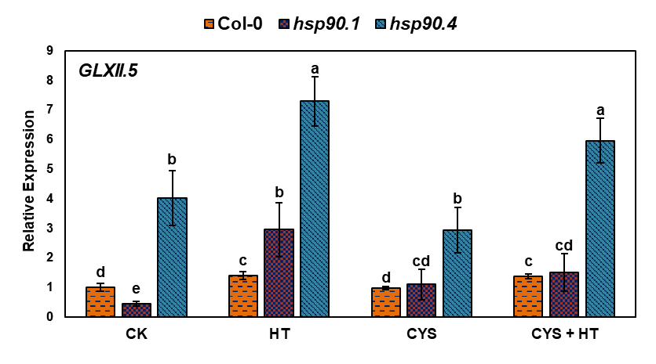
Fig. S1. Effect of exogenous cysteine on expression profiles of GLXII.5 in Col-0 and mutant plants.
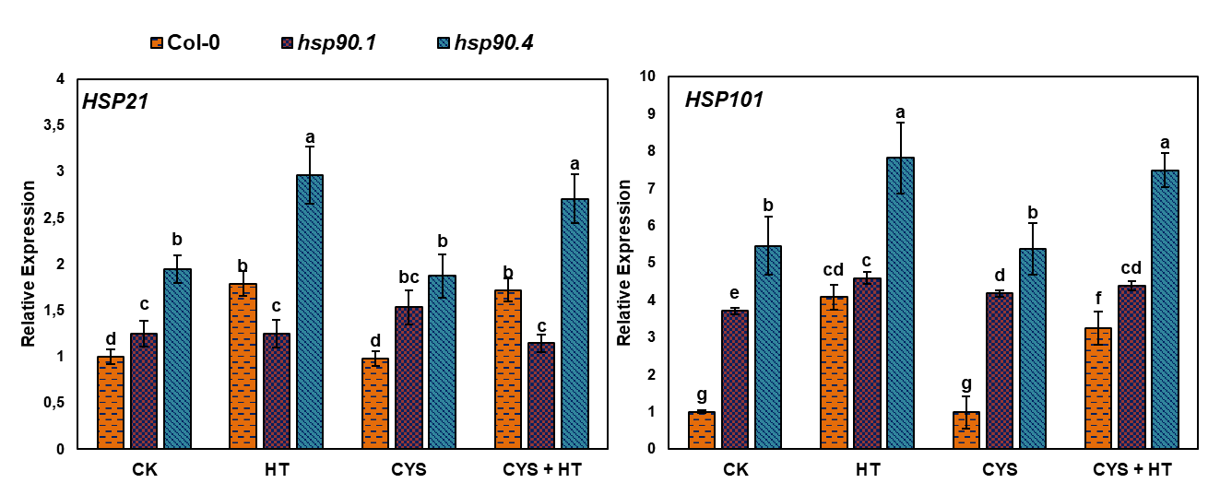
Fig. S2. Effect of exogenous cysteine on expression profiles of HSP21 and HSP101 in Col-0 and mutant plants.
- Supplemental Data

  - Supplemental Tables
Table S1. Sequences of primers used for RT-PCR experiment in this research.
Name | Forward Primer | Reverse Primer
HSP21 | 5′-GAACACGATCTCAGCTCCCA-3′ | 5′-TCGATGACTTTGGCTGGAC-3′
HSP70 | 5′-GTGGAGTGTGGGTCTGAGA-3′ | 5′-ACGCAGTGAGTGCTGAACAA-3′
HSP101 | 5′-GGTTCGTTAGCTGGGAAATC-3′ | 5′-CCTGAGCTTGACCTTGTCTT-3′
HSP90.1 | 5′-TCTGGGGACAGATGGAAGTG-3′ | 5′-TCTGATCCGCTTATTACCTC-3′
HSP90.4 | 5′-TAACAGCGGTACTGCAAGA-3′ | 5′-CGACCACGGTGTCTACTTCT-3′
GLXI.1 | 5′-CTGTCAAGGTGGGAAACTGT-3′ | 5′-GGCATTGGTGACTGTGACTG-3′
GLXI.2 | 5′-CGGCACCAGATGCTTCATT-3′ | 5′-ACAAAACAGGAAGCACACACA-3′
GLXI.3 | 5′-GTCACTTGGTGGGAAGAC-3′ | 5′-GAGGCTGCTCCATTGACTT-3′
GLXII.2 | 5′-CGCAGAGTTGGGGAACAT-3′ | 5′-TCAAAGTTTGGAGTGGTAGC-3′
GLXII.4 | 5′-TCATTCTTGTGGAGGAACGAC-3′ | 5′-TACGACGGCATGATGGACA-3′
GLXII.5 | 5′-TGAACTGGTGGTTTGACTTGG-3′ | 5′-AGCTCGACCAAGTGACAGGACA-3′
DJ-1A | 5′-TCCAGAGATGCCTCTCTCAG-3′ | 5′-TACCGACATCTGCTGCTGTT-3′
DJ-1D | 5′-GTGGATGTTTGTGGATGTT-3′ | 5′-GTGGATGTTTGTGGATGTT-3′
D-LDH | 5′-GAAGGGATGGGAGCTTTC-3′ | 5′-GCAACGCGCACCAGTAATGT-3′
ACT7 | 5′- CCATCGCTCATCGGAATGGA -3′ | 5′- TGGAACCACCACTGAGAACG-3′

