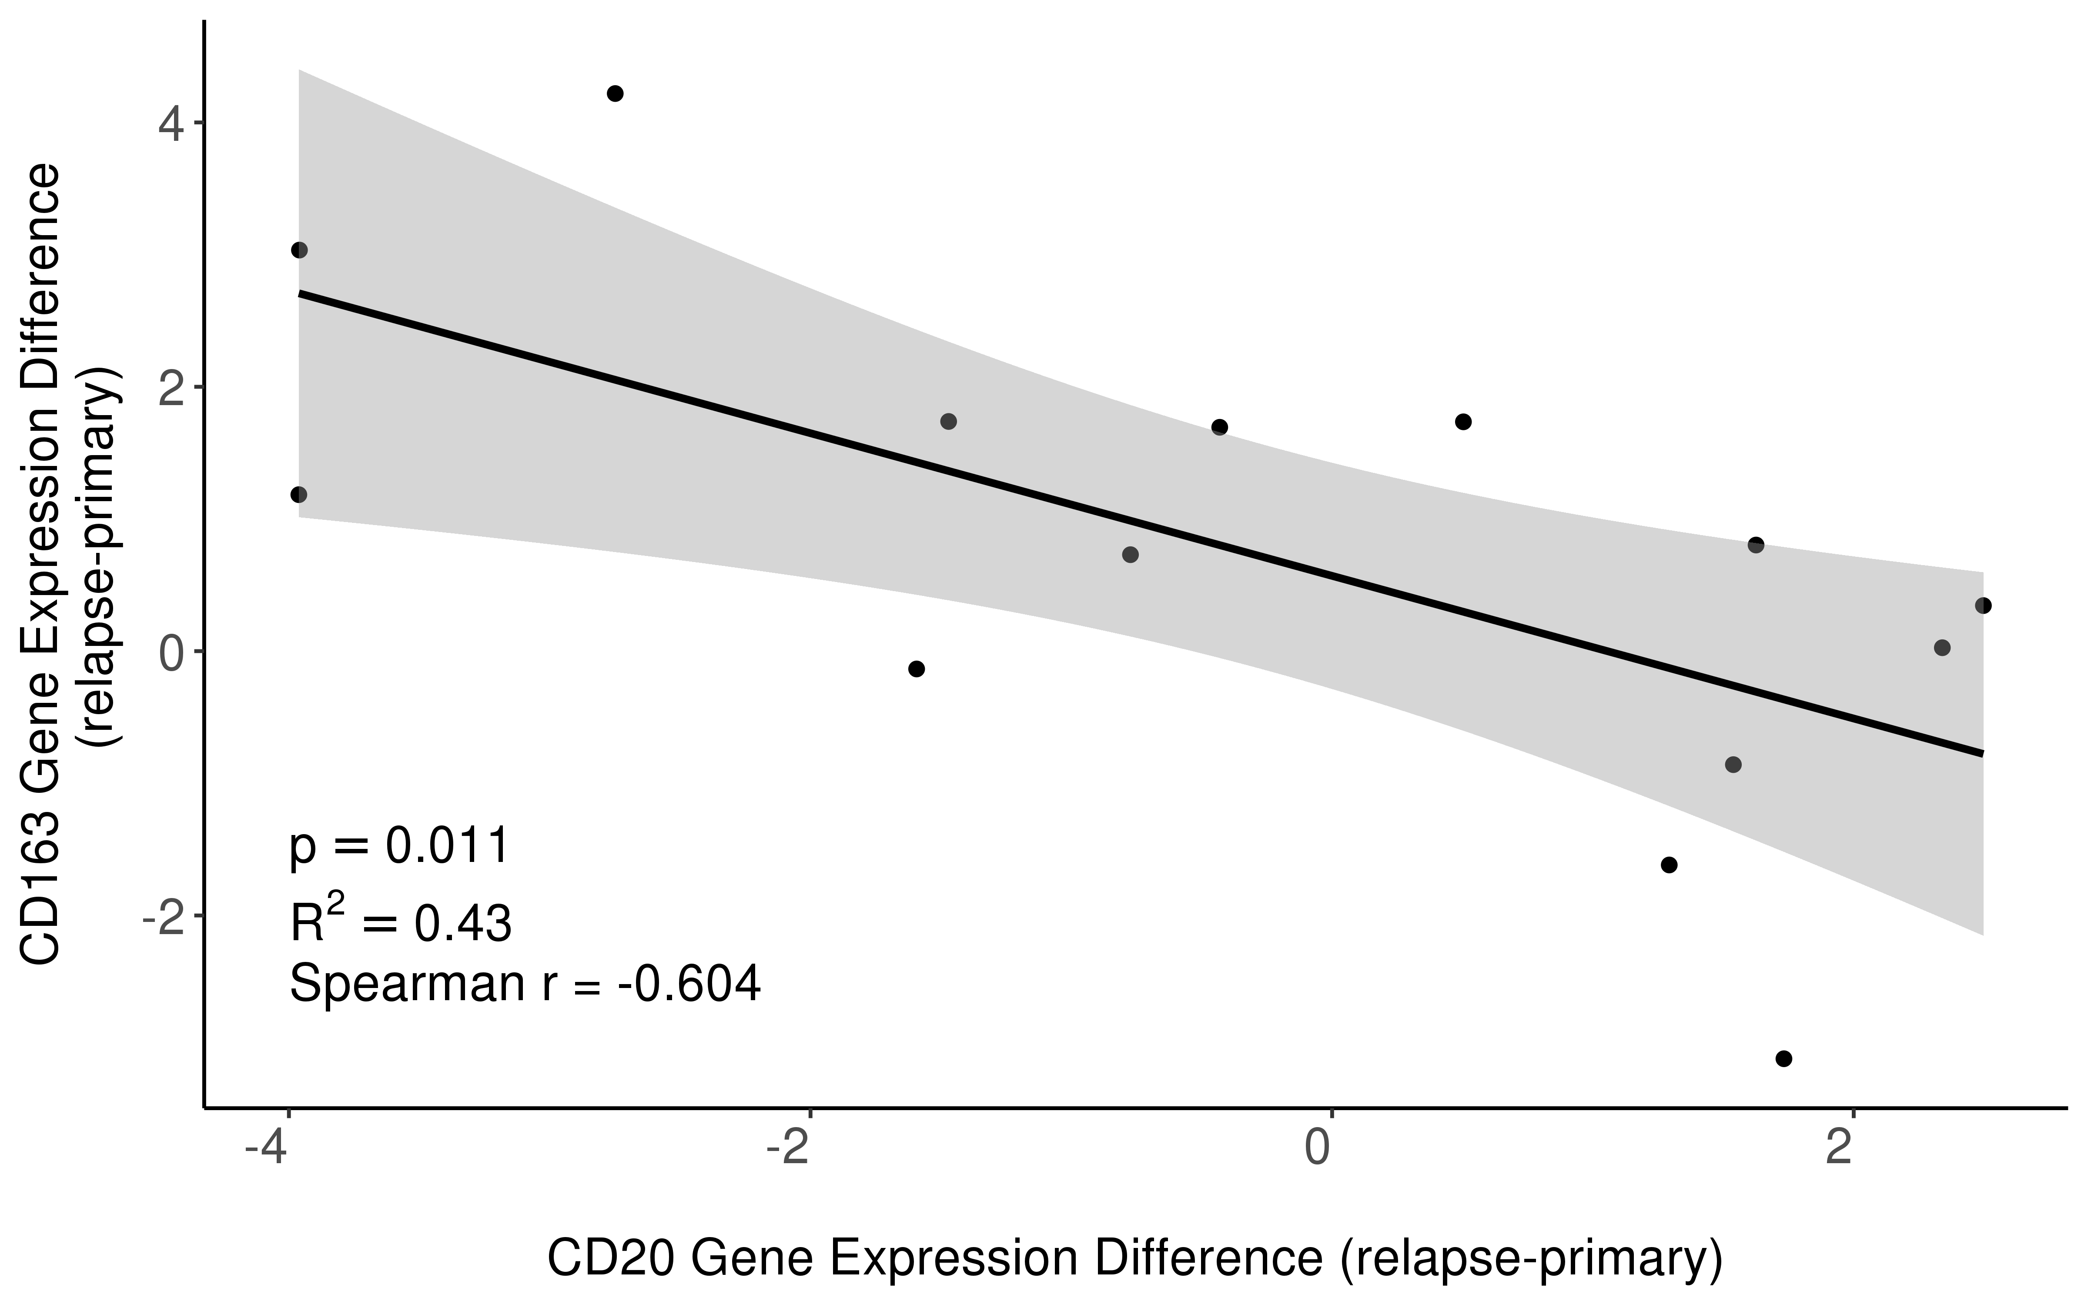

Supplementary figure 2: Scatterplot illustrating the inverse correlation of logFC Gene Expression in CD163 (y-axis) and CD20 (x-axis) between relapse and primary specimen (Spearman r= -0.604; P =0.011).

