Supplementary Table 1. Descriptive cognitive characteristics of study participants stratified based on the median of GMCtv in mm³.

VARIABLES | Minor GMCtv  (n=18) | Major GMCtv  (n=18) | p-value | Corrected p-value
MMSE | 26.00  (23.75;28.25) | 24.50  (18.75;28.25) | 0.31 | 0.17
MOCA | 18.00  (13.50;22.00) | 13.00  (10.00;19.00) | 0.05 | 0.04
Clock Drawing Test | 7.00  (3.00;10.00) | 8.50  (4.75;10.00) | 0.84 | 0.60
CRIq School | 96.00  (90.50;102.75) | 93.00  (89.00;101.25) | 0.50 | 0.37
CRIq Work | 89.00  (78.75;111.00) | 83.50  (73.75;97.25) | 0.18 | 0.21
CRIq Free Time | 102.50  (89.25;122.75) | 111.50  (91.00;117.00) | 0.73 | 0.77
CRIq Total | 100.00  (87.00;108.75) | 95.00  (84.25;110.00) | 0.58 | 0.39

Notes: Values are expressed as median (interquartile range).

Abbreviations: MMSE = Mini Mental State Examination; MOCA = Montreal Cognitive Assessment; CRIq = Cognitive Reserve Index questionnaire; GMCtv = Total gray matter cerebellum.

Supplementary Table 2. Simple linear correlations between motor cerebellar volumes and cognitive features.
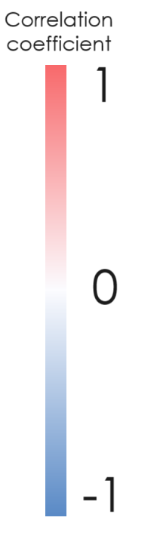
 | Criq School | Criq Work | Criq Free-Time | Criq Total | MMSE | MOCA | CDT
Left_I_IV
Right_I_IV |  |  | X
Left_V |  | X
Right_V |  | X
Left_VIIIa
Vermis_VIIIa
Right_VIIIa
Left_VIIIb
Vermis_VIIIb |  | X
Right_VIIIb
Left_X |  | X
Vermis_X |  | X
Right_X

Abbreviations: CRIq = Cognitive Reserve Index questionnaire; MMSE = Mini Mental State Examination; MOCA = Montreal Cognitive Assessment; CDT = Clock Drawing Test. X means significant correlations (p<0.05).
Supplementary Table 3. Simple linear correlations between cognitive cerebellar volumes and cognitive features.
 | Criq School | Criq Work | Criq Free-Time | Criq Total | MMSE | MOCA | CDT
Left_Crus_I |  |  |  |  |  |  | X
Right_Crus_I |  |  |  |  |  |  | X
Left_Crus_II |  | X
Vermis_Crus_II
Right_Crus_II
Left_VIIb
Vermis_VIIb |  | X
Right_VIIb |  |  |  |  | X
Left_IX |  | X
Vermis_IX
Right_IX

Abbreviations: CRIq = Cognitive Reserve Index questionnaire; MMSE = Mini Mental State Examination; MOCA = Montreal Cognitive Assessment; CDT = Clock Drawing Test. X means significant correlations (p<0.05).

Supplementary Table 4. Simple linear correlations between cognitive-motor cerebellar volumes and cognitive features.
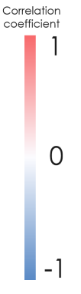
 | Criq School | Criq Work | Criq Free-Time | Criq Total | MMSE | MOCA | CDT
Left_VI |  | X
Vermis_VI |  | X |  |  |  | X
Right_VI
Total Cerebellar Volumes
eTIV
Vermis-tv |  | X |  |  |  | X

Abbreviations: CRIq = Cognitive Reserve Index questionnaire; MMSE = Mini Mental State Examination; MOCA = Montreal Cognitive Assessment; CDT = Clock Drawing Test; eTIV = Estimated total intracranial volume; Vermis-tv: Vermis volume. X means significant correlations (p<0.05).

