Supplementary Material
Supplementary Table 1 Eligibility criteria for individuals with SCA
Characteristic | Inclusion criteria
Age | 18–75 years
Health characteristics | Adequate hearing and vision with a confirmed diagnosis of SCA1, SCA2, SCA3, or SCA6, and no other medical condition that may contribute significantly to the individuals’ symptoms of ataxia or that may confound assessment of ataxia symptoms
Skills and training | A minimum of 6 years of education or equivalent
Language | Adequate language skills to provide informed consent and participate in an interview
Informed consent | Willing to provide written informed consent
Access | Access to computer video conference equipment
Time | Willing to participate in a 90-minute interview
Previous trial participation | Has not previously participated in BHV-4157 phase 3 troriluzole efficacy trial
SCA: spinocerebellar ataxia

Supplementary Table 2 Sample discussion guide for interviews with individuals with SCA
Part 1: Demographic and sample characterization questions
How old are you?
Instruction to interviewer: If participant reports that he/she is 18, ask for a date of birth to judge if the participant is 18 on the day of screening.
If participant is younger than 18 on the day of interview, end the interview.
What is your sex (as assigned at birth)?
- Male
- Female
- Prefer not to answer
Which state of the US are you currently living in?
What is your ethnicity (select all that apply)?
- American Indian or Alaska Native
- Asian
- Black or African American
- Native Hawaiian or other Pacific Islander
- White
- Hispanic
- Other (please specify)
How would you describe your work status (select all that apply)?
- Working full-time
- Working part-time
- Homemaker
- Student
- Retired
- Unemployed
- On disability benefit
- Other (please specify)
What is the highest level of education you have completed?
- High school graduate (or equivalent)
- Some college (no degree)
- Associate degree
- Bachelor’s degree
- Master’s degree
- Doctoral degree
- Other (please specify)
Please could you confirm that you have the diagnosis of SCA?
Instruction to interviewer: If no diagnosis of SCA end the interview
What SCA type were you diagnosed with?
- SCA1
- SCA2
- SCA3
- SCA6
- Other (please specify)
Please briefly explain how you first learned about your diagnosis?
Approximately how long ago were you diagnosed with SCA?
Instruction to interviewer: Ask the patient to provide a year of diagnosis or age at diagnosis
How severe is your SCA?
- Mild
- Moderate
- Severe
- Very severe
Please could you tell me why you gave this answer?
Part 2: Patient experience of SCA
Thank you for answering the previous questions, your responses are very helpful. For this next portion of the interview, I would like you to think about your experiences with SCA
Could you please walk me though the signs and symptoms you experience due to SCA day to day?
Which of these symptoms is most bothersome to you and why?
Please could you tell me about the impact(s) these symptoms have on your everyday life?
- Which of your daily activities are impacted by SCA?
- For completeness, how about in the evening or at night? (e.g. ability to rest, sleep, symptoms same, better or worse at night or in the evening)
Part 3: SCACOMS review
Part 3A: Item-level questions
Thank you for answering the previous questions. For this section of this interview, we are going to review the five items that make up a clinician assessment (SCACOMS).
Please note that some questions may seem repetitive, but we want to capture all your thoughts about SCACOMS. For this exercise, first I will display each item on the screen and ask you to read the item, and response options for the questions displayed. Then, I will ask you to talk me through your thoughts and ask you some follow-up questions. This is what we call a ‘think aloud’ exercise.
During the course of our conversation, I will ask you to consider different scenarios, including if your condition were to stay the same, improve or worsen. We are asking these questions to gain a better understanding of your perspective and to understand what is important to patients with SCA. We understand that some scenarios may not actually reflect a realistic progression of your condition. We appreciate your willingness to share your perspective.
- Do you have any questions about what we are going to do before we begin this section?
- In the last 3 years, have your SCA symptoms improved, worsened, or stayed the same?
Instruction to interviewer: if the patient was diagnosed less than 3 years ago ask ‘Since you have been diagnosed’

If participant mentions improvement, read the following question and response options:
- How much did it improve in comparison to 3 years ago/when you were first diagnosed with SCA?
  - Very much improved
  - Much improved
  - Minimally improved
- Please could you tell me which symptom or symptoms you were thinking of when giving this answer?
- How did this improvement translate into your day-to-day life?
[If participant mentions stabilisation, read the following question and response options]
- How do you determine that your condition was stable and why?
- What were you thinking about when providing this answer, for example all of your SCA symptoms or just one or some of them? Which ones?
- Was that stability meaningful to you?
[If participant mentioned worsening, read the following question and response options]
- How much worse is it in comparison to 3 years ago/when you were first diagnosed with SCA?
  - Minimally worse
  - Much worse
  - Very much worse
- Please could you tell me which symptom or symptoms you were thinking of when you gave this answer?
- How did this worsening translate into your day-to-day life?
- [If participant reported a symptom other than gait, speech, sitting or stance] What would it mean to you if these could have stayed stable over this time period?
[If participant mentioned any change (worsening/improving) in symptoms ask the following question]
- Have you talked to your doctor about these SCA symptom changes? If yes, what have you told them?
- Have any of your SCA symptoms remained stable? Which ones?
Part 3B: Ranking of importance
We would like to discuss some preliminary data that we have gathered through studying the natural history of SCA, in general. This data suggests that gait, stance, sitting, speech, and Clinician’s Assessment of Change in SCA condition may be the best indicators of disease progression in SCA (worsening of SCA symptoms over time). These factors combined might also be important when a clinician makes an assessment of the impact of a medication on a patient’s SCA progression.
I would like to ask you some questions considering all of these items together. Please look at the previous items displayed on the screen [items and number ranking list displayed on screen]
If you were to rank these items in terms of importance to you for assessing your SCA progression, could you rank these items from most important (1) to least important (5). Please talk aloud so that you can explain your rational behind your rankings. I will move each concept to the importance level you indicate.
- Can you please explain the ranking you selected?
- Why is [concept ranked as most important] most important to you?
- Why is [concept ranked as least important] the least important to you?
- Would you add any other concept that does not appear here to your ranking? If so, what?
  - Where would you place it?
Part 3B: Pie chart activity (weighting activity)
This pie chart (shown in Supplementary Fig. 1) represents the contribution of each concept we just discussed to an overall assessment of the change in your SCA over time.
The size of each pie slice in the pie chart corresponds to how important each item is in predicting the change in your SCA, from your perspective. To begin, we made all the slices of the pie the same size. Together all the slices of the pie add up to 100%.
- Thinking about those five items again, use this pie chart to show me the importance of each item for assessing the changes in your disease. All the slices are equal right now. I would like you to tell me how much the size of the slices should change so that the more important the item, the bigger is the slice that represents it. I will adjust the pie chart accordingly for you. Please think aloud and explain how you decide how big each slice of the pie should be.
Instruction to interviewer: Bring up the ranking from previous slide and paste it on this slide
- In the previous question, you mentioned the most important item was [state the item reported as most important], can you please explain how big the slice for this item should be?
- How large should each slice of pie be for each of the other items? Please explain how big each slice should be, in turn.
Instruction to interviewer: Show statistically-derived SCACOMS pie chart
This pie was created based on previous research conducted in a group of patients SCA. Mathematical calculations were used to construct the amounts you see in this pie chart.
The size of each pie slice corresponds to how relevant each item is in predicting the worsening of SCA. Together all the slices of the pie add up to 100%. The larger the slice, the larger the contribution of that corresponding item to the prediction of SCA worsening to the next stage of disease.
For example, the clinician impression of change in SCA is the largest of pie slices, therefore it has the largest contribution to the score.
- What do you think of this pie? Would this be an acceptable way to weight the different elements of SCA in a total score?
- On a scale of 1 to 5, where 1 is “strongly disagree” and 5 is “strongly agree”, how strongly would you agree or disagree with this division of the pie? Why is that?
Displayed is your pie and the pie created in previous research side by side.
- I see that you had a larger/smaller slice in your pie for [interviewer to state differences in concepts between pies] compared to the research-based pie.
- What do you think about that?
Part 3C: SCACOMS meaningful changes
We’ve talked about each of these evaluations individually, now I’d like to ask you some questions thinking about these evaluations together [interviewer to pause to let the participant digest and review the information]. Please let me know when you are ready to continue. In the absence of a cure and considering treatment options today:
- Would you consider stability, as captured for the symptoms and Clinician Global Impression assessment, meaningful?
  - If your current SCA status (gait, stance, sitting, speech, overall clinical impression) was to remain the same over time, would that be meaningful to you?
- If yes: Which one of these or a combination of these [gait, stance, speech, sitting and CGI] are you thinking of that you would want to remain the same, for it to be meaningful?
  - Is it one concept? Multiple concepts? Please describe.
- Would no change (i.e., stability) over time [interviewer to list previously reported concept(s)] be meaningful over a period of 1 year [note to interviewer: display the pie chart to aid the discussion]?
  - If 1 year is not meaningful: over a period of 2 years?
  - If 1 or 2 years are not meaningful: over a period of 3 years?
Earlier in the interview I asked you questions about meaningful worsening for each of these items individually. Now I would like to understand what meaningful worsening would look like, considering a number of these items together.
- Imagine there was a treatment available to you that would slow the worsening of your condition, and it slowed the [interviewer to state symptoms previously reported]
  - Please use the visual to explain to me how much the concept(s) would need to advance (i.e., as represented by the dots) to be meaningful to you? Move the dots to show how much these concepts would need to change.
- If a treatment slowed the worsening of one of the symptoms here but it wasn’t the [interviewer to state symptoms previously reported] that you stated as being what you wanted to change the worsening of, would that be meaningful to you? Please explain.
  - Can you use the visual to explain to me how that concept would need to advance (i.e., as represented by the dots) to be meaningful to you.
  - If no, would slowing the worsening of more than one symptom but it wasn’t [interviewer to state symptoms previously reported] that you stated as being what you wanted to the worsening of, would that now be meaningful to you?
I want to go back to something you said earlier in the discussion…you had rated [concept] as the symptom most severely impacted by SCA [either A. or B.]
- A. You also just mentioned that you do not want that to worsen on this. Is there a relationship between the desire for it not to worsen and the fact that this is your most severely impacted symptom? We would like to understand if there is a link or not between symptom severity and desires to remain stable?
- B. You did not mention anything about wanting to slow the progression of this symptom even though this is your worst symptom. Can you share with us your thinking on this…We would like to understand if there is a link or not between symptom severity and a desire for change?
Note to interviewer: If the most bothersome concept was also reported as the most severe, ask the following:
- Earlier in the interview you mentioned [concept] as your most bothersome symptom and:
  - EITHER: We noticed that this is also your worst symptom. Is there a relationship between this?
    - Is [concept] your most bothersome symptom because it is the worst? Why or why not?
    - Do you think case that your worst symptom will also always be the most bothersome?
Note to interviewer: If the most bothersome concept was not reported as the most severe, ask the following:
  - EITHER: But we notice that it is not your worst symptom. Could you please describe why [concept] is the most bothersome, but may not be the worst?
- Would it be meaningful to you if only this [concept rated as the worst] remained the same? How would that impact your life?
  - Over 1 year?
    - For example, if only this [concept rated as the worst] remained the same over 1 year (regardless of all other symptoms here) would that be meaningful to you?
  - Over 3 years?
    - For example, if only this [concept rated as the worst] remained the same over 3 years (regardless of all other symptoms here) would that be meaningful to you?
Part 3D: Time to delay-to-worsening
Reminder: Please continue to think about all of the concepts we’ve discussed up to this point.
In absence of a cure, imagine there was a treatment that could slow down the worsening of your condition. Imagine that with this treatment, you would remain at your current ability level for a longer amount of time than you would without treatment, before you progress to a worse state.
- What is the minimal amount of time that would be meaningful to you to delay your SCA worsening?
- What is the minimal amount of time considering the course of 1 year that would be meaningful for you to slow the worsening of your condition, if at all?
  - Imagine your condition over the past year. Would it be meaningful if the worsening of your condition slowed by 1 of the 12 months, so a fraction of the time; or majority of the time such as 11 of the 12 months; or something in the middle?
  - How do you envision how that may impact how you function and feel, if at all? Please describe.
- What is the minimal amount of time across the next 2 years that would be meaningful for you to slow the worsening of your condition, if at all?
- What is the minimal amount of time across the next 3 years that would be meaningful for you to slow the worsening of your condition, if at all?
Part 3E: Overall questions and final thoughts
- This instrument is designed to measure multiple components of your condition. Do you think that description of your overall SCA status is a meaningful description of your condition?
- This idea of a multicomponent assessment may be caused by clinicians who care for people with SCA. To your knowledge, have you been assessed using this type of instrument before?
This was the final question. Thank you very much for participating in this study. We very much appreciate your answers. Do you have any final comments that you would like to share before we end the interview?

Supplementary Table 3 Changes in SCACOMS item scores associated with meaningful worsening by individuals with SCA
SCA severity | Median score change reported per SCACOMS item
SCA severity | Gait | Stance | Sitting | Speech | CGI
All individuals with SCA (N = 24) | 1.0 | 1.0 | 1.5 | 1.0 | 1.0
SCA severity
Mild (n = 8) | 1.0 (n = 4) | 1.0 (n = 3) | 3.0 (n = 3) | 1.0 (n = 6) | 1.0 (n = 3)
Moderate (n = 8) | 1.0 (n = 5) | 1.0 (n = 1) | 1.0 (n = 2) | 1.0 (n = 4) | 1.0 (n = 3)
Severe (n = 8) | 1.0 (n = 3) | 1.0 (n = 2) | 2.0 (n = 1) | 1.0 (n = 6) | N/A
CGI: Clinician Global Impression of Change; N/A: not applicable; SCA: spinocerebellar ataxia; SCACOMS: spinocerebellar ataxia composite score

Supplementary Fig. 1 SCACOMS pie chart visual aid for individuals with SCA

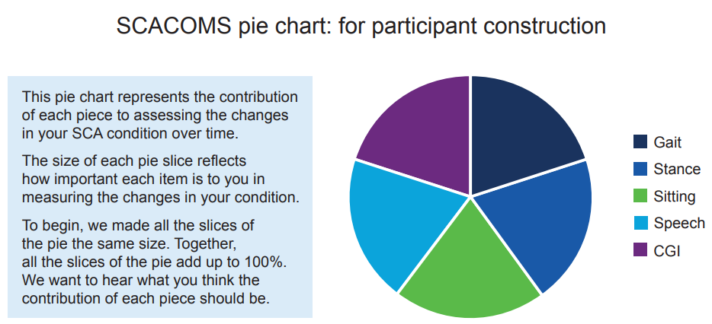

CGI: Clinician Global Impression of Change; SCA: spinocerebellar ataxia; SCACOMS: spinocerebellar ataxia composite score

Supplementary Fig. 2 Assigned relative contribution of SCACOMS items by individuals with SCA stratified by disease severity
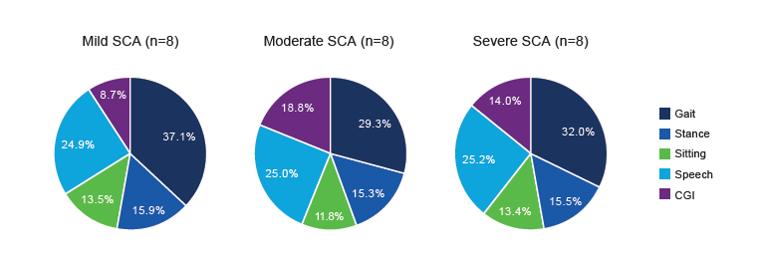

CGI: Clinician Global Impression of Change; SCA: spinocerebellar ataxia; SCACOMS: spinocerebellar ataxia composite score

