Supplementary figure 1
Distribution of individual component scores
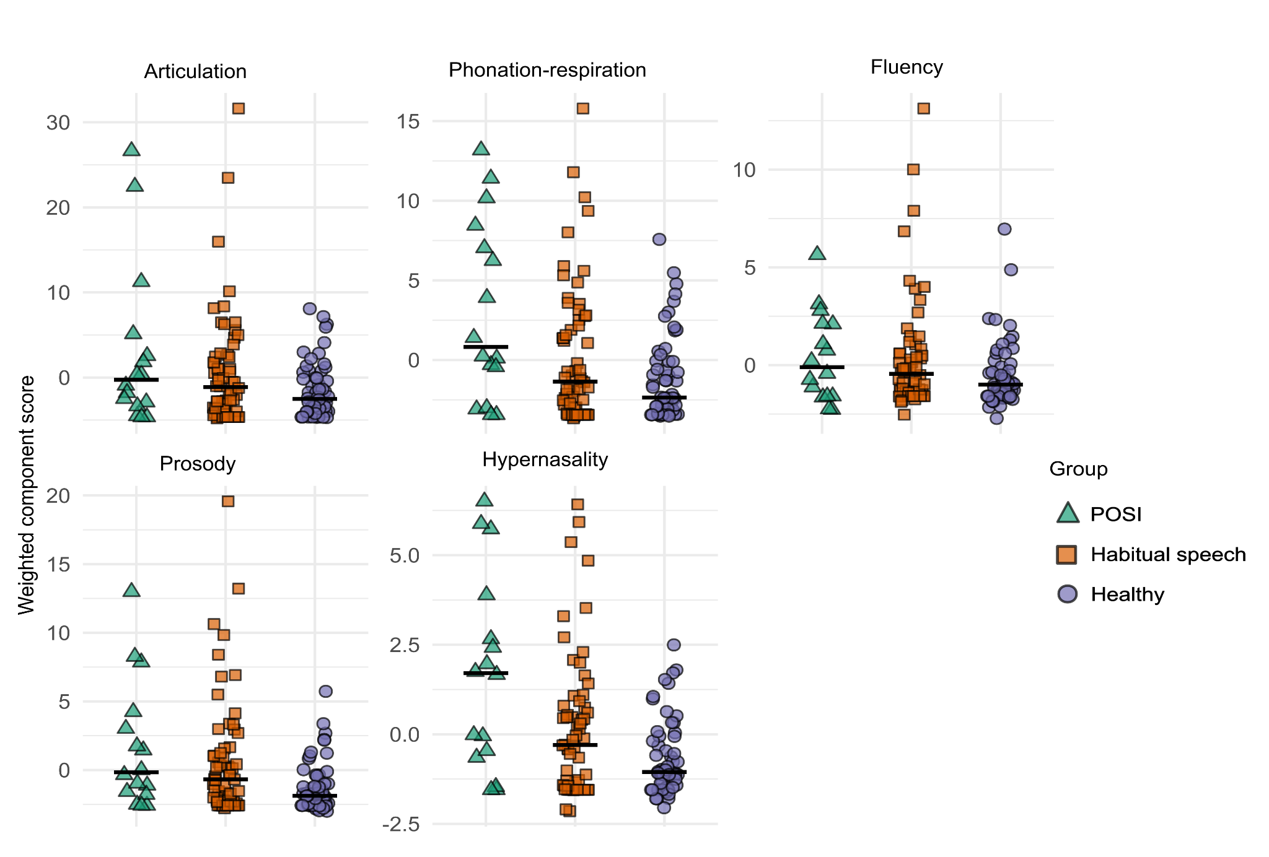
POSI stands for postoperative speech impairment (i.e., mutism and/or reduced speech). The horizontal line shows the median component score for each group.

Supplementary figure 2
Distribution of perceptual ratings assigned by each rater across speech features
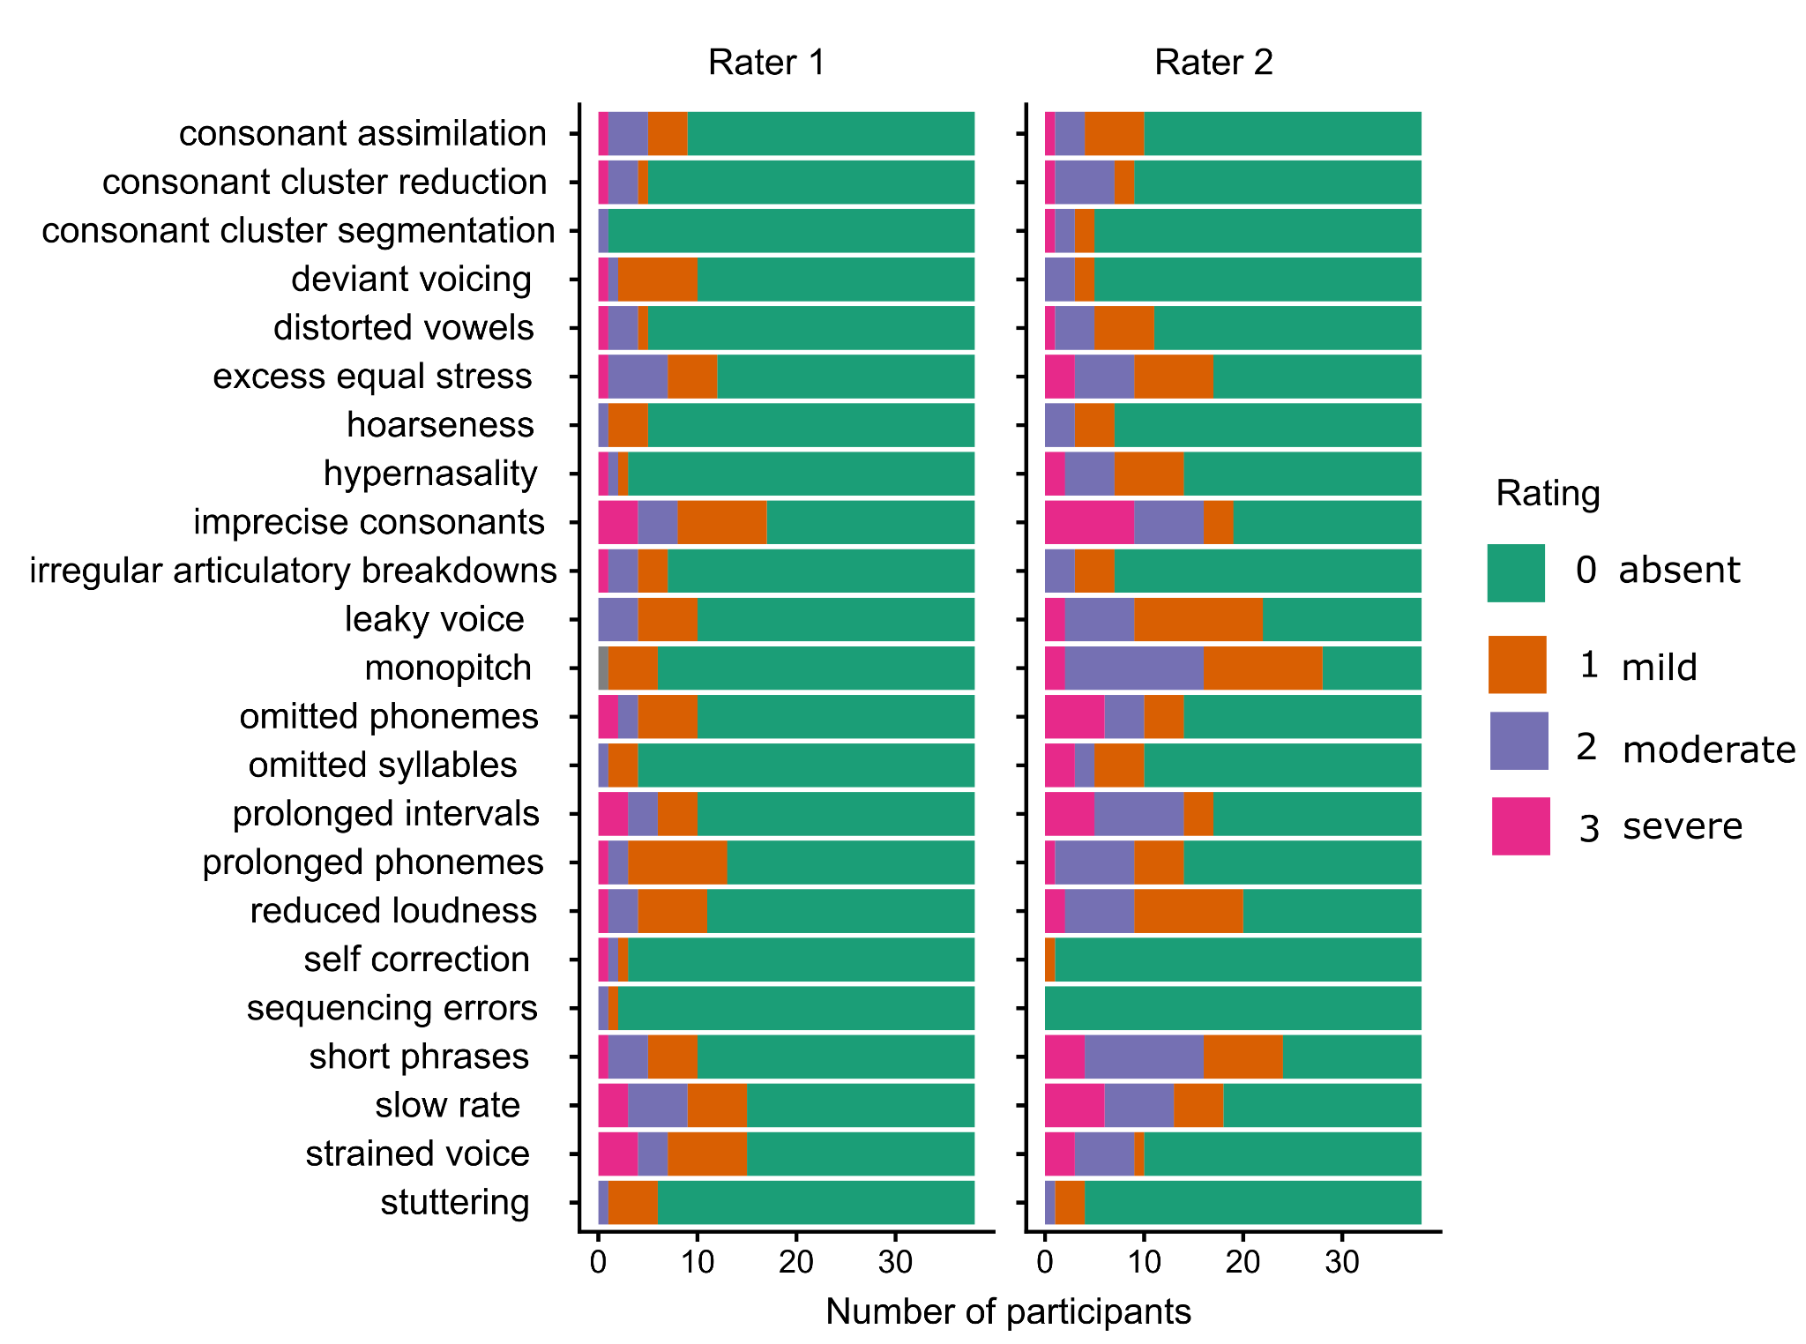
Note. Stacked bar plots showing the frequency of perceptual ratings assigned by Rater 1 (left panel) and Rater 2 (right panel) for each speech feature. Data are from 38 English speaking patients.

