Supplementary Material

Supplementary Material S1. Clinical trials

In FREEDOMS and FREEDOMS II, patients with RRMS were randomized 1:1:1 to fingolimod 0.5 mg (n = 425 and 358, respectively), fingolimod 1.25 mg (n = 429 and 370, respectively) or placebo
(n = 418 and 355, respectively) for 24 months (approximately 103 weeks). In the DEFINE trial, patients were randomized 1:1:1 to DMF 240 mg twice daily (n = 410), DMF 240 mg three times daily (n = 416) or placebo (n = 408) for 96 weeks. The 24-month CONFIRM trial randomized patients to these groups (n = 359, 345 and 363, respectively) or to an active comparator, subcutaneous glatiramer acetate 20 mg once daily (n = 350). In the TEMSO trial, patients were randomized to teriflunomide 7 mg (n = 365) or 14 mg (n = 358), or placebo (n = 363), over 106 weeks.

Key differences in the inclusion and exclusion criteria between the five trials were as follows: FREEDOMS, FREEDOMS II and TEMSO allowed patients with higher baseline EDSS scores (0–5.5) than DEFINE and CONFIRM (0–5). DEFINE and CONFIRM included patients with one or more relapse in the 12 months before randomization or at least one gadolinium (Gd)-enhancing lesion 0–6 weeks before randomization. The other trials required both relapses and Gd-enhancing lesions in the previous year. Some differences in the exclusion criteria existed between trials with regard to previous DMT use, laboratory results, comorbidities and participating countries.

Supplementary Material S2. Prediction model
The probability of achieving NEDA status is modelled as follows:
$$\begin{matrix}y_{i} & \sim & Bernoulli\left(p_{i}\right) \\ p_{i} & = & α_{j}+β^{T}x_{i}+\sum_{k=1}^{2}{I(t_{i}=k)\left({γ_{0k}+γ{}_{k}}^{T}x_{i}\right)}\end{matrix}$$

where $y_{i }$indicates if patient i is disease free ($y_{i}=1$ if disease free, and 0 otherwise). A linear link function is used to regress the probability of being disease free on patient-level baseline covariates. $α_{j}$ is a study level-stratifying variable and j(i) = 1 or 2 indicates which study patient i is from. $x_{i}$ is a vector of patient-level baseline covariates. These have been centred about their mean value for continuous variables, and are dummy variables for categorical variables, with the lowest level of a category being the reference category and fixed to zero for an identifiability constraint (EDSS score = 0–1.5). $β$ is a parameter vector of main effects of these covariates. $t_{i}$ indicates which treatment group patient i is in ($t_{i}$= 0 for placebo and 1 for treatment with fingolimod at 0.5 mg and 2 for treatment at 1.25 mg), I() is an indicator function, and k indexes the treatment arm. $γ_{0k}$ is the absolute probability increase of being disease free given fingolimod in treatment arm k compared with placebo, at the mean value of the patient characteristics and the reference category of categorical covariates. $γ_{k}^{T}$is a parameter vector of treatment–patient covariate interaction effects. It is necessary to include treatment–covariate interactions in the model to be able to predict the relative risk given patient baseline characteristics.

Predicting the relative risk of achieving NEDA status given fingolimod 0.5 mg compared with placebo
Given a vector of patient characteristics, $x_{i}$, a study j (= 1 or 2) and treatment group k (k = 0 for placebo and 1 for fingolimod 0.5 mg), the probability of being disease free is estimated by ${\hat{p}}_{jk}$
$${{\hat{p}}_{jk}=\hat{α}}_{j}+{\hat{β}}^{T}x_{i}+{{\hat{γ}}_{0k}+\hat{γ}{}_{k}}^{T}x_{i}$$
where the hats indicate the maximum likelihood estimates of the parameters. The variance of ${\hat{p}}_{jk}$, V(${\hat{p}}_{jk}),$and covariance of ${\hat{p}}_{jk}$ and ${\hat{p}}_{lm}$, $Cov{(\hat{p}}_{jk}, {\hat{p}}_{lm})$ (j and l = 1 or 2, and k and m = 0 or 1), can be found from the variance–covariance matrices of the parameter estimates. We estimate the relative risk of being disease free given fingolimod 0.5 mg compared to placebo from the weighted sum of relative risks in each study:
$$\begin{matrix}\log\left(RR\right) & = & \frac{w_{1}log\left(RR_{1}\right)+w_{2}log\left(RR_{2}\right)}{w_{1}+w_{2}} \\ \log\left(RR_{j}\right) & = & \log\left(\frac{{\hat{p}}_{j1}}{{\hat{p}}_{j0}}\right) \\ w_{j} & = & \frac{1}{V\left(log⁡(RR_{j})\right)}\end{matrix}$$

where the variance of the log RR in study j is found by the delta method
$$V\left(log⁡(RR_{j})\right)=V\left(\log\left(\frac{{\hat{p}}_{j1}}{{\hat{p}}_{j0}}\right)\right)≈ \frac{V({\hat{p}}_{j0})}{{\hat{p}}_{j0}^{2}}+ \frac{V({\hat{p}}_{j1})}{{\hat{p}}_{j1}^{2}}-\frac{2Cov\left({\hat{p}}_{j0},{\hat{p}}_{j1} \right)}{{\hat{p}}_{j0}{\hat{p}}_{j1}}$$

Similarly the delta method can be used to find the variance of the log RR overall:
$$\begin{matrix}V\left(\log\left(RR\right)\right) & = & \frac{1}{w_{1}+w_{2}}+\frac{w_{1w_{2}}}{{\left(w_{1}+w_{2}\right)}^{2}}Cov\left(\log\left(RR_{1}\right),\log\left(RR_{2}\right)\right) \\ Cov\left(\log\left(RR_{1}\right),\log\left(RR_{2}\right)\right) & ≈ & \frac{Cov\left({\hat{p}}_{10},{\hat{p}}_{20} \right)}{{\hat{p}}_{10}{\hat{p}}_{20}}+\frac{Cov\left({\hat{p}}_{11},{\hat{p}}_{21} \right)}{{\hat{p}}_{11}{\hat{p}}_{21}}-\frac{Cov\left({\hat{p}}_{10},{\hat{p}}_{21} \right)}{{\hat{p}}_{10}{\hat{p}}_{21}}-\frac{Cov\left({\hat{p}}_{11},{\hat{p}}_{20} \right)}{{\hat{p}}_{11}{\hat{p}}_{20}}\end{matrix}$$

Confidence intervals for log(RR) can be found using a Normal approximation, and taking exponentials leads to confidence intervals for the RR.

Supplementary Material S3. Prediction model goodness-of-fit
Goodness-of-fit of the prediction models is assessed by visually comparing the observed probability of being disease free with the probability predicted by the model (Supplementary Material S5). Hosmer–Lemeshow grouping is used, where the fitted values from the model are ordered by size and grouped into 25 bins (of approximately 100 patients each). The average number of observed disease-free patients in each group is then compared to the average predicted probability of being disease free. The predicted probability of being disease free agrees very well with that observed.
Supplementary Material S4. Impact of baseline characteristics on predicted RRs for fingolimod versus placebo ª (initial model)

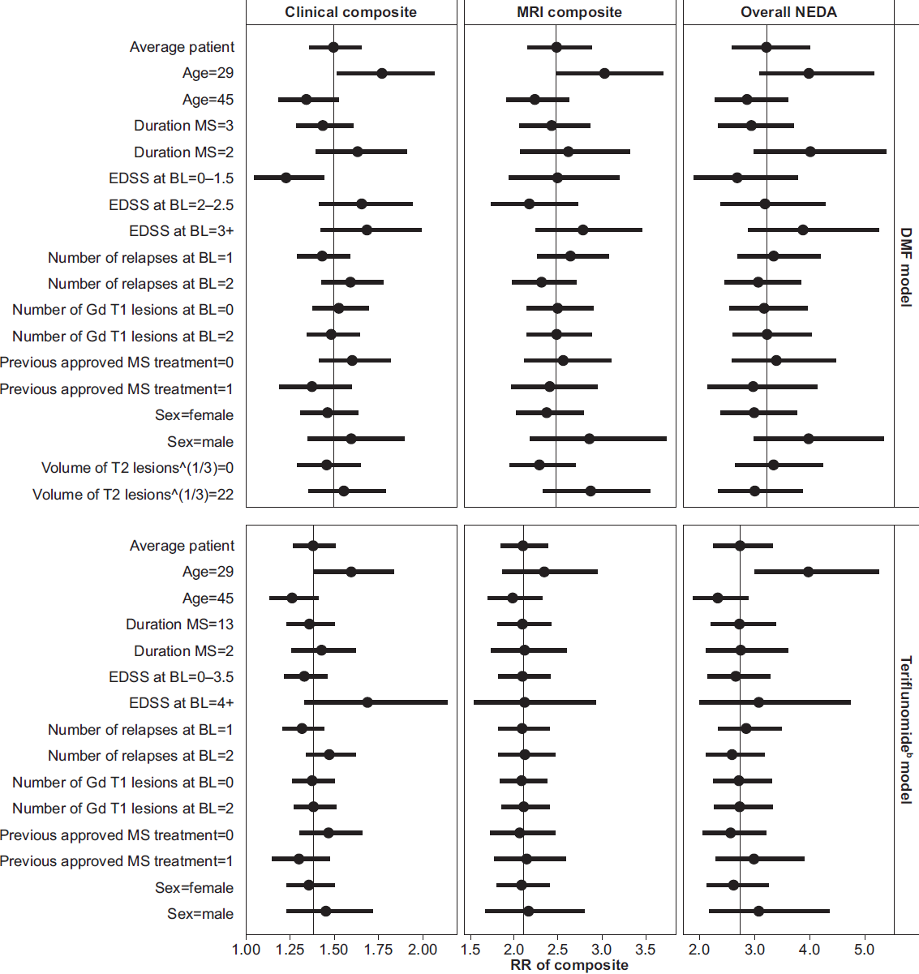
An RR above 1.0 indicates an improved outcome for treatment relative to placebo.
ªFor non-binary covariates, the model predicts the treatment effect for setting that variable at the 1st and 3rd quartile of the distribution whilst holding all other covariates constant.
^{b}Volume of T2 lesions at baseline was not included in the initial model for the teriflunomide analysis, and EDSS-defined progression was reported differently (0–3.5 instead of 0–1.5 in the DMF analysis).
Abbreviations: BL baseline, DMF dimethyl fumarate, EDSS expanded disability status scale, Gd gadolinium, MRI magnetic resonance imaging, MS multiple sclerosis, NEDA no evidence of disease activity, RR relative risk.
Supplementary Material S5. Goodness-of-fit of the prediction models for the probability of achieving NEDA status.
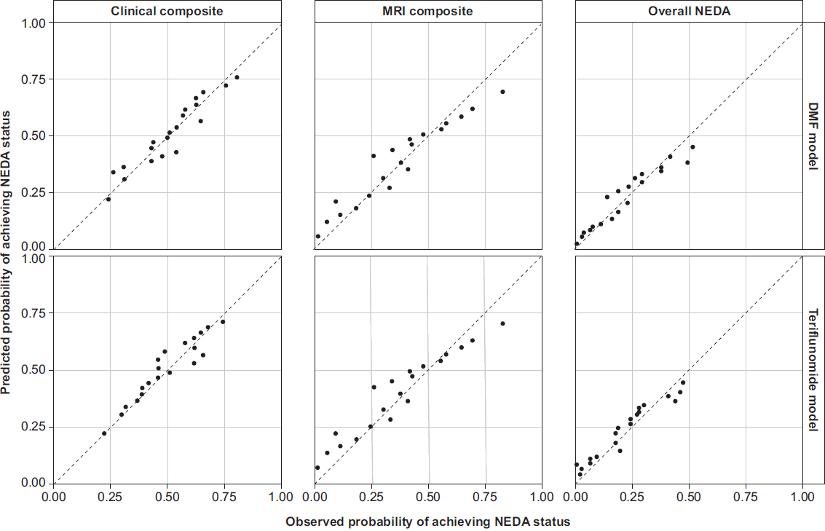
Abbreviations: DMF dimethyl fumarate, MRI magnetic resonance imaging, NEDA no evidence of disease activity.

Supplementary Material S6. Results for individual component measures for the DMF comparison.
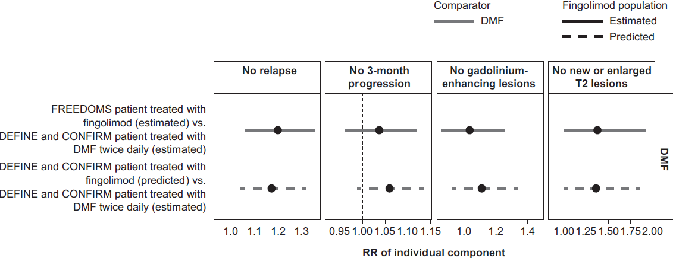

Abbreviations: CONFIRM comparator and an oral fumarate in relapsing–remitting multiple sclerosis, DEFINE determination of the efficacy and safety of oral fumarate in relapsing–remitting multiple sclerosis, DMF dimethyl fumarate, FREEDOMS FTY720 research evaluating effects of daily oral therapy in multiple sclerosis, MRI magnetic resonance imaging, RR relative risk.

