ESM Fig. 1 Scatter plot of each parameter from this study and previous study data [19]. Correlation between urine volume and (a) urinary glucose excretion, (b) water intake, (c) urinary Na excretion, (d) urinary K excretion, (e) urine osmolality, (f) plasma NT-proBNP, (g) plasma ANP, (h) plasma renin activity, (i) plasma aldosterone, and (j) plasma vasopressin. Left panel represents change from Day 0, and right panel represents actual value. The four (change from baseline) or six (actual value) scatter plots were shown in each graph: upper graph represents the data of the present study, lower graph represents the data of the previous study [19].
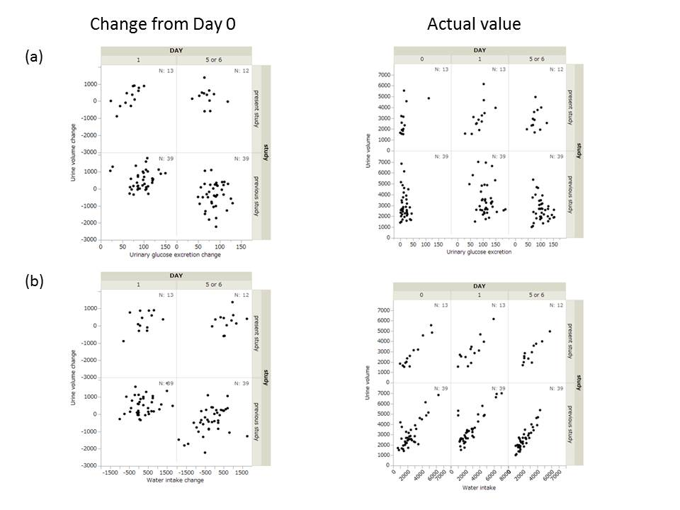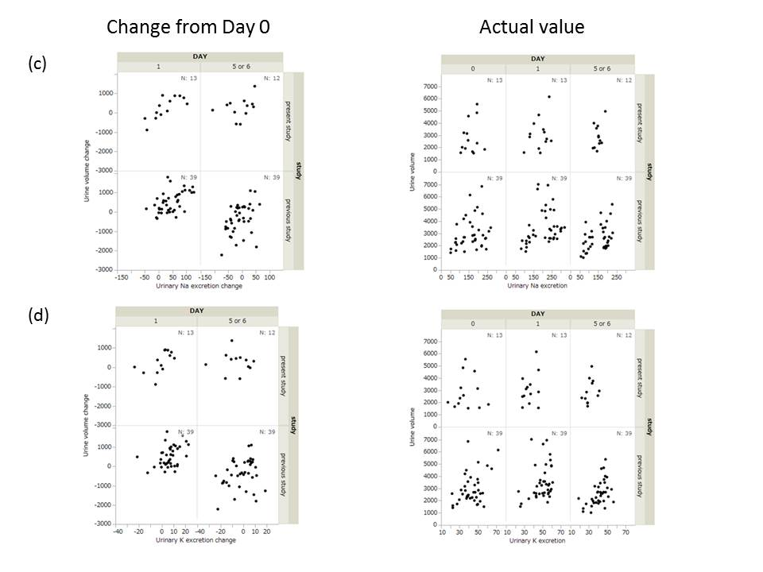

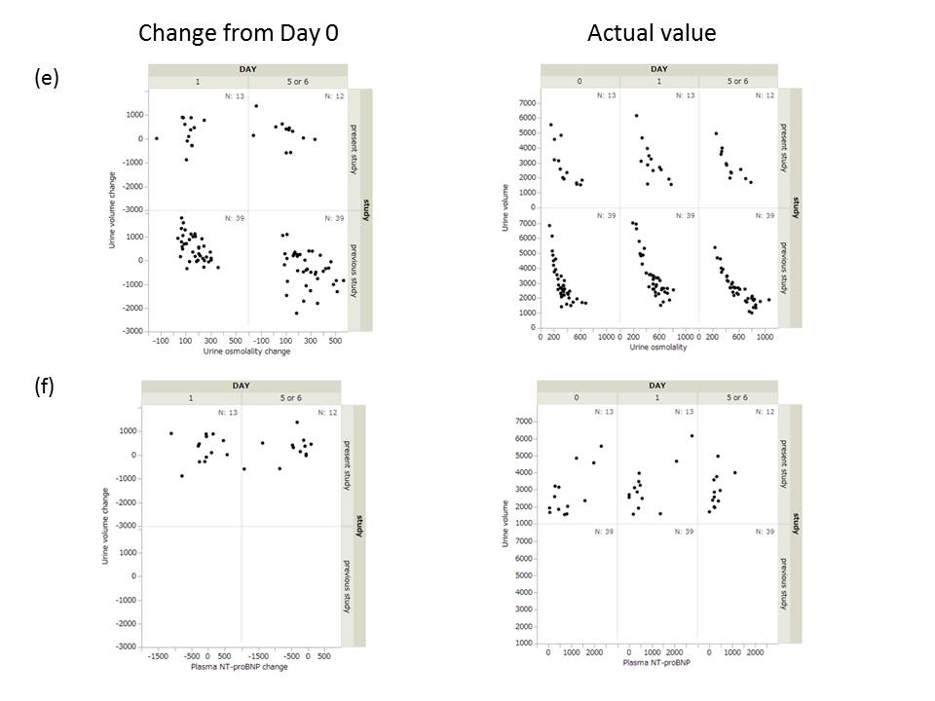

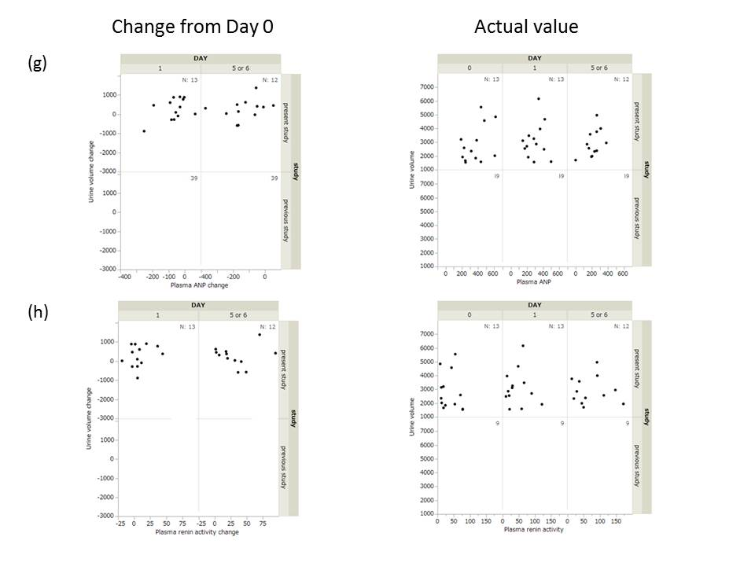

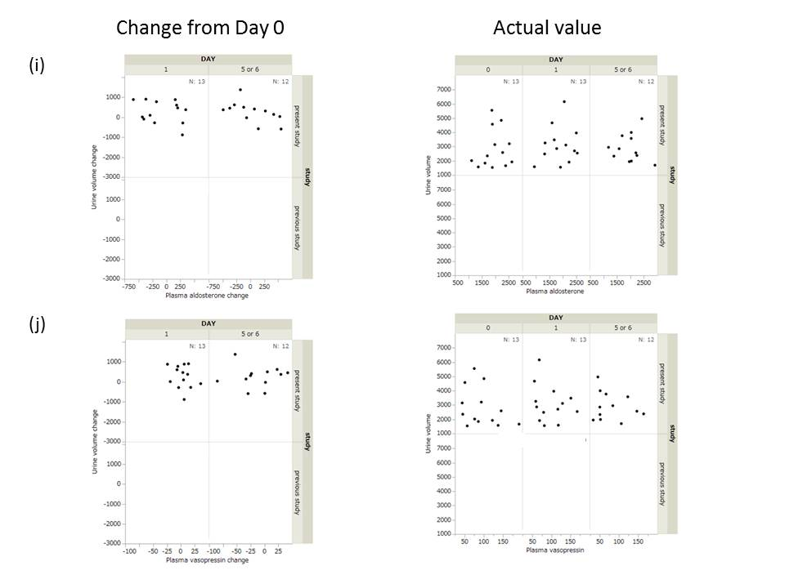

ESM Table 1 Canagliflozin-induced change in urine volume and urinary sodium excretion: post-hoc analysis of data from our previous study [19].
 | Urine volume (mL)
 | Actual values |  |  |  | Changes from Day 0
Day 0 | Dose (mg) | n | Mean | SD
Day 0 | 0 | 10 | 2820.8 | 899.0
Day 0 | 25 | 12 | 2890.9 | 1060.1
Day 0 | 100 | 12 | 2587.7 | 474.4
Day 0 | 200 | 14 | 3305.6 | 1493.7
Day 0 | 400 | 13 | 2973.8 | 1469.3
Day 1 | Dose (mg) | n | Mean | SD | Mean | SD | 95% CI
Day 1 | 0 | 10 | 2714.8 | 876.6 | −106.0 | 435.2 | −417.3 to 205.3
Day 1 | 25 | 11 | 3460.8 | 974.6 | 509.5 | 646.0 | 75.5 to 943.4
Day 1 | 100 | 12 | 3064.3 | 426.0 | 476.7 | 448.8 | 191.5 to 761.8
Day 1 | 200 | 14 | 3682.1 | 1751.8 | 376.6 | 529.5 | 70.8 to 682.3
Day 1 | 400 | 13 | 3684.6 | 1594.1 | 710.8 | 607.3 | 343.8 to 1077.8
Day 6 | Dose (mg) | n | Mean | SD | Mean | SD | 95% CI
Day 6 | 0 | 9 | 2743.2 | 1075.1 | −176.7 | 983.1 | −932.3 to 579.0
Day 6 | 25 | 12 | 2601.8 | 862.9 | −289.1 | 651.1 | −702.8 to 124.6
Day 6 | 100 | 12 | 2372.9 | 484.6 | −214.8 | 512.7 | −540.5 to 111.0
Day 6 | 200 | 14 | 2763.4 | 1264.7 | −542.2 | 655.5 | −920.7 to −163.8
Day 6 | 400 | 13 | 2655.4 | 1061.6 | −318.5 | 1011.4 | −929.6 to 292.7
Day 16 | Dose (mg) | n | Mean | SD | Mean | SD | 95% CI
Day 16 | 0 | 9 | 3090.2 | 1297.7 | 170.3 | 1031.3 | −622.4 to 963.1
Day 16 | 25 | 12 | 2883.7 | 821.7 | −7.3 | 746.1 | −481.3 to 466.8
Day 16 | 100 | 12 | 2481.4 | 507.2 | −106.3 | 573.0 | −470.3 to 257.8
Day 16 | 200 | 14 | 3286.9 | 1698.2 | −18.6 | 697.4 | −421.3 to 384.0
Day 16 | 400 | 13 | 3211.5 | 1474.8 | 237.7 | 1150.5 | −457.5 to 932.9

 | Uninary Na excretion (mEq)
 | Actual values |  |  |  | Changes from Day 0
Day 0 | Dose (mg) | n | Mean | SD
Day 0 | 0 | 10 | 191.57 | 41.70
Day 0 | 25 | 12 | 225.61 | 38.76
Day 0 | 100 | 12 | 216.47 | 35.49
Day 0 | 200 | 14 | 130.79 | 51.40
Day 0 | 400 | 13 | 140.81 | 57.08
Day 1 | Dose (mg) | n | Mean | SD | Mean | SD | 95% CI
Day 1 | 0 | 10 | 170.32 | 46.08 | -21.25 | 36.64 | -47.46 to 4.96
Day 1 | 25 | 11 | 258.13 | 25.84 | 29.73 | 43.45 | 0.54 to 58.92
Day 1 | 100 | 12 | 270.58 | 29.21 | 54.12 | 41.80 | 27.56 to 80.68
Day 1 | 200 | 14 | 175.11 | 68.80 | 44.32 | 49.89 | 15.52 to 73.13
Day 1 | 400 | 13 | 176.96 | 53.21 | 36.15 | 33.35 | 16.00 to 56.31
Day 6 | Dose (mg) | n | Mean | SD | Mean | SD | 95% CI
Day 6 | 0 | 9 | 173.90 | 52.57 | -28.59 | 49.12 | -66.35 to 9.17
Day 6 | 25 | 12 | 200.03 | 30.05 | -25.58 | 47.38 | -55.68 to 4.53
Day 6 | 100 | 12 | 197.28 | 16.27 | -19.19 | 28.08 | -37.03 to -1.35
Day 6 | 200 | 14 | 134.43 | 57.33 | 3.64 | 28.48 | -12.80 to 20.09
Day 6 | 400 | 13 | 128.12 | 51.91 | -12.68 | 43.55 | -39.00 to 13.63
Day 16 | Dose (mg) | n | Mean | SD | Mean | SD | 95% CI
Day 16 | 0 | 9 | 197.37 | 43.74 | -5.12 | 33.72 | -31.04 to 20.80
Day 16 | 25 | 12 | 230.80 | 32.80 | 5.19 | 53.48 | -28.79 to 39.17
Day 16 | 100 | 12 | 191.74 | 38.64 | -24.73 | 40.99 | -50.77 to 1.32
Day 16 | 200 | 14 | 145.44 | 76.80 | 14.66 | 49.27 | -13.79 to 43.10
Day 16 | 400 | 13 | 165.59 | 69.63 | 24.78 | 49.95 | -5.40 to 54.97

ESM Table 2 Spearman’s correlations between urine volume and factors known to affect urine volume in the previous study[19].
 |  | Urine volume  Changes from Day 0 |  |  |  |  | Urine volume  Actual values
Changes from Day 0 |  | Day 1  n=39 |  | Day 6  n=39 |  | Actual values | Day 0  n=39 |  | Day 1  n=39 |  | Day 6  n=39
 |  | r |  | r |  | Actual values | r |  | r |  | r
 | Urinary glucose excretionª | 0.195 |  | 0.151 |  | Urinaryglucose excretionª | −0.085 |  | −0.083 |  | −0.177
 | Water intakeª | 0.216 |  | 0.460 | * | Water intakeª | 0.619 | * | 0.691 | * | 0.834 | *
 | Urinary Na excretionª | 0.521 | * | 0.438 | * | Urinary Na excretionª | 0.321 | * | 0.387 | * | 0.359 | *
 | Urinary K excretionª | 0.376 | * | 0.229 |  | Urinary K excretionª | 0.255 |  | 0.345 | * | 0.557 | *
 | Urine osmolalityª | −0.583 | * | −0.393 | * | Urine osmolalityª | −0.823 | * | −0.848 | * | −0.927 | *

ª 24 h
*, p<0.05

ESM Table 3 Changes from baseline in 24-h blood glucose, AUCs of 24-h blood glucose, postprandial blood glucose after breakfast, lunch, and supper, and GLP-1 after breakfast
 | Time point | n | Mean | SD | 95% CI
Mean 24-h blood glucose | Day 1 | 13 | −32.83 | 16.73 | −42.94 to −22.72
(mg/dL) | Day 5 | 12 | −48.11 | 19.34 | −60.40 to −35.83
Blood glucose AUC_{0–24h} | Day 1 | 13 | −771.98 | 512.95 | −1081.95 to −462.01
(mg dL⁻¹ h) | Day 5 | 12 | −1005.92 | 420.42 | −1273.04 to −738.79
Postprandial blood glucose AUC_{0–2.0h} after breakfast | Day 1 | 13 | −86.54 | 35.03 | −107.71 to −65.37
(mg dL⁻¹ h) | Day 5 | 12 | −145.63 | 41.17 | −171.78 to −119.47
Postprandial blood glucose AUC_{4.5–6.5h} after lunch | Day 1 | 13 | −70.35 | 54.56 | −103.31 to −37.38
(mg dL⁻¹ h) | Day 5 | 12 | −93.15 | 54.90 | −128.03 to −58.26
Postprandial blood glucose AUC_{10.5–12.5h} after supper | Day 1 | 13 | −42.15 | 57.94 | −77.16 to −7.14
(mg dL⁻¹ h) | Day 5 | 12 | −53.75 | 38.75 | −78.37 to −29.13
Postprandial GLP-1 AUC_{0–2.0h} after breakfast | Day 1 | 13 | 10.15 | 9.00 | 4.70 to 15.59
(pmol L⁻¹ h) | Day 5 | 12 | 8.48 | 5.26 | 5.13 to 11.82

GLP-1,glucagon-like peptide-1

ESM Table 4 Vital signs and laboratory testsª
Parameters | Treatment period | n | Mean | SD
Body weight | Baseline | 13 | 73.48 | 13.58
(kg) | 1 day | 13 | 72.81 | 13.32
 | 5 days | 12 | 73.58 | 11.36
Systolic BP^{b} | Baseline | 13 | 117.8 | 12.7
(mmHg) | 1 day | 13 | 121.6 | 7.3
 | 5 days | 12 | 121.8 | 9.1
Diastolic BP^{b} | Baseline | 13 | 68.2 | 7.5
(mmHg) | 1 day | 13 | 71.0 | 8.4
 | 5 days | 12 | 69.3 | 6.2
Insulin | Baseline | 13 | 11.80 | 12.02
(μU/mL) | 1 day | 13 | 8.08 | 7.17
 | 5 days | 12 | 6.98 | 7.01
Ketone body acetoacetate | Baseline | 13 | 41.26 | 56.02
Ketone body acetoacetate | 1 day | 13 | 108.53 | 124.11
(μmol/L) | 5 days | 12 | 74.94 | 33.21
Ketone body 3-OHBA | Baseline | 13 | 181.03 | 292.13
Ketone body 3-OHBA | 1 day | 13 | 541.28 | 793.66
(μmol/L) | 5 days | 12 | 473.78 | 318.03
Total ketone bodies | Baseline | 13 | 222.29 | 348.01
(μmol/L) | 1 day | 13 | 649.82 | 916.47
 | 5 days | 12 | 548.73 | 347.04
Ketone body ratio^{c} | Baseline | 13 | 0.268 | 0.058
 | 1 day | 13 | 0.258 | 0.086
 | 5 days | 12 | 0.176 | 0.044

BP, blood pressure; 3-OHBA, 3-Hydroxybutyric acid

ª All data were obtained before breakfast: Baseline, 1 day treatment and 5 days treatment data were obtained at Day 1, Day 2, and Day 6 before breakfast.

^{b} Recumbent position

^{c} Acetoacetate/3-OHBA

