Table S1 Patient characteristics at baseline, in the ITT and EXT populations
Baseline characteristic | ITT population |  | EXT population
Baseline characteristic | FF/UMEC/VI  100/62.5/25 µg  (n = 911) | BUD/FOR  400/12 µg  (n = 899) | FF/UMEC/VI  100/62.5/25 µg  (n = 210) | BUD/FOR  400/12 µg  (n = 220)
Age, mean years (SD) | 64.2 (8.56) | 63.7 (8.71) | 63.7 (7.76) | 63.3 (8.43)
Female, n (%) | 233 (26) | 236 (26) | 53 (25) | 58 (26)
Current smokers, n (%) | 400 (44) | 394 (44) | 95 (45) | 97 (44)
Smoking pack-years, mean (SD) | 39.5 (21.87) | 39.2 (22.15) | 39.8 (19.92) | 39.6 (23.12)
Cardiovascular risk factors* n (%) | 599 (66) | 602 (67) | 144 (69) | 152 (69)
Moderate/severe COPD exacerbations in previous 12 months, n (%)  0  1  ≥2 | 313 (34)  252 (28)  346 (38) | 317 (35)  253 (28)  329 (37) | 62 (30)  77 (37)  71 (34) | 72 (33)  79 (36)  69 (31)
History of pneumonia, n (%) | 87 (10) | 99 (11) | 18 (9) | 20 (9)
Mean FEV₁ absolute, L (SD) | 1.349 (0.46) | 1.339 (0.48) | 1.425 (0.50) | 1.368 (0.51)
Mean FEV₁ predicted, % (SD) | 45.5 (12.97) | 45.1 (13.64) | 47.1 (13.30) | 45.4 (14.85)
Mean SGRQ total score, (SD) | 51.8 (16.29) | 50.8 (16.73) | 53.0 (16.14) | 50.8 (15.49)
Mean E-RS: COPD, (SD) | 13.20 (5.828) | 12.97 (5.928) | 13.54 (5.439) | 13.00 (5.576)
BUD/FOR budesonide/formoterol; CAT COPD Assessment Test; COPD chronic obstructive pulmonary disease; EXT extension; FEV₁ forced expiratory volume in 1 second; FF/UMEC/VI fluticasone furoate/umeclidinium/vilanterol; ITT intent-to-treat; SD standard deviation. *Cardiovascular risk factors included, but were not limited to, hypertension, hypercholesterolemia, coronary heart disease, and diabetes mellitus.

Table S2
Distribution of patients within subgroups by prior COPD medication class at screening in the ITT population and the EXT population
 | Week 24 (ITT population) |  |  | Week 52 (EXT population)
 | FF/UMEC/VI (n=911) | BUD/FOR (n=899) | Total (N=1810) | FF/UMEC/VI (n=210) | BUD/FOR (n=220) | Total (n=430)
COPD medication class at screening#, n (%) | (n=705) | (n=678) | (n=1383) | (n=181) | (n=171) | (n=352)
ICS+LABA | 268 (29) | 259 (29) | 527 (29) | 72 (34) | 68 (31) | 140 (33)
BUD+FOR | 87 (10) | 83 (9) | 170 (9) | 28 (13) | 25 (11) | 53 (12)
ICS+LABA+LAMA | 257 (28) | 256 (28) | 513 (28) | 63 (30) | 58 (26) | 121 (28)
LAMA alone | 79 (9) | 79 (9) | 158 (9) | 20 (10) | 20 (9) | 40 (9)
TIO alone | 65 (7) | 67 (7) | 132 (7) | 15 (7) | 16 (7) | 31 (7)
LAMA+LABA | 101 (11) | 84 (9) | 185 (10) | 26 (12) | 25 (11) | 51 (12)

Table S3
Change from baseline in SGRQ domain scores and E-RS: COPD scores in the EXT population
SGRQ or E-RS: COPD score | EXT population (52 weeks)
SGRQ or E-RS: COPD score | LS mean change from baseline (95% CI) FF/UMEC/VI  100/62.5/25 µg  (n = 210) | LS mean change from baseline (95% CI)  BUD/FOR  400/12 µg  (n = 220) | Treatment difference  (95% CI) P value
SGRQ domain scores
Week 4  Symptoms  Activity  Impacts | -3.8 (-5.9 to -1.7)  -2.0 (-3.9 to -0.2)  -1.9 (-3.9 to 0.0) | -4.6 (-6.6 to -2.5)  -1.1 (-2.9 to 0.7)  -2.1 (-4.0 to -0.2) | 0.7 (-2.2 to 3.7); 0.620  -0.9 (-3.5 to 1.7); 0.486  0.1 (-2.5 to 2.8); 0.914
Week 24  Symptoms  Activity  Impacts | -9.7 (-12.0 to -7.3)  -5.4 (-7.3 to -3.4)  -5.2 (-7.1 to -3.3) | -8.5 (-10.9 to -6.1)  -2.4 (-4.3 to -0.4)  -3.6 (-5.6 to -1.7) | -1.2 (-4.6 to 2.2); 0.484  -3.0 (-5.7 to -0.2); 0.035  -1.5 (-4.2 to 1.2); 0.265
Week 52  Symptoms  Activity  Impacts | -8.7 (-11.1 to -6.2)  -3.3 (-5.6 to -1.0)  -4.0 (-6.3 to -1.7) | -8.4 (-10.9 to -5.9)  -0.8 (-3.2 to 1.5)  -0.7 (-3.0 to 1.7) | -0.3 (-3.8 to 3.2); 0.870  -2.5 (-5.7 to 0.8); 0.139  -3.3 (-6.6 to 0.0); 0.051
E-RS: COPD total score
Weeks 1-4 | -1.24 (-1.68 to -0.81) | -0.72 (-1.15 to -0.29) | -0.52 (-1.13 to 0.09); 0.094
Weeks 21-24 | -2.63 (-3.30 to -1.96) | -1.52 (-2.19 to -0.86) | -1.11 (-2.05 to -0.16); 0.022
Weeks 49-52 | -2.03 (-2.76 to -1.30) | -0.61 (-1.34 to 0.12) | -1.42 (-2.45 to -0.39); 0.007
E-RS: COPD subscale scores
Weeks 1-4  Breathlessness  Cough and sputum  Chest | -0.64 (-0.87 to -0.40)  -0.34 (-0.47 to -0.21)  -0.27 (-0.41 to -0.13) | -0.31 (-0.54 to -0.07)  -0.32 (-0.45 to -0.19)  -0.09 (-0.23 to 0.04) | -0.33 (-0.66 to 0.00); 0.051  -0.02 (-0.20 to 0.16); 0.840  -0.18 (-0.37 to 0.01); 0.068
Weeks 21-24  Breathlessness  Cough and sputum  Chest | -1.13 (-1.51 to -0.76)  -0.83 (-1.03 to -0.64)  -0.68 (-0.88 to -0.48) | -0.50 (-0.87 to -0.13)  -0.71 (-0.91 to -0.52)  -0.30 (-0.50 to -0.10) | -0.64 (-1.16 to -0.11); 0.018  -0.12 (-0.39 to 0.15); 0.388  -0.37 (-0.66 to -0.09); 0.010
Weeks 49-52  Breathlessness  Cough and sputum  Chest | -0.96 (-1.36 to -0.55)  -0.61 (-0.80 to -0.14)  -0.49 (-0.72 to -0.26) | -0.08 (-0.49 to 0.33)  -0.44 (-0.64 to -0.24)  -0.08 (-0.31 to 0.14) | -0.87 (-1.45 to -0.03); 0.003  -0.17 (-0.45 to 0.11); 0.231  -0.41 (-0.73 to -0.09); 0.013
BUD/FOR budesonide/formoterol, CI confidence interval, E-RS: COPD Evaluating Respiratory Symptoms in COPD, EXT extension, FF/UMEC/VI fluticasone furoate/umeclidinium/vilanterol, LS least squares, SGRQ St George’s Respiratory Questionnaire

Fig. S1
FULFIL study design
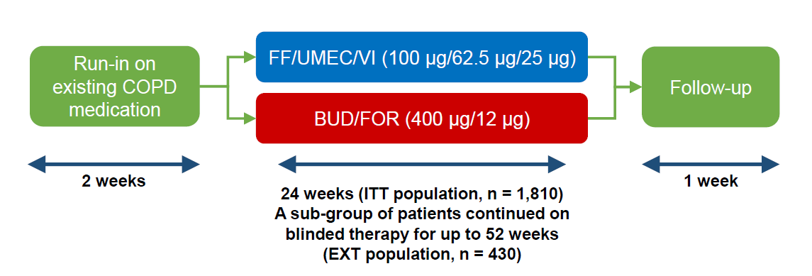
BUD/FOR budesonide/formoterol, COPD chronic obstructive pulmonary disease, EXT extension, FF/UMEC/VI fluticasone furoate/umeclidinium/vilanterol, ITT intent-to-treat

