Pharmacokinetics of Daratumumab in Combination Therapy Regimens for Patients with Multiple Myeloma Supplemental Data

Supplemental Table 1. Eligibility criteria for clinical studies.
Study | Key eligibility criteria
GEN503 | - Age ≥18 years with measurable, documented MM  - ECOG performance status ≤2  Part 1:  - Between 2 and 4 prior lines of therapy  - Eligible for treatment with Rd  Part 2:  - ≥1 prior line of therapy and a PR or better with a prior treatment  - Disease progression on the last line of therapy
EQUULEUS | - Age ≥18 years with measurable, documented MM  - ECOG performance status ≤2  D-Vd and D-VTd arms:  - Newly diagnosed with symptomatic disease fulfilling CRAB criteria  D-VMP arm:  - Newly diagnosed with symptomatic disease fulfilling CRAB criteria and ineligible for transplantation  D-Pd arm:  - ≥2 prior lines of therapy, including R and V  - Disease refractory to the last line of treatment
POLLUX | - Age ≥18 years with measurable, documented MM  - ECOG performance status ≤2  - ≥1 prior line of therapy and a PR or better with a prior treatment  - Disease progression on the last line of therapy  - Not intolerant or refractory to R
CASTOR | - Age ≥18 years with measurable, documented MM  - ECOG performance status ≤2  - ≥1 prior line of therapy and a PR or better with a prior treatment  - Disease progression on the last line of therapy  - Not intolerant or refractory to V or other PIs
MM, multiple myeloma; ECOG, Eastern Cooperative Oncology Group; Rd, lenalidomide and dexamethasone; PR, partial response; D-Vd, daratumumab plus bortezomib and dexamethasone; D-VTd, daratumumab plus bortezomib, thalidomide, and dexamethasone; CRAB, calcium elevated, renal failure, anemia, and bone lesions; D-VMP, daratumumab plus bortezomib, melphalan, and prednisone; D-Pd, daratumumab plus pomalidomide and dexamethasone; R, lenalidomide; V, bortezomib; PI, proteasome inhibitor.

Supplemental Table 2. Dosing schedules for clinical studies.
Study | Daratumumab dose and schedule
GEN503 | Dose: Daratumumab 2, 4, 8, and 16 mg/kg IV (Part 1) OR  Daratumumab 16 mg/kg IV (Part 2)  Scheduleª: QW for Cycles 1-2, Q2W for Cycles 3-6, then Q4W thereafter
EQUULEUS | Dose: Daratumumab 16 mg/kg IV  Schedule: QW for Cycles 1-2, then Q3W thereafter (D-Vd^{b} and D-VTd^{b} arms) OR QW for Cycle 1, then Q3W thereafter (D-VMP^{c} arm)  QW for Cycles 1-2, Q2W for Cycles 3-6, then Q4W thereafter (D-Pd armª)
POLLUX | Dose: Daratumumab 16 mg/kg IV  Scheduleª: QW for Cycles 1-2, Q2W for Cycles 3-6, then Q4W thereafter
CASTOR | Dose: Daratumumab 16 mg/kg IV  Schedule: QW for Cycles 1-3,^{b} Q3W on Cycles 4-8,^{b} then Q4W thereafterª
IV, intravenous; QW, weekly; Q2W, every 2 weeks; Q4W, every 4 weeks; Q3W, every 3 weeks; D-Vd, daratumumab plus bortezomib and dexamethasone; D-VTd, daratumumab plus bortezomib, thalidomide, and dexamethasone; D-VMP, daratumumab plus bortezomib, melphalan, and prednisone; D-Pd, daratumumab plus pomalidomide and dexamethasone.
ª28-day cycles.
^{b}21-day cycles.
^{c}42-day cycles.

Supplemental Table 3. Descriptive statistics of baseline continuous covariates.
 | GEN503  N = 44 | EQUULEUS  N = 128 | POLLUX  N = 282 | CASTOR  N = 240 | Combined  N = 694
Weight (kg)
N | 44 | 127 | 282 | 240 | 693
Mean (SD) | 82.9 (14.90) | 78.9 (18.71) | 73.8 (16.24) | 78.3 (17.06) | 76.9 (17.11)
Median | 81.5 | 77.3 | 73.0 | 77.8 | 75.9
Range | (57.0-120.0) | (41.2-137.0) | (37.0-132.0) | (45.0-134.8) | (37.0-137.0)
Body mass index (kg/m²)
N | 44 | 126 | 278 | 240 | 688
Mean (SD) | 27.8 (4.29) | 27.8 (5.67) | 26.7 (4.57) | 28.0 (5.35) | 27.5 (5.08)
Median | 27.0 | 27.3 | 26.2 | 27.3 | 26.8
Range | (20.7-40.7) | (15.3-43.1) | (16.8-44.6) | (16.5-46.5) | (15.3-46.5)
Age (years)
N | 44 | 128 | 282 | 240 | 694
Mean (SD) | 60.6 (8.57) | 63.5 (10.51) | 64.4 (9.03) | 62.5 (9.57) | 63.3 (9.52)
Median | 61.0 | 65.0 | 65.0 | 63.0 | 64.0
Range | (41.0-76.0) | (35.0-86.0) | (34.0-89.0) | (30.0-84.0) | (30.0-89.0)
Albumin (g/L)
N | 44 | 128 | 282 | 240 | 694
Mean (SD) | 37.1 (6.17) | 36.1 (5.78) | 38.0 (4.96) | 37.7 (6.09) | 37.5 (5.64)
Median | 38.0 | 36.0 | 38.0 | 39.0 | 38.0
Range | (16.0-46.5) | (21.0-50.0) | (17.0-51.0) | (3.7-52.0) | (3.7-52.0)
Alanine aminotransferase (U/L)
N | 44 | 128 | 281 | 240 | 693
Mean (SD) | 28.3 (32.40) | 26.4 (20.44) | 23.1 (29.24) | 24.1 (17.53) | 24.4 (24.42)
Median | 19.0 | 21.0 | 18.0 | 19.5 | 19.0
Range | (5.0-144.0) | (7.0-170.0) | (4.8-401.0) | (5.0-120.0) | (4.8-401.0)
Aspartate aminotransferase (U/L)
N | 44 | 128 | 276 | 239 | 687
Mean (SD) | 25.8 (12.89) | 30.5 (30.55) | 25.3 (23.61) | 25.8 (13.20) | 26.5 (21.70)
Median | 21.0 | 23.5 | 22.0 | 23.0 | 22.2
Range | (5.0-61.0) | (10.0-319.5) | (6.0-371.0) | (7.0-121.0) | (5.0-371.0)
Creatinine clearance (mL/min)
N | 44 | 127 | 282 | 240 | 693
Mean (SD) | 98.3 (35.47) | 79.3 (30.04) | 81.4 (33.67) | 84.6 (33.48) | 83.2 (33.31)
Median | 92.2 | 72.8 | 74.0 | 80.6 | 77.8
Range | (42.6-224.7) | (26.1-176.4) | (24.0-266.5) | (21.1-208.7) | (21.1-266.5)
Alkaline phosphatase (U/L)
N | 44 | 128 | 282 | 240 | 694
Mean (SD) | 59.6 (18.19) | 71.4 (38.76) | 83.1 (50.51) | 85.8 (61.58) | 80.4 (51.90)
Median | 60.0 | 62.2 | 69.0 | 67.0 | 66.0
Range | (28.0-114.0) | (21.0-252.0) | (27.0-352.0) | (19.0-631.0) | (19.0-631.0)
Total bilirubin (µmol/L)
N | 44 | 128 | 280 | 240 | 692
Mean (SD) | 6.2 (2.43) | 9.2 (6.73) | 8.5 (4.20) | 9.6 (7.58) | 8.9 (6.03)
Median | 5.7 | 7.1 | 7.8 | 8.1 | 7.7
Range | (1.7-11.5) | (2.6-60.0) | (2.9-29.0) | (2.0-100.7) | (1.7-100.7)
Total protein (g/L)
N | 44 | 128 | 282 | 240 | 694
Mean (SD) | 76.9 (14.82) | 82.5 (20.19) | 79.5 (13.88) | 82.7 (15.69) | 81.0 (15.96)
Median | 77.0 | 79.9 | 77.0 | 80.5 | 79.0
Range | (25.0-114.0) | (47.0-158.0) | (51.0-131.0) | (55.0-140.0) | (25.0-158.0)
Estimated glomerular filtration rate (mL/min/1.73 m²)
N | 44 | 128 | 282 | 240 | 694
Mean (SD) | 83.4 (40.15) | 70.5 (23.15) | 77.1 (27.18) | 73.4 (24.90) | 75.0 (26.88)
Median | 76.1 | 68.4 | 74.2 | 72.2 | 72.6
Range | (27.9-278.2) | (8.5-139.1) | (24.0-231.8) | (18.3-165.4) | (8.5-278.2)
Note: Statistics were calculated before the imputation of missing values.
SD, standard deviation.

Supplemental Table 4. Descriptive statistics of baseline categorical covariates.

 | GEN503  N = 44 | EQUULEUS  N = 128 |  | POLLUX  N = 282 | CASTOR  N = 240 | Combined  N = 694
Dose group (N = 694)
2 mg/kg | 6.8% (3) | 0% (0) | 0% (0) |  | 0% (0) | 0.4% (3)
4 mg/kg | 6.8% (3) | 0% (0) | 0% (0) |  | 0% (0) | 0.4% (3)
8 mg/kg | 9.1% (4) | 0% (0) | 0% (0) |  | 0% (0) | 0.6% (4)
16 mg/kg | 77.3% (34) | 100% (128) | 100% (282) |  | 100% (240) | 98.6% (684)
Sex (N = 694)
Male | 70.5% (31) | 55.5% (71) | 60.3% (170) |  | 54.6% (131) | 58.1% (403)
Female | 29.5% (13) | 44.5% (57) | 39.7% (112) |  | 45.4% (109) | 41.9% (291)
Race (N = 694)
White, not Hispanic or Latino | 95.5% (42) | 74.2% (95) | 72.0% (203) |  | 83.8% (201) | 78.0% (541)
Black, of African heritage or African American | 0% (0) | 11.7% (15) | 1.8% (5) |  | 5.4% (13) | 4.8% (33)
White, Hispanic or Latino | 2.3% (1) | 7.0% (9) | 0.4% (1) |  | 2.5% (6) | 2.4% (17)
Asian | 2.3% (1) | 0% (0) | 18.8% (53) |  | 5.0% (12) | 9.5% (66)
Native Hawaiian or other Pacific Islander | 0% (0) | 0% (0) | 0% (0) |  | 0.4% (1) | 0.1% (1)
American Indian or Alaskan Native | 0% (0) | 0% (0) | 0% (0) |  | 0.4% (1) | 0.1% (1)
Other | 0% (0) | 7.0% (9) | 7.1% (20) |  | 2.5% (6) | 5.0% (35)
Region (N = 694)
EU | 93.2% (41) | 39.8% (51) | 65.2% (184) |  | 75.0% (180) | 65.7% (456)
North America | 6.8% (3) | 60.2% (77) | 13.5% (38) |  | 6.7% (16) | 19.3% (134)
Asia/Pacific (other than Japan) | 0% (0) | 0% (0) | 14.2% (40) |  | 12.9% (31) | 10.2% (71)
Japan | 0% (0) | 0% (0) | 7.1% (20) |  | 0% (0) | 2.9% (20)
Other | 0% (0) | 0% (0) | 0% (0) |  | 5.4% (13) | 1.9% (13)
Age category (N = 694)
Age <65 yr | 65.9% (29) | 49.2% (63) | 46.5% (131) |  | 53.8% (129) | 50.7% (352)
65 yr ≤ Age <75 yr | 29.5% (13) | 39.8% (51) | 43.3% (122) |  | 38.3% (92) | 40.1% (278)
Age ≥75 yr | 4.5% (2) | 10.9% (14) | 10.3% (29) |  | 7.9% (19) | 9.2% (64)
Creatinine clearance category (N = 693)
Number of patients | N = 44 | n = 127 | N = 282 |  | N = 240 | n = 693
≥90 mL/min | 52.3% (23) | 33.1% (42) | 34.4% (97) |  | 37.1% (89) | 36.2% (251)
≥60 - <90 mL/min | 38.6% (17) | 35.4% (45) | 37.6% (106) |  | 40.0% (96) | 38.1% (264)
≥30 - <60 mL/min | 9.1% (4) | 29.9% (38) | 27.3% (77) |  | 19.6% (47) | 24.0% (166)
≥15 - <30 mL/min | 0% (0) | 1.6% (2) | 0.7% (2) |  | 3.3% (8) | 1.7% (12)
Hepatic dysfunctionª (N = 687)
Number of patients | N = 44 | N = 128 | n = 275 |  | n = 239 | n = 686
Normal | 86.4% (38) | 83.6% (107) | 92.4% (254) |  | 83.3% (199) | 87.2% (598)
Mild dysfunction | 13.6% (6) | 14.8% (19) | 7.3% (20) |  | 15.9% (38) | 12.1% (83)
Moderate dysfunction | 0% (0) | 1.6% (2) | 0.4% (1) |  | 0.4% (1) | 0.6% (4)
Severe dysfunction | 0% (0) | 0% (0) | 0% (0) |  | 0.4% (1) | 0.1% (1)
Baseline ECOG score (N = 693)
Number of patients | N = 44 | N = 128 | N = 282 |  | n = 239 | n = 693
ECOG = 0 | 59.1% (26) | 33.6% (43) | 48.6% (137) |  | 43.1% (103) | 44.6% (309)
ECOG = 1 | 38.6% (17) | 55.5% (71) | 47.5% (134) |  | 51.5% (123) | 49.8% (345)
ECOG = 2 | 2.3% (1) | 10.9% (14) | 3.9% (11) |  | 5.4% (13) | 5.6% (39)
Lines of prior therapy (N = 665)
Number of patients | N = 44 | n = 99 | N = 282 |  | N = 240 | n = 665
1 line | 34.1% (15) | 3.0% (3) | 51.8% (146) |  | 49.2% (118) | 42.4% (282)
2 lines | 31.8% (14) | 20.2% (20) | 30.1% (85) |  | 26.7% (64) | 27.5% (183)
3 lines | 27.3% (12) | 25.3% (25) | 13.1% (37) |  | 15.4% (37) | 16.7% (111)
>3 lines | 6.8% (3) | 51.5% (51) | 5.0% (14) |  | 8.8% (21) | 13.4% (89)
Type of myeloma at baseline by immunofixation (N = 694)
IgG | 59.1% (26) | 63.3% (81) | 57.4% (162) |  | 55.0% (132) | 57.8% (401)
Non-IgG | 40.9% (18) | 36.7% (47) | 42.6% (120) |  | 45.0% (108) | 42.2% (293)
Refractory status (N = 307)
Number of patients | N = 44 | n = 99 | n = 79 |  | n = 85 | n = 307
None | 68.2% (30) | 0% (0) | 8.9% (7) |  | 5.9% (5) | 13.7% (42)
PI only | 15.9% (7) | 8.1% (8) | 69.6% (55) |  | 3.5% (3) | 23.8% (73)
IMiD only | 6.8% (3) | 21.2% (21) | 12.7% (10) |  | 81.2% (69) | 33.6% (103)
Both PI and IMiD | 9.1% (4) | 70.7% (70) | 8.9% (7) |  | 9.4% (8) | 29.0% (89)
Combination medication (N = 694)
Rd | 100% (44) | 0.0% (0) | 100% (282) |  | 0% (0) | 47.0% (326)
Vd | 0% (0) | 4.7% (6) | 0% (0) |  | 100% (240) | 35.4% (246)
VTd | 0% (0) | 9.4% (12) | 0% (0) |  | 0% (0) | 1.7% (12)
VMP | 0% (0) | 8.6% (11) | 0% (0) |  | 0% (0) | 1.6% (11)
Pd | 0% (0) | 77.3% (99) | 0% (0) |  | 0% (0) | 14.3% (99)
Note: Statistics were calculated before the imputation of missing values. Data are represented as percentages (number of patients with the observation).
EU, European Union; yr, year; ECOG, Eastern Cooperative Oncology Group; Ig, immunoglobulin; PI, proteasome inhibitor; IMiD, immunomodulatory drug; Rd, lenalidomide and dexamethasone; Vd, bortezomib and dexamethasone; VTd, bortezomib, thalidomide, and dexamethasone; VMP, bortezomib, melphalan, and prednisone; Pd, pomalidomide and dexamethasone.
ªBaseline hepatic dysfunction categories follow National Cancer Institute (NCI) criteria based on aspartate aminotransferase (AST) and total bilirubin (TB): mild = TB 1.0x to 1.5x upper limit of normal (ULN) or AST >ULN; moderate = TB >1.5x to 3.0 x ULN; severe = TB >3.0x ULN.

Supplemental Table 5. Parameter estimates of daratumumab for the final covariate model.

Parameter, unit |  | Estimate | RSE (%) | IIV (%CV) | RSE (%)
CL (L/hr) |  | 0.00489 | 6.6 | 34.5 | 11.5
ALB on CL |  | -0.421 | 26.1
WT on CL |  | 0.934 | 9.4
FORM on CL |  | -0.0505 | 130.5
TPMM on CL |  | 0.489 | 12.0
V₁ (L) |  | 4.40 | 2.4 | 34.6 | 4.8
WT on V₁ |  | 0.525 | 17.2
Sex on V₁ |  | -0.146 | 20.6
V₂ (L) |  | 3.30 | 4.0
Q (L/hr) |  | 0.00863 | 7.8
V_{max} (mg/hr) |  | 0.843 | 9.8 | 78.6 | 7.8
K_{DES} (1/hr) |  | 0.0003 | 17.3 | 124.5 | 28.5
K_{M} (µg/mL) |  | 0.305 | 13.2
ADD ERR (%CV) |  | 32.2 | 0.5
 | RSE, relative standard error; IIV, interindividual variability; CV, coefficient of variation; CL, linear clearance; ALB, serum albumin concentration; WT, body weight; FORM, Phase 2 pre-change/Phase 3 post-change drug product; TPMM, type of myeloma (IgG versus non-IgG); V₁, volume of distribution in the central compartment; V₂, volume of distribution in the peripheral compartment; Q, inter-compartmental clearance; V_{max}, maximum velocity of the saturable clearance process; K_{DES}, first-order rate for decrease of V_{max}; K_{M}, Michaelis-Menten constant; ADD ERR, additive error term on the log-scale.
Note: The objective function value was -3,218.80. The condition number, 85.84, was calculated as the ratio of the largest to smallest eigenvalue of correlation matrix of estimate.
Note: For IIV, RSE% is given as %CV and is an approximate value.
Note: The typical values (TV) of PK parameters, $TVCL=0.00489∙{\left(\frac{WT}{78.6}\right)}^{0.934}∙{\left(\frac{ALB}{37.0}\right)}^{-0.421}∙{FORM}_{CL} ∙{TPMM}_{CL}$ where FORM _{CL} is a shift factor of 1 for Phase 2 pre-change product and 1-0.0505 for Phase 3 post-change product, and TPMM _{CL} is a shift factor of 1 for non-IgG MM subjects and 1+0.489 for IgG MM subjects. $TVV1=4.40∙{\left(\frac{WT}{78.6}\right)}^{0.525}∙{SEX}_{V1}$ where SEX_{V1} is a shift factor of 1 for male and 1- 0.146 for female.

Supplemental Figure Legend
Supplemental Fig. 1 Comparison of daratumumab concentration versus time profiles in monotherapy studies GEN501 and SIRIUS versus combination therapy studies POLLUX (a), CASTOR (b), and EQUULEUS (c).

a.
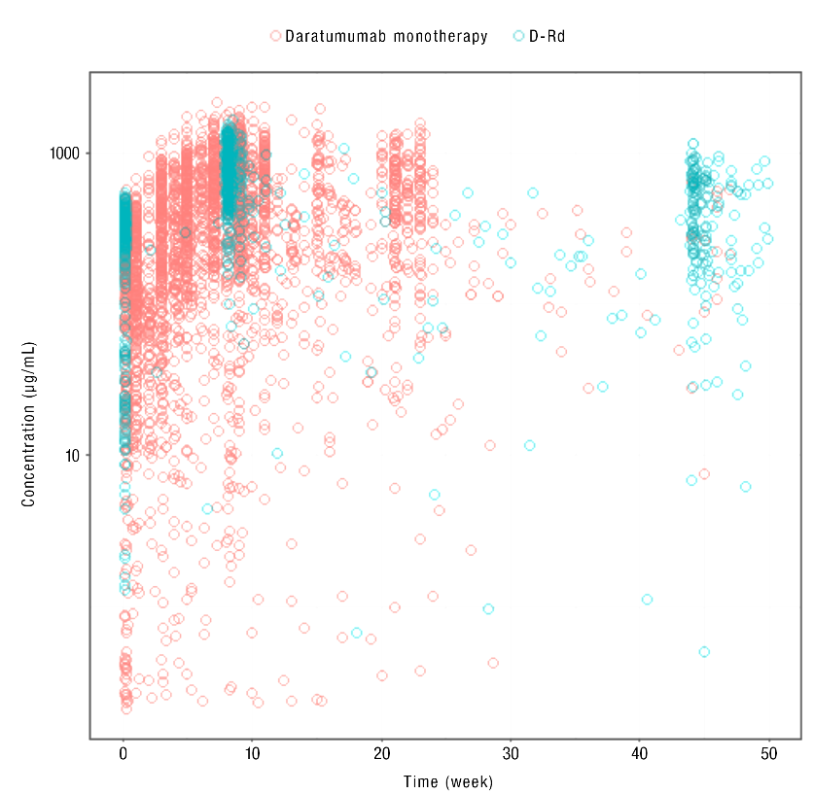

b.
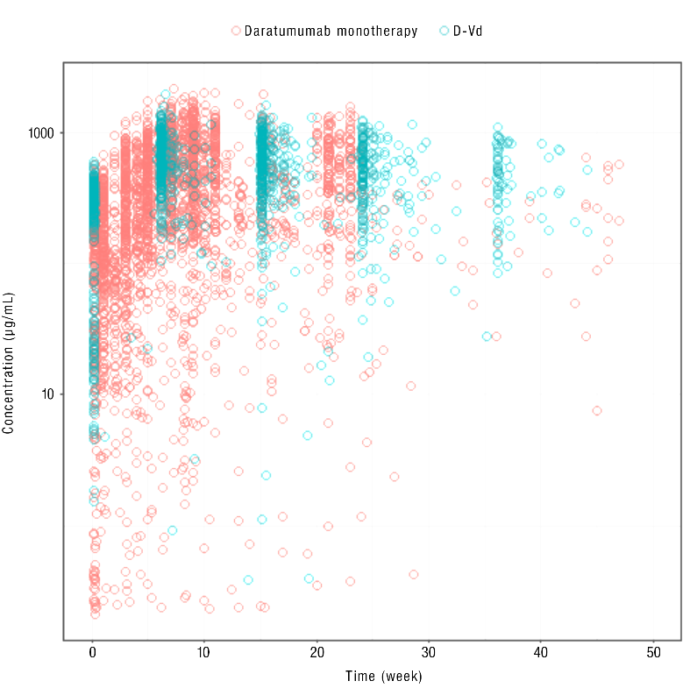

c.
