SUPPLEMENTARY MATERIAL
Supplementary Table 1. Summary of assumptions to base case and scenario cost-effectiveness analyses
Assumption | Base case | Scenario analyses
Time horizon | Lifetime | 24 weeks, 1 year, 10 years
Minimum response | ACR20 | ACR50 and ACR70
Discount rates | 3% for the US | 0% and 6%
Perspective | 3rd party payer | Societal
Population | MOBILITY RCT; cDMARD-IR patients | –
Treatment comparators | - adalimumab 40 mg SC q2w + methotrexate  - certolizumab 200 mg SC q2w + methotrexate  - etanercept 25 mg SC q1w + methotrexate  - golimumab 50 mg SC q4w + methotrexate  - tocilizumab 162 mg SC administered every week (q1w) or q2w, + methotrexate  - tofacitinib 5 mg bid oral + methotrexate  - csDMARD active treatment | –
Subsequent treatments | abatacept intravenous (IV) + methotrexate >> rituximab IV + methotrexate>> csDMARD palliative treatment | –
Response rates | Based on network meta-analysis | Increased response rates for sarilumab, tocilizumab and TNFi
Annual increase of HAQ-DI score for csDMARD palliative care | 0.045 | Higher rate (0.06)
Annual increase of HAQ-DI score for csDMARD palliative care | 0.045 | Lower rate (0.012)
Utilities | 0.76-0.28xHAQ-DI+0.05xFemale [1] | Hurst: 0.862-0.327xHAQ-DI [2]  Marra: 0.72-0.2xHAQ-DI+0.25xAge [3]  Diamantopoulos: 0.82-0.11xHAQ-DI-0.07xHAQ-DI² [4]
HAQ-DI based mortality equation | Continuous (0.25 unit HAQ increase) baseline HAQ-DI hazard ratio of 1.17 (95% confidence interval [CI]: 1.12, 1.22) [5] | Yellin: Baseline HAQ-DI [6]:  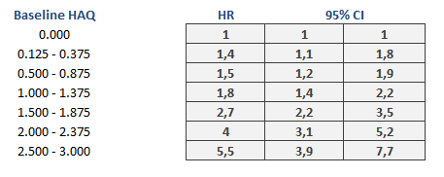  Yellin: Baseline HAQ-DI hazard ratio of 1.17 (95% confidence interval [CI]: 1.12, 1.22) [6]  Michaud: Baseline HAQ-DI [5]
Routine care costs equation | 7.63xAge+1.19xDisease duration+230.74xIndex of co-morbidities-108.2xHAQ-DI at baseline+603.79xCurrent HAQ-DI+90.32xMale-104.06xOnDMARD as well as biologic+81.21xNumber of previous DMARDs+6.3xYears of education-43.27xEthnicity (white)-104.35+ Treatment dependent constant [7] | Marra: EXP(6.49 - 1.18 x age + 0.15 x female + 0.39 x HAQ-DI + 0.5 x 1.66) [3]
Indirect (societal) costs | None | Annual indirect costs =([1-work capacity] X (47,085 X [male] + 33,774 X [female])) with Work capacity = 1.09-(0.18 X HAQ-DI) [3]
Time to treatment discontinuation | Use TNFi curve for all treatment classes according to RHUMADATA results | By treatment class according to RHUMADATA results  Stevenson equation [8]
Adverse events | Adverse events captured in utilities | –
Drug administration | No costs for SC treatments, outpatient administration costs for IV sequential treatments | –
Wastage | With wastage (no vial or pack sharing) | No wastage (sharing of vials and packs)
ACR, American College of Rheumatology; cDMARD-IR, ; csDMARD, conventional synthetic disease modifying anti-rheumatic drugs; EXP, ; HAQ-DI, Health Assessment Questionnaire Disability Index; IR, inadequate response; IV, intravenous; q1w, every week; q2w, every 2 weeks, q4w, every 4 weeks; RCT, ; SC, subcutaneous; TNFi, tumor necrosis factor-α inhibitors.

Supplementary Figure 1. RHUMADATA Registry analyses on treatment duration
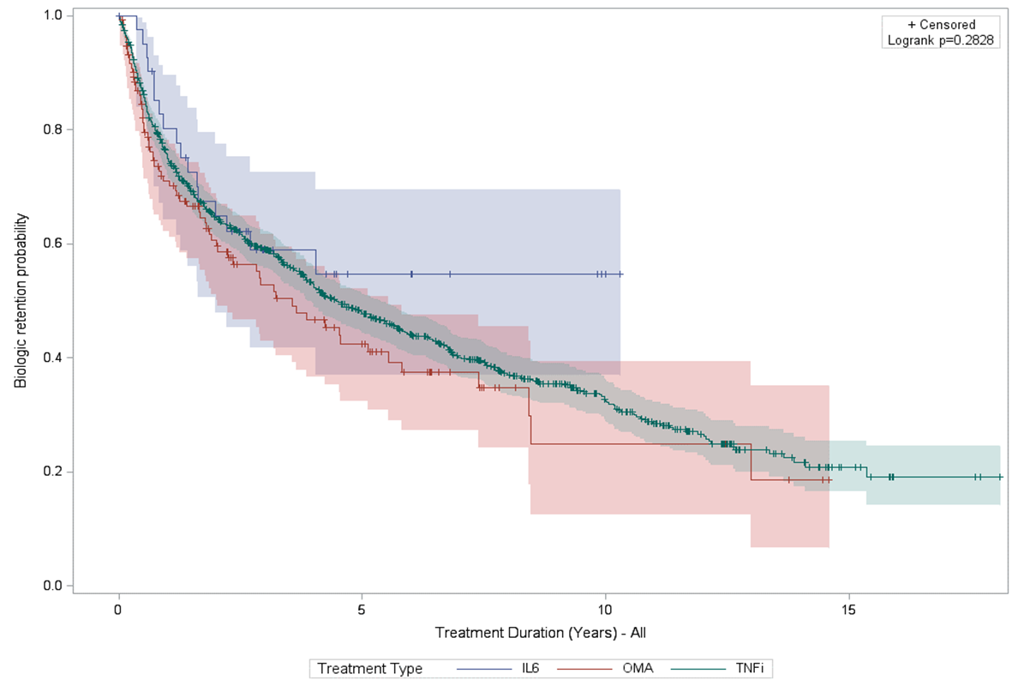
IL6, interleukin-6; OMA, other mode of action; TNFi, tumor necrosis factor inhibitor

References
1. Bansback NJ, Brennan A, Ghatnekar O. Cost effectiveness of adalimumab in the treatment of patients with moderate to severe rheumatoid arthritis in Sweden. Ann Rheum Dis. 2005;64(7):995-1002. doi:10.1136/ard.2004.027565.
2. Hurst NP, Kind P, Ruta D, Hunter M, Stubbings A. Measuring health-related quality of life in rheumatoid arthritis: validity, responsiveness and reliability of EuroQol (EQ-5D). Br J Rheumatol. 1997;36(5):551-9.
3. Marra CA, Marion SA, Guh DP, Najafzadeh M, Wolfe F, Esdaile JM, et al. Not all "quality-adjusted life years" are equal. J Clin Epidemiol. 2007;60(6):616-24. doi:10.1016/j.jclinepi.2006.09.006.
4. Diamantopoulos A, Benucci M, Capri S, Berger W, Wintfeld N, Giuliani G, et al. Economic evaluation of tocilizumab combination in the treatment of moderate-to-severe rheumatoid arthritis in Italy. J Med Econ. 2012;15(3):576-85. doi:10.3111/13696998.2012.665110.
5. Michaud K, Vera-Llonch M, Oster G. Mortality risk by functional status and health-related quality of life in patients with rheumatoid arthritis. J Rheumatol. 2012;39(1):54-9. doi:10.3899/jrheum.110491.
6. Yellin M, Paliienko I, Balanescu A, Ter-Vartanian S, Tseluyko V, Xu LA, et al. A phase II, randomized, double-blind, placebo-controlled study evaluating the efficacy and safety of MDX-1100, a fully human anti-CXCL10 monoclonal antibody, in combination with methotrexate in patients with rheumatoid arthritis. Arthritis Rheum. 2012;64(6):1730-9. doi:10.1002/art.34330.
7. Wailoo A, Brennan A, Bansback N, Nixon R, Wolfe F, Michaud K. Modeling the cost effectiveness of etanercept, adalimumab and anakinra compared to infliximab in the treatment of patients with rheumatoid arthritis in the Medicare program. Oct 2006; Available from: http://www.cms.gov/Research-Statistics-Data-and-Systems/Statistics-Trends-and-Reports/Reports/Research-Reports-Items/CMS1202288.html accessed.
8. Stevenson M, Archer R, Tosh J, Simpson E, Everson-Hock E, Stevens J, et al. Adalimumab, etanercept, infliximab, certolizumab pegol, golimumab, tocilizumab and abatacept for the treatment of rheumatoid arthritis not previously treated with disease-modifying antirheumatic drugs and after the failure of conventional disease-modifying antirheumatic drugs only: systematic review and economic evaluation. Health Technol Assess. 2016;20(35):1-610. doi:10.3310/hta20350.

