SUPPLEMENTARY MATERIAL
Supplemental Table 1. Eligibility criteria for respondents
Inclusion criteria
Cardiologist or pulmonologist/respiratory physician
Worked between 2 and 30 years in current specialty
US only: Board eligible or certified
Personally involved in treatment/management of PAH patient
Currently manages ≥7 PAH patients
Currently manages ≥5 PAH patients across WHO FC II, III and IV
Prescribes ERA and PC therapy
Prescribes ERA therapy to ≥5 PAH patients
Prescribes PC therapy to ≥1 patient
Exclusion criterion
Personally affiliated or have a member of family affiliated/employed by any pharmaceutical company or an advertisement agency or a market research firm
ERA, endothelin receptor antagonists; PAH, pulmonary arterial hypertension; PC, prostacyclin; WHO FC, New York Heart Association/World Health Organization functional class

Supplemental Table 2. Physician details
 | USA  (N=30) | Germany (N=20) | Italy  (N=20) | France  (N=20) | Total  (N=90)
Specialty, n (%)  Cardiologist  Pulmonologist | 12 (40.0%)  18 (60.0%) | 13 (65.0%)  7 (35.0%) | 13 (65.0%)  7 (35.0%) | 14 (70.0%)  6 (30.0%) | 52 (57.8%)  38 (42.2%)
Work setting, n (%)  University hospital  Public (non-university hospital)  Private hospital  Office-based  PAH centre | 9 (30.0%)  6 (20.0%)  3 (10.0%)  12 (40.0%)  0 (0%) | 10 (50.0%)  2 (10.0%)  2 (10.0%)  6 (30.0%)  0 (0%) | 8 (40.0%)  8 (40.0%)  2 (10.0%)  2 (10.0%)  0 (0%) | 12 (60.0%)  5 (25.0%)  2 (10.0%)  0 (0%)  1 (5.0%) | 39 (43.3%)  21 (23.3%)  9 (10.0%)  20 (22.2%)  1 (1.1%)
Years qualified in current specialty, n (%)  2–5 years  6–10 years  11–15 years  16–20 years  21–25 years  26–30 years  >30 years  Mean  SD | 1 (3.0%)  3 (10.0%)  6 (20.0%)  8 (26.7%)  9 (30.0%)  3 (10.0%)  2 (6.7%)  18.8  6.83 | 1 (5.0%)  6 (30.0%)  4 (20.0%)  6 (30.0%)  1 (5.0%)  2 (10.0%)  1 (5.0%)  14.6  6.84 | 0 (0%)  4 (20.0%)  5 (25.0%)  3 (15.0%)  6 (30.0%)  2 (10.0%)  2 (10.0%)  17.6  7.35 | 1 (5.0%)  4 (20.0%)  3 (15.0%)  8 (40.0%)  1 (5.0%)  3 (15.0%)  0 (0)  16.7  7.09 | 3 (3.3%)  17 (18.9%)  18 (20.0%)  25 (27.8%)  17 (18.9%)  10 (11.1%)  5 (5.6%)  17.1  7.06
Number of PAH Patients, n  Mean  Median [range] | 101  60 [10-500] | 50  38 [10-200] | 63  35 [10-200] | 61  43 [20-200] | 72  43 [10-500]

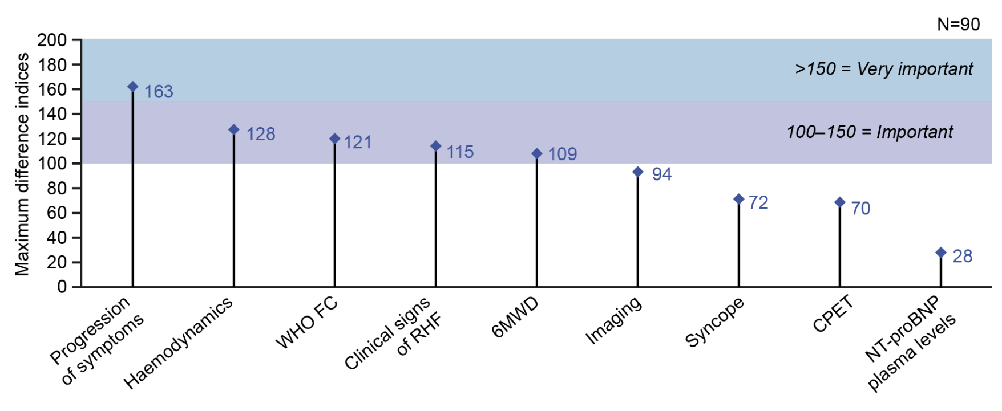
Supplementary Figure 1. Relative importance of parameters to respondents (N=90), as determined by maximum difference scaling survey
Results of a maximum difference scaling survey, which ranks the nine parameters, in terms of their importance to respondents for assessing risk, on a common scale with scores over 150 being classified as ‘very important’ and scores between 100 and 150 being classified as ‘important’.
6MWD, 6-minute walking distance; CPET, cardiopulmonary exercise testing; NT-proBNP, N-terminal pro-brain natriuretic peptide; RHF, right heart failure; WHO FC, World Health Organization functional class.
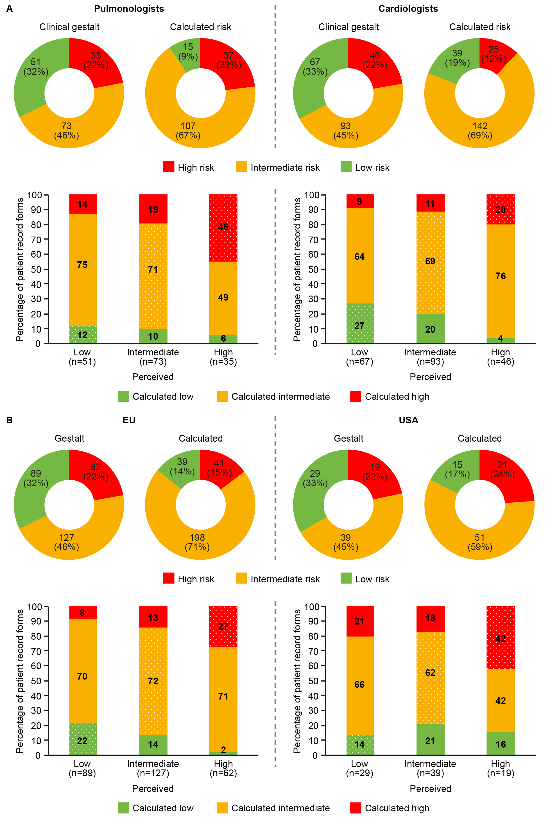
Supplementary Figure 2: Concordance between gestalt and calculated risk, for patient record forms included in the risk calculation analysis split out by (A) physician speciality (cardiologist or pulmonologist) and (B) region (USA or EU), by gestalt risk category
Dots indicate where gestalt and calculated risk are in agreement.
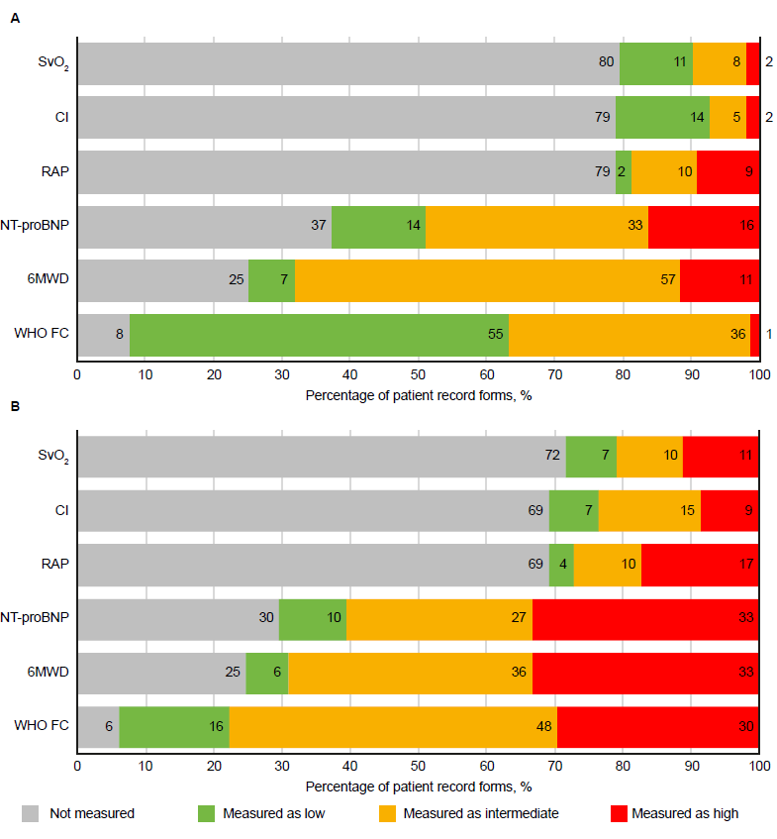
Supplementary Figure 3: Classification of individual variable measurements from patient record forms judged as (A) intermediate risk (N=166) and (B) high risk (N=81) by physicians
Data labels are percentages.

