Appendix S1: Systematic literature search protocol
Date of search: 2019 May 23

Database: EBM Reviews - Cochrane Central Register of Controlled Trials <April 2019>, Embase <1974 to 2019 May 22>, Ovid MEDLINE(R) and Epub Ahead of Print, In-Process & Other Non-Indexed Citations and Daily <1946 to May 21, 2019>

Search Strategy:
--------------------------------------------------------------------------------
1 (Arctic Front$2 or ArcticFront$2).tw,kf. (457)
2 (AFACA or ARCCB or ARC-Adv-CB or Arc-CB or CB-ADV or CB-A or CB-A-PRO or CB-Adv-PRO or Gen2CB).tw,kf. (1601)
3 1 or 2 [TRADE NAMES] (2027)
4 Cryosurgery/ (21079)
5 ((freez* or froze* or cold or cryo*) adj3 ablat*).tw,kf. (6069)
6 (cryoablat* or cryo-ablat* or cryoballoon* or cryo-balloon* or cryosurg* or cryo-surg*).tw,kf. (20198)
7 CB ablat*.tw,kf. (328)
8 Catheter Ablation/ (62938)
9 Cardiac Catheters/ (5078)
10 exp Cardiac Catheterization/ (108701)
11 Balloon Occlusion/ (7399)
12 or/8-11 (178664)
13 exp Cold Temperature/ (94601)
14 12 and 13 (216)
15 or/4-7,14 [CRYOABLATION, CRYOBALLOON ABLATION] (32666)
16 Arrhythmias, Cardiac/ (91052)
17 Atrial Fibrillation/ (100931)
18 (atria? adj1 fibrillation*).tw,kf. (185908)
19 (A-fib or AFIB).tw,kf. (2193)
20 Tachycardia, Paroxysmal/ (6736)
21 paroxysmal AF.tw,kf. (10391)
22 persistent AF.tw,kf. (9996)
23 PerAF.tw,kf. (161)
24 PAF.tw,kf. (27162)
25 Pulmonary Veins/su [surgery] (4696)
26 (pulmonary vein? adj3 isolat*).tw,kf. (13057)
27 (PV adj3 isolat*).tw,kf. (4204)
28 PVI.tw,kf. (8368)
29 (APVI or CPVI or PVAI).tw,kf. (915)
30 or/16-29 [AF, PVI] (329679)
31 15 and 30 [CRYOABLATION IN AF, PVI] (4644)
32 3 or 31 [TRADE NAMES OR CRYOABLATION IN AF, PVI] (6111)
33 exp Child/ not (exp Adult/ or Adolescent/) (2287477)
34 exp Infant/ not (exp Adult/ or Adolescent/) (1368078)
35 32 not (33 or 34) [CHILD-/INFANT-ONLY REMOVED] (6045)
36 exp Animals/ not Humans/ (17406547)
37 35 not 36 [ANIMAL-ONLY REMOVED] (3832)
38 (comment or editorial or news or newspaper article).pt. (1920962)
39 (letter not (letter and randomized controlled trial)).pt. (2090912)
40 37 not (38 or 39) [OPINION PIECES REMOVED] (3688)
41 limit 40 to yr="2010-current" (2560)
42 41 use ppez [MEDLINE RECORDS] (1132)
43 (Arctic Front$2 or ArcticFront$2).tw,kw,dv. (716)
44 (AFACA or ARCCB or ARC-Adv-CB or Arc-CB or CB-ADV or CB-A or CB-A-PRO or CB-Adv-PRO or Gen2CB).tw,kw,dv. (1603)
45 43 or 44 [TRADE NAMES] (2269)
46 cryosurgery/ (21079)
47 cryosurgery device/ (77)
48 cryoablation/ (18899)
49 ((freez* or froze* or cold or cryo*) adj3 ablat*).tw,kw. (6183)
50 (cryoablat* or cryo-ablat* or cryoballoon* or cryo-balloon* or cryosurg* or cryo-surg*).tw,kw. (20599)
51 CB ablat*.tw,kw. (329)
52 ablation therapy/ (16061)
53 catheter ablation/ (62938)
54 ablation catheter/ (34232)
55 exp heart catheter/ (9255)
56 heart catheterization/ (103828)
57 balloon catheter/ (16383)
58 balloon catheterization/ (310)
59 balloon occlusion/ (7399)
60 occlusion balloon catheter/ (649)
61 or/52-60 (206386)
62 cold/ (72460)
63 61 and 62 (212)
64 or/46-51,63 [CRYOABLATION, CRYOBALLOON ABLATION] (34617)
65 heart fibrillation/ (1089)
66 atrial fibrillation/ (100931)
67 (atria? adj1 fibrillation*).tw,kw. (187834)
68 (A-fib or AFIB).tw,kw. (2197)
69 paroxysmal atrial fibrillation/ (54639)
70 paroxysmal AF.tw,kw. (10396)
71 persistent atrial fibrillation/ (53045)
72 persistent AF.tw,kw. (9998)
73 PerAF.tw,kw. (162)
74 PAF.tw,kw. (27310)
75 pulmonary vein isolation/ (7509)
76 (pulmonary vein? adj3 isolat*).tw,kw. (13205)
77 (PV adj3 isolat*).tw,kw. (4206)
78 PVI.tw,kf. (8368)
79 (APVI or CPVI or PVAI).tw,kw. (915)
80 or/65-79 [AF, PVI] (241591)
81 64 and 80 [CRYOABLATION IN AF, PVI] (4873)
82 45 or 81 [TRADE NAMES OR CRYOABLATION IN AF, PVI] (6361)
83 exp adolescent/ not exp adult/ (1127670)
84 exp child/ not exp adult/ (2991998)
85 fetus/ not exp adult/ (219979)
86 82 not (83 or 84 or 85) [ADOLESCENT-/CHILD-/INFANT-ONLY REMOVED] (6278)
87 exp animal/ or exp animal experimentation/ or exp animal model/ or exp animal experiment/ or nonhuman/ or exp vertebrate/ (48760086)
88 exp human/ or exp human experimentation/ or exp human experiment/ (37977470)
89 87 not 88 (10784162)
90 86 not 89 [ANIMAL-ONLY REMOVED] (5982)
91 editorial.pt. (1093544)
92 letter.pt. not (letter.pt. and randomized controlled trial/) (2090796)
93 90 not (91 or 92) [OPINION PIECES REMOVED] (5720)
94 limit 93 to yr="2010-current" (4632)
95 conference abstract.pt. (3429565)
96 94 not 95 [CONFERENCE ABSTRACTS REMOVED] (3189)
97 96 use oemezd [EMBASE RECORDS] (1332)
98 (Arctic Front$2 or ArcticFront$2).ti,ab,kw. (457)
99 (AFACA or ARCCB or ARC-Adv-CB or Arc-CB or CB-ADV or CB-A or CB-A-PRO or CB-Adv-PRO or Gen2CB).ti,ab,kw. (1601)
100 98 or 99 [TRADE NAMES] (2027)
101 Cryosurgery/ (21079)
102 ((freez* or froze* or cold or cryo*) adj3 ablat*).ti,ab,kw. (6183)
103 (cryoablat* or cryo-ablat* or cryoballoon* or cryo-balloon* or cryosurg* or cryo-surg*).ti,ab,kw. (20599)
104 CB ablat*.ti,ab,kw. (329)
105 Catheter Ablation/ (62938)
106 Cardiac Catheters/ (5078)
107 exp Cardiac Catheterization/ (108701)
108 Balloon Occlusion/ (7399)
109 or/105-108 (178664)
110 exp Cold Temperature/ (94601)
111 109 and 110 (216)
112 or/101-104,111 [CRYOABLATION, CRYOBALLOON ABLATION] (32986)
113 Arrhythmias, Cardiac/ (91052)
114 Atrial Fibrillation/ (100931)
115 (atria? adj1 fibrillation*).ti,ab,kw. (187834)
116 (A-fib or AFIB).ti,ab,kw. (2197)
117 Tachycardia, Paroxysmal/ (6736)
118 paroxysmal AF.ti,ab,kw. (10396)
119 persistent AF.ti,ab,kw. (9998)
120 PerAF.ti,ab,kw. (162)
121 PAF.tw,kf. (27162)
122 Pulmonary Veins/su [surgery] (4696)
123 (pulmonary vein? adj3 isolat*).ti,ab,kw. (13205)
124 (PV adj3 isolat*).ti,ab,kw. (4206)
125 PVI.ti,ab,kw. (8366)
126 (APVI or CPVI or PVAI).ti,ab,kw. (915)
127 or/113-126 [AF, PVI] (331292)
128 112 and 127 [CRYOABLATION IN AF, PVI] (4708)
129 100 or 128 [TRADE NAMES OR CRYOABLATION IN AF, PVI] (6173)
130 exp Child/ not (exp Adult/ or Adolescent/) (2287477)
131 exp Infant/ not (exp Adult/ or Adolescent/) (1368078)
132 129 not (130 or 131) [CHILD-/INFANT-ONLY REMOVED] (6107)
133 limit 132 to yr="2010-current" (4749)
134 conference abstract.pt. (3429565)
135 133 not 134 [CONFERENCE ABSTRACTS REMOVED] (3268)
136 135 use cctr [CENTRAL RECORDS] (783)
137 42 or 97 or 136 [ALL DATABASES] (3247)
138 remove duplicates from 137 (2186)
139 138 use ppez [MEDLINE UNIQUE RECORDS] (1130)
140 138 use oemezd [EMBASE UNIQUE RECORDS] (390)
141 138 use cctr [CENTRAL UNIQUE RECORDS] (666)

***************************

Appendix S2: PICOS Criteria for the identification of CB studies
 | Inclusion Criteria
Population | - Adults (≥18 years) with symptomatic, paroxysmal AF receiving first-time ablation
Intervention | - Cryoballoon (CB) catheter ablation with the Arctic Front Advance Cryoablation Catheter
Comparator | - No criteria
Outcomes | - Proportion of patients free from AF/AT/AFL at 1 year  - Proportion of patients with recurrence of AF/AT/AFL at 1 year  - Time-to-event data
Study Design | - Prospective  - Single-arm or comparative  - ≥50 patients in the CB cohort
Abbreviations: AF= atrial fibrillation; AFL= atrial flutter; AT= atrial tachyarrhythmias; CB = second-generation cryoballoon.

Appendix S3: Cox proportional hazards regression estimates of absolute efficacy of STAI and CB2: Solimene IPD vs. Pooled CB and Solimene and Hussein IPD vs. Pooled CB
Estimates |  | Published Data | STAI IPD
 |  | Pooled CB | Unadjusted |  | Matched and Adjusted (Scenarios)
 |  | Pooled CB | Naïve | Matched | Scenario A | Scenario B | Scenario C  (Primary)
 |  |  | Solimene IPD
Proportion of patients arrhythmia-free at 12 monthsª |  | 0.83  (0.77-0.88) | 0.91  (0.86-0.95) | 0.92  (0.88-0.96) | 0.95  (0.90-0.98) | 0.93  (0.87-0.97) | 0.93  (0.88-0.97)
Proportion of patients with recurrent arrhythmia at 12 monthsª |  | 0.17  (0.12-0.23) | 0.09  (0.05-0.14) | 0.08  (0.04-0.12) | 0.05  (0.02-0.10) | 0.07  (0.03-0.13) | 0.07  (0.03-0.12)
 |  |  | Solimene and Hussein IPD
Proportion of patients arrhythmia-free at 12 monthsª |  | 0.83  (0.77-0.88) | 0.88  (0.84-0.92) | 0.90  (0.85-0.95) | 0.89  (0.84-0.94) | 0.90  (0.85-0.94) | NA
Proportion of patients with recurrent arrhythmia at 12 monthsª |  | 0.17  (0.12-0.23) | 0.12  (0.08-0.16) | 0.10  (0.05-0.15) | 0.11  (0.06-0.16) | 0.10  (0.06-0.15) | NA
ª95% confidence intervals were obtained using the percentiles of 1000 bootstrap samples.
Abbreviations: CB = second-generation cryoballoon; IPD = individual patient-level data; NA = not applicable; STAI = ThermoCool SmartTouch™ with Ablation Index.

Appendix S4: Hazard Ratio for AF Recurrence (Pairwise Analyses for Solimene STAI IPD vs. Individual CB Cohorts)
Figure S4.1: Hazard ratio for AF recurrence (Solimene vs. Di Giovanni)
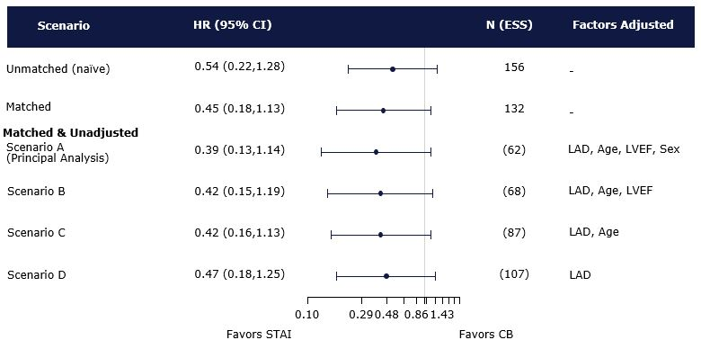
Forest plot for Solimene vs. Di Giovanni showing the HR (95% CI) for arrhythmia recurrence with STAI compared to CB at 12-months follow-up. Hazard Ratio < 1 represents lower recurrence with STAI than CB, whereas HR > 1 represents greater recurrence with STAI than with CB.
Abbreviations: AF = atrial fibrillation; CB = second-generation cryoballoon; CI = confidence interval; ESS = effective sample size; HR = hazard ratio; LAD = left atrial diameter; LVEF = left ventricular ejection fraction; STAI = ThermoCool SmartTouch™ with Ablation Index.
Figure S4.2: Hazard ratio for AF recurrence (Solimene vs. Jourda)
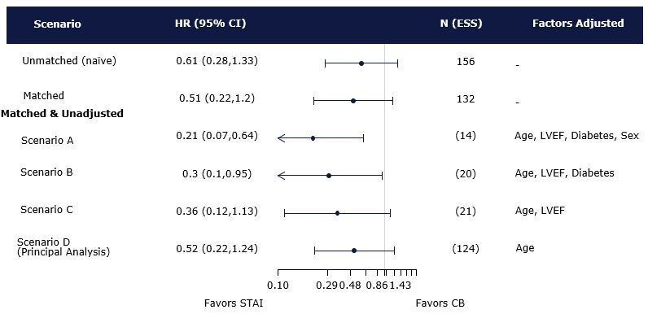
Forest plot for Solimene vs. Jourda showing the HR (95% CI) for arrhythmia recurrence with STAI compared to CB at 12-months follow-up. Hazard Ratio < 1 represents lower recurrence with STAI than CB, whereas HR > 1 represents greater recurrence with STAI than with CB.
Abbreviations: AF = atrial fibrillation; CB = second-generation cryoballoon; CI = confidence interval; ESS = effective sample size; HR = hazard ratio; LVEF = left ventricular ejection fraction; STAI = ThermoCool SmartTouch™ with Ablation Index.
Figure S4.3: Hazard ratio for AF recurrence (Solimene vs. Zhao)
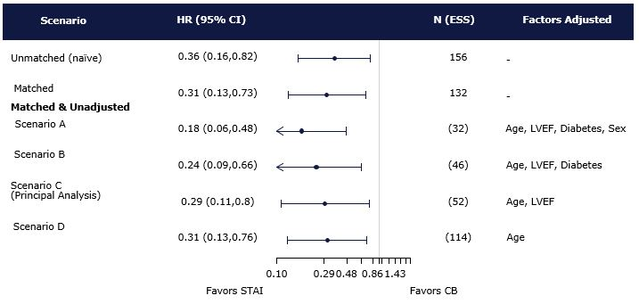
Forest plot for Solimene vs. Zhao showing the HR (95% CI) for arrhythmia recurrence with STAI compared to CB at 12-months follow-up. Hazard Ratio < 1 represents lower recurrence with STAI than CB, whereas HR > 1 represents greater recurrence with STAI than with CB.
Abbreviations: AF = atrial fibrillation; CB = second-generation cryoballoon; CI = confidence interval; ESS = effective sample size; HR = hazard ratio; LVEF = left ventricular ejection fraction; STAI = ThermoCool SmartTouch™ with Ablation Index.

Appendix S5: Kaplan-Meier curve of freedom from atrial fibrillation comparing Solimene + Hussein STAI IPD to pooled CB trials
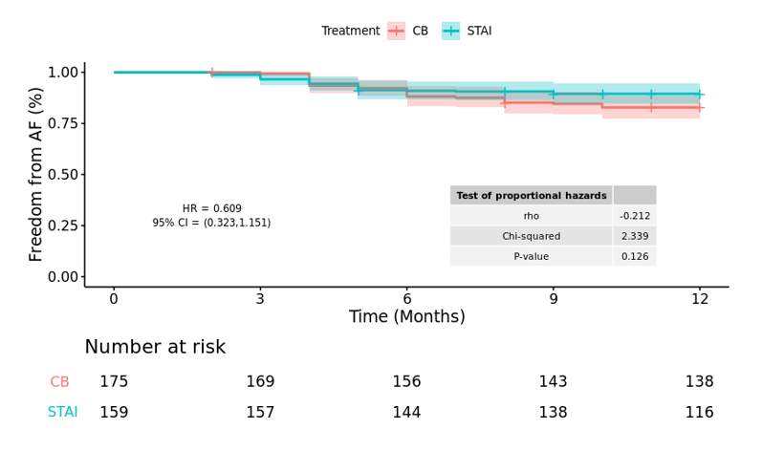
Abbreviations: AF = atrial fibrillation; CB = second-generation cryoballoon; CI = confidence interval; HR = hazard ratio; IPD = individual patient data; KM = Kaplan-Meier; STAI = ThermoCool SmartTouch™ with Ablation Index.

Appendix S6: Hazard Ratio for AF Recurrence (Pairwise Analyses for Solimene + Hussein STAI IPD vs. Individual CB Cohorts)
Figure S6.1: Hazard ratio for AF recurrence (Solimene + Hussein vs. Di Giovanni)
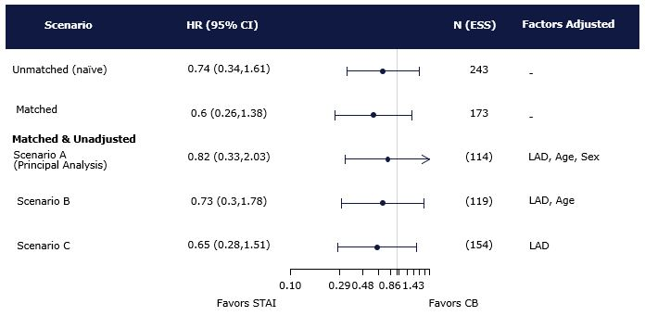
Forest plot for Solimene + Hussein vs. Di Giovanni showing the HR (95% CI) for arrhythmia recurrence with STAI compared to CB at 12-months follow-up. Hazard Ratio < 1 represents lower recurrence with STAI than CB, whereas HR > 1 represents greater recurrence with STAI than with CB.
Abbreviations: AF = atrial fibrillation; CB = second-generation cryoballoon; CI = confidence interval; ESS = effective sample size; HR = hazard ratio; LAD = left atrial diameter; STAI= ThermoCool SmartTouch™ with Ablation Index.
Figure S6.2: Hazard ratio for AF recurrence (Solimene + Hussein vs. Jourda)
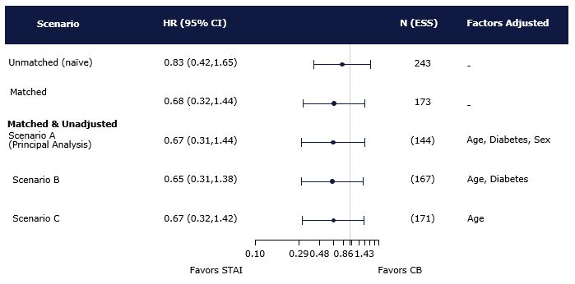
Forest plot for Solimene + Hussein vs. Jourda showing the HR (95% CI) for arrhythmia recurrence with STAI compared to CB at 12-months follow-up. Hazard Ratio < 1 represents lower recurrence with STAI than CB, whereas HR > 1 represents greater recurrence with STAI than with CB.
Abbreviations: AF = atrial fibrillation; CB = second-generation cryoballoon; CI = confidence interval; ESS = effective sample size; HR = hazard ratio; STAI = ThermoCool SmartTouch™ with Ablation Index.
Figure S6.3: Hazard ratio for AF recurrence (Solimene + Hussein vs. Zhao)
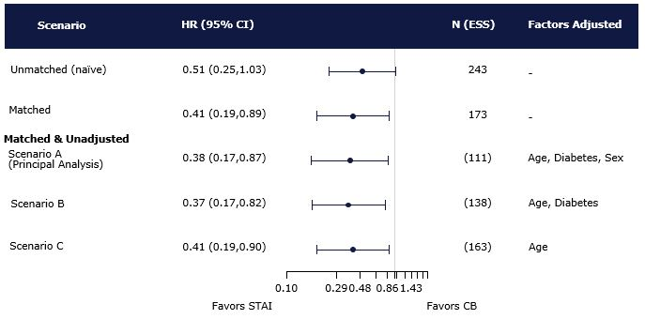
Forest plot for Solimene + Hussein vs. Zhao showing the HR (95% CI) for arrhythmia recurrence with STAI compared to CB at 12-months follow-up. Hazard Ratio < 1 represents lower recurrence with STAI than CB, whereas HR > 1 represents greater recurrence with STAI than with CB.
Abbreviations: AF = atrial fibrillation; CB = second-generation cryoballoon; CI = confidence interval; ESS = effective sample size; HR = hazard ratio; STAI = ThermoCool SmartTouch™ with Ablation Index.

Appendix S7: MAIC Weights Histogram: Solimene vs. Pooled CB Trials
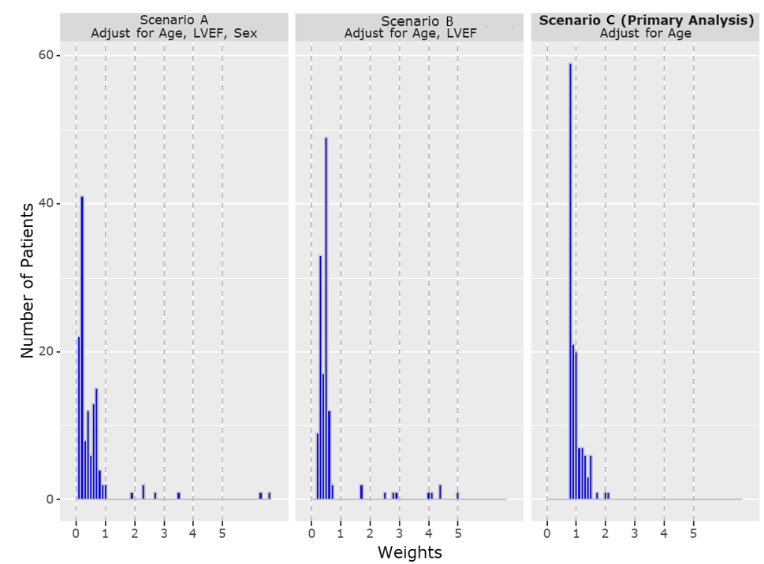
Abbreviations: CB = second-generation cryoballoon; LVEF = left ventricular ejection fraction.

Appendix S8: Evaluation of Kaplan Meier curve digitization
Study | Di Giovanni | Jourda | Zhao
Published Kaplan-Meier Curve  [cropped image file] | 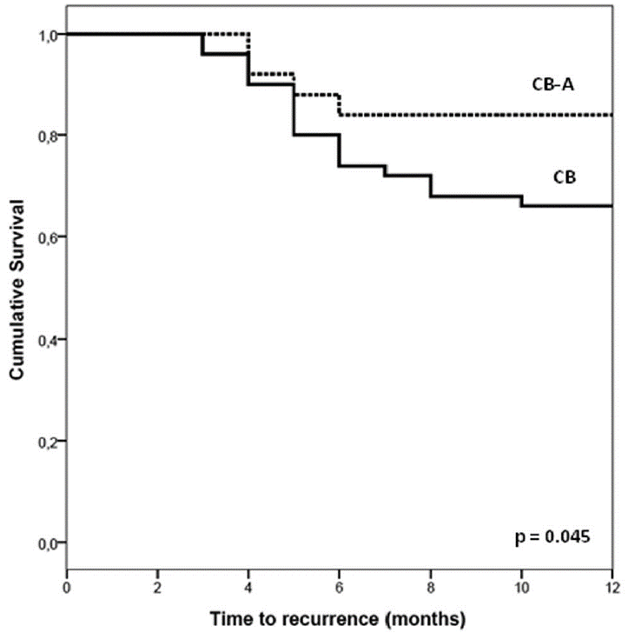 | 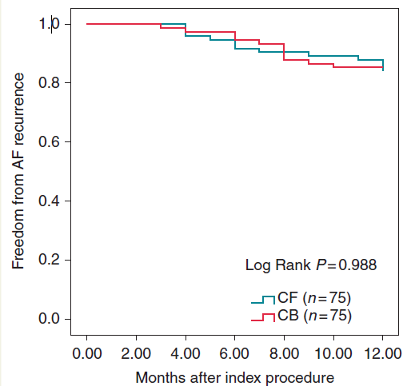
Published number of recurrences of atrial arrhythmias in CB group | 8 | 11 | 12
Estimated number of recurrences of atrial arrhythmias from pseudo IPD for CB group | 8 | 11 | 12
Abbreviations: CB = second-generation cryoballoon; CF = contact force; IPD = individual patient data.

Appendix S9: Nonproportionality tests
Table S9: Test of proportional hazards
Analysis | Factors adjusted | P-value
Unmatched (naïve) | - | 0.727
Matched | - | 0.908
Matched & Adjusted
Scenario A | Age, LVEF, Sex | 0.997
Scenario B | Age, LVEF | 1.000
Scenario C (Primary Analysis) | Age | 0.976
Notes: The test of proportional hazards is based on the association between the scaled Schoenfeld residuals for the treatment covariate and time.
Abbreviations: LVEF = left ventricular ejection fraction.

Appendix S10: Reported Method of Outcome Measurement
Study (Year) | Reported Method of Outcome Measure
Giovanni et al., (2014) | - Continuous echocardiographic monitoring for at least 18-h post-procedure  - 24-h Holter monitor at each follow-up visit
Hussein et al., (2017) | - 12-lead echocardiograph recordings supplemented with 24-h Holder monitoring as needed
Jourda et al., (2015) | - Systematic transthoracic echocardiography and 24-h Holter monitor at discharge  - 12-lead echocardiogram and 24-h Holter monitor at each follow-up visit
Solimene et al., (2019) | - Echocardiograph at 3, 6, and 12 months (and every 6 months thereafter) and Holter monitor at 3 and 12 months (and every 12 months thereafter)
Zhao et al., (2017) | - Systematic transthoracic echocardiography and 24-h Holter monitor at discharge  - 12-lead echocardiogram and 24-h Holter monitor at each follow-up visit

Appendix S11: Clinician Rankings of Prognostic Factors
Variable | Reported in Solimene | Average ranking for Solimene (A) | Reported in Hussein | Average Rank for Hussein (B) | Reported in Both | Average Ranking  (A+B / 2)
AF Type | N | N/A | Y | 5 | N | N/A
Age | Y | 3 | Y | 1 | Y | 2
BMI | N | N/A | Y | 3 | N | N/A
CHADS | N | N/A | Y | 4 | N | N/A
Diabetes | Y | 6 | Y | 7 | Y | 6.5
Gender | Y | 7 | Y | 9 | Y | 8
Heart Disease | Y | 5 | N | N/A | N | N/A
Heart Failure | N | N/A | Y | 6 | N | N/A
Hypertension | N | N/A | Y | 8 | N | N/A
LAD | Y | 1 | Y | 2 | Y | 1.5
LAV | Y | 2 | N | N/A | N | N/A
LVEF | Y | 4 | N | N/A | N | N/A
Previously Failed AADs | N | N/A | Y | 10 | N | N/A
Stroke | Y | 8 | Y | 11 | Y | 9.5
Abbreviations: AADs = antiarrhythmic drugs; AF = atrial fibrillation; BMI = body mass index; LAD = left atrial diameter; LAV = left atrial volume; LVEF = left ventricular ejection fraction; N/A = not applicable.

