Supplementary Appendix
Methods
Inconsistency Testing
For any pair of treatments AB which have been directly compared, approximate statistical tests can be obtained for the null hypothesis that there is no difference between direct and indirect evidence, i.e., there is no inconsistency as assessed by inconsistency factor ($ω_{AB}$ = 0), by referring to the test statistic.
In an NMA with the assumption that alongside estimate $d_{AB}^{Dir}$ based on direct evidence on some contrast (A, B) within a connected evidence network on treatments …A, B, C, D,… with variance $V_{AB}^{Dir}$, an overall NMA synthesis based on the entire network of evidence produces an estimate $d_{AB}^{MTC}$ with posterior variance $V_{AB}^{MTC}$. Here, $d_{AB}^{MTC}$ is an inverse-weighted average of the direct estimate $d_{AB}^{Dir}$ and indirect estimate $d_{AB}^{Rest}$. The difference between direct and indirect estimate, $ω_{AB}$ = $d_{AB}^{Dir}$ – $d_{AB}^{Rest}$ can be considered as an estimate of inconsistency, which can be used to construct the test statistics in Equation 1.
$z_{AB}$ = $ω_{AB}$/$\sqrt{Var(ω_{AB})}$ (Equation 1)
For any set of three treatments A, B, and C, it can be confirmed that:
│$ω_{BC}$│ = │$ω_{AC}$│ = │$ω_{AB}$│ and Var($ω_{BC}$) = Var($ω_{AC}$) = Var($ω_{AB}$)
This implies that the same absolute measure of inconsistency and the same test result will be obtained, whichever edge of the triangle is being looked at.

Table S1 Electronic search strategies
# | Embase® and MEDLINE® search strategy
#1 | 'clinical trial'/exp
#2 | 'randomization'/de
#3 | 'controlled study'/de
#4 | 'comparative study'/de
#5 | 'single blind procedure'/de
#6 | 'double blind procedure'/de
#7 | 'crossover procedure'/de
#8 | 'placebo'/de
#9 | 'clinical trial' OR 'clinical trials'
#10 | 'controlled clinical trial' OR 'controlled clinical trials'
#11 | 'randomised controlled trial' OR 'randomized controlled trial' OR 'randomised controlled trials' OR 'randomized controlled trials'
#12 | 'randomisation' OR 'randomization' OR random*
#13 | Rct
#14 | 'random allocation' OR 'random assignment'
#15 | 'randomly allocated' OR 'randomly assigned'
#16 | 'allocated randomly' OR 'assigned randomly'
#17 | allocated NEAR/2 random OR assign* NEAR/2 random* OR randomi*
#18 | (single OR double OR triple OR treble) NEAR/1 (blind* OR mask*)
#19 | placebo*
#20 | 'prospective study'/de
#21 | #1 OR #2 OR #3 OR #4 OR #5 OR #6 OR #7 OR #8 OR #9 OR #10 OR #11 OR #12 OR #13 OR #14 OR #15 OR #16 OR #17 OR #18 OR #19 OR #20
#22 | 'case study'/de
#23 | 'case report'
#24 | 'abstract report'/de
#25 | 'letter'/de
#26 | #22 OR #23 OR #24 OR #25
#27 | #21 NOT #26
#28 | 'chronic obstructive lung disease'/syn OR 'chronic bronchitis'/syn OR 'emphysema'/syn OR (chronic* NEAR/3 bronchiti*):ab,ti OR (obstruct* NEAR/3 (pulmonary OR lung* OR airway* OR airflow* OR bronch* OR respirat*)):ab,ti
#29 | 'inhaled corticosteroids' OR (steroid* OR glucocorticoid* OR corticosteroid*) NEAR/3 inhal* OR ics:ab,ti
#30 | 'triamcinolone'/syn OR triaderm OR trilone OR tristoject OR tricortone OR azmacort OR ultrahaler
#31 | 'betamethasone'/syn OR 'mometasone'/syn OR qab149 OR twisthaler OR 'fluticasone'/syn OR flunase OR thoreus OR atemur OR flixonase OR flutivate OR flutinase OR flovent OR flonase OR flixotide OR accuhaler OR diskhaler OR diskus OR surehaler OR rotadisk OR nebules OR allermist OR avamys OR veramyst OR 'budesonide'/syn OR activaero OR budenobronch OR giona OR modulite OR nebuamp OR respules OR obucort OR swinghaler OR flexhaler OR easyhaler OR 'beclometasone'/syn OR clickhaler OR aerobec OR aerocort OR asmabec OR beclazone OR beclojet OR beclomet OR becloturmant OR ventolair OR clenil OR pulvinal OR ecobec OR sanasthmax OR junik OR qvar OR 'flunisolide'/syn OR flunitec OR nisolid OR 'ciclesonide'/syn OR omnair OR zetonna OR ultrahaler OR 'dexamethasone cipecilate'/syn
#32 | 'beta adrenergic receptor stimulating agent'/de OR bronchodilat* NEAR/2 'long acting' OR laba:ab,ti OR (beta* NEXT/2 (agonist* OR adrenergic*) OR 'β2 agonist' AND 'long acting')
#33 | 'salmeterol'/syn OR accuhaler OR aeromax OR diskhaler OR diskus OR salmetador OR serevent OR serobid OR ultrabeta OR 'formoterol'/syn OR aformoterol OR certihaleri OR aerolizer OR atimos OR atock OR brovana OR foradil OR foradile OR forair OR fordilen OR innovata OR perforomist OR oxese OR turbuhaler OR novolizer OR orion OR skyhaler OR 'bambuterol'/syn OR 'indacaterol'/syn OR breezhaler OR neohaler OR 'olodaterol'/syn OR 'abediterol'/syn OR 'clenbuterol'/syn OR 'vilanterol'/syn OR 'arformoterol'/syn
#34 | 'muscarinic receptor blocking agent'/de OR (anti NEAR/2 musca* OR musca* NEAR/2 antagon* AND 'long acting')
#35 | 'tiotropium bromide'/syn OR handihaler OR respimat OR taifun OR 'aclidinium bromide'/syn OR 'oxitropium bromide'/syn OR tersigan OR ventox OR 'glycopyrronium bromide'/syn OR vectura OR 'umeclidinium'/syn OR pt00
#36 | 'fluticasone furoate plus vilanterol'/syn OR 'budesonide plus formoterol'/syn OR turb?haler OR rilast OR vannair OR foracort OR 'fluticasone propionate plus salmeterol'/syn OR foxair OR seretide OR atmadisc OR accuhaler OR evohaler OR diskus OR 'formoterol fumarate plus mometasone furoate'/syn OR zenhale OR 'fluticasone propionate plus formoterol fumarate'/syn OR 'beclometasone dipropionate plus formoterol fumarate'/syn OR innovair OR foster OR modulite OR 'beclometasone/formoterol' OR 'mometasone plus indacaterol' OR 'qmf 149' OR mometasone NEAR/2 indacaterol OR pt003 OR formoterol NEAR/2 (glycopyrrolate OR glycopyrronium) OR 'umeclidinium plus vilanterol'/syn OR pt010 OR 'glycopyrronium bromide plus indacaterol'/syn
#37 | #29 OR #30 OR #31 OR #32 OR #33 OR #34 OR #35 OR #36
#38 | #27 AND #28 AND #37
#39 | #27 AND #28 AND #37 AND [animals]/lim
#40 | #27 AND #28 AND #37 AND ([conference review]/lim OR [editorial]/lim OR [letter]/lim OR [note]/lim OR [review]/lim OR [short survey]/lim)
#41 | #39 OR #40
#42 | #38 NOT #41

# | Cochrane search strategy
#1 | MeSH descriptor: [Pulmonary Disease, Chronic Obstructive] explode all trees
#2 | MeSH descriptor: [Bronchitis, Chronic] explode all trees
#3 | MeSH descriptor: [Emphysema] explode all trees
#4 | (chronic* near/3 bronchiti*):ti,ab,kw
#5 | (emphysema* or copd or coad):ti,ab,kw
#6 | (obstruct* near/3 (pulmonary or lung* or airway* or airflow* or bronch* or respirat*)):ti,ab,kw
#7 | #1 or #2 or #3 or #4 or #5 or #6
#8 | inhaled corticosteroids or (steroid* or glucocorticoid* or corticosteroid*) near/3 inhal* or ics:ti,ab,kw
#9 | MeSH descriptor: [Triamcinolone] explode all trees
#10 | triaderm or trilone or tristoject or tricortone or azmacort or ultrahaler or cetocot or adcortyl or aristocort or aristodan or azmacor or celeste or "cl 19823" or cl19823 or clinacort or clinalog or delphicort or fluoxiprednisolone or fluoxyprednisolone or "ken-jec 40" or kenacort or korticoid or ledercort or omcilon or polcortolon or "rp 8357" or rp8357 or simacort or sterocort or "tac 3" or triamcinolon* or triacortyl or triam-a or triam-forte or triamcort or "triamonide 40" or triamsicort or triancinolon or u-tri-lone or volon
#11 | MeSH descriptor: [Betamethasone] explode all trees
#12 | betametaso* or bethametaso* or betamethaso* or bethamethso* or adbeon or becasone or benoson or beprogel or betacortril or betadexamethasone or betamethazone or betason or betnasol or betnelan or betnesol or "betnovate a" or betsolon or betsopart or celestan or celeston* or cidoten or dermobet or diprolen or flubenisolone or methasone or "nsc 39470" or nsc39470 or "rg 833" or rg833 or rinderon or "sch 4831" or sch4831 or walacort
#13 | mometasone or mometaid or "qab149" or twisthaler or "allermax aqueous" or asmanex or dermotasone or dermovel or ecural or elica or elocom or elocon or elomet or eloson or flumeta or mefurosan or metaspray or momate or mometasone or monovel or morecort or motaderm or nasonex or novasone or rinelon or rivelon or "sch 32088" or sch32088 or uniclar
#14 | fluticasone or flutaide or flixovate or flunase or thoreus or atemur or flixonase or flutivate or flutinase or flovent or flonase or flixotide or accuhaler or diskhaler or diskus or surehaler or rotadisk or reohaler or nebules or allermist or avamys or veramyst or furamist or 685698
#15 | MeSH descriptor: [Budesonide] explode all trees
#16 | activaero or budenobronch or giona or modulite or nebuamp or respules or obucort or swinghaler or flexhaler or turbuhaler or easyhaler or allercort or aquacort or budecol or budecort or budefat or budeflam or "budenase aq" or budenoside or budes or budeson or budiair or "budicort respules" or budon or bunase or butacort or clebudan or cycortide or "desona nasal" or dexbudesonide or duasma or eltair or entocort or esonide or "giona easyhaler" or inflammide or inflanaze or "map 0010" or map0010 or miflonide or neo-rinactive or novopulmon or numark or olfex or preferid or pulmaxan or pulmicon susp for nebulizer or pulmicort or pulmoliseflam or pulmotide or respicort or rhinocort or "s 1320" or s1320 or spirocort or uceris
#17 | MeSH descriptor: [Beclomethasone] explode all trees
#18 | clickhaler or aerobec or aerocort or asmabec or beclazone or beclojet or beclomet or becloturmant or ventolair or clenil or pulvinal or ecobec or sanasthmax or junik or qvar or beclomethasone
#19 | flunisolide or flunitec or nisolid or rinhalar or aerobid or "aerobid m" or aerospan or "aerospan hfa" or bronalide or bronilide or cyntaris or flunitec or gibiflu or inhacort or locasyn or lokilan or "lunibron a" or lunis or nasalide or nasarel or rhinalar or "rs 3999" or rs3999 or sanergal or synaclyn or syntaris or "val 679" or val679
#20 | ciclesonide or omnair or zetonna or tbn15 or "tbn 15" or ultrahaler or alvesco or "b 9207 015" or "b 9207015" or "b9207 015" or b9207015 or "by 9010" or by9010 or omnaris or zetonna
#21 | MeSH descriptor: [Dexamethasone] explode all trees
#22 | erizas or st126 or "st 126" or "ns 126" or "ns 126c" or ns126 or ns126c
#23 | MeSH descriptor: [Adrenergic beta-2 Receptor Agonists] explode all trees
#24 | bronchodilat* near/2 "long acting" or laba:ti,ab,kw or (beta* next/2 (agonist* or adrenergic*) or "β2 agonist" and "long acting")
#25 | salmeterol or accuhaler or aeromax or diskhaler or diskus or salmetador or serevent or serobid or ultrabeta or perforomist or beglan or "gr 33343x"
#26 | formoterol or aformoterol or certihaleri or aerolizer or atimos or atock or brovana or foradil or foradile or forair or fordilen or innovata or perforomist or oxese or turbuhaler or novolizer or orion or skyhaler or eformoterol or oxis
#27 | bambuterol or levobambuterol or laevobambuterol or rbambuterol or "r bambuterol" or bambec or oxeol
#28 | indacaterol or breezhaler or neohaler or arcapta or "hirobriz breezhaler" or onbrez or onbrez breezhaler or "oslif breezhaler" or "qab 149" or qab149
#29 | olodaterol or respimat or "bi 1744" or "bi 1744 cl" or bi1744
#30 | abediterol or "las 100977" or las100977
#31 | clenbuterol or clenasma or clenbutol or contrasmina or contraspasmin or monores or "nab 365" or novegan or "p 5369" or planipart or prontovent or spiropent or ventipulmin or ventolase
#32 | vilanterol or "gsk 642444" or gsk642444 or "gw 642444" or gw642444
#33 | Arformoterol or brovana
#34 | MeSH descriptor: [Clenbuterol] explode all trees
#35 | MeSH descriptor: [Muscarinic Antagonists] explode all trees
#36 | anti near/2 musca* or musca* near/2 antagon* and "long acting"
#37 | tiotropium or handihaler or respimat or tiova or taifun or "ba 679 br" or "ba679 br" or spiriva or "tiova rotacaps"
#38 | aclidinium or bretaris or eklira or "las 34273" or las34273 or tudorza
#39 | oxitropium or tersigan or pulsigan or ventox or "ba 253" or "ba 253 br" or ba253 or "ba253 br" or oxivent or oxytropium or tersigat or ventilat
#40 | MeSH descriptor: [Glycopyrrolate] explode all trees
#41 | glycopyrronium or vectura or "ad 237" or ad237 or "ahr 504" or ahr504 or cuvposa or enurev or gastrodyn or glersa or glycopyrrolate or glycopyrronium or mobinul or nodapton or "nva 237" or nva237 or robinal or robinol or robinul or "robinul v" or seebri or sroton or strodin or tarodyl or tarodyn or tovanor
#42 | umeclidinium or sk-573719 or gsk-573719a or "gsk 573719" or "gsk 573719a" or gsk573719 or gsk573719a or incruse
#43 | fluticasone furoate plus vilanterol or "vilanterol plus fluticasone" or breo or "breo ellipta" or relovair or relvar or "relvar ellipta" or "revinty ellipta"
#44 | budesonide plus formoterol or turbuhaler or turbohaler or rilast or vannair or budoxis or foracort or multihaler or "biresp spiromax" or "budesonide-formoterol" or "budesonide/formoterol" or "duoresp spiromax" or "formoterol-budesonide" or "formoterol plus budesonide" or "formoterol/budesonide" or "symbicort"
#45 | fluticasone propionate plus salmeterol or foxair or seretide or atmadisc or accuhaler or evohaler or diskus or advair or atmadisc or fluticasone-salmeterol or "fluticasone propionate - salmeterol combination" or "fluticasone propionate salmeterol combination" or "fluticasone salmeterol" or "salmeterol plus fluticasone propionate" or viani
#46 | formoterol fumarate plus mometasone furoate or zenhale or dulera or "formoterol fumarate-mometasone furoate" or "formoterol fumarate and mometasone furoate" or "formoterol fumarate/mometasone furoate" or "mometasone furoate-formoterol fumarate" or "mometasone furoate and formoterol fumarate" or "mometasone furoate plus formoterol fumarate" or "mometasone furoate/formoterol fumarate"
#47 | fluticasone propionate plus formoterol fumarate or avessa or flofera or flutiform or flutiformo or "formoterol fumarate plus fluticasone propionate" or iffeza
#48 | beclometasone dipropionate plus formoterol fumarate or innovair or foster or modulite or "formoterol fumarate dihydrate plus beclometasone dipropionate" or "formoterol fumarate plus beclometasone dipropionate" or fostair or inuvair or kantos or "beclometasone/formoterol"
#49 | PT003
#50 | mometasone plus indacaterol or "QMF 149" or QMF149 or "mometasone/indacaterol"
#51 | formoterol near/2 (glycopyrrolate or glycopyrronium) or "umeclidinium plus vilanterol" or anoro or "anoro ellipta" or laventair or "umeclidinium-vilanterol" or "umeclidinium/vilanterol" or "vilanterol-umeclidinium" or "vilanterol plus umeclidinium" or "vilanterol/umeclidinium" or "umeclidinium/vilanterol"
#52 | GSK961081 or "GSK 961081" or "td 5959" or td5959 or "thrx 198321" or thrx198321 or "las 190792" or las190792 or "gsk 256066" or "sk-256066" or "gsk-256066b" or "gsk 256066b" or gsk256066 or gsk256066b or "glycopyrronium bromide plus indacaterol" or "indacaterol plus glycopyrronium" or "qva 149" or "qva 149a" or qva149 or qva149a or ultibro or ulunar or breezhaler or xoterna or "glycopyrronium/indacaterol" or "indacaterol/glycopyrronium" or PT010
#53 | #8 or #9 or #10 or #11 or #12 or #13 or #14 or #15 or #16 or #17 or #18 or #19 or #20 or #21 or #22 or #23 or #24 or #25 or #26 or #27 or #28 or #29 or #30 or #31 or #32 or #33 or #34 or #35 or #36 or #37 or #38 or #39 or #40 or #41 or #42 or #43 or #44 or #45 or #46 or #47 or #48 or #49 or #50 or #51 or #52
#54 | #7 and #53
#55 | #54, in Trials (CENTRAL)

# | MEDLINE® InProcess search strategy
#1 | Search “chronic obstructive lung disease”
#2 | Search (“chronic bronchitis” OR emphysema)
#3 | Search (chronic*) AND bronchiti*
#4 | Search (obstruct*[Title/Abstract]) AND (pulmonary OR lung* OR airway* OR airflow* OR bronch* OR respirat*[Title/Abstract])
#5 | Search #1 OR #2 OR #3 OR #4
#6 | Search (“inhaled corticosteroids” OR ics)
#7 | Search ((steroid* OR glucocorticoid* OR corticosteroid*)) AND inhal*
#8 | Search (triamcinolone OR triaderm OR trilone OR tristoject OR tricortone OR azmacort OR ultrahaler OR cetocot OR adcortyl OR aristocort OR aristodan OR azmacor OR celeste OR “cl 19823” OR cl19823 OR clinacort OR clinalog OR delphicort OR fluoxiprednisolone OR fluoxyprednisolone OR “ken-jec 40” OR kenacort OR korticoid OR ledercort OR omcilon OR polcortolon OR “rp 8357” OR rp8357 OR simacort OR sterocort OR “tac 3” OR triamcinolon* OR triacortyl OR triam-a OR triam-forte OR triamcort OR “triamonide 40” OR triamsicort OR triancinolon OR u-tri-lone OR volon)
#9 | Search (betamethasone OR betametaso* OR bethametaso* OR betamethaso* OR bethamethso* OR adbeon OR becasone OR benoson OR beprogel OR betacortril OR betadexamethasone OR betamethazone OR betason OR betnasol OR betnelan OR betnesol OR “betnovate a” OR betsolon OR betsopart OR celestan OR celeston* OR cidoten OR dermobet OR diprolen OR flubenisolone OR methasone OR “nsc 39470” OR nsc39470 OR “rg 833” OR rg833 OR rinderon OR “sch 4831” OR sch4831 OR walacort)
#10 | Search (mometasone OR mometaid OR “qab149” OR twisthaler OR “allermax aqueous” OR asmanex OR dermotasone OR dermovel OR ecural OR elica OR elocom OR elocon OR elomet OR eloson OR flumeta OR mefurosan OR metaspray OR momate OR mometasone OR monovel OR morecort OR motaderm OR nasonex OR novasone OR rinelon OR rivelon OR “sch 32088” OR sch32088 OR uniclar)
#11 | Search (fluticasone OR flutaide OR flixovate OR flunase OR thoreus OR atemur OR flixonase OR flutivate OR flutinase OR flovent OR flonase OR flixotide OR accuhaler OR diskhaler OR diskus OR surehaler OR rotadisk OR reohaler OR nebules OR allermist OR avamys OR veramyst OR furamist OR 685698)
#12 | Search (budesonide OR activaero OR budenobronch OR giona OR modulite OR nebuamp OR respules OR obucort OR swinghaler OR flexhaler OR turbuhaler OR easyhaler OR allercort OR aquacort OR budecol OR budecort OR budefat OR budeflam OR “budenase aq” OR budenoside OR budes OR budeson OR budiair OR “budicort respules” OR budon OR bunase OR butacort OR clebudan OR cycortide OR “desona nasal” OR dexbudesonide OR duasma OR eltair OR entocort OR entocort ec OR esonide OR giona easyhaler OR inflammide OR inflanaze OR map 0010 OR map0010 OR miflonide OR miflonide inhaler OR neo-rinactive OR novopulmon OR numark OR olfex OR olfex bucal OR preferid OR pulmaxan OR pulmicon susp for nebulizer OR pulmicort OR pulmoliseflam OR pulmotide OR respicort OR rhinocort OR rhinocort aqua OR rhinocort aqueous OR rhinocort hayfever OR “s 1320” OR s1320 OR spirocort OR uceris)
#13 | Search (beclometasone OR clickhaler OR aerobec OR aerocort OR asmabec OR beclazone OR beclojet OR beclomet OR becloturmant OR ventolair OR clenil OR pulvinal OR ecobec OR sanasthmax OR junik OR qvar OR beclomethasone)
#14 | Search (flunisolide OR flunitec OR nisolid OR rinhalar OR aerobid OR “aerobid m” OR aerospan OR “aerospan hfa” OR bronalide OR bronilide OR cyntaris OR flunitec OR gibiflu OR inhacort OR locasyn OR lokilan OR “lunibron a” OR lunis OR nasalide OR nasarel OR rhinalar OR “rs 3999” OR rs3999 OR sanergal OR synaclyn OR syntaris OR “val 679” OR val679)
#15 | Search (ciclesonide OR omnair OR zetonna OR tbn15 OR “tbn 15” OR ultrahaler OR alvesco OR “b 9207 015” OR “b 9207015” OR “b9207 015” OR b9207015 OR “by 9010” OR by9010 OR omnaris OR zetonna)
#16 | Search (dexamethasone OR erizas OR st126 OR “st 126” OR “ns 126” OR “ns 126c” OR ns126 OR ns126c)
#17 | Search “beta adrenergic receptor stimulating agent”
#18 | Search (bronchodilat*) AND “long acting”
#19 | Search laba[Title/Abstract]
#20 | Search ((beta* AND (agonist* OR adrenergic*) OR “β2 agonist”) AND “long acting”)
#21 | Search salmeterol OR accuhaler OR aeromax OR diskhaler OR diskus OR salmetador OR serevent OR serobid OR ultrabeta OR perforomist OR beglan OR “gr 33343x”
#22 | Search (formoterol OR aformoterol OR certihaleri OR aerolizer OR atimos OR atock OR brovana OR foradil OR foradile OR forair OR fordilen OR innovata OR perforomist OR oxese OR turbuhaler OR novolizer OR orion OR skyhaler OR eformoterol OR oxis)
#23 | Search (bambuterol OR levobambuterol OR laevobambuterol OR rbambuterol OR “r bambuterol” OR bambec OR oxeol)
#24 | Search (indacaterol OR breezhaler OR neohaler OR arcapta OR “hirobriz breezhaler” OR onbrez OR onbrez breezhaler OR “oslif breezhaler” OR “qab 149” OR qab149)
#25 | Search (olodaterol OR respimat OR “bi 1744” OR “bi 1744 cl” OR bi1744)
#26 | Search (abediterol OR “las 100977” OR las100977)
#27 | Search (clenbuterol OR clenasma OR clenbutol OR contrasmina OR contraspasmin OR monores OR “nab 365” OR novegan OR “p 5369” OR planipart OR prontovent OR spiropent OR ventipulmin OR ventolase)
#28 | Search (vilanterol OR “gsk 642444” OR gsk642444 OR “gw 642444” OR gw642444)
#29 | Search (Arformoterol or brovana)
#30 | Search “muscarinic receptor blocking agent”
#31 | Search (((anti AND musca*) OR (musca* AND antagon*)) AND “long acting”)
#32 | Search (tiotropium OR handihaler OR respimat OR tiova OR taifun OR “ba 679 br” OR “ba679 br” OR spiriva OR “tiova rotacaps”)
#33 | Search (aclidinium OR bretaris OR eklira OR “las 34273” OR las34273 OR tudorza)
#34 | Search (oxitropium OR tersigan OR pulsigan OR ventox OR “ba 253” OR “ba 253 br” OR ba253 OR “ba253 br” OR oxivent OR oxytropium OR tersigat OR ventilat)
#35 | Search (glycopyrronium OR vectura OR “ad 237” OR ad237 OR “ahr 504” OR ahr504 OR cuvposa OR enurev OR gastrodyn OR glersa OR glycopyrrolate OR glycopyrronium OR mobinul OR nodapton OR “nva 237” OR nva237 OR robinal OR robinol OR robinul OR “robinul v” OR seebri OR sroton OR strodin OR tarodyl OR tarodyn OR tovanor)
#36 | Search (umeclidinium OR sk-573719 OR gsk-573719a OR “gsk 573719” OR “gsk 573719a” OR gsk573719 OR gsk573719a OR incruse)
#37 | Search (“fluticasone furoate plus vilanterol” OR “vilanterol plus fluticasone” OR breo OR “breo ellipta” OR relovair OR relvar OR “relvar ellipta” OR “revinty ellipta”)
#38 | Search (“budesonide plus formoterol” OR turbuhaler OR turbohaler OR rilast OR vannair OR budoxis OR foracort OR multihaler OR “biresp spiromax” OR budesonide-formoterol OR budesonide/formoterol OR “duoresp spiromax” OR formoterol-budesonide OR “formoterol plus budesonide” OR formoterol/budesonide OR symbicort)
#39 | Search (“fluticasone propionate plus salmeterol” OR foxair OR seretide OR atmadisc OR accuhaler OR evohaler OR diskus OR advair OR atmadisc OR fluticasone-salmeterol OR “fluticasone propionate - salmeterol combination” OR “fluticasone propionate salmeterol combination” OR “fluticasone salmeterol” OR “salmeterol plus fluticasone propionate” OR viani)
#40 | Search (“formoterol fumarate plus mometasone furoate” OR zenhale OR dulera OR “formoterol fumarate-mometasone furoate” OR “formoterol fumarate and mometasone furoate” OR “formoterol fumarate/mometasone furoate” OR “mometasone furoate-formoterol fumarate” OR “mometasone furoate and formoterol fumarate” OR “mometasone furoate plus formoterol fumarate” OR mometasone furoate/formoterol fumarate)
#41 | Search (“fluticasone propionate plus formoterol fumarate” OR avessa OR flofera OR flutiform OR flutiformo OR “formoterol fumarate plus fluticasone propionate” OR iffeza)
#42 | Search (“beclometasone dipropionate plus formoterol fumarate” OR innovair OR foster OR modulite OR “formoterol fumarate dihydrate plus beclometasone dipropionate” OR “formoterol fumarate plus beclometasone dipropionate” OR fostair OR inuvair OR kantos OR beclometasone/formoterol)
#43 | Search (mometasone plus indacaterol” OR “QMF 149” OR QMF149 OR “mometasone/indacaterol”)
#44 | Search PT003
#45 | Search (Formoterol) AND (glycopyrrolate OR glycopyrronium)
#46 | Search (“umeclidinium plus vilanterol” OR anoro OR “anoro ellipta” OR laventair OR “umeclidinium-vilanterol” OR umeclidinium/vilanterol OR “vilanterol-umeclidinium” OR “vilanterol plus umeclidinium” OR “vilanterol/umeclidinium” OR “umeclidinium/vilanterol”)
#47 | Search PT010
#48 | Search #6 OR #7 OR #8 OR #9 OR #10 OR #11 OR #12 OR #13 OR #14 OR #15 OR #16 OR #17 OR #18 OR #19 OR #20 OR #21 OR #22 OR #23 OR #24 OR #25 OR #26 OR #27 OR #28 OR #29 OR #30 OR #31 OR #32 OR #33 OR #34 OR #35 OR #36 OR #37 OR #38 OR #39 OR #40 OR #41 OR #42 OR #43 OR #44 OR #45 OR #46 OR #47
#49 | Search #5 AND #48
#50 | Search #49 AND (inprocess[sb] OR pubstatusaheadofprint)

Table S2 List of outcomes reported at the time points of interest across included studies
Outcome | Aaron 2007 [1] | Bremner 2018 [2] | FULFIL [3] | Hanania 2012 [4] | IMPACT [5] | Jung 2012 [6]ª | KRONOS [7] | Lee 2016 [8]ª | Study 200109 [9] | Study 200110 [9] | Study AC4116135 [10] | Study AC4116136 [10] | SUNSET [11] | TRIBUTE [12] | TRILOGY [13] | TRINITY [14] | Welte 2009 [15] | WISDOM [16]
Moderate/severe exacerbations (event rate) | ✓ | ✓ | ✓ | ✓ | ✓ | – | ✓ | ✓ | ✓ | ✓ | ✓ | ✓ | ✓ | ✓ | ✓ | ✓ | – | ✓
Severe exacerbations (event rate) | ✓ | ✓ | ✓ | ✓ | ✓ | – | ✓ | – | – | – | – | – | ✓^{b} | ✓ | ✓ | ✓ | ✓ | ✓
Trough/pre-bronchodilator FEV₁: change from baseline | – | 24W | 24W | 24W | – | 24W | 24W | – | – | – | – | – | 26W | 26W | 26W | 26W | – | –
Peak/post-bronchodilator FEV₁: change from baseline | – | – | 24W | 24W^{c} | – | – | 24W | – | – | – | – | – | – | – | 26W | – | – | –
SGRQ: change from baseline | – | 24W | 24W | – | – | 24W | 24W | – | – | – | – | – | 26W | 26W | 26W | 26W | – | –
TDI focal score | – | 24W | 24W | – | – | – | 24W | – | – | – | – | – | 26W^{c} | – | 26W | – | – | –
Rescue medication use: change from baseline | – | – | 12W–24W^{d} | – | 12W–24W^{d} | – | 12W–24W | – | – | – | – | – | – | 13W–26W | 13W–26W | 13W–26W | – | –
ªOpen-label study (not included in the base-case); ^{b}Zero events in both arms, hence not included in the analyses; ^{c}Not connected in the network; ^{d}Values were calculated at the time points of interest
FEV₁, forced expiratory volume in 1 second; SGRQ, St. George’s Respiratory Questionnaire; TDI, Transition Dyspnea Index; W, week

Table S3 Quality assessment of the included RCTs
Study name | Randomization and allocation concealment | Baseline characteristics | Blinding | Withdrawals | Outcomes selection and reporting | Statistical analysis
Aaron 2007 [1] | Low risk | Low risk | Low risk | Low risk | Unclear risk | Low risk
Bremner 2018 [2] | Low risk | Low risk | Low risk | Low risk | Low risk | Low risk
FULFIL [3] | Low risk | Low risk | Low risk | Low risk | Low risk | Low risk
Hanania 2012 [4] | Low risk | Low risk | Unclear risk | Low risk | Low risk | Low risk
IMPACT [5] | Low risk | Low risk | Low risk | Low risk | Low risk | Low risk
Jung 2012 [6] | Low risk | Low risk | High risk | Low risk | Unclear risk | Low risk
KRONOS [7] | Low risk | Low risk | Low risk | Low risk | Low risk | Low risk
Lee 2016 [8] | Low risk | Low risk | High risk | Low risk | Low risk | Low risk
Study 200109 [9] | Low risk | Low risk | Low risk | Low risk | Low risk | Low risk
Study 200110 [9] | Low risk | Low risk | Low risk | Low risk | Low risk | Low risk
Study AC4116135 [10] | Low risk | Low risk | Low risk | Low risk | Low risk | Low risk
Study AC4116136 [10] | Low risk | Low risk | Low risk | Low risk | Low risk | Low risk
SUNSET [11] | Low risk | Low risk | Low risk | Low risk | Low risk | Low risk
TRIBUTE [12] | Low risk | Low risk | Low risk | Low risk | Low risk | Low risk
TRILOGY [13] | Low risk | Low risk | Low risk | Low risk | Low risk | Low risk
TRINITY [14] | Low risk | Low risk | Low risk | Low risk | Low risk | Low risk
Welte 2009 [15] | Low risk | Low risk | Unclear risk | Low risk | High risk | Low risk
WISDOM [16] | Low risk | Low risk | Low risk | Low risk | Low risk | Low risk
RCT, randomized controlled trial

Table S4 Summary of sensitivity analyses
BGF MDI vs. | Moderate/severe exacerbations |  |  | Severe exacerbations |  |  | Trough FEV₁: change from baseline at 24 weeks (mL) |  | SGRQ score: change from baseline at 24 weeks
BGF MDI vs. | Base case | Symptomatic only | Including open label |  | Base case | Symptomatic only | Base case | Including open label | Base case | Including open label
BDP/GLY/FOR | 0.99  (0.80, 1.17) | 0.98  (0.75, 1.24) | 0.98  (0.79, 1.16) |  | 0.96  (0.63, 1.21) | 0.96  (0.54, 1.43) | –0.8  (–50.9, 47.7) | –1.4  (–47.3, 41.7) | –0.09  (–1.52, 1.39) | –0.12  (–1.62, 1.26)
FF/UMEC/VI | 0.99  (0.81, 1.18) | 1.00  (0.77, 1.28) | 0.99  (0.80, 1.19) |  | 0.99  (0.71, 1.33) | 1.00  (0.62, 1.66) | –37.6  (–116.4, 18.3) | –36.0  (–112.2, 15.2) | 0.37  (–0.77, 2.38) | 0.37  (–0.77, 2.42)
BDP/FOR 200/12 μg BID + TIO 18 μg OD | 0.99  (0.79, 1.2) | 0.99  (0.74, 1.31) | 0.99  (0.78, 1.20) |  | 0.99  (0.67, 1.35) | 0.99  (0.57, 1.68) | –7.2  (–72.5, 46.6) | –8.1  (–70.6, 40.6) | 0.47  (–0.71, 2.95) | 0.42  (–0.84, 2.75)
BUD/FOR 320/9 μg BID + TIO 18 μg OD | – | – | 1.01  (0.83, 1.36) |  | 1.00  (0.71, 1.47) | – | – | – | – | –
FP/SAL 250/50 μg BID + TIO 18 μg OD | 0.99  (0.76, 1.23) | 0.99  (0.72, 1.36) | 0.99  (0.76, 1.24) |  | 1.00  (0.69, 1.49) | 1.01  (0.6, 2.41) | –17.7  (–105.6, 35.3) | –11.9  (–86.4, 36.0) | - | 0.29  (–1.12, 3.48)
FP/SAL 500/50 μg BID + TIO 18 μg OD | 0.98  (0.78, 1.15) | 0.98  (0.70, 1.27) | 0.98  (0.77, 1.16) |  | 1.00  (0.72, 1.37) | – | –7.0  (–73.7, 48.1) | –6.8  (–69.4, 42.6) | 0.05  (–1.49, 1.93) | 0.05  (–1.51, 1.95)
FP 500 μg BID (red.) + SAL 50 μg BID + TIO 18 μg OD | 0.98  (0.76, 1.16) | – | 0.98  (0.75, 1.18) |  | 0.97  (0.64, 1.28) | – | – | – | – | –
FF/VI 100/25 μg OD + UMEC 62.5 μg OD | 0.98  (0.76, 1.17) | 0.99  (0.73, 1.29) | 0.98  (0.76, 1.19) |  | 0.97  (0.60, 1.25) | 0.96  (0.48, 1.49) | –14.5  (–95.1, 39.6) | –13.3  (–89.9, 36.4) | 0.02  (–1.53, 1.86) | 0.02  (–1.49, 1.90)
FP/SAL 250/50 μg BID + UMEC 62.5 μg OD | 1.00  (0.79, 1.28) | 1.00  (0.76, 1.42) | 1.00  (0.79, 1.3) |  | – | – | – | – | – | –
FF/VI 100/25 μg OD + UMEC 125 μg OD | 0.99  (0.74, 1.2) | 0.99  (0.69, 1.31) | 0.99  (0.76, 1.23) |  | – | – | – | – | – | –
FP/SAL 250/50 μg BID + UMEC 125 μg OD | 1.00  (0.82, 1.36) | 1.01  (0.80, 1.53) | 1.00  (0.82, 1.37) |  | – | – | – | – | – | –
Data for moderate/severe exacerbations and severe exacerbations are RR (95% CrI). Data for trough FEV₁ and SGRQ score are mean differences (95% CrI).
BDP, beclomethasone dipropionate; BID, twice daily; BGF, budesonide/glycopyrronium/formoterol fumarate; BUD, budesonide; CrI, credible interval; FEV₁: forced expiratory volume in one second; FF, fluticasone furoate; FOR, formoterol; FP, fluticasone propionate; GLY, glycopyrronium; MDI, metered dose inhaler; OD, once daily; red., reducing; RR, rate ratio; SAL, salmeterol; SGRQ, St George’s Respiratory Questionnaire; TIO, tiotropium; UMEC, umeclidinium; VI, vilanterol
Table S5 Summary of meta-regression results
BGF MDI vs. | Moderate/severe exacerbations |  |  |  |  | Severe exacerbations
BGF MDI vs. | Base case | Proportion of patients with ≥1 exac. in previous year | Proportion of current smokers | Mean BMI (kg/m²) | COPD severity | Base case | Proportion of patients with ≥1 exac. in previous year | Proportion of current smokers | Mean BMI (kg/m²) | COPD severity
BDP/GLY/FOR | 0.99  (0.80, 1.17) | 1.00  (0.8,1.32) | 0.94  (0.73, 1.12) | 0.98  (0.77, 1.22) | 1.00  (0.78, 1.31) | 0.96  (0.63, 1.21) | 0.96  (0.63, 1.22) | 0.93  (0.54, 1.21) | 0.95  (0.55, 1.31) | 0.92  (0.44, 1.29)
FF/UMEC/VI | 0.99  (0.81, 1.18) | 1.00  (0.82,1.32) | 1.01  (0.84, 1.28) | 0.95  (0.70, 1.18) | 1.00  (0.79, 1.28) | 0.99  (0.71, 1.33) | 0.99  (0.70, 1.35) | 1.00  (0.71, 1.53) | 0.97  (0.55, 1.54) | 1.00  (0.64, 1.56)
BDP/FOR 200/12 μg BID + TIO 18 μg OD | 0.99  (0.79, 1.20) | 1.00  (0.79,1.33) | 0.96  (0.73, 1.17) | 0.99  (0.75, 1.26) | 1.00  (0.77, 1.32) | 0.99  (0.67, 1.35) | 0.99  (0.66, 1.36) | 0.98  (0.59, 1.40) | 0.99  (0.59, 1.51) | 0.97  (0.49, 1.48)
BUD/FOR 320/9 μg BID + TIO 18 μg OD | – | – | – | – | – | 1.00  (0.71, 1.47) | 1.00  (0.70, 1.50) | 1.00  (0.65, 1.66) | 1.00  (0.64,1.81) | 1.00  (0.57, 1.75)
FP/SAL 250/50 μg BID + TIO 18 μg OD | 0.99  (0.76, 1.23) | – | 0.97  (0.70, 1.24) | 0.99  (0.71, 1.39) | 1.00  (0.74, 1.37) | 1.00  (0.69, 1.49) | – | 1.00  (0.64,1.68) | 1.00  (0.62, 2.00) | 1.00  (0.57, 1.90)
FP/SAL 500/50 μg BID + TIO 18 μg OD | 0.98  (0.78, 1.15) | 0.99 (0.78,1.27) | 0.96  (0.73, 1.14) | 0.97  (0.72, 1.21) | 0.99  (0.74, 1.27) | 1.00  (0.72, 1.37) | 1.00  (0.72, 1.40) | 1.00  (0.65, 1.47) | 0.99 (0.59,1.55) | 1.00  (0.54, 1.65)
FP 500 μg BID (red.) + SAL 50 μg BID + TIO 18 μg OD | 0.98  (0.76, 1.16) | 0.99 (0.76,1.27) | 0.95  (0.70, 1.14) | – | 0.99  (0.72, 1.28) | 0.97  (0.64, 1.28) | 0.97  (0.64, 1.30) | 0.96  (0.57, 1.37) | – | 0.96  (0.49, 1.51)
FF/VI 100/25 μg OD + UMEC 62.5 μg OD | 0.98  (0.76, 1.17) | 0.99 (0.77,1.27) | 0.96  (0.73, 1.18) | 1.00  (0.77, 1.51) | 0.99  (0.76, 1.28) | 0.97  (0.60, 1.25) | 0.97  (0.58, 1.25) | 0.96  (0.56, 1.33) | – | 0.95  (0.49, 1.40)
FP/SAL 250/50 μg BID + UMEC 62.5 μg OD | 1.00  (0.79, 1.28) | 1.00  (0.78,1.38) | 0.98  (0.73, 1.29) | 1.00  (0.74, 1.41) | 1.00  (0.75, 1.32) | – | – | – | – | –
FF/VI 100/25 μg OD + UMEC 125 μg OD | 0.99  (0.74, 1.20) | 0.99  (0.74,1.29) | 0.95  (0.68, 1.18) | 0.98  (0.70, 1.33) | 0.99  (0.73, 1.29) | – | – | – | – | –
FP/SAL 250/50 μg BID + UMEC 125 μg OD | 1.00  (0.82, 1.36) | 1.01  (0.83,1.51) | 1.00  (0.77, 1.37) | 1.01  (0.79, 1.51) | 1.00  (0.80, 1.43) | – | – | – | – | –
Beta coefficient (95% CrI) | – | 0.19  (–0.26, 0.67) | –2.74  (–5.53, –0.79) | –0.11  (–0.40, 0.17) | 0.35  (–0.40, 1.29) | – | –0.20  (–1.29, 0.79) | –1.83  (–7.67, 3.67) | –0.16  (–0.95, 0.57) | –0.46  (–2.63, 1.42)
Data are RR (95% CrI).
BDP, beclomethasone dipropionate; BID, twice daily; BGF, budesonide/glycopyrronium/formoterol fumarate; BMI, body mass index; BUD, budesonide; COPD, chronic obstructive pulmonary disease; CrI, credible interval; exac., moderate/severe exacerbation; FF, fluticasone furoate; FOR, formoterol; FP, fluticasone propionate; GLY, glycopyrronium; MDI, metered dose inhaler; OD, once daily; red., reducing; RR, rate ratio; SAL, salmeterol; TIO, tiotropium; UMEC, umeclidinium; VI, vilanterol
Fig. S1 Network diagram for studies contributing to the analysis of (a) moderate/severe exacerbations and (b) severe exacerbations
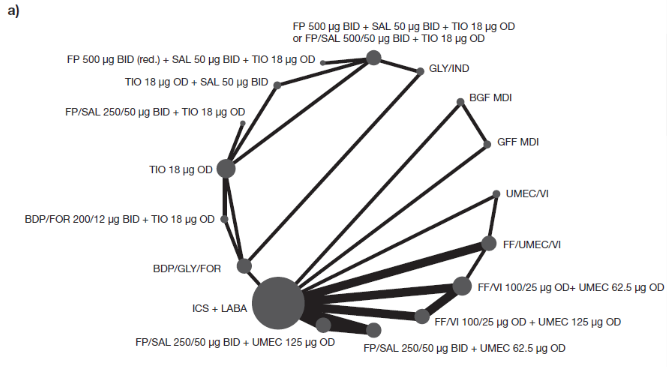
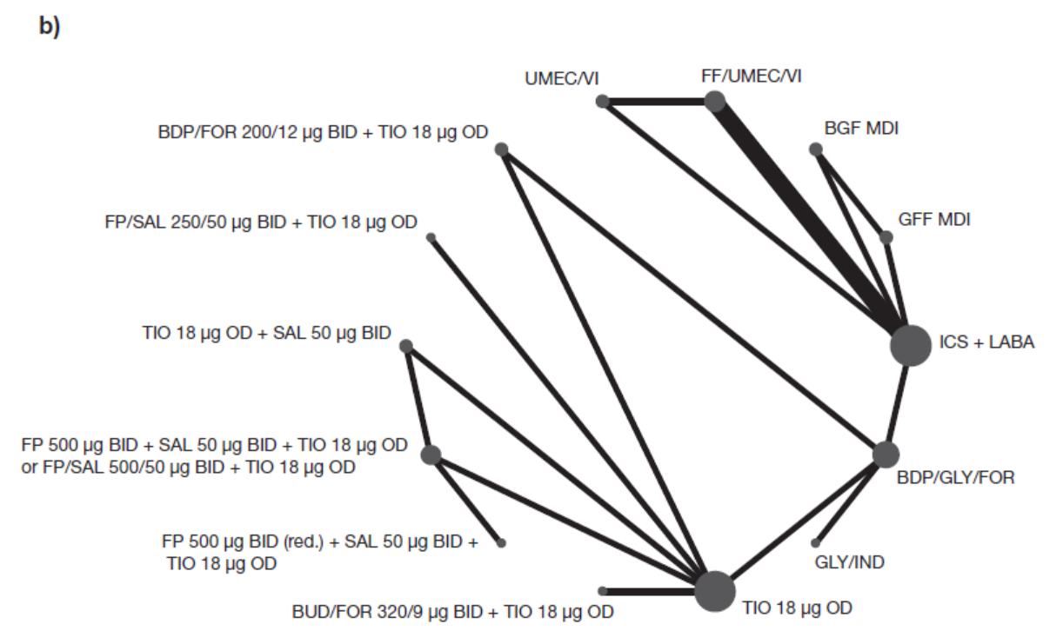
Fixed-dose combinations are represented with ‘/’ between components; open combinations are represented with ‘+’ between components
BDP, beclomethasone dipropionate; BGF, budesonide/glycopyrronium/formoterol fumarate; BID, twice daily; BUD, budesonide; FF, fluticasone furoate; FOR, formoterol; FP, fluticasone propionate; GFF, glycopyrronium/formoterol fumarate; GLY, glycopyrronium; ICS, inhaled corticosteroid; IND, indacaterol; LABA, long-acting β₂-agonist; MDI, metered dose inhaler; OD, once daily; SAL, salmeterol; TIO, tiotropium; UMEC, umeclidinium; VI, vilanterol
Fig. S2 Network diagram for studies contributing to the analysis of trough (a) and peak (b) FEV₁ at 24 weeks
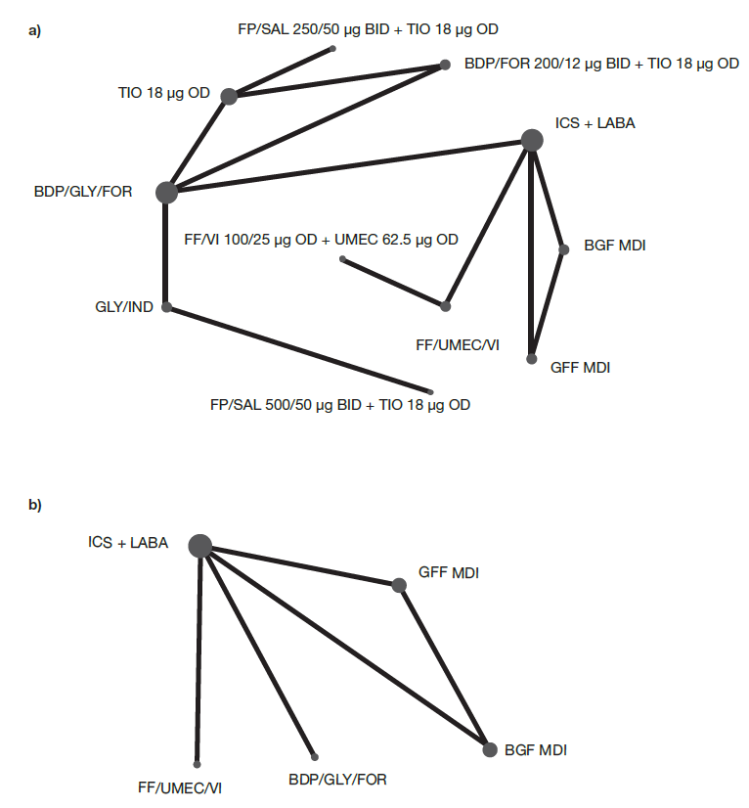
Fixed-dose combinations are represented with ‘/’ between components; open combinations are represented with ‘+’ between components
BDP, beclomethasone dipropionate; BGF, budesonide/glycopyrronium/formoterol fumarate; BID, twice daily; FEV₁: forced expiratory volume in one second; FF, fluticasone furoate; FOR, formoterol; FP, fluticasone propionate; GFF, glycopyrronium/formoterol fumarate; GLY, glycopyrronium; ICS, inhaled corticosteroid; IND, indacaterol; LABA, long-acting β₂-agonist; MDI, metered dose inhaler; OD, once daily; SAL, salmeterol; TIO, tiotropium; UMEC, umeclidinium; VI, vilanterol

Fig. S3 Network diagram for studies contributing to the analysis of (a) change from baseline in SGRQ total score at 24 weeks, (b) TDI focal score at 24 weeks, and (c) change from baseline in rescue medication use over 12 to 24 weeks
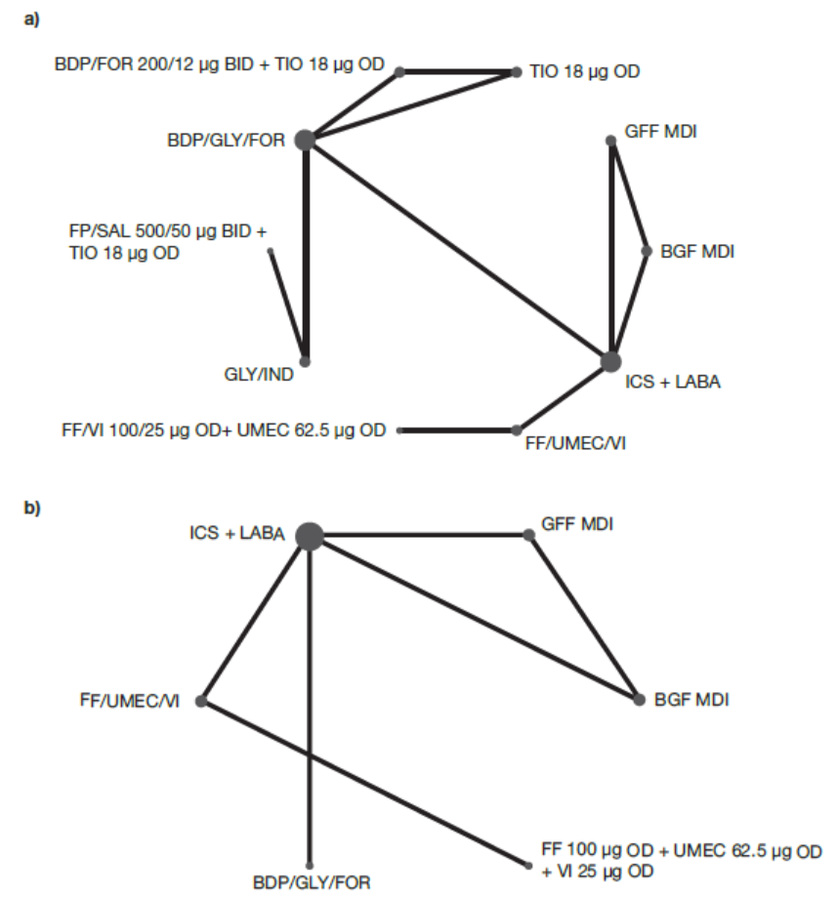
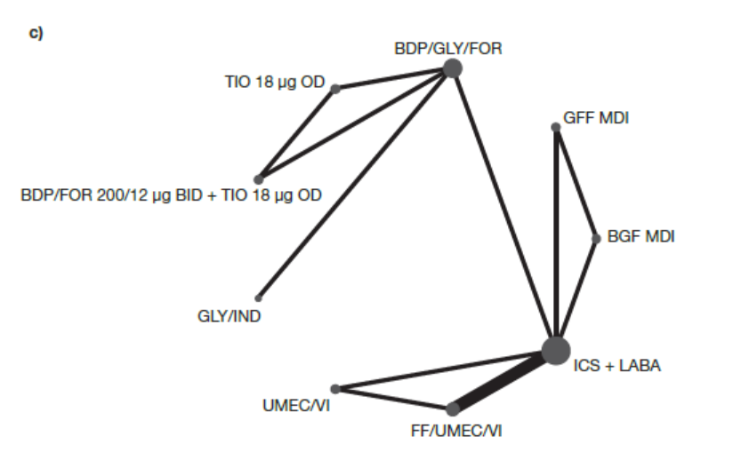
Fixed-dose combinations are represented with ‘/’ between components; open combinations are represented with ‘+’ between components
BDP, beclomethasone dipropionate; BGF, budesonide/glycopyrronium/formoterol fumarate; BID, twice daily; FF, fluticasone furoate; FOR, formoterol; FP, fluticasone propionate; GFF, glycopyrronium/formoterol fumarate; GLY, glycopyrronium; ICS, inhaled corticosteroid; LABA, long-acting β₂-agonist; MDI, metered dose inhaler; OD, once daily; SAL, salmeterol; SGRQ, St George’s Respiratory Questionnaire; TDI, Transition Dyspnea Index; TIO, tiotropium; UMEC, umeclidinium; VI, vilanterol
References
1. Aaron SD, Vandemheen KL, Fergusson D, et al. Tiotropium in combination with placebo, salmeterol, or fluticasone-salmeterol for treatment of chronic obstructive pulmonary disease: a randomized trial. Ann Intern Med. 2007;146:545-55.
2. Bremner PR, Birk R, Brealey N, Ismaila AS, Zhu CQ, Lipson DA. Single-inhaler fluticasone furoate/umeclidinium/vilanterol versus fluticasone furoate/vilanterol plus umeclidinium using two inhalers for chronic obstructive pulmonary disease: a randomized non-inferiority study. Respir Res. 2018;19:19.
3. Lipson DA, Barnacle H, Birk R, et al. FULFIL trial: once-daily triple therapy for patients with chronic obstructive pulmonary disease. Am J Respir Crit Care Med. 2017;196:438-46.
4. Hanania NA, Crater GD, Morris AN, Emmett AH, O'Dell DM, Niewoehner DE. Benefits of adding fluticasone propionate/salmeterol to tiotropium in moderate to severe COPD. Respir Med. 2012;106:91-101.
5. Lipson DA, Barnhart F, Brealey N, et al. Once-daily single-inhaler triple versus dual therapy in patients with COPD. N Engl J Med. 2018;378:1671-80.
6. Jung KS, Park HY, Park SY, et al. Comparison of tiotropium plus fluticasone propionate/salmeterol with tiotropium in COPD: a randomized controlled study. Respir Med. 2012;106:382-9.
7. Ferguson GT, Rabe KF, Martinez FJ, et al. Triple therapy with budesonide/glycopyrrolate/formoterol fumarate with co-suspension delivery technology versus dual therapies in chronic obstructive pulmonary disease (KRONOS): a double-blind, parallel-group, multicentre, phase 3 randomised controlled trial. Lancet Respir Med. 2018;6:747-58.
8. Lee SD, Xie CM, Yunus F, et al. Efficacy and tolerability of budesonide/formoterol added to tiotropium compared with tiotropium alone in patients with severe or very severe COPD: A randomized, multicentre study in East Asia. Respirology. 2016;21:119-27.
9. Siler TM, Kerwin E, Sousa AR, Donald A, Ali R, Church A. Efficacy and safety of umeclidinium added to fluticasone furoate/vilanterol in chronic obstructive pulmonary disease: Results of two randomized studies. Respir Med. 2015;109:1155-63.
10. Siler TM, Kerwin E, Singletary K, Brooks J, Church A. Efficacy and safety of umeclidinium added to fluticasone propionate/salmeterol in patients with COPD: results of two randomized, double-blind studies. COPD. 2016;13:1-10.
11. Chapman KR, Hurst JR, Frent SM, et al. Long-term triple therapy de-escalation to indacaterol/glycopyrronium in patients with chronic obstructive pulmonary disease (SUNSET): a randomized, double-blind, triple-dummy clinical trial. Am J Respir Crit Care Med. 2018;198:329-39.
12. Papi A, Vestbo J, Fabbri L, et al. Extrafine inhaled triple therapy versus dual bronchodilator therapy in chronic obstructive pulmonary disease (TRIBUTE): a double-blind, parallel group, randomised controlled trial. Lancet. 2018;391:1076-84.
13. Singh D, Papi A, Corradi M, et al. Single inhaler triple therapy versus inhaled corticosteroid plus long-acting β₂-agonist therapy for chronic obstructive pulmonary disease (TRILOGY): a double-blind, parallel group, randomised controlled trial. Lancet. 2016;388:963-73.
14. Vestbo J, Papi A, Corradi M, et al. Single inhaler extrafine triple therapy versus long-acting muscarinic antagonist therapy for chronic obstructive pulmonary disease (TRINITY): a double-blind, parallel group, randomised controlled trial. Lancet. 2017;389:1919-29.
15. Welte T, Miravitlles M, Hernandez P, et al. Efficacy and tolerability of budesonide/formoterol added to tiotropium in patients with chronic obstructive pulmonary disease. Am J Respir Crit Care Med. 2009;180:741-50.
16. Magnussen H, Disse B, Rodriguez-Roisin R, et al. Withdrawal of inhaled glucocorticoids and exacerbations of COPD. N Engl J Med. 2014;371:1285-94.

