Supplementary Material

Supplementary Methods: Sensitivity Analyses
The sensitivity analyses conducted were as follows.
- Variation in time horizon: the base-case analysis used a 50-year time horizon, and the impact of shortening the time horizon of the analysis was examined by running analyses over 20- and 10-year time horizons.
- Variation in discount rates: the base-case analysis applied discount rates of 3.5% per annum for future clinical and cost outcomes, with a sensitivity analysis conducted applying 0% discount rates.
- Variation in treatment effects: the base-case analysis applied all treatment effects irrespective of statistical significance, and a sensitivity analysis was prepared with only the statistically significant differences between the once-weekly semaglutide 1 mg and once-daily liraglutide 1.2 mg arms applied. In the once-weekly semaglutide 1 mg arm, changes in glycated haemoglobin (HbA1c), total cholesterol, triglycerides and body mass index (BMI) were applied as per the base-case analysis, with all other parameters equal to the once-daily liraglutide 1.2 mg arm.
- Alternative BMI disutility: the base-case analysis applied a disutility per BMI unit above 25 kg/m² of −0.0061, and a sensitivity analysis was conducted using an alternative value of −0.01 [1, 2]. This larger disutility gives greater impact to weight changes than the conservative disutility used in the base-case analysis.
- Alternative hypoglycaemia disutilities: the base-case analysis applied hypoglycaemic event disutilities based on Evans et al., and the effect of applying alternative disutilities for severe and non-severe hypoglycaemic events was assessed by using the values published by Currie et al. (−0.0118 per non-severe hypoglycaemic event and −0.0035 per severe hypoglycaemic event) [3].
- Alternative risk equations: the base-case analysis used the risk equations from the UK Prospective Diabetes Study (UKPDS) 64, but in February 2014, an update to the IQVIA CORE Diabetes Model was released, incorporating data from the UKPDS 82, with these risk equations applied in a sensitivity analysis [4, 5]. Although a validation study of the revised model has been published, the model proprietors suggest that the update is used in a sensitivity analysis, with the previous version being used in the base case [6].
- Alternative HbA1c progression: in the base-case analysis, HbA1c increased based on the UKPDS progression equation for the duration of the analysis in both arms. An alternative was explored with HbA1c increasing by 0.14% per year in both arms of the analysis while patients received once-weekly semaglutide 1 mg or once-daily liraglutide 1.2 mg, based on the metformin arm of the ADOPT study [7]. When patients initiated basal insulin, HbA1c followed the UKPDS equation, as in the base case.
- Alternative lipid progression: in the base-case analysis, serum lipids followed the Framingham progression equations [8], and an alternative was explored in a sensitivity analysis in which lipids returned to baseline when basal insulin was initiated and then no further progression occurred.
- Alternative BMI progression: in the base-case analysis, BMI returned to baseline on treatment intensification, and an alternative was explored with BMI returning to baseline followed by a further increase based on the Willis et al. equations [9].
- Second intensification to basal bolus included: in the base-case analysis, only one intensification step was included, and a sensitivity analysis was conducted with a second intensification to basal bolus insulin when HbA1c exceeded 7.5% for the second time. A reduction in HbA1c and an increase in BMI were applied, based on the Willis et al. equations [9]. Hypoglycaemic event rates were based on people with type 2 diabetes receiving basal bolus insulin therapy in the HIT study following the second intensification to basal bolus insulin [10].
- Fixed duration of treatment: instead of the treatment switching approach based on an HbA1c threshold applied in the base-case analysis, an alternative was explored with treatment switching after 3 years in both arms. In this analysis, the difference in HbA1c was held constant while patients received once-weekly semaglutide 1 mg or once-daily liraglutide 1.2 mg, and abolished on treatment intensification. This resulted in a balanced analysis with differences in HbA1c and BMI maintained only while there were differences in treatment costs.
- Alternative basal insulin cost: in the base-case analysis, patients intensified treatment with insulin Abasaglar® (Eli Lilly Nederland B.V.), the most commonly used generic analogue insulin, and sensitivity analyses were performed with the costs of insulin Semglee® (Mylan S.A.S.; the lowest cost analogue insulin available in the UK) and insulin glargine (the most commonly used branded insulin analogue) applied.
- Discontinuation of sulphonylureas and sodium–glucose cotransporter-2 inhibitors upon insulin initiation: the base-case analysis assumed that patients discontinued once-weekly semaglutide 1 mg or once-daily liraglutide 1.2 mg on intensification, but that patients receiving an SGLT-2 inhibitor or a sulfonylurea continued to receive these medications. An alternative to this was explored, with SGLT-2 inhibitors and sulfonylureas discontinued in all patients.
- First-order Monte Carlo simulation: the base-case analysis was performed using a second-order Monte Carlo approach, with sampling around inputs to capture both first- and second-order uncertainty. A sensitivity analysis was performed using a first-order Monte Carlo approach, with no sampling around baseline characteristics, treatment effects, costs of complications utilities or transition probabilities.

Supplementary Tables
Table S1 Baseline characteristics in SUSTAIN 10
Characteristic | SUSTAIN 10, all patients
Demographics and risk factors, mean (standard deviation)
Start age, years | 59.54 (10.23)
Duration of diabetes, years | 9.00ª (5.9)
Proportion male, % | 56.7
HbA1c, % | 8.23 (0.96)
Systolic blood pressure, mmHg | 136.42 (14.82)
Diastolic blood pressure, mmHg | 81.24 (9.40)
Total cholesterol, mg/dL | 176.68 (44.50)
HDL cholesterol, mg/dL | 45.49 (11.12)
LDL cholesterol, mg/dL | 95.32 (36.58)
Triglycerides, mg/dL | 192.89 (122.87)
BMI, kg/m² | 33.69 (6.80)
Estimated glomerular filtration rate, mL/min/1.73m² | 92.4 (17.40)
Haemoglobin, g/dL | 13.86 (1.37)
White blood cell count, 10⁶/mL | 7.37 (1.93)
Heart rate, bpm | 74.29 (10.73)
Waist:hip ratio | 0.9 (0.00)^{b}
Urinary albumin excretion rate, mg/mmol | 3.1 (0.00)^{b}
Serum creatinine, mg/dL | 0.79 (0.20)
Serum albumin, g/dL | 4.26 (0.25)
Proportion smokers, % | 14.73
Cigarettes per day^{c} | 8^{d}
Alcohol consumption, oz/week^{e} | 7.52
Ethnic group, %
White | 96.53
Black | 0.52
Hispanic | 1.56
Asian/Pacific Islander | 1.39
Baseline microvascular and macrovascular complications, %
Myocardial infarction | 4.68
Angina | 4.33
Peripheral vascular disease | 2.43
Stroke | 1.70
Congestive heart failure | 0.00
Atrial fibrillation | 3.81
Left ventricular hypertrophy | 8.70
Baseline renal complications, %
Microalbuminuria | 5.20
Gross proteinuria | 0.00
End-stage renal disease | 0.00
Baseline retinopathy complications, %
Background diabetic retinopathy | 14.21
Proliferative diabetic retinopathy | 0.52
Severe vision loss | 0.00
Macular oedema | 0.00
Cataract | 6.59
Baseline neuropathy, ulcer and amputation, %
Neuropathy | 16.46
Uninfected ulcer | 0.00
Infected ulcer | 0.00
Healed ulcer | 0.00
Amputation | 0.17
Antidiabetic medication at baseline, %
Biguanides | 94.8
Sulfonylureas | 46.8
Sodium–glucose cotransporter-2 inhibitors | 24.6
Dipeptidyl peptidase-4 inhibitors^{f} | 0.2
Other blood glucose-lowering drugs (excluding insulin)^{f} | 0.2
BMI body mass index, HbA1c glycated haemoglobin, HDL high-density lipoprotein, LDL low-density lipoprotein
ªRounded value, because the model only accepts integer values for duration of diabetes
^{b}IQVIA CORE Diabetes Model default value. Lipid values are presented in mg/dL, because these are required by the IQVIA CORE Diabetes Model
^{c}Assumed to be the same as the general population in the UK (taken from the Office for National Statistics [11])
^{d}Rounded value because the model only accepts integer values for the number of cigarettes per day
^{e}Assumed to be the same as the general population in the UK (taken from the World Health Organization [12])
^{f}Patients were randomized in error and discontinued treatment
Total cholesterol, HDL cholesterol and LDL cholesterol values can be converted from mg/dL to mmol/L by multiplying by 38.67. Triglyceride values can be converted from mg/dL to mmol/L by multiplying by 88.5

Table S2 Pharmacy acquisition costs, MIMS October 2019
Item | Pack contents | Pack price, GBP
Study medications
Semaglutide (28 days) | 2 pens each containing 2 mg | 73.25
Liraglutide (30 days) | 2 pens each containing 18 mg | 78.48
Concomitant medications
Metformin | 28 tablets each containing 50 mg | 0.93
Glimepiride | 30 tablets each containing 2 mg | 2.06
Empagliflozin | 28 tablets each containing 25 mg | 35.59
Intensification treatment
Insulin Abasaglar | 5 pens each containing 300 IU | 35.28
Consumables
BD MicroFine+™ 5mm/31G needles (Becton Dickinson) | 100 needles | 9.69
SMBG test strips (GlucoRx Ltd.) | 50 test strips | 8.95
AccuCheck® FastClix lancets (Roche Diabetes Care Ltd.) | 204 lancets | 5.90
GBP 2018 pounds sterling, IU international unit, MIMS Monthly Index of Medical Specialities, SMBG self-monitoring of blood glucose

Table S3 Annual treatment costs
Item | Once-weekly semaglutide 1 mg, GBP | Once-daily liraglutide 1.2 mg, GBP | Intensification, GBP
Study medications
Annual once-weekly semaglutide cost | 955.52 | – | –
Annual once-daily liraglutide cost | – | 955.49 | –
Concomitant medications
Annual metformin cost | 46.69 | 45.31 | 46.69
Annual glimepiride cost | 11.76 | 11.71 | 11.76
Annual empagliflozin cost | 120.14 | 114.74 | 120.14
Intensification treatment
Annual insulin Abasaglar cost | – | – | 343.63
Consumables
Annual needle cost | 0 | 35.39 | 35.39
Annual SMBG testing cost | 0 | 0 | 75.94
Total annual cost | 1134.11 | 1162.65 | 633.55
GBP 2018 pounds sterling, SMBG self-monitoring of blood glucose

Table S4 Costs of treating diabetes-related complications
Complication | Annual cost, GBP | Reference
Myocardial infarction (year of event) | 7849 | [13]
Myocardial infarction (years 2 +) | 1951 | [13]
Angina (year of event) | 2317 | [14]
Angina (years 2 +) | 388 | [14]
Congestive heart failure (year of event) | 4458 | [13]
Congestive heart failure (years 2 +) | 2615 | [13]
Stroke (year of event) | 8441 | [13]
Stroke (years 2 +) | 2011 | [13]
Death within 30 days due to stroke | 4227 | [13]
Peripheral vascular disease (year of event) | 1666 | [15]
Peripheral vascular disease (years 2 +) | 1666 | [15]
Haemodialysis (year of event) | 23,428 | [15]
Haemodialysis (years 2 +) | 23,428 | [15]
Peritoneal dialysis (year of event) | 27,209 | [15]
Peritoneal dialysis (years 2 +) | 27,209 | [15]
Renal transplant (year of event) | 26,851 | [16]
Renal transplant (years 2 +) | 1253 | [16]
Non-severe hypoglycaemic event (nocturnal or diurnal) | 4 | [17]
Severe hypoglycaemic event (nocturnal or diurnal) | 427 | [18]
Laser treatment | 90 | [15]
Cataract operation | 748 | [13]
Cost following cataract operation | 721 | [13]
Blindness (year of onset) | 3362 | [13]
Blindness (years 2 +) | 1273 | [13]
Neuropathy (year of event) | 31 | [19]
Neuropathy (years 2 +) | 31 | [19]
Amputation (event based) | 13,090 | [13]
Prosthesis (event based) | 3638 | [13]
Gangrene treatment | 3559 | [20]
Cost following healed ulcer | 269 | [20]
Infected ulcer | 2041 | [20]
Standard uninfected ulcer | 2001 | [20]
Healed ulcer (history of amputation) | 269 | [20]
GBP 2018 pounds sterling

Table S5 Health state utilities
Complication | Utility | Reference
Patient with type 2 diabetes baseline (no complications) | 0.785 (0.007) | [21]
Myocardial infarction event | −0.055 (0.005) | [21]
Post myocardial infarction | 0.730 (0.009) | [21]
Angina | 0.695 (0.010) | [21]
Congestive heart failure | 0.677 (0.010) | [21]
Stroke event | −0.164 (0.008) | [21]
Post stroke | 0.621 (0.011) | [21]
Peripheral vascular disease | 0.724 (0.008) | [1]
Microalbuminuria | 0.785 (0.007) | [21]
Gross proteinuria | 0.737 (0.008) | [1]
Haemodialysis | 0.621 (0.029) | [22]
Peritoneal dialysis | 0.581 (0.030) | [22]
Renal transplant | 0.762 (0.118) | [23]
Background diabetic retinopathy | 0.745 (0.021) | [24]
Background diabetic retinopathy wrongly treated | 0.745 (0.021) | [24]
Proliferative diabetic retinopathy: laser treated | 0.715 (0.022) | [24]
Proliferative diabetic retinopathy: not laser treated | 0.715 (0.022) | [24]
Macular oedema | 0.745 (0.021) | [24]
Severe vision loss | 0.711 (0.010) | [21]
Cataract | 0.769 (0.016) | [25]
Neuropathy | 0.701 (0.008) | [1]
Healed ulcer | 0.785 (0.007) | [21]
Active ulcer | 0.615 (0.009) | [1]
Amputation event | −0.280 (0.011) | [21]
Post amputation | 0.505 (0.013) | [21]
Non-severe hypoglycaemic event (daytime) | −0.005 (0.001) | [26]
Non-severe hypoglycaemic event (nocturnal) | −0.008 (0.001) | [26]
Severe hypoglycaemic event (daytime) | −0.062 (0.017) | [26]
Severe hypoglycaemic event (nocturnal) | −0.066 (0.005) | [26]
Each unit of BMI over 25 kg/m² | −0.0061 (0ª) | [1]
BMI body mass index
ªStandard error not applied because this decrement was applied through the ‘Annual utility score associated with treatment’ field, which does not include the option to specify a standard error
Values are means (standard error)

Supplementary Figures
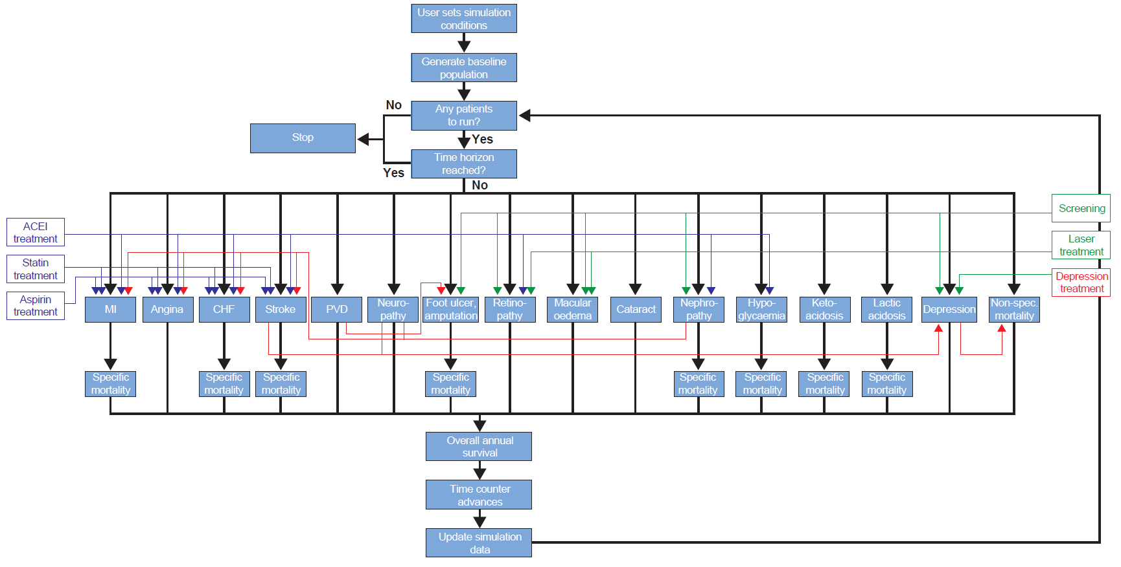
Fig. S1 Schematic of the IQVIA CORE Diabetes Model. ACEI angiotensin-converting enzyme inhibitor, CHF congestive heart failure, MI myocardial infarction, Non-spec non-specific, PVD peripheral vascular disease, ulc ulcer
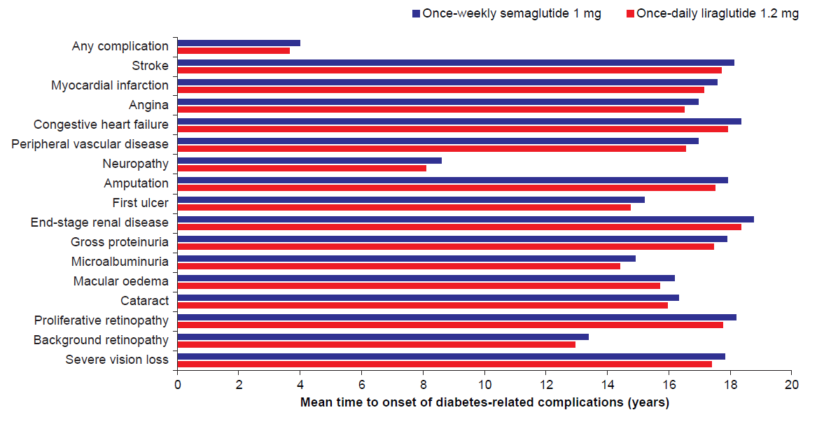
Fig. S2 Mean time to onset of diabetes-related complications
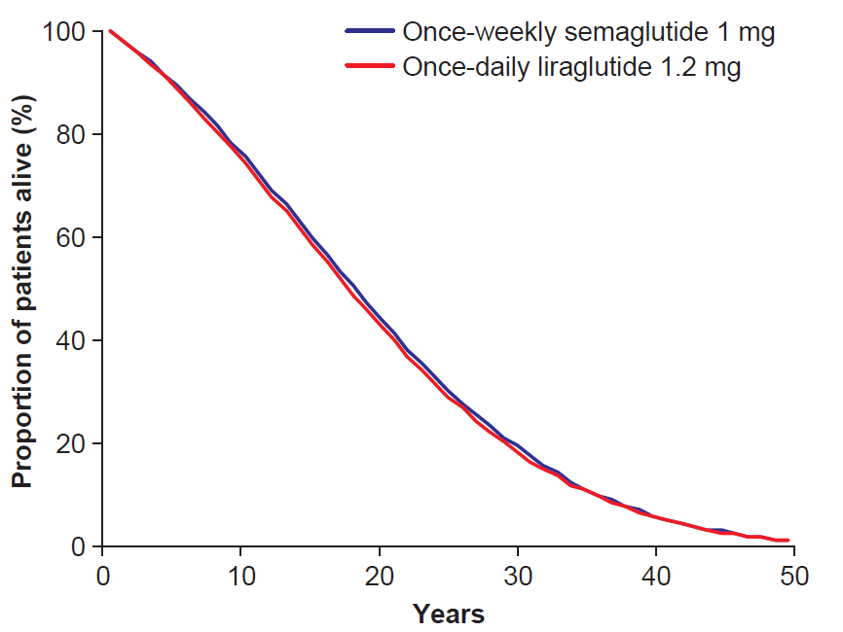
Fig. S3 Survival of patients over 50-year time horizon

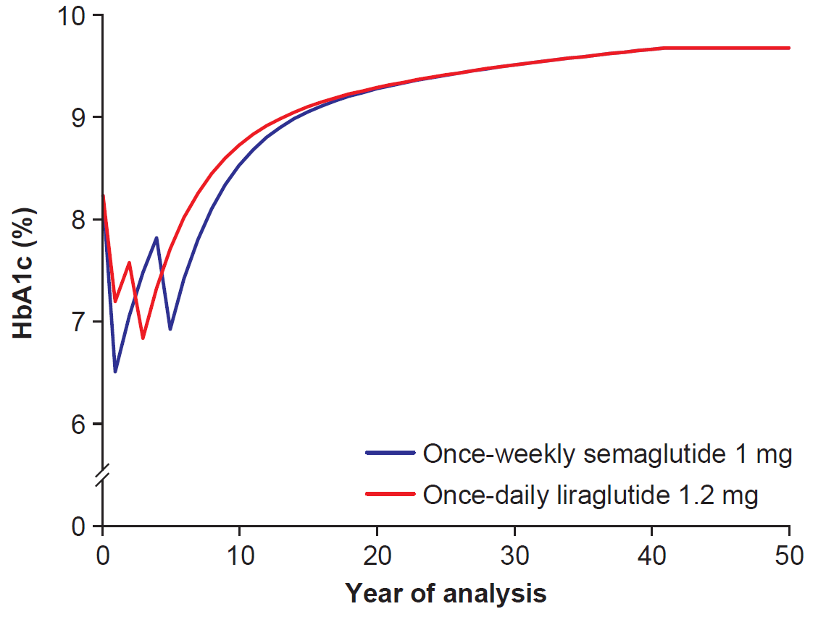
Fig. S4 Deterministic HbA1c progression curves. HbA1c glycated haemoglobin

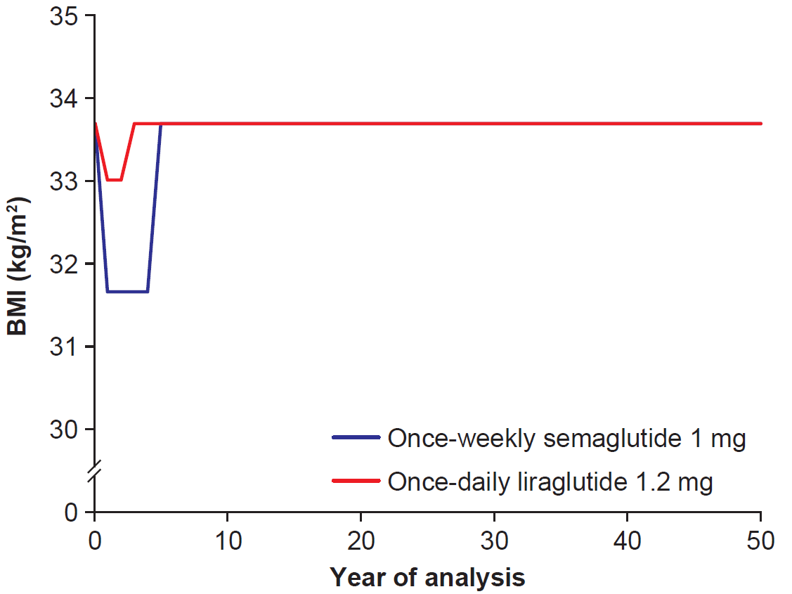
Fig. S5 Deterministic BMI progression curves. BMI body mass index

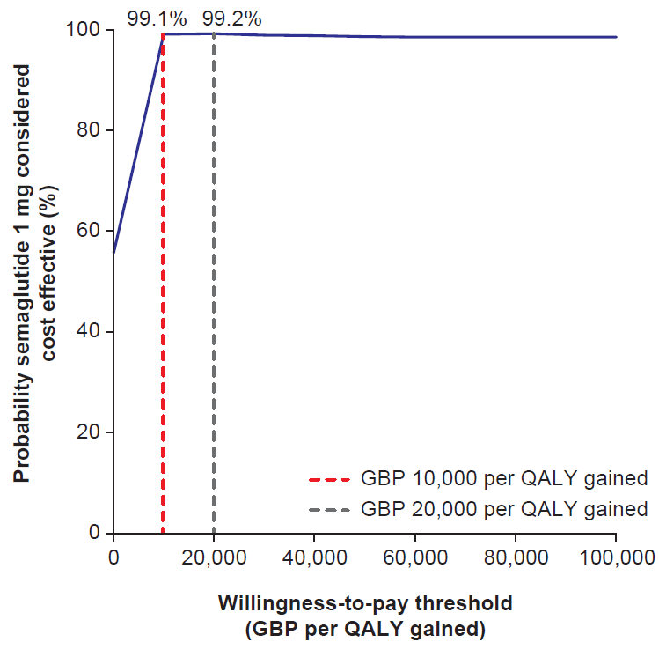
Fig. S6 Cost-effectiveness acceptability curve. GBP 2018 pounds sterling, QALY quality-adjusted life-year

References
1. Bagust A, Beale S. Modelling EuroQol health-related utility values for diabetic complications from CODE-2 data. Health Econ. 2005;14(3):217-30.
2. Lee AJ, Morgan CL, Morrissey M, Wittrup-Jensen KU, Kennedy-Martin T, Currie CJ. Evaluation of the association between the EQ-5D (health-related utility) and body mass index (obesity) in hospital-treated people with Type 1 diabetes, Type 2 diabetes and with no diagnosed diabetes. Diabet Med. 2005;22(11):1482-6.
3. Currie CJ, Morgan CL, Poole CD, Sharplin P, Lammert M, McEwan P. Multivariate models of health-related utility and the fear of hypoglycaemia in people with diabetes. Curr Med Res Opin. 2006;22(8):1523-34.
4. Clarke PM, Gray AM, Briggs A, et al. A model to estimate the lifetime health outcomes of patients with type 2 diabetes: the United Kingdom Prospective Diabetes Study (UKPDS) Outcomes Model (UKPDS no. 68). Diabetologia. 2004;47(10):1747–59.
5. Hayes AJ, Leal J, Gray AM, Holman RR, Clarke PM. UKPDS outcomes model 2: a new version of a model to simulate lifetime health outcomes of patients with type 2 diabetes mellitus using data from the 30 year United Kingdom Prospective Diabetes Study: UKPDS 82. Diabetologia. 2013;56(9):1925-33.
6. McEwan P, Foos V, Palmer JL, Lamotte M, Lloyd A, Grant D. Validation of the IMS CORE Diabetes Model. Value Health. 2014;17(6):714-24.
7. Viberti G, Kahn SE, Greene DA, et al. A diabetes outcome progression trial (ADOPT): an international multicenter study of the comparative efficacy of rosiglitazone, glyburide, and metformin in recently diagnosed type 2 diabetes. Diabetes Care. 2002;25(10):1737-43.
8. Palmer AJ, Roze S, Valentine WJ, et al. The CORE Diabetes Model: Projecting long-term clinical outcomes, costs and cost-effectiveness of interventions in diabetes mellitus (types 1 and 2) to support clinical and reimbursement decision-making. Curr Med Res Opin. 2004;20 Suppl 1:S5-26.
9. Willis M, Asseburg C, Nilsson A, Johnsson K, Kartman B. Multivariate Prediction Equations for HbA1c Lowering, Weight Change, and Hypoglycemic Events Associated with Insulin Rescue Medication in Type 2 Diabetes Mellitus: Informing Economic Modeling. Value Health. 2017;20(3):357-71.
10. Frier BM, Jensen MM, Chubb BD. Hypoglycaemia in adults with insulin-treated diabetes in the UK: self-reported frequency and effects. Diabet Med. 2016;33(8):1125-32.
11. Office for National Statistics. Adult smoking habits in Great Britain 2018. https://www.ons.gov.uk/peoplepopulationandcommunity/healthandsocialcare/drugusealcoholandsmoking/datasets/adultsmokinghabitsingreatbritain (Accessed December 2019)
12. World Health Organization. United Kingdom of Great Britain and Northern Ireland. Alcohol consumption: levels and patterns 2018. https://www.who.int/substance_abuse/publications/global_alcohol_report/profiles/gbr.pdf (Accessed December 2019)
13. Alva ML, Gray A, Mihaylova B, Leal J, Holman RR. The impact of diabetes-related complications on healthcare costs: new results from the UKPDS (UKPDS 84). Diabet Med. 2015;32(4):459-66.
14. Danese M, Gleeson M, Kutikova L, et al. Costs of cardiovascular (CV) events in the United Kingdom (UK) using real-world data. Value Health. 2015;18(7):A387.
15. NHS England. Reference costs 2018. https://improvement.nhs.uk/resources/reference-costs/#rc1718 (Accessed November 2019)
16. Kent S, Schlackow I, Lozano-Kuhne J, et al. What is the impact of chronic kidney disease stage and cardiovascular disease on the annual cost of hospital care in moderate-to-severe kidney disease? BMC Nephrol. 2015;16:65.
17. Chubb B, Tikkanen C. The cost of non-severe hypoglycaemia in Europe. Value Health. 2015;18(7):A611.
18. Hammer M, Lammert M, Mejias SM, Kern W, Frier BM. Costs of managing severe hypoglycaemia in three European countries. J Med Econ. 2009;12(4):281-90.
19. Monthly Index of Medical Specialities. July 2019. https://www.mims.co.uk/ (Accessed September 2019)
20. Ghatnekar O, Willis M, Persson U. Cost-effectiveness of treating deep diabetic foot ulcers with Promogran in four European countries. J Wound Care. 2002;11(2):70-4.
21. Clarke P, Gray A, Holman R. Estimating utility values for health states of type 2 diabetic patients using the EQ-5D (UKPDS 62). Med Decis Making. 2002;22(4):340-9.
22. Wasserfallen JB, Halabi G, Saudan P, et al. Quality of life on chronic dialysis: comparison between haemodialysis and peritoneal dialysis. Nephrol Dial Transplant. 2004;19(6):1594-9.
23. Kiberd BA, Jindal KK. Screening to prevent renal failure in insulin dependent diabetic patients: an economic evaluation. BMJ. 1995;311(7020):1595-9.
24. Fenwick EK, Xie J, Ratcliffe J, et al. The impact of diabetic retinopathy and diabetic macular edema on health-related quality of life in type 1 and type 2 diabetes. Invest Ophthalmol Vis Sci. 2012;53(2):677-84.
25. Lee WJ, Song KH, Noh JH, Choi YJ, Jo MW. Health-related quality of life using the EuroQol 5D questionnaire in Korean patients with type 2 diabetes. J Korean Med Sci. 2012;27(3):255-60.
26. Evans M, Khunti K, Mamdani M, et al. Health-related quality of life associated with daytime and nocturnal hypoglycaemic events: a time trade-off survey in five countries. Health Qual Life Outcomes. 2013;11:90.

