SUPPLEMENTARY APPENDIX
A Retrospective Chart Review Study of Real-World Use of Talimogene Laherparepvec in Unresectable Stage IIIB–IVM1a Melanoma in Four European Countries
Alexander C. J. van Akkooi • Sebastian Haferkamp • Sophie Papa • Viola Franke • Andreas Pinter • Carsten Weishaupt • Margit A. Huber • Carmen Loquai • Erika Richtig • Priya Gokani • Katarina Öhrling • Karly S. Louie • Peter Mohr

Table S1 Institutional ethics committees and review boards
Investigator Name | Country | Site Name | Site Address | Institutional ethics committees and review board names | Ethics committee  submission | Ethics committee approval
Richtig, Erika | Austria | Steiermärkische Krankenanstalten- gesellschaft m.b.H. (KAGes) | Universitaetsklinik fuer Dermatologie und Venerologie Auenbruggerplatz 8  Graz, 8036 | Ethics Committee of Medical University Graz | 16-Jan-2017 | 28-Feb-2017
Haferkamp, Sebastian | Germany | Universitätsklinikum Regensburg | Univ. Klinikum Regensburg  Klinik für Dermatologie Franz-Josef-Strauß-Allee 11  Regensburg, 93053 | Ethics Committee at University Regensburg | 18-Jan-2017 | 22-Feb-2017
Huber, Margit | Germany | Universitätsklinikum Ulm | Universitätsklinikum Ulm Klinik für Dermatologie und Allergologie  Albert-Einstein-Allee 23  Ulm, 89081 | Ethics Committee Ulm | 29-Mar-2017 | 30-Mar-2017
Loquai, Carmen | Germany | Universitätsmedizin der Johannes Gutenberg- Universität Mainz | Universitätsmedizin Mainz Langenbeckstr. 1  Mainz, 55131 | Ethics Committee State Physician Chamber Rheinland-Pfalz | 13-Mar-2017 | 16-Mar-2017
Mohr, Peter | Germany | Elbe Kliniken | Elbe Kliniken Stade - Buxtehude GmbH Klinik für Dermatologie Am Krankenhaus 1 Buxtehude, Niedersachsen 21614 | Ethics Committee at Physcian Chamber Niedersachsen | 26-May-2017 | 07-Jun-2017
Pinter, Andreas | Germany | Universitätsklinikum Frankfurt | Universitätsklinikum Frankfurt  Klinik für Dermatologie, Venerologie und Allergologie  Theodor-Stern-Kai 7  Frankfurt am Main, Hessen 60590 | Ethics Committee of Medical Department Of J.W Goethe University Frankfurt | 30-Mar-2017 | 26-Apr-2017
Weishaupt, Carsten | Germany | Universitätsklinikum Münster | Universitätsklinikum Münster  Dept. of Dermatology Von-Esmarch-Str. 58  Münster, 48149 | Ethics Committee of Physcian Chamber Westfalen-Lippe and of Westfaelische Wilhelms University  Muenster | 17-Mar-2017 | 23-Mar-2017
Van Akkooi, Alexander | Netherlands | Antoni van Leeuwenhoek Nederlands Kanker Instituut | Netherlands Cancer Institute Plesmanlaan 121  Amsterdam, North Holland 1066CX | Antoni Van Leeuwenhoek Nederlands Kanker Instituut | 27-Feb-2018 | 30-Mar-2018
Papa, Sophia | United Kingdom | Guy's and St Thomas' NHS Foundation Trust Cancer Centre | Guy's and St Thomas' NHS Foundation Trust Cancer Centre, Floor C1 Great Maze Pond London, SE1 9RT | Liverpool Central Research Ethics Committee | 14-Dec-2017 | 16-Jan-2018

Table S2 Patients’ demographic and clinical characteristics at first dose of talimogene laherparepvec (country-specific data for Austria, Germany and the UK)
Patient characteristic | Austria  (N = 3) | Germany  (N = 27) | UK  (N = 5)
Age, years
Median (range) | 67 (61–85) | 68 (26–87) | 69 (38–90)
Sex, n (%)
Male | 2 (66.7) | 13 (48.1) | 1 (20.0)
Female | 1 (33.3) | 14 (51.9) | 4 (80.0)
Median period since primary diagnosis, years, median (range) ª | 2.2 (1.2–9.1) | 3.2 (0.9–18.3) | 1.9 (1.3–12.6)
Disease stage,ª n (%)
IIIB/C | 2 (66.7) | 12 (44.4) | 3 (60.0)
IVM1a | 1 (33.3) | 11 (40.7) | 1 (20.0)
Unknown | 0 | 4 (14.8) | 1 (20.0)
ECOG performance status, n (%)
0 | 3 (100) | 9 (33.3) | 1 (20.0)
1 | 0 | 6 (22.2) | 1 (20.0)
2 | 0 | 0 | 1 (20.0)
Unknown | 0 | 12 (44.4) | 2 (40.0)
Lactate dehydrogenase, n (%)
≤ULN | 3 (100) | 16 (59.3) | 1 (20.0)
>ULN | 0 | 8 (29.6) | 4 (80.0)
<1.5× ULN | 3 (100) | 24 (88.9) | 5 (100)
≥1.5× ULN | 0 | 0 | 0
Unknown | 0 | 3 (11.1) | 0
BRAF status, n (%)
Mutated | 1 (33.3) | 7 (25.9) | 1 (20.0)
Wild-type | 2 (66.7) | 17 (63.0) | 2 (40.0)
Unknown | 0 | 3 (11.1) | 2 (40.0)
ª American Joint Committee on Cancer, Cancer Staging Manual, 7th edition.
ECOG Eastern Cooperative Oncology Group, ULN upper limit of normal range

Table S3 Treatment history prior to talimogene laherparepvec administration in Austria, Germany and the UK
Treatment history prior to T-VEC | Austria  (N = 3)  n (%) | Germany  (N = 27)  n (%) | UK  (N = 5)  n (%)
Surgery, N (%) | 3 (100) | 27 (100) | 5 (100)
Type of surgery, n (%)
Sentinel biopsy | 0 | 16 (59.3) | 2 (40.0)
Lymphadenectomy | 1 (33.3) | 15 (55.6) | 1 (20.0)
Recorded resection of recurrent disease | 0 | 14 (51.9) | 3 (60.0)
No. of resections for recurrent disease per patient, median (IQR; range) | 0 | 3.0 (1,5; 1–11) | 3.0 (2,4; 2–4)
Months from resection for recurrent disease to initiating T-VEC, median (range) | N/A | 26.7 (2–162) | 24.7 (7–58)
Adjuvant therapy, N (%) | 1 (33.3) | 11 (40.7) | 0
Local (intralesional therapy injection of IL-2 or IFN-α) | 0 | 3 (27.3) | 0
Systemic (IFN-α) | 1 (100) | 11 (100) | 0
Locoregional treatment, N (%) | 2 (66.7) | 14 (51.9) | 1 (20.0)
Electrochemotherapy | 0 | 4 (28.6) | 0
Radiation therapy | 2 (100.0) | 11 (78.6) | 1 (100.0)
Local ablation therapy | 0 | 1 (7.1) | 0
Intralesional therapy injection of IL-2 or IFN-α | 0 | 3 (21.4) | 0
Topical imiquimod | 1 (50.0) | 0 | 0
Other local treatment | 1 (50.0) | 0 | 0
Isolated limb perfusion | 0 | 2 (14.3) | 0
Systemic therapy, N (%) | 1 (33.3) | 15 (55.6) | 5 (100.0)
Pembrolizumab | 0 | 4 (26.7) | 4 (80.0)
Ipilimumab | 1 (100.0) | 6 (40.0) | 1 (20.0)
Nivolumab | 0 | 3 (20.0) | 0
Ipilimumab / Nivolumab | 0 | 0 | 1 (20.0)
IFN-α | 1 (100.0) | 11 (73.3) | 0
IL-2 | 1 (100.0) | 2 (13.3) | 0
Trametinib/dabrafenib | 0 | 1 (6.7) | 0
Imatinib | 1 (100.0) | 0 | 0
Chemotherapy (e.g. dacarbazine, temozolomide, taxanes) | 1 (100.0) | 5 (33.3) | 1 (20.0)
Other | 0 | 1 (6.7) | 1 (20.0)
IFN interferon, IL interleukin, IQR interquartile range, T-VEC talimogene laherparepvec

Fig. S1 Systemic treatmentsª received (a) before talimogene laherparepvec (T-VEC; n = 18) during the chart review period and (b) after T-VEC discontinuation during the study period (n = 10). Note: patient numbers in (a) do not necessarily correspond to those in (b)
a
Patient number | Line of treatment
Patient number | 1st | 2nd | 3rd | 4th | 5th | 6th
1 | Interleukin-2 | Chemotherapy^{b} | Interleukin-2 | Targeted therapy  (imatinib) | Ipilimumab | T-VEC | Targeted therapy (imatinib)
2 | Chemotherapy^{b} | Ipilimumab | T-VEC
3 | Ipilimumab | Nivolumab | T-VEC
4 | Ipilimumab | Pembrolizumab | T-VEC
5 | Chemotherapy^{b} | T-VEC
6 | Targeted therapy (trametinib/ dabrafenib) | T-VEC
7 | Ipilimumab | Nivolumab | Chemotherapy^{b} | Pembrolizumab | T-VEC
8 | Ipilimumab | Pembrolizumab | T-VEC
9 | Other systemic therapy^{c} | T-VEC
10 | Chemotherapy^{b} | Ipilimumab | Nivolumab | T-VEC
11 | Chemotherapy^{b} | Pembrolizumab | T-VEC
12 | Chemotherapy^{b} | Ipilimumab | Pembrolizumab | T-VEC
13 | Pembrolizumab | T-VEC
14 | Ipilimumab/nivolumab | T-VEC
15 | Pembrolizumab | T-VEC
16 | Other systemic therapy^{d} | Pembrolizumab | T-VEC
17 | Pembrolizumab | Targeted therapy (dabrafenib) | T-VEC
18 | Pembrolizumab | T-VEC

b
Patient number | Line of treatment
Patient number | 1st | 2nd | 3rd | 4th | 5th
1 | Ipilimumab | Nivolumab | T-VEC | Chemotherapy^{b}
2 | Targeted therapy  (trametinib/dabrafenib) | T-VEC | Pembrolizumab | Targeted therapy  (vemurafenib / cobimetinib)
3 | Ipilimumab | Pembrolizumab | T-VEC | Targeted therapy  (trametinib) | Chemotherapy^{b}
4 | Other systemic therapy^{c} | T-VEC | Ipilimumab/ nivolumab
5 | Chemotherapy^{b} | Ipilimumab | Nivolumab | T-VEC | Targeted therapy  (trametinib/dabrafenib)
6 | T-VEC | Ipilimumab/ nivolumab
7 | T-VEC | Pembrolizumab
8 | T-VEC | Ipilimumab/ nivolumab
9 | T-VEC | Pembrolizumab
10 | T-VEC | Pembrolizumab
ª Excluding adjuvant therapies
^{b} Chemotherapy included dacarbazine, temozolomide and taxanes
^{c} Clinical trial of systemic therapy
^{d} Bevacizumab

Fig. S2 Kaplan–Meier analysis of time to talimogene laherparepvec treatment discontinuation by disease stage in Austria, Germany and the UK versus the Netherlands
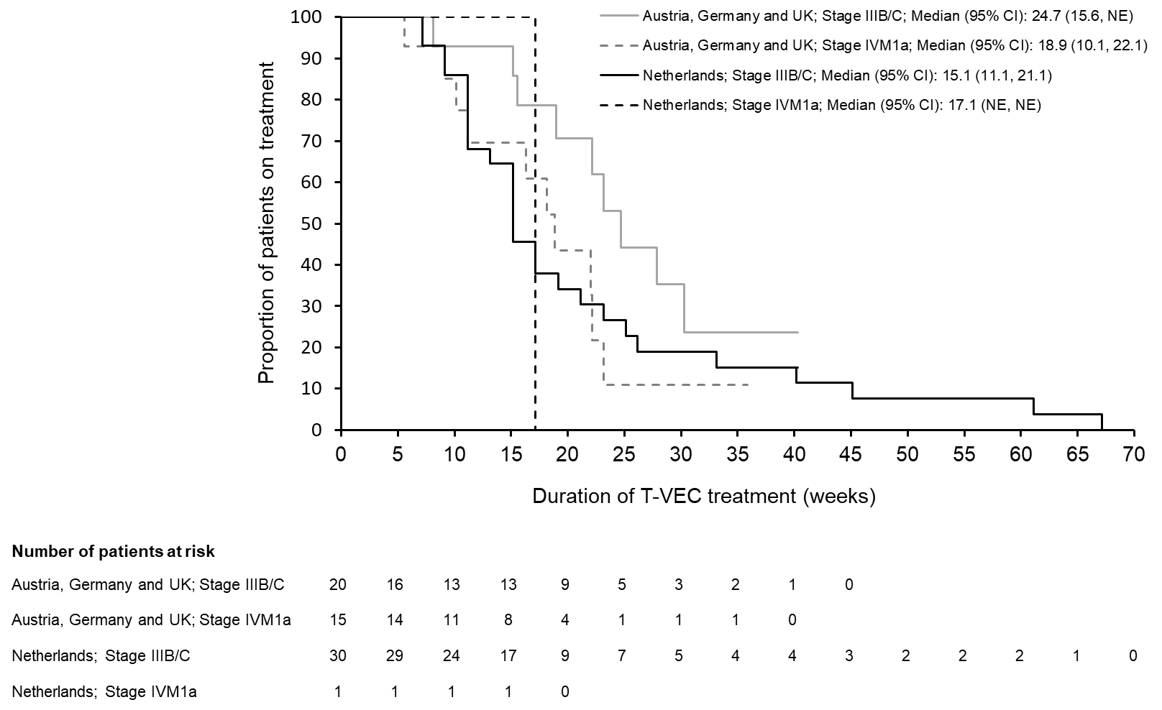

Fig. S3 Kaplan–Meier analysis of time to talimogene laherparepvec treatment discontinuation by line of therapy
