Figure S1. Proxy criteria for progression applied during the study (incident and existing fibrosing ILD). Criteria were not mutually exclusive, and an individual patient could have more than one criterion applied. The majority of patients (90.3%) had only one proxy applied, and data are shown (a) for all patients and (b) for those with only one proxy applied.
a. All patients
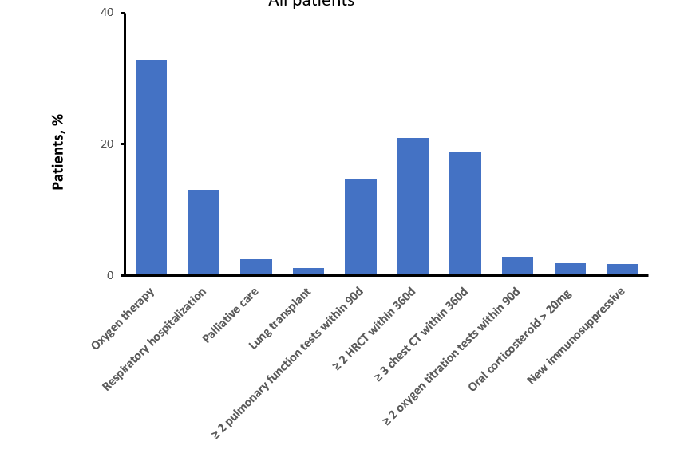
b. Patients with one proxy

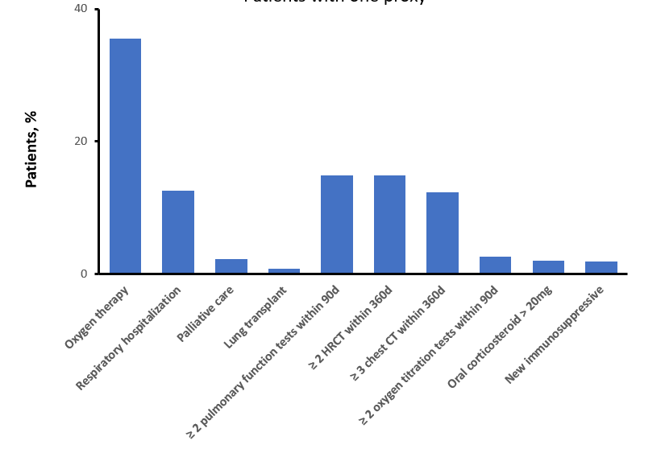
CT, computed tomography, HRCT, high-resolution computed tomography; ILD, interstitial lung disease.

Table S1. Eligible ICD-9 codes for a diagnosis of fibrosing ILD
ICD-9 code | Description
515 | Post-inflammatory pulmonary fibrosis
516.3 | Idiopathic fibrosing alveolitis
516.30 | Idiopathic interstitial pneumonia, not otherwise specified
516.32 | Idiopathic NSIP
516.8 | Other specified alveolar and parietoalveolar pneumopathies (interstitial pneumonia, desquamative interstitial pneumonia, lymphoid interstitial pneumonia)
516.9 | Unspecified alveolar and parietoalveolar pneumopathy
517.1 | Rheumatic pneumonia
517.2 | Lung involvement in systemic sclerosis
517.8 | Lung involvement in other diseases classified elsewhere (autoimmune, sarcoid)
714.81 | Rheumatoid lung
The code for idiopathic pulmonary fibrosis (516.31) was not eligible for a diagnosis of fibrosing ILD but patients with this code were not excluded if they had another, eligible, code.
ICD-9, International Classification of Diseases, Ninth Revision; ILD, interstitial lung disease; NSIP, non-specific interstitial pneumonia.
Table S2. Codes used to define fibrosing ILD overall and by underlying disease
Measure | Applicable lung fibrosis code(s) | Determination of underlying condition based on the presence or absence of codes during baseline
All fibrosing ILD | 515; 516.3; 516.30; 516.32; 516.8; 516.9; 517.1; 517.2; 517.8; 714.81 | N/A; no additional requirement during baseline
Sarcoidosis | 515; 516.3; 516.30; 516.32; 516.8; 516.9; 517.8 | Presence of 135: Sarcoidosis
RA-ILD | 515; 516.3; 516.30; 516.32; 516.8; 516.9; 517.1; 714.81 | Presence of RA – 714: Rheumatoid arthritis; 714.1: Felty's syndrome; 714.2: Other rheumatoid arthritis with visceral or systemic involvement; 714.4: Chronic postrheumatic arthropathy
RA-ILD | 515; 516.3; 516.30; 516.32; 516.8; 516.9; 517.1; 517.8; 714.81 | Presence of Other inflammatory polyarthropathies – 714.8: Other specified inflammatory polyarthropathies; 714.89: Rheumatoid arthritis and other inflammatory polyarthropathies; 714.9: Unspecified inflammatory polyarthropathies; 716.5: Unspecified polyarthropathy or polyarthritis
SSc-ILD | 515; 516.3; 516.30; 516.32; 516.8; 516.9; 517.2; 517.8 | Presence of 710.1: Systemic sclerosis
MCTD-ILD | 515; 516.3; 516.30; 516.32; 516.8; 516.9; 517.1; 517.2; 517.8; 714.81. | Presence of 710.8: Other specified diffuse diseases of connective tissue
Exposure-related ILD | 515; 516.3; 516.30; 516.32; 516.8; 516.9; 517.8 | Presence of any of the following:  Pneumoconiosis – 500: Coal Workers' Pneumoconiosis; 501: Asbestosis; 502: Pneumoconiosis due to silica; 503: Pneumoconiosis due to inorganic dust; 504: Pneumoconiosis due to the inhalation of other dust; maybe HP; 505: Pneumoconiosis, unspecified; need to ensure fibrotic  Pneumoconiosis due to external agents – 506: Bronchitis and pneumonitis due to fumes and vapor; 506.3: Other acute and subacute respiratory conditions due to fumes and vapors; 506.4: Chronic respiratory conditions due to fumes and vapors  Pneumoconioses and other lung diseases due to external agents – 508: Radiation pneumonitis; 508.1: Chronic and other pulmonary manifestations due to radiation; 508.8: Respiratory conditions due to other specified external agents; 508.9: Respiratory conditions due to unspecified specified external agents
Hypersensitivity pneumonitis | 515; 516.3; 516.30; 516.32; 516.8; 516.9; 517.8 | Presence of Extrinsic allergic alveolitis – 495: Farmer's lung; 495.1: Bagassosis; 495.2: Bird fanciers' lung; 495.3: Suberosis; 495.4: Malt workers' lung; 495.5: Mushroom workers' lung; 495.6: Maple bark-strippers' lung; 495.7: Ventilation pneumonitis; 495.8: Other specified allergic alveolitis and pneumonitis; 495.9: Unspecified allergic alveolitis and pneumonitis
Unclassifiable IIP | 515; 516.30; 516.8; 516.9 | Absence of any of the above underlying medical conditions and other diffuse diseases of the connective tissue (710: Systemic lupus erythematosus; 710.2: Sicca syndrome/Sjogren’s; 710.3: Dermatomyositis; 710.4: Polymyositis; 710.9: Unspecified connective tissue disease)
iNSIPs | 516.32
The code for idiopathic pulmonary fibrosis (516.31) was not eligible for a diagnosis of fibrosing ILD but patients with this code were not excluded if they had another, eligible, code.
IIP, idiopathic interstitial pneumonia; ILD, interstitial lung disease; iNSIP, idiopathic non-specific interstitial pneumonia; MCTD, mixed connective tissue disease; RA, rheumatoid arthritis; SSc, systemic sclerosis.
Table S3. Crude prevalence of fibrosing ILD and progressive fibrosing ILD by age and sex (requiring a single eligible claim to define fibrosing ILD)
Fibrosing ILD
Characteristic | Number of cases* | Persons at risk | Crude prevalence  per 100,000 persons  (95% CI)
Overall study persons | 147,678 | 37,565,644 | 393.12 (391.12, 395.12)
Age category, years
18–39 | 6,922 | 15,363,409 | 45.06 (43.99, 46.12)
40–49 | 12,539 | 8,313,711 | 150.82 (148.19, 153.46)
50–59 | 29,985 | 9,012,816 | 332.69 (328.93, 336.45)
60–69 | 36,485 | 5,674,094 | 643.01 (636.43, 649.59)
70–79 | 30,503 | 1,736,038 | 1,757.05 (1,737.50, 1 ,776.59)
80+ | 31,244 | 1,136,978 | 2,747.99 (2,717.94, 2,778.04)
Gender
Male | 68,695 | 17,818,937 | 385.52 (382.64, 388.39)
Female | 78,983 | 19,746,707 | 399.98 (397.20, 402.76)
Progressive fibrosing ILD
Characteristic | Number of cases | Persons at risk | Crude prevalence  per 100,000 persons  (95% CI)
Overall study persons | 59,580 | 37,565,644 | 158.60 (157.33, 159.87)
Age category, years
18–39 | 1,912 | 15,363,409 | 12.45 (11.89, 13.00)
40–49 | 3,793 | 8,313,711 | 45.62 (44.17, 47.08)
50–59 | 10,357 | 9,012,816 | 114.91 (112.70, 117.13)
60–69 | 14,967 | 5,674,094 | 263.78 (259.56, 268.00)
70–79 | 14,674 | 1,736,038 | 845.26 (831.64, 858.88)
80+ | 13,877 | 1,136,978 | 1220.52 (1200.33, 1240.70)
Gender
Male | 28,197 | 17,818,937 | 158.24 (156.40, 160.09)
Female | 31,383 | 19,746,707 | 158.93 (157.17, 160.68)
CI, confidence interval; ILD, interstitial lung disease.
Table S4. Crude incidence rate of fibrosing ILD and progressive fibrosing ILD by age and sex (requiring a single eligible claim to define fibrosing ILD)
Fibrosing ILD
Characteristic | Number of new cases | Person-years at risk | Crude incidence  per 100,000 PY  (95% CI)
Overall study persons | 128,231 | 53,296,413.59 | 240.60 (239.28, 241.92)
Age category, years
18–39 | 6,287 | 18,691,998.76 | 33.63 (32.80, 34.47)
40–49 | 11,042 | 10,566,377.00 | 104.50 (102.55, 106.45)
50–59 | 26,205 | 12,091,416.30 | 216.72 (214.10, 219.35)
60–69 | 31,442 | 7,487,279.21 | 419.94 (415.30, 424.58)
70–79 | 26,028 | 2,656,993.27 | 979.60 (967.70, 991.50)
80+ | 27,227 | 1,802,349.04 | 1,510.64 (1,492.70, 1,528.58)
Gender
Male | 60,112 | 25,150,147.23 | 239.01 (237.10, 240.92)
Female | 68,119 | 28,146,266.36 | 242.02 (240.20, 243.84)
Progressive fibrosing ILD
Characteristic | Number of new cases | Person-years at risk | Crude incidence  per 100,000 PY  (95% CI)
Overall study persons | 49,377 | 53,400,729.70 | 92.47 (91.65, 93.28)
Age category, years
18–39 | 1,626 | 18,696,962.65 | 8.70 (8.27, 9.12)
40–49 | 3,087 | 10,575,610.77 | 29.19 (28.16, 30.22)
50–59 | 8,492 | 12,113,626.54 | 70.10 (68.61, 71.59)
60–69 | 12,286 | 7,513,036.39 | 163.53 (160.64, 166.42)
70–79 | 12,195 | 2,677,249.68 | 455.50 (447.42, 463.59)
80+ | 11,691 | 1,824,243.67 | 640.87 (629.25, 652.49)
Gender
Male | 23,586 | 25,197,765.72 | 93.60 (92.41, 94.80)
Female | 25,791 | 28,202,963.98 | 91.45 (90.33, 92.56)
CI, confidence interval; ILD, interstitial lung disease; PY, patient-years.

