Supplementary material

Table 1. Clinical status of the hospitalized patients with COVID-19 and supplemental oxygen after 15 days.
 | Remdesivir (n=232) |  | Placebo (n=203)
 | N (%) | 95% CI | N (%) | 95% CI
Hospitalized patients requiring noninvasive ventilation or the use of high-flow oxygen devices | 5 (2·16) | - | 7 (3·45) | -
Hospitalized patients receiving  invasive mechanical ventilation or ECMO | 13 (5·60) | - | 21 (10·34) | -
Patients in ICUs* | 18 (7·76) | 4·35% – 11·25% | 28 (13·79) | 8·97% - 18·43%
Difference, %* | 6·02; 95% CI: 5·19 - 6·53
Relative risk* | 0·56; 95% CI: 0·49-0·61
Note: *Estimations based on the results from the ACTT-1 trial. Abbreviations: CI: confidence interval; ECMO: extracorporeal membrane oxygenation. Source: Beigel, 2020¹⁰.

Figure 1. Scheme of the study population.
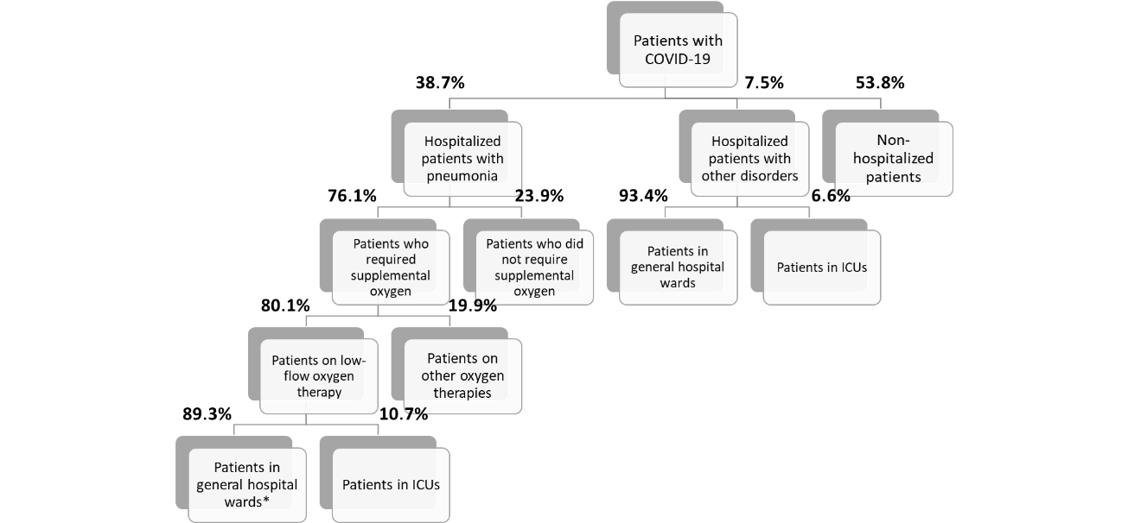
Note: *Candidate patients for treatment with remdesivir. Abbreviations: ICUs: Intensive Care Units. Sources: Instituto de Salud Carlos III, 2020¹¹; Gold, 2020¹³; Instituto de Salud Carlos III. Informe no 33, 2020¹².

