SUPPLEMENTARY MATERIAL

ASCENT-COPD Study Population
Atherothrombotic risk factors: ≥65 years of age for men, ≥70 years of age for women; waist circumference ≥40 inches for men, waist circumference ≥38 inches for women, estimated glomerular filtration rate <60 mL/min and microalbuminuria (≥30‒300 μg/mg creatinine on a spot urine test or ≥30 mg albumin on a 24-hour urine collection), dyslipidemia, diabetes, or hypertension. Exclusion criteria included: current use of triple therapy (inhaled corticosteroid [ICS]/long-acting muscarinic agonist [LAMA]/long-acting β₂-agonist [LABA]), COPD exacerbation within 4 weeks of screening, unstable or life-threatening COPD or CV disease, lung disease other than COPD, planned lung transplant or lung surgery, or malignancy treated within 5 years before screening.
Figure S1 Baseline versus concomitant treatment
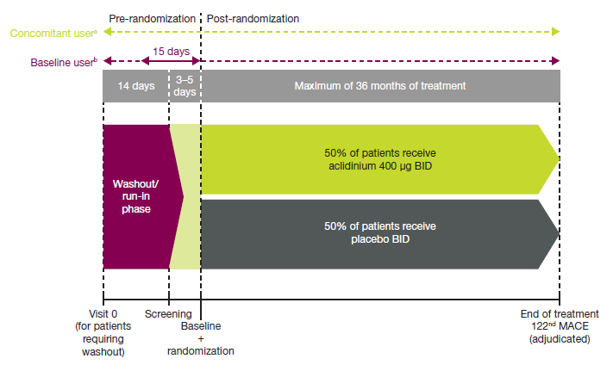Solid line = defined time; dashed line = undefined time
ªConcomitant users include patients who initiated treatment prior to randomization and continued beyond the first dose of study treatment
^{b}Baseline users include patients who took treatment within 15 days prior to the administration of the first dose study treatment, regardless of continuation
Figure S2 a baseline treatment; b concomitant treatment subgroups
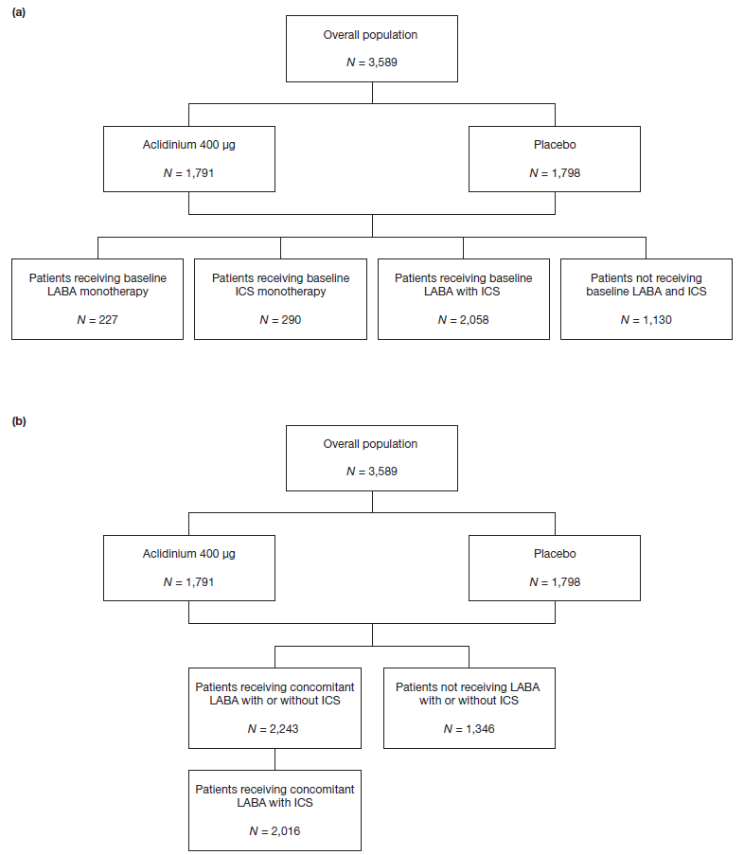
ICS inhaled corticosteroid; LABA long-acting β₂-agonist; N number of patients in each group
Baseline users include patients who took treatment within 15 days prior to the administration of the first dose study treatment, regardless of continuation. Concomitant users include patients who initiated treatment prior to randomization and continued beyond the first dose of study treatment. Patients receiving LABA with ICS included those taking fixed and free combinations. Fixed combinations were defined as >1 drug in a single device; free combinations used multiple individual devices. Of note, monotherapy subgroups were defined as those not taking fixed combination and, therefore, they were not exclusive from other subgroups. Of the 517 patients receiving LABA or ICS monotherapy, 116 were taking a free combination of LABA and ICS
Figure S3 Moderate-to-severe COPD exacerbation rate during the first year of treatment by concomitant treatment (on-treatment)
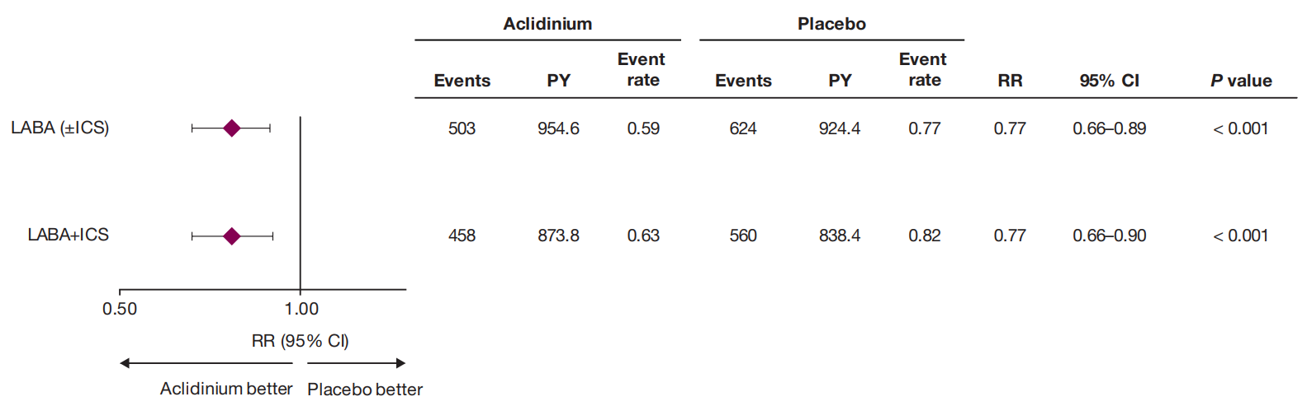
CI confidence interval, COPD chronic obstructive pulmonary disease, ICS inhaled corticosteroid, LABA long-acting β₂-agonist, PY patient-years, RR rate ratio
Data derived using the negative binomial regression model with treatment group, baseline ICS use, baseline COPD severity, history of ≥1 exacerbation in the past year, and smoking status as factors, and the log of the exposure time adjusted for the time the patients experience exacerbations as an offset variable. Concomitant users include patients who initiated treatment prior to randomization and continued beyond the first dose of study treatment
Figure S4 Change from baseline in trough FEV₁ over 156 weeks in a patients receiving concomitant LABA (±ICS) and b patients receiving concomitant LABA+ICS
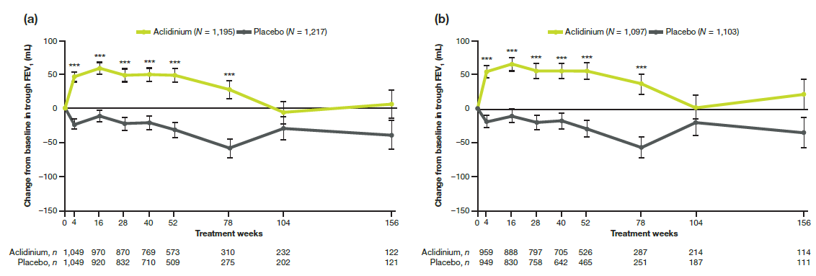
FEV₁ forced expiratory volume in 1 second, ICS inhaled corticosteroid, LABA long-acting β₂-agonist, MMRM mixed model for repeated measures, n number of patients in analysis, N number of patients in the treatment group
***P < 0.001 for aclidinium versus placebo
Data are least squares means ± standard error. The analysis was based on an MMRM for change from baseline in trough FEV₁ with pre- and post-bronchodilator (albuterol/salbutamol) FEV₁ at screening visit and baseline FEV₁ as covariates, and treatment group, smoking status, baseline ICS use, visit, and treatment-group-by-visit interaction as fixed effect factors. Visit is fitted as a categorical variable, and the variance–covariance matrix is assumed to be unstructured. Week 156 includes assessments from patients who completed 3 years treatment or who were on-treatment when the study was stopped. Concomitant users include patients who initiated treatment prior to randomization and continued beyond the first dose of study treatment
Figure S5 Change from baseline in CAT total score over 156 weeks in a patients receiving concomitant LABA (±ICS) and b patients receiving concomitant LABA+ICS
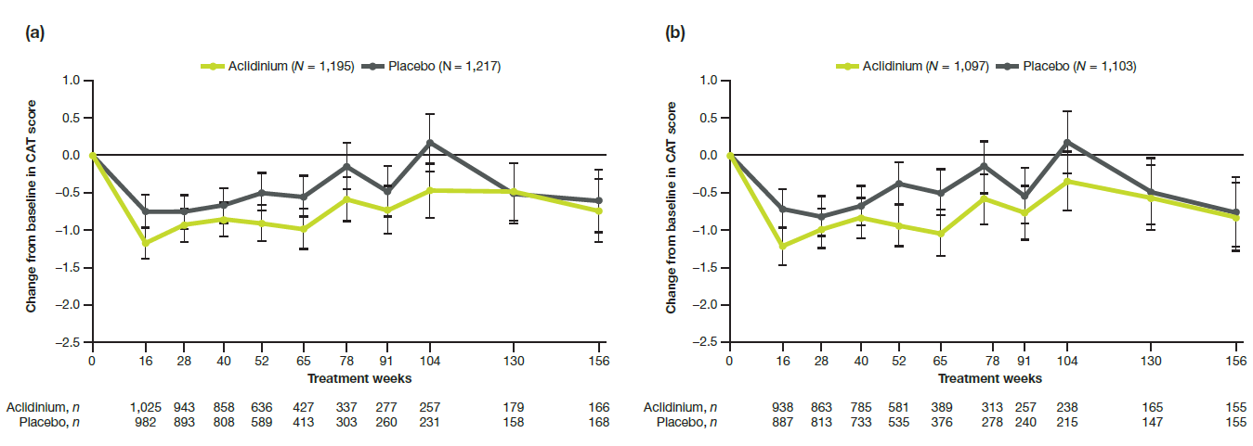
CAT COPD assessment test, ICS inhaled corticosteroid, LABA long-acting β₂-agonist, MMRM mixed model for repeated measures, n number of patients in analysis, N number of patients in the treatment group
Data are least squares means ± standard error. The analysis was based on an MMRM for change from baseline in CAT assessments with baseline CAT total score as a covariate, and treatment group, smoking status, baseline ICS use, visit, and treatment-group-by-visit interaction as fixed effect factors. Visit is fitted as a categorical variable, and the variance–covariance matrix is assumed to be unstructured. Week 156 includes assessments from patients who completed 3 years treatment or who were on-treatment when the study was stopped. Concomitant users include patients who initiated treatment prior to randomization and continued beyond the first dose of study treatment
Independent Ethics Committees/Institutional Review Boards Consulted
Center no. | Name and address of IEC/IRB | Chairman of IEC/IRB
1005 | Health Research Ethics Authority, 95 Bonaventure Ave, Suite 200, A1B 2X5, St. John's, Canada | Bonnell, Weldon
1005 | IRB Services, 372 Hollandview Trail, Suite 300, L4G 0A5, Aurora, Canada | Bonnell, Weldon
1006 | Humber River Hospital, Research Ethics Board 3C3014, 1235 Wilson Avenue, M3M 0B2, Toronto, Canada | Chiang, Lisa
1006 | IRB Services, 372 Hollandview Trail, Suite 300, L4G 0A5, Aurora, Canada | Chiang, Lisa
1017 | IRB Services, 372 Hollandview Trail, Suite 300, L4G 0A5, Aurora, Canada | Vanderwel, Marianne
1014, 1015 | Health Research Ethics Board of Alberta, Clinical Trials Committee, 1500 10104 103 Ave NW, T5J 4A7, Edmonton, Canada | Barber, Kirk
1014, 1015 | IRB Services, 372 Hollandview Trail, Suite 300, L4G 0A5, Aurora, Canada | Barber, Kirk
2339 | Bay Pines VA Healthcare System Human Studies Subcommittee, 10000 Bay Pines Boulevard, , 33744, Bay Pines, United States of America | Hoeldtke, John
2361 | St Luke's Hospital-IRB, 232 South Woods Mill Road, 63017, Chesterfield, United States of America | Buettner, John
2395 | Baylor University Medical Center, 3310 Live Oak, Suite 501, 75204, Dallas, United States of America | Schiller, Lawrence
2409 | Mayo Clinic Rochester, 201 First Street SW, Building RM 4-60, 55905, Rochester, United States of America | Wright, R
2505 | Johns Hopkins Medicine Institutional Review Boards, 1620 McElderry Street, Reed Hall, Suite B-130, 21205, Baltimore, United States of America | Carrese, Joseph
2703 | The University of Texas Health Center at Tyler, 11937 US Hwy. 271, 75708, Tyler, United States of America | Sartor, Joe
3145 | EC Wake Forest University Health Sciences, WFU School of Medicine, Medical Center Blvd, 27157, Winston-Salem, United States of America | Hawkins, Gregory
3154 | Kansas City VA Medical Center IRB, 4801 E Linwood Blvd #151, 64128, Kansas City, United States of America | Sharma, Ram
3417 | EC VA Greater Los Angeles Healthcare System IRB, 11301 Wilshire Blvd Building 114, Mail Code 151, Room 325, 90073, Los Angeles, United States of America | Yamaguchi, Dean
3646 | EC Saint Vincent Mercy Medical Center, 2213 Cherry St., , 43608, Toledo, United States of America | Oatis, Pamela
3653 | Creighton University Institutional Review Board, 2500 California Plaza, 68178, Omaha, United States of America | Kunes-Connell, Mary
3675 | Western Institutional Review Board IRB, 3535 7th Avenue SW,  98502, Olympia, United States of America | Wells, Christine
3683 | Western Institutional Review Board IRB, 3535 7th Avenue SW, 98502, Olympia, United States of America | Wilkins, R
3762 | Northwestern University Institutional Review Board, 750 N Lake Shore Drive, Arthur Rubloff Building, 7th Floor, 60611, Chicago, United States of America | Gitelman, Darren
3769 | Tuscaloosa VAMC Subcommittee on Human Studies (IRB), Tuscaloosa VA Medical Center, 3701 Loop Road East , 35404, Tuscaloosa, United States of America | Rosenfeld, Stephen
3770 | University of Nevada, Reno biomedical Institutional Review B, 218 Ross Hall/331, , 89557, Reno, United States of America | Bjur, Richard
3771 | VA Loma Linda Healthcare System Pulmonary, 11201 Benton St., Research Service 151, 92357, Loma Linda, United States of America | Hall, Susan
3952 | Dignity Health IRB, 3400 Data Drive, 95670, Rancho Cordova, United States of America | Braff, Jeffrey
3954 | University of Missouri Health Care, 905 Hitt Street, , 65212, Columbia, United States of America | Beck, Niels
3967 | VA WNY HealthCare System, 3495 Bailey Avenue, , 14215, Buffalo, United States of America | Donnelly, Kerry
3994 | Berkshire Medical Center, 725 North Street, 01201, Pittsfield, United States of America | Perera, Richard
4005 | University of Louisville Human Subjects Protection Program, 501  E. Broadway, Med Center One, Suite 200, 40202, Louisville , United States of America | Clark, Laura
4038 | Phoenix VA Health Care System Institutional Review Board, 650 E. Indian School Road, , 85012, Phoenix, United States of America | Banaszak, Matt
4039 | UC Davis IRB, 2921 Stockton, Blvd., Suite 1400, Room 1429, 95817, Sacramento, United States of America | Macmillan, John
4048 | EC Hines V.A. Hospital, 5000 South 5th Ave. 60141, Hines, United States of America | Lucerom, Yvonne
4051 | Birmingham VA Medical Center, Investigational Review Board, 700 South 19th Street, 35223, Birmingham, United States of America | Harris, Kevin
3767, 3892 | Integris Health, Inc. Institutional Review Board, 3400 NW Expressway, Suite 806, 73112, Oklahoma City, United States of America | Rickner, Kyle
2367, 3886, 7910 | Western Institutional Review Board IRB, 1019 39th Ave SE, Suite 120, 98374-2115, Puyallup, United States of America | Abraham, Lindsay
1001, 1002, 1003, 1007, 1009, 1010, 1012, 1016, 2535, 2742, 3448, 3495, 3652, 3753, 3754, 3763, 3772, 3773, 3824, 3826, 3827, 3829, 3830, 3842, 3887, 3905, 4026, 4036, 4041, 4044, | IRB Services, 372 Hollandview Trail, Suite 300, L4G 0A5, Aurora, Canada | Blajchman, Morris
475, 564, 2343, 2345, 2348, 2352, 2372, 2381, 2386, 2399, 2402, 2407, 2413, 2417, 2418, 2423, 2424, 2425, 2460, 2461, 2498, 2532, 2536, 2542, 2549, 2634, 2670, 2678, 2687, 2690, 2691, 2704, 2707, 2714, 2715, 2721, 2722, 2730, 2745, 2746, 2751, 2892, 2953, 2954, 2956, 2957, 2960, 2967, 2972, 2973, 2980, 2982, 2983, 2993, 3000, 3016, 3017, 3025, 3028, 3035, 3038, 3045, 3047, 3056, 3068, 3075, 3083, 3087, 3091, 3109, 3110, 3111, 3118, 3119, 3124, 3127, 3135, 3142, 3150, 3151, 3164, 3167, 3344, 3355, 3357, 3358, 3359, 3360, 3362, 3363, 3400, 3410, 3411, 3415, 3422, 3424, 3426, 3427, 3435, 3428, 3451, 3455, 3456, 3471, 3487 3500, 3519, 3645, 3647, 3650, 3651, 3654, 3655, 3656, 3658, 3659, 3660, 3661, 3664, 3665, 3669, 3670, 3671, 3672, 3673, 3674, 3677, 3679, 3680, 3681, 3682, 3684, 3685, 3686, 3687, 3688, 3689, 3690, 3691, 3692, 3693, 3695, 3696, 3697, 3699, 3700, 3704, 3705, 3707, 3708, 3710, 3711, 3712, 3713, 3714, 3719, 3720, 3723, 3724, 3725, 3726, 3727, 3729, 3731, 3733, 3736, 3737, 3738, 3741, 3742, 3743, 3745, 3746, 3747, 3748, 3750, 3755, 3756, 3757, 3758, 3761, 3766, 3768, 3774, 3775, 3776, 3777, 3778, 3779, 3780, 3783, 3784, 3785, 3786, 3789, 3790, 3792, 3793, 3794, 3795, 3796, 3798, 3799, 3800, 3801, 3803, 3804, 3806, 3807, 3810, 3812, 3813, 3817, 3818, 3820, 3823, 3832, 3833, 3835, 3836, 3837, 3839, 3840, 3841, 3843, 3844, 3845, 3846, 3847, 3849, 3850, 3851, 3854, 3855, 3856, 3857, 3858, 3861, 3862, 3863, 3864, 3866, 3869, 3870, 3871, 3872, 3873, 3874, 3875, 3876, 3877, 3878, 3879, 3880, 3881, 3882, 3883, 3886, 3889, 3890, 3894, 3896, 3897, 3902, 3903, 3908, 3909, 3910, 3911, 3914, 3915, 3916, 3917, 3918, 3919, 3912, 3923, 3924, 3925, 3927, 3928, 3939, 3930, 3932, 3933, 3934, 3936, 3937, 3938, 3941, 3942, 3944, 3945, 3947, 3948, 3949, 3950, 3951, 3952, 3953, 3955, 3959, 3961, 3965, 3966, 3968, 3969, 3970, 3971, 3976, 3977, 3978, 3979, 3983, 3988, 3989, 3990, 3991, 3992, 3995, 3997, 3999, 4000, 4002, 4003, 4008, 4009, 4012, 4013, 4014, 4015, 4016, 4018, 4019, 4022, 4023, 4024, 4025, 4027, 4028, 4029, 4030, 4031, 4032, 4033, 4035, 4037, 4042, 4043, 4045, 4046, 4050, 4054, 4055, 4056, 4059, 4061, 4064, 4065, 4068, 4072, 4073, 4074, 7803, 7804, 7806, 7807, 7809, 7811, 7812, 7817, 7818, 7820, 7823, 7824, 7825, 7829, 7830, 7831, 7832, 7833, 7834, 7835, 7837, 7838, 7839, 7841, 7844, 7846, 7847, 7848, 7851, 7852, 7854, 7856, 7858, 7859, 7862, 7863, 7867, 7867, 7868, 7870, 7874, 7875, 7877, 7878, 7879, 7880, 7881, 7883, 7885, 7887, 7891, 7893, 7894, 7895, 7898, 7899, 7900, 7908, 7909, 7911, 7912, 7914, 7915, 7916, 7918, 7920, 7921, 7925, 7927, 7933, 7935, 7937, 7939, 7942, 7943, 7945, 7947, 7948, 7950, 7951, 7952, 7953, 7954, 7956, 7959, 7961, 7962, 7964, 7965, 7967, 7968, 7970, 7974, 7975, 7977, 7978 | Quorum Review Institutional Review Board, 1501 Fourth Avenue, Suite 800, 98101, Seattle, United States of America | Rosenfeld, Stephen

