Table S1. Demographic data for subjects that received ciprofol and propofol
Parameters | Part 1 study (N = 6) | Part 2 study (N = 8)
Age, years | 26.7 ± 1.5 (22, 28) | 25.5 ± 3.6 (21, 33)
Weight, kg | 53.10 ± 3.16 (50.4, 58.1) | 61.15 ±12.20 (48.1, 75.5)
Height, cm | 159.5 ± 7.1 (151.0, 171.0) | 165.1 ± 11.5 (149.5, 178.5)
BMI, kg.m⁻² | 20.9 ± 1.10 (19.1, 22.6) | 22.29 ± 1.85 (19.8, 24.9)
Gender, male/female | 2/4 | 4/4
Note: All values are mean ± standard deviation (SD)
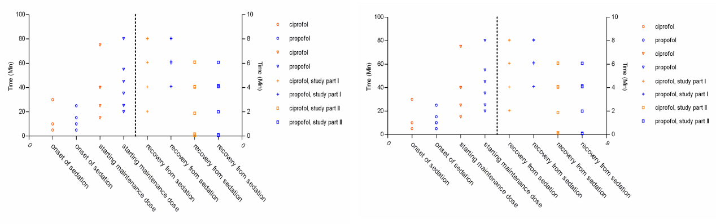
Figure S1. Individual PD parameters with onset of sedation, starting maintenance dose, recovery from sedation and TBS, TRASS in 8 subjects with ciprofol and propofol infusion in the part 1 and part 2 studies.

