Supplemental results
Population Pharmacokinetics and Exposure-Response Analyses for Venetoclax in Combination with R-CHOP in Previously Untreated Patients with Diffuse Large B-Cell Lymphoma
Samineni D, et al.
Journal: Advances in Therapy
Corresponding Author: Divya Samineni
Affiliation: Genentech, Inc., South San Francisco, CA, USA
Email: samineni.divya@gene.com

PopPK analysis
The biases from the legacy model included: a minor bias in the plot of observed concentrations (DV) versus population predictions (PRED), where the model slightly over-estimated the DV (along with a group of under-predicted high DV samples); a minor bias in the plot of DV versus individual predictions (IPRED), where the model slightly under-estimated the observed concentrations; and a strong bias in the plots of conditional weighted residuals (CWRES) versus time, and time after dose, where the model over-estimated the observed concentrations for the first 3 hours following venetoclax administration. A similar bias (to those previously mentioned) was also evident in the plots of CWRES versus time, and time after dose in the legacy model diagnostic plots.
In the final model evaluation, the CWRES did not show any major trends when plotted against population predicted values, with most values between ± 2 standard normal deviations (Fig. 2; panel 3), indicating that the model was appropriately unbiased and adequately described variability. Examination of the final model CWRES versus time (Fig. 2; panel 6) indicated no apparent trend over time, confirming the lack of time-dependent pharmacokinetics of venetoclax. The dependencies of the random effects on covariates did not show any further trends unaccounted for by the model. The visual predictive check (VPC) and normalized prediction distribution error (NPDE) plots (Fig. S1 and Fig. S2) further supported good description of the observed CAVALLI study data by the PopPK model. The VPC plots of the simulated percentiles overlaid with the observed data showed good agreement between the simulated and observed data, indicating that the model was able to describe the central tendency and variability of the data (Fig. S1). The NPDE plots illustrated good predictive abilities of the model, with no dependencies of NPDE on time, time after dose, or population predictions (Fig. S2).

Fig. S1 Final model (018) evaluation: VPC plots for final model.
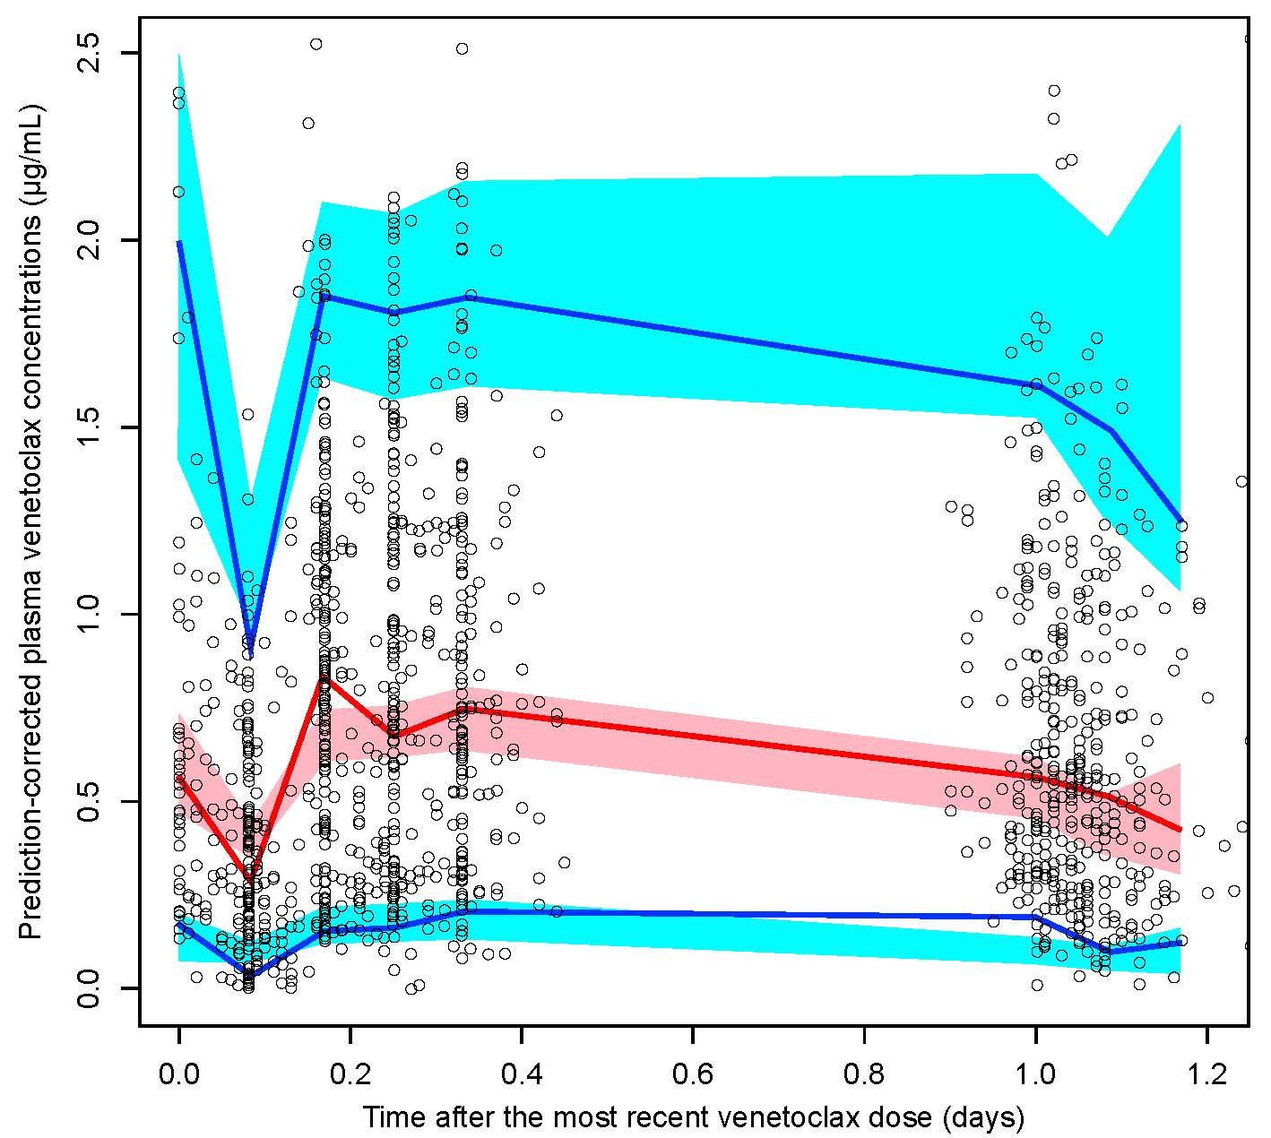
Points = prediction-corrected venetoclax concentrations (C_{ven}) versus time after most recent venetoclax dose. Red line = median, blue lines = 5th and 95th percentiles of prediction-corrected C_{ven}. Shading = 90% confidence intervals (simulated from 500 trials with dosing, sampling, and covariate values of the analysis dataset). VPC, prediction-corrected visual predictive check.

Fig S2. Final model (018) evaluation: NPDE plots for final model.
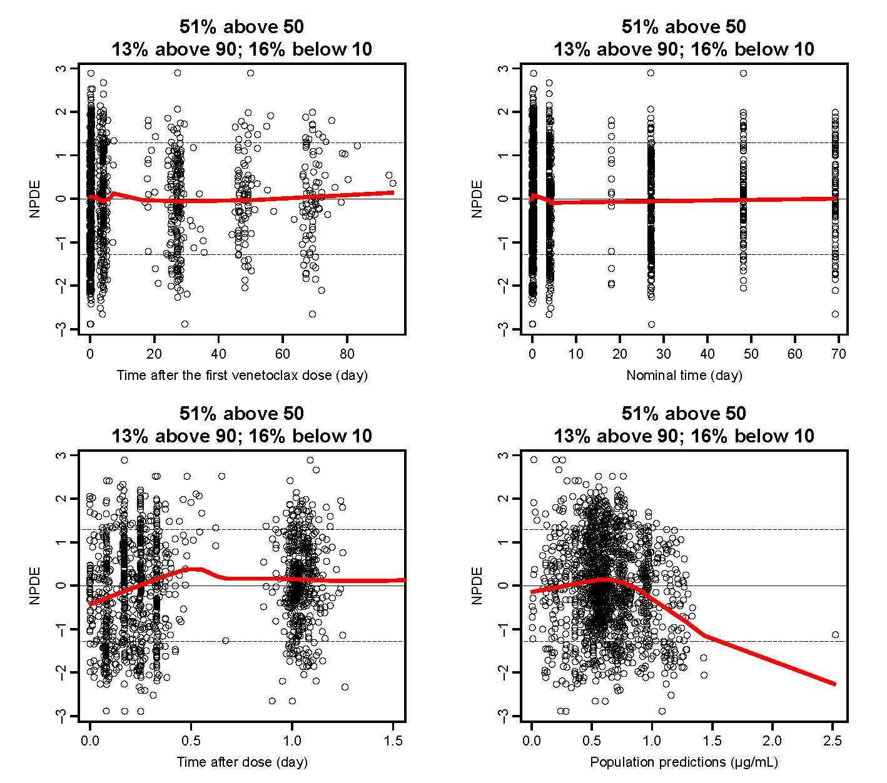
NPDE versus time from first dose, time after most recent dose and population predictions. Circles correspond to NPDE of observations in the distribution of 500 simulated values. Lines at y = 0 correspond to median values, and dashed lines show the 10th and 90th percentiles. Percentages of points below 10th percentile and above 50th and 90th percentiles are reported. Red lines show the lowess trend lines. NPDE, normalized prediction distribution error.

Table S1 List of IRBs/ECs for CAVALLI (study GO27878)
Site Name | Site Country | IRB/EC Name
Fakultni nemocnice Hradec Kralove | Czech Republic | Eticka komise Fakultni nemocnice Hradec Kralove
Hospital Universitario La Paz | Spain | CEIC Hospital Universitario La Paz
CHU Montpellier - Hopital Saint Eloi | France | Comité de Protection des Personnes
University of Rochester | United States | WIRB
VU Medisch Centrum | Netherlands | VU Medisch Centrum Medical Ethical Committee
The West Clinic | United States | WIRB
Cross Cancer Institute | Canada | Alberta Cancer Research Ethics Board
Azienda Ospedaliero Universitaria San Martino | Italy | Comitato Etico Regionale della Liguria
Jonsson Comprehensive Cancer Center | United States | UCLA Medical Center IRB
Semmelweis Egyetem | Hungary | Orszagos Gyogyszereszteti es Elelmezes-egeszsegugyi Intezet
TRIO - Central Coast Medical Oncology Corporation | United States | WIRB
BC Cancer Agency Center for the Southern Interior | Canada | UBC BC Cancer Agency Research Ethics Board
CHU de Nancy - Hôpital de Brabois Adultes | France | Comité de Protection des Personnes
Tennessee Oncology | United States | WIRB
Concord Repatriation General Hospital | Australia | Sydney Local Health Network
ICO l´Hospitalet – Hospital Duran i Reynals | Spain | CEIC Hospital Universitario
Hackensack University Medical Center PARTNER | United States | WIRB
LKH - Universitätsklinikum der PMU Salzburg | Austria | Ethikkommission fur das Bundesland Salzburg
Hôpital Henri Mondor | France | Comité de Protection des Personnes
Fakultni nemocnice Ostrava | Czech Republic | Eticka komise Fakultni nemocnice Ostrava
Debreceni Egyetem | Hungary | Orszagos Gyogyszereszteti es Elelmezes-egeszsegugyi Intezet
AKH - Medizinische Universität Wien | Austria | Ethikkommission der Medizinischen Universität Wien
SMBD Jewish General Hospital d/b/a Jewish General Hospital | Canada | Jewish General Hospital Clinical Ethics Committee
TRIO - St. Jude Heritage Healthcare | United States | WIRB
CHU Rennes - Hopital Pontchaillou | France | Comité de Protection des Personnes
CHU de Quebec - Hôpital de l' Enfant Jésus | Canada | CHA-Hopital Enfant Jesus-Comite
Clinique Victor Hugo - Centre Jean Bernard | France | Comité de Protection des Personnes
CHU Nantes - Hôtel Dieu | France | Comité de Protection des Personnes
Hospital Universitario Ramon y Cajal | Spain | CEIC Hospital Universitario Ramon y Cajal
Erasmus Medisch Centrum | Netherlands | VU Medisch Centrum Medical Ethical Committee
Centre Hospitalier Départemental Les Oudairies | France | Comité de Protection des Personnes
Hospital Universitari Vall d'Hebron | Spain | CEIC Hospital Universitari Vall d'Hebron
Princess Alexandra Hospital | Australia | Metro South Health Service
Hospital Universitario de Salamanca | Spain | CEIC Hospital Universitario de Salamanca
Peter MacCallum Cancer Centre-East Melbourne | Australia | Peter MacCallum Cancer Centre Ethics Committee
Royal Melbourne Hospital | Australia | Melbourne Health Human Research Ethics Committee
Fakultni nemocnice Brno | Czech Republic | Eticka komise Fakultni nemocnice Brno
UMC Utrecht | Netherlands | VU Medisch Centrum Medical Ethical Committee
Hopital Claude Huriez - CHRU Lille | France | Comité de Protection des Personnes
San Juan Oncology Associates | United States | Copernicus Group IRB
Azienda Ospedaliera Vincenzo Cervello | Italy | Comitato Etico Regionale della Sicilia
Azienda Ospedaliero Universitaria Pisana | Italy | Comitato Etico Area Vasta Nord
Istituto Nazionale Tumori Fondazione G. Pascale | Italy | Comitato Etico Regionale della Campania
Orszagos Onkologiai Intezet | Hungary | Orszagos Gyogyszereszteti es Elelmezes-egeszsegugyi Intezet
Hospital del Mar | Spain | CEIC Hospital Universitario
Centre Hospitalier Lyon Sud | France | Comité de Protection des Personnes
BC Cancer Agency Vancouver Centre | Canada | UBC BC Cancer Agency Research Ethics Board
Hôpital Saint-Louis | France | Comité de Protection des Personnes
Centre Henri Becquerel | France | Comité de Protection des Personnes
Vseobecna fakultni nemocnice v Praze | Czech Republic | Eticka komise Vseobecne fakultni nemocnice v Praze
Azienda Ospedaliera Città della Salute e della Scienza di Torino | Italy | Azienda Ospedalier a Città della Piemonte
Memorial Sloan Kettering Cancer Center | United States | Memorial Sloan-Kettering Ethics Committee
EC ethics committee, IRB institutional review board.

