Title: Once-weekly semaglutide use in type 2 diabetes: real-world data from the SURE Netherlands observational study
Authors: Bruce HR Wolffenbuttel,¹ Michel P Brugts,² Andrei-Mircea Catarig,³ Alice Clark,³ Maarten Kok,⁴ Aloysius G Lieverse,⁵ Jaap van Soest⁶

Author affiliations: ¹Department of Endocrinology, University of Groningen, University Medical Center Groningen, The Netherlands; ²Ikazia Hospital, Rotterdam, The Netherlands; ³Novo Nordisk A/S, Søborg, Denmark; ⁴Novo Nordisk, Alphen aan den Rijn, The Netherlands; ⁵MMC, Ds Theodor Fliednerstraat, Eindhoven, The Netherlands; ⁶Huisartsenmaatschap MCN, Nijverdal, The Netherlands
Corresponding author
Prof Bruce HR Wolffenbuttel, Department of Endocrinology, University of Groningen, University Medical Center Groningen, P.O. Box 30001, 9700 RB Groningen, The Netherlands
Email: bwo@umcg.nl
Phone: +31 - 50 – 3613962
Fax: +31 - 50 – 3619392

Contents
Details of SAE | Page 3
Table S1 Glucose-lowering medications at baseline and EOS | Page 4
Table S2 Change from baseline to EOS in HbA_{1c} by most frequently used medications at baseline | Page 5
Table S3 Change from baseline to EOS in HbA_{1c} and body weight by baseline HbA_{1c} subgroup | Page 6
Table S4 Results of prespecified and post hoc sensitivity analyses | Page 7
Table S5 Change from baseline to EOS in body weight by most frequently used medications at baseline | Page 8
Table S6 Baseline characteristics and glucose-lowering medications at baseline and EOS by type of prescriber | Page 9
Table S7 Adverse events and severe or documented hypoglycaemic episodes | Page 10
Table S8 Details of Institutional Review Board | Page 11
Figure S1 Participant disposition | Page 12

SUPPLEMENTARY MATERIAL
Details of SAE
The SAE case of cholecystitis was reported in a female (age 53 years) with a BMI of 34 kg/m², and was classified as mild in severity. Symptoms first occurred 6 days after semaglutide treatment initiation. The participant initially interrupted semaglutide, and on day 15 discontinued treatment due to unacceptable GI intolerability. This participant was hospitalised
for one night, 6 months later, with symptoms of cholecystitis, after which the event was considered resolved.

Supplementary tables
Table S1 Glucose-lowering medications at baseline and EOS 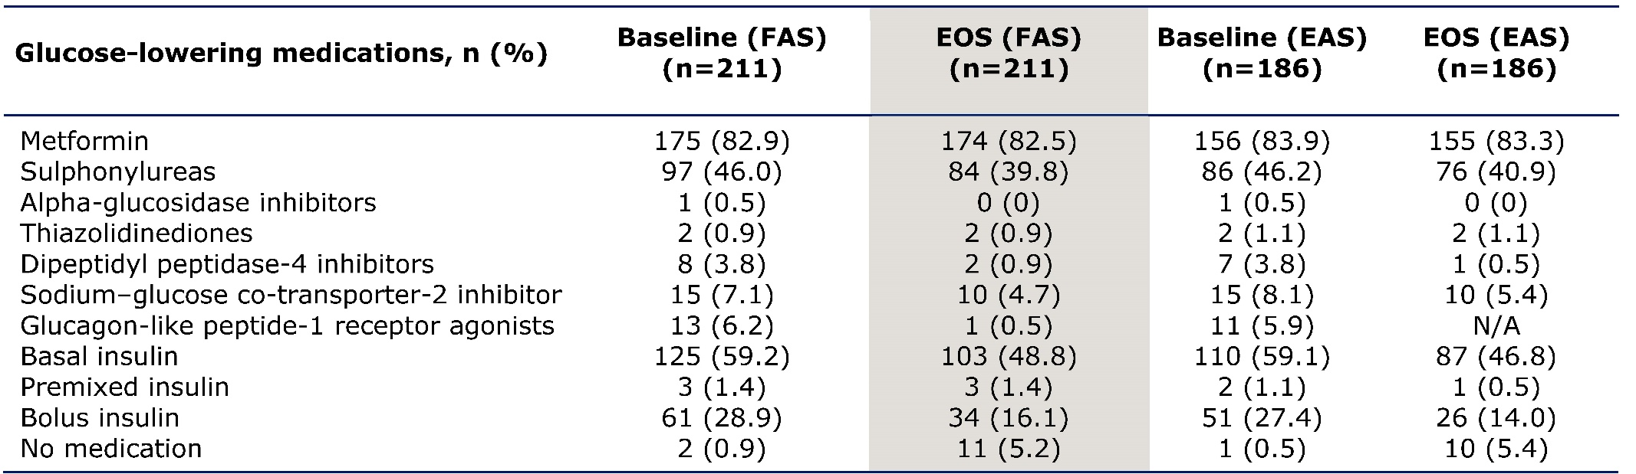EAS, effectiveness analysis set; EOS, end of study; FAS, full analysis set; n, number of participants; N/A, not applicable.

Table S2 Change from baseline to EOS in HbA_{1c} by most frequently used medications at baseline
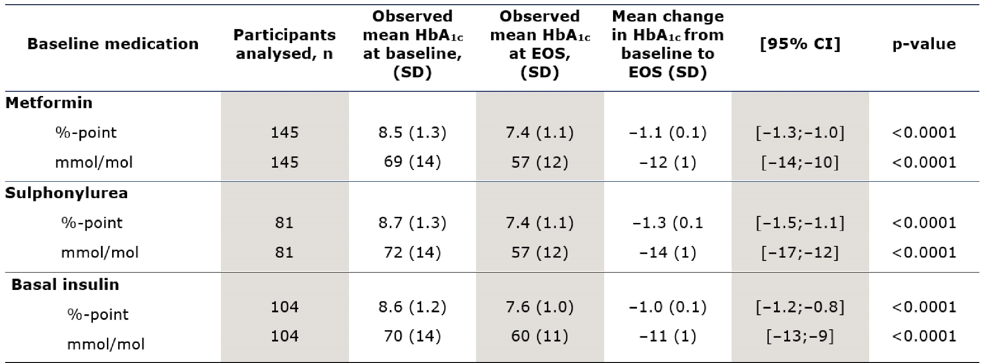
Data are from the EAS.
CI, confidence interval; EAS, effectiveness analysis set; EOS, end of study; n, number of participants;
SD, standard deviation.

Table S3 Change from baseline to EOS in HbA_{1c} and body weight by baseline HbA_{1c} subgroup
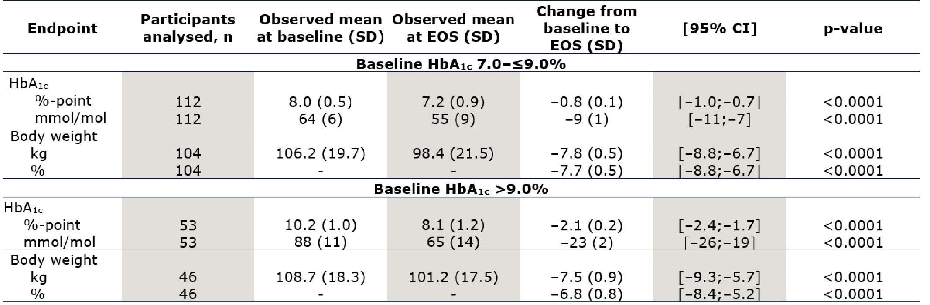
Data are from the EAS.
Data not shown for participants with baseline HbA_{1c} <7.0% as the group was not powered for statistical analysis
(n=9 for HbA_{1c}, n=10 for body weight).
CI, confidence interval; EAS, effectiveness analysis set; EOS, end of study; n, number of participants;
SD, standard deviation.

Table S4 Results of prespecified and post hoc sensitivity analyses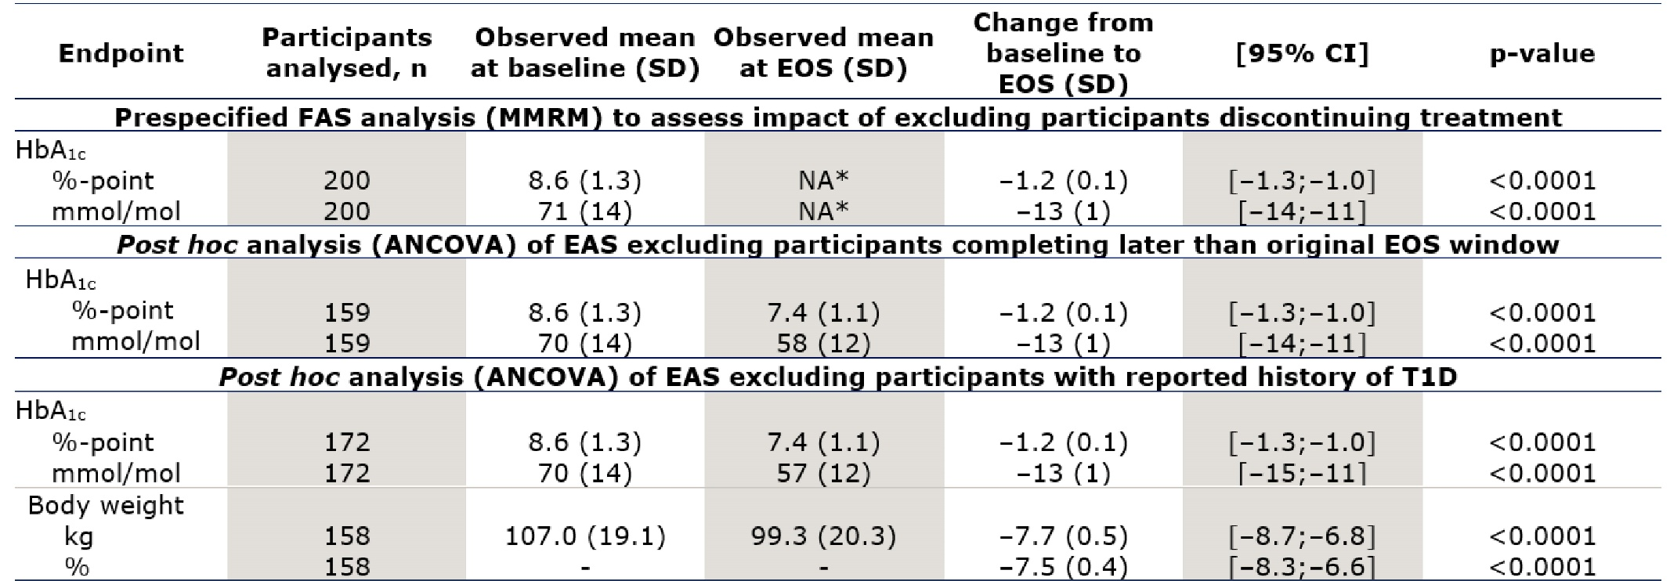
*Observed mean at EOS not available as point estimate in MMRM performed at week 30; EOS during the study ran from week 28 to week 38. Participants who did not complete the study, discontinued treatment or were missing information on HbA_{1c} at EOS were excluded from the analysis. Prespecified sensitivity analyses were performed on the FAS using an MMRM to assess the impact of excluded data in the primary analysis, which excluded participants who did not complete the study, discontinued treatment or were missing information on HbA_{1c} at EOS. A post hoc sensitivity analysis was conducted to assess whether the extension of the EOS window due to the COVID-19 pandemic had an impact on the results. This analysis was restricted to patients completing the study within the original visit window (28–38 weeks). A post hoc sensitivity analysis omitting participants with a recorded history of T1D was also performed.
ANCOVA, analysis of covariance; CI, confidence interval; EAS, effectiveness analysis set; EOS, end of study; FAS, full analysis set; MMRM, mixed model for repeated measurements; n, number of participants; NA, not available;
SD, standard deviation.

Table S5 Change from baseline to EOS in body weight by most frequently used medications at baseline
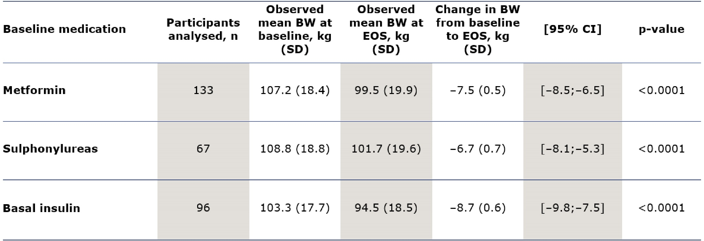
Data are from the EAS.
BW, body weight; CI, confidence interval; EAS, effectiveness analysis set; EOS, end of study; n, number of participants;
SD, standard deviation.

Table S6 Baseline characteristics and glucose-lowering medications at baseline and EOS by type of prescriber
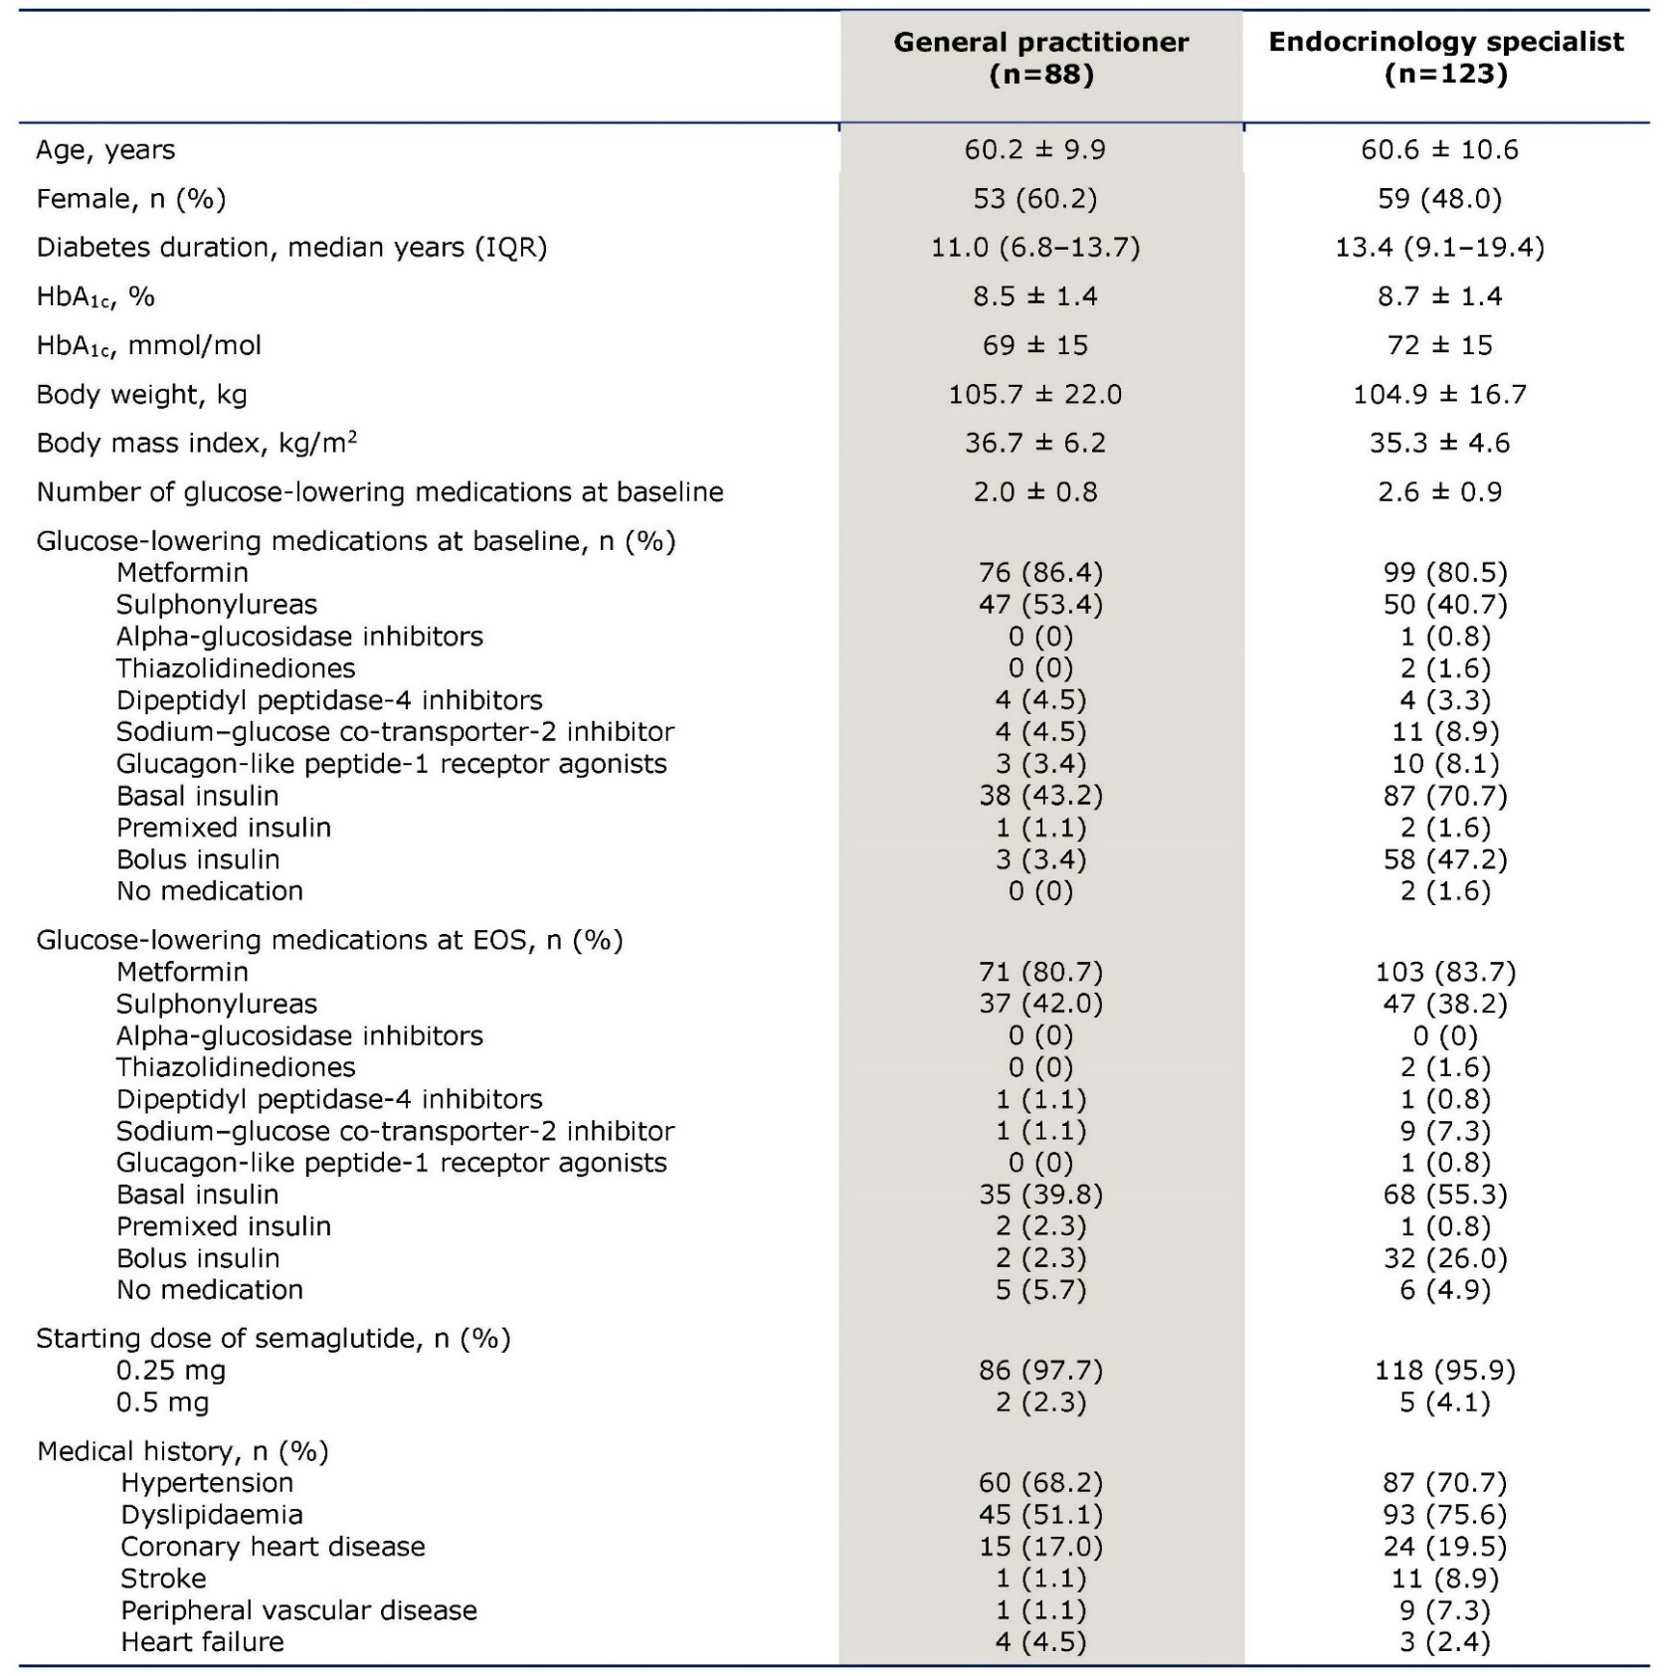

Data are from the FAS. Values are mean ± SD unless otherwise stated.
FAS, full analysis set; EOS, end of study; IQR, interquartile range; n, number of participants; SD, standard deviation.

Table S7 Adverse events and severe or documented hypoglycaemic episodes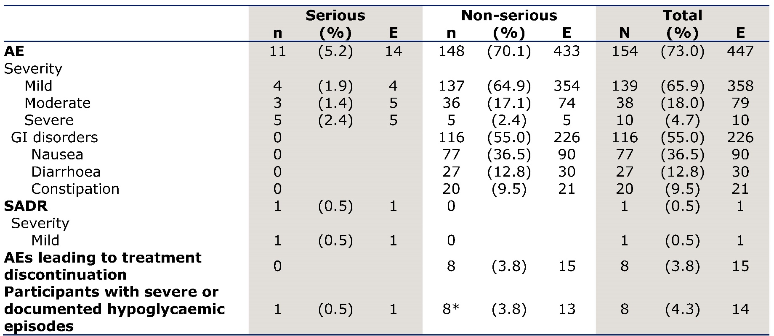
*The patient experiencing a severe episode of hypoglycaemia also experienced a documented episode in the same month.
Data are from the FAS.
AE, adverse event; E, event; FAS, full analysis set; GI, gastrointestinal; n/N, number of participants;
SADR, serious adverse drug reaction.

Table S8 Details of Institutional Review Board
The Universitair Medisch Centrum Groningen was the sole ethics committee for the study.

Supplementary figure
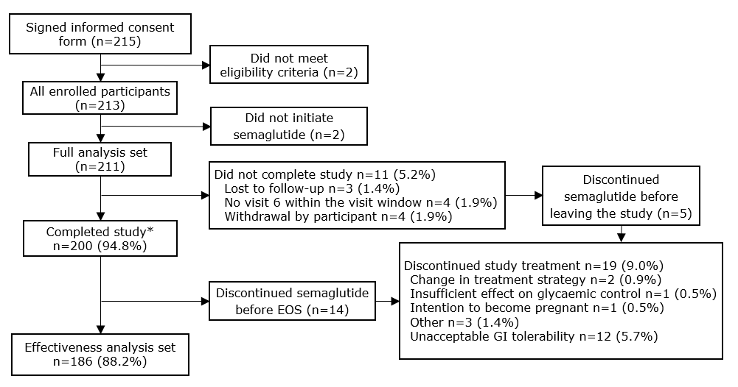
Figure S1 Participant disposition

*Participants who initiated the semaglutide treatment and attended the end of study visit.
EOS, end of study; GI, gastrointestinal; n, number of participants.

