Crossover Randomized Study of Pharmacologic Effects of Ripasudil–Brimonidine Fixed-Dose Combination Versus Ripasudil or Brimonidine
Electronic Supplementary Material
Authors: Hidenobu Tanihara¹, Tetsuya Yamamoto², Makoto Aihara³, Noriko Koizumi⁴, Hiroomi Minami⁵, Satoshi Kojima⁵, Tomoyuki Isobe⁶, Mizuho Kanazawa⁷, Hideki Suganami⁸; K-232 Clinical Study Group.

Affiliations: ¹Department of Ophthalmology, Biei Municipal Hospital, Hokkaido, Japan; ²Prof. Kazuo Iwata Memorial Kaijin Glaucoma Center, Kaiya Eye Clinic, Shizuoka, Japan; ³Department of Ophthalmology, The University of Tokyo, Tokyo, Japan; ⁴Department of Biomedical Engineering, Faculty of Life and Medical Sciences, Doshisha University, Kyoto, Japan; ⁵Pharmaceutical Clinical Development Management Department, Kowa Company, Ltd., Tokyo, Japan; ⁶Tokyo New Drug Research Laboratories, Kowa Company, Ltd., Tokyo, Japan; ⁷Medical Affairs Department, Kowa Company, Ltd., Tokyo, Japan; ⁸Data Science Center, Kowa Company, Ltd., Tokyo, Japan.
Corresponding author: Hidenobu Tanihara
Email: tanihara@pearl.ocn.ne.jp

Appendix
K-232 Clinical Study Group member list
Steering and writing committee members: Hidenobu Tanihara, Tetsuya Yamamoto, Makoto Aihara, Noriko Koizumi, Hiroomi Minami, Satoshi Kojima, Tomoyuki Isobe, Mizuho Kanazawa, and Hideki Suganami.
Study investigators: Yasuko Owada, Hiroshi Mikami, Michio Yagi, Hidetoshi Furuie, Tomoko Hayashibara, and Eriko Kawai (Medical Corporation Heishinkai OPHAC Hospital, Osaka, Osaka, Japan); Kiyoshi Kano (Fukushima Eye Clinic, Osaka, Osaka, Japan); Hisashi Mashimo (Japan Community Health care Organization Osaka Hospital, Osaka, Osaka, Japan); Makoto Ando (Ando Eye Clinic, Toyonaka, Osaka, Japan); and Masashi Takata (Hyogo Medical University, Nishinomiya, Hyogo, Japan).

Supplementary Table S1 Study exclusion criteria
Exclusion criteria
- History of an allergy to any medications.
- History of an illness that is inappropriate for participation, including hepatic disorder, renal disorder, cardiovascular disease, endocrine disease, cerebrovascular disorder, or orthostatic hypotension.
- A subject who had used drugs (including over-the-counter drugs) for systemic or local diseases within 30 days before day –1 (the day of admission in administration phase 1) or a subject who needed to use drugs from day –1 to the end of examination on day 9 in administration phase 3.
- A subject who had taken any supplements within 7 days before day –1 (the day of admission in administration phase 1) or a subject who needed to use supplements from day –1 to the end of examination on day 9 in administration phase 3.
- Ocular diseases except myopia, hyperopia, or astigmatism.
- Best corrected visual acuity of less than 20/25 in either eye.
- Shaffer classification grade 0 to 2 in either eye.
- Difficulty in measuring intraocular pressure using a Goldmann applanation tonometer in either eye.
- Corneal endothelial cell density of less than 2000 cells/mm² in either eye.
- Corneal guttae in either eye.
- Corneal thickness 620 μm or more in either eye.
- A subject who had donated 200 mL or more of blood within 4 weeks before the screening day, who had donated 400 mL or more of blood within 12 weeks before the screening day, or who had collected component blood samples (plasma component/platelet component) within 2 weeks before the screening day.
- Participation in other clinical trials within 16 weeks before day −1 or who had participated in other clinical trials at the same time as this study.
- Addiction to alcohol or drugs.
- A subject who tested positive for HBsAg, HCV antibody, HIV antigen antibody, or serologic test for syphilis at a screening test.
- A subject who was not able to stop wearing contact lenses from day –1 until the end of the examination on day 9 in administration phase 3.
- Ophthalmic laser surgery, ophthalmic surgery, or other nasolacrimal duct surgery in the past, or those who needed to undergo such surgery during the period from day –1 to the completion of examinations on day 9 in administration phase 3.
- A subject who had received ripasudil–brimonidine fixed-dose combination ophthalmic solution in the past.
- A subject who was judged by the investigator to be ineligible to participate in this study.
HBsAg hepatitis B surface antigen, HCV hepatitis C virus, HIV human immunodeficiency virus

Supplementary Table S2 Summary of adverse events and adverse drug reactions with ripasudil–brimonidine fixed-dose combination and the two individual agents as monotherapy
 | Ripasudil–brimonidine fixed-dose combination  (n = 17) | Ripasudil  (n = 18) | Brimonidine  (n = 17)
Any AE, n (%) | 17 (100.0) | 18 (100.0) | 12 (70.6)
Conjunctival hyperemia | 17 (100.0) | 18 (100.0) | 10 (58.8)
Punctate keratitis | 5 (29.4) | 3 (16.7) | 4 (23.5)
Eye irritation | 1 (5.9) | 0 | 0
Diarrhea | 1 (5.9) | 0 | 0
Pityriasis rosea | 1 (5.9) | 0 | 0
Feces soft | 0 | 1 (5.6) | 0
Feeling hot | 0 | 1 (5.6) | 0
Pyrexia | 0 | 1 (5.6) | 0
Headache | 0 | 1 (5.6) | 0
Eczema | 0 | 1 (5.6) | 0
Miliaria | 0 | 1 (5.6) | 0
Any ADR, n (%) | 17 (100.0) | 18 (100.0) | 10 (58.8)
Conjunctival hyperemia | 17 (100.0) | 18 (100.0) | 8 (47.1)
Punctate keratitis | 4 (23.5) | 2 (11.1) | 3 (17.6)
Eye irritation | 1 (5.9) | 0 | 0
ADR adverse drug reaction, AE adverse event

Supplementary Table S3 Pharmacokinetic parameters of unchanged ripasudil, its major metabolite, and unchanged brimonidine following instillation of the ripasudil–brimonidine fixed-dose combination or either agent alone on day 8
 | Agent | Geometric mean C_{max}ª | Geometric mean AUC_{0-τ}^{b} | Median t_{max} (h) | Arithmetic mean t_{1/2} (h)
Ripasudil–brimonidine fixed-dose combination  (n = 17) | Ripasudil | 0.3461 | 0.1064 | 0.083 | 0.325^{c}
Ripasudil–brimonidine fixed-dose combination  (n = 17) | M1 | 0.7379 | 2.4998 | 0.500 | 3.096
Ripasudil–brimonidine fixed-dose combination  (n = 17) | Brimonidine | 33.751 | 59.983 | 0.083 | 1.903
Ripasudil (n = 17) | Ripasudil | 0.6093 | 0.1700 | 0.083 | 0.250^{c}
Ripasudil (n = 17) | M1 | 0.9643 | 2.9351 | 0.500 | 3.264
Brimonidine (n = 17) | Brimonidine | 22.246 | 76.967 | 0.500 | 2.087
AUC_{0-τ} area under the plasma concentration-time curve from time 0 to last observation, C_{max} peak plasma concentration, M1 ripasudil major metabolite, t_{1/2} elimination half-life, t_{max} time to peak plasma concentration
ªUnits are ng/mL for ripasudil and M1, and pg/mL for brimonidine
^{b}Units are ng･h/mL for ripasudil and M1, and pg･h/mL for brimonidine
^{c}n = 1
Supplementary Fig. S1 Study design
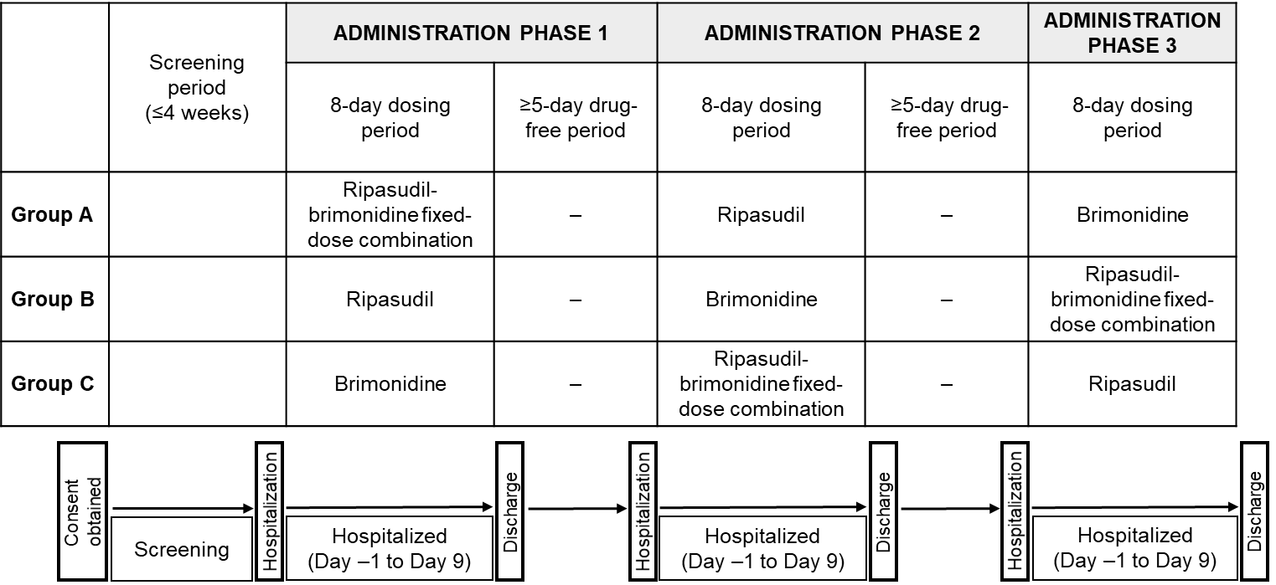

Supplementary Fig. S2 Predefined criteria for evaluation of palpebral and bulbar conjunctival hyperemia using slit lamp microscopy
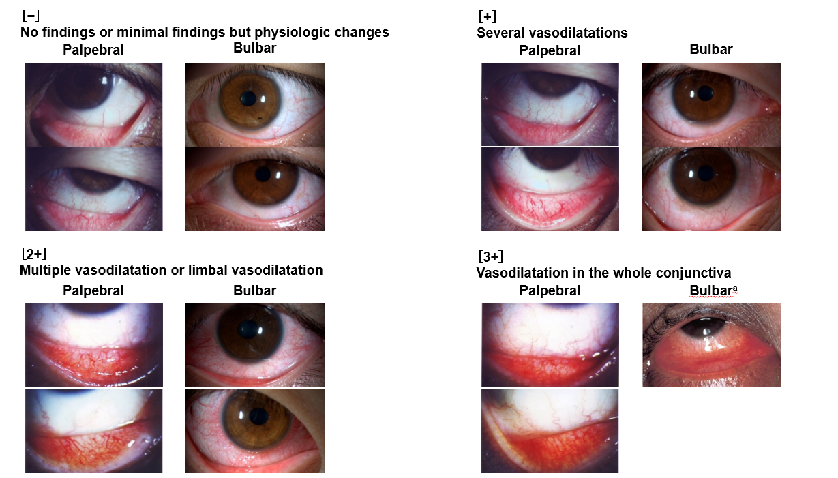
ªJapanese Society of Ocular Allergology Committee on Guidelines. Japanese guideline for the management of allergic conjunctival diseases (3rd edition) [in Japanese]. https://www.nichigan.or.jp/Portals/0/resources/member/guideline/ACD3rd_chap2-2.pdf. Accessed January 24, 2023.
Supplementary Fig. S3 Criteria for classification of corneal endothelial cell morphology based on specular microscopy images (note that the evaluation is based on the area of focus, rather than the entire image).
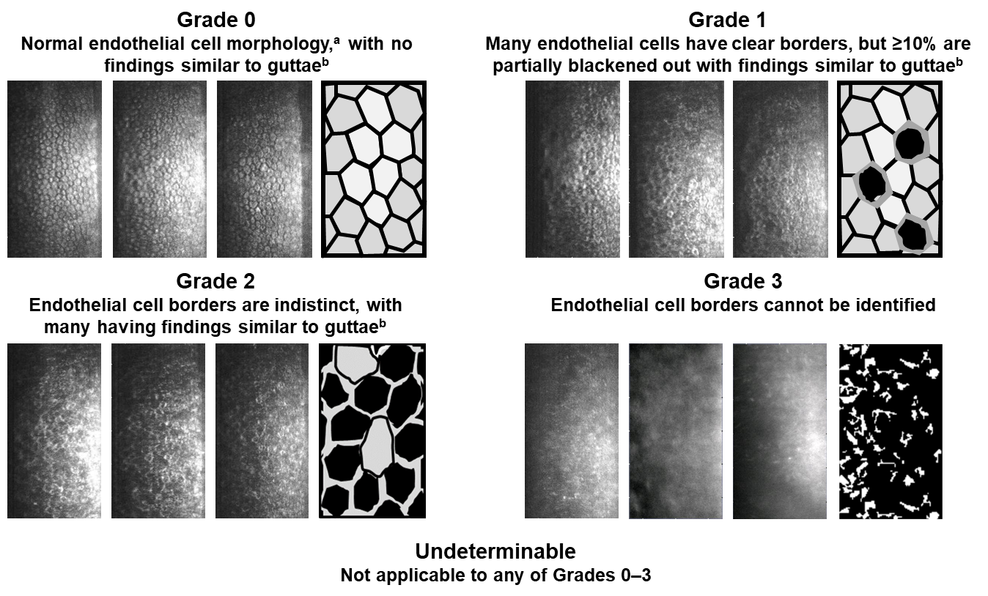
ªNormal endothelial cells appear as white polygons with black borders
^{b}Corneal guttae findings are black irregularly shaped cells with white borders

