SUPPLEMENTAL MATERIAL
Systematic literature review (SLR) and network meta-analysis (NMA) feasibility assessment
Systematic review of conference proceedings
In addition to searching the academic literature databases, conference proceedings during the period 2016–2022 were searched according to predefined criteria, as detailed in Supplemental Table 1. The conferences searched were: the American College of Gastroenterology (ACG); Asia Pacific Digestive Week (APDW) English sections only; Digestive Disease Week (DDW); European Crohn’s and Colitis Organisation (ECCO); Japanese Society for Inflammatory Bowel Disease (JSIBD) English sections only; and the United European Gastroenterology Week (UEGW).
Results of the literature search and NMA feasibility assessment
A total of 6,172 unique citations were identified by the SLR. Abstracts were double-reviewed for eligibility and 231 full-text articles were assessed. Following full-text review, a total of 117 publications were eligible for inclusion (81 full-text publications and 36 conference abstracts). Twenty-three publications reported open-label extensions and were not eligible for extraction. Overall, 94 publications reporting on 68 unique studies that investigated induction or maintenance treatments or both were included in the SLR.
Eventually, 34 of the 71 studies considered for inclusion in the NMA were excluded (see Supplemental Table 3 for more details). Of the final 37 studies included in the NMA, in the induction NMA, data for at least one efficacy outcome were reported by 24 studies in the biologic/Janus kinase inhibitor (JAKi)-naïve population, and 14 studies in the biologic/JAKi-experienced population. Twenty-two studies reported data for at least one safety outcome for the overall population and were included in the safety NMA. For the maintenance NMA, data for at least one efficacy outcome was reported by 15 studies in a biologic/JAKi-naïve population and 11 studies in a biologic/JAKi-experienced population.
Additional information on statistical analyses
A predictive distribution of the baseline was obtained by fitting baseline models to the placebo data [1]. Uninformative priors were placed on all parameters (Supplemental Table 3). Sampling was done using four chains with 10,000 iterations each, including 5,000 warmup iterations.
For each analysis, both fixed-effect and random-effects models were considered. Results under fixed effect and random effects, baseline risk adjusted and unadjusted models were compared for goodness of fit to the data based on model selection criteria outlined in the NICE Decision Support Unit Technical Support Documents [1-4], including deviance information criterion (DIC) [50] and visual inspection of diagnostic plots. An unrelated mean effects model was used to test for the presence of inconsistency [4].
The deviance information criterion
Reviewing the unadjusted models, in the biologic/JAKi-naïve population, the residual deviance for the random effects model was lower than the fixed effect model (136.86 vs 139.40) and the 95% credible interval (CrI) for the posterior estimate of the between-study standard deviation (tau) was reasonable (mean 0.10 [95% Crl 0.00 to 0.26]). While the DIC was marginally larger in the random effects model (176.09 vs 174.86 for the fixed effect model), clinical heterogeneity, observed in Supplemental Table 6, favours the random effects model.
In the maintenance population, the fixed effect model had a reasonable fit in terms of DIC and residual deviance. Although clinical heterogeneity, observed in Supplemental Table 6, favours the random effects model, the reduced network of evidence available in the biologic/JAKi-naïve population introduced highly uncertain results under the random effects model wherein all treatments were considered comparable to one another.
Baseline risk adjustment
While varying baseline risk across studies has been noted in previous NMAs of ulcerative colitis [6-11], to our knowledge, only a few NMAs implement baseline risk adjustment through meta-regression to account for differences in placebo rates across studies where model fit suggested adjustment was appropriate. Panaccione and colleagues [12] reported application of baseline risk adjustment using a different analytic approach to the one reported here. As a result of these differences, and differences in the evidence base, the authors reported convergence and/or running issues for all but two networks (induction clinical response in the biologic naïve population and all cause adverse events). Due to a difference in outcomes and approach for these two networks a comparison of results is not presented.
Supplemental Table 1. Systematic literature review eligibility criteria

PICOS | Inclusion criteria | Exclusion criteria
Patient population | Adults (aged ≥18 years) with moderately-to-severely active UCª | Non-adults (<18 years of age)  Disease severity other than moderate or severe as defined by Mayo Score (i.e. mild disease)
Interventions | Approved targeted therapies (and biosimilars):  - Adalimumab  - Filgotinib  - Golimumab  - Infliximab  - Ozanimod  - Tofacitinib  - Ustekinumab  - Vedolizumab  Emerging therapies:  - Bertilimumab  - Brazikumab  - Cobitolimod  - Deucravacitinib  - Etrasimod  - Mirikizumab†  - Risankizumab  - Ontamalimab  - Upadacitinib† | Any treatments other than those listed in interventions inclusion criteria
Comparators | Placebo (or standard of care)  Any of the above interventions alone or in combination with conventional drugs | Any treatments other than those listed in comparators inclusion criteria
Outcomes | Induction phase:  - Clinical response  - Clinical remission  - Endoscopic remission / endoscopic improvement / mucosal healing  - Histologic remission  - Steroid free clinical remission  Maintenance phase:  - Clinical response  - Clinical remission  - Maintenance of clinical response (durable clinical response)  - Maintenance of clinical remission (durable clinical remission)  - Mucosal healing at end of maintenance (durable mucosal healing)  - Steroid free remission  Additional outcomes:  - Mayo score (full, partial, modified)  - Mayo subscores (RBS, SFS, sigmoidoscopy, PGA)  - UC-DAI  - IBDQ  Safety outcomes:  - Adverse events  - Serious/ severe adverse events  - Discontinuation (due to lack of efficacy or due to adverse events) | Studies that did not report at least one of the outcomes of interest
Study design | Randomised controlled trials*  Pooled analyses, SLRs and meta-analyses** | Non-randomised studies (interventional or observational)  Editorials or commentaries  Any other study designs other than those listed in inclusion criteria
Date restriction | 1990 to present | Prior to 1990
Language restriction | English language only*** | Non-English language
ªRelevant studies including patients aged <18 years were excluded.
*Cross-over design was permitted but only data prior to cross-over was extracted and included.
**The 5 most recent relevant SLRs and meta-analyses were used to validate study inclusion and listed separately; no data were extracted from these publications.
***Studies excluded for ‘non-English’ were recorded accordingly.
† The intervention groupings listed in the table reflect the eligibility criteria at the time of the search and selection process of the SLR. Subsequently, mirikizumab and upadacitinib have received FDA and EMA approval.
EMA, European Medicines Agency; FDA, Food and Drug Administration; IBDQ, Inflammatory Bowel Disease Questionnaire; PICOS, population, intervention, comparator, outcome and study; RBS, rectal bleeding subscore; SFS, stool frequency subscore; PGA, Physician Global Assessment; SLR, systematic literature review; UC, ulcerative colitis; UC-DAI, UC-Disease Activity Index.

Supplemental Table 2. Approved doses and regimens of targeted therapies for UC (links correspond to EMA summary of product characteristics and FDA prescribing information for each drug)
Drug | EMAapproved dose and regimen |  | FDA approved dose and regimen |  | Abbreviated NMA label
 | Induction | Maintenance | Induction | Maintenance | Induction | Maintenance
Adalimumab | 160/80 mg (sc); 160 mg at week 0, 80 mg at week 2 | 80/40 mg (sc) Q2W; 40 mg (or 80 mg if needed) Q2W | 160/80 mg (sc); 160 mg at week 0, 80 mg at week 2 | 40 mg (sc) Q2W | ADA | ADA
Filgotinib | 200 mg QD for 10 or 22 weeks (depending on response) | 200 mg QD (length of maintenance treatment not specified) | No FDA approval | No FDA approval | FIL | FIL
Golimumab | 200/100 mg (sc); 200 mg at week 0, 100 mg at week 2 (and at week 6 if needed) | 100/50 mg (sc) Q4W from week 6 | 200/100 mg (sc); 200 mg at week 0, 100 mg at week 2 | 100 mg (sc) Q4W | GOL | GOL 50 mg  GOL 100 mg
Infliximab | 5 mg/kg (iv) week 0, 2 and 6 | 5 mg/kg (iv) Q8W | 5 mg/kg (iv) week 0, 2 and 6 | 5 mg/kg (iv) Q8W from week 6 | IFX | IFX
Mirikizumab | 300 mg (iv) at weeks 0, 4 and 8 | 200 mg (SC) Q4W | 300 mg (iv) at weeks 0, 4 and 8 | 200 mg (SC) at Week 12 then Q4W | MIRI | MIRI
Ozanimod* | 0.23 mg QD from Days 1–4  0.46 mg QD from Days 5–7 0.92 mg QD from Day 8 on | 0.92 mg QD from Day 8 on | 0.23 mg or 0.46 mg or 0.92 mg QD | 0.92 mg QD | OZD | OZD
Tofacitinib | 10 mg (oral) BID for 8 weeks (extended to 16 weeks if needed) | 5 or 10 mg (oral) BID | 10 mg (oral) BID for 8 weeks | 5 and 10 mg (oral) BID | TOF | TOF 5 mg  TOF 10 mg
Tofacitinib extended release | Application for extension in progress | Application for extension in progress | 22 mg (oral) QD for 8 weeks (extended to 16 weeks if needed) | 11 mg (oral) QD | TOF | TOF 5 mg  TOF 10 mg
Upadacitinib | 45 mg (oral) QD for 8 weeks | 15 or 30 mg (oral) QD | 45 mg (oral) QD for 8 weeks | 15 or 30 mg (oral) QD | UPA | UPA 15 mg  UPA 30 mg
Ustekinumab | 260 mg (iv) or 390 mg (iv) or 520 mg (iv) based on weight, single dose | 90 mg (sc) Q12W (or Q8W if needed) | 260 mg (iv) or 390 mg (iv) or 520 mg (iv) based on weight single dose | 90 mg (sc) Q8W from week 8 | UST | UST 90 mg Q8W  UST 90 mg Q12W
Vedolizumab | 300 mg (iv) week 0, 2 and 6 | 300 mg (iv) Q8W (or Q4W if needed)  108 mg (sc) Q2W | 300 mg (iv) week 0, 2 and 6 | 300 mg (iv) Q8W | VED | VED 108 mg Q2W  VED 300 mg Q4W  VED 300 mg Q8W
*0.25 mg ozanimod hydrochloride (HCl) is equivalent to 0.23 mg ozanimod, 0.5 mg ozanimod HCl is equivalent to 0.46 mg ozanimod, and 1 mg ozanimod HCl is equivalent to 0.92 mg ozanimod.
BID, twice daily; EMA, European Medicines Agency; FDA, Food and Drug Administration; IV, intravenous; NMA, network meta-analysis; QD, once daily; Q2W, once every 2 weeks; Q4W, once every 4 weeks; Q8W, once every 8 weeks; Q12W, once every 12 weeks; SC, subcutaneous; UC, ulcerative colitis.
Supplemental Table 3. Default NMA model priors
Parameter | Prior distribution
Study intercepts (μ) | $$N(0,{100}^{2})$$
Relative treatment effects (d) | $$N(0,{10}^{2})$$
Between-study variation (sd) | $$half‑N(0,5^{2})$$
Meta-regression coefficient (β) | $$N(0,{10}^{2})$$

Supplemental Table 4. Studies excluded from the NMA and reasons for exclusion
Study | Reason for exclusion
AMAC_Induction [13] | Intervention (MIRI dose)
AMAC_Maintenance [13] | Intervention (MIRI dose)
Armuzzi 2004 [14] | Comparator (IFX versus MPN)
CONDUCT [15] | Intervention (cobitolimod not approved)
CONSTRUCT [16] | Comparator (IFX versus ciclosporin)
Danese 2020 [17] | Intervention (APR not approved)
Florholmen 2011 [18] | Intervention (AZA not approved)
HAYABUSA [19] | Intervention (IFX dosing regimen continued versus discontinued)
Laharie 2012 [20] | Intervention and comparator (IFX dose not approved, versus ciclosporin)
LATTICE-UC [21] | Intervention (deucravacitinib not approved)
NOR-DRUM part A [22] | Comparator (IFX dosing study)
NOR-SWITCH [23] | Intervention and comparator (IFX dose not clear, versus CT-P13)
OASIS [24] | Intervention (etrasimod not approved)
Ochsenkuhn 2004 [25] | Comparator (IFX versus prednisolone)
Parikh 2012 [26] | Intervention (VED dose not approved)
PRECISION [27] | Intervention (IFX dosing study)
PURSUIT-IV [28] | Intervention (GOL dose not approved)
RIVETING [29] | Population (received TOF 10mg for 2 years and were in stable remission for 6 months prior to study entry)
Roblin, 2017 [30] | Intervention (IFX and AZA combination therapy)
Sands, 2001 [31] | Intervention (IFX dose not approved)
Schreiber 2021 [32] | Intervention (CT-P13 not approved)
SERENE-UC_Induction_Integrated [33] | Comparator (ADA dosing study)
SERENE-UC_Induction_Japan [33] | Comparator (ADA dosing study)
SERENE-UC_Induction [33] | Comparator (ADA dosing study)
SERENE-UC_Maintenance_Integrated [33] | Comparator (ADA dosing study)
SERENE-UC_Maintenance_Japan [33] | Comparator (ADA dosing study)
SERENE-UC_Maintenance [33] | Comparator (ADA dosing study)
Silva ECCO, 2017 [34] | Intervention (IFX versus ADA, dose not clear)
TOUCHSTONE [35] | Population (outcome data not available by prior therapy subgroup)
TURANDOT II [36] | Intervention (SHP647 not approved)
TURANDOT [37] | Intervention (SHP647 not approved)
UC SUCCESS [38] | Comparator (AZA not approved)
Vermeire, 2011 [39] | Intervention (SHP647 not approved)
Vermeire, 2014 [40] | Intervention (etrolizumab and SHP647 not approved)
APR, apremilast; AZA, azathioprine; IFX, infliximab; MIRI, mirikizumab; MPN, methylprednisolone; NMA, network meta-analysis; TOF, tofacitinib.
Supplemental Table 5. Characteristics of included trials by population and outcome of interest, induction and maintenance NMAs

Induction NMAs
Study | Intervention | Timepoint (weeks) | Biologic/JAKi naïve |  |  | Biologic/JAKi experienced |  |  | Overall (mixedª) population
Study | Intervention | Timepoint (weeks) | Population definition | Clinical response and remission | Mucosal healing | Population definition | Clinical response and remission | Mucosal healing | All cause discontinuation | SAEs
ACT 1 [41] | IFX | 8 | TNF naïve | ✓ | ✓
ACT 2 [41] | IFX | 8 | TNF naïve | ✓ | ✓
GEMINI 1 [42] | VED | 6 | TNF naïve | ✓ | ✓ | TNF failure | ✓ | ✓ | ✓ | ✓
HIBISCUS 1 [43] | ADA | 10 | TNF naïve | ✓ |  |  |  |  | ✓ | ✓
HIBISCUS 2 [43] | ADA | 10 | TNF naïve | ✓ |  |  |  |  | ✓ | ✓
Jiang 2015 [44] | IFX | 8 | TNF naïve | ✓ | ✓
Kobayashi 2016 [45] | IFX | 8 | TNF naïve | ✓ | ✓ |  |  |  | ✓ | ✓
LUCENT [46] | MIRI | 12 | No biologic/JAKi failure | ✓ | ✓ | Biologic/JAKi failure | ✓ | ✓ | ✓ | ✓
Motoya 2019 [47] | VED | 10 | TNF naïve | ✓ | ✓ | TNF experienced | ✓ | ✓ | ✓ | ✓
OCTAVE 1 [48] | TOF | 8 | TNF naïve | ✓ | ✓ | TNF failure | ✓ | ✓ | ✓ | ✓
OCTAVE 2 [48] | TOF | 8 | TNF naïve | ✓ | ✓ | TNF failure | ✓ | ✓ | ✓ | ✓
Probert 2003 [49] | IFX | 6 |  |  |  |  |  |  |  | ✓
PURSUIT-SC 2 [50] | GOL | 6 | TNF naïve | ✓ | ✓ |  |  |  | ✓ | ✓^{b}
PURSUIT-SC 3 [50] | GOL | 6 | TNF naïve | ✓ | ✓ |  |  |  | ✓ | ✓^{b}
Sandborn 2012 [51] | TOF | 8^{c} | TNF naïve | ✓ |  | TNF experienced | ✓ |  | ✓ | ✓
SELECTION A [52] | FIL | 10 | Biologic naïve | ✓ | ✓ |  |  |  | ✓ | ✓^{d}
SELECTION B [52] | FIL | 10 |  |  |  | Biologic experienced | ✓ | ✓ | ✓ | ✓^{d}
Suzuki 2014 [53] | ADA | 8 | TNF naïve | ✓ | ✓ |  |  |  | ✓ | ✓
TRUE NORTH [54] | OZD | 10 | TNF naïve | ✓ |  | TNF experienced | ✓ |  | ✓ | ✓
U-ACCOMPLISH [55] | UPA | 8 | No biologic failure | ✓ | ✓ | Biologic failure | ✓ | ✓ | ✓ | ✓
U-ACHIEVE [55] | UPA | 8 | No biologic failure | ✓ | ✓ | Biologic failure | ✓ | ✓ | ✓ | ✓
U-ACHIEVE Ph2b [56] | UPA | 8 | No biologic failure | ✓ | ✓ | Biologic failure | ✓ | ✓ | ✓ | ✓
ULTRA 1 [57] | ADA | 8 | TNF naïve | ✓ | ✓ |  |  |  | ✓ | ✓
ULTRA 2 [58] | ADA | 8 | TNF naïve | ✓ | ✓ | TNF experienced | ✓ | ✓ |  | ✓
UNIFI [59] | UST | 8 | Biologic naïve | ✓ | ✓ | Biologic failure | ✓ | ✓ | ✓ | ✓
VARSITY [60] | VED  ADA | 14 | TNF naïve | ✓ |  | TNF experienced | ✓

Maintenance NMAs

Study | Intervention | Maintenance period length (weeks) | Timepoint (weeks) | Study design | Biologic/JAKi naïve |  |  | Biologic/JAKi experienced
 |  |  |  |  | Population definition | Clinical response and remission | Mucosal healing | Population definition | Clinical response and remission | Mucosal healing
ACT 1 [41] | IFX | 46 | 54 | TT | TNF naïve | ✓ | ✓
GEMINI 1 [42] | VED | 46 | 52 | RR | TNF naïve | ✓ | ✓ | TNF failure | ✓ | ✓
LUCENT [46] | MIRI | 40 | 52 | RR | No biologic/JAKi failure | ✓ | ✓ | Biologic/JAKi failure | ✓ | ✓
Motoya 2019 [47] | VED | 50 | 60 | RR | TNF naïve | ✓ | ✓ | TNF experienced | ✓ | ✓
OCTAVE Sustain [48] | TOF | 52 | 60 | RR | TNF naïve | ✓ | ✓ | TNF failure | ✓ | ✓
PURSUIT-J [61] | GOL | 54 | 60 | RR | TNF naïve | ✓ | ✓
PURSUIT-M [62] | GOL | 54 | 60 | RR | TNF naïve | ✓
SELECTION Maintenance [52] | FIL | 48 | 58 | RR | Biologic naïve | ✓ | ✓ | Biologic experienced | ✓ | ✓
Suzuki 2014 [53] | ADA | 44 | 52 | TT | TNF naïve | ✓ | ✓
TRUE NORTH [54] | OZD | 42 | 52 | RR | TNF naïve | ✓ |  | TNF experienced | ✓
U-ACHIEVE [55] | UPA | 52 | 60 | RR | No biologic failure | ✓ | ✓ | Biologic failure | ✓ | ✓
ULTRA 2 [58] | ADA | 44 | 52 | TT | TNF naïve | ✓ | ✓ | TNF experienced | ✓ | ✓
UNIFI [59] | UST | 44 | 52 | RR | Biologic naïve | ✓ | ✓ | Biologic failure | ✓ | ✓
VARSITY [60] | VED  ADA | 38 | 52 | TT | TNF naïve | ✓ | ✓ | TNF experienced | ✓ | ✓
VISIBLE 1 [63] | VED | 46 | 52 | TT | TNF naïve | ✓ |  | TNF failure | ✓
ª Overall population with regards to prior medication.
^{b} PURSUIT-SC Total study results (i.e. phase 2 and phase 3) were used in the NMA of SAEs.
^{c} Safety outcomes for Sandborn et al. 2012 [51] were assessed at week 12.
^{d} Pooled results for SELECTION A and B were used in the NMA of SAEs.
Note: Maintenance period length denotes the number of weeks in the maintenance period of the study. Time point is inclusive of both the induction and maintenance periods.
ADA, adalimumab; FIL, filgotinib; GOL, golimumab; IFX, infliximab; JAKi, Janus kinase inhibitor; MIRI, mirikizumab; NMA, network meta-analysis; OZD, ozanimod; RR, re-randomised; SAE, serious adverse events; TNF, tumour necrosis factor; TOF, tofacitinib; TT, treat-through; UPA, upadacitinib; UST, ustekinumab; VED, vedolizumab.

Supplemental Table 6. Patient characteristics in included trials by population and outcome of interest, induction and maintenance

Induction studies
Biologic/JAKi-naïve populations
Study | Population | Treatment arm |  | N | Age (years), mean (SD) | % male | Disease duration (years), mean (SD) | Baseline Total Mayo clinic score, mean (SD) | Concomitant medications, %
 |  |  |  |  |  |  |  |  | GC only | GC/  CS (any) | IS only | IS any | GC and IS
ACT 1 [41] | TNF naïve | PBO |  | 121 | 41.4 (13.7) | 59.5 | 6.2 (5.9) | 8.4 (1.8) | – | 65.3 | – | 43.8 | –
ACT 1 [41] | TNF naïve | IFX |  | 121 | 42.4 (14.3) | 64.5 | 5.9 (5.4) | 8.5 (1.7) | – | 57.9 | – | 54.5 | –
ACT 2 [41] | TNF naïve | PBO |  | 123 | 39.3 (13.5) | 57.7 | 6.5 (6.7) | 8.5 (1.5) | – | 48.8 | – | 43.9 | –
ACT 2 [41] | TNF naïve | IFX |  | 121 | 40.5 (13.1) | 62.8 | 6.7 (5.3) | 8.3 (1.5) | – | 49.6 | – | 43 | –
GEMINI 1 [33] | TNF naïve | PBO |  | 76 | 40.5 (11.7) | 62 | 6.1 (6.4) | 8.5 (1.5) | – | 37.0 | 13.0 | – | 21
GEMINI 1 [33] | TNF naïve | VED |  | 130 | 39.7 (13.1) | 53 | 5.8 (5.2) | 8.4 (1.8) | – | 32.0 | 18.0 | – | 24
HIBISCUS 1 [43] | TNF naïve* | PBO |  | 72 | – (–) | 54 | – (–) | 8.7 (1.6) | 35 | – | 21 | – | 11
HIBISCUS 1 [43] | TNF naïve* | ADA |  | 142 | – (–) | 58 | – (–) | 8.9 (1.3) | 32 | – | 21 | – | 11
HIBISCUS 2 [43] | TNF naïve* | PBO |  | 72 | – (–) | 53 | – (–) | 8.8 (1.6) | 32 | – | 19 | – | 11
HIBISCUS 2 [43] | TNF naïve* | ADA |  | 143 | – (–) | 57 | – (–) | 8.7 (1.6) | 29 | – | 20 | – | 14
Jiang 2015 [44] | TNF naïve | PBO |  | 41 | 34.5 (14.9) | 60.9 | 4.4 (2.6) | – (–) | – | 51.2 | – | 31.7 | –
Jiang 2015 [44] | TNF naïve | IFX |  | 41 | 34.3 (14.3) | 63.4 | 4.4 (2.8) | – (–) | – | 53.7 | – | 29.3 | –
Kobayashi 2016 [45] | TNF naïve | PBO |  | 104 | 37.8 (12.9) | 64.4 | 7.1 (6.6) | 8.5 (1.4) | – | 66.3 | – | 47.1 | –
Kobayashi 2016 [45] | TNF naïve | IFX |  | 104 | 40.0 (12.7) | 63.5 | 8.1 (7.2) | 8.6 (1.4) | – | 65.4 | – | 48.1 | –
LUCENT [46] | No biologic/  JAKi failure* | MIRI | 868 |  | 42.9 (13.9) | 61.1 | 7.2 (6.7) | 8.8 (1.6) | 31.2 | – | 15.1 | – | 9.2
LUCENT [46] | No biologic/  JAKi failure* | PBO | 294 |  | 41.3 (13.8) | 56.1 | 6.9 (7.0) | 8.8 (1.6) | 30.3 | – | 15.3 | – | 8.2
Motoya 2019 [47] | TNF naïve* | VED | 164 |  | 42.3 (14.4) | 60.4 | 7.2 (6.2) | 8.3 (1.5) | 18.9 | – | 36.0 | 48.8 | 12.8
Motoya 2019 [47] | TNF naïve* | PBO | 82 |  | 44.0 (16.0) | 67.1 | 8.6 (8.0) | 8.1 (1.5) | 13.4 | – | 35.4 | – | 17.1
OCTAVE 1 [48] | TNF naïve* | PBO | 122 |  | 41.8 (15.3) | 63.1 | – (–) | 9.1 (1.4) | – | 80.3 | – | 68.0 | –
OCTAVE 1 [48] | TNF naïve* | TOF | 476 |  | 41.3 (14.1) | 58.2 | – (–) | 9.0 (1.4) | – | 73.5 | – | 75.6 | –
OCTAVE 2 [48] | TNF naïve* | PBO | 112 |  | 40.4 (13.2) | 49.1 | – (–) | 8.9 (1.5) | – | 74.1 | – | 67.0 | –
OCTAVE 2 [48] | TNF naïve* | TOF | 429 |  | 41.1 (13.5) | 60.4 | – (–) | 9.0 (1.5) | – | 70.6 | – | 70.2 | –
PURSUIT–SC 2 [50] | TNF naïve | PBO | 42 |  | – (–) | – | – (–) | – (–) | – | – | – | – | –
PURSUIT–SC 2 [50] | TNF naïve | GOL | 42 |  | – (–) | – | – (–) | – (–) | – | – | – | – | –
PURSUIT–SC 3 [50] | TNF naïve | PBO | 258 |  | 39.7 (13.4) | 50.4 | 6.4 (7.2) | 8.3 (1.5) | – | 41.1 | – | 29.5 | –
PURSUIT–SC 3 [50] | TNF naïve | GOL | 258 |  | 39.7 (13.8) | 54.3 | 6.4 (6.4) | 8.7 (1.6) | – | 45.3 | – | 29.5 | –
Sandborn [51] | TNF naïve* | PBO | 48 |  | 42.5 (14.7) | 48 | 8.8 (5.4) | 8.2 (1.6) | – | 27.0 | – | 60.0 | –
Sandborn [51] | TNF naïve* | TOF | 33 |  | 43.2 (12.8) | 64 | 10.9 (6.6) | 8.0 (1.7) | – | 58.0 | – | 76.0 | –
SELECTION A [52] | Biologic naïve | PBO | 137 |  | 41.0 (12.9) | 63.5 | 6.4 (7.4) | 8.7 (1.3) | – | 24.8 | – | 24.1 | 5.8
SELECTION A [52] | Biologic naïve | FIL | 245 |  | 42.0 (13.1) | 50.2 | 7.2 (6.9) | 8.6 (1.3) | – | 22.0 | – | 21.6 | 8.2
Suzuki 2014 [53] | TNF naïve | PBO | 96 |  | 41.3 (13.6) | 72.9 | 7.8 (6.6) | 8.5 (1.6) | – | 60.4 | – | 54.2 | –
Suzuki 2014 [53] | TNF naïve | ADA | 90 |  | 42.5 (14.6) | 67.8 | 7.8 (7.1) | 8.6 (1.4) | – | 63.3 | – | 45.6 | –
TRUE NORTH [58] | TNF naïve* | PBO | 216 |  | 41.9 (13.6) | 66.2 | 6.8 (7.0) | 8.9 (1.4) | – | 75.0 | – | 43.1 | –
TRUE NORTH [58] | TNF naïve* | OZD | 429 |  | 41.4 (13.5) | 57.1 | 6.9 (6.6) | 8.9 (1.5) | – | 75.1 | – | 40.6 | –
U–ACCOMPLISH [55] | No biologic failure* | PBO | 177 |  | 42.0 (24.0) | 61.5 | 7.4 (7.2) | – (–) | – | 41.0 | – | 2.0 | –
U–ACCOMPLISH [55] | No biologic failure* | UPA | 345 |  | 40.0 (24.0) | 62.8 | 7.3 (6.4) | – (–) | – | 35.0 | – | <1.0 | –
U–ACHIEVE [55] | No biologic failure* | PBO | 155 |  | 44.5 (23.0) | 63 | 9.1 (8.8) | – (–) | – | 40.0 | – | 2.0 | –
U–ACHIEVE [55] | No biologic failure* | UPA | 319 |  | 43.0 (23.0) | 62.1 | 8.6 (7.2) | – (–) | – | 39.0 | – | 1.0 | –
U–ACHIEVE Ph2b [56] | No biologic failure* | PBO | 46 |  | – (–) | 63 | – (–) | – (–) | – | 54.3 | – | 78.3 | –
U–ACHIEVE Ph2b [56] | No biologic failure* | UPA | 56 |  | – (–) | 66.1 | – (–) | – (–) | – | 50 | – | 73.2 | –
ULTRA 1 [57] | TNF naïve | PBO | 130 |  | – (–) | 63.1 | – (–) | 8.7 (1.6) | 41.5 | – | 13.8 | – | 26.1
ULTRA 1 [57] | TNF naïve | ADA | 130 |  | – (–) | 63.8 | – (–) | 8.8 (1.6) | 36.9 | – | 21.5 | – | 17.7
ULTRA 2 [58] | TNF naïve* | PBO | 260 |  | 41.3 (13.2) | 61.8 | 8.5 (7.4) | 8.9 (1.8) | – | 56.9 | – | 32.5 | 18.3
ULTRA 2 [58] | TNF naïve* | ADA | 258 |  | 39.6 (12.5) | 57.3 | 8.1 (7.1) | 8.9 (1.5) | – | 60.5 | – | 37.5 | 20.2
UNIFI [59] | Biologic naïve* | PBO | 319 |  | 41.2 (13.5) | 61.8 | 8.0 (7.2) | 8.9 (1.6) | – | 49.2 | – | 27.9 | –
UNIFI [59] | Biologic naïve* | UST | 302 |  | 42.2 (13.9) | 59.4 | 8.1 (7.2) | 8.9 (1.6) | – | 54.1 | – | 29.1 | –
VARSITY [60] | TNF naïve* | ADA | 386 |  | 40.5 (13.4) | 56.0 | 6.4 (6.0) | 8.7 (1.5) | 36.3 | – | 25.9 | – | –
VARSITY [60] | TNF naïve* | VED | 385 |  | 40.8 (13.7) | 60.8 | 7.3 (7.2) | 8.7 (1.6) | 36.1 | – | 26.2 | – | –

Induction studies
Biologic/JAKi-experienced populations
Study | Population | Treatment arm | N | Age (years), mean (SD) | % male | Disease duration (months), mean (SD) | Baseline Mayo clinic score, mean (SD) | Concomitant medications, %
 |  |  |  |  |  |  |  | GC only | GC/  CS (any) | IS only | IS any | GC and IS
GEMINI 1 [42] | TNF failure | PBO | 63 | 41.8 (13.1) | 56 | 8.0 (7.6) | 8.6 (1.9) | – | 43.0 | 10.0 | – | 13.0
GEMINI 1 [42] | TNF failure | VED | 82 | 39.7 (12.5) | 61 | 6.4 (5.0) | 8.7 (1.8) | – | 37.0 | 6.0 | – | 16.0
LUCENT [46] | Biologic/JAKi failure† | MIRI | 868 | 42.9 (13.9) | 61.1 | 7.2 (6.8) | 8.8 (1.6) | 31.2 | – | 15.1 | – | 9.2
LUCENT [46] | Biologic/JAKi failure† | PBO | 294 | 41.3 (13.8) | 56.1 | 6.9 (7.0) | 8.8 (1.6) | 30.3 | – | 15.3 | – | 8.2
Motoya 2019 [47] | TNF experienced† | VED | 164 | 42.3 (14.4) | 60.4 | 7.2 (6.2) | 8.3 (1.5) | 18.9 | – | 36.0 | 48.8 | 12.8
Motoya 2019 [47] | TNF experienced† | PBO | 82 | 44.0 (16.0) | 67.1 | 8.6 (8.0) | 8.1 (1.5) | 13.4 | – | 35.4 | – | 17.1
OCTAVE 1 [48] | TNF failure† | PBO | 122 | 41.8 (15.3) | 63.1 | – (–) | 9.1 (1.4) | – | 80.3 | – | 68.0 | –
OCTAVE 1 [48] | TNF failure† | TOF | 476 | 41.3 (14.1) | 58.2 | – (–) | 9.0 (1.4) | – | 73.5 | – | 75.6 | –
OCTAVE 2 [48] | TNF failure† | PBO | 112 | 40.4 (13.2) | 49.1 | – (–) | 8.9 (1.5) | – | 74.1 | – | 67.0 | –
OCTAVE 2 [48] | TNF failure† | TOF | 429 | 41.1 (13.5) | 60.4 | – (–) | 9.0 (1.5) | – | 70.6 | – | 70.2 | –
Sandborn 2012 [51] | TNF experienced† | PBO | 48 | 42.5 (14.7) | 48 | 8.8 (5.4) | 8.2 (1.6) | – | 27.0 | – | 60.0 | –
Sandborn 2012 [51] | TNF experienced† | TOF | 33 | 43.2 (12.8) | 64 | 10.9 (6.6) | 8.0 (1.7) | – | 58.0 | – | 76.0 | –
SELECTION B [52] | Biologic experienced | PBO | 142 | 44.0 (14.9) | 60.6 | 10.2 (8.2) | 9.3 (1.4) | – | 35.9 | – | 14.8 | 7.7
SELECTION B [52] | Biologic experienced | FIL | 262 | 43.0 (14.2) | 56.5 | 9.8 (7.6) | 9.2 (1.4) | – | 35.9 | – | 13.0 | 10.7
TRUE NORTH [54] | TNF experienced† | PBO | 216 | 41.9 (13.6) | 66.2 | 6.8 (7.0) | 8.9 (1.4) | – | 75.0 | – | 43.1 | –
TRUE NORTH [54] | TNF experienced† | OZA | 429 | 41.4 (13.5) | 57.1 | 6.9 (6.6) | 8.9 (1.5) | – | 75.1 | – | 40.6 | –
U–ACCOMPLISH [55] | Biologic failure† | PBO | 177 | 42.0 (24.0) | 61.5 | 7.4 (7.2) | – (–) | – | 41.0 | – | 2.0 | –
U–ACCOMPLISH [55] | Biologic failure† | UPA | 345 | 40.0 (24.0) | 62.8 | 7.3 (6.4) | – (–) | – | 35.0 | – | <1.0 | –
U–ACHIEVE [55] | Biologic failure† | PBO | 155 | 44.5 (23.0) | 63 | 9.1 (8.8) | – (–) | – | 40.0 | – | 2.0 | –
U–ACHIEVE [55] | Biologic failure† | UPA | 319 | 43.0 (23.0) | 62.1 | 8.6 (7.2) | – (–) | – | 39.0 | – | 1.0 | –
U–ACHIEVE Ph2b [56] | Biologic failure† | PBO | 46 | – (–) | 63 | – (–) | – (–) | – | 54.3 | – | 78.3 | –
U–ACHIEVE Ph2b [56] | Biologic failure† | UPA | 56 | – (–) | 66.1 | – (–) | – (–) | – | 50 | – | 73.2 | –
ULTRA 2 [58] | TNF experienced† | PBO | 260 | 41.3 (13.2) | 61.8 | 8.5 (7.4) | 8.9 (1.8) | – | 56.9 | – | 32.5 | 18.3
ULTRA 2 [58] | TNF experienced† | ADA | 258 | 39.6 (12.5) | 57.3 | 8.1 (7.1) | 8.9 (1.5) | – | 60.5 | – | 37.5 | 20.2
UNIFI [59] | Biologic failure† | PBO | 319 | 41.2 (13.5) | 61.8 | 8.0 (7.2) | 8.9 (1.6) | – | 49.2 | – | 27.9 | –
UNIFI [59] | Biologic failure† | UST | 302 | 42.2 (13.9) | 59.4 | 8.1 (7.2) | 8.9 (1.6) | – | 54.1 | – | 29.1 | –
VARSITY [60] | TNF experienced† | ADA | 386 | 40.5 (13.4) | 56.0 | 6.4 (6.0) | 8.7 (1.5) | 36.3 | – | 25.9 | – | –
VARSITY [60] | TNF experienced† | VED | 385 | 40.8 (13.7) | 60.8 | 7.3 (7.2) | 8.7 (1.6) | 36.1 | – | 26.2 | – | –

Maintenance studies
Biologic/JAKi-naïve populations
Study | Population | Treatment arm | N | Age (years), mean (SD) | % male | Disease duration (months), mean (SD) | Baseline Mayo clinic score, mean (SD) | Concomitant medications, %
 |  |  |  |  |  |  |  | GC only | GC/  CS (any) | IS only | IS any | GC and IS
GEMINI 1 [42] | TNF naïve | PBO | 79 | 39.5 (14.2) | 57 | 6.4 (5.6) | 8.4 (1.7) | – | 35.0 | 24.0 | – | 19.0
GEMINI 1 [42] | TNF naïve | VED 300mg Q8W | 72 | 41.0 (13.8) | 54 | 5.8 (4.8) | 8.3 (1.8) | – | 38.0 | 25.0 | – | 17.0
GEMINI 1 [42] | TNF naïve | VED 300mg Q4W | 73 | 38.3 (12.6) | 53 | 7.0 (6.2) | 8.2 (1.8) | – | 40.0 | 19.0 | – | 21.0
LUCENT [46] | No biologic/  JAKi failure‡ | MIRI | 365 | 43.4 (14.2) | 58.6 | 6.9 (7.1) | 6.5 (1.3) | – | – | – | – | –
LUCENT [46] | No biologic/  JAKi failure‡ | PBO | 179 | 41.2 (12.8) | 58.1 | 6.7 (5.6) | 6.6 (1.2) | – | – | – | – | –
Motoya 2019 [47] | TNF naïve‡ | VED 300mg Q8W | 41 | 43.0 (14.3) | 51.2 | 8.6 (7.8) | 8.1 (1.6) | 22.0 | – | 43.9 | 53.7 | 9.8
Motoya 2019 [47] | TNF naïve‡ | PBO | 42 | 42.6 (14.4) | 54.8 | 8.7 (7.0) | 7.9 (1.6) | 26.2 | – | 40.5 | – | 9.5
OCTAVE Sustain [48] | TNF naïve‡ | PBO | 198 | 43.4 (14.0) | 58.6 | – (–) | 3.3 (1.8) | – | 76.3 | – | 65.2 | –
OCTAVE Sustain [48] | TNF naïve‡ | TOF | 197 | 42.9 (14.4) | 55.8 | – (–) | 3.4 (1.8) | – | 75.6 | – | 71.6 | –
PURSUIT–J [61] | TNF naïve | GOL | 32 | 39.3 (12.0) | 59 | – (–) | 8 (median) (6–11 (min, max)) | – | 28.0 | – | – | –
PURSUIT–J [61] | TNF naïve | PBO | 31 | 42.9 (14.4) | 61 | – (–) | 8 (median) (6–12 (min, max)) | – | 29.0 | – | – | –
PURSUIT–M [62] | TNF naïve | PBO | 156 | 40.2 (14.1) | 48.1 | 6.9 (7.0) | 8.3 (1.4) | – | 53.2 | – | 33.3 | –
PURSUIT–M [62] | TNF naïve | GOL | 154 | 39.1 (13.1) | 57.8 | 7.2 (7.0) | 8.5 (1.3) | – | 51.3 | – | 31.2 | –
SELECTION Maintenance [52] | Biologic naïve | PBO | 99 | 42.0 (13.0) | 48 | 8.9 (7.6) | – (–) | 31.0 | – | 18.0 | – | 9.0
SELECTION Maintenance [52] | Biologic naïve | FIL | 202 | 43.0 (14.0) | 47 | 8.4 (7.4) | – (–) | 30.0 | – | 17.0 | – | 9.0
TRUE NORTH [54] | TNF naïve‡ | PBO | 227 | – (–) | – | – (–) | – (–) | – | – | – | – | –
TRUE NORTH [54] | TNF naïve‡ | OZD | 230 | – (–) | – | – (–) | – (–) | – | – | – | – | –
U–ACHIEVE [55] | Biologic failure‡ | PBO | 149 | 40.0 (21.0) | 57 | 6.2 (8.6) | – (–) | – | 40 | – | 0 | –
U–ACHIEVE [55] | Biologic failure‡ | UPA 15mg | 148 | 40.0 (22.0) | 64 | 6.4 (10.6) | – (–) | – | 37 | – | <1 | –
U–ACHIEVE [55] | Biologic failure‡ | UPA 30mg | 154 | 41.0 (7.0) | 56 | 6.0 (9.7) | – (–) | – | 37 | – | <1 | –
UNIFI [59] | Biologic naïve‡ | PBO | 175 | 42.0 (13.9) | 61.1 | 7.5 (6.8) | 8.7 (1.5) | – | 54.3 | – | 28.0 | –
UNIFI [59] | Biologic naïve‡ | UST 90mg Q12W | 172 | 40.7 (13.5) | 55.8 | 8.6 (8.3) | 8.9 (1.6) | – | 48.3 | – | 25.6 | –
UNIFI [59] | Biologic naïve‡ | UST 90mg Q8W | 176 | 39.5 (13.3) | 53.4 | 8.1 (6.6) | 8.9 (1.6) | – | 54.0 | – | 26.1 | –
VISIBLE 1 [63] | TNF naïve‡ | PBO | 56 | 39.4 (11.7) | 60.7 | 7.4 (7.1) | 9 (median) (6–11 (range)) | – | 39.3 | – | – | –
VISIBLE 1 [63] | TNF naïve‡ | VED 108mg Q2W | 106 | 38.1 (13.1) | 61.3 | 8.0 (6.2) | 9 (median) (6–12 (range)) | – | 26.4 | – | – | –
VISIBLE 1 [63] | TNF naïve‡ | VED 300mg Q8W | 54 | 41.6 (14.1) | 57.4 | 8.2 (5.9) | 9 (median) (6–12 (range)) | – | 38.9 | – | – | –

Maintenance studies
Biologic/JAKi-experienced populations
Study | Population | Treatment arm | N | Age (years), mean (SD) | % male | Disease duration (months), mean (SD) | Baseline Mayo clinic score, mean (SD) | Concomitant medications, %
 |  |  |  |  |  |  |  | GC only | GC/  CS (any) | IS only | IS any | GC and IS
GEMINI 1 [42] | TNF failure | PBO | 38 | 41.6 (13.4) | 55 | 9.8 (8.4) | 8.2 (1.7) | – | 42.0 | 16.0 | – | 18.0
GEMINI 1 [42] | TNF failure | VED 300mg Q8W | 43 | 41.3 (10.9) | 56 | 6.8 (4.5) | 8.5 (1.9) | – | 49.0 | 5.0 | – | 12.0
GEMINI 1 [42] | TNF failure | VED 300mg Q4W | 40 | 39.9 (18.1) | 53 | 8.1 (7.4) | 8.4 (1.6) | – | 28.0 | 13.0 | – | 20.0
LUCENT [46] | Biologic/JAKi failure§ | MIRI | 365 | 43.4 (14.2) | 58.6 | 6.9 (7.1) | 6.5 (1.3) | – | – | – | – | –
LUCENT [46] | Biologic/JAKi failure§ | PBO | 179 | 41.2 (12.8) | 58.1 | 6.7 (5.6) | 6.6 (1.2) | – | – | – | – | –
Motoya 2019 [47] | TNF experienced§ | VED 300mg Q8W | 41 | 43.0 (14.3) | 51.2 | 8.6 (7.8) | 8.1 (1.6) | 22.0 | – | 43.9 | 53.7 | 9.8
Motoya 2019 [47] | TNF experienced§ | PBO | 42 | 42.6 (14.4) | 54.8 | 8.7 (7.0) | 7.9 (1.6) | 26.2 | – | 40.5 | – | 9.5
OCTAVE Sustain [48] | TNF failure§ | PBO | 198 | 43.4 (14.0) | 58.6 | – (–) | 3.3 (1.8) | – | 76.3 | – | 65.2 | –
OCTAVE Sustain [48] | TNF failure§ | TOF | 197 | 42.9 (14.4) | 55.8 | – (–) | 3.4 (1.8) | – | 75.6 | – | 71.6 | –
SELECTION Maintenance [52] | Biologic experienced§ | PBO | 99 | 42.0 (13.0) | 48 | 8.9 (7.6) | – (–) | 31.0 | – | 18.0 | – | 9.0
SELECTION Maintenance [52] | Biologic experienced§ | FIL | 202 | 43.0 (14.0) | 47 | 8.4 (7.4) | – (–) | 30.0 | – | 17.0 | – | 9.0
TRUE NORTH [54] | TNF experienced§ | PBO | 227 | – (–) | – | – (–) | – (–) | – | – | – | – | –
TRUE NORTH [54] | TNF experienced§ | OZD | 230 | – (–) | – | – (–) | – (–) | – | – | – | – | –
U–ACHIEVE [55] | Biologic failure§ | PBO | 149 | 40.0 (21.0) | 57 | 6.2 (8.6) | – (–) | – | 40 | – | 0 | –
U–ACHIEVE [55] | Biologic failure§ | UPA 15mg | 148 | 40.0 (22.0) | 64 | 6.4 (10.6) | – (–) | – | 37 | – | <1 | –
U–ACHIEVE [55] | Biologic failure§ | UPA 30mg | 154 | 41.0 (7.0) | 56 | 6.0 (9.7) | – (–) | – | 37 | – | <1 | –
UNIFI [59] | Biologic failure§ | PBO | 175 | 42.0 (13.9) | 61.1 | 7.5 (6.8) | 8.7 (1.5) | – | 54.3 | – | 28.0 | –
UNIFI [59] | Biologic failure§ | UST 90mg Q12W | 172 | 40.7 (13.5) | 55.8 | 8.6 (8.3) | 8.9 (1.6) | – | 48.3 | – | 25.6 | –
UNIFI [59] | Biologic failure§ | UST 90mg Q8W | 176 | 39.5 (13.3) | 53.4 | 8.1 (6.6) | 8.9 (1.6) | – | 54.0 | – | 26.1 | –
VISIBLE 1 [63] | TNF failure§ | PBO | 56 | 39.4 (11.7) | 60.7 | 7.4 (7.1) | 9 (median) (6–11 (range)) | – | 39.3 | – | – | –
VISIBLE 1 [63] | TNF failure§ | VED 108mg Q2W | 106 | 38.1 (13.1) | 61.3 | 8.0 (6.2) | 9 (median) (6–12 (range)) | – | 26.4 | – | – | –
VISIBLE 1 [63] | TNF failure§ | VED 300mg Q8W | 54 | 41.6 (14.1) | 57.4 | 8.2 (5.9) | 9 (median) (6–12 (range)) | – | 38.9 | – | – | –
*Patient baseline characteristics for biologic/JAKi-naïve population not reported separately and are presented for the entire study population.
†Patient baseline characteristics for biologic/JAKi-experienced population not reported separately and are presented for the entire study population.
‡Patient baseline characteristics for biologic/JAKi-naïve population not reported separately and are presented for the entire study population.
§Patient baseline characteristics for biologic/JAKi-experienced population not reported separately and are presented for the entire study population.
Note: Baseline characteristics for maintenance studies with treat–through designs (ACT 1, Suzuki 2014 [53], ULTRA 2, and VARSITY) are available only for baseline at induction. Baseline characteristics for LUCENT are available only for baseline at induction for the subset of induction study mirikizumab responders who were re–randomised and participated in the maintenance study.
Note: Data baseline characteristics for maintenance studies with treat-through designs (ULTRA 2, and VARSITY) are available only for baseline at induction and have been omitted from this table. Baseline characteristics for LUCENT are available only for baseline at induction for the subset of induction study mirikizumab responders who were re-randomised and participated in the maintenance study.
ADA, adalimumab; CrI, credible interval; CS, corticosteroids; GC, glucocorticoids; GOL, golimumab; IFX, infliximab; JAKi, Janus kinase inhibitor; IS, immunosuppressants; MIRI, mirikizumab; PBO, placebo; OZD, ozanimod; TNF, tumour necrosis factor; TOF = tofacitinib; UST = ustekinumab; VED = vedolizumab.

Supplemental Table 7. Summary of model fit statistics
(Information about the deviance information criterion per model.)
A). Clinical response and remission, induction, biologic/JAKi-naïve population

 | Unadjustedª |  | Adjustedª
 | FE | RE^{b} | FE | RE^{b}
Beta^{c} | - | - | -0.28 (-0.51, 0.01) | -0.16 (-0.61, 0.01)
Tau^{c} | - | 0.10 (0.00, 0.26) | - | 0.10 (0.01, 0.24)
Residual deviance | 139.40 | 136.86 | 140.98 | 137.60
pD | 35.45 | 39.23 | 36.54 | 40.94
DIC | 174.86 | 176.09 | 177.52 | 178.53

B). Clinical response and remission, maintenance, biologic/JAKi-naïve population

 | Unadjustedª |  | Adjustedª
 | FE | RE^{b} | FE | RE^{b}
Beta^{c} | - | - | -1.35 (-2.13, -0.67) | -1.16 (-2.26, 0.04)
Tau^{c} | - | 0.41 (0.09, 1.04) | - | 0.22 (0.01, 0.80)
Residual deviance | 194.00 | 185.28 | 187.13 | 185.52
pD | 32.64 | 36.69 | 34.50 | 36.60
DIC | 226.64 | 221.98 | 221.63 | 222.12

C). Clinical response and remission, induction, biologic/JAKi-experienced population

 | Unadjustedª |  | Adjustedª
 | FE | RE^{b} | FE | RE^{b}
Beta^{c} | - | - | 0.13 (-0.60, 1.47) | -0.11 (-1.63, 1.62)
Tau^{c} | - | 0.21 (0.01, 0.62) | - | 0.26 (0.1, 0.83)
Residual deviance | 88.68 | 86.79 | 89.26 | 87.32
pD | 23.85 | 26.69 | 25.31 | 28.20
DIC | 112.53 | 113.48 | 114.57 | 115.52

D). Clinical response and remission, maintenance, biologic/JAKi-experienced population

 | Unadjustedª |  | Adjustedª
 | FE | RE^{b} | FE | RE^{b}
Beta^{c} | - | - | 0.01 (-0.90, 2.13) | -0.06 (-2.73, 3.06)
Tau^{c} | - | 0.48 (0.02, 1.86) | - | 0.67 (0.02, 2.55)
Residual deviance | 68.71 | 68.56 | 69.55 | 69.07
pD | 25.51 | 27.29 | 26.61 | 28.03
DIC | 94.22 | 95.85 | 96.16 | 97.10

E). Clinical response and remission, maintenance, biologic/JAKi-naïve population, re-randomised studies sensitivity analysis

 | Unadjustedª |  | Adjustedª
 | FE | RE^{b} | FE | RE^{b}
Beta^{c} | - | - | -0.84 (-2.02, 0.64) | -0.81 (-3.68, 2.01)
Tau^{c} | - | 0.51 (0.03, 1.76) | - | 0.51 (0.02, 2.07)
Residual deviance | 141.26 | 138.83 | 140.51 | 138.84
pD | 26.44 | 29.01 | 28.35 | 29.38
DIC | 167.70 | 167.84 | 168.86 | 168.22

F). Clinical response and remission, maintenance, biologic/JAKi-experienced population, re-randomised studies sensitivity analysis

 | Unadjustedª |  | Adjustedª
 | FE | RE^{b} | FE | RE^{b}
Beta^{c} | - | - | 0.04 (-0.76, 2.00) | -0.01 (-4.04, 4.14)
Tau^{c} | - | 0.55 (0.01, 2.29) | - | 0.98 (0.03, 3.76)
Residual deviance | 62.95 | 63.71 | 63.82 | 64.36
pD | 22.60 | 23.47 | 23.45 | 24.02
DIC | 85.55 | 87.18 | 87.27 | 88.39

ª Models with or without meta-regression adjustment for baseline risk.
^{b} RE model with a half-Normal (location: 0, scale: 5) prior for the between-trial standard deviation.
^{c} Mean (95% CrI).
CrI, credible interval; DIC, deviance information criterion; FE, fixed effect; RE, random effects.

Supplemental Table 8. Predicted absolute clinical response and remission rates for each intervention in the induction period for the biologic/JAKi-naïve population

Intervention | Clinical response, % |  | Clinical remission, %
Intervention | Mean (SD) | Median (95% CrI) | Mean (SD) | Median (95% CrI)
Placebo | 34.9 (10.4) | 34.3 (16.2, 56.3) | 9.2 (4.8) | 8.4 (2.5, 20.7)
Adalimumab | 50.0 (11.6) | 50.1 (27.5, 72.2) | 17.5 (7.6) | 16.4 (5.7, 35.0)
Filgotinib | 52.7 (12.7) | 52.9 (27.6, 76.7) | 19.6 (9.0) | 18.3 (5.8, 40.3)
Golimumab | 54.1 (12.2) | 54.4 (29.6, 76.8) | 20.4 (8.8) | 19.3 (6.5, 40.2)
Infliximab | 66.1 (10.9) | 66.8 (42.7, 85.1) | 30.2 (10.4) | 29.4 (12.3, 52.5)
Mirikizumab | 53.0 (12.5) | 53.1 (28.5, 76.5) | 19.7 (8.8) | 18.5 (6.1, 39.9)
Ozanimod | 59.9 (12.4) | 60.4 (34.3, 82.3) | 25.0 (10.3) | 23.8 (8.4, 48.2)
Tofacitinib | 57.7 (12.0) | 58.1 (33.4, 79.8) | 23.1 (9.5) | 22.0 (8.0, 44.4)
Upadacitinib | 75.2 (9.9) | 76.3 (53.0, 91.0) | 40.2 (11.9) | 39.8 (18.4, 64.2)
Ustekinumab | 58.6 (12.7) | 59.1 (32.7, 81.4) | 24.0 (10.2) | 22.7 (7.8, 46.8)
Vedolizumab | 61.7 (11.5) | 62.3 (38.0, 82.1) | 26.3 (9.8) | 25.3 (9.9, 47.8)

CrI, credible interval; JAKi, Janus kinase inhibitor; SD, standard deviation.

Supplemental Table 9. Predicted absolute clinical response and remission rates for each intervention in the maintenance period for the biologic/JAKi-naïve population

Intervention | Clinical response, % |  | Clinical remission, %
Intervention | Mean (SD) | Median (95% CrI) | Mean (SD) | Median (95% CrI)
Placebo | 36.4 (11.6) | 35.6 (15.8, 60.6) | 20.4 (8.9) | 19.2 (6.6, 40.8)
Adalimumab | 60.1 (12.4) | 60.5 (34.6, 82.4) | 41.3 (12.5) | 40.7 (18.5, 66.7)
Filgotinib | 72.0 (11.4) | 73.1 (47.3, 90.7) | 54.3 (13.3) | 54.5 (28.3, 79.4)
Golimumab 50 mg | 50.8 (12.9) | 50.8 (26.0, 75.5) | 32.4 (11.7) | 31.5 (12.6, 57.3)
Golimumab 100 mg | 53.4 (12.8) | 53.5 (28.1, 77.5) | 34.8 (12.0) | 33.9 (14.0, 60.0)
Infliximab | 65.9 (12.7) | 66.7 (39.2, 87.7) | 47.5 (13.8) | 47.1 (21.8, 74.5)
Mirikizumab | 80.4 (9.9) | 81.9 (57.7, 95.1) | 65.0 (13.1) | 66.0 (37.7, 87.6)
Ozanimod | 65.6 (12.4) | 66.4 (39.4, 86.8) | 47.1 (13.3) | 46.8 (22.0, 73.1)
Tofacitinib 5 mg | 56.3 (13.5) | 56.7 (29.1, 81.2) | 37.6 (13.0) | 37.0 (14.6, 64.8)
Tofacitinib 10 mg | 61.2 (13.2) | 62.0 (33.9, 84.7) | 42.6 (13.5) | 42.1 (17.8, 69.7)
Upadacitinib 15 mg | 61.4 (13.5) | 62.3 (33.2, 85.1) | 42.8 (13.8) | 42.5 (17.4, 70.4)
Upadacitinib 30 mg | 73.7 (11.6) | 75.2 (47.6, 92.0) | 56.5 (13.8) | 57.0 (28.8, 81.7)
Ustekinumab 90 mg Q8W | 77.3 (11.1) | 78.8 (51.8, 94.3) | 61.0 (14.0) | 61.7 (32.3, 86.1)
Ustekinumab 90 mg Q12W | 75.9 (11.4) | 77.3 (50.1, 93.6) | 59.2 (14.0) | 59.7 (30.8, 84.6)
Vedolizumab 108 mg Q2W | 51.8 (14.2) | 51.9 (24.4, 78.8) | 33.5 (13.1) | 32.4 (11.6, 61.7)
Vedolizumab 300 mg Q4W | 60.7 (13.1) | 61.4 (33.6, 84.2) | 42.0 (13.3) | 41.5 (17.9, 69.0)
Vedolizumab 300 mg Q8W | 61.6 (12.3) | 62.2 (36.2, 83.6) | 42.8 (12.7) | 42.3 (19.5, 68.3)

CrI, credible interval; JAKi, Janus kinase inhibitor; Q2W, once every 2 weeks; Q4W, once every 4 weeks; Q8W, once every 8 weeks; Q12W, once every 12 weeks; SD, standard deviation.

Supplemental Table 10. Predicted absolute clinical response and remission rates for each intervention in the induction period for the biologic/JAKi-experienced population

Intervention | Clinical response, % |  | Clinical remission, %
Intervention | Mean (SD) | Median (95% CrI) | Mean (SD) | Median (95% CrI)
Placebo | 22.5 (6.8) | 21.9 (10.9, 37.3) | 3.2 (1.7) | 29. (0.9, 7.4)
Adalimumab | 23.9 (8.3) | 23.1 (10.3, 42.2) | 3.6 (2.2 | 3.1 (0.8, 9.3)
Filgotinib | 54.2 (10.4) | 54.3 (33.7, 74.1) | 16.3 (6.6) | 15.4 (6.1, 31.5)
Mirikizumab | 42.6 (10.1) | 42.3 (23.8, 63.2) | 10.1 (4.7) | 9.4 (3.3, 21.5)
Ozanimod | 41.9 (11.5) | 41.5 (20.7, 65.1) | 10.0 (5.4) | 9.0 (2.6, 23.1)
Tofacitinib | 51.1 (10.2) | 51.2 (31.2, 70.7) | 14.4 (5.9) | 13.6 (5.2, 28.1)
Upadacitinib | 74.0 (8.3) | 74.7 (55.9, 88.2) | 32.8 (9.2) | 32.2 (16.5, 52.4)
Ustekinumab | 49.9 (10.4) | 49.9 (29.7, 69.8) | 13.8 (5.8) | 12.9 (4.8, 27.3)
Vedolizumab | 37.0 (9.8) | 36.6 (19.3, 57.1) | 7.8 (3.9) | 7.1 (2.3, 17.2)

CrI, credible interval; JAKi, Janus kinase inhibitor; SD, standard deviation.

Supplemental Table 11. Predicted absolute clinical response and remission rates for each intervention in the maintenance period for the biologic/JAKi-experienced population

Intervention | Clinical response, % |  | Clinical remission, %
Intervention | Mean (SD) | Median (95% CrI) | Mean (SD) | Median (95% CrI)
Placebo | 24.6 (11.8) | 23.0 (6.5, 51.6) | 10.7 (7.2) | 9.1 (1.7, 28.8)
Adalimumab | 57.0 (16.7) | 57.8 (23.6, 86.6) | 35.8 (15.9) | 34.5 (9.4, 69.6)
Filgotinib | 55.2 (16.5) | 55.6 (22.9, 85.1) | 34.0 (15.4) | 32.4 (9.0, 67.3)
Mirikizumab | 53.0 (15.9) | 53.1 (21.8, 82.4) | 31.9 (14.4) | 30.3 (8.5, 63.2)
Ozanimod | 51.5 (16.3) | 51.7 (20.3, 82.3) | 30.6 (14.5) | 29.0 (7.7, 62.8)
Tofacitinib 5 mg | 53.2 (16.2) | 53.4 (21.6, 82.9) | 32.1 (14.7) | 30.5 (8.4, 63.9)
Tofacitinib 10 mg | 66.2 (14.9) | 67.5 (34.0, 90.7) | 44.9 (16.1) | 44.3 (15.8, 76.6)
Upadacitinib 15 mg | 70.0 (14.6) | 71.6 (37.8, 92.9) | 49.2 (16.6) | 49.0 (18.1, 80.9)
Upadacitinib 30 mg | 76.0 (13.2) | 78.2 (45.1, 95.3) | 56.5 (16.4) | 57.2 (23.7, 86.0)
Ustekinumab 90 mg Q8W | 47.4 (15.8) | 47.2 (18.1, 78.1) | 27.0 (13.3) | 25.2 (6.5, 57.3)
Ustekinumab 90 mg Q12W | 35.6 (15.0) | 34.4 (10.3, 67.7) | 18.0 (10.9) | 15.2 (3.1, 44.3)
Vedolizumab 108 mg Q2W | 62.7 (17.7) | 64.1 (25.3, 91.9) | 41.9 (18.3) | 40.7 (10.3, 78.9)
Vedolizumab 300 mg Q4W | 54.7 (17.1) | 55.0 (21.2, 85.7) | 33.7 (15.9) | 31.9 (8.2, 68.1)
Vedolizumab 300 mg Q8W | 55.3 (16.0) | 55.7 (23.8, 84.4) | 34.0 (14.9) | 32.6 (9.5, 66.2)

CrI, credible interval; JAKi, Janus kinase inhibitor; Q2W, once every 2 weeks; Q4W, once every 4 weeks; Q8W, once every 8 weeks; Q12W, once every 12 weeks; SD, standard deviation.

Supplemental Figure 1. All pairwise ORs in the induction period for the biologic/JAKi naïve population for clinical response (A), clinical remission (B) and mucosal healing (C)
A)
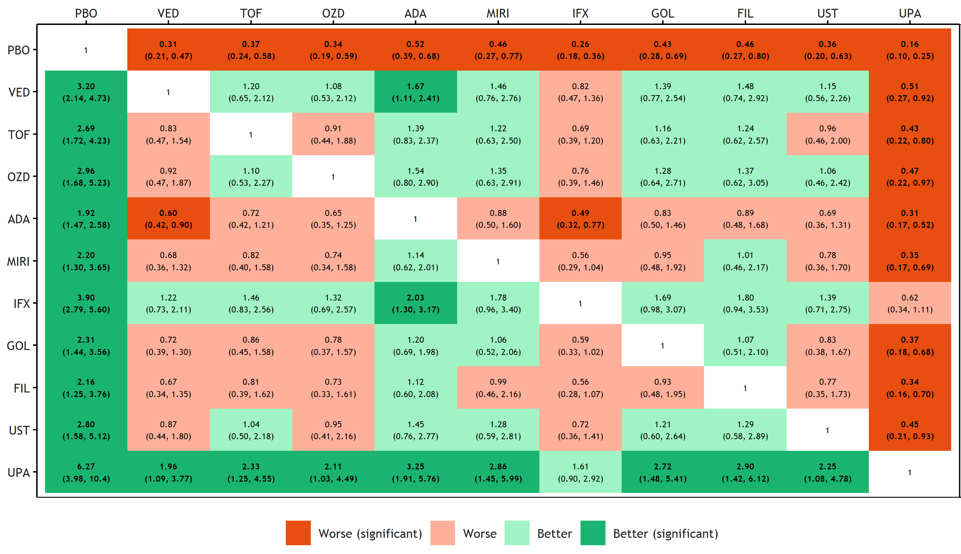

B)
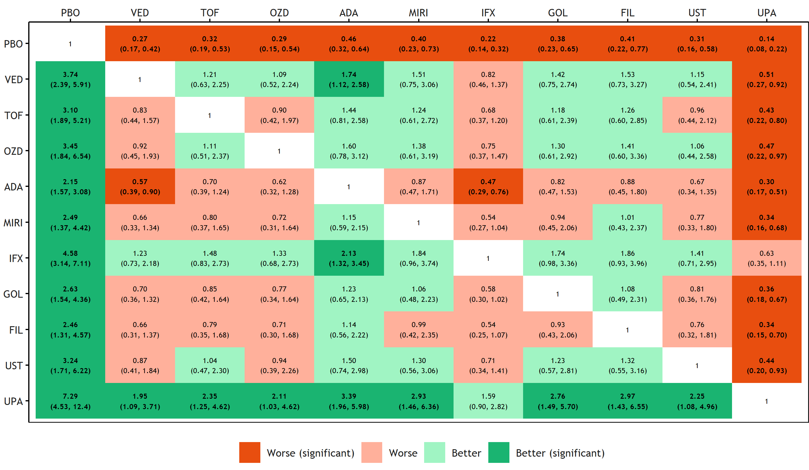

C)
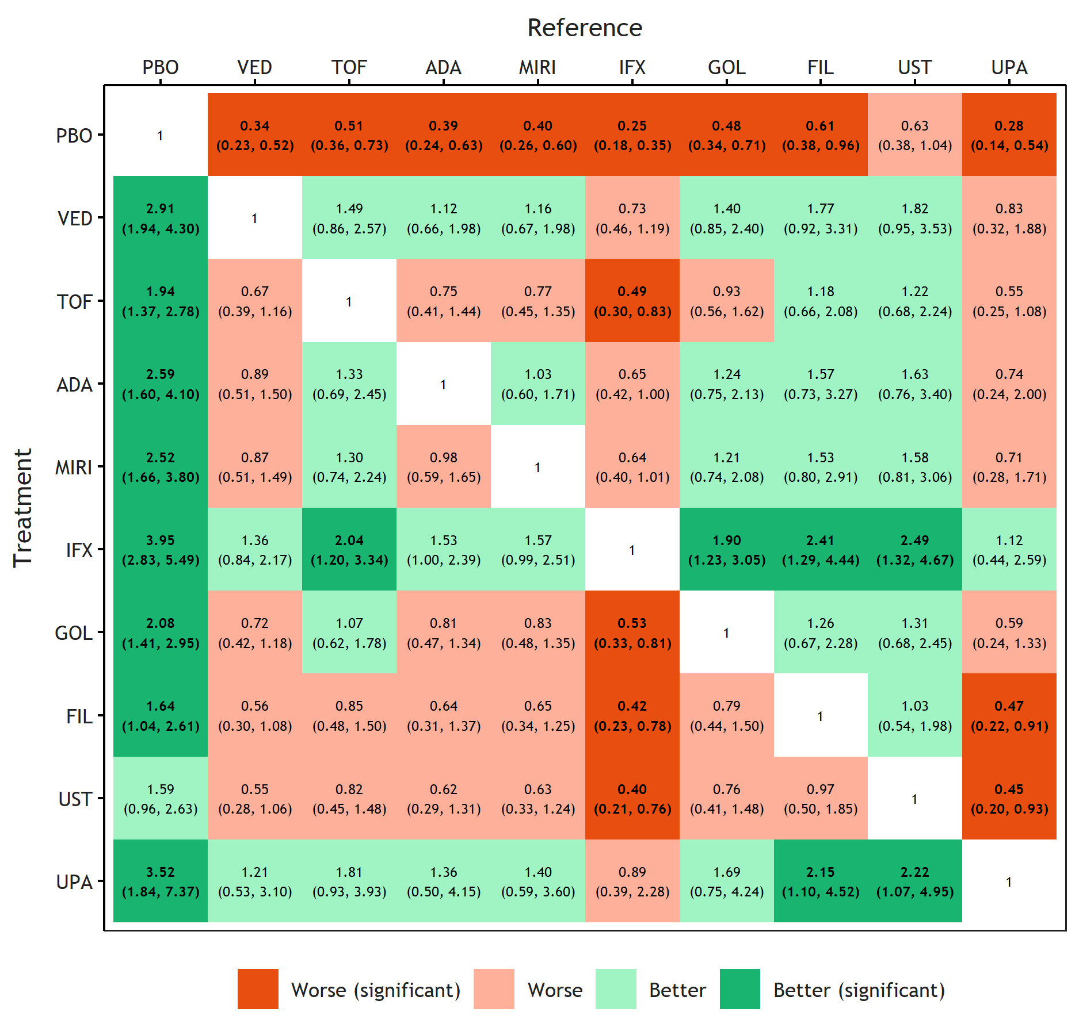

Median ORs and 95% CrIs (and associated colour shading) correspond to the comparison of row treatment versus column treatment i.e., an OR>1 illustrates a result in favour of the row treatment.
ADA, adalimumab; CrI, credible interval; FIL, filgotinib; GOL, golimumab; IFX, infliximab; JAKi, Janus kinase inhibitor; MIRI, mirikizumab; OR, odds ratio; OZD, ozanimod; PBO, placebo; TOF, tofacitinib; UPA, upadacitinib; UST, ustekinumab; VED, vedolizumab.

Supplemental Figure 2. All pairwise ORs in the induction period for the biologic/JAKi experienced population for clinical response (A), clinical remission (B) and mucosal healing (C)
A)
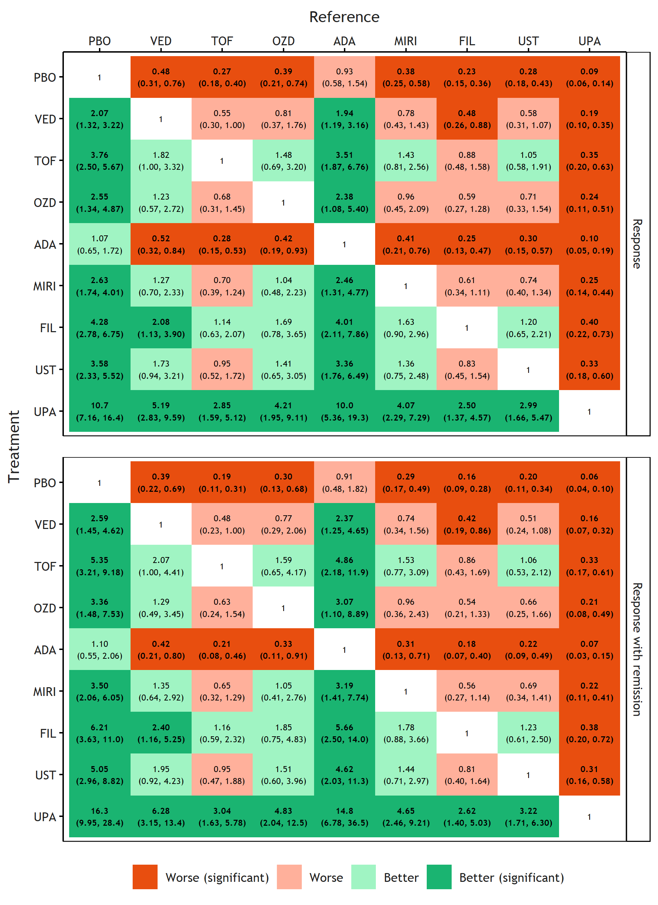
B)

C)

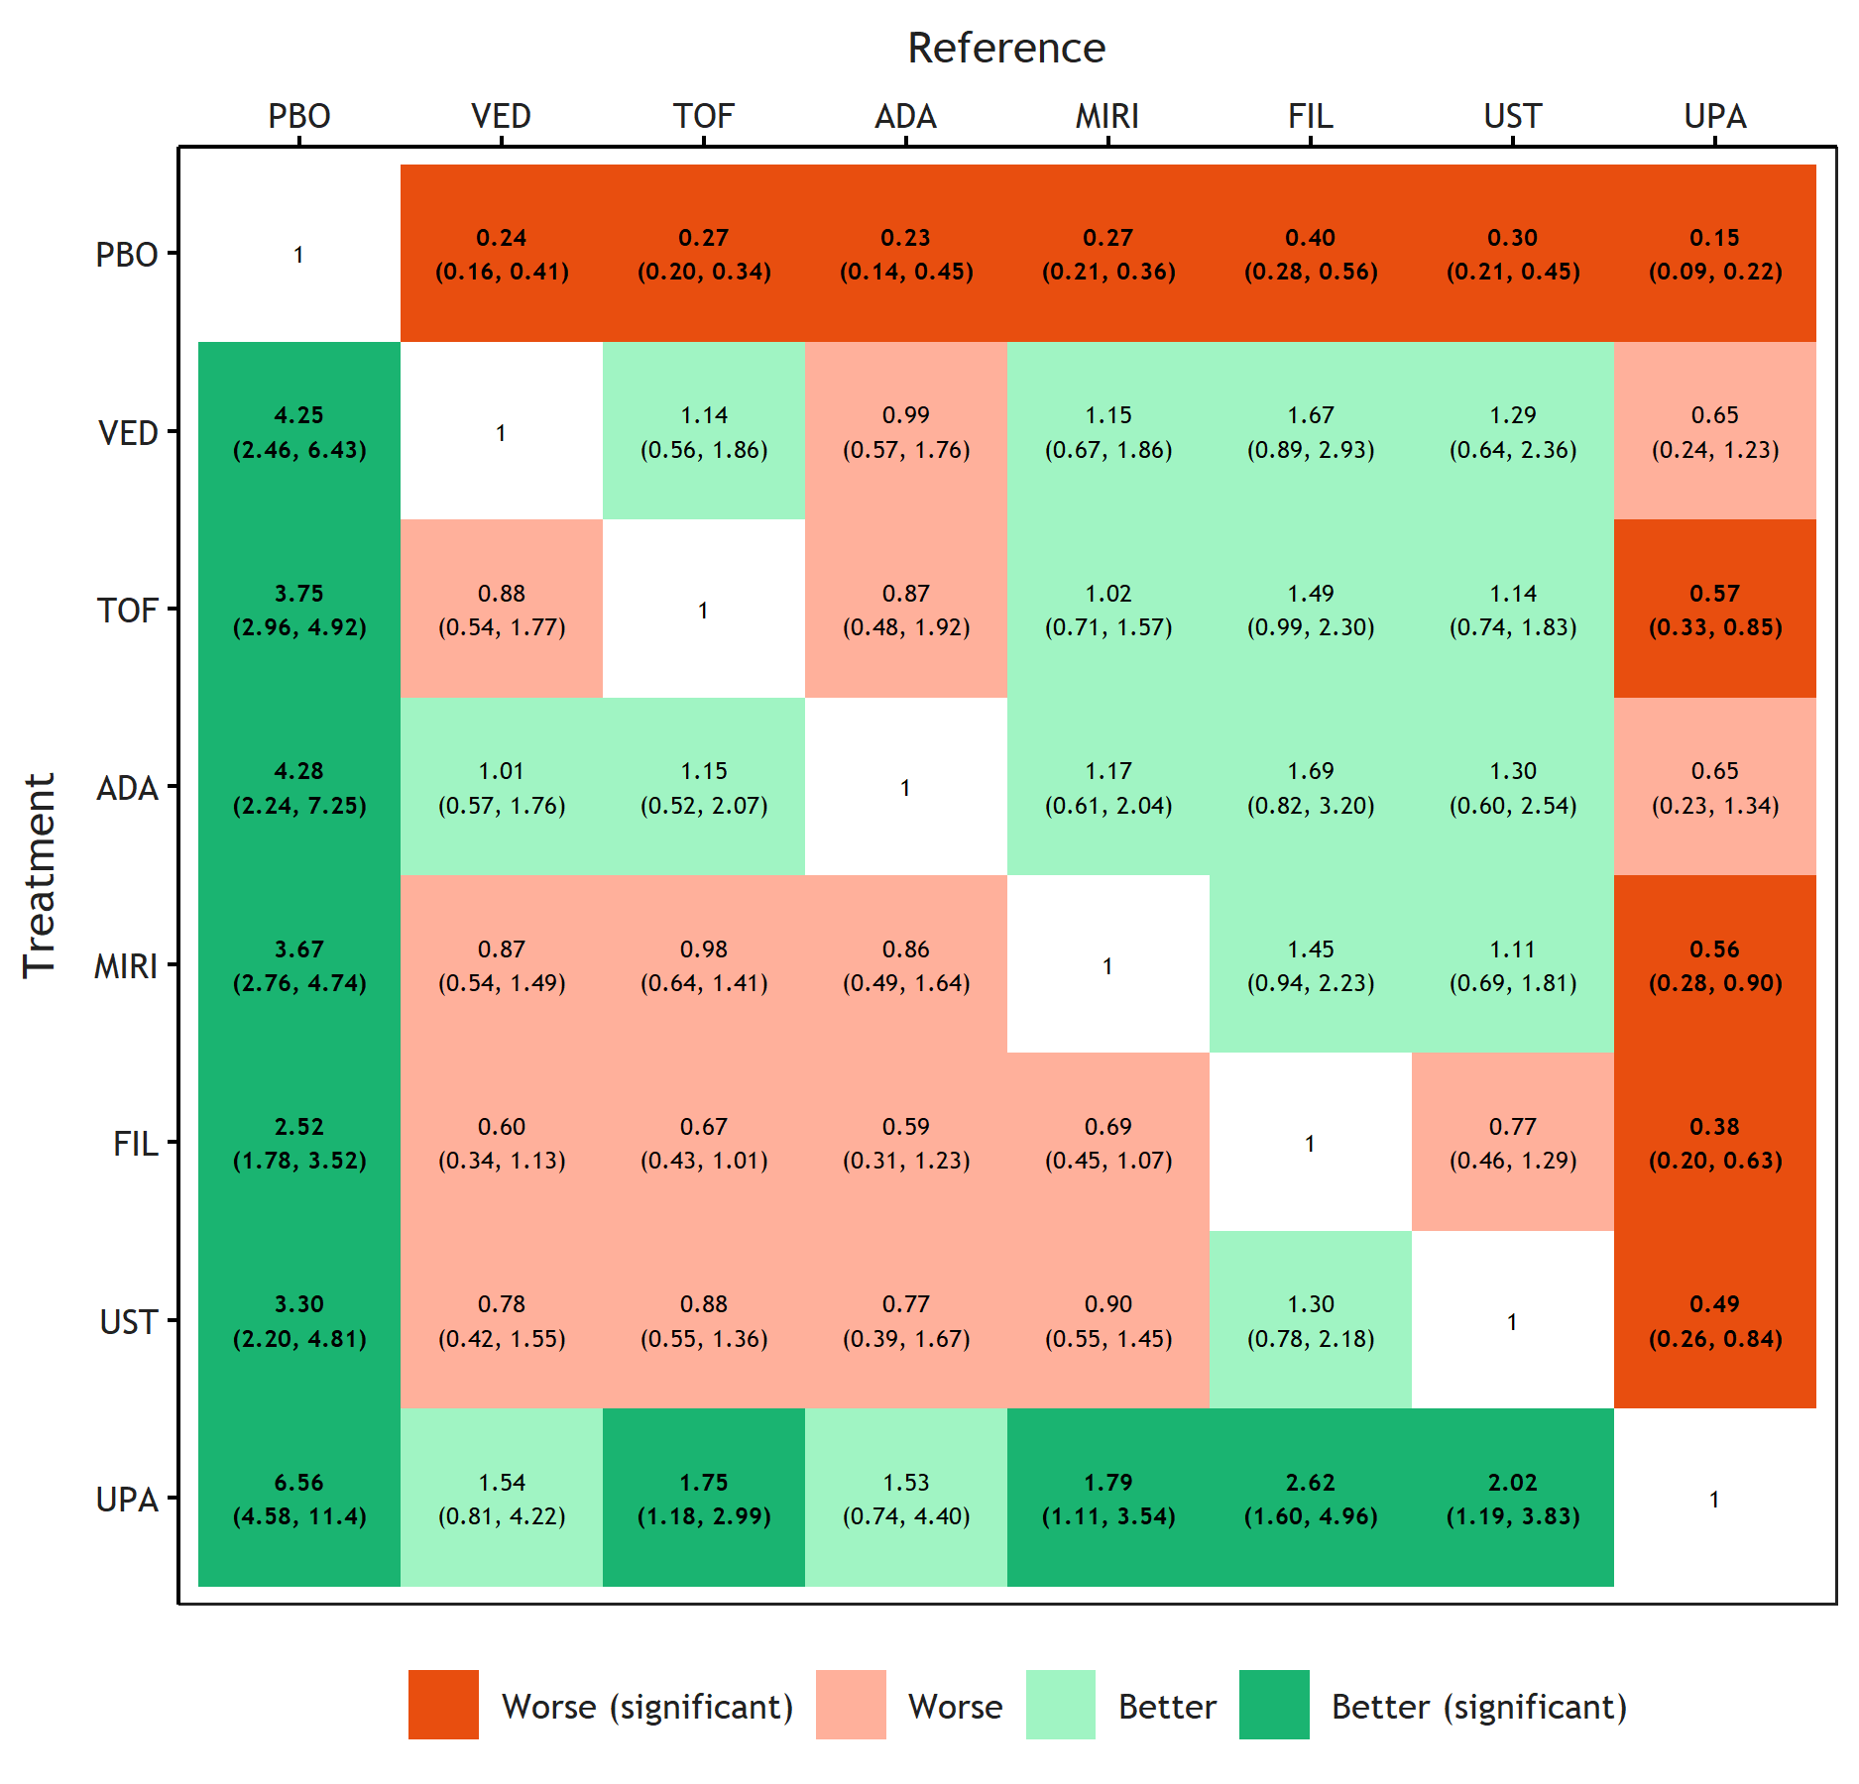
Median ORs and 95% CrIs (and associated colour shading) correspond to the comparison of row treatment versus column treatment i.e., an OR>1 illustrates a result in favour of the row treatment.
ADA, adalimumab; CrI, credible interval; FIL, filgotinib; GOL, golimumab; IFX, infliximab; JAKi, Janus kinase inhibitor; MIRI, mirikizumab; OR, odds ratio; OZD, ozanimod; PBO, placebo; TOF, tofacitinib; UPA, upadacitinib; UST, ustekinumab; VED, vedolizumab.
Supplemental Figure 3. All pairwise ORs in the maintenance period for the biologic/JAKi experienced population for clinical response (A), clinical remission (B) and mucosal healing (C)
A)
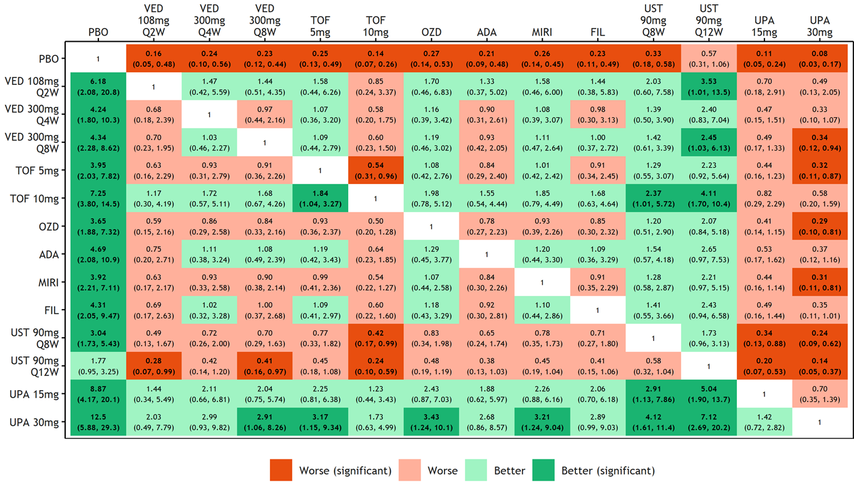

B)
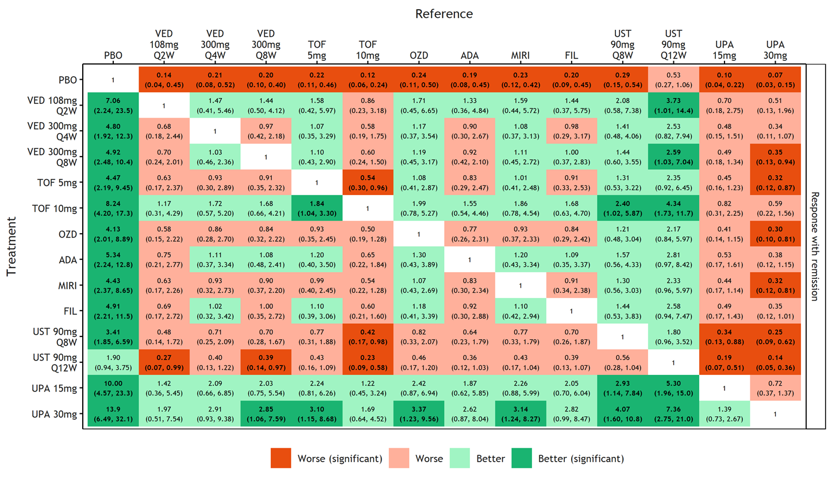

C)
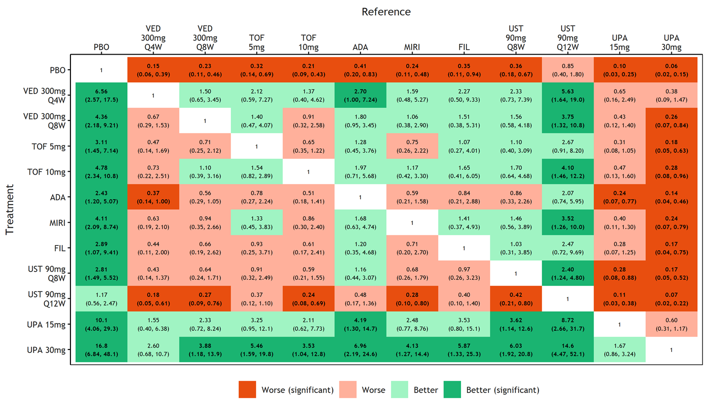

Median ORs and 95% CrIs (and associated colour shading) correspond to the comparison of row treatment versus column treatment i.e., an OR>1 illustrates a result in favour of the row treatment.
ADA, adalimumab; CrI, credible interval; FIL, filgotinib; GOL, golimumab; IFX, infliximab; JAKi, Janus kinase inhibitor; MIRI, mirikizumab; OR, odds ratio; OZD, ozanimod; PBO, placebo; Q2W, once every 2 weeks; Q4W, once every 4 weeks; Q8W, once every 8 weeks; Q12W, once every 12 weeks; TOF, tofacitinib; UPA, upadacitinib; UST, ustekinumab; VED, vedolizumab.

Supplemental Figure 4. Network plot for all cause discontinuation (A) and serious adverse events (B) in the induction period and overall population, median ORs (95% credible intervals) versus placebo for all cause discontinuations (C) and serious adverse events (D), and all pairwise ORs for all cause discontinuations (E) and serious adverse events (F).

E)
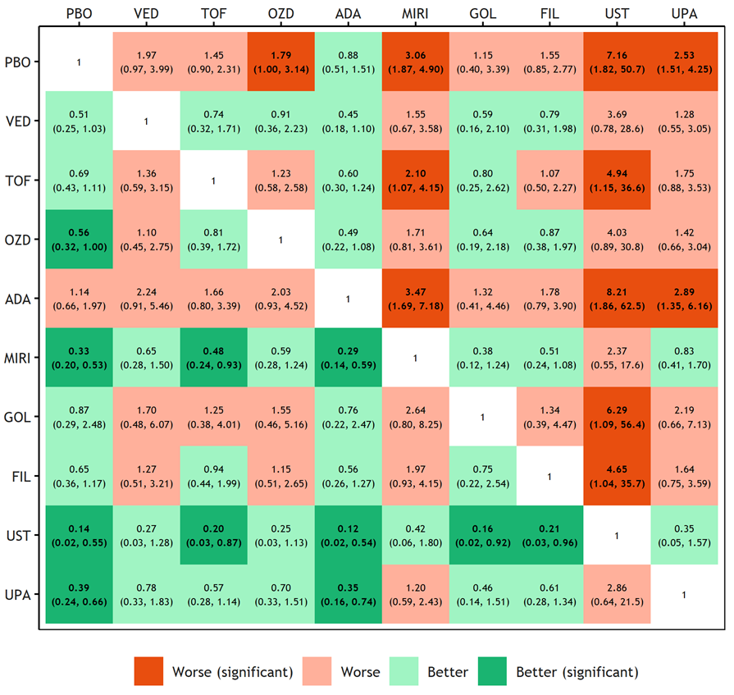

F)
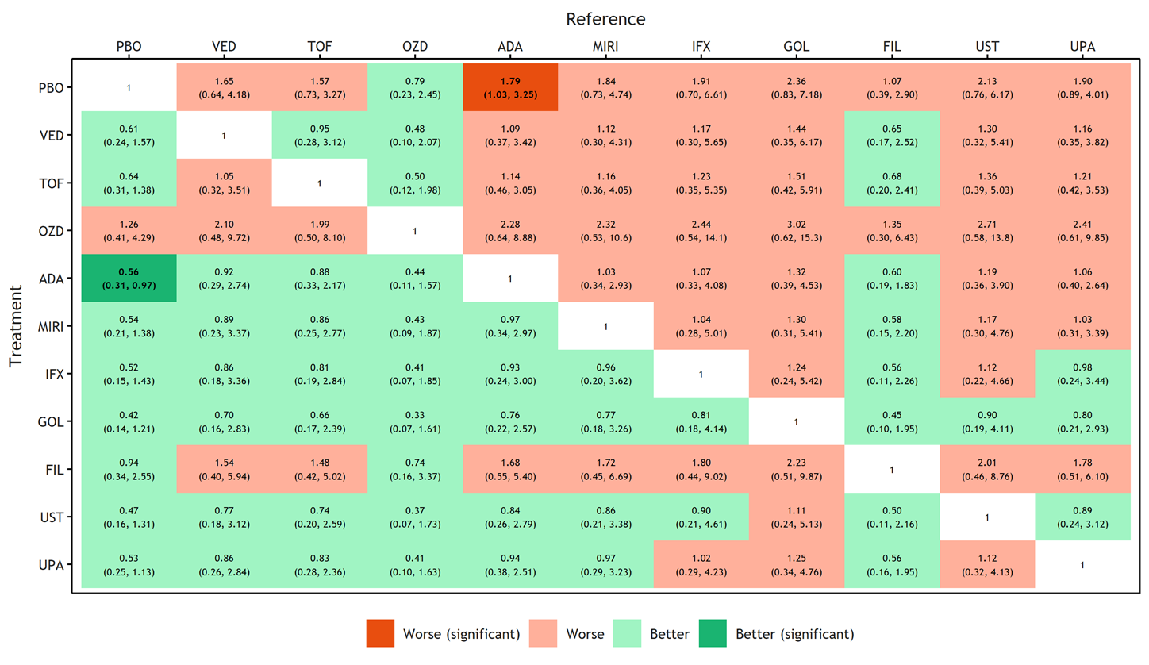
ADA, adalimumab; CrI, credible interval; FIL, filgotinib; GOL, golimumab; MIRI, mirikizumab; OR, odds ratio; OZD, ozanimod; PBO, placebo; TOF, tofacitinib; UPA, upadacitinib; UST, ustekinumab; VED, vedolizumab.

References
1. Dias S, Welton NJ, Sutton A, et al. NICE DSU Technical Support Document 5: Evidence Synthesis in the Baseline Natural History Model. NICE Decision Support Unit Technical Support Documents. National Institute for Health and Care Excellence (NICE); 2012. PMID 27466660
2. Dias S, Welton NJ, Sutton AJ, et al. NICE DSU Technical Support Document 2: A generalised linear modelling framework for pairwise and network meta-analysis of randomised controlled trials. NICE Decision Support Unit Technical Support Documents. National Institute for Health and Care Excellence (NICE); 2016. PMID 7466657
3. Dias S, Sutton AJ, Welton NJ, Ades AE. NICE DSU Technical Support Document 3: Heterogeneity—subgroups, meta-regression, bias, and bias-adjustment. NICE Decision Support Unit Technical Support Documents. National Institute for Health and Care Excellence (NICE); 2012.
4. Dias S, Welton NJ, Sutton AJ, et al. NICE DSU Technical Support Document 4: Inconsistency in networks of evidence based on randomised controlled trials. NICE Decision Support Unit Technical Support Documents. National Institute for Health and Care Excellence (NICE); 2014. PMID 27466656
5. Hoaglin DC, Hawkins N, Jansen JP, et al. Conducting indirect-treatment-comparison and network-meta-analysis studies: report of the ISPOR Task Force on Indirect Treatment Comparisons Good Research Practices: part 2. Value Health. 2011; 14:429–37. doi: 10.1016/j.jval.2011.01.011
6. Jairath V, Chan K, Lasch K, et al. Integrating efficacy and safety of vedolizumab compared with other advanced therapies to assess net clinical benefit of ulcerative colitis treatments: a network meta-analysis. Expert Rev Gastroenterol Hepatol. 2021; 15:711–22. doi: 10.1080/17474124.2021.1880319
7. Welty M, Mesana L, Padhiar A, et al. Efficacy of ustekinumab vs. advanced therapies for the treatment of moderately to severely active ulcerative colitis: a systematic review and network meta-analysis. Curr Med Res Opin. 2020; 36:595–606. doi: 10.1080/03007995.2020.1716701
8. Cholapranee A, Hazlewood GS, Kaplan GG, et al. Systematic review with meta-analysis: comparative efficacy of biologics for induction and maintenance of mucosal healing in Crohn's disease and ulcerative colitis controlled trials. Aliment Pharmacol Ther. 2017; 45:1291–302. doi: 10.1111/apt.14030
9. Lohan C, Diamantopoulos A, LeReun C, et al. Tofacitinib for the treatment of moderately to severely active ulcerative colitis: a systematic review, network meta-analysis and economic evaluation. BMJ Open Gastroenterol. 2019; 6:e000302. doi: 10.1136/bmjgast-2019-000302
10. Archer R, Tappenden P, Ren S, et al. Infliximab, adalimumab and golimumab for treating moderately to severely active ulcerative colitis after the failure of conventional therapy (including a review of TA140 and TA262): clinical effectiveness systematic review and economic model. Health Technol Assess. 2016; 20:1–326. doi:10.3310/hta20390
11. Vickers AD, Ainsworth C, Mody R, et al. Systematic review with network meta-analysis: comparative efficacy of biologics in the treatment of moderately to severely active ulcerative colitis. PLoS One. 2016; 11:e0165435. doi:10.1371/journal.pone.0165435
12. Panaccione R, Collins EB, Melmed GY,et al. Efficacy and safety of advanced therapies for moderately to severely active ulcerative colitis at induction and maintenance: an indirect treatment comparison using bayesian network meta-analysis. Crohns Colitis 2023; 360:5:1–17. doi.org/10.1093/crocol/otad009
13. Sandborn WJ, Ferrante M, Bhandari BR, et al. Efficacy and safety of mirikizumab in a randomized phase 2 study of patients with ulcerative colitis. Gastroenterology 2020; 158:537–49.e10. doi: 10.1053/j.gastro.2019.08.043
14. Armuzzi A, De Pascalis B, Lupascu A, et al. Infliximab in the treatment of steroid-dependent ulcerative colitis. Eur Rev Med Pharmacol Sci. 2004; 8:231–3. PMID 1563836
15. Atreya R, Peyrin-Biroulet L, Klymenko A, et al. Cobitolimod for moderate-to-severe, left-sided ulcerative colitis (CONDUCT): a phase 2b randomised, double-blind, placebo-controlled, dose-ranging induction trial. Lancet Gastroenterol Hepatol. 2020; 5:1063–15. doi: 10.1016/S2468-1253(20)30301-0
16. Williams JG, Alam MF, Alrubaiy L, et al. Infliximab versus ciclosporin for steroid-resistant acute severe ulcerative colitis (CONSTRUCT): a mixed methods, open-label, pragmatic randomised trial. Lancet Gastroenterol Hepatol. 2016; 1:15–24. doi: 10.1016/S2468-1253(16)30003-6
17. Danese S, Neurath MF, Kopoń A, et al. Effects of apremilast, an oral inhibitor of phosphodiesterase 4, in a randomized trial of patients with active ulcerative colitis. Clin Gastroenterol Hepatol. 2020; 18:2526–34.e9. doi: 10.1016/j.cgh.2019.12.032
18. Florholmen J, Øverland G, Olsen T, et al. Short-and long-term clinical outcomes of infliximab in fulminant ulcerative colitis. Ulcers 2011. Article ID 156407. doi: 10.1155/2011/156407
19. Kobayashi T, Motoya S, Nakamura S, et al. Discontinuation of infliximab in patients with ulcerative colitis in remission (HAYABUSA): a multicentre, open-label, randomised controlled trial. Lancet Gastroenterol Hepatol. 2021; 6:429–37. doi: 10.1016/S2468-1253(21)00062-5
20. Laharie D, Bourreille A, Branche J, et al. Ciclosporin versus infliximab in patients with severe ulcerative colitis refractory to intravenous steroids: A parallel, open-label randomised controlled trial. Lancet 2012; 380:1909–15. doi: 10.1016/S0140-6736(12)61084-8
21. Danese S, Panaccione R, D’Haens G, et al. DOP42 Efficacy and safety of deucravacitinib, an oral, selective tyrosine kinase 2 inhibitor, in patients with moderately-to-severely active ulcerative colitis: 12-week results from the Phase 2 LATTICE-UC study. J Crohns Colitis. 2022; 16(Supplement_1):i091–2. doi.org/10.1093/ecco-jcc/jjab232.081
22. Syversen SW, Goll GL, Jørgensen KK, et al. Effect of therapeutic drug monitoring vs. standard therapy during infliximab induction on disease remission in patients with chronic immune-mediated inflammatory diseases: a randomized clinical trial. JAMA. 2021; 325:1744–54. doi: 10.1001/jama.2021.4172
23. Jørgensen KK, Olsen IC, Goll GL, et al. Switching from originator infliximab to biosimilar CT-P13 compared with maintained treatment with originator infliximab (NOR-SWITCH): a 52-week, randomised, double-blind, non-inferiority trial. Lancet 2017; 389:2304–16. doi: 10.1016/S0140-6736(17)30068-5
24. Sandborn WJ, Peyrin-Biroulet L, Zhang J, et al. Efficacy and safety of etrasimod in a phase 2 randomized trial of patients with ulcerative colitis. Gastroenterology 2020; 158:550–61. doi: 10.1053/j.gastro.2019.10.035
25. Ochsenkühn T, Sackmann M, Göke B. Infliximab for acute, not steroid-refractory ulcerative colitis: A randomized pilot study. Eur J Gastroenterol Hepatol 2004; 16:1167–71. doi: 10.1097/00042737-200411000-00014
26. Parikh A, Leach T, Wyant T, et al. Vedolizumab for the treatment of active ulcerative colitis: A randomized controlled phase 2 dose-ranging study. Inflamm Bowel Dis. 2012; 18:1470–79. doi: 10.1002/ibd.21896
27. Strik AS, Löwenberg M, Mould DR, et al. Efficacy of dashboard driven dosing of infliximab in inflammatory bowel disease patients; a randomized controlled trial. Scand J Gastroenterol. 2021; 56:145–54. doi: 10.1080/00365521.2020.1856405
28. Rutgeerts P, Feagan BG, Marano CW, et al. Randomised clinical trial: A placebo-controlled study of intravenous golimumab induction therapy for ulcerative colitis. Aliment Pharmacol Ther. 2015; 42:504–14. doi: 10.1111/apt.13291
29. Vermeire S, Su C, Lawendy N, et al. Outcomes of tofacitinib dose reduction in patients with ulcerative colitis in stable remission from the randomised RIVETING trial. J Crohns Colitis 2021;15:1130–41. doi: 10.1093/ecco-jcc/jjaa249
30. Roblin X, Boschetti G, Williet N, et al. Azathioprine dose reduction in inflammatory bowel disease patients on combination therapy: an open-label, prospective and randomised clinical trial. Aliment Pharmacol Ther. 2017; 46:142–9. doi: 10.1111/apt.14106
31. Sands BE, Tremaine WJ, Sandborn WJ, et al. Infliximab in the treatment of severe, steroid-refractory ulcerative colitis: a pilot study. Inflamm Bowel Dis. 2001; 7:83–8. doi: 10.1097/00054725-200105000-00001
32. Schreiber S, Ben-Horin S, Leszczyszyn J, et al. Randomized controlled trial: subcutaneous vs intravenous infliximab CT-P13 maintenance in inflammatory bowel disease. Gastroenterology 2021; 160:2340–53. doi: 10.1053/j.gastro.2021.02.068
33. Panés J, Colombel J-F, D’Haens GR, et al. Higher vs standard adalimumab induction and maintenance dosing regimens for treatment of ulcerative colitis: SERENE UC trial results. Gastroenterology 2022; 162:1891–910. doi: 10.1053/j.gastro.2022.02.033.
34. Silva RPL, Bissoli GC, Farinelli E, et al. Infliximab versus adalimumab: Clinical and endoscopy response in ulcerative colitis patients. A prospective study. Conference Abstract. J Crohns Colitis. 2017; 11:S496.
35. Sandborn WJ, Feagan BG, Hanauer S, et al. Long-term efficacy and safety of ozanimod in moderately to severely active ulcerative colitis: results from the open-label extension of the randomized, phase 2 TOUCHSTONE study. J Crohns Colitis. 2021; 15:1120–9. doi:10.1093/ecco–jcc/jjab012
36. Reinisch W, Sandborn WJ, Danese, et al. Long-term safety and efficacy of the anti-MAdCAM-1 monoclonal antibody ontamalimab [SHP647] for the treatment of ulcerative colitis: The open-label study TURANDOT II. J Crohns Colitis. 2021; 15:938–49. doi: 10.1093/ecco-jcc/jjab023
37. Vermeire S, Sandborn WJ, Danese S, et al. Anti-MAdCAM antibody (PF-00547659) for ulcerative colitis (TURANDOT): a phase 2, randomised, double-blind, placebo-controlled trial. Lancet 2017; 390:135–44. doi: 10.1016/S0140-6736(17)30930-3
38. Panaccione R, Ghosh S, Middleton S, et al. Combination therapy with infliximab and azathioprine is superior to monotherapy with either agent in ulcerative colitis. Gastroenterology 2014; 146:32–400.e393. 9 doi: 10.1053/j.gastro.2013.10.052
39. Vermeire S, Ghosh S, Panes J, et al. The mucosal address in cell adhesion molecule antibody PF-00547,659 in ulcerative colitis: A randomised study. Gut 2011; 60:1068–75. doi: 10.1136/gut.2010.226548
40. Vermeire S, O'Byrne S, Keir M, et al. Etrolizumab as induction therapy for ulcerative colitis: a randomised, controlled, phase 2 trial. Lancet 2014; 384:309–18. doi: 10.1016/S0140-6736(14)60661-9
41. Rutgeerts P, Sandborn WJ, Feagan BG, et al. Infliximab for induction and maintenance therapy for ulcerative colitis. N Eng J Med. 2005; 353:2462–76. doi: 10.1056/NEJMoa050516
42.Feagan BG, Rutgeerts P, Sands BE, et al. Vedolizumab as induction and maintenance therapy for ulcerative colitis. New Engl J Med 2013; 369:699–710. doi: 10.1056/NEJMoa1215734
43. Rubin DT, Raine T, Finney-Hayward T, et al. S854 upadacitinib is effective at inducing clinical remission and response in ulcerative colitis patients regardless of baseline corticosteroid use: results from two Phase 3 studies. Am J Gastroenterol. 2021; 116:S398. 10.14309/01.ajg.0000776948.02517.78
44. Jiang X-L, Cui H-F, Gao J, et al. Low-dose infliximab for induction and maintenance treatment in chinese patients with moderate to severe active ulcerative colitis. J Clin Gastroenterol. 2015; 49:582–8. doi: 10.1097/MCG.0000000000000319
45. Kobayashi T, Suzuki Y, Motoya S, et al. First trough level of infliximab at week 2 predicts future outcomes of induction therapy in ulcerative colitis-results from a multicenter prospective randomized controlled trial and its post hoc analysis. J Gastroenterol. 2016; 51:241–51. doi: 10.1007/s00535-015-1102-z
46. D’Haens G, Dubinsky M, Kobayashi T, et al. Mirikizumab as induction and maintenance therapy for ulcerative colitis. N Engl J Med. 2023; 388:2444–55. doi: 10.1056/NEJMoa2207940
47. Motoya S, Watanabe K, Ogata H, et al. Vedolizumab in Japanese patients with ulcerative colitis: A Phase 3, randomized, double-blind, placebo-controlled study. PLoS One. 2019; 14:e0212989. doi: 10.1371/journal.pone.0212989
48. Sandborn WJ, Su C, Sands BE, et al. Tofacitinib as induction and maintenance therapy for ulcerative colitis. N Eng J Med. 2017; 376:1723–36. doi: 10.1056/NEJMc1707500
49. Probert CS, Hearing SD, Schreiber S, et al. Infliximab in moderately severe glucocorticoid resistant ulcerative colitis: a randomised controlled trial. Gut 2003; 52:998–1002. doi: 10.1136/gut.52.7.998
50. Sandborn WJ, Feagan BG, Marano C, et al. Subcutaneous golimumab induces clinical response and remission in patients with moderate-to-severe ulcerative colitis. Gastroenterology 2014; 146:85–95; quiz e14–5. doi: 10.1053/j.gastro.2013.05.048.
51. Sandborn WJ, van Assche G, Reinisch W, et al. Adalimumab induces and maintains clinical remission in patients with moderate-to-severe ulcerative colitis. Gastroenterology 2012; 142:257–65. doi: 10.1053/j.gastro.2011.10.032
52. Feagan BG, Danese S, Loftus EV, Jr, et al. Filgotinib as induction and maintenance therapy for ulcerative colitis (SELECTION): a phase 2b/3 double-blind, randomised, placebo-controlled trial. Lancet 2021; 397:2372–84. doi: 10.1016/S0140-6736(21)00666-8
53. Suzuki Y, Motoya S, Hanai H, et al. Efficacy and safety of adalimumab in Japanese patients with moderately to severely active ulcerative colitis. J Gastroenterol. 2014; 49:283–94. doi: 10.1007/s00535-013-0922-y
54. Sandborn WJ, Ghosh S, Panes J, et al. Tofacitinib, an oral Janus kinase inhibitor, in active ulcerative colitis. N Eng J Med. 2012; 367:616–24. doi: 10.1056/NEJMoa1112168
55. Danese S, Vermeire S, Zhou W, et al. Upadacitinib as induction and maintenance therapy for moderately to severely active ulcerative colitis: results from three phase 3, multicentre, double-blind, randomised trials. Lancet 2022; 399:2113–28. doi: 10.1016/S0140-6736(22)00581-5
56. Sandborn WJ, Ghosh S, Panes J, et al. Efficacy of upadacitinib in a randomized trial of patients with active ulcerative colitis. Gastroenterology 2020; 158:2139–49.e14. doi: 10.1053/j.gastro.2020.02.030
57. Reinisch W, Sandborn WJ, Hommes DW, et al. Adalimumab for induction of clinical remission in moderately to severely active ulcerative colitis: results of a randomised controlled trial. Gut 2011; 60:780–7. doi: 10.1136/gut.2010.221127
58. Sandborn WJ, Ghosh S, Panes J, et al. Tofacitinib, an oral Janus kinase inhibitor, in active ulcerative colitis. N Eng J Med. 2012; 367:616–24.
59. Sands BE, Sandborn WJ, Panaccione R, et al. Ustekinumab as induction and maintenance therapy for ulcerative colitis. N Engl J Med. 2019; 381:1201–14. doi: 10.1056/NEJMoa1900750
60. Sands BE, Peyrin-Biroulet L, Loftus EV Jr, et al. Vedolizumab versus adalimumab for moderate-to-severe ulcerative colitis. N Engl J Med. 2019; 381:1215–26. doi: 10.1056/NEJMoa1905725
61. Hibi T, Imai Y, Senoo A, et al. Efficacy and safety of golimumab 52-week maintenance therapy in Japanese patients with moderate to severely active ulcerative colitis: a phase 3, double-blind, randomized, placebo-controlled study-(PURSUIT-J study). J Gastroenterol. 2017; 52:1101–11. doi: 10.1007/s00535-017-1326-1
62. Sandborn WJ, Feagan BG, Marano C, et al. Subcutaneous golimumab maintains clinical response in patients with moderate-to severe ulcerative colitis. Gastroenterology 2014; 146:96–109.e1. doi: 10.1053/j.gastro.2013.06.010
63. Sandborn WJ, Baert F, Danese S, et al. Efficacy and safety of vedolizumab subcutaneous formulation in a randomized trial of patients with ulcerative colitis. Gastroenterology 2020; 158:562–72.e12. doi: 10.1053/j.gastro.2019.08.027

