Supplementary Material

Title: Patient-reported outcomes for patients with previously treated small-cell lung cancer receiving tarlatamab: Results from the DeLLphi-301 Phase 2, single arm trial
Author details (names, affiliations, and addresses):
Horst-Dieter Hummel¹, Myung-Ju Ahn², Fiona Blackhall³, Martin Reck⁴, Hiroaki Akamatsu⁵, Suresh Ramalingam⁶, Hossein Borghaei⁷, Melissa Johnson⁸, Franziska Dirnberger⁹, Kim Cocks¹⁰, Shuang Huang¹¹, Sujoy Mukherjee¹², Luis Paz-Ares¹³

¹ Translational Oncology/Early Clinical Trial Unit (ECTU), Bavarian Cancer Research Center, National Center for Tumor Diseases, Comprehensive Cancer Center Mainfranken and University Hospital Würzburg, Würzburg, Germany
;
² Samsung Medical Center, Sungkyunkwan University School of Medicine, Section of Hematology-Oncology, Department of Medicine, Seoul, Korea;
³Department of Medical Oncology, The Christie NHS Foundation Trust, Division of Cancer Sciences, University of Manchester, Manchester, UK;
⁴ Airway Research Center North (ARCN), German Center for Lung Research (DZL), LungenClinic , Großhansdorf, Germany;
⁵ Wakayama Medical University Hospital, Wakayama (H.A.), Japan;
⁶ Winship Cancer Institute of Emory University, Atlanta (S.S.R.), USA;
⁷Fox Chase Cancer Center, Philadelphia, PA, USA;
⁸ Sarah Cannon Research Institute, Tennessee Oncology, Nashville, TN, USA;
⁹ Amgen GmbH, Munich, Germany;
¹⁰ Adelphi Values Ltd, Patient-Centered Outcomes, Bollington, Cheshire, UK;
¹¹⁻¹² Amgen, Inc., Thousand Oaks, CA, USA;
¹³ Hospital Universitario 12 de Octubre, CNIO-H120 Lung Cancer Unit, Ciberonc and 21 Universidad Complutense, Madrid, Spain;

Correspondence details: Horst-Dieter Hummel, Translational Oncology, Early Clinical Trial Unit (ECTU), Comprehensive Cancer Center Mainfranken, University Hospital Wuerzburg, Haus A9, Ebene 2, Straubmühlweg 2a, 97078 Würzburg, mail: hummel_h@ukw.de

Supplementary Figures

Figure S 1: Mean change from baseline (descriptive analysis) for
- QLQ-C30 GHS/QOL and physical functioning
- QLQ-LC13/C30 cough, chest pain, and dyspnea

A
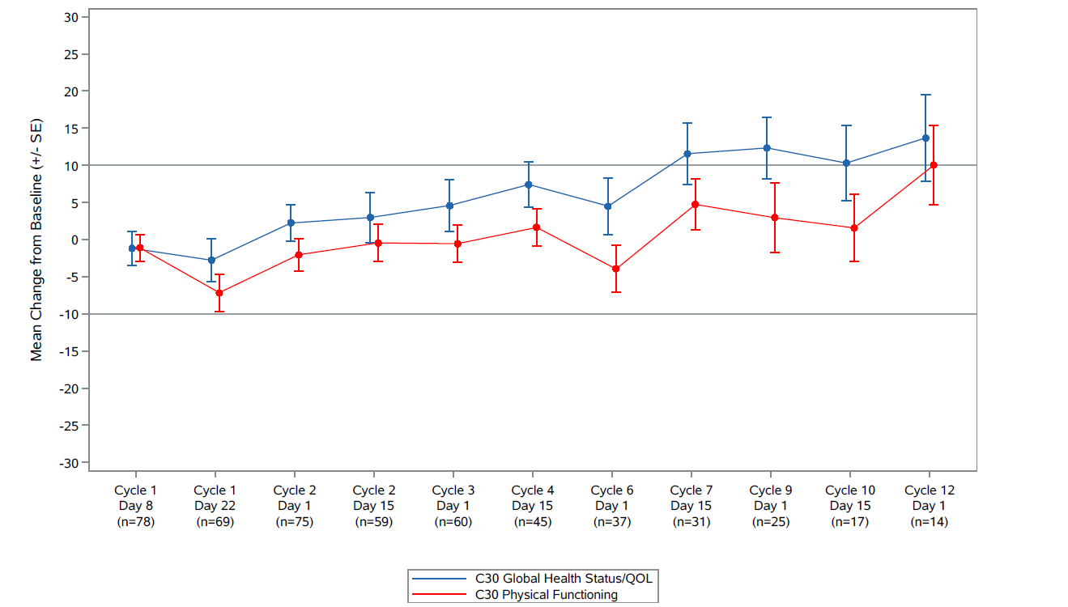
B
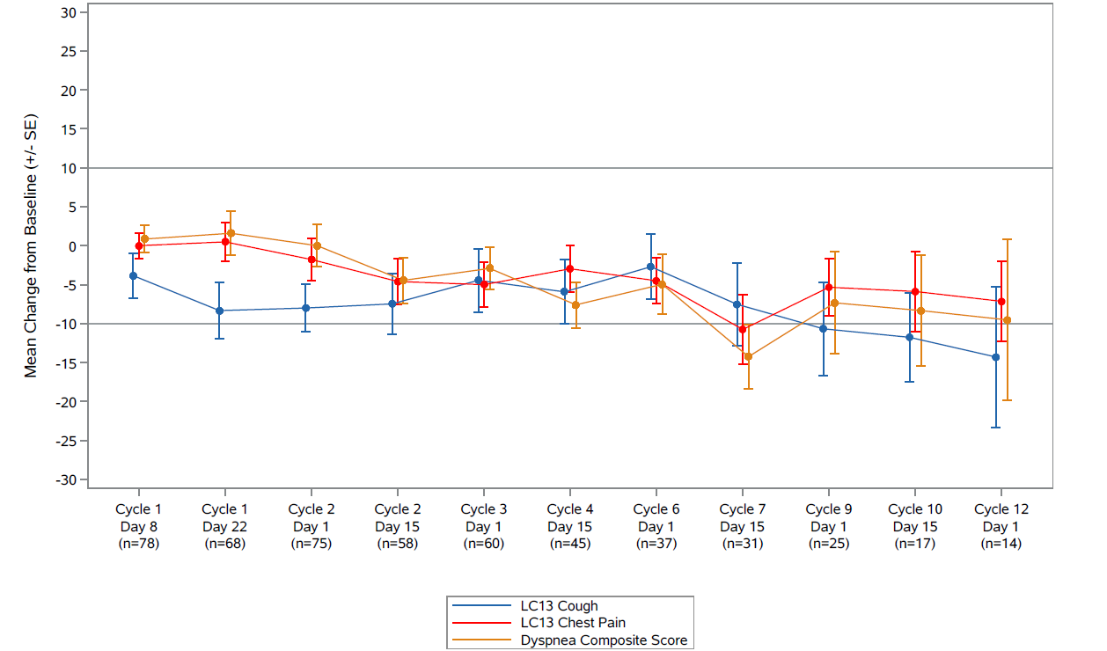
For GHS/functioning scales a positive change represents improvement; for symptom scales a negative change represents improvement.
Figure S 2: QLQ-C30 functional and symptoms least squares mean change from baseline
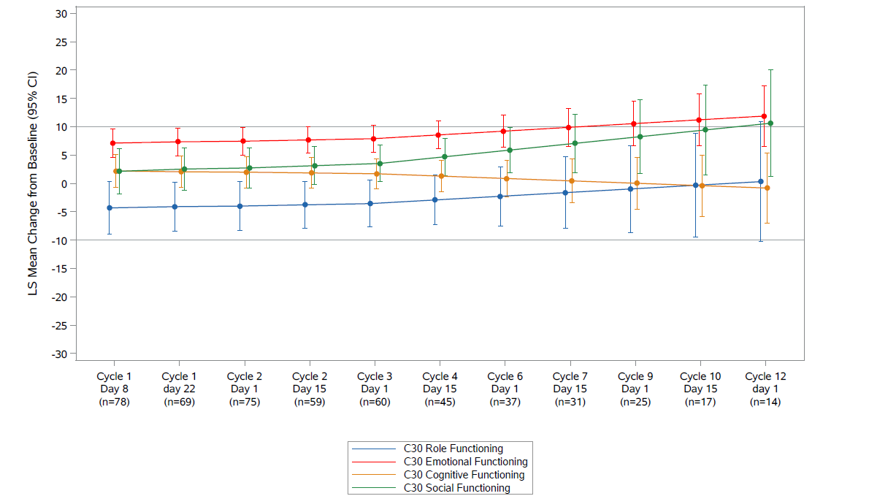
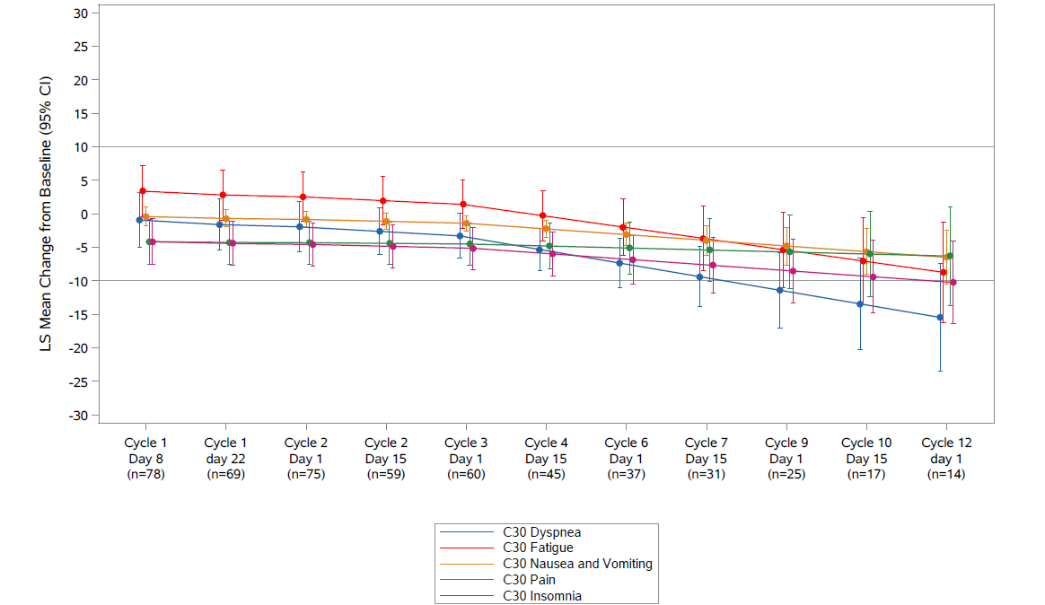
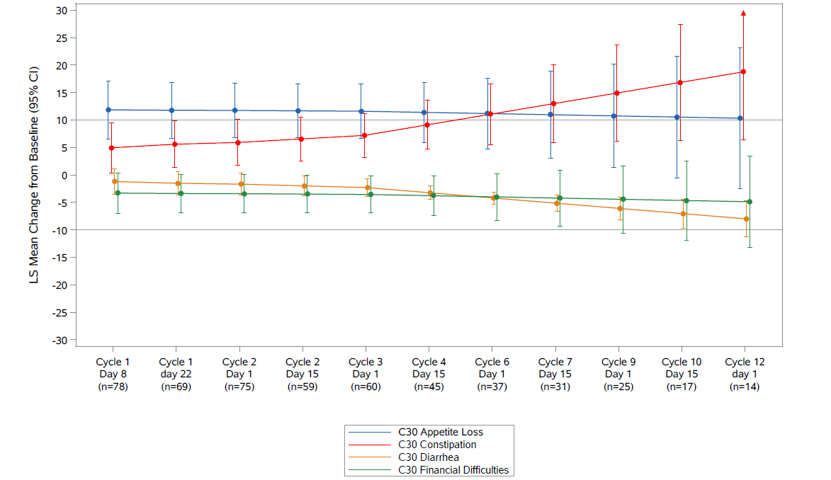
For GHS/functioning scales a positive change represents improvement; for symptom scales a negative change represents improvement.

Figure S 3: QLQ-LC13 symptoms least squares mean change from baseline
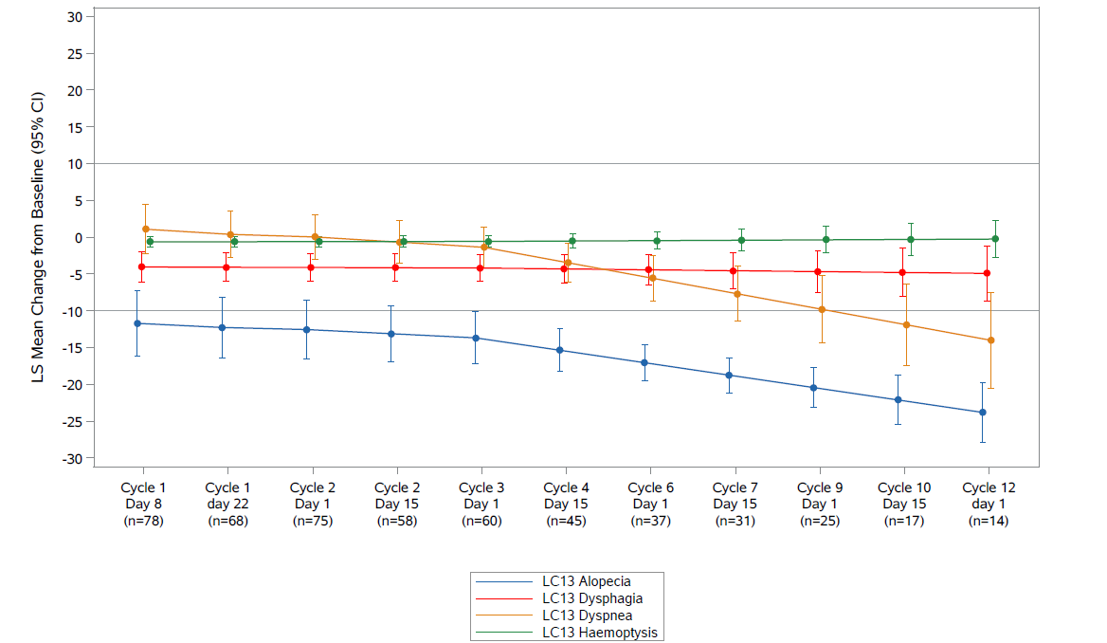
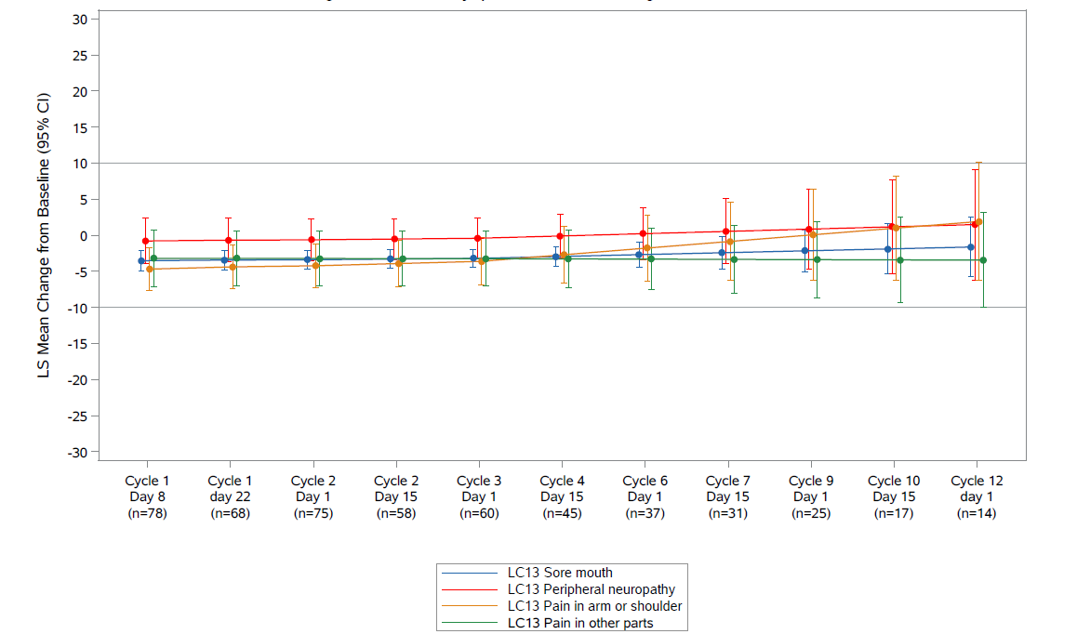

For symptom scales a negative change represents improvement.

Figure S 4: PRO-CTCAE item frequency (arm or leg swelling, palpitations, headache, anxiety, and shivering/shaking chills) and presence (rash)
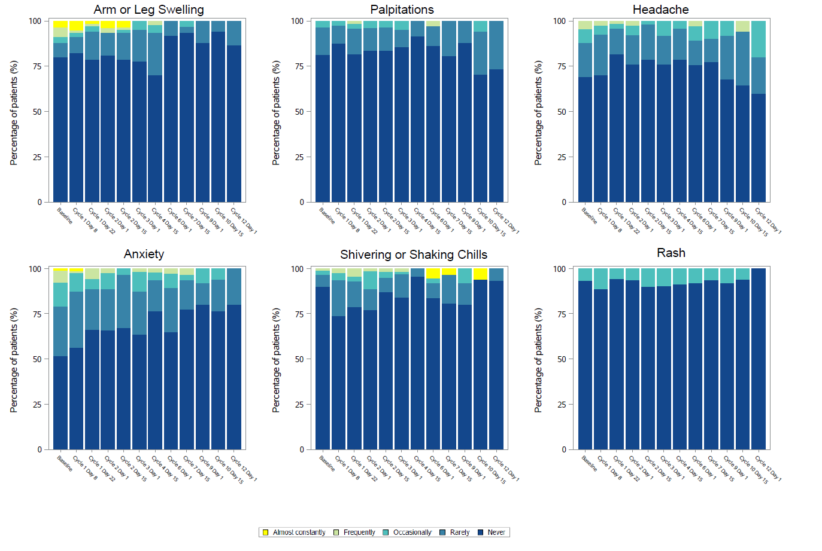
Figure S 5: PRO-CTCAE item severity (arm or leg swelling, palpitations, headache, anxiety, shivering/shaking chills, concentration)
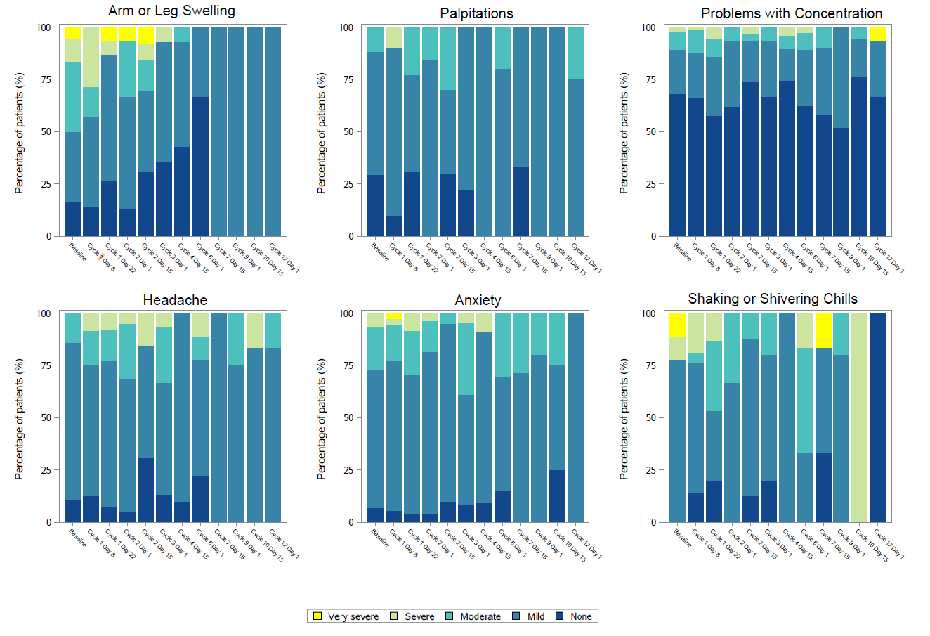

Figure S 6: PRO-CTCAE item interference (arm or leg swelling, headache, anxiety, concentration)
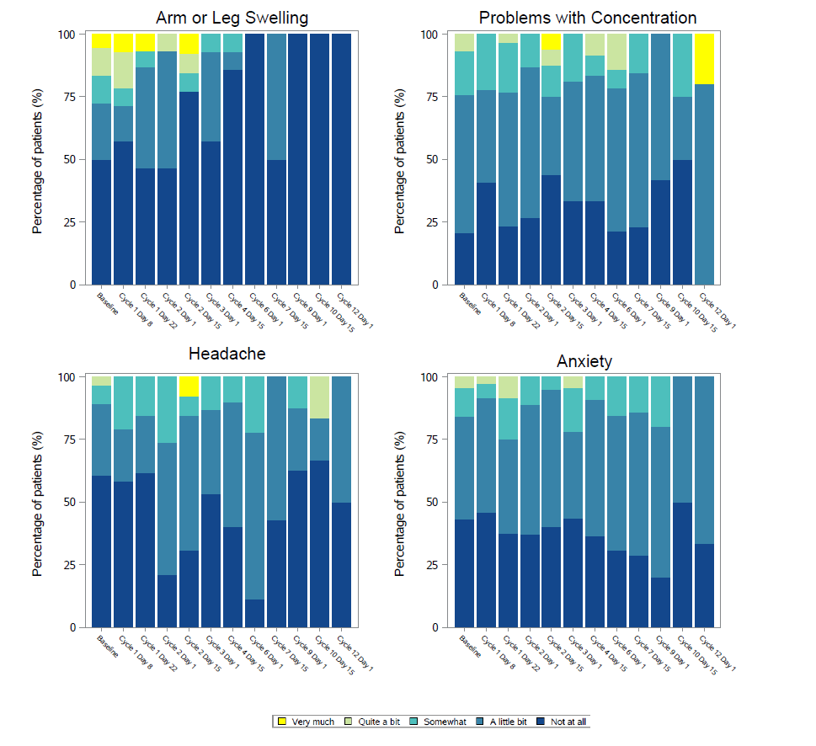

Supplementary Tables

Table S1: Available data and Completion rates of PRO
Visit | QLQ-C30 |  |  | QLQ-LC13 |  |  | PRO-CTCAE | FACT-GP5
Visit | Available data rate | Completion rate | Available data rate |  | Completion rate | Available data rate |  | Available data rate
Baseline | 92/100 (92.0%) | 92/99 (92.9%) | 91/100 (91.0%) |  | 91/99 (91.9%) | 91/100 (91.0%) |  | 91/100 (91.0%)
Cycle 1 Day 8 | 80/100 (80.0%) | 80/93 (86.0%) | 80/100 (80.0%) |  | 80/93 (86.0%) | 80/100 (80.0%) |  | 80/100 (80.0%)
Cycle 1 Day 22 | 73/100 (73.0%) | 73/89 (82.0%) | 72/100 (72.0%) |  | 72/89 (80.9%) | 72/100 (72.0%) |  | 72/100 (72.0%)
Cycle 2 Day 1 | 81/100 (81.0%) | 81/85 (95.3%) | 80/100 (80.0%) |  | 80/85 (94.1%) | 80/100 (80.0%) |  | 80/100 (80.0%)
Cycle 2 Day 15 | 74/100 (74.0%) | 74/80 (92.5%) | 72/100 (72.0%) |  | 72/80 (90.0%) | 72/100 (72.0%) |  | 72/100 (72.0%)
Cycle 3 Day 1 | 73/100 (73.0%) | 73/76 (96.1%) | 73/100 (73.0%) |  | 73/76 (96.1%) | 73/100 (73.0%) |  | 73/100 (73.0%)
Cycle 4 Day 15 | 57/100 (57.0%) | 57/64 (89.1%) | 57/100 (57.0%) |  | 57/64 (89.1%) | 57/100 (57.0%) |  | 57/100 (57.0%)
Cycle 6 Day 1 | 48/100 (48.0%) | 48/53 (90.6%) | 47/100 (47.0%) |  | 47/53 (88.7%) | 47/100 (47.0%) |  | 47/100 (47.0%)
Cycle 7 Day 15 | 40/100 (40.0%) | 40/43 (93.0%) | 40/100 (40.0%) |  | 40/43 (93.0%) | 40/100 (40.0%) |  | 40/100 (40.0%)
Cycle 9 Day 1 | 30/100 (30.0%) | 30/34 (88.2%) | 31/100 (31.0%) |  | 31/34 (91.2%) | 31/100 (31.0%) |  | 31/100 (31.0%)
Cycle 10 Day 15 | 24/100 (24.0%) | 24/27 (88.9%) | 24/100 (24.0%) |  | 24/27 (88.9%) | 24/100 (24.0%) |  | 24/100 (24.0%)
Cycle 12 Day 1 | 19/100 (19.0%) | 19/22 (86.4%) | 19/100 (19.0%) |  | 19/22 (86.4%) | 19/100 (19.0%) |  | 19/100 (19.0%)
Cycle 15 Day 1 | 4/100 (4.0%) | 4/4 (100.0%) | 4/100 (4.0%) |  | 4/4 (100.0%) | 4/100 (4.0%) |  | 4/100 (4.0%)

Available data rate=number of patients completing PRO out of number in ITT population; Completion rate=number of patients completing PRO out of number expected at that visit (still alive and expected to complete PRO).
Table S2: QLQ-C30 and LC other subscales baseline data
PRO subscale | Reference Value | N | Mean (SD) Baseline Score | N (%) who can improve*
Key PRO domains
QLQ-C30 Global Health Status/QOL | 67.1 | 92 | 59.2 (19.4) | 89 (96.7)
QLQ-C30 Physical Functioning | 78.7 | 92 | 74.5 (19.4) | 67 (72.8)
QLQ-LC13 Cough | 34.2 | 91 | 26.7 (27.3) | 54 (59.3)
QLQ-LC13 Chest Pain | 16.0 | 91 | 11.4 (21.8) | 23 (25.3)
QLQ-C30/LC13 Dyspnea Composite | 25.8 | 92 | 26.0 (21.6) | 65 (70.7)
Other PRO domains
QLQ-C30 Role Functioning | 73.9 | 92 | 74.5 (28.1) | 56 (60.9)
QLQ-C30 Emotional Functioning | 75.9 | 92 | 75.6 (20.2) | 57 (62)
QLQ-C30 Cognitive Functioning | 85.7 | 92 | 85.1 (18.6) | 50 (54.3)
QLQ-C30 Social Functioning | 76.0 | 92 | 75.0 (27.6) | 55 (59.8)
QLQ-C30 Fatigue | 36.4 | 92 | 36.2 (25.7) | 79 (85.9)
QLQ-C30 Nausea/Vomiting | 9.9 | 92 | 7.4 (15.5) | 24 (26.1)
QLQ-C30 Pain | 18.4 | 92 | 25.9 (27.4) | 57 (62)
QLQ-C30 Dyspnea | 31.8 | 92 | 27.5 (28.7) | 55 (59.8)
QLQ-C30 Insomnia | 23.1 | 92 | 27.9 (31.4) | 50 (54.3)
QLQ-C30 Appetite Loss | 24.3 | 92 | 26.1 (32.3) | 45 (48.9)
QLQ-C30 Constipation | 15.6 | 92 | 22.8 (29.2) | 42 (45.7)
QLQ-C30 Diarrhea | 7.3 | 92 | 5.8 (14.5) | 14 (15.2)
QLQ-C30 Financial Difficulties | 17.0 | 92 | 19.9 (24.2) | 43 (46.7)
QLQ-L13 Dyspnea | 25.8 | 91 | 25.5 (21.2) | 75 (82.4)
QLQ-L13 Haemoptysis | 3.1 | 91 | 2.2 (8.3) | 6 (6.6)
QLQ-L13 Sore Mouth | 5.2 | 91 | 5.9 (13.7) | 15 (16.5)
QLQ-L13 Dysphagia | 9.8 | 91 | 10.3 (20.9) | 21 (23.1)
QLQ-L13 Peripheral Neuropathy | 16.9 | 91 | 13.2 (21.6) | 28 (30.8)
QLQ-LC13 Alopecia | 36.6 | 91 | 26.7 (39.2) | 34 (37.4)
QLQ-LC13 Pain in Arm or Shoulder | 12.7 | 91 | 18.3 (26.9) | 34 (37.4)
QLQ-LC13 Pain in Other Parts | 17.8 | 91 | 23.4 (26.1) | 47 (51.6)
*Number of patients who can improve from their baseline score by 10 points or more: for GHS/QOL and functioning scales with a baseline score ≤90; for symptom scales with a baseline score ≥10. Higher baseline scores indicate better GHS/functioning and a higher level of symptoms.

Reference values taken from: Scott N, Fayers P, Aaronson N, et al. EORTC QLQ-C30. Reference values Brussels: EORTC. 2008;
SCLC reference values are for all stage SCLC (n=658); disease stage was unknown for most patients (82%) and recurrent or metastatic in 18%; 62%/38% of patients were male/female and the majority (71%) were aged between 50 and 69 years.

Table S3: QLQ-C30 and LC13 time to first deterioration

PRO | N | N (%) with event | Median TTD  (95% CI) months
Key PRO domains
QLQ-C30 Global Health Status/QOL | 86 | 48 (55.8) | 1.9 (0.8, NE)
QLQ-C30 Physical Functioning | 87 | 55 (63.2) | 1.4 (0.8, 2.1)
QLQ-LC13 Cough | 83 | 38 (45.8) | 7.3 (2.0, NE)
QLQ-LC13 Chest Pain | 86 | 37 (43.0) | NE (3.3, NE)
QLQ-C30/LC13 Dyspnea Composite | 86 | 40 (46.5) | 6.0 (1.6, NE)
Other PRO domains
QLQ-C30 Role Functioning | 83 | 61 (73.5) | 0.8 (0.7, 1.4)
QLQ-C30 Emotional Functioning | 87 | 33 (37.9) | 10.4 (4.6, NE)
QLQ-C30 Cognitive Functioning | 86 | 49 (57.0) | 3.3 (1.0, 6.2)
QLQ-C30 Social Functioning | 84 | 59 (70.2) | 1.0 (0.8, 2.3)
QLQ-C30 Fatigue | 86 | 62 (72.1) | 0.8 (0.7, 1.2)
QLQ-C30 Nausea/Vomiting | 87 | 36 (41.4) | NE
QLQ-C30 Pain | 86 | 45 (52.3) | 6.0 (1.4, 8.8)
QLQ-C30 Dyspnea | 82 | 38 (46.3) | 6.0 (1.5, NE)
QLQ-C30 Insomnia | 81 | 35 (43.2) | NE
QLQ-C30 Appetite Loss | 80 | 59 (73.8) | 0.9 (0.7, 1.5)
QLQ-C30 Constipation | 84 | 54 (64.3) | 1.0 (0.8, 3.2)
QLQ-C30 Diarrhea | 87 | 27 (31.0) | 12.9 (12.9, NE)
QLQ-C30 Financial Difficulties | 87 | 37 (43.0) | 8.1 (3.2, NE)
QLQ-L13 Dyspnea | 86 | 53 (61.6) | 1.2 (0.7, 3.3)
QLQ-L13 Hemoptysis | 87 | 8 (9.2) | NE
QLQ-L13 Sore Mouth | 87 | 26 (29.9) | NE
QLQ-L13 Dysphagia | 86 | 20 (23.3) | NE
QLQ-L13 Peripheral Neuropathy | 87 | 41 (47.1) | 7.3 (3.3, NE)
QLQ-LC13 Alopecia | 72 | 23 (31.9) | NE
QLQ-LC13 Pain in Arm or Shoulder | 85 | 34 (40.0) | 8.6 (4.7, NE)
QLQ-LC13 Pain in Other Parts | 86 | 38 (44.2) | 8.6 (1.9, NE)
CI=confidence interval; NE=not estimable; TTD=time to first deterioration
N is the number of patients with a baseline and at least one post-baseline score and who meet the baseline score threshold: global health status and functioning ≥ 10 points; symptoms ≤ 90.

