Supplementary Materials

Cardiometabolic and Renal Outcomes in Semaglutide Users with Type 2 Diabetes Achieving Glycemic and Weight Goals: An Observational Cohort Study
Xi Tan, PhD, PharmDª; Wan-Lun Tsai, MSª; Yuanjie Liang, MSª; Caroline Swift, PhDª; Gang Fang, PhD, PharmDª; Chalak Muhammad, MD, MPHª; Adam de Havenon, MD, MS^{b}

ª Novo Nordisk Inc., Clinical Development, Medical and Regulatory Affairs, Plainsboro, NJ, USA
^{b} Department of Neurology, Center for Brain and Mind Health, Yale University, New Haven, CT, USA

Corresponding Author:
Xi Tan
Novo Nordisk Inc.
800 Scudders Mill Road
Plainsboro, NJ 08536
E-mail address: mxtz@novonordisk.com

Supplementary Figure 1. Study design

Supplementary Figure 2. Patient attrition
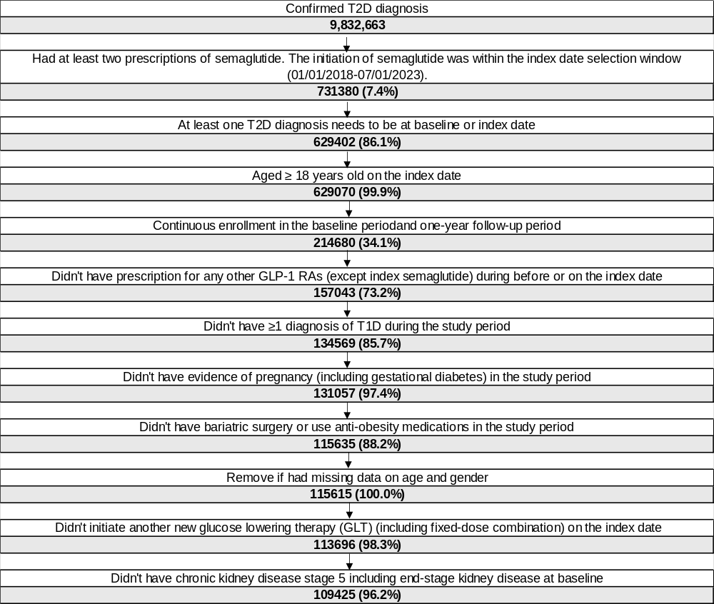
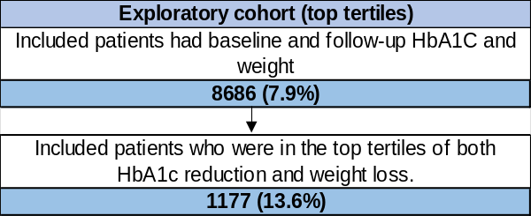
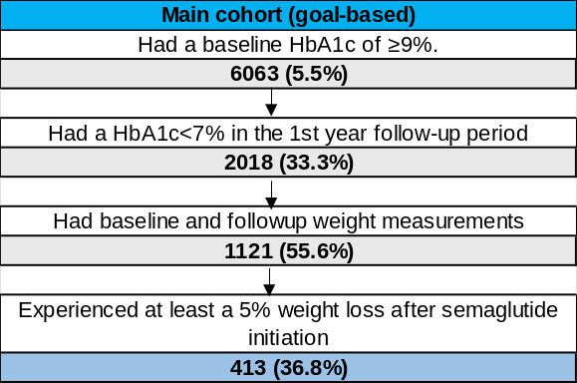
Abbreviations: GLT, Glucose lowering therapy; HbA1c, Glycated hemoglobin; SGLT2i, sodium-glucose co-transporter-2 inhibitors; T1D, type 1 diabetes; T2D, type 2 diabetes

Supplementary Figure 3. Renal outcome changes after semaglutide initiation among individuals with type 2 diabetes who achieved glycemic and weight goals
Abbreviations: eGFR, estimated glomerular filtration rate; UACR, urine albumin-to-creatinine ratio.
*P<0.001

Supplementary Figure 4. Renal outcomes changes after semaglutide initiation in type 2 diabetes achieving top-tertile HbA1c reduction and weight loss
Abbreviations: eGFR, estimated glomerular filtration rate; HbA1C, glycated hemoglobin; urine albumin-to-creatinine ratio.

Supplementary Table 1. Valid range of clinical measurements
 | Valid range*
HbA1c | 4-18%
LDL-C | 5-500 mg/dL
HDL-C | 10-350 mg/dL
Triglycerides | ≥30 mg/dL
Total cholesterol | 50-800 mg/dL
SBP | 40-300 mmHg
DBP | 20-200 mmHg
BMI | 10-70 kg/m2
Height | >0-250cm
eGFR | >0-120 mL/min/1.73 m²
*Some of these valid ranges were adapted from King A, Tan X, Dhopeshwarkar N, Bohn R, Dea K, Leonard CE, de Havenon A. Effect of glucagon-like peptide-1 receptor agonists on vascular risk factors among adults with type 2 diabetes and established atherosclerotic cardiovascular disease. Am J Prev Cardiol. 2025 Jan 8;21:100922. doi: 10.1016/j.ajpc.2024.100922.

Supplementary Table 2. All baseline characteristics and semaglutide utilization for the primary study cohort (N=413)
Characteristics (N=413) | N (%)/ Mean (SD)
Demographics
Age at index date (years)
Mean ± SD | 56.9 (12.1)
Median (IQR) | 57.0 (17.0)
Age at index date, n (%)
18-44 | 60.0 (14.5%)
45-64 | 247.0 (59.8%)
65-79 | 93.0 (22.5%)
≥80 | 13.0 (3.1%)
Sex, n (%)
Male | 209.0 (50.6%)
Female | 204.0 (49.4%)
Race, n (%)
Black | 53.0 (12.8%)
Asian | 10.0 (2.4%)
White | 312.0 (75.5%)
Other/unknown | 38.0 (9.2%)
Ethnicity, n (%)
Hispanic | 26.0 (6.3%)
Not Hispanic | 318.0 (77.0%)
Unknown | 69.0 (16.7%)
Geographic region, n (%)
Northeast | 89.0 (21.5%)
South | 131.0 (31.7%)
Midwest | 144.0 (34.9%)
West | 34.0 (8.2%)
Other/unknown | 15.0 (3.6%)
Index year, n (%)
2018 | 14.0 (3.4%)
2019 | 52.0 (12.6%)
2020 | 79.0 (19.1%)
2021 | 101.0 (24.5%)
2022 | 107.0 (25.9%)
2023 | 60.0 (14.5%)
T2D history (years) from database regardless of study period
Mean ± SD | 3.4 (2.5)
Median (IQR) | 4.0 (4.0)
Payer type, n (%)
Commercial | 261.0 (63.2%)
Medicaid | 31.0 (7.5%)
Medicare | 120.0 (29.1%)
Other/unknown | <5 (0.0%)
Prescriber specialty, n (%)
Primary care | 281.0 (68.0%)
Endocrinologist | 83.0 (20.1%)
Cardiologist | <5 (0.0%)
Nephrologist | <5 (0.0%)
Other | 19.0 (4.6%)
Unknown/Missing | 26.0 (6.3%)
Baseline Comorbidities, n (%)
Atrial fibrillation and flutter | 20.0 (4.8%)
Deep vein thrombosis or pulmonary embolism | 6.0 (1.5%)
Dementia | <5 (0.0%)
Chronic heart failure | 35.0 (8.5%)
Hypertension | 307.0 (74.3%)
Hyperlipidemia/dyslipidemia | 309.0 (74.8%)
Anxiety | 88.0 (21.3%)
Depression | 64.0 (15.5%)
Smoking | 51.0 (12.3%)
Neuropathic pain | 39.0 (9.4%)
ASCVD components including:
Ischemic stroke | 12.0 (2.9%)
Transient ischemic attack | 6.0 (1.5%)
Other atherosclerotic cerebrovascular disease | 31.0 (7.5%)
Myocardial infarction | 14.0 (3.4%)
Other coronary heart disease | 81.0 (19.6%)
Peripheral artery disease | 39.0 (9.4%)
CKD stage
Stage2/Normal | 151.0 (36.6%)
Stage3 | 48.0 (11.6%)
Stage4 | <5 (0.0%)
Obesity-Related Conditions
Asthma | 51.0 (12.3%)
Gastroesophageal reflux disease | 83.0 (20.1%)
Musculoskeletal pain | 180.0 (43.6%)
Nonalcoholic steatohepatitis/non-alcoholic fatty liver disease | 32.0 (7.7%)
Obstructive sleep apnea | 102.0 (24.7%)
Osteoarthritis of the knee or hip | 46.0 (11.1%)
Knee replacement | <5 (0.0%)
Polycystic ovarian syndrome (reported among females only) | <5 (0.0%)
Acute/chronic pancreatitis | <5 (0.0%)
Feeding difficulties | <5 (0.0%)
Liver cirrhosis | <5 (0.0%)
Eating disorders | 7.0 (1.7%)
CCI adjusted without diabetes2
Mean ± SD | 1.0 (1.4)
Median (IQR) | 0.0 (1.0)
DCSI
Mean ± SD | 1.4 (1.8)
Median (IQR) | 1.0 (2.0)
Baseline CV Procedures, n (%)
Baseline CV Procedures, n (%) | 9.0 (2.2%)
Baseline Medications
Selected non-GLT during the baseline period, n (%)
Antihypertensive agents | 310.0 (75.1%)
Antiplatelets | 50.0 (12.1%)
Antihyperlipidemic agents | 299.0 (72.4%)
Anticoagulants | 59.0 (14.3%)
Antidepressants | 136.0 (32.9%)
Additional antianginal agents | 25.0 (6.1%)
Additional HF drugs | 32.0 (7.7%)
Medications associated with weight gain | 275.0 (66.6%)
Medications associated with weight loss | 136.0 (32.9%)
GLT during the baseline period
Baseline GLT drug class, n (%)
 | 139.0 (33.7%)
Biguanides (metformin) | 330.0 (79.9%)
SU | 116.0 (28.1%)
 | <5 (0.0%)
TZD | 15.0 (3.6%)
 | <5 (0.0%)
SGLT2is | 69.0 (16.7%)
DPP-4i | 59.0 (14.3%)
Number of GLT used (generic name level), n (%)
0 | 35.0 (8.5%)
1 | 134.0 (32.4%)
2 | 93.0 (22.5%)
3 | 78.0 (18.9%)
4 | 49.0 (11.9%)
>=5 | 24.0 (5.8%)
Number of GLT class, n (%)
0 | 35.0 (8.5%)
1 | 151.0 (36.6%)
2 | 131.0 (31.7%)
>=3 | 96.0 (23.2%)
Number of prescription drugs (by generic names)
Mean ± SD | 12.1 (6.8)
Median (IQR) | 12.0 (9.0)
Baseline Lab
BMI, n (%)
<25 or unknown | 10.0 (2.4%)
25-<30 | 74.0 (17.9%)
30-<35 | 112.0 (27.1%)
35-<40 | 105.0 (25.4%)
≥40 | 112.0 (27.1%)
Semaglutide utilization measured during follow-up
Dosing
Highest dose, n (%)
< 1 mg | 143.0 (34.6%)
1 mg | 186.0 (45.0%)
2 mg | 84.0 (20.3%)
Proportion of days patients on their highest dose (days supply on the highest dose/ total days supply on semaglutide)
1 mg
Mean ± SD | 0.3 (0.4)
2 mg
Mean ± SD | 0.1 (0.1)
Adherence (proportion days of covered [PDC])
Mean ± SD | 0.8 (0.2)
Median (IQR) | 0.8 (0.2)
< 80% | 184.0 (44.6%)
>= 80% | 229.0 (55.4%)
Persistence, n (%)
Persistence | 170.0 (41.2%)
Abbreviations: AIDS, acquired immunodeficiency syndrome; BMI, body mass index; CCI, Charlson Comorbidity Index; CKD, chronic kidney disease; COPD, chronic obstructive pulmonary disease; DCSI, Diabetes Compliations Severity Index; DPP4i, dipeptidyl peptidase-4 inhibitors; ER, emergency room; GLP1-RA, glucagon-like peptide 1 receptor agonists; GLT, glucose lowering therapy; HCRU, healthcare resource utilization; HIV, human immunodeficiency virus; IQR, interquartile range; PPPM, per person per month; SD, standard deviation; SGLT2i, sodium-glucose co-transporter-2 inhibitors; SU, Sulfonylureas; T2D, type 2 diabetes; TZD, Thiazolidinediones

Supplementary Table 3. Changes in use of key cardiometabolic therapies among the primary cohort (N=413)
Medication class | At baseline  n (%) | Initiated  n (%) |  | Discontinued  n (%) |  | No change*  n (%)
 |  | In the 1st year of follow-up | In the 2nd year of follow-up | In the 1st year of follow-up | In the 2nd year of follow-up | In the 1st year of follow-up | In the 2nd year of follow-up
SGLT2is | 69 (16.71) | 42 (10.17) | 16 (3.87) | <5 | 19 (4.6) | 367 (88.86) | 332 (80.39)
Insulin | 138 (33.41) | 26 (6.3) | <5 | 30 (7.26) | 40 (9.69) | 357 (86.44) | 316 (76.51)
Other GLT | 351 (84.99) | 24 (5.81) | <5 | 37 (8.96) | 67 (16.22) | 352 (85.23) | 281 (68.04)
Antihypertensive medications | 310 (75.06) | 21 (5.08) | 7 (1.69) | 5 (1.21) | 32 (7.75) | 387 (93.7) | 348 (84.26)
Antihyperlipidemic agents | 299 (72.4) | 52 (12.59) | 11 (2.66) | 12 (2.91) | 40 (9.69) | 349 (84.5) | 298 (72.15)
*The no change category includes individuals whose use, or lack thereof, of a cardiometabolic therapy was consistent during the follow-up period (ie, stable users and non-users).
GLT, glucose-lowering therapy; SGLT2is, sodium-glucose co-transporter-2 inhibitors.

Supplementary Table 4. Cardiometabolic risk factors among semaglutide users who received stable treatment with cardiometabolic therapies: a sensitivity analysis

Cardiovascular risk factors | Users receiving stable treatment during the 1st year of follow-up (n=232) |  |  |  | Users receiving stable treatment during the 2nd year of follow-up (n=130)
 | Baseline | Changes between baseline and 1st year follow-up period | Baseline | Changes between baseline and 2nd year follow-up period | Baseline | Changes between baseline and 1st year follow-up period | Baseline | Changes between baseline and 2nd year follow-up period
Low-density lipoprotein cholesterol (LDL)
n (%) |  | 147 (63.36) |  | 104 (44.83) |  | 88 (67.69) |  | 68 (52.31)
Mean ± SD | 88.92 (32.86) | -14.75 (29.43) | 86.79 (34.88) | -13.53 (30.3) | 83.5 (32.16) | -15.53 (26.67) | 85.26 (34.59) | -13.78 (29.31)
P valueª | - | <0.001 | - | <0.001 | - | <0.001 | - | <0.001
Median (IQR) | 86 (45.5) | -12 (36) | 83 (45.28) | -11 (35.5) | 80.5 (43.25) | -11.5 (32.5) | 81.5 (45.03) | -8 (32.25)
High-density lipoprotein cholesterol (HDL)
n (%) |  | 149 (64.22) |  | 103 (44.4) |  | 86 (66.15) |  | 67 (51.54)
Mean ± SD | 41.78 (10.21) | 2.76 (9.62) | 40.37 (9.99) | 4.31 (9.58) | 39.98 (8.75) | 2.61 (7.94) | 38.61 (8.57) | 4.02 (8.4)
P valueª | - | <0.001 | - | <0.001 | - | 0.002 | - | <0.001
Median (IQR) | 39 (12) | 3 (9) | 39 (11.3) | 4 (9) | 39 (10.75) | 3 (8.75) | 38 (11.5) | 3 (8)
Very low-density lipoprotein cholesterol (VLDL)
n (%) |  | 44 (18.97) |  | 33 (14.22) |  | 25 (19.23) |  | 24 (18.46)
Mean ± SD | 39.09 (19.25) | -14.89 (18.19) | 35.7 (20.74) | -13.09 (17.75) | 39.47 (22.74) | -14.21 (22.58) | 39.38 (22.85) | -16.17 (18.58)
P valueª | - | <0.001 | - | <0.001 | - | 0.004 | - | <0.001
Median (IQR) | 34.5 (24.25) | -13 (21.5) | 31 (18) | -9 (13) | 34 (24) | -11 (25) | 34.5 (20) | -13.5 (16.5)
Total cholesterol
n (%) |  | 149 (64.22) |  | 103 (44.4) |  | 86 (66.15) |  | 67 (51.54)
Mean ± SD | 172.72 (47.97) | -27.82 (43.98) | 169.98 (50.3) | -22.49 (41.34) | 167.53 (48.81) | -28.88 (41.24) | 169.07 (49.72) | -26 (36.41)
P valueª | - | <0.001 | - | <0.001 | - | <0.001 | - | <0.001
Median (IQR) | 165 (54) | -21 (48) | 163 (49) | -19 (40.5) | 159 (50.25) | -22.5 (43.75) | 161 (42.5) | -19 (36)
Triglycerides
n (%) |  | 149 (64.22) |  | 102 (43.97) |  | 86 (66.15) |  | 67 (51.54)
Mean ± SD | 234.52 (201.38) | -98.54 (190.81) | 239.86 (203.1) | -95.12 (163.65) | 248.44 (218.1) | -103.92 (205.07) | 259.06 (209.3) | -111.18 (158.06)
P valueª | - | <0.001 | - | <0.001 | - | <0.001 | - | <0.001
Median (IQR) | 182 (146) | -51 (118) | 191 (123) | -60 (103.5) | 199 (147.25) | -52 (125.75) | 211 (141) | -75 (96.5)
Systolic blood pressure
n (%) |  | 229 (98.71) |  | 167 (71.98) |  | 129 (99.23) |  | 104 (80)
Mean ± SD | 130.2 (15.03) | -5.89 (18.5) | 129.13 (14.16) | -4.02 (17.89) | 128.85 (14.73) | -3.7 (16.15) | 128.28 (14.29) | -2.62 (17.14)
P valueª | - | <0.001 | - | <0.001 | - | 0.007 | - | 0.080
Median (IQR) | 128 (20) | -5 (21) | 128 (18.75) | -4 (22.25) | 128 (20) | -2 (20) | 128 (19.25) | 0 (19.5)
Diastolic blood pressure
n (%) |  | 229 (98.71) |  | 167 (71.98) |  | 129 (99.23) |  | 104 (80)
Mean ± SD | 78.66 (10.14) | -3.26 (12.17) | 77.89 (9.94) | -2.06 (11.15) | 77.61 (10.73) | -2.34 (11.55) | 77.17 (10.17) | -1.29 (10.7)
P valueª | - | <0.001 | - | 0.007 | - | 0.044 | - | 0.238
Median (IQR) | 80 (14) | -2 (14) | 79 (13.5) | -2 (14) | 78 (14) | -2 (16) | 78 (12.13) | -2 (14)
ª P-values were assessed using Paired Wilcoxon signed-rank tests.
Abbreviations: SD, standard deviation; IQR, interquartile range

Supplementary Table 5. Renal outcomes among semaglutide users who received stable treatment with cardiometabolic therapies: a sensitivity analysis
Renal outcomes | Users receiving stable treatment during the 1st year of follow-up (n=232) |  |  |  | Users receiving stable treatment during the 2nd year of follow-up (n=130)
 | Baseline | Changes between baseline and 1st year follow-up period | Baseline | Changes between baseline and 2nd year follow-up period | Baseline | Changes between baseline and 1st year follow-up period | Baseline | Changes between baseline and 2nd year follow-up period
Estimated glomerular filtration rate (eGFR)
n (%) | 184 (79.3) | 184 (79.3) | 127 (54.7) | 127 (54.7) | 103 (79.2) | 103 (79.2) | 79 (60.8) | 79 (60.8)
Mean ± SD | 76.54 (19.26) | 0.53 (14.71) | 73.63 (18.24) | 1.93 (15.27) | 75.38 (18.19) | 0.37 (13.67) | 74.99 (17.49) | 0.34 (14.05)
P valueª | - | 0.98 | - | 0.27 | - | 0.87 | - | 0.89
Median (IQR) | 76.50 (30) | 0.00 (12.25) | 75.00 (27.99) | 0.00 (19.24) | 75.00 (28.99) | 0.00 (8.5) | 76.00 (27.99) | 0.00 (15.69)
eGFR change, n (%)
Decline <40% |  | 81 (44.0) |  | 54 (42.5) |  | 42 (40.8) |  | 37 (46.8)
Decline ≥40% |  | <5 |  | 0 |  | <5 |  | 0
Increase |  | 72 (39.1) |  | 57 (44.9) |  | 35 (34.0) |  | 28 (35.4%)
No changes |  | 30 (16.3) |  | 16 (12.6) |  | 25 (24.3) |  | 14 (17.7%)
Urine albumin-to-creatinine ratio (UACR)
n (%) | 67 (28.9) | 67 (28.9) | 53 (22.8) | 53 (22.8) | 42 (32.3) | 42 (32.3) | 35 (26.9) | 35 (26.9)
Mean ± SD | 63.64 (114.90) | -33.76 (102.43) | 154.71 (561.85) | -106.51 (436.34) | 61.59 (112.38) | -34.40 (98.48) | 196.24 (683.96) | -141.57 (531.87)
P valueª | - | <0.001 | - | <0.001 | - | <0.001 | - | <0.001
Median (IQR) | 20.00 (45.7) | -8.90 (26.05) | 18.99 (58) | -3.30 (58.1) | 17.25 (39.1) | -8.95 (21.63) | 18.99 (65.35) | -3.4 (65.05)
UACR categories, n (%)
<30 | 73 (56.6) | 73 (67.6) |  | 60 (66.7) | 42 (56.8) | 46 (69.7) |  | 42 (68.9)
30-300 | 49 (38.0) | 33 (30.6) |  | 26 (28.9) | 26 (35.1) | 18 (27.3) |  | 17 (27.9)
>300 | 7 (5.4) | <5 |  | <5 | 6 (8.1) | <5 |  | <5
ª P-values were assessed using Paired Wilcoxon signed-rank tests.
Abbreviations: SD, standard deviation; IQR, interquartile range

Supplementary Table 6. Major adverse cardiovascular events (MACE) among semaglutide users who receive treatment with cardiometabolic therapies: a sensitivity analysis
MACE (per 1000 PY) | Users receiving stable treatment during the 1st year of follow-up (n=232) |  |  | Users receiving stable treatment during the 2nd year of follow-up (n=130)
 | Baseline | 1st year follow-up period | 2nd year follow-up period | Baseline | 1st year follow-up period | 2nd year follow-up period
Ischemic stroke | 13.01 | 0.00 | 5.64 | 7.71 | 0.00 | 0.00
Myocardial infarction (MI) | 8.64 | 8.67 | 5.62 | 0.00 | 0.00 | 0.00
3-point MACE: ischemic stroke, MI, or all-cause death | 21.74 | 8.67 | 28.22 | 7.71 | 0.00 | 18.80
5-point MACE: ischemic stroke, MI, all-cause death, hospitalization for heart failure, or hospitalization for unstable angina | 39.45 | 21.85 | 28.28 | 31.18 | 15.55 | 18.87
Abbreviations: PY, person-years

Supplementary Table 7. All baseline characteristics and semaglutide utilization for the exploratory study cohort (N=1,177)
Characteristics (N=1177) | N (%)/ Mean (SD)
Demographics
Age at index date (years)
Mean ± SD | 57.7 (11.3)
Median (IQR) | 58.0 (15.0)
Age at index date, n (%)
18-44 | 141.0 (12.0%)
45-64 | 722.0 (61.3%)
65-79 | 290.0 (24.6%)
≥80 | 24.0 (2.0%)
Sex, n (%)
Male | 540.0 (45.9%)
Female | 637.0 (54.1%)
Race, n (%)
Black | 156.0 (13.3%)
Asian | 27.0 (2.3%)
White | 901.0 (76.6%)
Other/unknown | 93.0 (7.9%)
Ethnicity, n (%)
Hispanic | 64.0 (5.4%)
Not Hispanic | 946.0 (80.4%)
Unknown | 167.0 (14.2%)
Geographic region, n (%)
Northeast | 255.0 (21.7%)
South | 371.0 (31.5%)
Midwest | 401.0 (34.1%)
West | 112.0 (9.5%)
Other/unknown | 38.0 (3.2%)
Index year, n (%)
2018 | 43.0 (3.7%)
2019 | 189.0 (16.1%)
2020 | 198.0 (16.8%)
2021 | 284.0 (24.1%)
2022 | 292.0 (24.8%)
2023 | 171.0 (14.5%)
T2D history (years) from database regardless of study period
Mean ± SD | 3.8 (2.3)
Median (IQR) | 4.0 (4.0)
Payer type, n (%)
Commercial | 748.0 (63.6%)
Medicaid | 83.0 (7.1%)
Medicare | 341.0 (29.0%)
Other/unknown | 5.0 (0.4%)
Prescriber specialty, n (%)
Primary care | 772.0 (65.6%)
Endocrinologist | 266.0 (22.6%)
Cardiologist | 10.0 (0.8%)
Nephrologist | <5 (0.0%)
Other | 57.0 (4.8%)
Unknown/Missing | 69.0 (5.9%)
Baseline Comorbidities, n (%)
Atrial fibrillation and flutter | 72.0 (6.1%)
Deep vein thrombosis or pulmonary embolism | 23.0 (2.0%)
Dementia | 15.0 (1.3%)
Chronic heart failure | 82.0 (7.0%)
Hypertension | 884.0 (75.1%)
Hyperlipidemia/dyslipidemia | 911.0 (77.4%)
Anxiety | 245.0 (20.8%)
Depression | 206.0 (17.5%)
Smoking | 121.0 (10.3%)
Neuropathic pain | 133.0 (11.3%)
ASCVD components including:
Ischemic stroke | 24.0 (2.0%)
Transient ischemic attack | 10.0 (0.8%)
Other atherosclerotic cerebrovascular disease | 63.0 (5.4%)
Myocardial infarction | 31.0 (2.6%)
Other coronary heart disease | 213.0 (18.1%)
Peripheral artery disease | 101.0 (8.6%)
CKD stage
Stage2/Normal | 492.0 (41.8%)
Stage3 | 140.0 (11.9%)
Stage4 | 9.0 (0.8%)
Obesity-Related Conditions
Asthma | 141.0 (12.0%)
Gastroesophageal reflux disease | 278.0 (23.6%)
Musculoskeletal pain | 543.0 (46.1%)
Nonalcoholic steatohepatitis/non-alcoholic fatty liver disease | 105.0 (8.9%)
Obstructive sleep apnea | 285.0 (24.2%)
Osteoarthritis of the knee or hip | 135.0 (11.5%)
Knee replacement | <5 (0.0%)
Polycystic ovarian syndrome (reported among females only) | 12.0 (1.0%)
Acute/chronic pancreatitis | <5 (0.0%)
Feeding difficulties | <5 (0.0%)
Liver cirrhosis | 14.0 (1.2%)
Eating disorders | 11.0 (0.9%)
CCI adjusted without diabetes2
Mean ± SD | 0.9 (1.3)
Median (IQR) | 0.0 (1.0)
DCSI
Mean ± SD | 1.4 (1.6)
Median (IQR) | 1.0 (2.0)
Baseline CV Procedures, n (%)
Baseline CV Procedures, n (%) | 23.0 (2.0%)
Baseline Medications
Selected non-GLT during the baseline period, n (%)
Antihypertensive agents | 940.0 (79.9%)
Antiplatelets | 132.0 (11.2%)
Antihyperlipidemic agents | 922.0 (78.3%)
Anticoagulants | 165.0 (14.0%)
Antidepressants | 407.0 (34.6%)
Additional antianginal agents | 59.0 (5.0%)
Additional HF drugs | 129.0 (11.0%)
Medications associated with weight gain | 824.0 (70.0%)
Medications associated with weight loss | 396.0 (33.6%)
GLT during the baseline period
Baseline GLT drug class, n (%)
Insulin | 372.0 (31.6%)
Biguanides (metformin) | 950.0 (80.7%)
SU | 339.0 (28.8%)
Meglitinides | 14.0 (1.2%)
TZD | 59.0 (5.0%)
Alpha-glucosidase inhibitors | <5 (0.0%)
SGLT2is | 267.0 (22.7%)
DPP-4i | 208.0 (17.7%)
Number of GLT used (generic name level), n (%)
0 | 89.0 (7.6%)
1 | 360.0 (30.6%)
2 | 293.0 (24.9%)
3 | 208.0 (17.7%)
4 | 134.0 (11.4%)
>=5 | 93.0 (7.9%)
Number of GLT class, n (%)
0 | 89.0 (7.6%)
1 | 400.0 (34.0%)
2 | 388.0 (33.0%)
>=3 | 300.0 (25.5%)
Number of prescription drugs (by generic names)
Mean ± SD | 12.5 (6.6)
Median (IQR) | 12.0 (8.0)
Baseline Lab
BMI, n (%)
<25 or unknown | 30.0 (2.5%)
25-<30 | 192.0 (16.3%)
30-<35 | 342.0 (29.1%)
35-<40 | 286.0 (24.3%)
≥40 | 327.0 (27.8%)
Semaglutide utilization measured during follow-up
Dosing
Highest dose, n (%)
< 1 mg | 399.0 (33.9%)
1 mg | 512.0 (43.5%)
2 mg | 266.0 (22.6%)
Proportion of days patients on their highest dose (days supply on the highest dose/ total days supply on semaglutide)
1 mg
Mean ± SD | 0.3 (0.4)
2 mg
Mean ± SD | 0.1 (0.2)
Adherence (proportion days of covered [PDC])
Mean ± SD | 0.8 (0.2)
Median (IQR) | 0.8 (0.2)
< 80% | 472.0 (40.1%)
>= 80% | 705.0 (59.9%)
Persistence, n (%)
Persistence | 560.0 (47.6%)
Abbreviations: AIDS, acquired immunodeficiency syndrome; BMI, body mass index; CCI, Charlson Comorbidity Index; CKD, chronic kidney disease; COPD, chronic obstructive pulmonary disease; DCSI, Diabetes Compliations Severity Index; DPP4i, dipeptidyl peptidase-4 inhibitors; ER, emergency room; GLP1-RA, glucagon-like peptide 1 receptor agonists; GLT, glucose lowering therapy; HCRU, healthcare resource utilization; HIV, human immunodeficiency virus; IQR, interquartile range; PPPM, per person per month; SD, standard deviation; SGLT2i, sodium-glucose co-transporter-2 inhibitors; SU, Sulfonylureas; T2D, type 2 diabetes; TZD, Thiazolidinediones
Supplementary Table 8. Cardiometabolic risk factor changes after semaglutide initiation in type 2 diabetes achieving top-tertile HbA1c reduction and weight loss
Cardiovascular Risk Factors | Baseline | Changes between baseline and 1st-year follow-up period | Baseline | Changes between baseline and 2nd-year follow-up period
Low-density lipoprotein cholesterol (LDL)
n (%) |  | 806 (68.4%) |  | 558 (47.3%)
Mean ± SD | 93.72 (39.31) | -13.87 (36.7) | 91.04 (40) | -12.00 (38.7)
P valueª | - | <0.001 | - | <0.001
Median (IQR) | 88 (50) | -11.0 (36.0) | 83 (49.75) | -7.00 (38.0)
High density lipoprotein cholesterol (HDL)
n (%) |  | 812 (68.9%) |  | 564 (47.8%)
Mean ± SD | 42.84 (11.87) | 2.11 (8.5) | 42.66 (11.9) | 4.40 (9.3)
P valueª | - | <0.001 | - | <0.001
Median (IQR) | 41 (14) | 2.0 (10.0) | 40.25 (14) | 4.00 (10.0)
Very low-density lipoprotein cholesterol (VLDL)
n (%) |  | 227 (19.3%) |  | 148 (12.6%)
Mean ± SD | 36.13 (21.28) | -10.59 (18.0) | 37.98 (24.27) | -11.50 (23.0)
P valueª | - | <0.001 | - | <0.001
Median (IQR) | 31 (21) | -8.0 (17.0) | 30 (22) | -7.00 (18.3)
Total cholesterol
n (%) |  | 813 (69.0%) |  | 566 (48.0%)
Mean ± SD | 174.31 (48.14) | -22.89 (42.1) | 172.96 (49.4) | -19.18 (45.1)
P valueª | - | <0.001 | - | <0.001
Median (IQR) | 169 (60) | -17.0 (44.0) | 165 (56.75) | -13.00 (45.5)
Triglycerides
n (%) |  | 815 (69.1%) |  | 561 (47.6%)
Mean ± SD | 214.15 (180.69) | -72.65 (169.5) | 217.03 (164.27) | -71.24 (141.4)
P valueª | - | <0.001 | - | <0.001
Median (IQR) | 168 (126.5) | -40.0 (88.0) | 172 (128) | -41.00 (97.0)
Systolic blood pressure
n (%) |  | 1165 (98.8%) |  | 858 (72.8%)
Mean ± SD | 130.83 (14.98) | -2.19 (11.1) | 130.72 (15.07) | -4.60 (18.2)
P valueª | - | <0.001 | - | <0.001
Median (IQR) | 130 (20) | -2.0 (15.0) | 130 (20) | -4.00 (22.5)
Diastolic blood pressure
n (%) |  | 1165 (98.8%) |  | 857 (72.7%)
Mean ± SD | 78.12 (9.99) | -5.58 (17.5) | 78.09 (9.96) | -2.29 (10.8)
P valueª | - | <0.001 | - | <0.001
Median (IQR) | 79 (13) | -6.0 (21.0) | 79 (14) | -2.00 (13.0)
ª P-values were assessed using Paired Wilcoxon signed-rank tests.
Abbreviation: SD, standard deviation; IQR, interquartile range
Supplementary Table 9. Renal outcomes changes after semaglutide initiation in type 2 diabetes achieving top-tertile HbA1c reduction and weight loss
Renal Outcomes | Baseline | 1st year | Baseline | 2nd year
estimated Glomerular Filtration Rate (eGFR) |  | Changes from baseline |  | Changes from baseline
N (%) | 955 (81.1%) | 955 (81.1%) | 702 (59.6%) | 702 (59.6%)
Mean ± SD (%) | 74.81 (18.77) | -0.98 (13.71) | 73.94 (19.07) | -1.16 (14.47)
P-valueª | - | 0.010 | - | 0.008
Median (IQR) | 74.00 (28.99) | 0.00 (12.01) | 73.00 (27.99) | 0.00 (14.01)
Urine Albumin-to-Creatinine Ratio (UACR) |  | Changes from baseline |  | Changes from baseline
N (%) | 323 (27.4) | 323 (27.4) | 270 (22.9) | 270 (22.9)
Mean ± SD | 113.54 (320.95) | -39.92 (223.79) | 127.10 (448.54) | -28.66 (398.76)
P-valueª | - | <0.001 | - | <0.001
Median (IQR) | 22.00 (61.01) | -6.60 (30) | 19.10 (50.12) | -4.00 (25.39)
ª P values were assessed by using Paired Wilcoxon signed-rank test.
Abbreviation: SD, standard deviation; IQR, interquartile range

Supplementary Table 10. Changes in event rates of major adverse cardiovascular events (MACEs) after semaglutide initiation in type 2 diabetes achieving top-tertile HbA1c reduction and weight loss (N=1,177)
MACE (per 1000PY) | Baseline | 1st-year follow-up period | 2nd-year follow-up period
Ischemic stroke | 7.66 | 4.25 | 4.48
Myocardial infarction (MI) | 11.08 | 6.82 | 5.61
3-point MACE: ischemic stroke, MI or all-cause death | 18.78 | 11.11 | 16.86
5-point MACE: ischemic stroke, MI, all-cause death, hospitalization for heart failure, or hospitalization for unstable angina | 25.70 | 20.62 | 23.70
By design, death was excluded from MACE at baseline and during the 1st-year follow-up, but included during the 2nd-year follow-up.

