Supplementary material
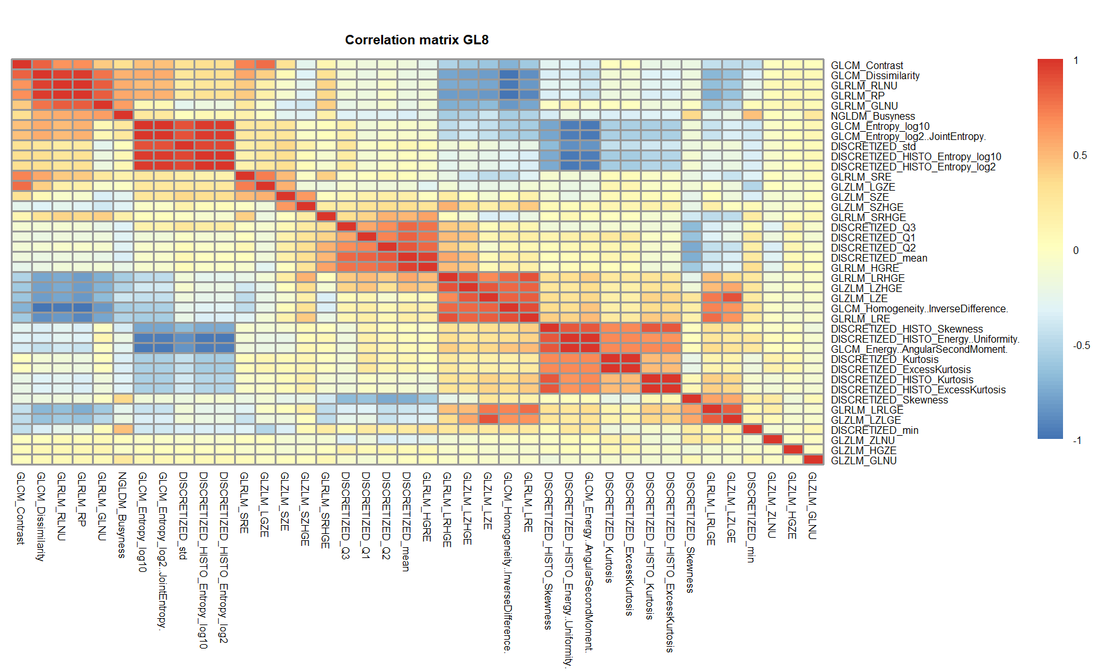
Figure S1. Heatmap of pairwise Pearson’s correlation between radiomic features for GL 8.
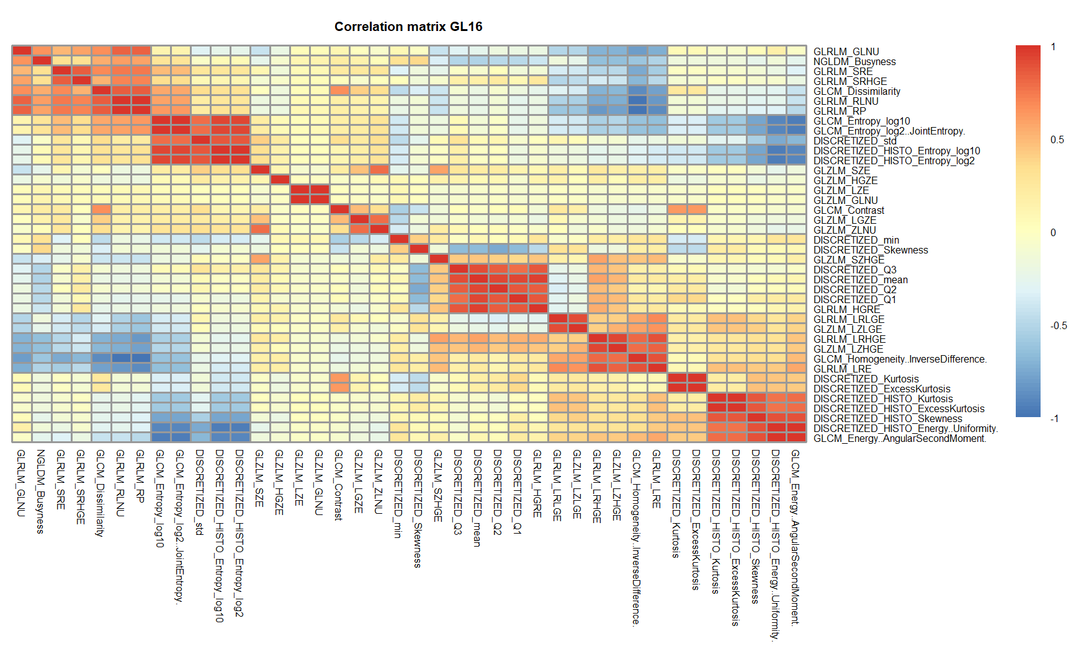
Figure S2. Heatmap of pairwise Pearson’s correlation between radiomic features for GL 16.
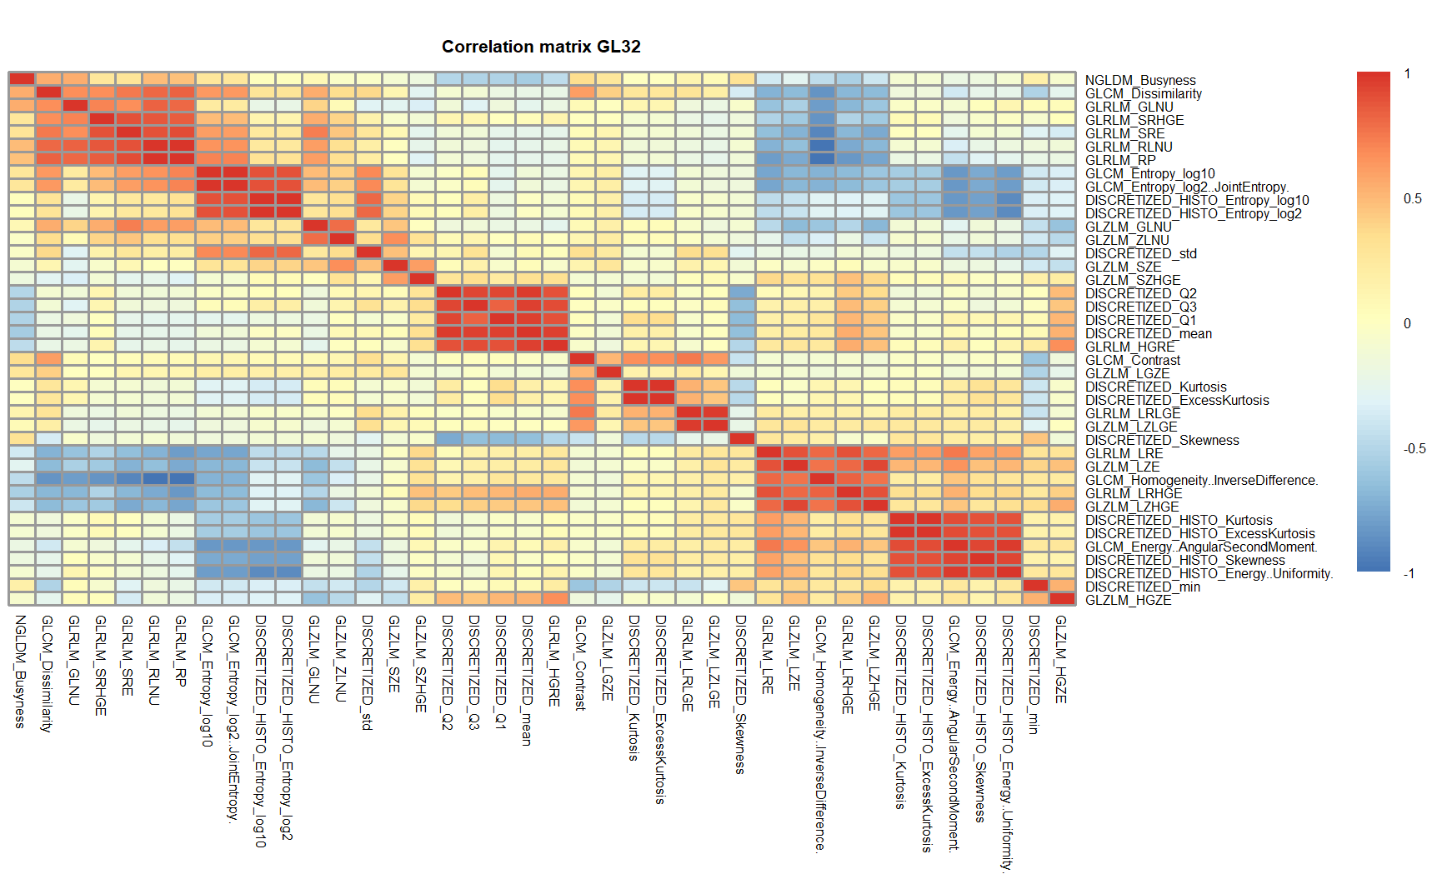
Figure S3. Heatmap of pairwise Pearson’s correlation between radiomic features for GL 32.

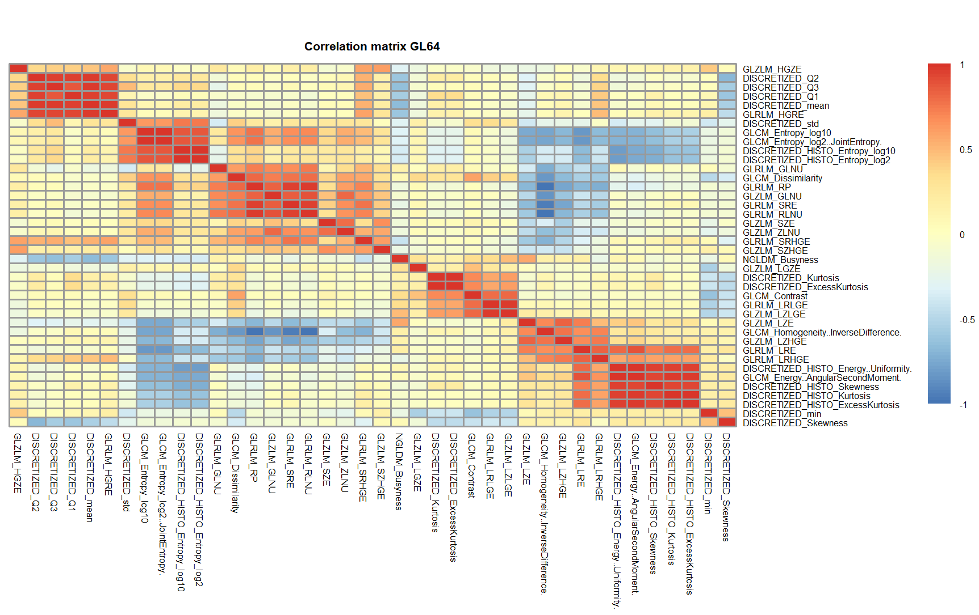Figure S4. Heatmap of pairwise Pearson’s correlation between radiomic features for GL 64.
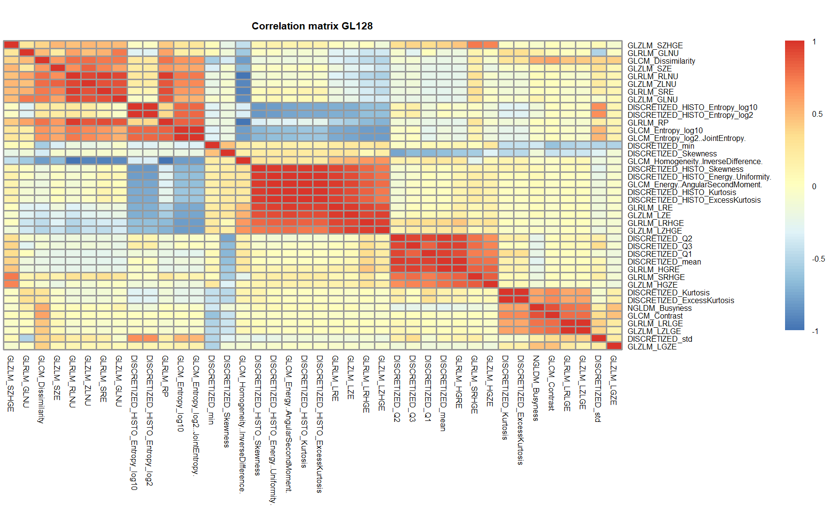
Figure S5. Heatmap of pairwise Pearson’s correlation between radiomic features for GL 128.

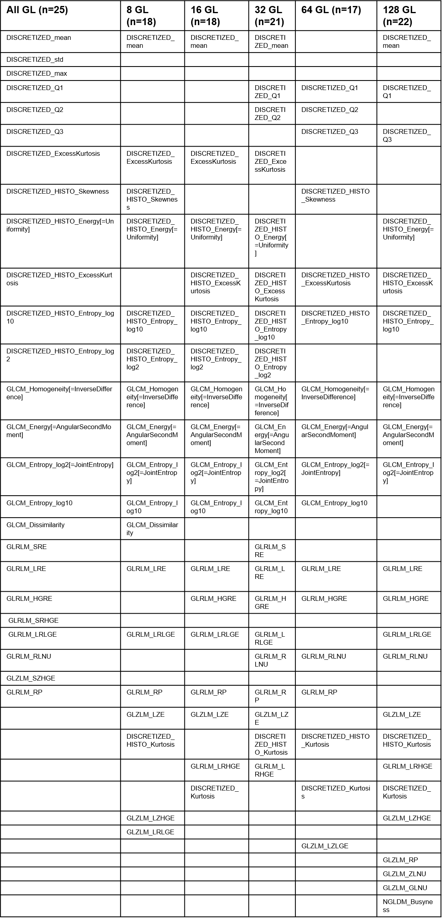
Figure S6. Features with a pairwise Pearson’s correlation coefficient |𝜌| ≥ 0.85 for each GL discretization.

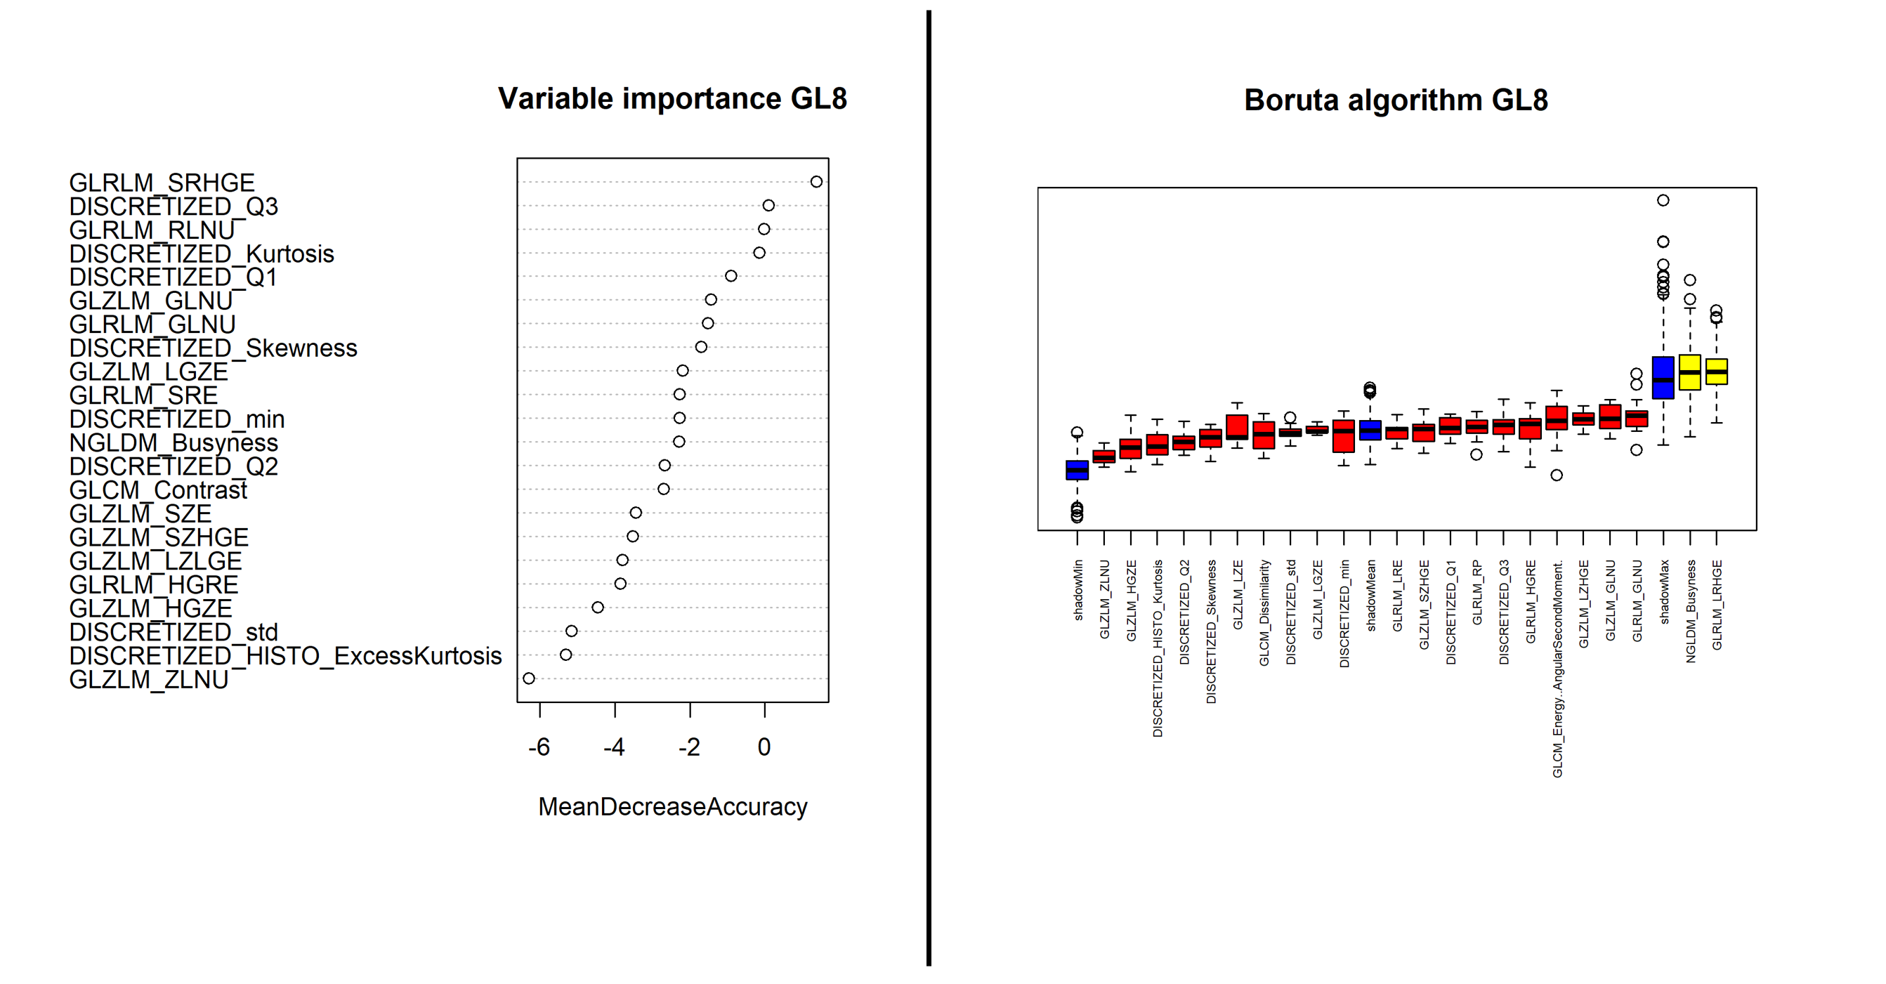
Figure S7. Feature selection with variable importance plot and Boruta algorithm for GL8. Blue boxes correspond to shadow attributes, green color indicates important attributes, and red boxes are unimportant.

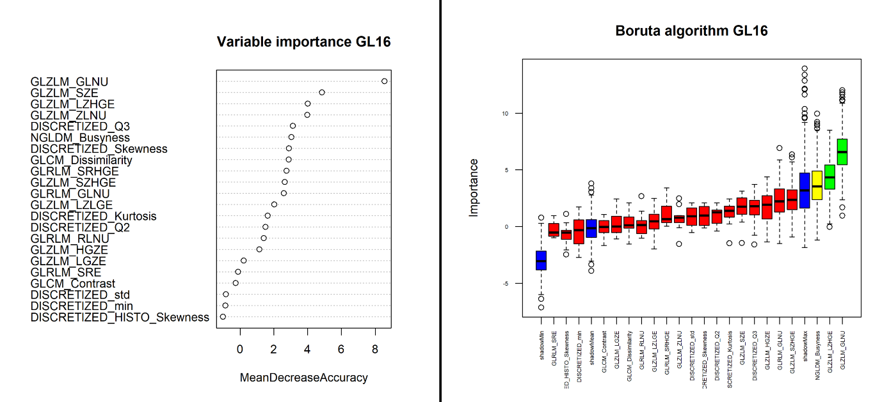
Figure S8. Feature selection with variable importance plot and Boruta algorithm for GL16.

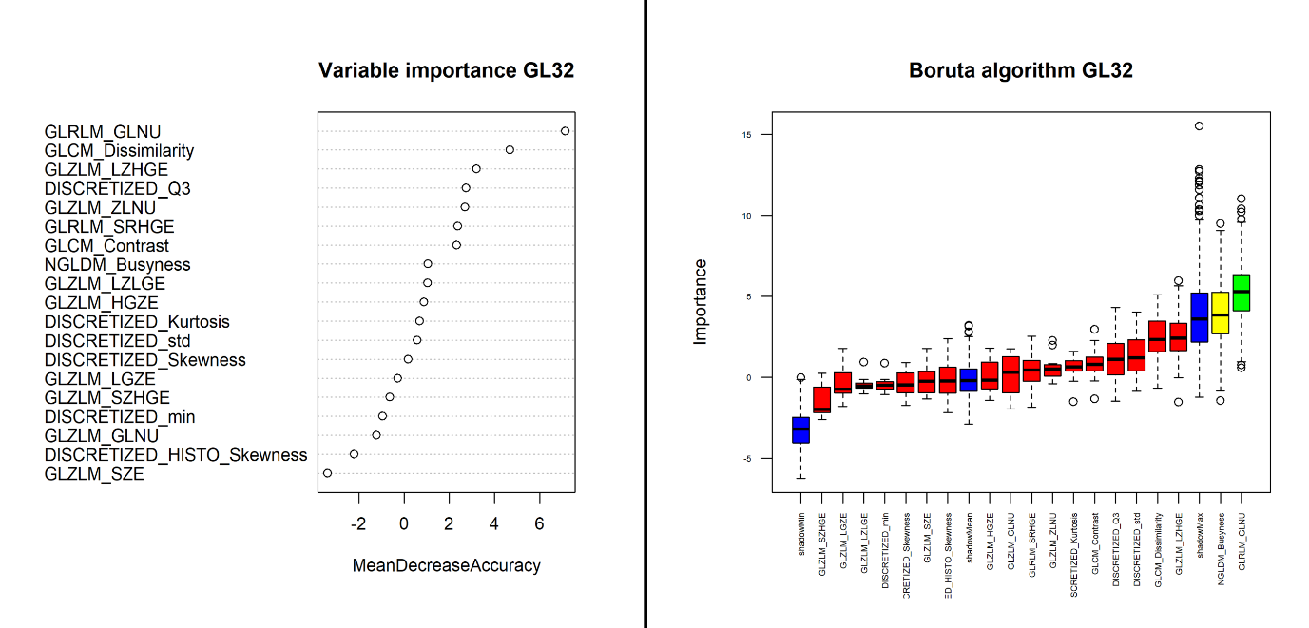
Figure S9. Feature selection with variable importance plot and Boruta algorithm for GL32.

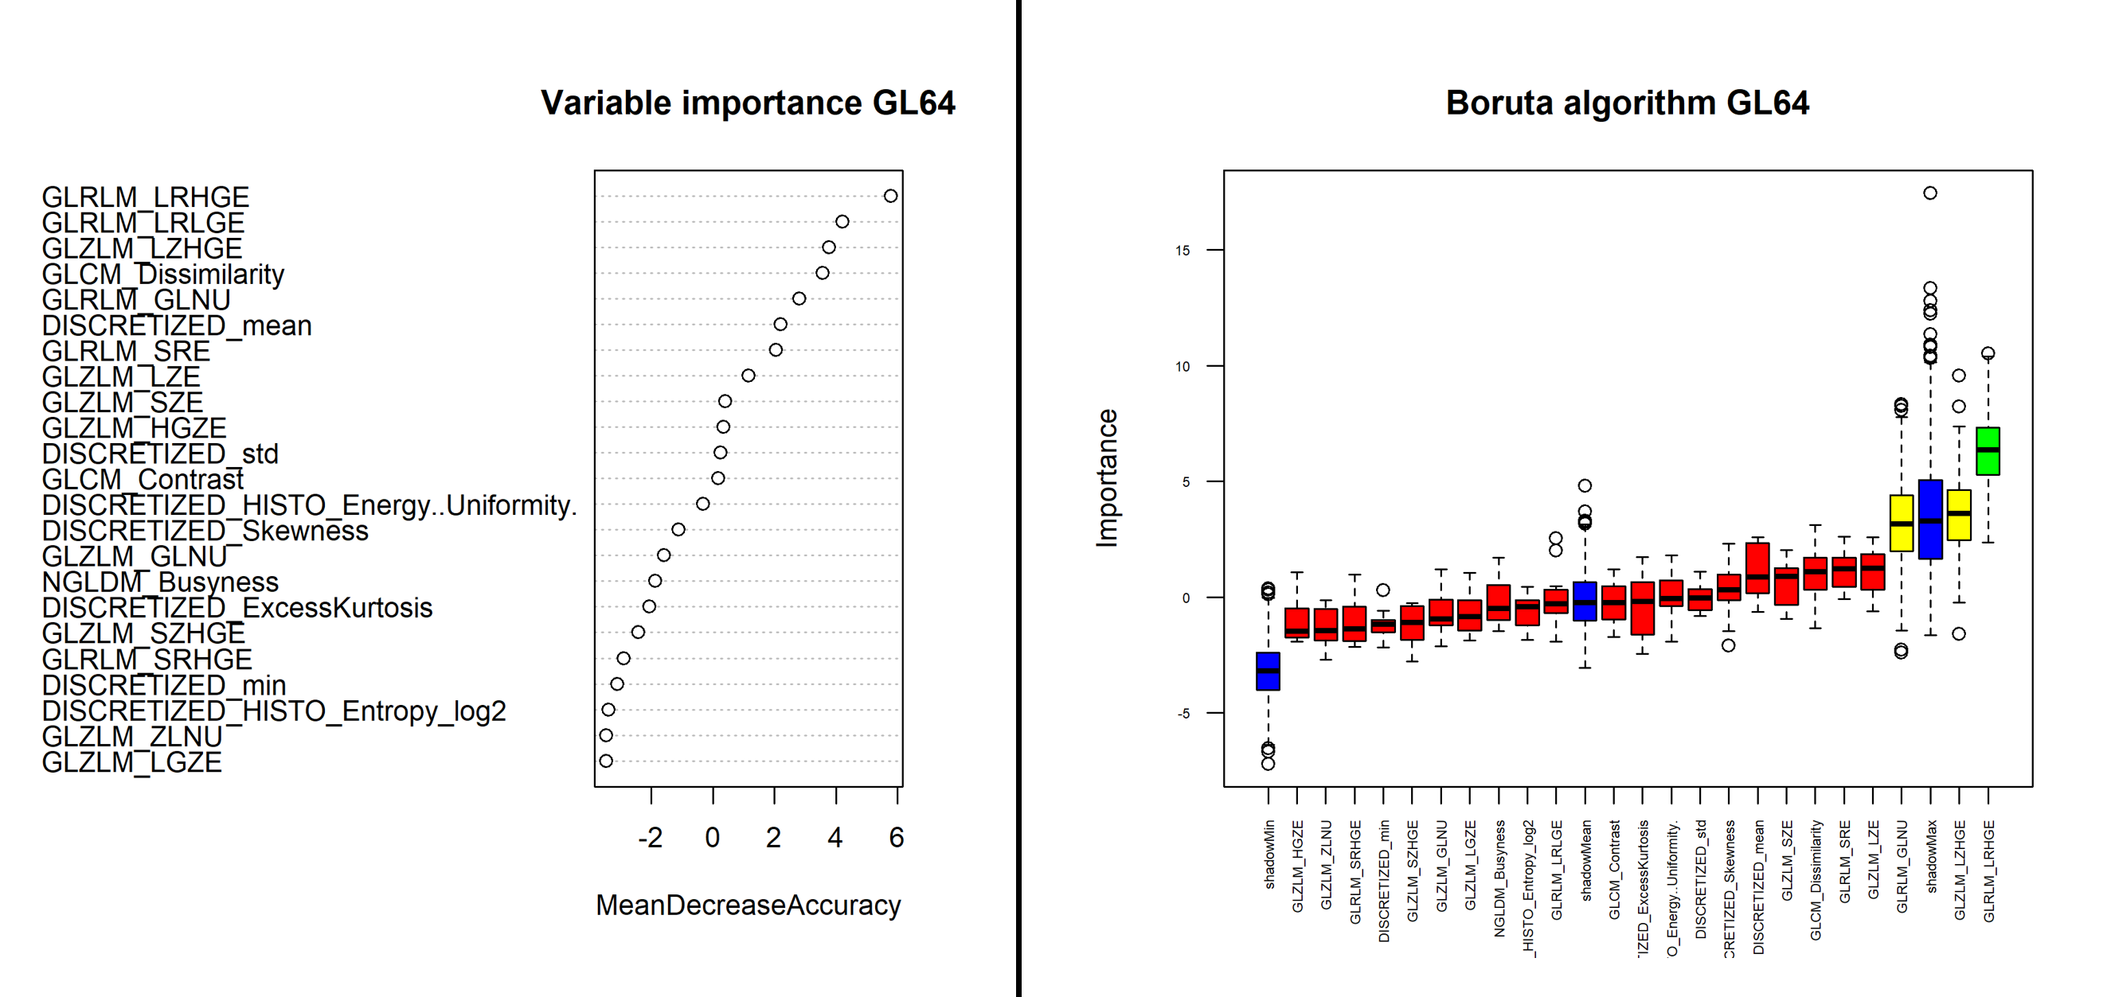
Figure S10. Feature selection with variable importance plot and Boruta algorithm for GL64.

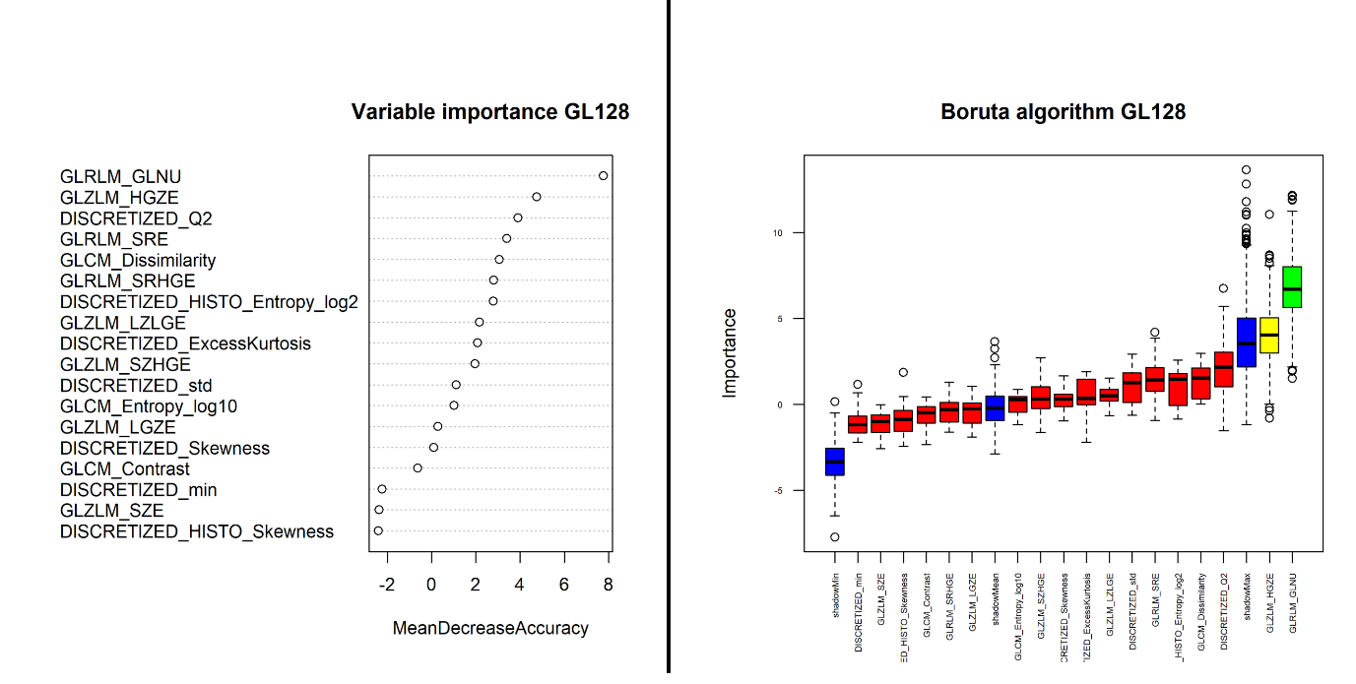
Figure S11. Feature selection with variable importance plot and Boruta algorithm for GL128.

Figure S12. Results from the univariate and multivariate regression analysis including all the variables from variable importance plot GL16 (see Figure S8 above) with numerical estimate of the feature importance >0. Of note, and as in the approach in the main manuscript, only GLRM_GLNU remained a significant predictor of reduced MFR in multivariate analysis.

