Supplementary material

Title
Implicit and explicit attitudes towards artificial agents: a cross-cultural comparison

Journal name
International Journal of Social Robotics

Authors
Fabiola Diana^{1,2}, Misako Kawahara³, Isabella Saccardi⁴, Ruud Hortensius⁵, Akihiro Tanaka³, Mariska E. Kret^{1,2}

Corresponding Author
Fabiola Diana, d.fabiola@fsw.leidenuniv.nl, Comparative Psychology and Affective Neuroscience Lab, Cognitive Psychology Unit, Leiden University, Netherlands

Tables

 |  | Mean Age | Graduated | Under graduated | Females | Males
Experiment 1 | Dutch | 19.75(±2.38) | 86,2% | 13,7% | 80,7% | 19,2%
Experiment 1 | Japanese | 25,88(±3.67) | 51,1% | 48,8% | 50% | 50%
Experiment 2 | Dutch | 42.65 (±5.85) | 82% | 17,9% | 42,3% | 57,6%
Experiment 2 | Japanese | 41.29 (±9.60) | 76,9% | 23% | 52,5% | 47,4%
Supplementary Table 1a: Additional demographic information for the included samples in the two experiments

Level of education | ISCED | Dutch Sample (1) | Japanese Sample (1) | Dutch Sample (2) | Japanese Sample (2)
Primary Education | 1 | 0 % | 0 % | 1,28 % | 0 %
Lower secondary education | 2 | 2,50 % | 7,14 % | 10,25 % | 8,97 %
Upper secondary education | 3 | 6,25 % | 4,76 % | 2,56 % | 8,97 %
Post-secondary education | 4 | 77,50 % | 36,90 % | 3,84 % | 3,84%
Short-cycle tertiary education | 5 | 0 % | 0 % | 0 % | 0 %
Bachelor’s or equivalent | 6 | 10 % | 46,42 % | 44,87 % | 62,82 %
Master’s or equivalent | 7 | 2,50 % | 3,5 % | 30,76 % | 10,25 %
Doctorate or equivalent | 8 | 1,25 % | 1,19 % | 5,12 % | 3,84 %
Supplementary Table 1b: Dutch and Japanese participants' level of education in percentage, based on the International Standard Classification of Education (ISCED) of UNESCO
 |  | Mean Age | Graduated | Under graduated | Females | Males
Experiment 1 | Dutch | 23.23(±9.33) | 94,7% | 5,2% | 65,7% | 34,2%
Experiment 1 | Japanese | 27.05(±4.35) | 54,2% | 45,7% | 60,7% | 39,2%
Experiment 2 | Dutch | 42.54(±6.17) | 83,3% | 16,1% | 51,6% | 45,6%
Experiment 2 | Japanese | 38.60(±10.39) | 64,8% | 35,1% | 56,3% | 43,6%
Supplementary Table 1c: Demographic information of the participants excluded because of incomplete data

Robot name | Human-likeness
Silverlit | 41.55
Darwin | 40.04
Tetrix | 31.01
Manoi AT01 Type-C body | 41.55
Wow Wee Robosapien | 38.95
Pepper | 28.64
Thespian | 47.27
QurRong | 34.32
NAO | 38.42
HRP-4 | 44.22
Aelos S1 | 41.13
NARJOG ViVi | 29.39
Leju | 23.93
Romeo | 47.27
OSP | 28.91
DJI RoboMaster S1 | 0.97
Jalshree | 2.05
Niryo | 0
Vector | 13.87
Cozmo | 13.87
Mi Robot Builder Rover | 13.88
DIY Robotic arm | 0
MiP | 19.12
Mazebreaker | 16.04
Cady Wile | 17.02
Miko 3 | 14.25
Cruzr | 11.50
Zenbo Junior II | 15.06

Supplementary Table 2: human-likeness score of the robots calculated using the ABOT database (http://www.abotdatabase.info/)

Japanese unpleasant words | Dutch unpleasant words
苦痛 | Ondraaglike pijn
危険な | Gevaarlijk
あてにならない | Onbetrouwbaar
怖い | Verschrikkelijk
不愉快な | Vreselijk
卑劣な | Smerig
害悪 | Kwaadaardig
ひどい | Afschuwelijk
失敗 | Falen
死 | Dood
傷ついた | Pijn
殺人者 | Moordenaar
Supplementary Table 3: list of Japanese and Dutch unpleasant word used in the Implicit Association Test (IAT) task

Japanese pleasant words | Dutch pleasant words
喜び | Vreugde
愛情 | Liefde
平和 | Vrede
信頼できる | Gelacht
愉快 | Genot
頼りになる | Glorieus
幸せな | Blij
協力的な | Prachtig
成功 | Success
親切 | Vriendelijkheid
Supplementary Table 4: list of Japanese and Dutch pleasant word used in the Implicit Association Test (IAT) task

Supplementary Analysis

Experiment 1 – Linear regressions to control for Age
We performed three linear regressions with age as a covariate and Nationality as a factor to predict the dependent variables central to the hypothesis (NARS score, Robot D-score, Avatar D-score). No issue of multicollinearity was detected. Age did not significantly predict the explicit attitude towards robot (t(163)=-1.640, p=.103, 95% CI [-0.75, 0.70]), nor the implicit attitude towards robot (t(163)=-0.064, p=.949, 95% CI [-0.017, 0.016]), and avatar (t(163)=-0.622, p=.535, 95% CI [-0.020, 0.010]).

Experiment 1 – Effect of Age and Level of education
We found no significant effect of Age on the explicit attitudes towards robot and avatar (F(1, 160) = 3.099, p=.080, η²p = 0.019), nor on the implicit attitudes (F(1, 160) = 0.020, p=.889, η²p = 0.0001). Crucially, we did not found an effect of Age in the implicit attitude towards different types of robots (F(1, 160) = 0.0003, p=.985, η²p <.0001). We found no significant effect of Level of Education on the explicit attitude towards robot and avatar (F(1, 160) = 0.847, p=.359, η²p = 0.005), nor on the implicit attitudes (F(1, 160) = 3.013, p=.085, η²p = 0.018). However, we did find a between-subject effect of level of education on the implicit attitude towards robot (F(1, 160) = 5.925, p=.016, η²p = 0.036), but there was no significant interaction effect between type of robot and level of education (F(1, 160) = 0.844, p=.360, η²p = 0.005), (see Supplementary Figure 1).
Robot Types’ D-scores plot by Level of Education
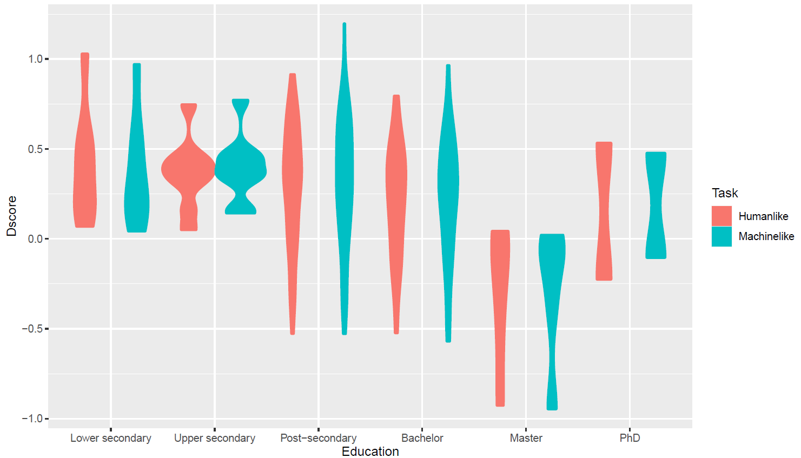
Supplementary figure 1: human-like and machine-like robot D-scores plot by Level of Education

Correlations

Correlations between NARS and Type of Robots
We found correlations between NARS subscales and the D-score in the Robot IAT only for the Dutch participants. To verify that these correlations were not driven by a particular robot body type, we carried out fifteen Pearson correlations tests between NARS, human-like D-score, and machine-like D-score tested against a Bonferroni-adjusted alpha level of 0.003 (0.05/15). Our results indicate that the correlations between NARS subscales and Robot IAT D-score were not driven by a particular body type as respective correlations were found both for machine-like (NARS-S1: r=0.319, p<.001; NARS-S3: r=0.240, p=.002) and human-like D scores (NARS-S1: r=0.319, p<.001; NARS-S2: r=0.247, p=.002, NARS-S3: r=0.236, p=.003). The only exception is the correlation between machine-like D-score and NARS-S2, whose p-value does not reach the Bonferroni-adjusted significance (r=0.214, p=.007).

Fitting Cumulative Linear Mixed Model based on Taylor et al., (2021)
Studies that provide norms of Likert ratings typically report per-item summary statistics. Traditionally, these summary statistics comprise the mean and the standard deviation (SD) of the ratings, and the number of observations. Such summary statistics can preserve the rank order of items, but provide distorted estimates of the relative distances between items because of the ordinal nature of Likert ratings. Inter-item relations in such ordinal scales can be more appropriately modeled by cumulative-link mixed-effects models (CLMMs).
Although the generative Bayesian model can afford rich posterior distributions, we fitted an equal-variance model with maximum likelihood as we were only interested in estimating per-item latent means. The authors estimated r=.997 correlation between the two approaches, meaning the simpler equal variance model and the Bayesian model provide extremely similar estimations and equal variance models can generally be used to estimate latent means without any great loss inaccuracy. In addition, despite CLMM providing more accurate estimates for norming studies, the authors encourage reporting them in addition to more traditional measures like Likert means and SDs, rather than instead of them. This is important to ensure that results are still comparable with the existing dataset reporting only mean and SDs.
All CLMM models were fitted using the ordinal package in R v4.1.2 (R Core Team, 2016), using the script released by Taylor et al., (2021). For Experiment 1, we fitted a CLMM with Nationality, Nationality*NARS Subscale, Age and Level of Education as Fixed effect, Participants and Subscales as Random Effect, and the NARS scores as Dependent variable. Results go in the same direction as in the rm ANOVA. We found a significant effect of NARS Subscales Nationality*Subscales interaction (β = -0.1345, SE = 0.058, p=.020). We did not found a significant effect of Nationality (β = -0.04635, SE = 0.187, p=.804), Age (β = -0.03320, SE = 0.018, p=.066) and Level of Education (β = 0.7232, SE = 0.048, p=.137). For Experiment 2, we fitted a CLMM model with Nationality, Nationality*NARS Subscale as Fixed effect, Participants and Subscales as Random Effect, and the NARS scores as Dependent variable. Results go in the same direction as in the rm ANOVA. We found a significant effect of Nationality (β = -0.7556, SE = 0.136, p<.001) and Nationality*Subscales interaction (β = 0.3294, SE = 0.059, p<.001). Crucially a between-subject effect of Nationality was confirmed for Experiment 2 but not for Experiment 1 corroborating the concerns related to the use of metric analyzes on ordinal variables (Liddel & Kruschke, 2018; Taylor et al., 2021).

McDonald’s Omega calculation
We estimated the Omega coefficient (ωu) following the guidelines and the scripts provided by Flora (2020). For both experiments, we estimated the coefficients separately for each subscale and each sample.

Experiment 1 – Dutch sample

NARS Susbscale 1
We fitted a one-factor model for the Negative Attitudes towards Situations and Interactions with Robots including all the items in the aforementioned subscale of the NARS questionnaire as fixed effects. With the residuals command on the fitted model, we found a notable residual correlation between items 7 and 12 (.098) and 10 and 12 (.095). Therefore, we respecified the one-factor model for the Subscale 1 items, but now include a new line to specify the free error covariance between items 7 and 12 and items 10 and 12. Based on the Anova function between the two models, adding the free error covariance between items did not improve significantly the fitting of the model (p=.218). Therefore, we report the reliability based on the model that is not accounting for free error covariance. The reliability of NARS Subscale 1 for Experiment 1 was ωu = 0.711.

NARS Subscale 2
We fitted a one-factor model for the Negative Attitudes toward Social Influence of Robots including all the items in the aforementioned subscale of the NARS questionnaire as fixed effects. The residuals analysis did not reveal any notable correlations between the items. The reliability of NARS Subscale 2 for Experiment 1 was ωu = 0.694.

NARS Subscale 3
We fitted a one-factor model for the Negative Attitudes toward Emotions in Interaction with Robots including all the items in the aforementioned subscale of the NARS questionnaire as fixed effects. The residuals analysis did not reveal any notable correlations between the items. The reliability of NARS Subscale 2 for Experiment 1 was ωu = 0.643.

Experiment 1 – Japanese sample

NARS Susbscale 1
We fitted a one-factor model for the Negative Attitudes towards Situations and Interactions with Robots including all the items in the aforementioned subscale of the NARS questionnaire as fixed effects. With the residuals command on the fitted model, we found a notable residual correlation between items 4 and 10 (.103). Therefore, we respecified the one-factor model for the Subscale 1 items, but now include a new line to specify the free error covariance between items 4 and 10. Based on the Anova function between the two models, adding the free error covariance between items did improve significantly the fitting of the model (p<.05). Therefore, we report the reliability based on the model that is accounting for free error covariance. The reliability of NARS Subscale 1 for Experiment 1 was ωu = 0.868.

NARS Subscale 2
We fitted a one-factor model for the Negative Attitudes toward Social Influence of Robots including all the items in the aforementioned subscale of the NARS questionnaire as fixed effects. The residuals analysis did not reveal any notable correlations between the items. The reliability of NARS Subscale 2 for Experiment 1 was ωu = 0.859.

NARS Subscale 3
We fitted a one-factor model (j_mod3f) for the Negative Attitudes toward Emotions in Interaction with Robots including all the items in the aforementioned subscale of the NARS questionnaire as fixed effects. The residuals analysis did not reveal any notable correlations between the items. The reliability of NARS Subscale 2 for Experiment 1 was ωu = 0.807.

Experiment 2 – Dutch

NARS Susbscale 1
We fitted a one-factor model for the Negative Attitudes towards Situations and Interactions with Robots including all the items in the aforementioned subscale of the NARS questionnaire as fixed effects. With the residuals command on the fitted model, we found a notable residual correlation between items 4 and 7 (.111), 7 and 9 (.112), and 7 and 10 (-.133). Therefore, we respecified the one-factor model for the Subscale 1 items, but now include a new line to specify the free error covariance between items 4 and 7, 7 and 9, and 7 and 10. Based on the Anova function between the two models, adding the free error covariance between items did not improve significantly the fitting of the model (p=.136). Therefore, we report the reliability based on the model that is not accounting for free error covariance. The reliability of NARS Subscale 1 for Experiment 2 was ωu = 0.683.

NARS Subscale 2
We fitted a one-factor model for the Negative Attitudes toward Social Influence of Robots including all the items in the aforementioned subscale of the NARS questionnaire as fixed effects. With the residuals command on the fitted model, we found a notable residual correlation between items 1 and 14 (.155), items 11 and 14 (.209), and items 13 and 14 (.091). Therefore, we respecified the one-factor model for the Subscale 1 items, Therefore, we respecified the one-factor model for the Subscale 1 items, but now include a new line to specify the free error covariance between items 1 and 14, items 11 and 14, and items 13 and 14. Based on the Anova function between the two models, adding the free error covariance between items improved significantly the fitting of the model (p<.005). Therefore, we report the reliability calculated by accounting for the free error covariance. The reliability of NARS Subscale 2 for Experiment 2 was ωu = 0.681.

NARS Subscale 3
We fitted a one-factor model for the Negative Attitudes toward Emotions in Interaction with Robots including all the items in the aforementioned subscale of the NARS questionnaire as fixed effects. The residuals analysis did not reveal any notable correlations between the items. The reliability of NARS Subscale 2 for Experiment 1 was ωu = 0.784.

Experiment 2 – Japanese

NARS Susbscale 1
We fitted a one-factor model (j_mod1f-2) for the Negative Attitudes towards Situations and Interactions with Robots including all the items in the aforementioned subscale of the NARS questionnaire as fixed effects. With the residuals command on the fitted model, we found a notable residual correlation between items 4 and 7 (.204), and 4 and 10 (.138). Therefore, we respecified the one-factor model for the Subscale 1 items, but now include a new line to specify the free error covariance between items 4 and 10 (j_mod1fR-2). Based on the Anova function between the two models, adding the free error covariance between items improved significantly the fitting of the model (p<.005). Therefore, we report the reliability calculated by accounting for the free error covariance. The reliability of NARS Subscale 2 for Experiment 2 was ωu = 0.703.

NARS Subscale 2
We fitted a one-factor model for the Negative Attitudes toward Social Influence of Robots including all the items in the aforementioned subscale of the NARS questionnaire as fixed effects. With the residuals command on the fitted model, we found a notable residual correlation between items 1 and 2 (.108), items 1 and 13 (-.100), items 1 and 14 (-.116), items 11 and 13 (.142), and items 11 and 14 (.156). Therefore, we respecified the one-factor model for the Subscale 1 items, but now include a new line to specify the free error covariance between the aforementioned items dyads. Based on the Anova function between the two models, adding the free error covariance between items improved significantly the fitting of the model (p<.001). Therefore, we report the reliability calculated by accounting for the free error covariance. The reliability of NARS Subscale 2 for Experiment 2 was ωu = 0.760.

NARS Subscale 3
We fitted a one-factor model for the Negative Attitudes toward Emotions in Interaction with Robots including all the items in the aforementioned subscale of the NARS questionnaire as fixed effects. The residuals analysis did not reveal any notable correlations between the items. The reliability of NARS Subscale 2 for Experiment 1 was ωu = 0.625.

