Supplementary Appendices for “Antisemitism: Here and Now? Trends in Jewish Young Adult Experiences and Perceptions of Antisemitism in America from 2017 to 2019”

Appendix 1: Details of Index Construction and Variable Descriptions

Jewish background index
This index was created in four steps:
Step 1: Using the following six variables we count the number of Jewish experiences a respondent had in childhood
- Celebrated Hanukkah
- Celebrated Seder
- Attendance Jewish religious services
- The family kept kosher at home
- Having Shabbat meal
- Celebrated a bar/bat mitzvah
Step 2: We identify the most advanced level of Jewish education for each respondent
- Jewish Day school
- Supplementary Jewish education
- None
Step 3: We identify whether a respondent had any of the following informal Jewish experiences
- Attended a Jewish day camp
- Attended a Jewish overnight camp
- Was a member of a Jewish youth group
Step 4: The variables created in Steps 1-3 were z-scored and summed. The resulting variables were then recoded into “Low,” “Medium and “High” categories based on the resulting distribution.

Current Jewish behavior
We used factor analysis to create an index of current Jewish behaviors out of the following variables
- Having Shabbat meal
- Belonging to the orthodox denomination
- Attendance of Jewish religious services
- Participation in a social event sponsored by a Jewish organization

Israeliness index
We used factor analysis to create an index out of the following variables
- Connection to Israel
- Emotional attachment to Israel
- Confidence in understanding the situation in Israel
- Number of visits to Israel

Table 5: Descriptive Statistics
 |  | % | N
Experienced antisemitism | No experience of antisemitism | 80% | 23,198
Experienced antisemitism | Experienced antisemitism | 20% | 5,466
Concerns about antisemitism on campuses | 1. Not at all | 13% | 3,823
Concerns about antisemitism on campuses | 2. A little | 23% | 6,500
Concerns about antisemitism on campuses | 3. Somewhat | 32% | 9,095
Concerns about antisemitism on campuses | 4. Very much | 33% | 8,993
Concerns about antisemitism in your country | 1. Not at all | 4% | 1,151
Concerns about antisemitism in your country | 2. A little | 14% | 4,265
Concerns about antisemitism in your country | 3. Somewhat | 34% | 9,697
Concerns about antisemitism in your country | 4. Very much | 48% | 13,284
Political views | Liberal | 62% | 17,475
Political views | Moderate | 21% | 5,848
Political views | Conservative | 17% | 4,542
Jewish childhood experience index | Low | 23% | 7,874
Jewish childhood experience index | Medium | 49% | 15,035
Jewish childhood experience index | High | 28% | 8,310
Number of Jewish friends | None/hardly any | 24% | 7,423
Number of Jewish friends | Some/Half | 49% | 14,322
Number of Jewish friends | Most | 19% | 5,646
Number of Jewish friends | All | 8% | 2,218
Jewish parents | One parent or None | 33% | 12,139
Jewish parents | Both parents are Jewish | 67% | 20,250
Age group | 18-21 | 49% | 18,207
Age group | 27-32 | 51% | 14,389
Gender | Female | 57% | 21,328
Student status | Being Undergraduate student | 50% | 17,635
 |  | Mean | Std.Dev.
Index for current Jewish behavior |  | 0.89 | 1.03
Israeliness Index |  | 2.22 | 0.1

Appendix 2: Multicollinearity Analysis
Table 5 presents Variance Inflation Factors (VIF) for the independent variables used in all models presented in the paper to assess the level of multicollinearity among the independent variables. FIV scores for all variables are below 3, and in most cases well below 2, indicating relatively low multicollinearity for the reported models.
Table 6: Variance Inflation Factors for independent variables used in reported models
Variable | VIF | Square root of VIF | Tolerance | R-Squared
Age (>22) | 2.03 | 1.42 | 0.4929 | 0.5071
Gender | 1.04 | 1.02 | 0.9599 | 0.0401
Undergraduate | 1.87 | 1.37 | 0.5345 | 0.4655
Having to Jewish parents | 1.42 | 1.19 | 0.7055 | 0.2945
Political views | 1.18 | 1.09 | 0.8491 | 0.1509
Jewish childhood index | 1.54 | 1.24 | 0.651 | 0.349
Number of Jewish friends | 1.48 | 1.22 | 0.6736 | 0.3264
Current Jewish behavior index | 1.66 | 1.29 | 0.6039 | 0.3961
Israel index | 1.3 | 1.14 | 0.7667 | 0.2333
Experienced antisemitism | 1.03 | 1.02 | 0.9699 | 0.0301

Appendix 3: Alternative Analysis of Experiencing Antisemitism with Interaction between Student Status and Time

Table 7: Binary logistic regression of experiencing antisemitism with the interaction between student status and time
 | All
VARIABLES | Coef. | SE
Age 22-26 | -0.055 | (0.061)
Gender (Female) | -0.160** | (0.045)
Undergrad student | 0.116 | (0.094)
Both parents are Jewish | -0.239** | (0.054)
Political views (moderate) | 0.037 | (0.052)
Political views (Conservative) | 0.210** | (0.061)
Childhood Jewish background - low | -0.100 | (0.061)
Childhood Jewish background - High | 0.020 | (0.057)
Number of J Friends - Some/Half | -0.363** | (0.051)
Number of J Friends - Most | -0.676** | (0.069)
Number of J Friends - All | -1.355** | (0.116)
Current Jewish behavior index | 0.227** | (0.027)
Israeliness index | 0.289** | (0.027)
Time point - Nov.17 | -0.016 | (0.096)
Time point - Apr.18 | 0.241** | (0.086)
Time point - Nov.18 | -0.004 | (0.113)
Time point - Apr.19 | 0.408** | (0.092)
Time point - Nov.19 | 0.015 | (0.096)
Undergrad x Nov.17 | 0.176 | (0.129)
Undergrad x Apr.18 | -0.067 | (0.111)
Undergrad x Nov.18 | -0.086 | (0.146)
Undergrad x Apr.19 | 0.031 | (0.118)
Undergrad x Nov.19 | 0.148 | (0.125)
Constant | -1.834** | (0.111)
Observations | 25,696
Note: Robust standard errors in parentheses. ** p<0.01, * p<0.05
Figure 5: Predicted probability of experiencing antisemitism, derived from the model where student status is interacted with time.
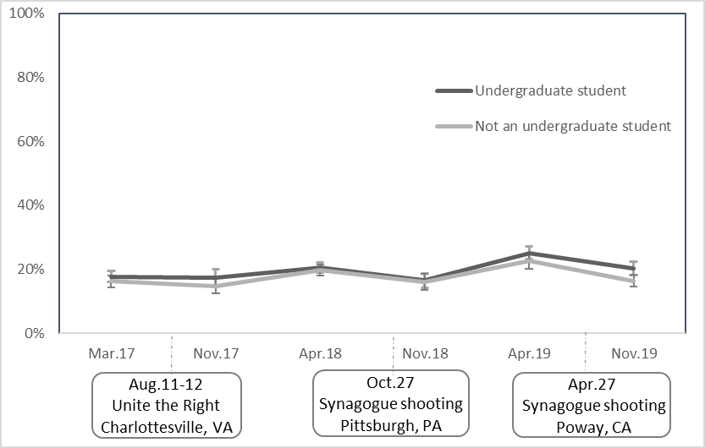
Error bars denote 95% confidence intervals

Appendix 4: Alternative analyses limited to Birthright Nonparticipants
Of the total sample of 32,596 observations collected across these six time points, 27,014 corrispond to applicants who went on a Birthright trip between the pre- and post-trip surveys, while 5,582 corrispond to applicants who never participated in a Birthright trip. The following charts present weighted proportions of experience and perceptions of antisemtism by time, seperatly for all respondents and limited to only those respondents who never participated in Birthright Israel.
Figure 6: Any experience of antisemitic harassment by time

Figure 7: “Very much” concerned about antisemitism by time

Figure 3: Concern about antisemitism on Campus

