Supplementary Table S1. Estimated Daily Intake (EDI) and Hazard quotient (HQ) of Pb and Hg for infants consuming the breast milk
 |  | Concentration (µg/L) | EDI (µg/kg．BWª /day) | HQ
 | Sample | Mean±SD  (min–max) | Median (25%-75%) | Median (25%-75%) | p-value
Pb ª
M1 | 5 | 0.65 ± 0.24 (0.47–1.07) | 0.58 (0.49–0.84) | 1.16 (0.98–1.68) | 0.012*
M2 | 13 | 0.71 ± 0.40 (0.13–1.45) | 0.65 (0.44–0.93) | 1.31 (0.88–1.86)
M3 | 20 | 0.55 ± 0.43 (0.03–1.94) | 0.48 (0.22–0.77) | 0.95 (0.43–1.54)
M4 | 30 | 0.69 ± 0.60 (0.03–2.16) | 0.49 (0.28–0.86) | 0.98 (0.56–1.72)
M5 | 23 | 0.45 ± 0.39 (0.11–1.66) | 0.34 (0.25–0.49) | 0.68 (0.50–0.99)
M6 | 29 | 0.49 ± 0.34 (0.08–1.32) | 0.38 (0.26–0.66) | 0.73 (0.52–1.31)
M7 | 22 | 0.59 ± 0.43 (0.03–1.57) | 0.45 (0.27–0.83) | 0.90 (0.54–1.65)
M8 | 15 | 0.33 ± 0.32 (0.09–1.11) | 0.29 (0.11–0.39) | 0.59 (0.23–0.78)
M9 | 8 | 0.28 ± 0.21 (0.03–0.58) | 0.32 (0.05–0.46) | 0.64 (0.09–0.92)
Hg ª
M1 | 5 | 0.06 ± 0.02 (0.04–0.09) | 0.06 (0.05–0.08) | 0.09 (0.08–0.14) | <0.001*
M2 | 13 | 0.11 ± 0.08 (0.04–0.34) | 0.08 (0.06–0.13) | 0.13 (0.10–0.22)
M3 | 20 | 0.10 ± 0.09 (0.01–0.37) | 0.07 (0.04–0.10) | 0.12 (0.07–0.17)
M4 | 30 | 0.07 ± 0.08 (0.00–0.38) | 0.06 (0.03–0.08) | 0.10 (0.06–0.14)
M5 | 23 | 0.06 ± 0.04 (0.01–0.21) | 0.05 (0.03–0.06) | 0.09 (0.05–0.11)
M6 | 29 | 0.05 ± 0.02 (0.01–0.09) | 0.04 (0.03–0.06) | 0.07 (0.06–0.10)
M7 | 22 | 0.06 ± 0.03 (0.02–0.13) | 0.05 (0.03–0.08) | 0.09 (0.05–0.13)
M8 | 15 | 0.03 ± 0.02 (0.01–0.09) | 0.02 (0.01–0.03) | 0.04 (0.02–0.06)
M9 | 8 | 0.04 ± 0.03 (0.00–0.10) | 0.03 (0.02–0.06) | 0.06 (0.03–0.10)
* p-value<0.05; a. Kruskal–Wallis test
ª body weight of infants

Supplementary Table S2. The samples exceeded the WHO limitation suggested for Pb of breast milk (<5 μg/L)
Month after delivery | n | <5 μg/L | >5 μg/L
1 | 5 | 3 (60%) | 2 (40%)
2 | 14 | 8 (57.1%) | 6 (42.9%)
3 | 28 | 16 (57.1%) | 12 (42.9%)
4 | 44 | 19 (43.2%) | 25 (56.8%)
5 | 33 | 17 (52.5%) | 16 (48.5%)
6 | 41 | 15 (36.6%) | 26 (63.4%)
7 | 31 | 11 (35.5%) | 20 (64.5%)
8 | 18 | 10 (55.6%) | 8 (44.4%)
9 | 14 | 9 (64.3%) | 5 (35.7%)
Total sample size | 228 | 108 | 120
Note: n and percentage in parentheses

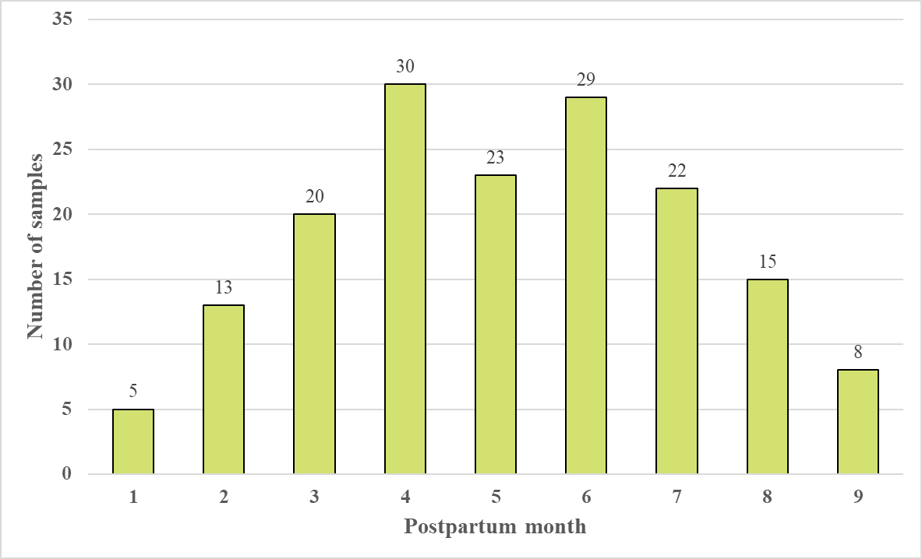
Figure S1. The sample size of breast milk in different postpartum months

A
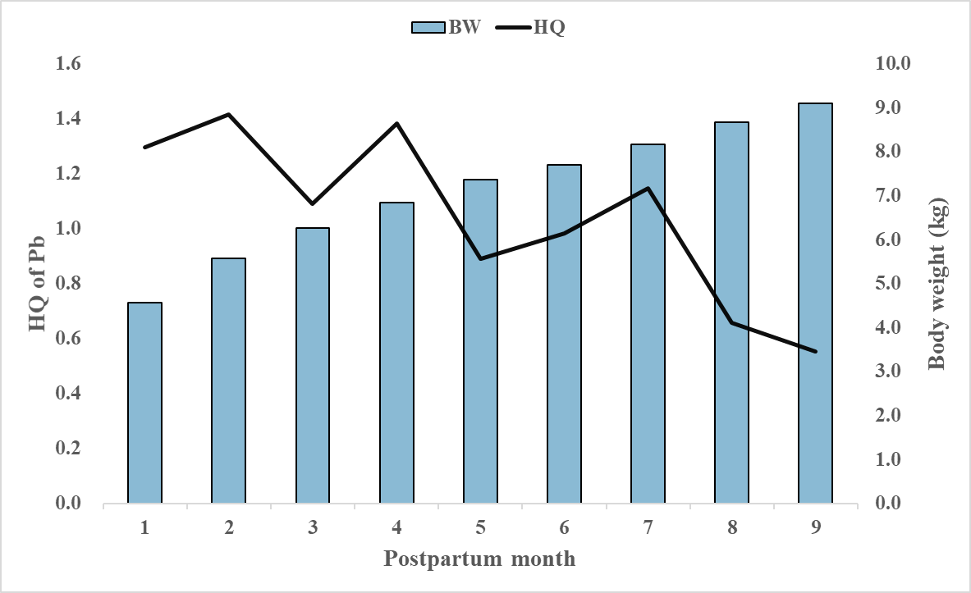
B
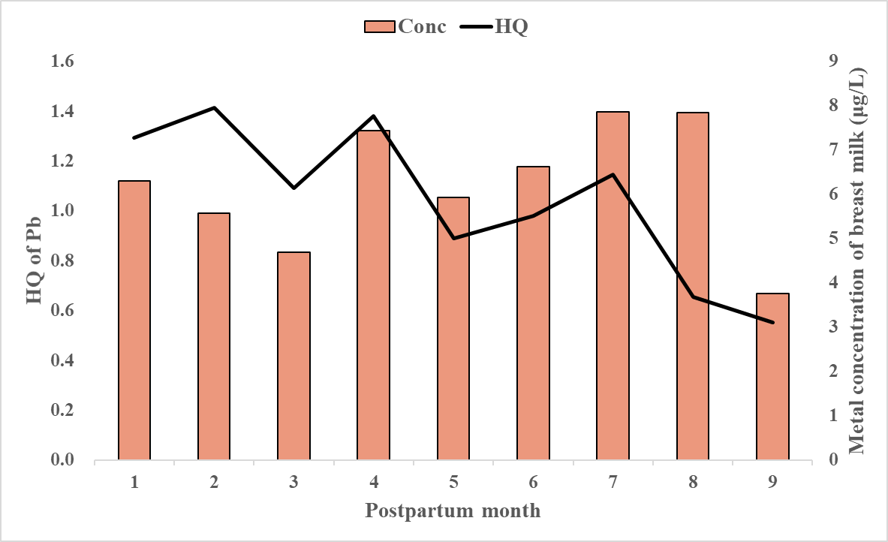
C
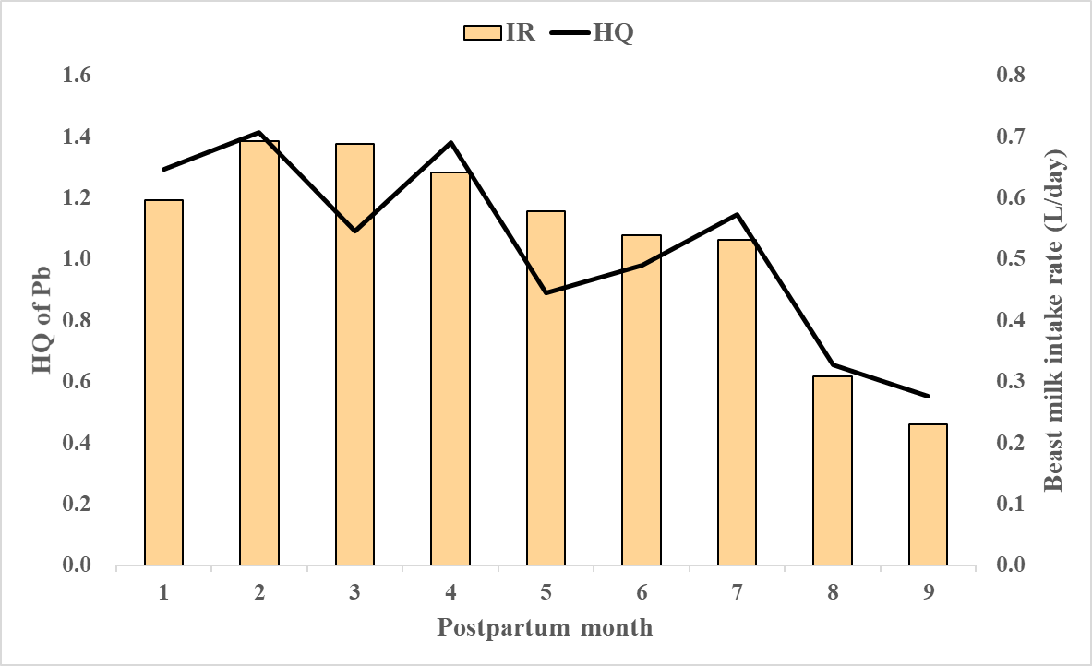
Figure S2. Trend between HQ of Pb, body weight, metal concentration and breast milk intake rate
A
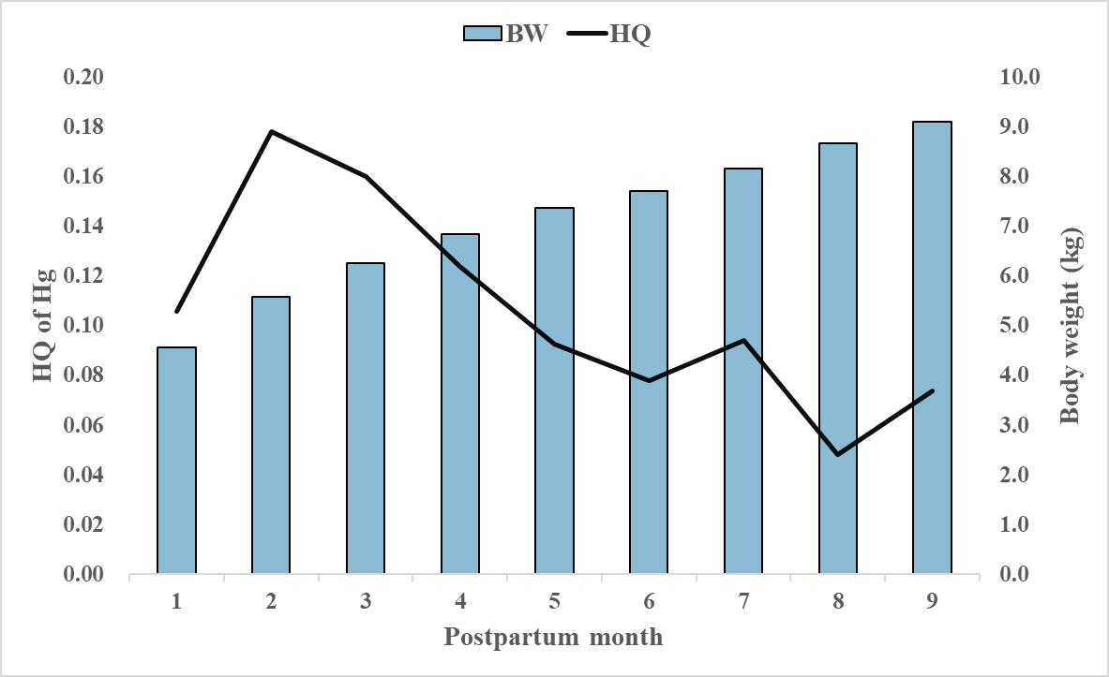
B
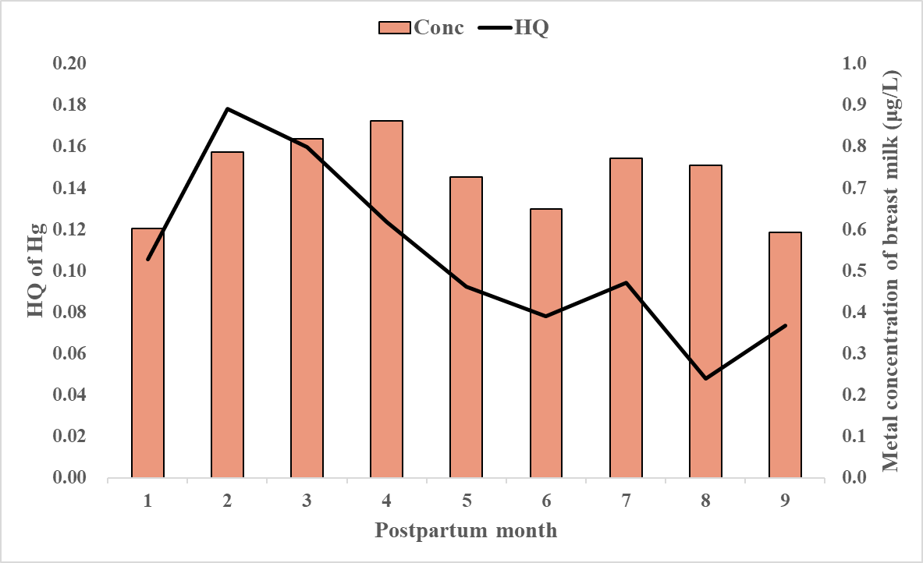
C
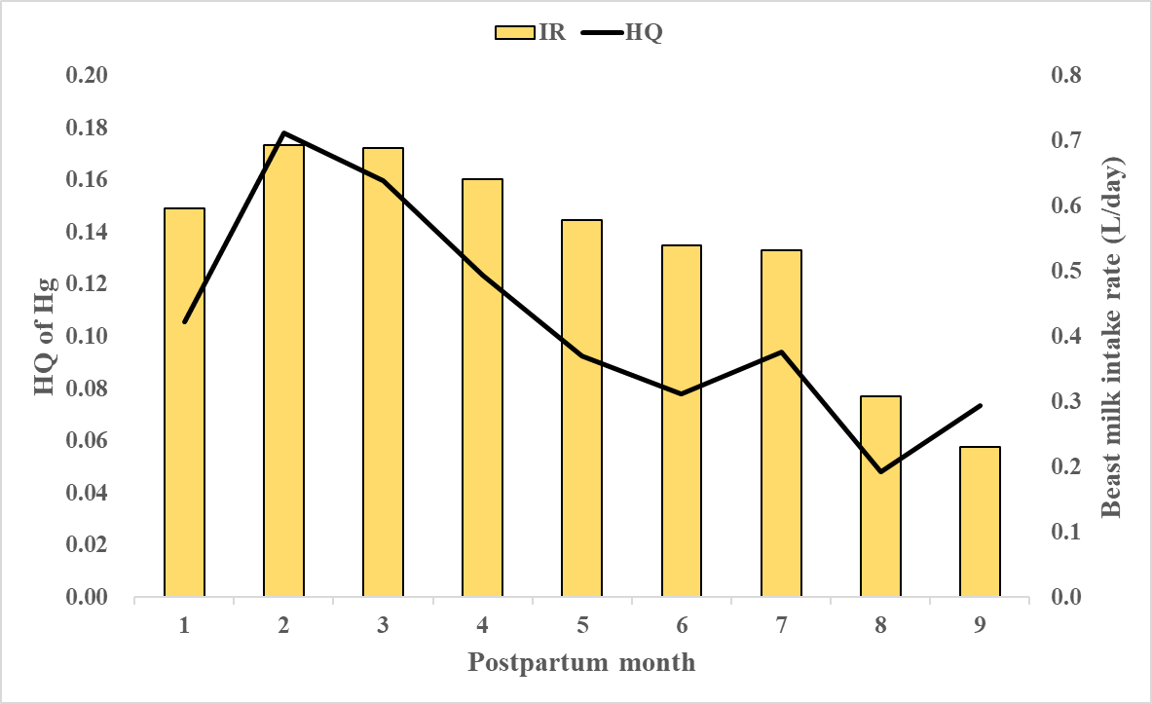

Figure S3. Trend between HQ of Hg, body weight, metal concentration and breast milk intake rate

