Supplementary Information
BDNF and KISS-1 levels in maternal serum, umbilical cord and placenta: The potential role of maternal levels as effect biomarker
Sebastian Granitzer^{1,6 #}, Raimund Widhalm^{1,6 #}, Simon Atteneder¹, Mariana F. Fernandez^{2,3,4}, Vicente Mustieles^{2,3,4}, Harald Zeisler⁵, Markus Hengstschläger ¹, Claudia Gundacker^{1,6}
¹Medical University of Vienna, Institute of Medical Genetics, Vienna, Austria
²University of Granada, Center for Biomedical Research (CIBM), Granada, Spain
³Instituto de Investigación Biosanitaria (ibs.GRANADA), Granada, Spain
⁴Consortium for Research and Public Health (CIBERESP), Instituto de Salud Carlos III, Madrid, Spain
⁵ Medical University Vienna, Department of Obstetrics and Gynecology, Vienna, Austria
⁶Exposome Austria, Research Infrastructure and National EIRENE Hub, Austria
# These authors contributed equally to this work

Corresponding Author
Claudia Gundacker
Institute of Medical Genetics, Medical University of Vienna
Waehringer Strasse 10, A-1090 Vienna, Austria
Tel: +43 1 40160 56503
E-mail: claudia.gundacker@meduniwien.ac.at

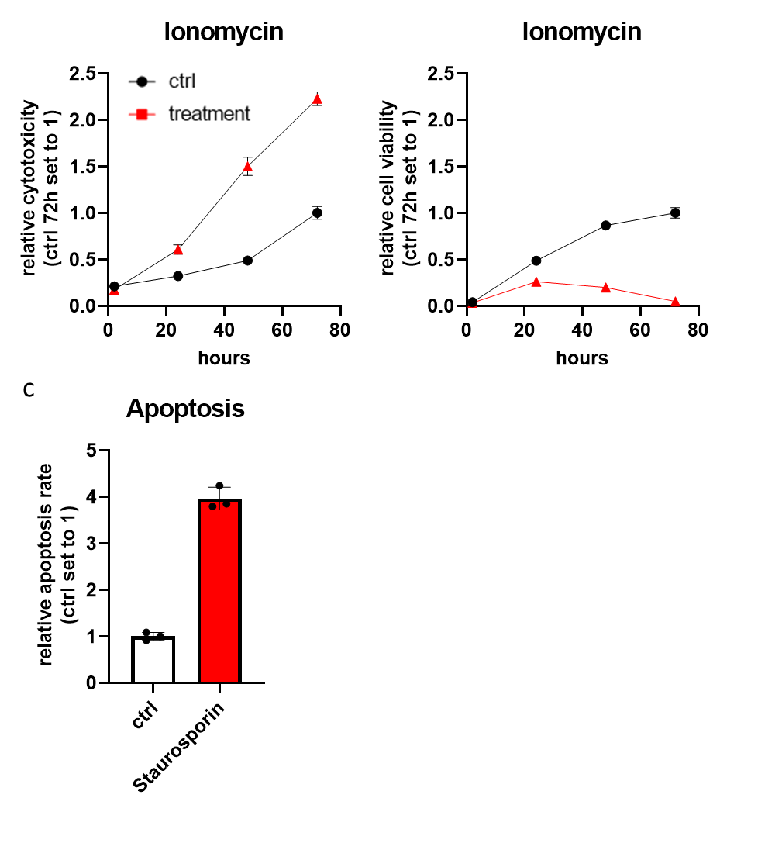
Suppl. Figure 1. Positive controls of cytotoxicity (a), viability (b) and apoptosis (c) assays according to Suppl. Figure 4. (N=3)

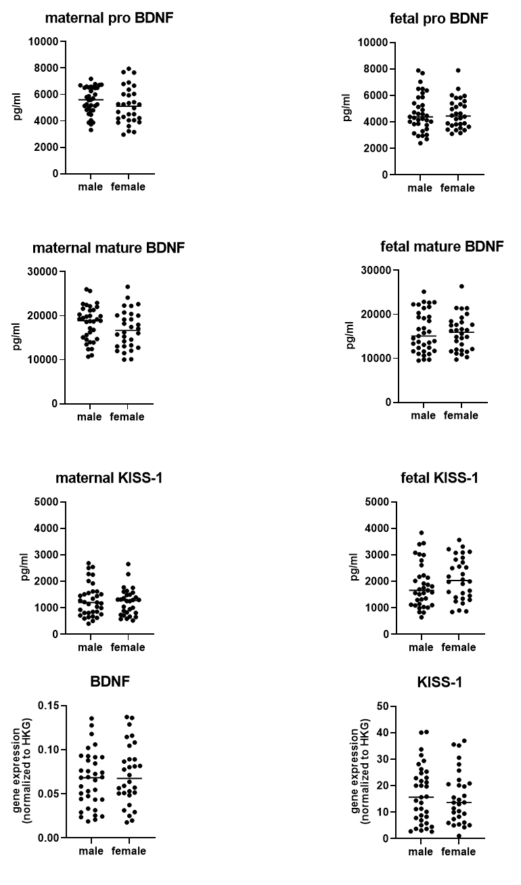
Suppl. Figure 2. No sex specific differences in serum levels and gene expression of BDNF and KISS-1 (35 male and 30 female newborns).

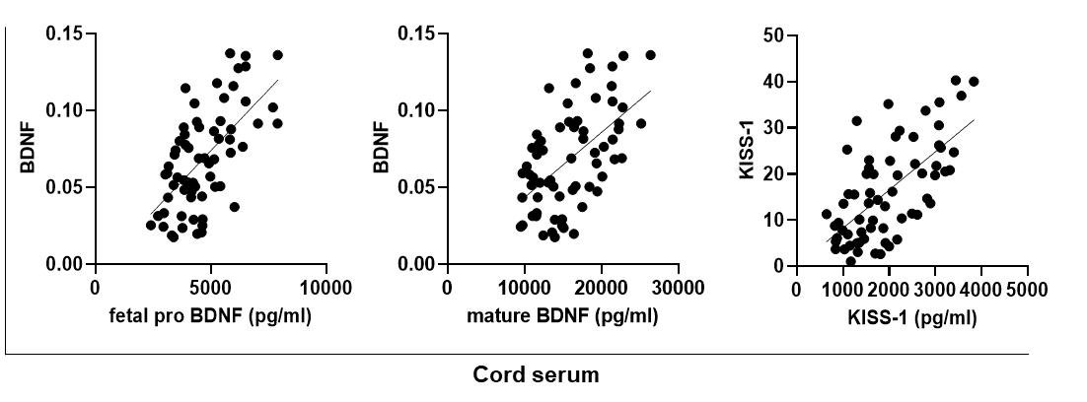
Suppl. Figure 3. Cord serum levels of pro BDNF, mature BDNF, and KISS-1 correlate with placental gene expression levels (N=65).

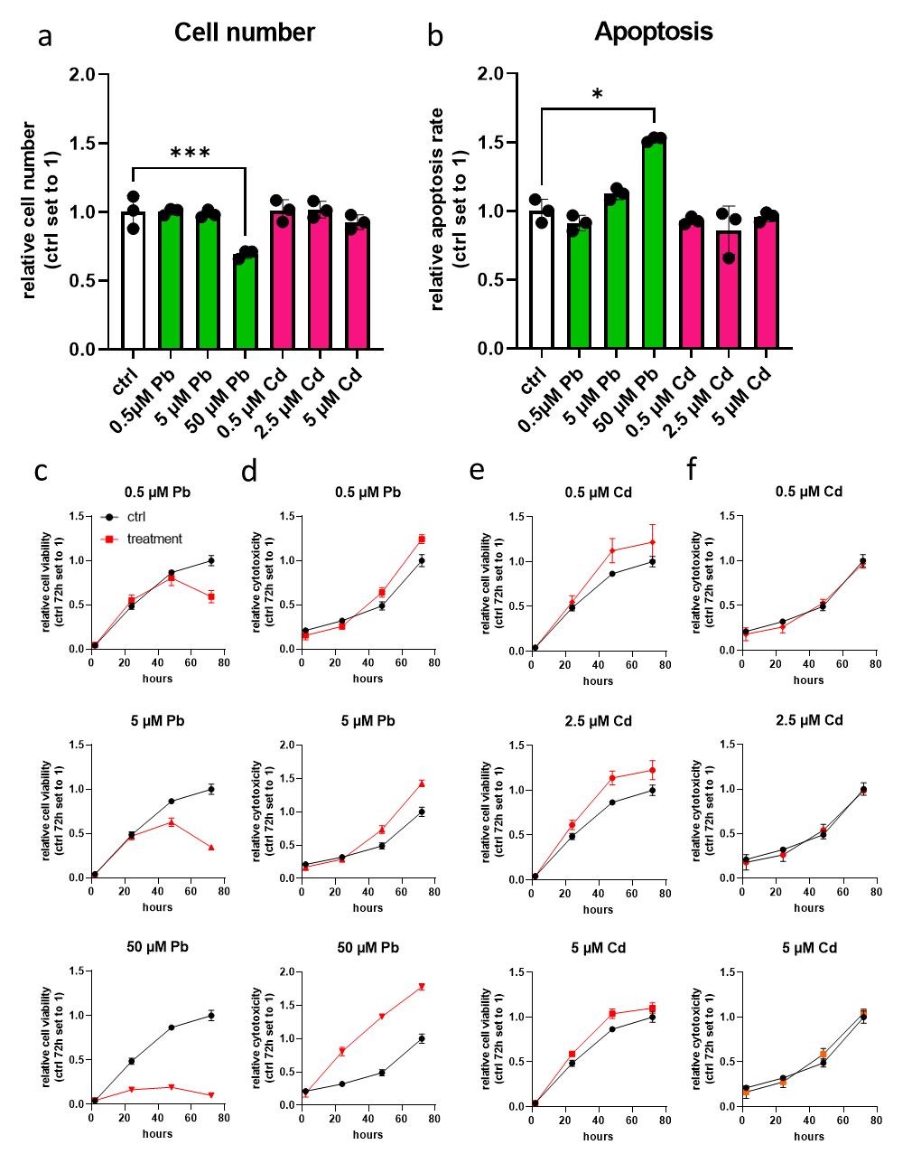
Suppl. Figure 4. Cell number (a), apoptosis (b), cell viability (c, e), and cytotoxicity (d, f) in Pb and Cd treated BeWo cells. Bar graphs represent mean ± SD from three independent experiments made in technical triplicates; One-Way ANOVA with Welch´s Correction; *P<0.05,***P<0.001

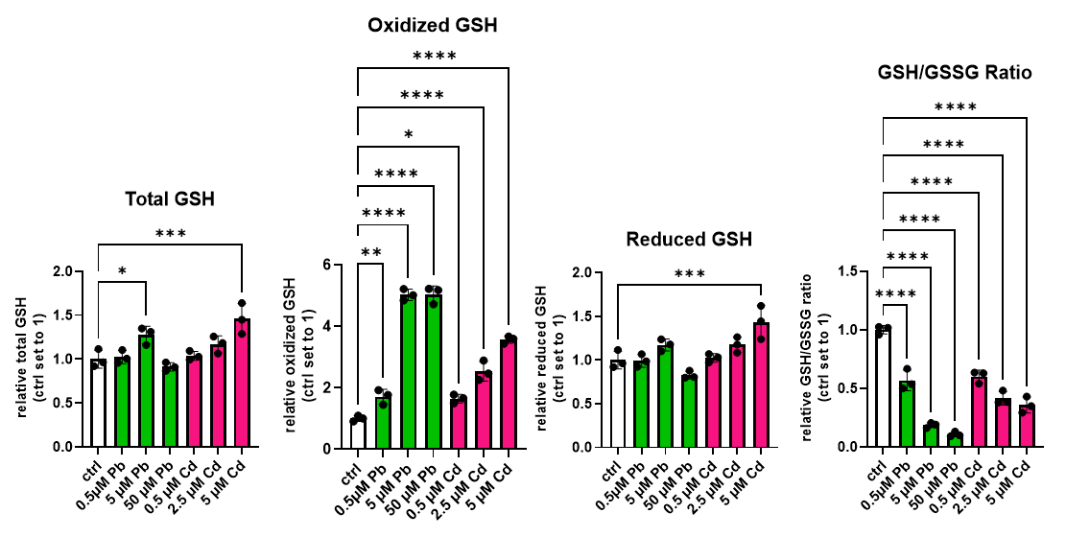Suppl. Figure 5. Glutathione status of Pb and Cd treated BeWo cells. Bar graphs represent mean ± SD from three independent experiments made in technical triplicates; One-Way ANOVA with Welch´s Correction; *P<0.05, **P<0.01, ***P<0.001, ****P<0.0001

