Distribution of water-soluble arsenic species in the sub-thallus of Australian brown macroalgae

Tuti H Siregar^{1,2*}, Jill Bartlett^{1,3}, Ross M. Thompson^{1,4}

¹Centre for Applied Water Science, Faculty of Science and Technology, University of Canberra, Kirrinari St, Bruce, ACT, Australia

²Research Centre for Food Processing and Technology, National Research and Innovation Agency, Jl Raya Yogyakarta Wonosari, DIY, Indonesia
³Pangaea Innovations Pty Ltd, Canberra, ACT, Australia
⁴Department of Zoology, University of Otago, Dunedin, New Zealand

* Correspondence should be sent to Tuti.Hartati.Siregar@brin.go.id

Exposure and Health, 2025

Supporting information 1: Peak identification of samples using anion standards (MA,DMA, AsIII, and AsV) and Ascophyllum nodosum used as an in-house reference material (A), and peak of arsenic species in the certified reference material NMIJ, Japan (B), samples of Pachydictyon paniculatum (C), Cystoseira trinodis D), Cystophora monilifera (E), Lobospira bicuspidate (F), Hormosira banksia (G), Phylospora comosa (H), and Fucus vesiculosus (I).
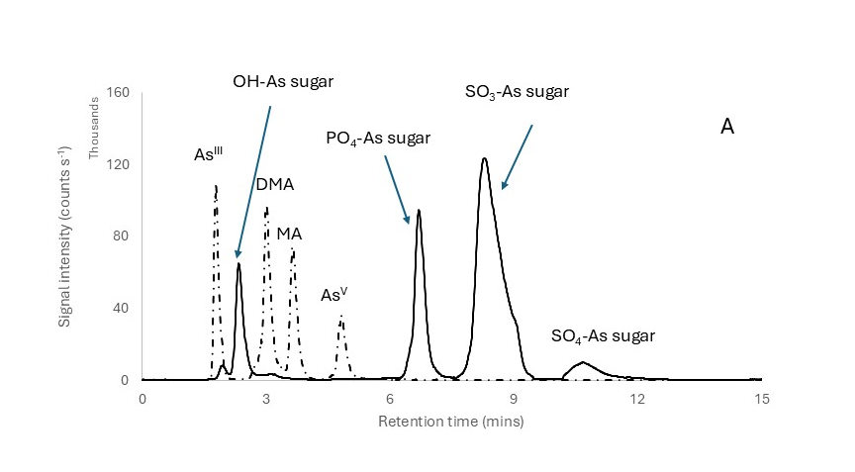
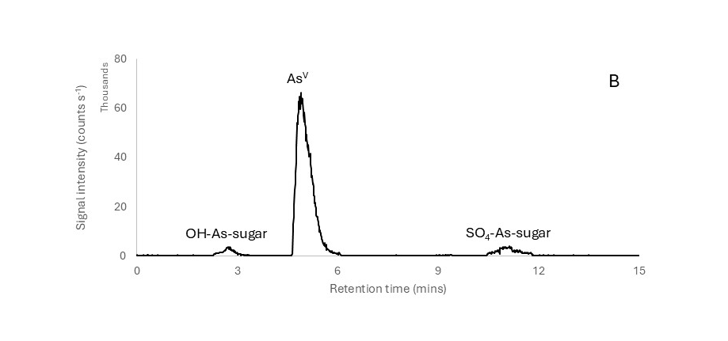
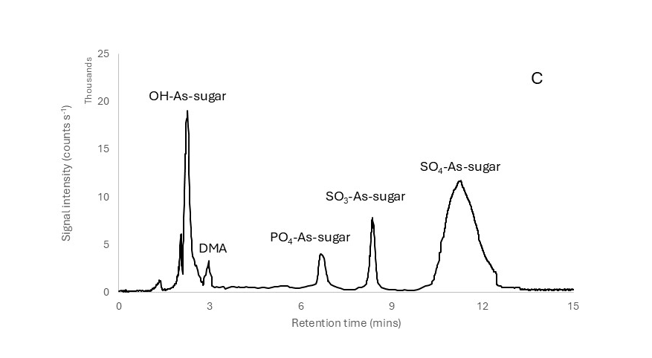
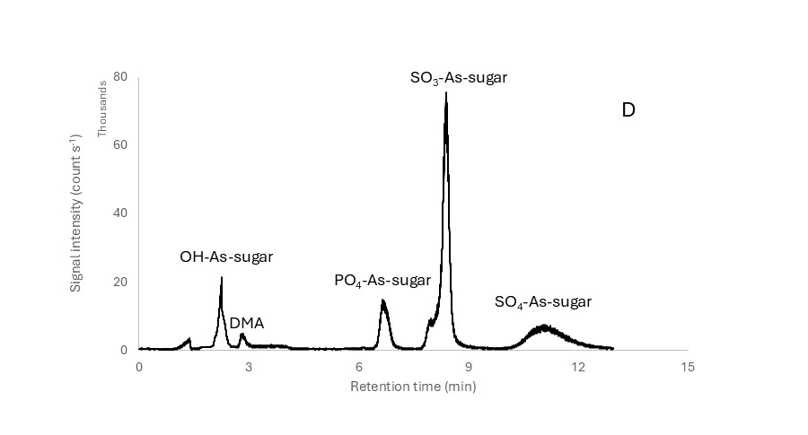
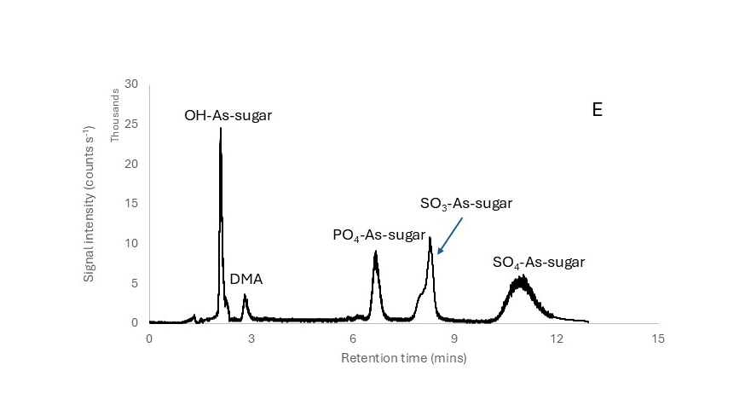
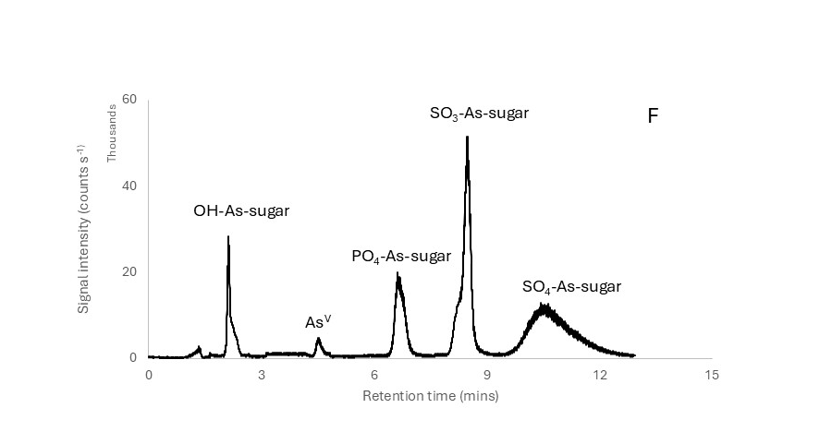
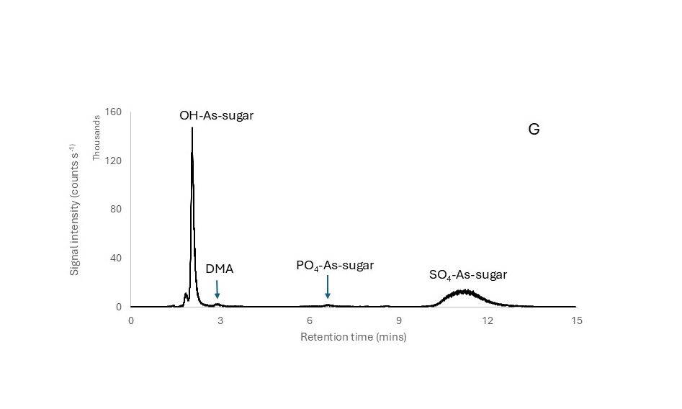
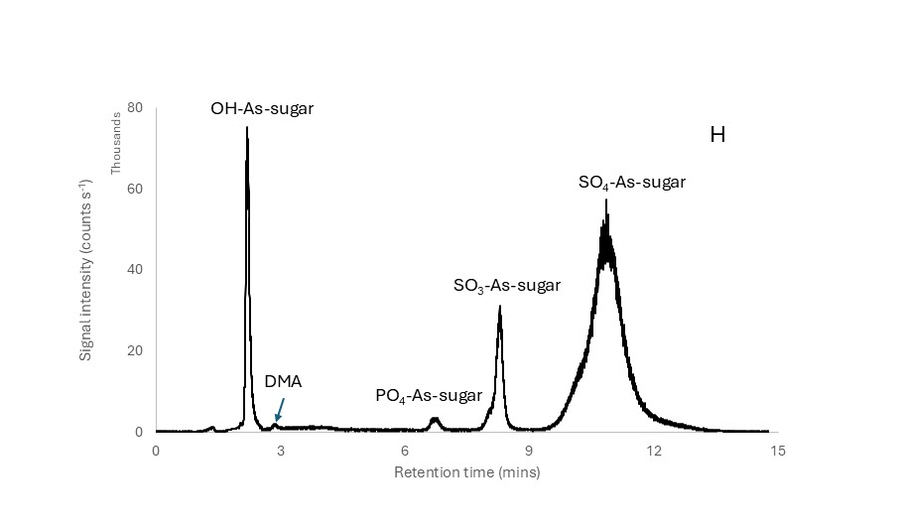
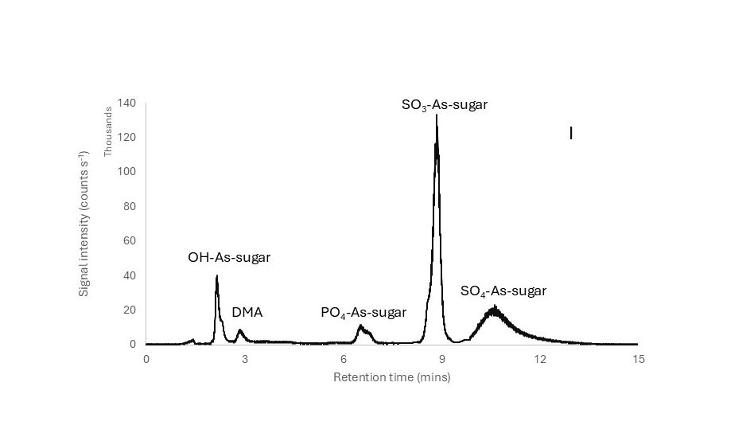

Supporting information 2: Two-factor ANOVA for differences in concentrations of total arsenic and arsenic species between different algal taxa (n=7) and different sections of the thallus (n=4) and their interaction. The sample size for total arsenic = 58. MA = monomethylarsonic acid, DMA = dimethylarsinic acid. Statistically significant results (p<0.05) are shown in bold.

As species | F statistic
As species | Algal taxa | Thallus section | taxa*section
Total As | 5972 | 1161 | 647
MA | 333 | 718 | 181
DMA | 125 | 25 | 41
As^{V} | 1122 | 344 | 97
SO₄ As-sugar | 742 | 109 | 21
SO₃ As-sugar | 76 | 84 | 71
PO₄ As-sugar | 304 | 175 | 73
OH As-sugar | 125 | 25 | 41

