SUPPLEMENTARY MATERIAL

Low-Level Environmental Cadmium Exposure and Its Effects on Renal and Bone Health in Brazilian Postmenopausal Women: A Cross-Sectional Study

Journal: Exposure and Health

Carlos Tadashi Kunioka^{1,2}, Jonas Carneiro Cruz³, Vanessa Cristina de Oliveira Souza³, Bruno Alves Rocha^{3,4}, Fernando Barbosa Jr³, Luís Belo⁵, Maria Conceição Manso^{1,6,7,8}, Márcia Carvalho^{1,6,7,8}*

¹ FP-I3ID, FP-BHS, Fernando Pessoa University, Praça de 9 de abril 349, 4249-004 Porto, Portugal (36181@ufp.edu.pt, cmanso@ufp.edu.pt; mcarv@ufp.edu.pt)
² Western Paraná State University (UNIOESTE), Cascavel 85819-110, Paraná, Brazil
³ University of São Paulo, School of Pharmaceutical Sciences of Ribeirao Preto, Department of Clinical Analyses, Toxicology and Food Sciences, Ribeirão Preto, SP, 14040-903, Brazil (jonas-cruz@hotmail.com, vcosouza@fcfrp.usp.br, fbarbosa@fcfrp.usp.br)
⁴ Institute of Chemistry, Federal University of Alfenas, 37130-001, Alfenas, MG, Brazil (farmbrunorocha@gmail.com)
⁵ UCIBIO i4HB, Faculdade de Farmácia, Universidade do Porto, Rua Jorge Viterbo Ferreira 228, 4050-313 Porto, Portugal (luisbelo@ff.up.pt)
⁶ LAQV/REQUIMTE, University of Porto, 4050-313 Porto, Portugal
⁷ RISE-Health, Faculty of Health Sciences, Fernando Pessoa University, Fernando Pessoa Teaching and Culture Foundation, Rua Carlos da Maia 296, 4200-150, Porto, Portugal
⁸ Faculty of Health Sciences, University Fernando Pessoa, Rua Carlos da Maia, 296, 4200-150 Porto, Portugal

* Corresponding author: mcarv@ufp.edu.pt (M. Carvalho)

Figure S1. Correlation between bone mineral density (BMD) values obtained at different bone sites (lumbar spine, femoral neck and total hip).

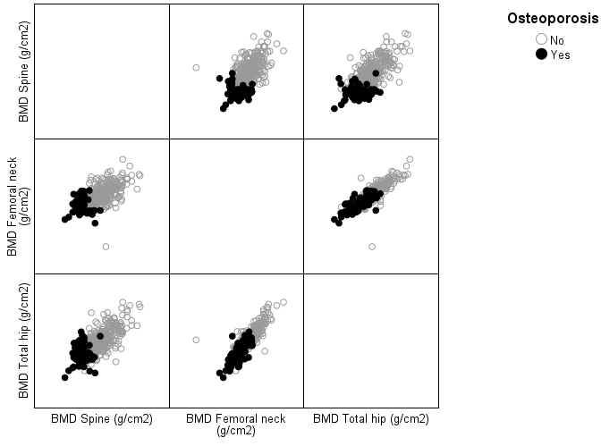

Figure S2. Correlation between creatinine-adjusted urinary β2-microglobulin (β2-MG/creat) and creatinine-adjusted urinary cadmium (Cd/creat) levels (variables ln-transformed) in postmenopausal women. r_{s}, Spearman’s rank correlation coefficient; P < 0.05 was considered as statistically significant.

