Supplemental Materials

Supplemental Figure S1. Directed acyclic graph of serum PFAS concentration, seafood consumption, and other variables.

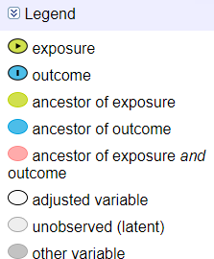
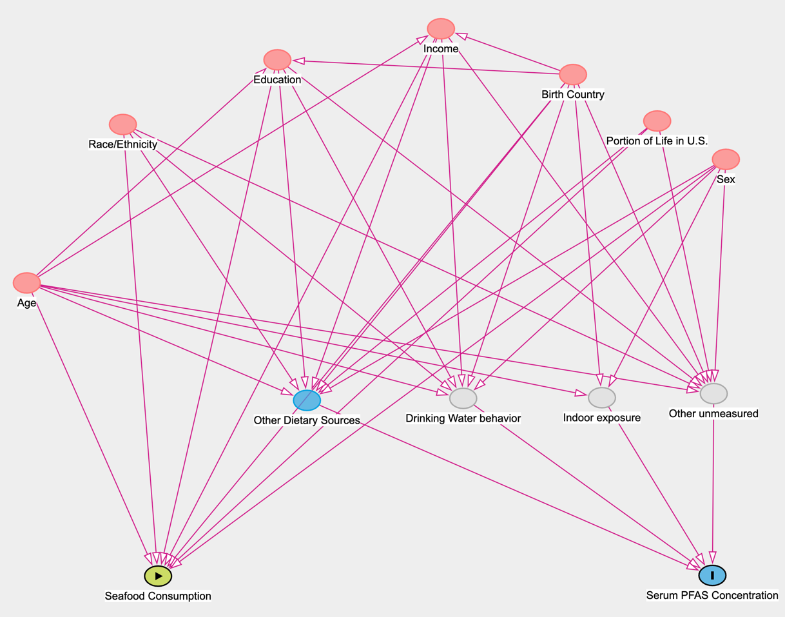

Supplemental Table 1. Serum PFAS Levels of other PFASs measured among participants in the ACE project (n = 195).

Analyte | ACE Phase | n | DF | LOD | GMª | GM 95% CI | 25th | 50th | 75th | 90th
4:2 FTS | 1 | 96 | 0% | 0.012 | * | * | < LOD | < LOD | < LOD | < LOD
 | 2 | 99 | 0% | 0.012 | * | * | < LOD | < LOD | < LOD | < LOD
5:3 FTCA | 1 | 96 | 0% | 0.05 | * | * | < LOD | < LOD | < LOD | < LOD
 | 2 | 99 | 2% | 0.05 | * | * | < LOD | < LOD | < LOD | < LOD
6:2 diPAP | 1 | 96 | 7.30% | 0.05 | * | * | < LOD | < LOD | < LOD | < LOD
 | 2 | 99 | 2% | 0.05 | * | * | < LOD | < LOD | < LOD | < LOD
6:2 FTCA | 1 | 96 | 0% | 0.25 | * | * | < LOD | < LOD | < LOD | < LOD
 | 2 | 99 | 0% | 0.25 | * | * | < LOD | < LOD | < LOD | < LOD
6:2 FTS | 1 | 96 | 0% | 0.05 | * | * | < LOD | < LOD | < LOD | < LOD
 | 2 | 99 | 3% | 0.05 | * | * | < LOD | < LOD | < LOD | < LOD
6:2 FTUCA | 1 | 96 | 0% | 0.012 | * | * | < LOD | < LOD | < LOD | < LOD
 | 2 | 99 | 0% | 0.012 | * | * | < LOD | < LOD | < LOD | < LOD
6:6 PFPiA | 1 | 96 | 0% | 0.012 | * | * | < LOD | < LOD | < LOD | < LOD
 | 2 | 99 | 0% | 0.01 | * | * | < LOD | < LOD | < LOD | < LOD
6:8 PFPiA | 1 | 96 | 0% | 0.05 | * | * | < LOD | < LOD | < LOD | < LOD
 | 2 | 99 | 0% | 0.05 | * | * | < LOD | < LOD | < LOD | < LOD
7:3 FTCA | 1 | 96 | 0% | 0.05 | * | * | < LOD | < LOD | < LOD | < LOD
 | 2 | 99 | 5.1% | 0.05 | * | * | < LOD | < LOD | < LOD | < LOD
8:2 diPAP | 1 | 96 | 0% | 0.25 | * | * | < LOD | < LOD | < LOD | < LOD
 | 2 | 99 | 0% | 0.25 | * | * | < LOD | < LOD | < LOD | < LOD
8:2 FTCA | 1 | 96 | 0% | 0.5 | * | * | < LOD | < LOD | < LOD | < LOD
 | 2 | 99 | 0% | 0.5 | * | * | < LOD | < LOD | < LOD | < LOD
8:2 FTS | 1 | 96 | 0% | 0.05 | * | * | < LOD | < LOD | < LOD | < LOD
 | 2 | 99 | 0% | 0.05 | * | * | < LOD | < LOD | < LOD | < LOD
8:2 FTUCA | 1 | 96 | 0% | 0.012 | * | * | < LOD | < LOD | < LOD | < LOD
 | 2 | 99 | 0% | 0.012 | * | * | < LOD | < LOD | < LOD | < LOD
8:2 PAP | 1 | 96 | 0% | 0.5 | * | * | < LOD | < LOD | < LOD | < LOD
 | 2 | 99 | 0% | 0.5 | * | * | < LOD | < LOD | < LOD | < LOD
Et-PFOSA-AcOH | 1 | 96 | 5.2% | 0.05 | * | * | < LOD | < LOD | < LOD | < LOD
 | 2 | 99 | 3% | 0.05 | * | * | < LOD | < LOD | < LOD | < LOD
Me-PFOSA-AcOH | 1 | 96 | 95.8% | 0.012 | 0.05 | (0.04, 0.07) | 0.03 | 0.05 | 0.10 | 0.23
 | 2 | 99 | 97% | 0.012 | 0.03 | (0.03, 0.04) | 0.02 | 0.03 | 0.05 | 0.11
PFBA | 1 | 96 | 62.5% | 0.05 | * | * | < LOD | 0.06 | 0.09 | 0.14
 | 2 | 99 | 67.7% | 0.05 | 0.06 | (0.05, 0.07) | < LOD | 0.06 | 0.07 | 0.10
PFBS | 1 | 96 | 0% | 0.044 | * | * | < LOD | < LOD | < LOD | < LOD
 | 2 | 99 | 3% | 0.04 | * | * | < LOD | < LOD | < LOD | < LOD
PFDoA | 1 | 96 | 56.3% | 0.05 | * | * | < LOD | 0.05 | 0.08 | 0.13
 | 2 | 99 | 52.5% | 0.05 | * | * | < LOD | 0.01 | 0.03 | 0.04
PFDS | 1 | 96 | 53.1% | 0.01 | * | * | < LOD | 0.01 | 0.02 | 0.05
 | 2 | 99 | 59.6% | 0.01 | * | * | < LOD | 0.05 | 0.08 | 0.13
PFHpA | 1 | 96 | 30.2% | 0.05 | * | * | < LOD | < LOD | 0.06 | 0.09
 | 2 | 99 | 20.2% | 0.05 | * | * | < LOD | < LOD | < LOD | 0.07
PFHxA | 1 | 96 | 97.9% | 0.056 | 0.18 | (0.16, 0.19) | 0.15 | 0.18 | 0.21 | 0.28
 | 2 | 99 | 98% | 0.06 | 0.19 | (0.17, 0.22) | 0.12 | 0.17 | 0.27 | 0.45
PFHxPA | 1 | 96 | 0% | 0.05 | * | * | < LOD | < LOD | < LOD | < LOD
 | 2 | 99 | 0% | 0.05 | * | * | < LOD | < LOD | < LOD | < LOD
PFOPA | 1 | 96 | 0% | 0.05 | * | * | < LOD | < LOD | < LOD | < LOD
 | 2 | 99 | 0% | 0.05 | * | * | < LOD | < LOD | < LOD | < LOD
PFOSA | 1 | 96 | 0% | 0.012 | * | * | < LOD | < LOD | < LOD | < LOD
 | 2 | 99 | 3% | 0.01 | * | * | < LOD | < LOD | < LOD | < LOD
PFPeA | 1 | 96 | 0% | 0.05 | * | * | < LOD | < LOD | < LOD | < LOD
 | 2 | 99 | 0% | 0.05 | * | * | < LOD | < LOD | < LOD | < LOD
Note: ACE, Asian/Pacific Islander Community Exposures; DF, detection frequency; LOD, limit of detection; Min, minimum; GM, geometric mean; CI, confidence interval
* Geometric mean was not calculated because the chemical was found in less than 65% of the study group.

Supplemental Table 2. Adjusted percent change (95% confidence interval) in serum PFAS levels per seafood consumption parameter over the past 30 days or past year
by ACE phase (n = 195).

 |  |  |  |  |  | PFOS |  |  | PFUnDA |  |  | PFDA |  |  | PFNA |  |  | PFHxS |  | PFOA
 | Parameter | Level | N  ACE 1 | N  ACE 2 | ACE 1 |  | ACE 2 | ACE 1 |  | ACE 2 | ACE 1 |  | ACE 2 | ACE 1 |  | ACE 2 | ACE 1 |  | ACE 2 |  | ACE 1 | ACE 2
 | Continuous
 | Past 30 day Total Seafood | Per 5 meals | 95 | 96 | 8 (1, 15) |  | 12 (4, 20) | 7 (0, 15) |  | 15 (5, 26) | 4 (-4, 12) |  | 10 (2, 18) | 5 (-2, 11) |  | 7 (1, 13) | 6 (0, 13) |  | -3 (-8, 3) |  | 4 (-1, 9) | 0 (-7, 7)
 | Past 30 Day Total Fish | Per 5 meals | 95 | 96 | 12 (3, 22) |  | 13 (3, 25) | 12 (4, 21) |  | 18 (4, 34) | 9 (-1, 19) |  | 11 (1, 22) | 7 (-1, 16) |  | 9 (2, 17) | 8 (0, 17) |  | -3 (-9, 4) |  | 3 (-4, 11) | 3 (-6, 12)
 | Past 30 day Bought Fish | Per 5 meals | 95 | 96 | 11 (1, 22) |  | 13 (1, 26) | 12 (3, 23) |  | 19 (4, 37) | 7 (-3, 18) |  | 10 (-1, 23) | 6 (-3, 15) |  | 9 (0, 18) | 7 (-2, 18) |  | -4 (-11, 3) |  | 2 (-6, 11) | 2 (-8, 13)
 | Past 30 Day Caught Fish | Per 5 meals | 95 | 96 | 40 (17, 68) |  | 37 (-2, 90) | 29 (9, 53) |  | 26 (-19, 96) | 38 (13, 69) |  | 32 (-9, 91) | 33 (16, 53) |  | 27 (-2, 64) | 22 (7, 39) |  | 10 (-5, 27) |  | 16 (4, 30) | 12 (-8, 36)
 | Past 30 day Bought Shellfish | Per 5 meals | 95 | 96 | 2 (-10, 16) |  | 18 (0, 40) | -2 (-19, 17) |  | 20 (1, 42) | -9 (-21, 4) |  | 17 (2, 36) | -2 (-14, 10) |  | 7 (-5, 20) | 9 (-5, 26) |  | 1 (-11, 14) |  | 5 (-8, 20) | -4 (-16, 8)
 | Categorical
 | Past 30 Day Total Fish | < 2 / week | 61 | 77 | Reference |  | Reference | Reference |  | Reference | Reference |  | Reference | Reference |  | Reference | Reference |  | Reference |  | Reference | Reference
 |  | 2-3 / week | 15 | 11 | -4 (-38, 50) |  | 31 (-9, 90) | -5 (-35, 40) |  | 53 (14, 106) | -13 (-38, 23) |  | 32 (-7, 87) | 5 (-26, 49) |  | 21 (-5, 54) | -17 (-45, 24) |  | -5 (-21, 16) |  | -20 (-46, 17) | 6 (-20, 42)
 |  | > 3 / week | 20 | 11 | 25 (-9, 73) |  | 59 (10, 129) | 27 (-5, 70) |  | 66 (3, 167) | 9 (-20, 50) |  | 41 (-2, 103) | 9 (-13, 37) |  | 33 (-3, 81) | 30 (-3, 74) |  | -8 (-28, 17) |  | 5 (-20, 39) | 11 (-20, 54)
 | Past Year Caught Fish | No | 70 | 62 | Reference |  | Reference | Reference |  | Reference | Reference |  | Reference | Reference |  | Reference | Reference |  | Reference |  | Reference | Reference
 |  | Yes | 26 | 37 | -1 (-29, 38) |  | 30 (-4, 76) | 17 (-12, 54) |  | 38 (0, 91) | 18 (-15, 64) |  | 35 (1, 79) | 0 (-23, 30) |  | 32 (4, 67) | -13 (-34, 15) |  | 24 (3, 48) |  | -3 (-28, 30) | 25 (2, 52)
 | Fish Paste, Balls, and Cakes ^{b} | No | 10 | 19 | Reference |  | Reference | Reference |  | Reference | Reference |  | Reference | Reference |  | Reference | Reference |  | Reference |  | Reference | Reference
 |  | Yes | 85 | 80 | 1 (-36, 59) |  | 42 (-8, 117) | 23 (-29, 111) |  | 55 (-3, 147) | -1 (-36, 53) |  | 37 (-4, 95) | -9 (-43, 46) |  | 23 (-11, 70) | -9 (-38, 34) |  | 6 (-25, 49) |  | 24 (-22, 99) | 15 (-18, 61)
 | Shrimp or Crab Sauce^{b} | No | 26 | 15 | Reference |  | Reference | Reference |  | Reference | Reference |  | Reference | Reference |  | Reference | Reference |  | Reference |  | Reference | Reference
 |  | Yes | 66 | 83 | 25 (-11, 75) |  | 59 (9, 130) | 19 (-14, 66) |  | 60 (-6, 172) | 8 (-30, 68) |  | 40 (-4, 105) | 0 (-31, 44) |  | 42 (8, 88) | 7 (-21, 46) |  | 30 (-4, 76) |  | -10 (-42, 40) | 23 (-8, 63)
Note: ACE, Asian/Pacific Islander Community Exposures; PFDA, perfluorodecanoic acid; PFHxS, perfluorohexane sulfonate; PFNA, perfluorononanoic acid; PFOA, perfluorooctanoic Acid; PFOS, perfluorooctane sulfonic acid; PFUnDA, perfluoroundecanoic acid
ª Each model adjusted for age (years), sex, birth country (U.S vs. non-U.S.), educational attainment (no college vs. some college or more), and portion of life in the U.S. (years), and accounted for clustering with random intercepts for each household. Estimates represent the proportional change in the geometric mean of serum PFAS for consumption of the seafood parameter level compared with the reference level, adjusted for all other variables in the model.
^{b} Information collected in ACE 2 only

Supplemental Table 3. Adjustedª percent change (95% confidence interval) in serum PFAS levels per seafood consumption parameter among ACE 2 participants, California, 2016-2017 (n=99).

Parameter | N | PFOS | PFUnDA | PFDA | PFNA | PFHxS | PFOA
Past Year Frequency of Caught Fish^{b} | 99
< 1 / month | 62 | Reference | Reference | Reference | Reference | Reference | Reference
1-3 / month | 15 | 49 (3, 116) | 56 (-5, 156) | 45 (3, 104) | 43 (4, 98) | 20 (-8, 55) | 22 (-4, 56)
1-2 / week | 15 | -5 (-37, 42) | 1 (-31, 48) | -1 (-33, 45) | 9 (-21, 50) | 23 (-3, 57) | 18 (-6, 48)
≥ 3 / week | 7 | 92 (29, 186) | 110 (53, 188) | 125 (73, 194) | 66 (32, 108) | 33 (-15, 108) | 30 (-10, 88)
Any Fish Part^{b} | 99
No | 16 | Reference | Reference | Reference | Reference | Reference | Reference
Yes | 83 | 124 (61, 211) | 110 (30, 241) | 99 (46, 170) | 49 (4, 113) | 20 (-23, 87) | 34 (4, 72)
Fish Head^{b} | 99
No | 36 | Reference | Reference | Reference | Reference | Reference | Reference
Yes | 63 | 53 (10, 114) | 122 (37, 262) | 67 (21, 131) | 42 (5, 92) | 36 (11, 65) | 14 (-14, 50)
Fish Eyes^{b} | 99
No | 64 | Reference | Reference | Reference | Reference | Reference | Reference
Yes | 35 | 89 (49, 140) | 65 (23, 121) | 79 (41, 127) | 41 (15, 72) | 4 (-20, 36) | 10 (-12, 37)
Fish Skin^{b} | 98
No | 64 | Reference | Reference | Reference | Reference | Reference | Reference
Yes | 34 | 71 (26, 133) | 49 (1, 119) | 48 (10, 98) | 25 (-7, 68) | 0 (-30, 44) | 13 (-11, 42)
Fish Organs^{b} | 99
No | 86 | Reference | Reference | Reference | Reference | Reference | Reference
Yes | 13 | 41 (13, 76) | 49 (17, 89) | 41 (15, 72) | 17 (-3, 40) | 2 (-19, 29) | -5 (-21, 15)
Note: ACE, Asian/Pacific Islander Community Exposures; PFDA, perfluorodecanoic acid; PFHxS, perfluorohexane sulfonate; PFNA, perfluorononanoic acid; PFOA, perfluorooctanoic Acid; PFOS, perfluorooctane sulfonic acid; PFUnDA, perfluoroundecanoic acid
ª Adjusted for age (years), sex, birth country (U.S vs. non-U.S.), educational attainment (no college vs. some college or more), and portion of life in the U.S. (years), and accounted for clustering with random intercepts for each household
^{b} Unable to run analysis among ACE 1 participants due to low n
^{c} Consumption parameters assessed only within ACE 2 participants

