Supporting Information

Soil indigenous microbes protect maize plants in arsenic-contaminated soils

Hang Guan^{1†}, Veronica Caggìa^{2,5†}, Andrea Gómez-Chamorro³, Suyi Hu⁴, Jan Waelchli⁵, Xiaowen Liu^{1,6}, Gabriel Deslandes^{2,5}, Alban Ramette³, Klaus Schlaeppi^{2,5}, Adrien Mestrot¹, Sandra Spielvogel^{7,8*} and Moritz Bigalke^{1,9*}

¹ Institute of Geography, University of Bern, Hallerstrasse 12, CH-3012 Bern, Switzerland
² Institute of Plant Sciences, University of Bern, Altenbergrain 21, CH-3013 Bern, Switzerland
³ Institute for Infectious Diseases, University of Bern, Friedbühlstrasse 51, CH-3001 Bern
⁴ ARTORG Center for Biomedical Engineering Research, University of Bern, Bern, Switzerland
⁵ Department of Environmental Sciences, University of Basel, Bernoullistrasse 32, CH-4056 Basel, Switzerland
⁶ Center of Deep Sea Research, Institute of Oceanology, Center for Ocean Mega-Science, Chinese Academy of Sciences, CN-266071 Qingdao, China
⁷ Institute of Plant Nutrition and Soil Science, Christian-Albrechts-Universität, Hermann-Rodewald-Strasse 2, D-24118 Kiel, Germany
⁸ Department of Agricultural Soil Science, Georg-August-Universität, Büsgenweg 2, D-37077 Göttingen, Germany
⁹ Institute of Applied Geoscience, Technical University Darmstadt, Schnittspahnstrasse 9, D-64287 Darmstadt, Germany

† Shared co-first authorship
*Correspondence: bigalke@geo.tu-darmstadt.de

The content includes 18 pages with 12 tables and 11 figures
Contents

List of Tables 3
List of Figures 3
1 Materials & Methods 4
1.1 Soil Incubation 4
1.2 Chemical Characterization of Soils 4
1.3 Preparation of Microbial Extracts 5
1.4 Maize Biomass Estimation Model 5
1.5 Plant Cultivation 5
1.6 Plant Harvest 6
2 Results 6
References 18

List of Tables

Table S1. Characterizations of native soil (NS) and disturbed soil (DS) 4
Table S2. N-β-acetylglucosaminidase, acid phosphatase, β-glucosidase, β-xylosidase and cellobiohydrolase were measured to determine soil functioning in different As treatments. 6
Table S3. Maize height and dry biomass were measured weekly and at the end, respectively, determining plant performance in different As treatments 7
Table S4. Alpha diversity for soil microbial community. 9
Table S5. Beta diversity for soil microbial community 10
Table S6. Alpha diversity and pairwise test for plant-associated microbiomes (soil, roots, leaves, and grains) 11
Table S7. Beta diversity for plant-associated microbiomes (soil, roots, leaves, and grains) 12
Table S8. The p values of univariate ANOVA statistical analysis on plant health parameters 13
Table S9. The estimated marginal means (emmeans, R Package) of totAs concentration and As species concentrations in maize roots 18
Table S10. The emmeans of totAs concentration and As species concentrations in maize stem 18
Table S11. The emmeans of totAs concentration and As species concentrations in maize leaves 19
Table S12. The emmeans of totAs concentration and As species concentrations in maize grains 19

List of Figures

Figure S1. (a) Preparation of microbial extracts in a concrete mixer and (b) sieving of their supernatants 5
Figure S2. Maize fresh biomass estimation model 5
Figure S3. Rarefaction of soil bacterial and fungal communities over time 7
Figure S4. Changes in BBCH-scale of maize over time under microbial disturbance and As treatments 8
Figure S5. Changes in (A) BBCH-scale and (B) leaf numbers under soil and As treatments. Data were mean values ± standard error. Pairwise comparisons were explored and reported using CLD letters. Different CLD letters indicated a statistically significant difference between emmeans (p < 0.05). 8
Figure S6. Changes in plant height under microbial disturbance and As treatments 13
Figure S7. Changes in fresh biomass under soil and As treatments 14
Figure S8. Changes in the leaf numbers over time under soil and As treatments 14
Figure S9. Changes in the chlorophyll content in maize leaves over time under soil and As treatments 15
Figure S10. Damage scale of leaf spot under soil and As treatments. Red dots represent the outliers. A line instead of a box is due to the data concentration. 15
Figure S11. The concentrations of essential nutrients (a) P; (b) Mn in maize stem under soil and As treatments. Minimum level stands for the average concentrations of these mineral elements in the dry stem required for adequate plant growth [2]. 16

1 Materials & Methods

1.1 Soil Incubation

After sampling soils from the field, the maximum water holding capacity (WHC) of the soil was measured following the ISO DIS 11268-2. The ISO 11465 was applied to the quantification of soil water content on the same day of soil sampling. During the soil incubation period, the water content in soils was maintained at 50% of WHC. The soils were incubated for two months in the greenhouse building Nr. 24 in Ostermundigen, Switzerland, until equilibrium in As concentrations between the soil and the soil water phases.

1.2 Chemical Characterization of Soils

Table S1. Characteristics of native soil (NS) and disturbed soil (DS)
 | pH | Clay | Silt | Sand | C_{org} | N | S
 |  | [%] | [%] | [%] | [g kg⁻¹] | [g kg⁻¹] | [g kg⁻¹]
Native Soil (NS) | 7.03 ± 0.06 | 17.27 ± 0.76 | 66.04 ± 1.04 | 16.69 ± 0.30 | 21.92 ± 0.12 | 2.70 ± 0.07 | 0.37 ± 0.03
Disturbed Soil (DS) | 7.14 ± 0.07 | 17.96 ± 0.80 | 70.95 ± 2.48 | 11.09 ± 3.21 | 22.79 ± 0.08 | 2.76 ± 0.09 | 0.42 ± 0.07
 | CEC | Na | Mg | Al | K | Mn | Fe
 | [mmol_{c} kg⁻¹] | [g kg⁻¹] | [g kg⁻¹] | [mg kg⁻¹] | [g kg⁻¹] | [g kg⁻¹] | [g kg⁻¹]
Native Soil (NS) | 268.41 ± 3.40 | 0.33 ± 0.01 | 2.21 ± 0.02 | 11.25 ± 7.30 | 2.40 ± 0.06 | 0.03 ± 0.00 | 21.71 ± 0.20
Disturbed Soil (DS) | 282.83 ± 1.12 | 0.32 ± 0.05 | 2.23 ± 0.03 | 10.72 ± 0.54 | 2.64 ± 0.04 g | 0.21 ± 0.00 | 22.21 ± 1.43
Values are reported as mean ± standard deviation.C_{org}: soil organic carbon
CEC: soil cation exchange capacity

1.3 Preparation of Microbial Extracts
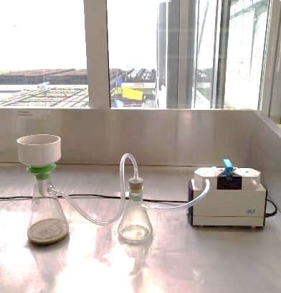
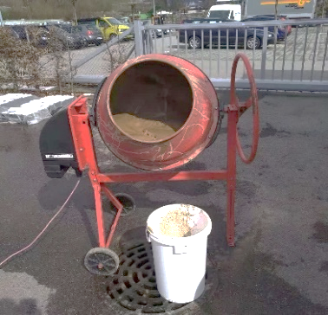
a
b

Figure S1. (a) Preparation of microbial extracts in a concrete mixer and (b) sieving of their supernatants

1.4 Maize Biomass Estimation Model

To control soil WHC, maize biomassneeded to be estimated without harvesting the plants during growth. This model was developed to correlate maize fresh biomass with their green pixel areas (Figure S2). With the model we could estimate their fresh biomass over time. 72 maize plants were grown, and images of three plants were captured using a conventional camera biweekly for four months. They were also harvested to determine their actual fresh biomass. In our experiment, this estimation model was used during maize cultivation to control soil WHC.
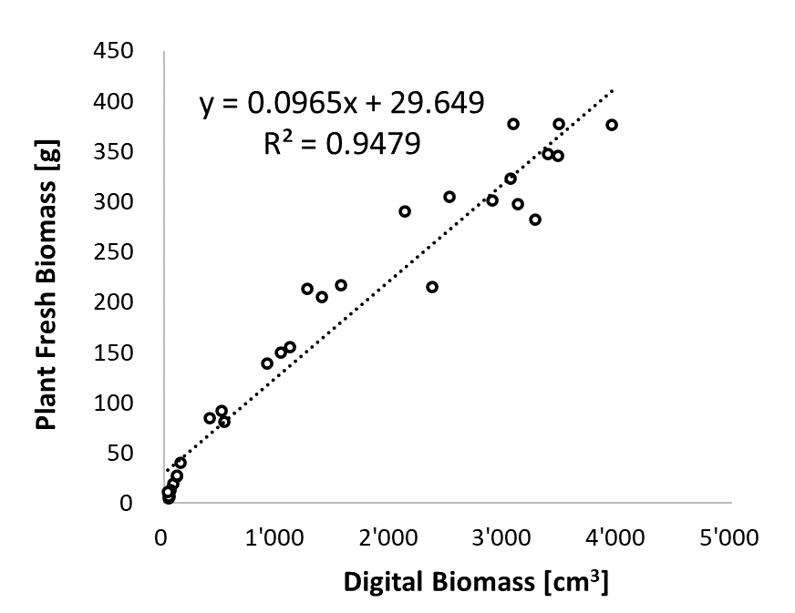
Figure S2. Maize fresh biomass estimation model

1.5 Plant Cultivation

In each pot, three maize kernels were placed on the soil surface in the middle of the pot with the embryo facing upwards. The kernels were then pressed 15-20 mm into the soil with one finger and covered with loose soils. For the first 1.5 days after the sowing, pots were watered from the saucers. During this period, maize required more water so that water content was adjusted to 80% of WHC. After three to four days of germination, pots were watered regularly from the top, and the weights of pots were recorded weekly to keep at 50% of WHC. The needed watering mass was calculated from the differences between the targeted mass corresponding to the requested WHC amount and the estimated growing biomass of maize. The fresh biomass of maize was estimated using the model derived from the side experiment above.

1.6 Plant Harvest

Maize was harvested after four months of growing. Aerial plant tissues were cut approximately 1 cm above the soil surface and separated into roots, stems, leaves, and cobs (grains). Roots were first cleaned with distilled water to remove most soil particles from the root surface and then washed with Milli-Q water (> 18.2 MΩ∙cm at 25°C). Before the determination of dry biomass, each plant part was dried in an oven at 70°C for about 72 hours until constant weight was reached (Gulz et al., 2005). After the measurements of dry biomass, further trace elemental analyses were applied.

2 Results

Table S2. N-β-acetylglucosaminidase, acid phosphatase, β-glucosidase, β-xylosidase and cellobiohydrolase were measured to determine soil functioning in different As treatments. Variables were untransformed (§), log transformed (¥), square-root transformed (∞) or ranked transformed (ⴕ) to meet the requirements to perform the analysis. F-values and significance levels for a two-way ANOVA with arsenic and time point as separate factors and their interaction term are shown. p-values: *p < 0.05 and ***p < 0.001. Different letters indicate statistical significantly differences among treatments.
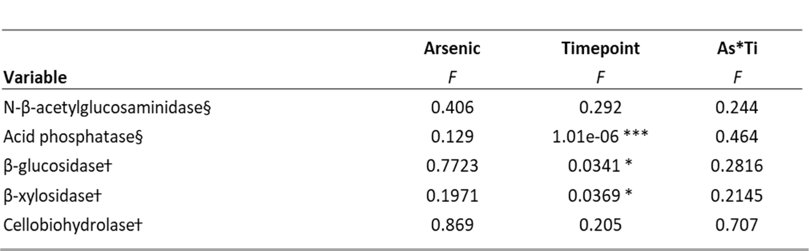
Table S3. Maize height and dry biomass were measured weekly and at the end, respectively, determining plant performance in different As treatments. Variables were untransformed (§), log transformed (¥), sqrt transformed (∞) or ranked transformed (ⴕ) to meet the requirements to perform the analysis. F-values and significance levels for a two-way ANOVA with arsenic (As) and time point (Ti) with their interaction for plant height and only the factor As for biomass. p-values: ***p < 0.001. Different letters mean statistically significant differences among treatments.
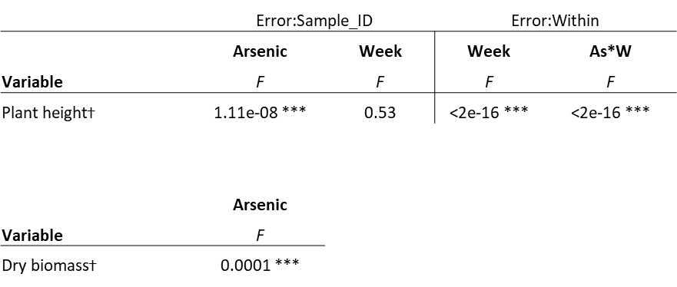

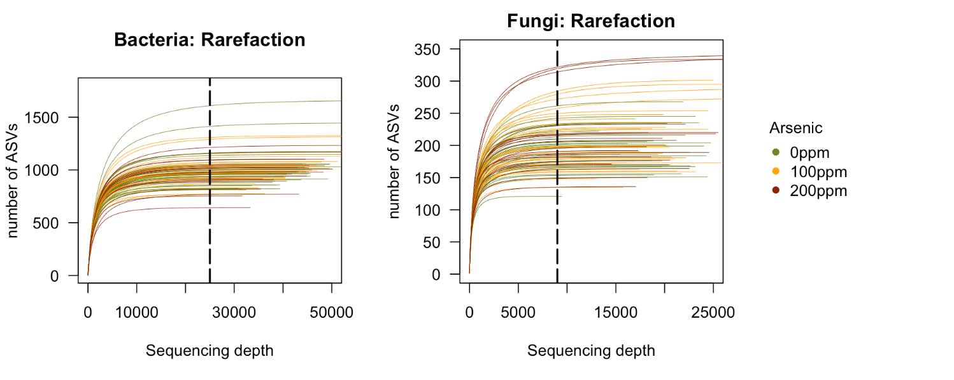
Figure S3. Rarefaction of soil bacterial and fungal communities over time

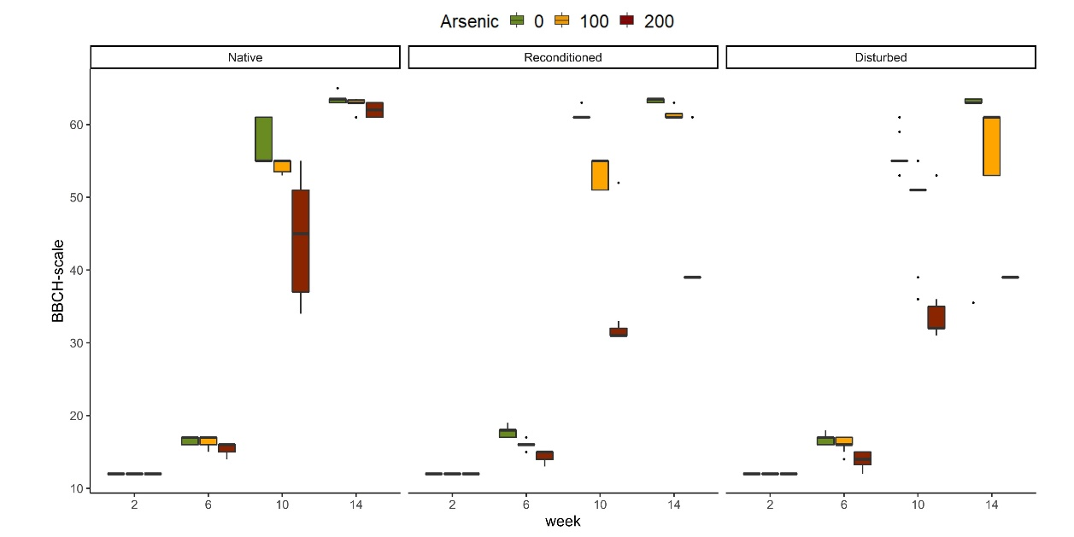
Figure S4. Changes in BBCH-scale of maize over time under microbial disturbance and As treatments
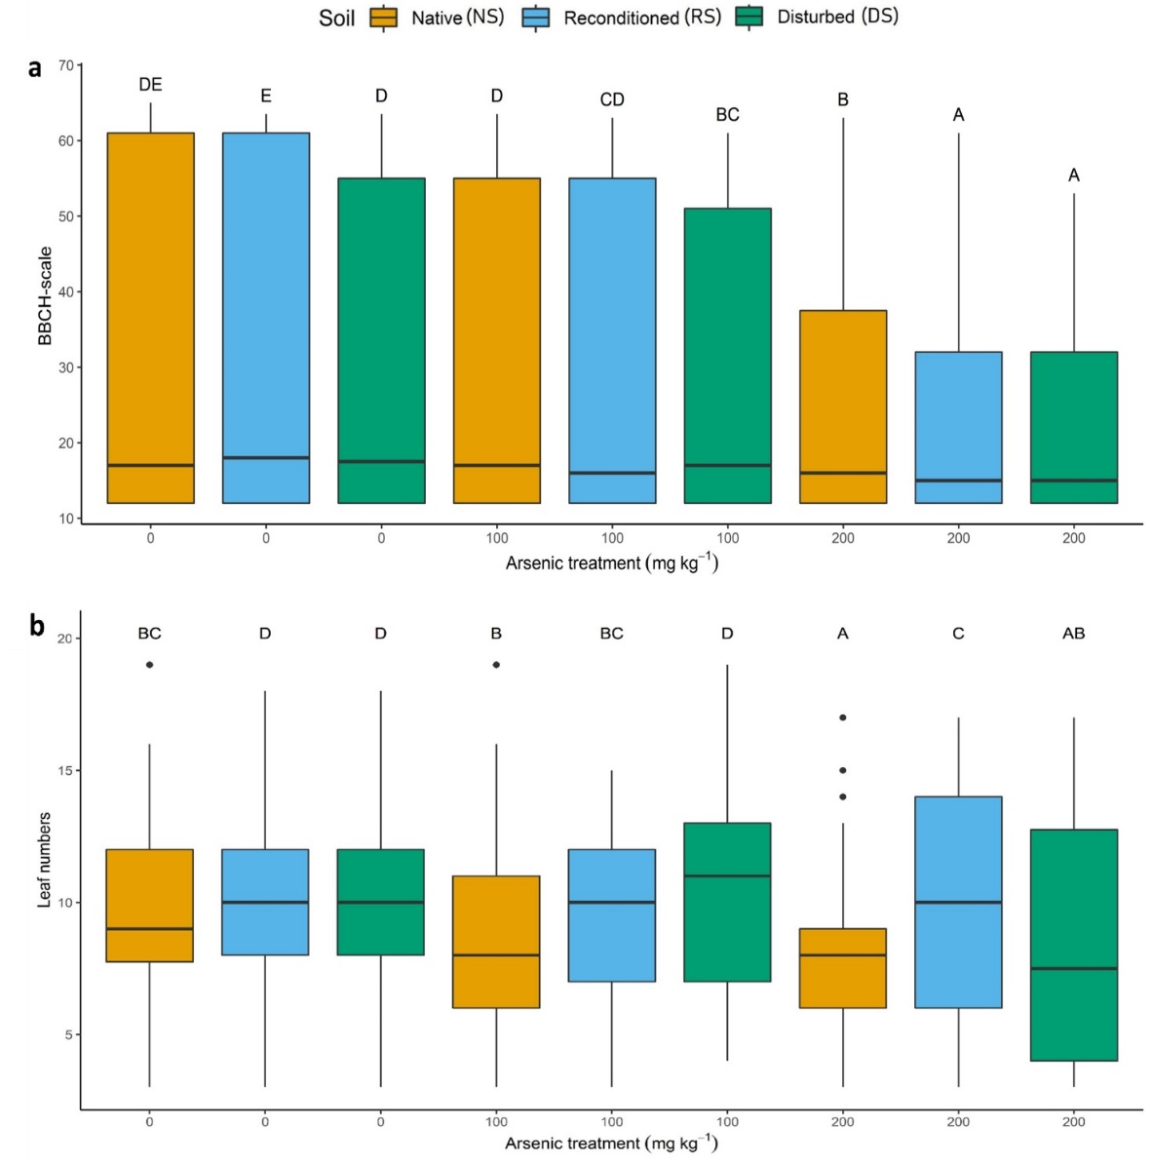
Figure S5. Changes in (A) BBCH-scale and (B) leaf numbers under soil and As treatments. Data were mean values ± standard error. Pairwise comparisons were explored and reported using CLD letters. Different CLD letters indicated a statistically significant difference between emmeans (p < 0.05).

Table S4. Alpha diversity for soil microbial community
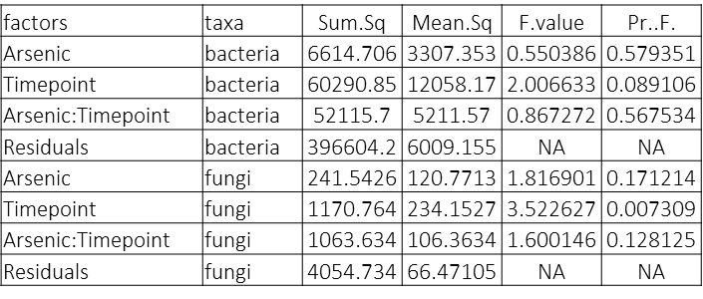

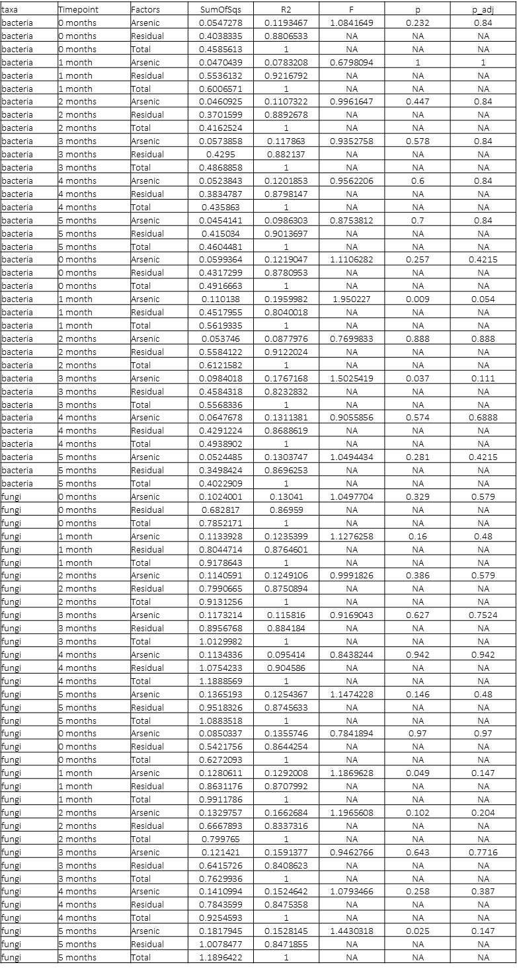
Table S5. Beta diversity for soil microbial community

Table S6. Alpha diversity and pairwise test for plant-associated microbiomes (soil, roots, leaves, and grains)
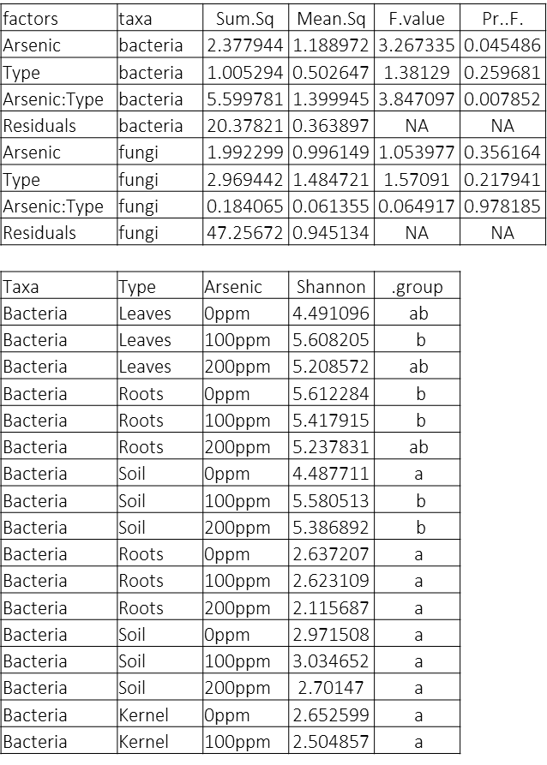

Table S7. Beta diversity for plant-associated microbiomes (soil, roots, leaves, and grains)
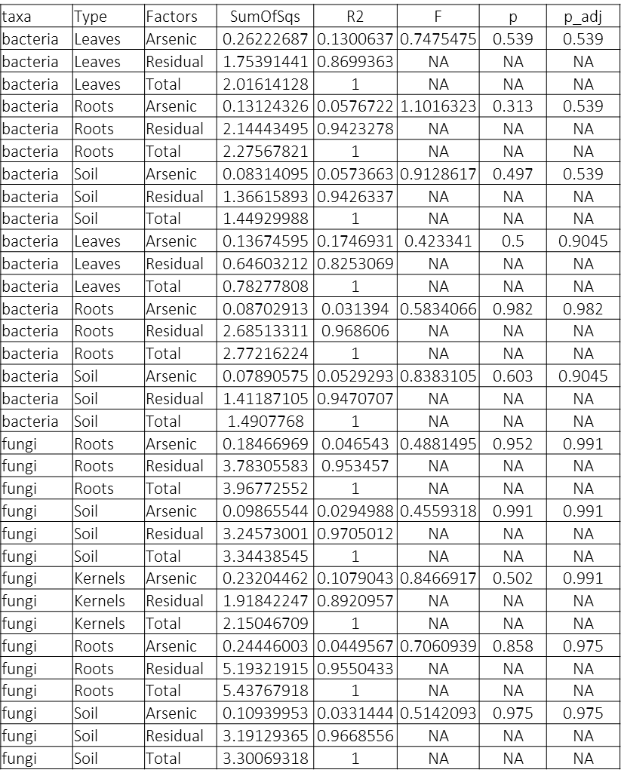

Table S8. The p values of univariate ANOVA statistical analysis on plant health parameters
Independent variables | Plant height | Fresh biomass | BBCH-scale | Leaf numbers | Chlorophyll | Damage scale
Microbial disturbance | *** | *** | *** | *** | *** | ***
As treatment | *** | *** | *** | *** | *** | ***
time | *** | *** | *** | *** | *** | ***
Microbial disturbance × As treatment | *** | 0.024* | *** | *** | *** | ***
× interaction terms
***: p < 0.001 (significant at α = 0.001); *: significant at α = 0.05

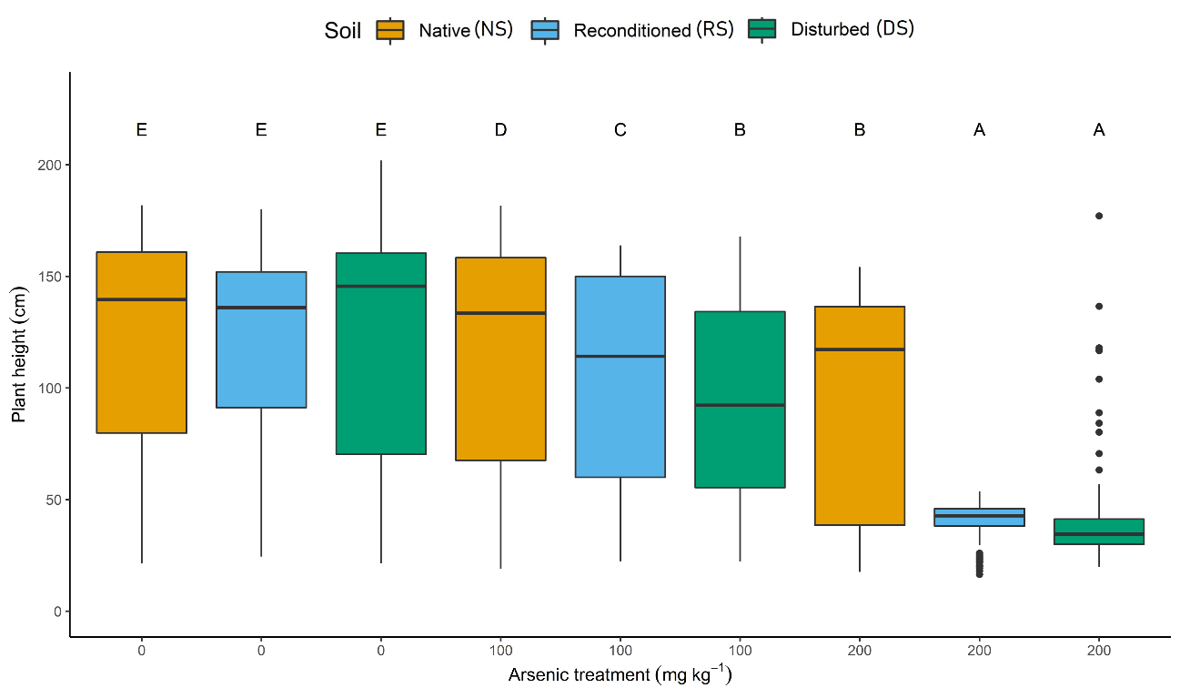
Figure S6. Changes in plant height under microbial disturbance and As treatments

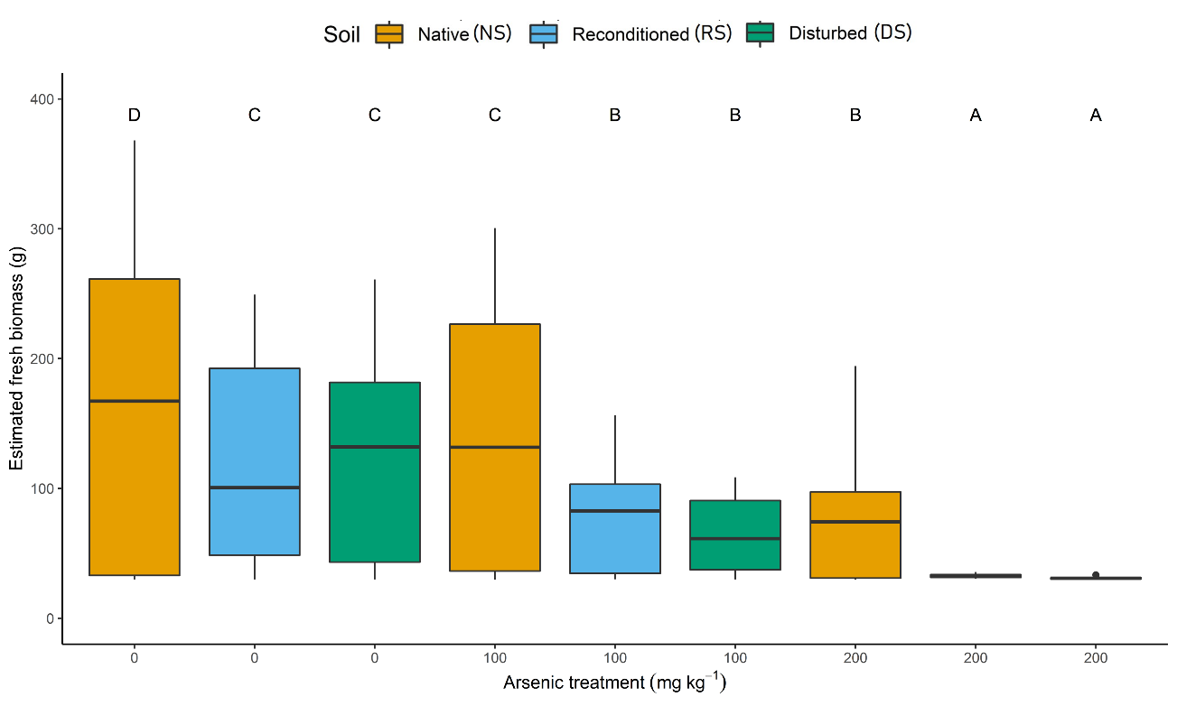
Figure S7. Changes in fresh biomass under soil and As treatments

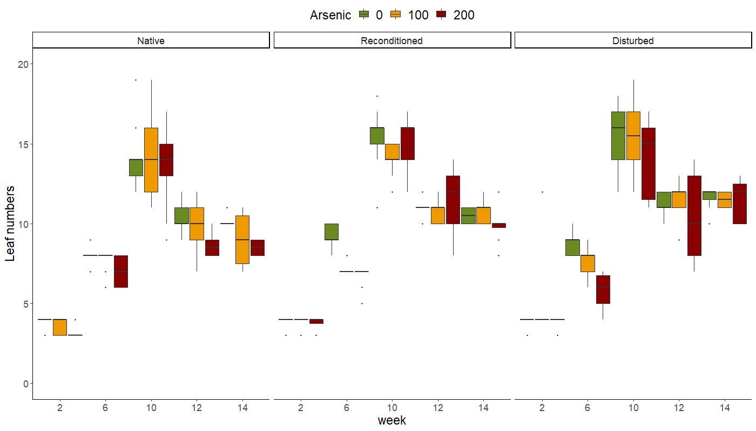
Figure S8. Changes in the leaf numbers over time under soil and As treatments
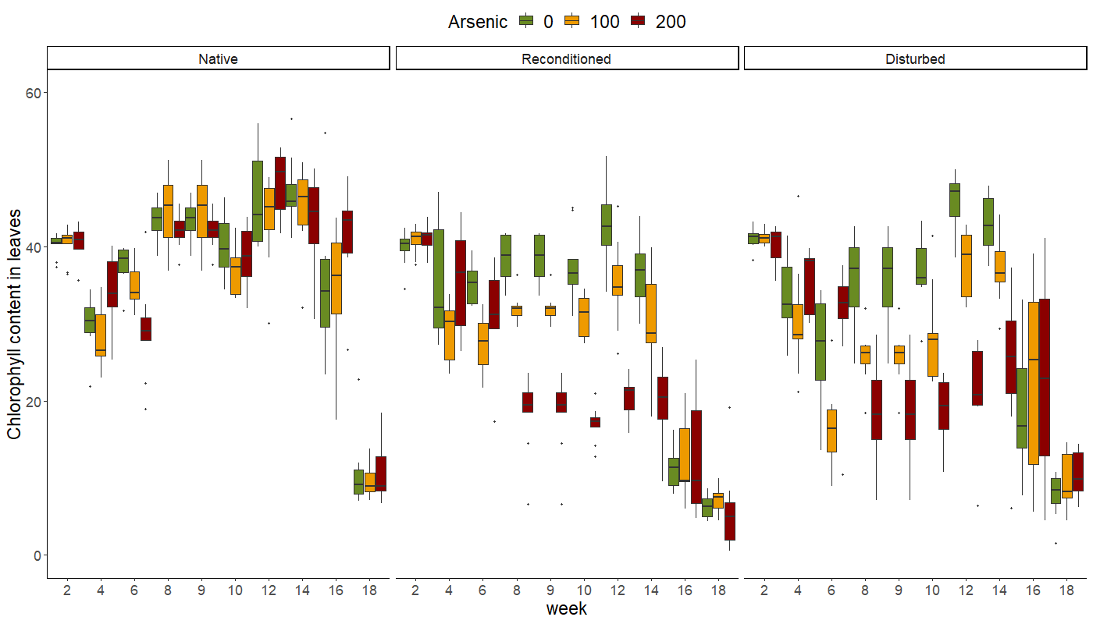
Figure S9. Changes in the chlorophyll content in maize leaves over time under soil and As treatments

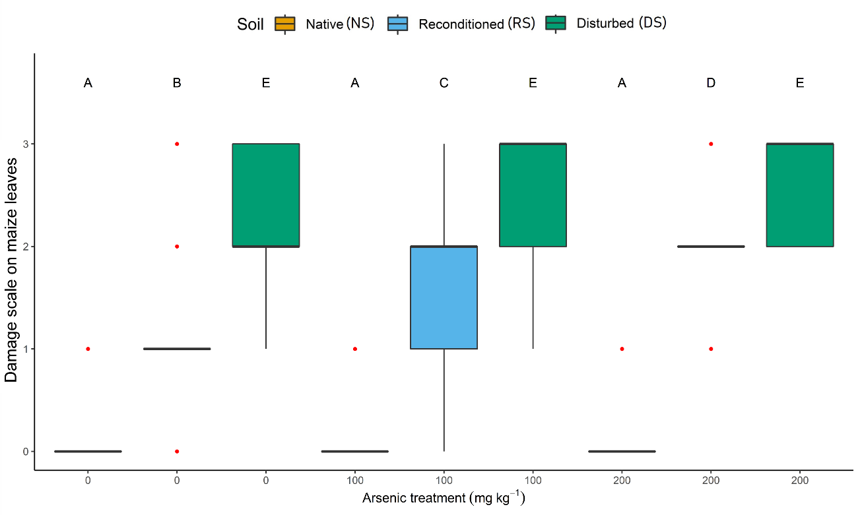
Figure S10. Damage scale of leaf spot under soil and As treatments. Red dots represent the outliers. A line instead of a box is due to the data concentration.

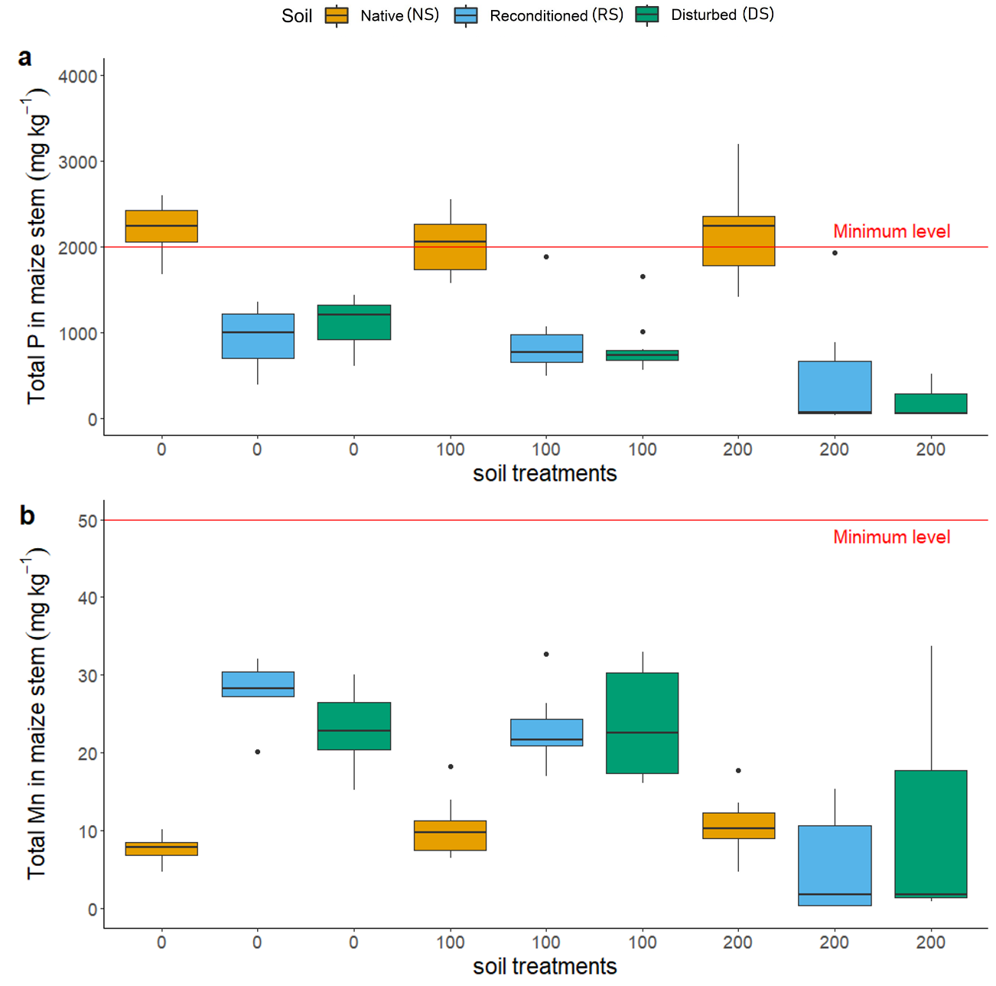
Figure S11. The concentrations of essential nutrients (a) P; (b) Mn in maize stem under soil and As treatments. Minimum level stands for the average concentrations of these mineral elements in the dry stem required for adequate plant growth (Kirkby, 2012).

Table S9. The estimated marginal means (emmeans, R Package) of totAs concentration and As species concentrations in maize roots
Treatments | totAs  µg/kg | inAs  µg/kg | orgAs  µg/kg | orgAs  % | MMA^{V}  µg/kg | DMA^{V}  µg/kg | TMAO  µg/kg
As₀-NS | 1277.29 ± 259 | 655.92 ± 140 | 20.09 ± 4.84 | 2.97 ± 0.63 | 4.82 ± 1.34 | 9.67 ± 2.61 | 4.28 ± 1.24
As₀-RS | 1986.79 ± 402 | 1043.37 ± 223 | 40.67 ± 9.79 | 3.75 ± 0.79 | 9.31 ± 2.59 | 21.21 ± 5.72 | 9.10 ± 2.64
As₀-DS | 2045.62 ± 414 | 1202.37 ± 257 | 53.86 ± 12.96 | 4.29 ± 0.90 | 10.26 ± 2.86 | 26.89 ± 7.25 | 15.82 ± 4.57
As₁₀₀-NS | 21402.44± 3627 | 23725.32 ± 3920 | 108.11 ± 20.15 | 0.45 ± 0.07 | 20.34 ± 4.39 | 50.61 ± 10.57 | 25.92 ± 5.79
As₁₀₀-RS | 35563.44 ± 6027 | 41399.20 ± 7650 | 173.79 ± 36.21 | 0.42 ± 0.08 | 27.75 ± 6.70 | 62.81 ± 14.67 | 74.87 ± 18.71
As₁₀₀-DS | 54131.32 ± 9173 | 63427.99 ± 11700 | 322.62 ± 67.23 | 0.50 ± 0.09 | 43.08 ± 10.39 | 132.55 ± 30.95 | 115.03 ± 28.75
As₂₀₀-NS | 63521.76 ± 10765 | 75844.48 ± 12500 | 161.61 ± 30.12 | 0.21 ± 0.03 | 26.37 ± 5.69 | 64.63 ± 13.50 | 32.97 ± 7.37
As₂₀₀-RS | 46344.70 ± 8279 | 52526.19 ± 19400 | 295.31 ± 123 | 0.56 ± 0.20 | 39.18 ± 18.90 | 63.34 ± 29.58 | 188.98 ± 94.46
As₂₀₀-DS | 52669.58 ± 10668 | 69804.82 ± 25800 | 276.89 ± 115 | 0.40 ± 0.14 | 34.23 ± 16.51 | 123.65 ± 57.75 | 109.02 ± 54.49
± standard errors

Table S10. The emmeans of totAs concentration and As species concentrations in maize stem
Treatments | totAs  µg/kg | inAs  µg/kg | orgAs  µg/kg | orgAs  % | MMA^{V}  µg/kg | DMA^{V}  µg/kg | TMAO  µg/kg
As₀-NS | 42.47 ± 9.29 | 48.12 ± 11.30 | 6.63 ± 1.75 | 12.04 ± 2.78 | 0.85 ± 0.26 | 2.27 ± 0.67 | 3.37 ± 1.07
As₀-RS | 155.25 ± 31.45 | 102.86 ± 20.30 | 8.58 ± 1.91 | 7.67 ± 1.50 | 0.70 ± 0.18 | 3.34 ± 0.83 | 4.43 ± 1.18
As₀-DS | 111.61 ± 22.61 | 72.29 ± 15.40 | 8.73 ± 2.10 | 10.73 ± 2.27 | 0.69 ± 0.19 | 3.39 ± 0.92 | 4.61 ± 1.33
As₁₀₀-NS | 1243.77 ± 211 | 1129.21 ± 197 | 15.86 ± 3.12 | 1.38 ± 0.24 | 1.54 ± 0.35 | 8.40 ± 1.85 | 5.40 ± 1.27
As₁₀₀-RS | 3235.71 ± 549 | 2612.71 ± 432 | 19.65 ± 3.66 | 0.75 ± 0.12 | 4.08 ± 0.88 | 6.99 ± 1.46 | 7.92 ± 1.77
As₁₀₀-DS | 3221.61 ± 546 | 3058.78 ± 565 | 27.91 ± 5.82 | 0.90 ± 0.16 | 6.92 ± 1.67 | 9.15 ± 2.14 | 11.13 ± 2.78
As₂₀₀-NS | 5551.31 ± 941 | 2061.47 ± 867 | 22.95 ± 4.51 | 1.19 ± 0.20 | 2.77 ± 0.63 | 11.62 ± 2.56 | 6.48 ± 1.53
As₂₀₀-RS | 10787.09 ± 1927 | 7665.46 ± 5115 | 66.99 ± 13.16 | 1.70 ± 0.29 | 7.95 ± 1.81 | 23.42 ± 5.16 | 30.50 ± 7.19
As₂₀₀-DS | 16358.46 ± 5062 | 16270.66 ± 3470 | 216.36 ± 52.06 | 1.31 ± 0.28 | 32.70 ± 9.11 | 80.63 ± 21.74 | 86.57 ± 24.98
± standard errors

Table S11. The emmeans of totAs concentration and As species concentrations in maize leaves
Treatments | totAs  µg/kg | inAs  µg/kg | orgAs  µg/kg | orgAs  % | MMA^{V}  µg/kg | DMA^{V}  µg/kg | TMAO  µg/kg
As₀-NS | 224.00 ± 37.96 | 108.61 ± 18.00 | 60.60 ± 11.23 | 34.80 ± 5.69 | 3.42 ± 0.74 | 16.83 ± 3.52 | 39.86 ± 8.91
As₀-RS | 410.83 ± 69.63 | 342.60 ± 56.60 | 85.72 ± 15.98 | 19.74 ± 3.23 | 4.04 ± 0.87 | 25.39 ± 5.30 | 55.16 ± 12.33
As₀-DS | 279.51 ± 52.96 | 188.51 ± 34.80 | 53.74 ± 11.20 | 22.09 ± 4.04 | 3.54 ± 0.85 | 16.47 ± 3.85 | 33.44 ± 8.36
As₁₀₀-NS | 1330.18 ± 225 | 1115.32 ± 184 | 85.71 ± 15.98 | 7.10 ± 1.16 | 5.55 ± 1.20 | 32.94 ± 6.88 | 46.12 ± 10.31
As₁₀₀-RS | 3196.80 ± 542 | 2700.84 ± 447 | 147.07 ± 27.41 | 5.14 ± 0.84 | 13.52 ± 2.92 | 41.35 ± 8.64 | 89.51 ± 20.07
As₁₀₀-DS | 3307.89 ± 561 | 2661.00 ± 440 | 173.75 ± 32.38 | 6.11 ± 1.00 | 13.97 ± 3.01 | 50.13 ± 10.47 | 107.41 ± 24.01
As₂₀₀-NS | 1313.29 ± 223 | 1696.67 ± 281 | 89.59 ± 16.70 | 5.00 ± 0.82 | 7.83 ± 1.69 | 35.33 ± 7.38 | 30.95 ± 6.92
As₂₀₀-RS | 4759.75 ± 807 | 3956.35 ± 689 | 435.85 ± 85.63 | 9.88 ± 1.70 | 29.38 ± 6.68 | 120.94 ± 26.63 | 280.37 ± 66.06
As₂₀₀-DS | 6637.53 ± 1258 | 5370.38 ± 993 | 642.52 ± 134 | 10.64 ± 1.94 | 33.55 ± 8.09 | 177.81 ± 41.52 | 421.76 ± 105
± standard errors
Table S12. The emmeans of totAs concentration and As species concentrations in maize grains
Treatments | totAs  µg/kg | inAs  µg/kg | orgAs  µg/kg | orgAs  % | MMA^{V}  µg/kg | DMA^{V}  µg/kg | TMAO  µg/kg
As₀-NS | 5.32 ± 1.16 | 3.79 ± 0.81 | 3.89 ± 0.94 | 48.42 ± 10.22 | 1.62 ± 0.45 | 1.03 ± 0.28 | 0.66 ± 0.19
As₀-RS | 10.38 ± 2.49 | 11.85 ± 2.53 | 5.87 ± 1.41 | 30.80 ± 6.50 | 2.06 ± 0.58 | 1.90 ± 0.51 | 1.68 ± 0.49
As₀-DS | 20.52 ± 4.16 | 10.96 ± 2.16 | 2.85 ± 0.64 | 19.74 ± 3.86 | 0.81 ± 0.21 | 1.19 ± 0.30 | 0.81 ± 0.22
As₁₀₀-NS | 46.44 ± 11.13 | 26.16 ± 6.12 | 4.42 ± 1.17 | 14.42 ± 3.33 | 0.77 ± 0.24 | 2.85 ± 0.84 | 0.77 ± 0.24
As₁₀₀-RS | 69.05 ± 26.17 | 33.14 ± 17.3 | 3.46 ± 2.04 | 9.45 ± 4.88 | 0.82 ± 0.56 | 1.82 ± 1.20 | 0.82 ± 0.58
As₁₀₀-DS | n.d. | n.d. | n.d. | n.d. | n.d. | n.d. | n.d.
As₂₀₀-NS | 77.58 ± 29.40 | n.d. | n.d. | n.d. | n.d. | n.d. | n.d.
As₂₀₀-RS | n.d. | n.d. | n.d. | n.d. | n.d. | n.d. | n.d.
As₂₀₀-DS | n.d. | n.d. | n.d. | n.d. | n.d. | n.d. | n.d.
± standard errors; n.d.: no data available due to the fruitless grains

References
Gulz, P.A., Gupta, S.-K., Schulin, R., 2005. Arsenic accumulation of common plants from contaminated soils. Plant Soil 272 (1-2), 337–347.
Kirkby, E., 2012. Introduction, Definition and Classification of Nutrients. Marschner's Mineral Nutrition of Higher Plants, 3–5.

