Supplement

Figure I
3D CTA-images (A) compared with the FA (B) of a 69-year old male (patient 1). AV=anterior vein, ALV=anterolateral vein, CABG=coronary artery bypass graft, CS=coronary sinus, ILV=inferolateral vein, IV=inferior vein, LA=left atrium, LAO=left anterior oblique, LTV=lateral vein, RA = right atrium, RAO=right anterior oblique, RV=right ventricle.
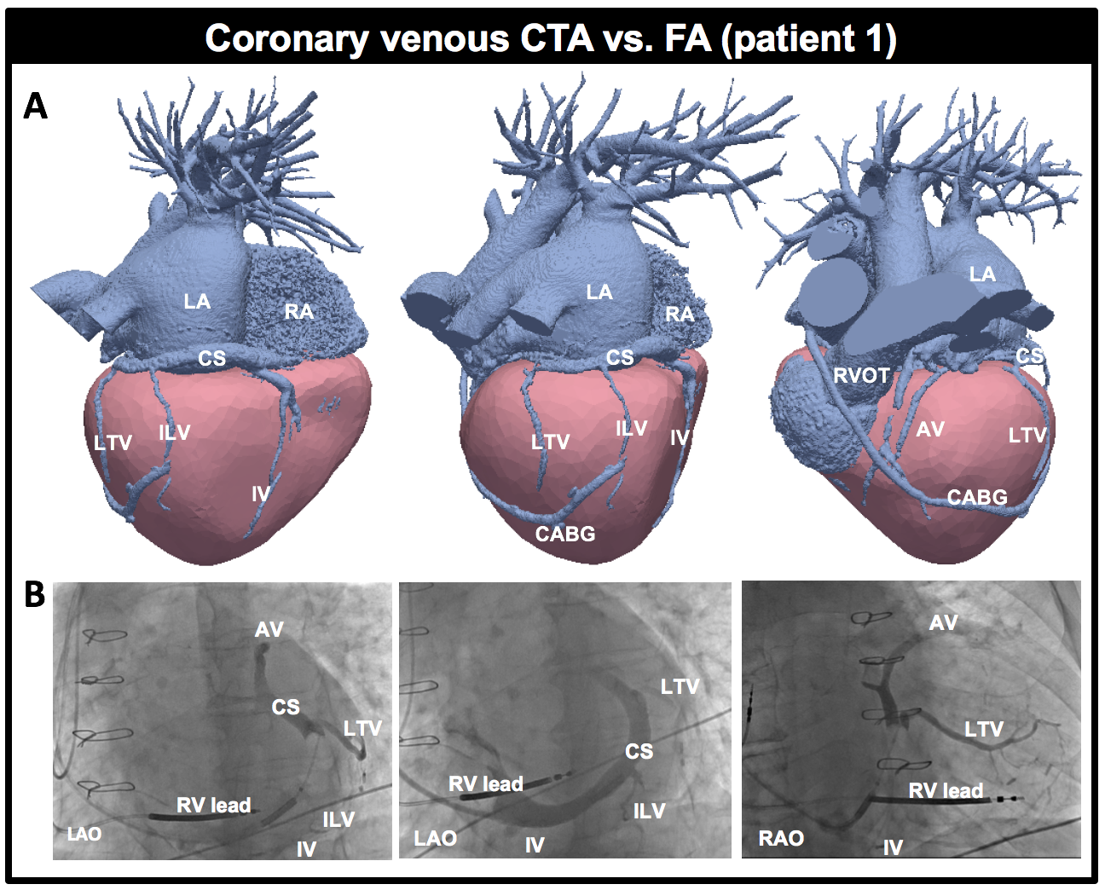

Supplement

Figure II
Transversal (A) and coronal (B) image of a 59-year old woman (patient 5) who demonstrated a RV thrombus of 1x2cm size (red arrow) on CTA. The abnormalities shown on the apex of the LV (green arrow) resulted from LV aneurysmectomy a few years earlier. LV=left ventricle, RV=right ventricle.
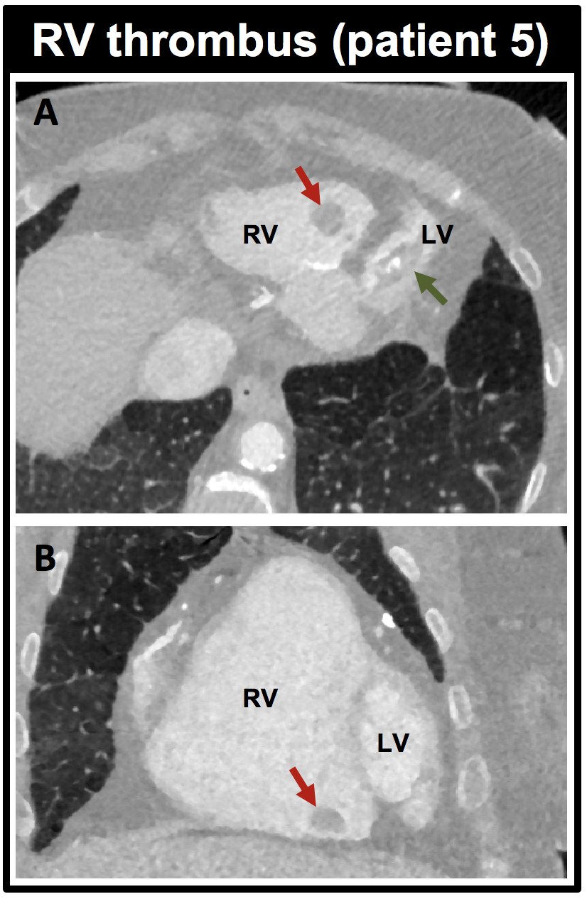

Supplement

Figure III
FA of a 73-year old male (patient 3) with anastomosis (green arrow) between the ILV and IV. Cannulation of the ILV was unsuccessful due to the sharp angulation (red) at the ostium. The LV-lead was finally advanced towards the ILV by cannulation of the IV. CS=coronary sinus, ILV=inferolateral vein, IV=inferior vein, LAO=left anterior oblique, LV=left ventricular, RAO=right anterior oblique, RV=right ventricular.
