- Pubmed search
- Supplemental Figures
  - Figure S1
  - Figure S2 A + B
  - Figure S3
  - Figure S4 A + B
- Supplemental Tables
  - Table S1
  - Table S2
  - Table S3
  - Table S4
  - Table S5
  - Table S6

- Pubmed search
("Coronary Occlusion"[Mesh] OR Chronic total occlusion*[title/abstract] OR Chronic total coronary occlusion*[title/abstract]) AND (percutaneous coronary intervention[title/abstract] OR angioplasty[title/abstract] OR recanali*[title/abstract] OR revasculari*[title/abstract]) AND (random* OR optimal medical therapy
- Supplemental Figures

Figure S1. All-cause mortality at 4 years

Figure S2a. Myocardial infarction at 12 months
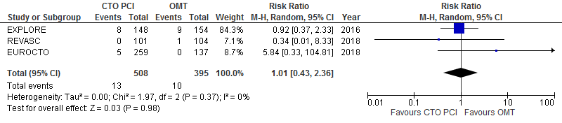

Figure S2b. Myocardial infarction at 4 years
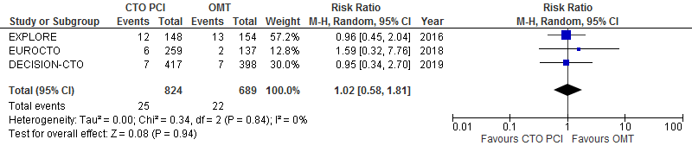

Figure S3. Target lesion revascularisation at 4 years (intention-to-treat)
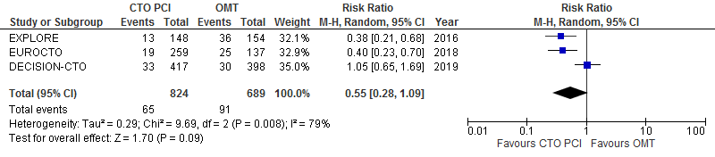

Figure S4a. Left ventricular ejection fraction at 4-6 months follow-up

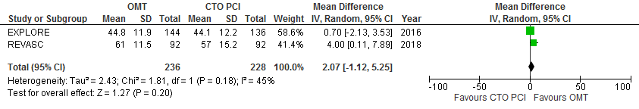

Figure S4b. Segmental wall thickening in dysfunctional CTO segments at 4-6 months follow-up
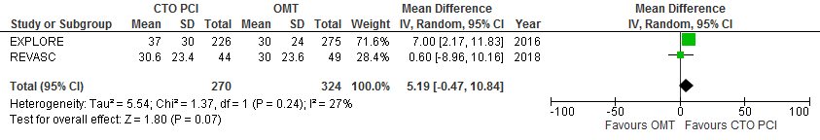

- Supplemental Tables

Table S1. Study characteristics
Study name | First author | Year | Journal | Study period | Study type | Participants | Randomisation | Total number of randomised patients |  | Longest median follow-up (m) | Intervention | Patients in intervention group | Timing of intervention | Comparison | Patients in comparison group | Primary outcome
EXPLORE¹² | Henriques | 2016 | JACC | 2007-2015 | RCT | Post-STEMI-patients with CTO in non-IRA | 1:1 |  | 302 | 47 | CTO PCI | 148 | <7 days after pPCI | No CTO PCI for >4 months | 154 | LVEF and LVEDV at 4 months
EUROCTO¹³ | Werner | 2018 | European Heart Journal | 2012-2015 | RCT | Symptomatic patients with CTO | 2:1 |  | 396 | 36 | CTO PCI | 259 | <4 weeks after randomisation | Optimal medical therapy | 137 | Health status subscales on SAQ at 12 months
REVASC¹⁴ | Mashayeki | 2018 | JACC: Cardiovascular Interventions | 2007-2015 | RCT | Symptomatic patients with CTO | 1:1 |  | 205 | 12 | CTO PCI | 101 | - | Optimal medical therapy | 104 | SWT in CTO territory at 6 months
IMPACTOR-CTO¹⁵ | Obedinskiy | 2018 | JACC: Cardiovascular Interventions | 2010-2014 | RCT | Patients with isolated dominant RCA CTO and stable angina | 1:1 |  | 72 | 12 | CTO PCI RCA | 39 | - | Optimal medical therapy | 33 | Decrease in myocardial ischemia burden from baseline to 12 months
DECISION-CTO¹⁶ | Lee | 2019 | Circulation | 2010-2016 | RCT | PCI-eligible patients with silent ischemia, stable angina or ACS and de novo CTO | 1:1 |  | 815 | 48 | CTO PCI | 417 | <30 days after randomisation | Optimal medical therapy | 398 | Composite of death, MI, stroke or revascularisation at 4 years
 |  |  |  |  |  |  | Total: |  | 1790 |  | Total: | 964 |  | Total: | 826
RCT = randomised controlled trial; STEMI = ST-segment elevation myocardial infarction; CTO = chronic total occlusion; IRA = infarction-related artery; PCI = percutaneous coronary intervention; RCA = right coronary artery; pPCI = primary PCI; LVEF = left ventricular ejection fraction; LVEDV = left ventricular end-diastolic volume; SAQ = Seattle Angina Questionnaire; SWT = segmental wall thickening; ACS = acute coronary syndrome; MI = myocardial infarction.

Table S2. Major inclusion and exclusion criteria of the included trials
Study name | Major inclusion criteria | Major exclusion criteria
EXPLORE | Post-STEMI-patients with CTO in non-IRA | - Hemodynamic instability for >48h after pPCI;  - Factors impeding reliable cardiac magnetic resonance imaging such as atrial fibrillation, severe renal insufficiency, and indications for pacemaker or implantable cardioverter-defibrillator insertion;  - Valvular disease requiring surgical treatment.
EUROCTO | Symptomatic patients with CTO suitable for PCI. In case of regional myocardial dysfunction assessment of viability with non-invasive imaging. | - ACS <4 weeks before enrolment;  - Contraindication for implantation of a drug-eluting stent (e.g. patients not tolerating dual antiplatelet therapy or need for elective non-cardiac surgery within 6 months).
REVASC | CTO-patients with indication for PCI based on symptoms or non-invasive functional testing | - ACS <72h;  - LVEF <25%;  - Contraindication for cardiac magnetic resonance imaging.
IMPACTOR-CTO | Patients with isolated dominant RCA CTO and stable angina | - Unsuccessful CTO PCI attempts;  - Patients non-compliant with OMT.
DECISION-CTO | PCI-eligible patients with silent ischemia, stable angina or ACS and de novo CTO | - CTO in distal coronary artery;  - 3 different vessel CTOs;  - 2 proximal CTOs in separate coronary arteries;  - CTO in left main segment;  - CTO based on in-stent restenosis;  - CTO in graft vessel;  - LVEF <30%;  - Severe CAD requiring CABG;  - Expected high procedural risk;  - Creatinine level ≥2.0 mg/dL

ACS = acute coronary syndrome; CABG = coronary artery bypass grafting; CAD = coronary artery disease; CTO = chronic total occlusion; IRA = infarct-related artery; LVEF = left ventricular ejection fraction; OMT = optimal medical therapy; PCI = percutaneous coronary intervention; pPCI = primary percutaneous coronary intervention; RCA = right coronary artery; STEMI = ST-segment elevation myocardial infarction.
Table S3. Risk of bias assessment
Study name | Random sequence generation | Allocation concealment | Blinding of participants and personnel | Blinding of outcome assessment | Incomplete outcome data | Selective outcome reporting? | Other bias | Score
EXPLORE | Low risk | Low risk | High risk | Low risk | Low risk | Low risk | Low risk | 6/7
EUROCTO | Low risk | Low risk | High risk | Unclear risk | Low risk | Low risk | Low risk | 5/7
REVASC | Low risk | Low risk | High risk | Low risk | Low risk | Low risk | Low risk | 6/7
IMPACTOR-CTO | High risk | Low risk | High risk | High risk | Low risk | Low risk | Low risk | 4/7
DECISION-CTO | Low risk | Low risk | High risk | Low risk | Low risk | Low risk | Low risk | 6/7

As adapted from the Risk of Bias assessment by the Cochrane Collaboration ⁹.

Table S4. Procedural complications
 | Total | EXPLORE | EUROCTO | REVASC | IMPACTOR-CTO | DECISION-CTO
 | n=1790 | n=302 | n=396 | n=205 | n=72 | n=815
PCI Successful | 809 (86.7) | 113 (76.9) | 220 (86.6) | 89 (88.1) | 39 (83.0) | 348 (90.6)
Total PCIs | 933 | 147 | 254 | 101 | 47 | 384
Complications
Dissection | 13 | 13 | - | - | - | -
Occlusion side branch | 2 | 2 | - | - | - | -
Thrombus | 2 | 1 | - | - | - | 1
Tamponade | 8 | 1 | 4 | 0 | 2 | 1
Major arrhythmias | 3 | 2 | - | - | - | 1
Resuscitation | 4 | 4 | 0 | - | - | -
Periprocedural MI | 15 | 4 | 0 | 11 | - | -
Vascular surgical repair | 2 | 0 | 2 | 0 | - | -
Blood transfusion | 5 | - | 5 | - | - | -
Vascular complication | 2 | - | - | - | 2 | -
Periprocedural stroke | 1 | - | - | - | - | 1
Total complications | 57 (6.1) | 27 (18.4) | 11 (4.3) | 11 (10.9) | 4 (8.5) | 4 (1.0)
Data are numbers (%). PCI = percutaneous coronary intervention, MI = myocardial infarction.

Table S5. Definitions of major adverse cardiac events in the included studies
Study name | Major Adverse Cardiac Events (MACE) components
 | Component 1 | Component 2 | Component 3 | Component 4
EXPLORE | Cardiac death | Myocardial infarction | Coronary artery bypass grafting | -
EUROCTO | Cardiac death | Non-fatal myocardial infarction | Ischemia-driven repeat target lesion revascularisation | -
REVASC | All-cause death | Myocardial infarction | Clinically driven repeat revascularisation | -
DECISION-CTO | All-cause death | Myocardial infarction | Any repeat revascularisation | Stroke
IMPACTOR-CTO | All-cause death | Myocardial infarction | Unplanned revascularisation | -

Table S6. Summary of findings table
 | Studies | Participants | Certainty* | Effect | 95% CI | p-value
Mortality
All-cause mortality at 1 year | 3 | 903 | ⨁⨁⨁⨁ HIGH | RR 1.70 | 0.50-5.80
All-cause mortality at 4 years | 2 | 1117 | ⨁⨁⨁⨁ HIGH | RR 1.14 | 0.38-3.40
Cardiac mortality at 1 year | 3 | 903 | ⨁⨁⨁⨁ HIGH | RR 1.77 | 0.19-16.06
Cardiac mortality at 4 years | 3 | 1513 | ⨁⨁⨁⨁ HIGH | RR 1.66 | 0.31-8.79
Adverse events
MACE at 4-6 months | 2 | 507 | ⨁⨁⨁⨁ HIGH | RR 1.21 | 0.41-3.60
MACE at 1 year | 3 | 903 | ⨁⨁⨁⨁ HIGH | RR 0.69 | 0.36-1.33
MACE at 4 years | 3 | 1513 | ⨁⨁⨁⨁ HIGH | RR 0.85 | 0.60-1.22
TLR at 1 year | 4 | 975 | ⨁⨁⨁⨁ HIGH | RR 0.28 | 0.15-0.52 | <0.001
TLR at 4 years | 3 | 1513 | ⨁⨁◯◯LOW† | RR 0.55 | 0.28-1.09 | 0.09
Myocardial infarction at 1 year | 3 | 903 | ⨁⨁⨁⨁ HIGH | RR 1.01 | 0.43-2.36
Myocardial infarction at 4 years | 3 | 1513 | ⨁⨁⨁⨁ HIGH | RR 1.02 | 0.58-1.81
Angina
Angina present at 1 year | 2 | 686 | ⨁⨁⨁⨁ HIGH | RR 0.65 | 0.50-0.84 | 0.001
SAQ at 1 year: Angina frequency | 2 | 1175 | ⨁⨁⨁⨁ HIGH | MD 1.38 | -3.46-6.21
SAQ at 1 year: Treatment satisfaction | 2 | 1170 | ⨁⨁⨁⨁ HIGH | MD 0.74 | -0.89-2.38
SAQ at 1 year: Physical limitation | 2 | 1151 | ⨁⨁⨁⨁ HIGH | MD 1.57 | -0.19-3.33
SAQ at 1 year: Quality of life | 2 | 1170 | ⨁⨁⨁⨁ HIGH | MD 1.89 | -2.33-6.11
Left ventricular function
LVEF at 4-6 months | 2 | 464 | ⨁⨁⨁⨁ HIGH | MD 2.07 | -1.12-5.25
LVEF change from baseline to 4-6 months | 2 | 365 | ⨁⨁⨁◯ MODERATE§ | MD 0.28 | -0.70-1.27
LVEDV index change from baseline to 4-6 months | 2 | 365 | ⨁⨁⨁⨁ HIGH | MD 0.03 | -2.93-2.99
SWT in CTO territory at 4-6 months | 2 | 364 | ⨁⨁⨁⨁ HIGH | MD 3.24 | -7.63-14.12
SWT in dysfunctional CTO segments at 4-6 months | 2 | 594 | ⨁⨁⨁⨁ HIGH | MD 5.19 | -0.47-10.84 | 0.07
*As assessed with the GRADE criteria. †Low score due to inconsistency in results and imprecision of results. §Moderate score due to inconsistency in results. CI = confidence interval, CTO = chronic total occlusion, LVEF = left ventricular ejection fraction, LVEDV = left ventricular end-diastolic volume, MACE = major adverse cardiac events, MD = mean difference, RR = risk ratio, SAQ = Seattle Angina Questionnaire, SWT = segmental wall thickening, TLR = target-lesion revascularisation.

