SUPPLEMENTARY MATERIAL

Prognostic value of epicardial and pericardial adipose tissue in patients with chronic heart failure

Y. Crum et al.

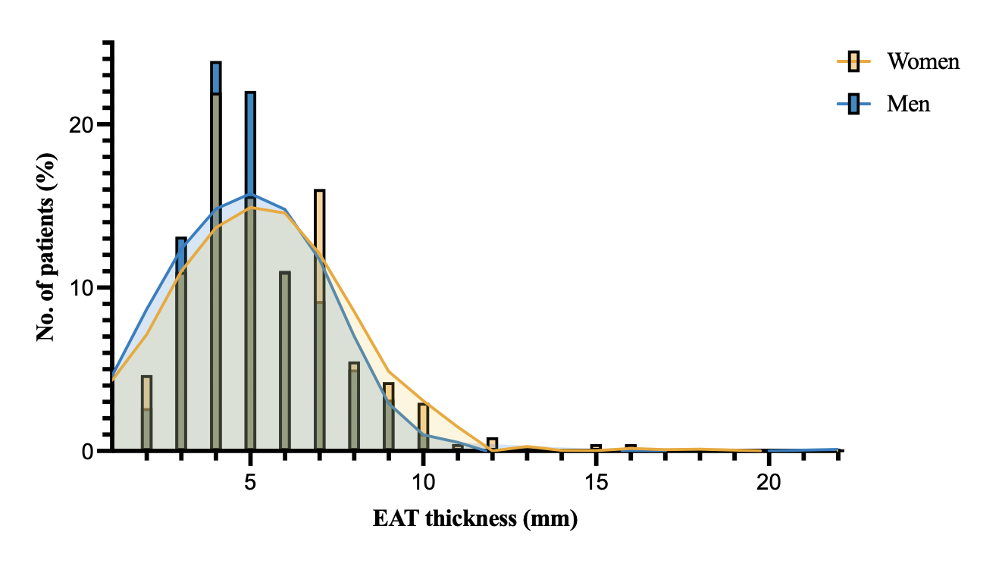
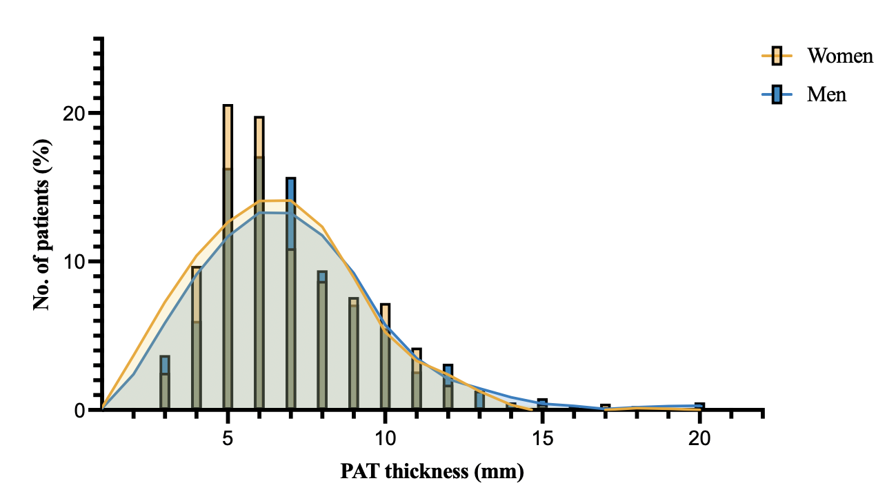
Supplemental Figure 1: Distribution of EAT and PAT
This figure shows the frequency distribution curves of EAT (A) and PAT (B) thickness according to sex. The orange line and bars represent women and the blue line and bars represent men. EAT, epicardial adipose tissue; PAT, pericardial adipose tissue
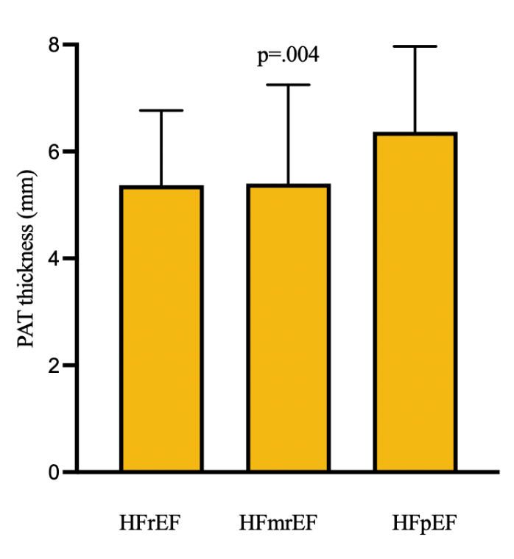
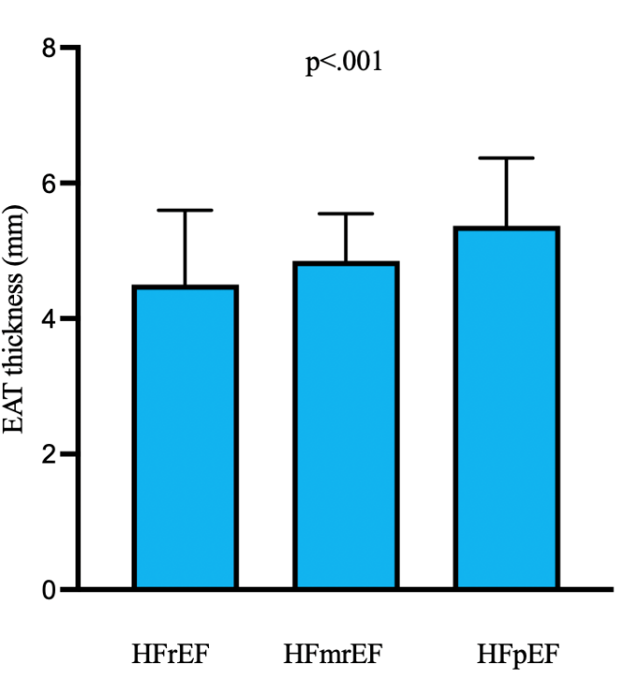
Supplemental Figure 2: Association of EAT and PAT within different groups of heart failure Figure A reflects the association with EAT and HF groups; Figure B reflects the association between PAT and HF groups. Error bars reflect the standard error of the mean. EAT, epicardial adipose tissue;HFrEF, heart failure with reduced ejection fraction; HFmrEF, heart failure with mildly reduced ejection fraction; HFpEF, heart failure with preserved ejection fraction; PAT, pericardial adipose tissue
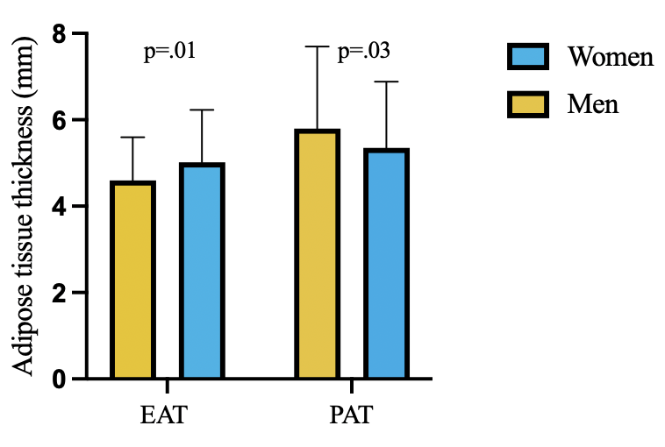
Q
Supplemental Figure 3: Difference in EAT and PAT between men and women Error bars reflect standard error of the mean EAT, epicardial adipose tissue; PAT, pericardial adipose tissue

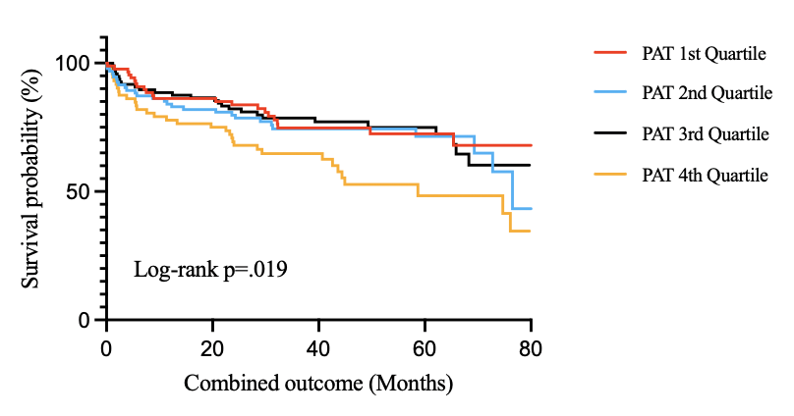

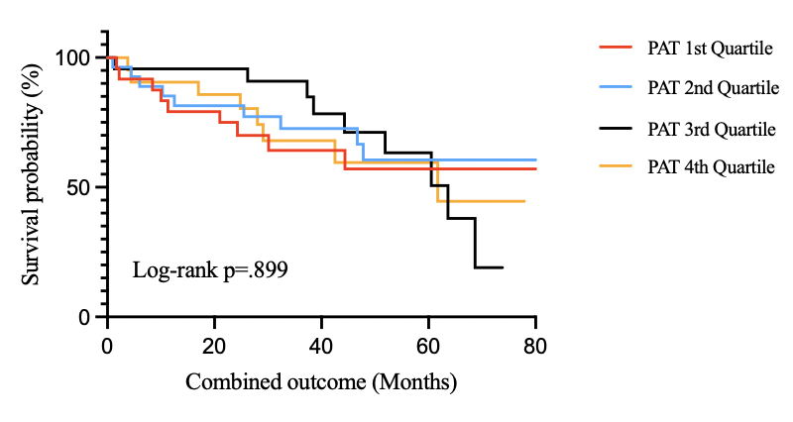

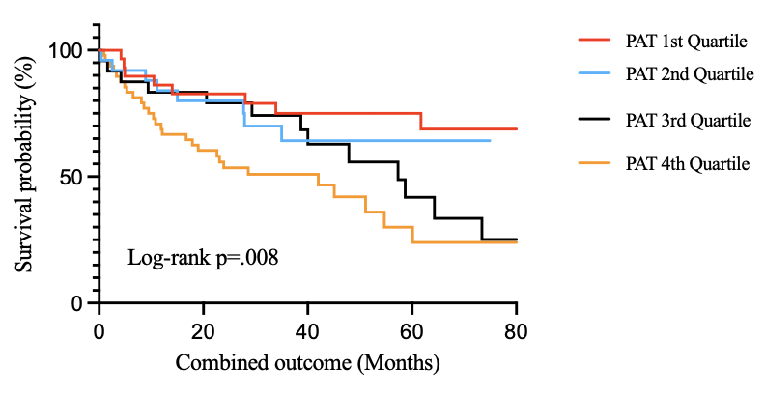

Supplemental Figure 4: Kaplan-Meier curves for the combined outcome Survival status PAT quartiles in HF groups. HFrEF (A), HFmrEF (B), HFpEF (C). HFpEF, heart failure with preserved ejection fraction; HFmrEF, heart failure with mildy reduced ejection fraction; HFrEF, heart failure with reduced ejection fraction; PAT, pericardial adipose tissue

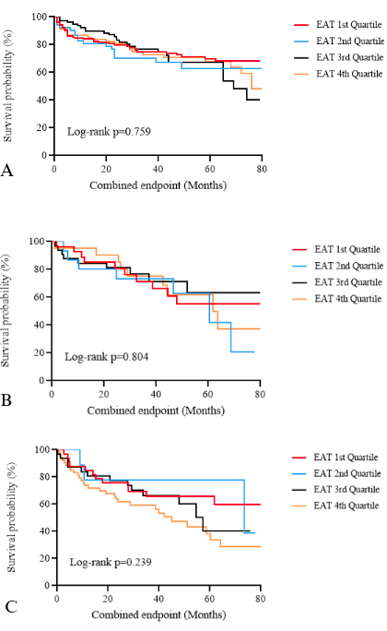
Supplemental Figure 5: Kaplan-Meier curves for the combined outcome Survival status EAT quartiles in HF groups. HFrEF (A), HFmrEF (B), HFpEF (C). EAT, epicardial adipose tissue; HFpEF, heart failure with preserved ejection fraction; HFmrEF, heart failure with mildy reduced ejection fraction; HFrEF, heart failure with reduced ejection fraction;

Supplementary Table 1: Baseline table EAT; demographics, physical examination, comorbidities, laboratory test and echocardiographic parameters
 | Total  (n=572) | EAT 1st Quartile (n=145) | EAT 2nd Quartile (n=140) | EAT 3rd Quartile (n=142) | EAT 4th Quartile  (n=145) | P for trend
Age, years | 67 ± 14 | 63 ± 17 | 67 ± 13 | 68 ± 13 § | 72 ± 11 §† | <0.001
Sex, females % | 217 (38%) | 51 (35%) | 52 (36%) | 51 (35%) | 71 (50%) §†‡ | 0.032
Body mass index (kg/m²) | 27 ± 6 | 25 ± 5 | 27 ± 5 § | 28 ± 5 § | 30 ± 6 §†‡ | <0.001
HF characteristics
HF type  - HFrEF  - HFmrEF  - HFpEF | 346 (60%)  100 (17%)  126 (22%) | 109 (75%)  14 (10%)  22 (15%) | 94 (66%)  29 (20%)  20 (14%) | 79 (55%) §  32 (22%)  32 (22%) | 70 (49%) §†  21 (15%)  52 (36%) | <0.001
Ischaemic heart disease | 237 (38%) | 42 (29%) | 48 (34%) | 54 (38%) | 72 (50%) §†‡ | 0.001
NYHA Class  - I  - II  - III  - IV | 182 (30%)  325 (52%)  100 (16%)  7 (1%) | 28 (20%)  72 (50%)  41 (28%)  2 (1%) | 24 (17%)  76 (53%)  40 (28%)  2 (1%) | 19 (13%)  80 (56%)  37 (26%)  2 (1%) | 12 (8%) §†  73 (51%)  55 (38%)  2 (1%) | 0.2
Comorbidities
Hypertension | 216 (34%) | 40 (28%) | 50 (35%) | 49 (34%) | 60 (42%) | 0.086
Atrial fibrillation, history | 241 (38%) | 50 (35%) | 51 (37%) | 58 (41%) | 54 (38%) | 0.7
Diabetes mellitus | 138 (22%) | 26 (18%) | 32 (22%) | 26 (18%) | 40 (28%) | 0.1
COPD | 85 (14%) | 9 (6%) | 14 (10%) | 18 (13%) § | 32 (22%) §† | <0.001
Cardiothoracic surgery | 94 (15%) | 20 (14%) | 25 (18%) | 22 (15%) | 18 (13%) | 0.676
Laboratory tests
eGFR, ml/min/1.73 m2 | 67 ± 25 | 72 ± 25 | 67 ± 27 | 66 ± 24 | 59 ± 23 § | <0.001
NT‐proBNP, ng/l | 1538 [558-3679] | 1526 [525 – 3869] | 1351 [538 – 3084] | 1461 [542 – 2688] | 1461 [542 – 2688] | 0.7
Medication
Beta‐blocker use | 534 (85%) | 120 (83%) | 120 (84%) | 125 (87%) | 128 (90%) | 0.3
ACEi/ARB use | 521 (83%) | 126 (87%) | 123 (86%) | 120 (84%) | 115 (80%) | 0.4
MRA use | 242 (39%) | 86 (47%) | 58 (41%) | 57 (40%) | 41 (29%) § | 0.015
Loop diuretic use | 437 (70%) | 96 (66%) | 96 (67%) | 94 (66%) | 112 (78%) | 0.063
Echocardiographic parameters
LVEF (%) | 38 ± 13 | 34 ± 12 | 34 ± 13 | 37 ± 14 | 42 ± 13 §†‡ | <0.001
LAVI | 43 ± 15 | 46 ± 15 | 40 ± 15 | 44 ± 13 | 41 ± 16 | 0.2
LVMI | 107 ± 32 | 107 ± 36 | 105 ± 39 | 109 ± 30 | 109 ± 25 | 0.9
e’ lateral | 8.3 ± 3.2 | 8.6 ± 3.6 | 8.3 ± 3.5 | 8.0 ± 3.1 | 8.1 ± 2.8 | 0.2
e’ septal | 5.9 ± 2.3 | 6.0 ± 2.5 | 6.1 ± 2.3 | 5.6 ± 2.1 | 6.0 ± 2.2 | 0.2
e’ mean | 7.1 ± 2.5 | 7.3 ± 2.7 | 7.2 ± 2.7 | 6.9 ± 2.3 | 7.1 ± 2.3 | 0.3
E/e’ | 12 ± 5 | 11 ± 6 | 12 ± 6 | 12 ± 5 | 12 ± 5 | 0.5
EAT | 4.8 ± 2.1 | 3.0 ± 0.6 | 4.1 ± 0.2 § | 5.0 ± 0.5 §† | 7.5 ± 1.9 §†‡ | <0.001
PAT | 5.7 ± 2.8 | 4.0 ± 1.8 | 5.8 ± 2.6 § | 6.1 ± 2.7 § | 7.3 ± 3.1 §†‡ | <0.001
Data are mean±SD, median [interquartile range] or n (%). Final column reflects overall differences in EAT tertiles. ANOVA was used for normally distributed parameters and Chi-squared was used for categorical parameters.
ACEi, angiotensin‐converting enzyme inhibitor; ARB, angiotensin receptor blocker; BMI, body mass index; COPD, chronic obstructive pulmonary disease; DBP, diastolic blood pressure; eGFR, estimated glomerular filtration rate; HF, heart failure; HFrEF, heart failure with reduced ejection fraction; HFmrEF, heart failure with mildly reduced ejection fraction; HFpEF, heart failure with preserved ejection fraction; LAVI, left atrial volumetric index; LVEF, left ventricular ejection fraction; LVMI, left ventricular mass index; MRA, mineralocorticoid receptor antagonist; NT‐proBNP, N‐terminal pro B‐type natriuretic peptide; NYHA, New York Heart Association; RVD, right ventricular dysfunction; SBP, systolic blood pressure § p<.05 versus 1st quartile; † p<.05 versus 2nd quartile; ‡ p<.05 verus 3rd quartile
Supplementary Table 2: Baseline table PAT; demographics, physical examination, comorbidities, laboratory test and echocardiographic parameters
 | Total  (n=572) | PAT 1st quartile (n=140) | PAT 2nd quartile  (n=146) | PAT 3rd quartile (n=143) | PAT 4th quartile  (n=143) | P for trend
Age, years | 67 ± 14 | 60 ± 18 | 67 ±12 § | 68 ± 14 § | 72 ± 10 § | <0.001
Sex, females % | 217 (38%) | 67 (48%) | 55 (38%) | 48 (34%) § | 54 (38%) | 0.087
Body mass index (kg/m²) | 27 ± 6 | 25 ± 5 | 27 ± 5 § | 28 ± 6 § | 29 ± 6 §† | <0.001
HF characteristics
HF type  - HFrEF  - HFmrEF  - HFpEF | 346 (60%)  100 (17%)  126 (22%) | 87 (62%)  24 (17%)  29 (21%) | 94 (64%)  27 (19%)  25 (17%) | 96 (67%)  23 (16%)  24 (17%) | 73 (51%) ‡  22 (15%)  48 (34%) | 0.013
Ischaemic heart disease | 237 (38%) | 35 (25%) | 61 (42%) § | 63 (44%) § | 57 (40%) § | 0.004
NYHA Class  I  II  III  IV | 182 (30%)  325 (52%)  100 (16%)  7 (1%) | 30 (22%)  61 (43%)  46 (1633  1 (1%) | 20 (14%)  87 (60%)  33 (23%)  4 (3%) | 19 (13%)  83 (58%)  37 (26%)  2 (1%) | 14 (10%) §  69 (48%)  56 (39%)  2 (1%) | 0.010
Comorbidities
Hypertension | 216 (34%) | 38 (27%) | 49 (34%) | 54 (38%) | 57 (40%) | 0.1
Atrial fibrillation, history | 241 (38%) | 50 (36%) | 59 (40%) | 41 (29%) | 63 (44%) §‡ | 0.044
Diabetes mellitus | 138 (22%) | 22 (16%) | 38 (26%) | 26 (18%) | 37 (26%) | 0.069
COPD | 85 (14%) | 10 (7%) | 19 (13%) | 14 (10%) | 29 (20%) §‡ | 0.006
Cardiothoracic surgery | 94 (15%) | 19 (14%) | 24 (16%) | 25 (18%) | 17 (12%) | 0.523
Laboratory tests
eGFR, ml/min/1.73 m2 | 67 ± 25 | 73 ± 27 | 68 ± 25 | 65 ± 25 § | 60 ± 23 § | <0.001
NT‐proBNP, ng/l | 1538 [558-3679] | 1538 [558-3679] | 1349 [452-3022] | 1396 [590-2953] | 1310 [562 – 2577] | 0.9
Medication
Beta‐blocker use | 534 (85%) | 112 (80%) | 128 (88%) | 126 (88%) | 125 (87%) | 0.2
ACEi/ARB use | 521 (83%) | 124 (89%) | 128 (89%) | 118 (83%) | 112 (79%) | 0.061
MRA use | 242 (39%) | 61 (44%) | 62 (43%) | 48 (34%) | 51 (36%) | 0.2
Loop diuretic use | 437 (70%) | 86 (61%) | 108 (74%) | 98 (69%) | 104 (73%) | 0.094
Echocardiographic parameters
LVEF (%) | 38 ± 13 | 37 ± 12 | 35 ± 13 | 35 ± 13 | 40 ± 14 †‡ | 0.010
LAVI | 43 ± 15 | 47 ± 18 | 42 ± 13 | 43 ± 16 | 41 ± 12 § | 0.019
LVMI | 107 ± 32 | 105 ± 36 | 110 ± 32 | 108 ± 34 | 107 ± 27 | 0.7
e’ lateral | 8.3 ± 3.2 | 9.1 ± 3.8 | 8.1 ± 3.4 | 7.7 ± 2.9 § | 8.1 ± 3.1 | 0.022
e’ septal | 5.9 ± 2.3 | 6.3 ± 2.7 | 5.6 ± 2.2 | 5.6 ± 1.8 | 6.1 ± 2.3 | 0.066
e’ mean | 7.1 ± 2.5 | 7.7 ± 2.9 | 7.0 ± 2.6 | 6.8 ± 2.0 | 7.1 ± 2.5 | 0.054
E/e’ | 12 ± 5 | 11 ± 6 | 12 ± 6 | 11 ± 5 | 12 ± 5 | 0.5
EAT | 4.8 ± 2.1 | 3.5 ± 1.8 | 4.5 ± 1.5 § | 5.0 ± 1.5 § | 6.1 ± 2.5 §†‡ | <0.001
PAT | 5.7 ± 2.8 | 2.8 ± 0.7 | 4.3 ± 0.4 § | 5.8 ± 0.5 §† | 9.4 ± 2.6 §†‡ | <0.001
Data are mean±SD, median [interquartile range] or n (%). Final column reflects overall differences in EAT tertiles. ANOVA was used for normally distributed parameters and Chi-squared was used for categorical parameters.
ACEi, angiotensin‐converting enzyme inhibitor; ARB, angiotensin receptor blocker; BMI, body mass index; COPD, chronic obstructive pulmonary disease; DBP, diastolic blood pressure; eGFR, estimated glomerular filtration rate; HF, heart failure; HFrEF, heart failure with reduced ejection fraction; HFmrEF, heart failure with mildly reduced ejection fraction; HFpEF, heart failure with preserved ejection fraction; LAVI, left atrial volumetric index; LVEF, left ventricular ejection fraction; LVMI, left ventricular mass index; MRA, mineralocorticoid receptor antagonist; NT‐proBNP, N‐terminal pro B‐type natriuretic peptide; NYHA, New York Heart Association; § p<.05 versus 1st quartile; † p<.05 versus 2nd quartile; ‡ p<.05 verus 3rd quartile

Supplementary Table 3: Baseline table BMI; demographics, physical examination,
comorbidities, laboratory test and echocardiographic parameters
 | Total  (n=572) | BMI  <25 kg/m²  (n=233) | BMI  25-30 kg/m²  (n=214) | BMI  30-35 kg/m²  (n=111) | BMI  >35 kg/m²  (n=58) | P for trend
Age, years | 67 ± 14 | 67 ± 16 | 67 ± 14 | 67 ± 13 | 67 ± 13 | 1.0
Sex, females % | 217 (38%) | 101 (43%) | 61 (29%) | 40 (36%) | 34 (58%) †‡ | <0.001
Body mass index (kg/m²) | 27 ± 6 | 22 ± 2 | 27 ± 1 § | 32 ± 1 §† | 39 ± 4 §†‡ | <0.001
HF characteristics
HF type  - HFrEF  - HFmrEF  - HFpEF | 346 (60%)  100 (17%)  126 (22%) | 87 (62%)  24 (17%)  29 (21%) | 94 (64%)  27 (19%)  25 (17%) | 96 (67%)  23 (16%)  24 (17%) | 73 (51%) ‡  22 (15%)  48 (34%) | 0.013
Ischaemic heart disease | 237 (38%) | 81 (35%) | 89 (42%) | 44 (40%) | 21 (36%) | 0.5
NYHA Class  I  II  III  IV | 182 (30%)  325 (52%)  100 (16%)  7 (1%) | 40 (17%)  111 (48%)  75 (32%)  4 (2%) | 31 (15%)  124 (58%)  52 (24%)  3 (1%) | 14 (13%)  59 (53%)  36 (32%)  1 (1%) | 5 (9%)  28 (48%)  23 (39%)  2 (3%) | 0.2
Comorbidities
Hypertension | 216 (34%) | 61 (26%) | 72 (34%) | 53 (48%) § | 28 (48%) § | <0.001
Atrial fibrillation, history | 241 (38%) | 82 (35%) | 74 (36%) | 48 (43%) § | 31 (53%) §† | 0.038
Diabetes mellitus | 138 (22%) | 32 (14%) | 41 (19%) | 36 (32%) §† | 28 (48%) §†‡ | <0.001
COPD | 85 (14%) | 31 (13%) | 28 (13%) | 18 (16%) | 6 (10%) | 0.7
Cardiothoracic surgery | 94 (15%) | 29 (14%) | 39 (18%) | 17 (15%) | 8 (14%) | 0.4
Laboratory tests
eGFR, ml/min/1.73 m2 | 67 ± 25 | 69 ± 27 | 66 ± 24 | 64 ± 24 | 67 ± 24 | 0.4
NT‐proBNP, ng/l | 1538 [558-3679] | 1820 [755-4409] | 1182 [446-2550] § | 1196 [450-2360] § | 727 [311-1702] § | <0.001
Medication
Beta‐blocker use | 534 (85%) | 188 (81%) | 188 (88%) | 99 (89%) | 52 (88%) | 0.078
ACEi/ARB use | 521 (83%) | 192 (82%) | 183 (86%) | 96 (87%) | 45 (76%) | 0.3
MRA use | 242 (39%) | 94 (40%) | 80 (37%) | 39 (35%) | 26 (44%) | 0.6
Loop diuretic use | 437 (70%) | 153 (66%) | 149 (70%) | 86 (78%) | 43 (73%) | 0.2
Echocardiographic parameters
LVEF (%) | 38 ± 13 | 35 ± 14 | 36 ± 13 | 40 ± 12 §† | 42 ± 12 §† | <0.001
LAVI | 43 ± 15 | 47 ± 18 | 43 ± 12 | 39 ± 11 § | 40 ± 13 § | 0.001
LVMI | 107 ± 32 | 108 ± 33 | 109 ± 30 | 104 ± 34 | 105 ± 35 | 0.6
e’ lateral | 8.3 ± 3.2 | 8.0 ± 3.8 | 8.0 ± 2.8 | 9.0 ± 3.2 | 9.0 ± 3.0 | 0.039
e’ septal | 5.9 ± 2.3 | 5.6 ± 2.4 | 5.9 ± 2.1 | 6.3 ± 2.1 | 6.6 ± 2.7 | 0.032
e’ mean | 7.1 ± 2.5 | 6.8 ± 2.7 | 7.0 ± 2.3 | 7.7 ± 2.4 | 7.8 ± 2.6 | 0.020
E/e’ | 12 ± 5 | 12 ± 6 | 12 ± 5 | 12 ± 5 | 11 ± 3 | 0.4
EAT | 4.8 ± 2.1 | 4.1 ± 1.7 | 4.7 ± 2.1 § | 5.7 ± 2.3 §† | 5.8 ± 1.8 §† | <0.001
PAT | 5.7 ± 2.8 | 4.8 ± 2.3 | 5.8 ± 2.6 § | 6.4 ± 3.5 § | 6.9 ± 3.0 §† | <0.001
Data are mean±SD, median [interquartile range] or n (%). Final column reflects overall differences in EAT tertiles. ANOVA was used for normally distributed parameters and Chi-squared was used for categorical parameters.
ACEi, angiotensin‐converting enzyme inhibitor; ARB, angiotensin receptor blocker; BMI, body mass index; COPD, chronic obstructive pulmonary disease; DBP, diastolic blood pressure; eGFR, estimated glomerular filtration rate; HF, heart failure; HFrEF, heart failure with reduced ejection fraction; HFmrEF, heart failure with mildly reduced ejection fraction; HFpEF, heart failure with preserved ejection fraction; LAVI, left atrial volumetric index; LVEF, left ventricular ejection fraction; LVMI, left ventricular mass index; MRA, mineralocorticoid receptor antagonist; NT‐proBNP, N‐terminal pro B‐type natriuretic peptide; NYHA, New York Heart Association; RVD, right ventricular dysfunction; SBP, systolic blood pressure. § p<.05 versus 1st quartile; † p<.05 versus 2nd quartile; ‡ p<.05 verus 3rd quartile

