Supplementary Material

ANNEXURE-I

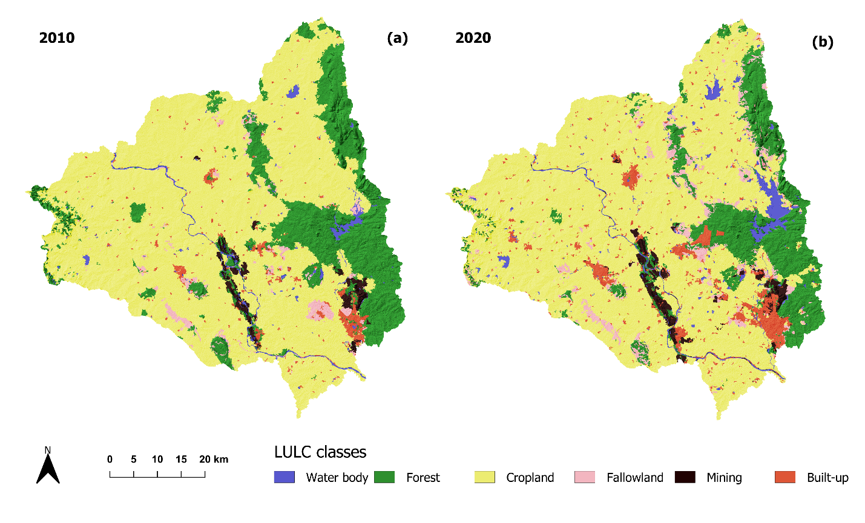
(a) Land use map for year 2010; (b) for year 2020
ANNEXURE-II
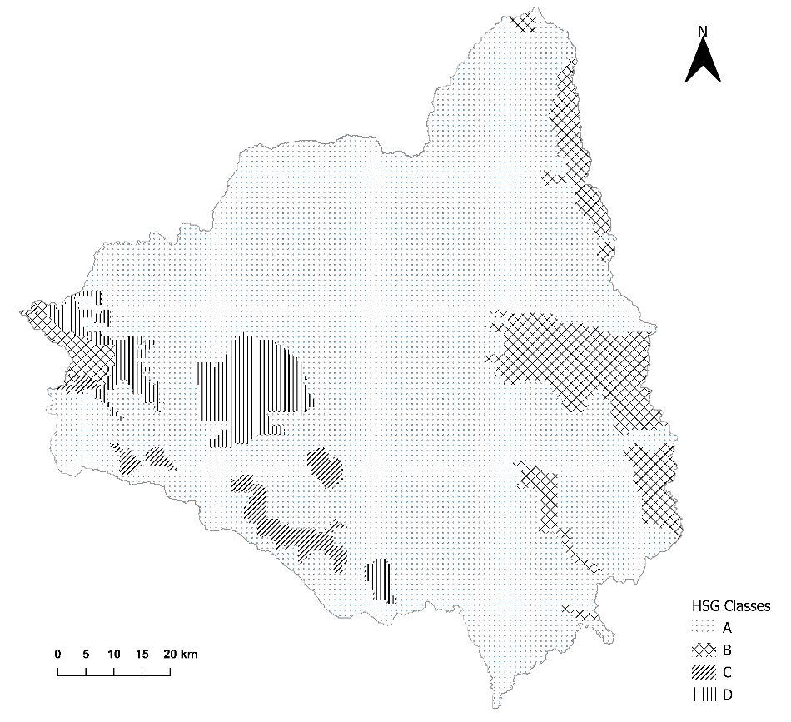
HSG map of the study area
ANNEXURE-III

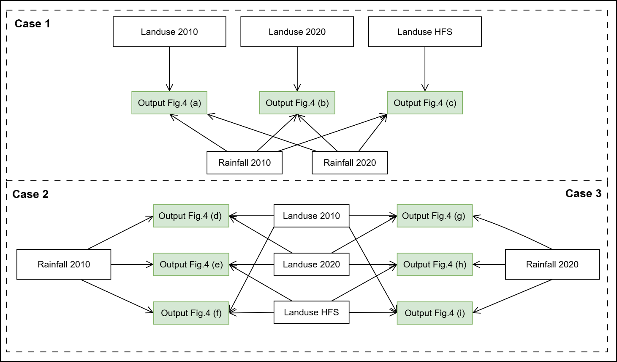
Workflow illustrating the process for deriving annual differential runoff maps.

ANNEXURE-IV

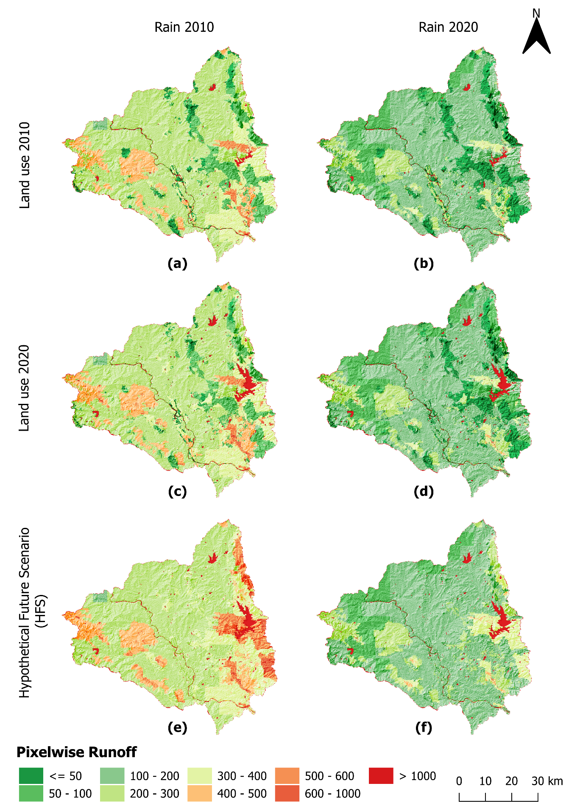
Intermediate-stage runoff maps used to derive the differential runoff maps

ANNEXURE-V

Scenario | Mean Runoff (mm) | Runoff-Rainfall Elasticity (Ɛ_p) | Runoff-Land Use Elasticity (Ɛ_CN)
Land Use 2010 | 183.44 | 1.67 | -
Land Use 2020 | 204.23 | 1.61 | 2.07 (vs 2010)
Land Use HFS | 247.79 | 1.58 | 1.91 (vs 2020)

ANNEXURE-VI
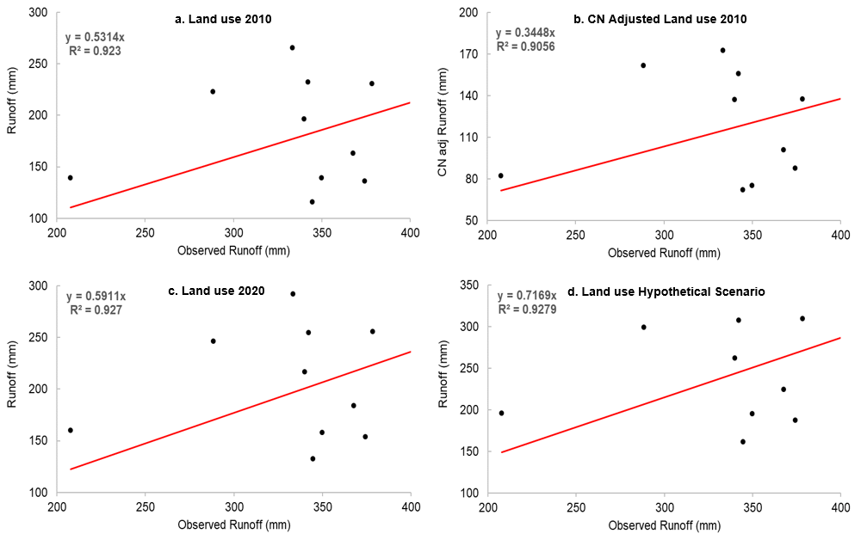
Scatterplots showing the coefficient of determination (R²) between simulated and observed runoff under different land-use scenarios: (a) 2010 land use; (b) CN-adjusted 2010 land use; (c) 2020 land use; and (d) HFS land use.

