Concept | Search terms
Children | “Infant” OR “newborn” OR “neonate” OR “neonates” OR “baby” OR “babies” OR “infant” OR “Children” OR “Child” OR “minors” OR “pediatric”
Fever | “Fever” OR “febril” OR “febrile” OR “hyperterm”
Guideline | “Guideline” OR “Guidelines”
Table 1. Search terms for PubMed, EBSCOhost and Web of Science database search

The concepts were combined as follows: “children” AND “fever” AND “guideline”
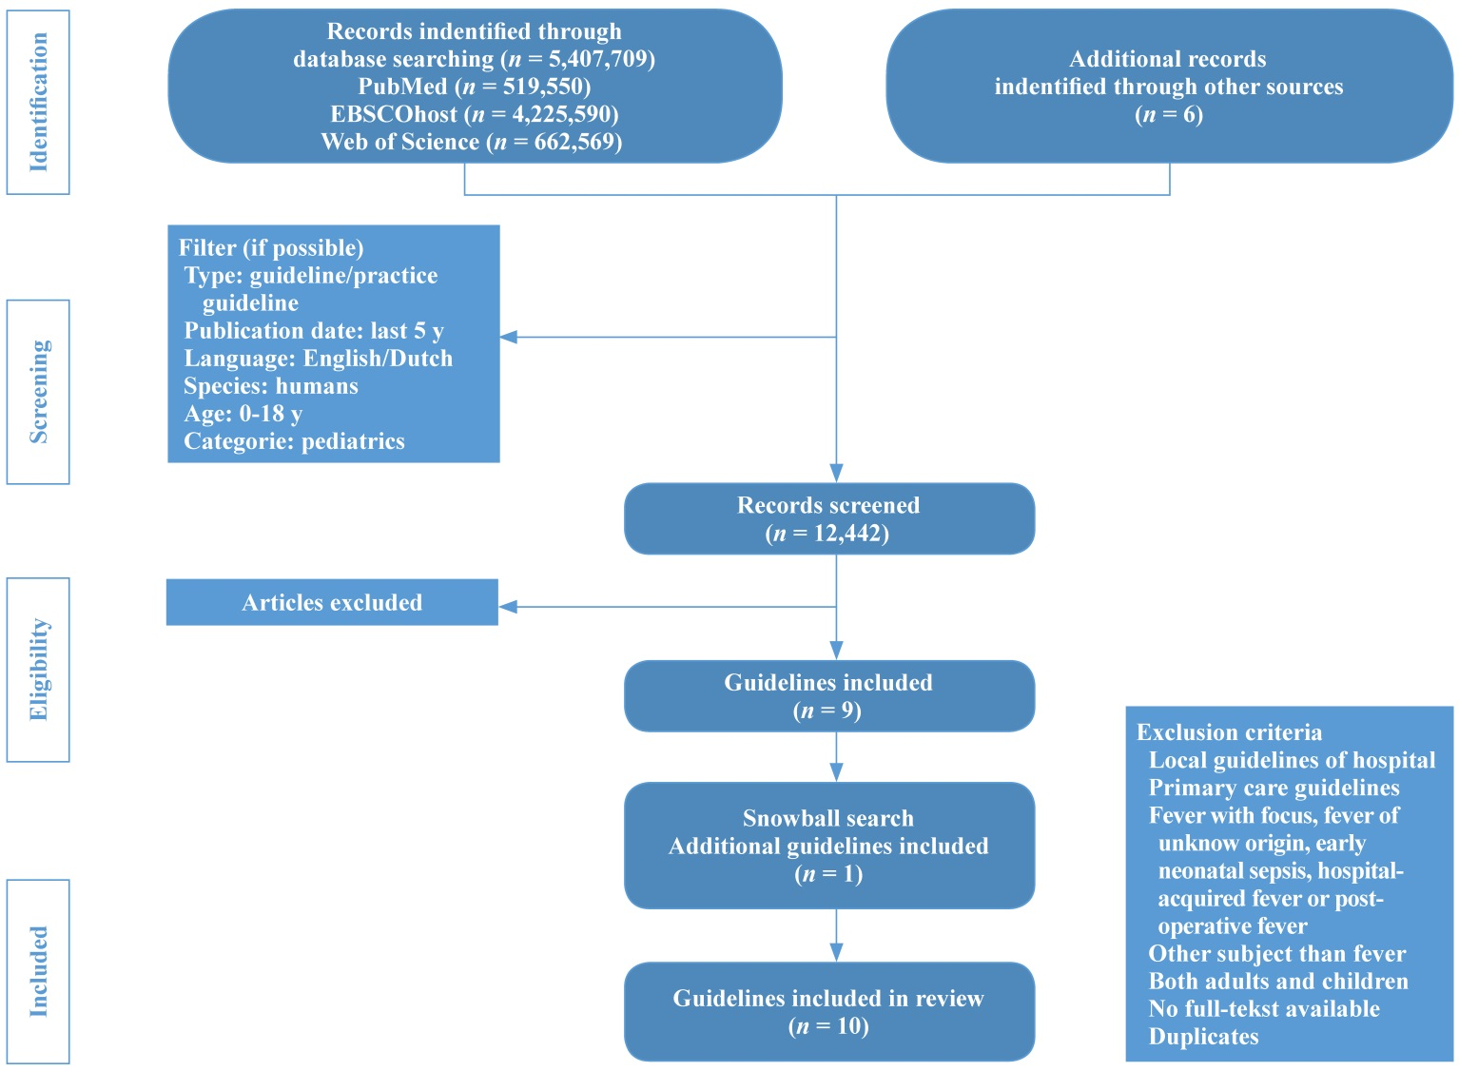
Fig. 1 Flowchart of the literature search
Table 2. Overview clinical criteria for low, intermediate and high risk of serious disease per guideline
Country | The Netherlands | UK | USA |  |  | Australia |  |  |  | Canada
Guideline | NVK  [19] | NICE  [20] | ACEP  [21] | AAP  [22] | AAP  [23] | NSW  [24] | SA  [25] | CHQ  [26] | CAHS  [27] | TREKK  [28]
Low risk
Normal color of skin, lips and tongue | X | X |  |  |  |  | X |  | X
Responds normally to social cues | X | X |  |  |  |  | X |  | X
Content/smiles | X | X |  |  |  |  | X |  | X
Stays awake of awakes quickly | X | X |  |  |  |  | X |  | X
Strong normal cry of not crying | X | X |  |  |  |  | X |  | X
Normal work of breathing |  |  |  |  |  |  | X |  | X
Normal skin and eyes | X | X |  |  |  |  | X |  | X
Moist mucous membranes | X | X |  |  |  |  | X |  | X
Previous healthy |  |  | X | X
Born after 37 wk of gestation | X | X | X |  |  |  | X |  |  | X
No prior hospitalization |  |  |  |  |  |  |  |  |  | X
No prolonged newborn nursery care |  |  |  |  |  |  |  |  |  | X
Uncomplicated newborn nursery care |  |  | X
Nontoxic clinical appearance | X | X | X | X
No intermediate or high risk signs | X | X |  |  |  |  |  |  | X
No focal bacterial infection on examination (except otitis media) | X | X | X | X
No evidence of any infection clinically | X | X |  |  |  |  | X
No unexplained jaundice | X | X |  |  |  |  |  |  |  | X
No chronic illness | X | X |  |  |  |  | X |  |  | X
No prior antibiotics | X | X |  |  |  |  | X |  |  | X
Intermediate risk
Pallor of skin, lips or tongue, or reported by parent or carer | X | X |  |  |  |  | X | X | X
Not responding normally to social cues | X | X |  |  |  |  | X | X | X
No smile | X | X |  |  |  |  | X | X | X
Wakes only with prolonged stimulation | X | X |  |  |  |  |  | X | X
Decreased activity | X | X |  |  |  |  | X | X
Irritable |  |  |  |  |  |  | X
Not strong cry |  |  |  |  |  |  |  | X
Appearing ill to a healthcare professional | X
Disease course different from previous diseases | X
Nasal flaring | X | X |  |  |  |  |  | X | X
Tachypnea | X | X |  |  |  |  |  | X | X
Oxygen saturation ≤ 95% | X | X |  |  |  |  |  | X | X
Auscultation: crepitations | X | X |  |  |  |  |  | X | X
Tachycardia | X | X |  |  |  |  |  | X | X
Dry mucous membranes | X | X |  |  |  |  | X |  | X
Poor feeding in infant | X | X |  |  |  |  | X | X | X
Reduced urine output | X | X |  |  |  |  | X | X | X
Capillary refill time ≥ 3 s | X | X |  |  |  |  |  | X | X
Rigors | X | X |  |  |  |  |  | X | X
Fever > 5 d | X | X |  |  |  |  |  |  | X
Swollen joint | X | X |  |  |  |  |  | X | X
New lump > 2 cm |  |  |  |  |  |  | X
Non-use of a limb | X | X |  |  |  |  |  |  | X
Unable to bear weight | X | X |  |  |  |  |  |  | X
Age 3-6 mon, temperature ≥ 39.0 ℃ |  | X |  |  |  |  |  |  | X
High risk
Pale/mottled/ashen/blue skin, lips or tongue | X | X |  | X |  | X | X |  | X
No response to social cues | X | X |  |  |  |  | X |  | X
Altered mental state |  |  |  |  |  |  |  | X
Lethargy |  |  |  | X |  | X |  | X |  | X
Irritability |  |  |  |  |  | X |  | X
Decreased activity |  |  |  |  |  | X
Decreased alertness |  |  |  |  |  | X
Appearing ill to a healthcare professional |  | X |  |  |  |  | X |  | X
Does not wake or if roused does not stay wake | X | X |  |  |  |  | X |  | X
Weak, high-pitched or continuous cry | X | X |  |  |  | X | X | X | X
Grunting | X | X |  |  |  |  | X | X | X
Hypoventilation or hyperventilation |  |  |  | X
Tachypnea | X | X |  |  |  | X | X | X | X
Moderate or severe chest indrawing | X | X |  |  |  | X |  | X | X
Auscultation: diminished breath sounds
Signs of poor perfusion |  |  |  | X |  | X |  | X
Cool peripheries |  |  |  |  |  |  | X | X
Bounding pulses or wide pulse pressure |  |  |  |  |  |  | X
Reduced skin turgor | X | X |  |  |  |  | X | X | X
Bilious vomiting |  |  |  |  |  |  | X
Decreased fluid intake |  |  |  |  |  | X | X | X
Decreased urine output |  |  |  |  |  | X | X | X
Tachycardia |  |  |  |  |  | X | X | X
Signs of shock |  |  |  |  |  |  |  |  |  | X
Neck stiffness | X | X |  |  |  |  |  |  | X
Bulging fontanelle | X | X |  |  |  |  | X |  | X
Petechiae | X |  |  |  |  |  | X
Non-blanching rash |  | X |  |  |  |  |  |  | X
Coagulopathy |  |  |  |  |  |  |  |  |  | X
Rigors |  |  |  |  |  |  | X
Status epilepticus | X | X |  |  |  |  |  |  | X
Focal seizures | X | X |  |  |  |  | X | X | X
Focal neurological symptoms | X | X |  |  |  |  |  |  | X
Age < 1 mon with FWS | X
Age < 3 mon with FWS |  | X |  |  |  |  |  |  | X
Evidence of organ dysfunction |  |  |  |  |  |  |  |  |  | X

FWS fever without a source, NVK Dutch Association for Pediatrics, NICE National Institute for Health and Care Excellence, ACEP American College of Emergency Physicians, AAP American Academy of Pediatrics, NSW New South Wales, SA South Australian, CHQ Children's Health Queensland Hospital and Health Service, CAHS Child and Adolescent Health Service, TREKK Translating Emergency Knowledge for Kids

