Supplementary Table 1. Literature search strategy
Up to March 26, 2022
PubMed: all fields
#3: #1 AND #2
(((bronchopulmonary dysplasia) OR (lung dysplasia)) OR (BPD)) AND (((((asthma) OR (asthmas)) OR (bronchial asthma)) OR(wheeze)) OR(wheezing))
#2: ((((asthma) OR(asthmas)) OR (bronchial asthma)) OR (wheeze)) OR (wheezing)
#1: ((bronchopulmonary dysplasia) OR (lung dysplasia)) OR (BPD)
Web of Science: TS
TS = (bronchopulmonary dysplasia OR lung dysplasia OR BPD) AND TS = (asthma OR asthmas OR bronchial asthma OR wheeze OR wheezing)
Cochrane Library: all text
(((bronchopulmonary dysplasia) OR (lung dysplasia)) OR (BPD)) AND (((((asthma) OR (asthmas)) OR (bronchial asthma)) OR (wheeze)) OR (wheezing))
Embase: all fields
#3: #1 AND #2
#2: “asthma”/exp OR asthma OR asthmas OR (bronchial AND asthma) OR wheeze OR wheezing
#1: “bronchopulmonary dysplasia”/exp OR “bronchopulmonary dysplasia” OR (bronchopulmonary AND (“dysplasia”/exp OR dysplasia)) OR (lung AND dysplasia) OR bpd
Scopus: TITLE-ABS-KEY
((TITLE-ABS-KEY (bronchopulmonary AND dysplasia) OR TITLE-ABS-KEY (lung AND dysplasia) OR TITLE-ABS-KEY (bpd))) AND ((TITLE-ABS-KEY (asthma) OR TITLE-ABS-KEY (asthmas) OR TITLE-ABS-KEY (bronchial AND asthma) OR TITLE-ABS-KEY (wheeze) OR TITLE-ABS-KEY (wheezing)))

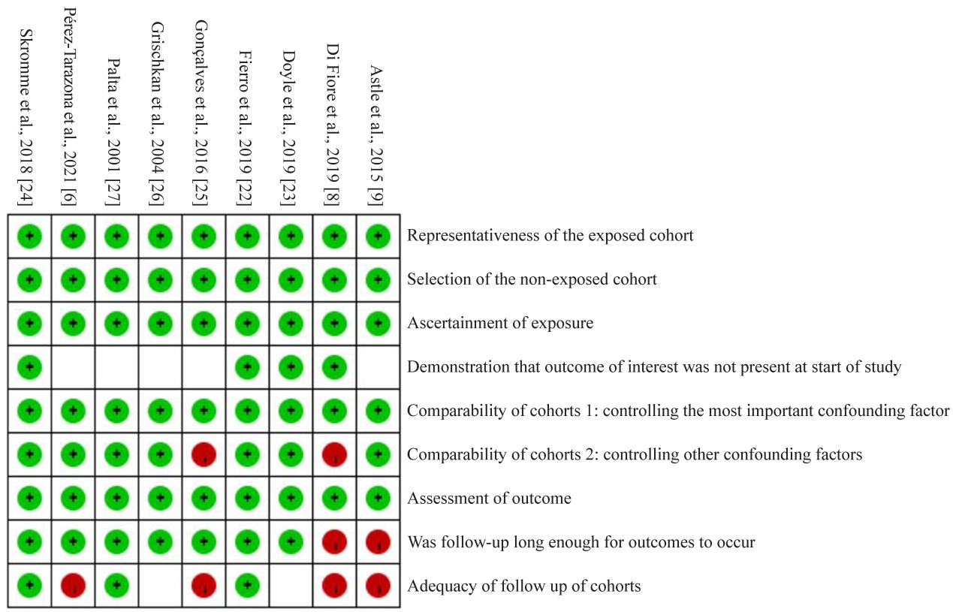

Supplementary Fig. 1 Newcastle-Ottawa Scale scores of study quality for included studies. Green circle means 1 point, red circle or blank means 0 point. The full points are 9

