Table S1. Sensitivity analysis result of the association between CALD with DV1 and DV2 through adjusting for more confounding variables and propensity score weighting
Outcome | A |  | B |  | C |  | D |  | F |  | G
Outcome | AOR | 95% CI | AOR | 95% CI | AOR | 95% CI | AOR | 95% CI | AOR | 95% CI | AOR | 95% CI
DV1 | 1.23 | 1.16, 1.31 | 1.22 | 1.14, 1.29 | 1.23 | 1.16, 1.31 | 1.22 | 1.15, 1.30 | 1.28 | 1.21, 1.36 | 1.25 | 1.17, 1.33
DV2 | 1.23 | 1.13, 1.33 | 1.21 | 1.12, 1.32 | 1.23 | 1.13, 1.33 | 1.22 | 1.13, 1.33 | 1.30 | 1.19, 1.40 | 1.28 | 1.18, 1.39
A: adjusted for census year, child sex at birth, maternal age, marital status, parity, birth season, child age, remoteness and socioeconomic index for areas
B: adjusted for covariates in model A and for small for gestational age
C: adjusted for covariates in model A and preterm birth
D: adjusted for covariates in model A and interpregnancy interval
F: adjusted for covariates in model A and maternal smoking
G: adjusted for covariates in model A and small for gestational age, Preterm birth, interpregnancy interval, and maternal smoking
Table S2. Sensitivity analysis for the Association between developmental vulnerability (DV1 and DV2) and variables used to define CALD.
Outcome | Variables used to define CALD |  | Unadjusted |  | Adjusted
Outcome |  |  | OR | 95% CI | OR | 95%CI
DV1 | Using English as a second language |  | 1.85 | 1.72, 1.98 | 1.84 | 1.68, 2.00
DV1 | Using language other than English at home |  | 1.41 | 1.32, 1.50 | 1.37 | 1.27, 1.48
DV1 | Children categorised as CALD by using Ethnicity |  | 1.30 | 1.22, 1.37 | 1.17 | 1.08, 1.47
DV1 | Ethnicity | Caucasian | 1.00 |  | 1.00
DV1 | Ethnicity | Asian | 1.10 | 1.02, 1.18 | 1.06 | 0.96, 1.16
DV1 | Ethnicity | African | 1.79 | 1.51, 2.13 | 1.35 | 1.10, 1.66
DV1 | Ethnicity | Polynesian/Maori | 1.57 | 1.29, 1.91 | 1.31 | 1.03, 1.66
DV1 | Ethnicity | Others | 1.52 | 1.39, 1.69 | 1.30 | 1.15, 1.47
DV1 | Country of birth | Children born from non-English speaking countries | 1.50 | 1.12, 2.00 | 1.41 | 1.00, 2.00
DV2 | Using English as a second language |  | 1.86 | 1.70, 2.03 | 1.74 | 1.56, 1.94
DV2 | Using language other than English at home |  | 1.40 | 1.29, 1.52 | 1.30 | 1.18, 1.43
DV2 | Children categorised as CALD by using Ethnicity |  | 1.31 | 1.21, 1.41 | 1.18 | 1.07, 1.30
DV2 | Ethnicity | Caucasian | 1.00 |  | 1.00
DV2 | Ethnicity | Asian | 1.07 | 0.96, 1.19 | 1.05 | 0.92, 1.19
DV2 | Ethnicity | African | 2.10 | 1.71, 2.58 | 1.44 | 1.13, 1.84
DV2 | Ethnicity | Polynesian/Maori | 1.71 | 1.34, 2.19 | 1.45 | 1.08, 1.94
DV2 | Ethnicity | Others | 1.50 | 1.32, 1.70 | 1.27 | 1.08, 1.49
DV2 | Country of birth | Children born from non-English speaking countries | 1.78 | 1.25, 2.53 | 1.77 | 1.14, 2.74
Adjusted for census year, child sex at birth, maternal age, marital status, parity, remoteness, Birth season, age of the child and socioeconomic index for areas.
Table S3. Subgroup analysis to assess the impact of CALD on developmental vulnerability (DV1 and DV2) for males and females.
Outcome | Sex | Unadjusted |  | Adjusted
Outcome | Sex | OR | 95% CI | OR | 95%CI
DV1 | Male | 1.22 | 1.14, 1.30 | 1.17 | 1.09, 1.27
DV1 | Female | 1.36 | 1.25, 1.48 | 1.34 | 1.22, 1.48
DV2 | Male | 1.25 | 1.15, 1.36 | 1.20 | 1.09, 1.32
DV2 | Female | 1.35 | 1.19, 1.53 | 1.30 | 1.12, 1.50
Adjusted for census year, child sex at birth, maternal age, marital status, parity, remoteness, Birth season, age of the child and socioeconomic index for areas
Table S4: Causal mediation analysis result on the influence of small for gestational age on the association between CALD and developmental vulnerability (DV1 and DV2)
Effects | DV1 |  |  | DV2
Effects | Estimates | 95% CI |  | Estimates | 95% CI
Controlled direct effects | 1.23 | 1.17 | 1.30 | 1.24 | 1.15 | 1.33
Natural direct effects | 1.23 | 1.17 | 1.30 | 1.24 | 1.15 | 1.33
Natural indirect effects | 1.02 | 1.01 | 1.02 | 1.02 | 1.01 | 1.02
Marginal total effects | 1.25 | 1.19 | 1.32 | 1.26 | 1.17 | 1.35
Proportion of mediated by low birth weight = [NDE × (NIE − 1)]/(NDE × NIE − 1) | 8.29% | 6.87% | 9.25% | 7.83% | 6.24% | 8.79%
Adjusted for census year, child sex at birth, maternal age, marital status, parity, remoteness, Birth season, age of the child and socioeconomic index for areas
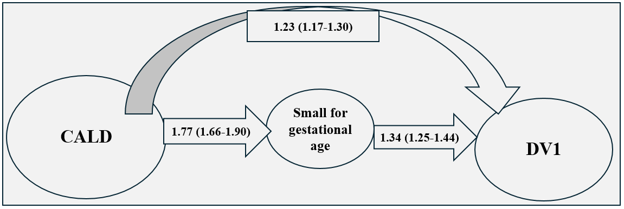
Fig S1: The influence of Small for gestational age on the association of CALD and DV1
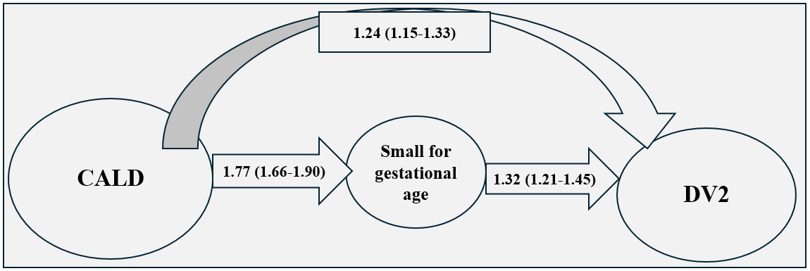
Fig S2: The influence of small for gestational age on the association of CALD and DV2

