Annex
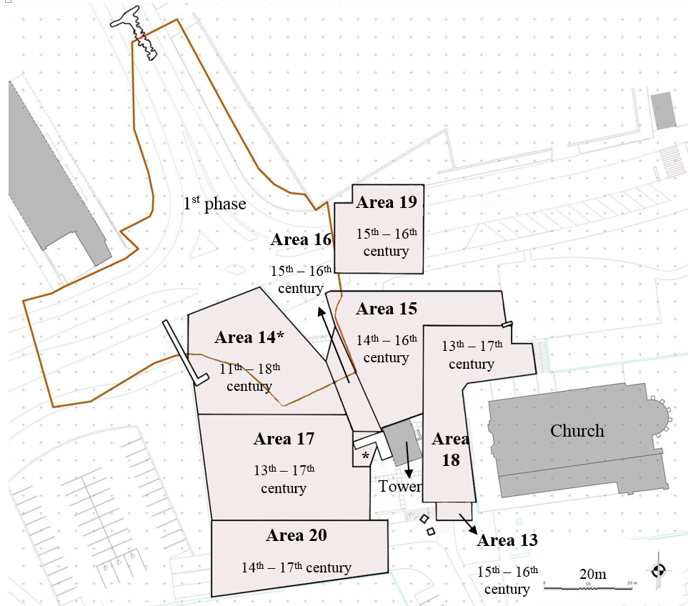
Figure A1. Map of the excavation. Area excavated during the 1st phase and areas 13 to 20, excavated during the 2nd phase.

Figure A2. Carbon and nitrogen stable isotope comparison between faunal remains from Tomar, Benipeixcar (15th – 16th century, Alexander et al., 2015) and Koksijde (12th – 15th century, Polet & Katzenberg, 2003).

Table A1. Stable isotope results (δ¹³C, δ¹⁵N and δ³⁴S) for human and faunal collagen.
 | Sex | Age | Status | Area | δ¹³C | %C | δ¹⁵N | %N | C/N | δ³⁴S | %S | C/S | N/S
Humans | Female | - | Higher | 13 | -18.8 | 32.1 | 10.6 | 11.2 | 3.4 | - | - | - | -
Humans | Female | - | Lower | 14 | -18.6 | 31.3 | 12.0 | 10.4 | 3.4 | - | - | - | -
Humans | Female | Mature | Lower | 16 | -18.3 | 41.8 | 10.5 | 14.8 | 3.3 | 13.2 | 0.2 | 208.8 | 74.0
Humans | Female | Mature | Lower | 14 | -18.9 | 41.3 | 10.2 | 14.6 | 3.3 | 14.1 | 0.2 | 206.5 | 73.2
Humans | Female | Old | Lower | 14 | -18.9 | 21.9 | 10.3 | 7.5 | 3.4 | 13.9 | 0.1 | 218.9 | 75.0
Humans | Female | Old | Lower | 14 | -18.7 | 41.0 | 10.5 | 14.5 | 3.3 | 11.5 | 0.2 | 204.8 | 72.6
Humans | Female | Mature | Higher | 18 | -19.1 | 40.8 | 8.9 | 14.4 | 3.3 | 13.5 | 0.2 | 204.0 | 71.9
Humans | Female | Old | Lower | 20 | -18.7 | 36.7 | 9.6 | 12.9 | 3.3 | - | - | - | -
Humans | Female | Young | Lower | 20 | -18.5 | 23.2 | 11.0 | 7.7 | 3.4 | 13.7 | 0.1 | 232.2 | 76.8
Humans | Female | Old | Higher | 18 | -18.3 | 34.5 | 12.3 | 11.9 | 3.4 | 13.6 | 0.2 | 172.4 | 59.7
Humans | Female | Mature | Lower | 20 | -18.6 | 23.0 | 11.0 | 7.9 | 3.4 | 13.1 | 0.1 | 229.9 | 78.7
Humans | Female | Young | Lower | 14 | -19.0 | 15.5 | 11.4 | 5.2 | 3.4 | 12.4 | 0.1 | 154.8 | 52.0
Humans | Female | Old | Lower | 14 | -18.7 | 41.7 | 10.1 | 14.3 | 3.4 | 14.8 | 0.2 | 208.4 | 71.5
Humans | Female | Young | Lower | 16 | -18.9 | 18.5 | 10.6 | 6.1 | 3.4 | - | - | - | -
Humans | Female | - | Higher | 19 | -17.8 | 32.7 | 11.2 | 11.5 | 3.3 | - | - | - | -
Humans | Male | - | Lower | 20 | -18.8 | 39.1 | 10.2 | 13.7 | 3.3 | - | - | - | -
Humans | Male | - | Higher | 19 | -18.9 | 41.0 | 9.6 | 14.1 | 3.4 | - | - | - | -
Humans | Male | Mature | Higher | 18 | -18.8 | 36.6 | 11.2 | 12.8 | 3.3 | 11.6 | 0.2 | 183.0 | 64.1
Humans | Male | Mature | Higher | 19 | -18.2 | 35.3 | 10.4 | 12.3 | 3.4 | 14.1 | 0.2 | 176.5 | 61.5
Humans | Male | Old | Higher | 18 | -19.0 | 37.9 | 10.5 | 12.5 | 3.4 | - | - | - | -
Humans | Male | Mature | Lower | 14 | -19.4 | 14.8 | 11.0 | 5.2 | 3.3 | 12.2 | 0.1 | 148.0 | 52.0
Humans | Male | - | Lower | 17 | -17.3 | 43.0 | 10.4 | 14.8 | 3.4 | - | - | - | -
Humans | Male | Young | Higher | 18 | -18.1 | 24.1 | 12.1 | 8.4 | 3.4 | 11.4 | 0.2 | 120.5 | 41.8
Humans | Male | Mature | Lower | 14 | -19.1 | 39.0 | 9.3 | 13.3 | 3.4 | - | - | - | -
Humans | Male | Young | Lower | 14 | -17.8 | 39.2 | 12.5 | 14.4 | 3.2 | - | - | - | -
Humans | Male | Young | Lower | 20 | -18.5 | 40.8 | 11.7 | 14.1 | 3.4 | 13.5 | 0.2 | 203.8 | 70.3
Humans | Male | Young | Lower | 16 | -18.3 | 36.1 | 10.7 | 12.6 | 3.4 | - | - | - | -
Humans | Male | Young | Lower | 14 | -15.4 | 25.7 | 12.3 | 9.0 | 3.3 | 9.3 | 0.2 | 128.5 | 45.1
Humans | Male | Mature | Lower | 14 | -17.9 | 42.1 | 11.2 | 14.9 | 3.3 | 15.6 | 0.2 | 210.3 | 74.4
Humans | Male | Mature | Higher | 15 | -18.3 | 33.7 | 10.5 | 11.7 | 3.4 | 14.8 | 0.2 | 168.5 | 58.4
Humans | Male | Mature | Lower | 14 | -17.6 | 32.6 | 11.6 | 10.9 | 3.4 | - | - | - | -
Humans | Male | Mature | Lower | 14 | -18.7 | 41.4 | 11.8 | 14.3 | 3.4 | 12.3 | 0.2 | 207.0 | 71.4
Humans | Male | Mature | Lower | 17 | -19.1 | 22.8 | 10.7 | 7.6 | 3.4 | 14.2 | 0.1 | 227.7 | 76.0
Fauna | Bos |  |  | 20 | -21.3 | 42.5 | 4.8 | 14.9 | 3.3 | 18.0 | 0.2 | 212.6 | 74.3
Fauna | Bos |  |  | 20 | -21.1 | 29.9 | 5.9 | 11.1 | 3.3 | 13.1 | 0.1 | 299.1 | 110.6
Fauna | Bos |  |  | 20 | -20.9 | 38.2 | 6.1 | 13.4 | 3.3 | - | - | - | -
Fauna | Bos |  |  | 20 | -21.1 | 42.2 | 5.7 | 14.8 | 3.3 | 18.5 | 0.2 | 211.1 | 74.1
Fauna | Canidae |  |  | 20 | -21.1 | 27.5 | 7.2 | 9.0 | 3.4 | - | - | - | -
Fauna | Domestic sus |  |  | 14 | -21.1 | 36.3 | 6.2 | 12.4 | 3.4 | - | - | - | -
Fauna | Domestic sus |  |  | 14 | -20.7 | 38.8 | 5.5 | 13.4 | 3.4 | - | - | - | -
Fauna | Domestic sus |  |  | 14 | -20.8 | 15.9 | 6.2 | 5.4 | 3.4 | 17.4 | 0.1 | 158.5 | 54.4
Fauna | Equus |  |  | 20 | -20.4 | 41.0 | 8.5 | 14.4 | 3.3 | 10.2 | 0.2 | 204.8 | 72.0
Fauna | Juvenile sus |  |  | 14 | -20.1 | 41.0 | 6.3 | 14.2 | 3.4 | 14.8 | 0.2 | 205.0 | 71.1
Fauna | Ovicapridae |  |  | 17 | -21.1 | 10.1 | 5.4 | 3.5 | 3.4 | 15.1 | 0.1 | 101.0 | 35.0
Fauna | Ovicapridae |  |  | 20 | -21.2 | 22.6 | 7.9 | 7.4 | 3.4 | 16.5 | 0.1 | 225.6 | 74.0
Fauna | Ovicapridae |  |  | 20 | -21.1 | 42.7 | 7.2 | 15.1 | 3.3 | 18.5 | 0.2 | 213.5 | 75.5
Fauna | Wild sus |  |  | 20 | -21.7 | 17.8 | 7.1 | 6.1 | 3.4 | 14.8 | 0.1 | 178.0 | 61.0
Fauna | Wild sus |  |  | 17 | -19.4 | 27.3 | 6.6 | 9.5 | 3.4 | 14.6 | 0.1 | 273.4 | 94.7

