Digital Image Analysis of the Mirasiviene stela (Lora del Río, Sevilla, Spain)

Miguel Ángel Rogerio Candelera
Instituto de Recursos Naturales y Agrobiología de Sevilla, Consejo Superior de Investigaciones Científicas (IRNAS-CSIC), Avda. Reina Mercedes, 10; 41012 Sevilla.

1.- Materials and Methods
The dimensions of the stele were determined by means of a tape measure and a hand-made drawing was elaborated, placing there the measured lengths: general width, height, and depth, as well as the lengths between the different control points marked on the surface of the stone (Figure 1). A total of 22 control points was selected on the complete stele, marked by 10x20 mm Kores stickers. These points would be used as references for building an ortophotomosaic.
The stele was photographically recorded using a Canon EOS 450D digital photographic camera, obtaining detailed images of 2848x4272 pixels, with vertical and horizontal resolution of 72 dpi, recorded in sRGB colour space. Recording conditions of the images were sunlight, f/4.5, 35 mm focal length, and exposure time of 1/500 – 1/800 s. The obtained images were stored as high resolution JPG files. The camera was placed normal to the recorded stele surface, in order to minimise the geometrical distortions generated by the conical projection of the photographic images.
In order to elaborate the ortophotomosaic, a geometric orthogonal transformation (Pazak 2012) was applied to pairs of photographs, using at least 10 points easily identifiable in every image. As pixel interpolation method a nearest neighbour algorithm was used, choosing as output pixel value, that of the closes one in the origin image. The different image pairs were stitched to compose a mosaic using the software package HyperCube 10.70 (US Army Geospatial Centre, Alexandria, VA). The photomosaic was then scaled using ImageJ 1.45s software (National Institutes of Health, Bethesda, MD).
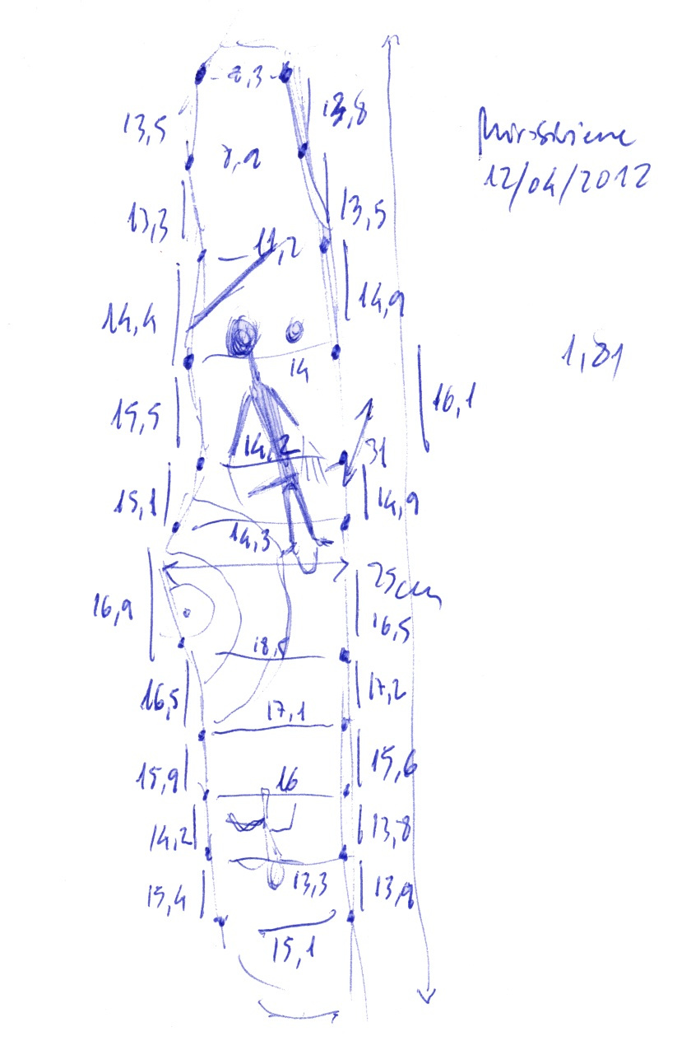
Figure 1. Scale sketch of Mirasiviene stele, showing the different control points.
The pixel values of the different detail images were uncorrelated by means of Principal Components Analysis (PCA), following the protocols of Rogerio-Candelera et al. (2011): implementation of PCA, bands inspection and elaboration of false colour images using all the bands obtained by PCA, and/or weighting the most pertinent bands. In any cases, six-band image cubes have been elaborated, later uncorrelated by PCA and these bands the basis for preparing three band false colour images. The using of more than three-band cubes is justified by possibility of explaining residual amounts of information enclosed in the images. A successful application of these kinds of synthetic image cubes allowed the differentiation of phases in an Aragonese painted rock art panel, confirmed by means of Laser Ablation-Induced Coupled Plasma/Mass Spectrometry technique (LA-ICP/MS) of microsamples (Rogerio-Candelera et al. 2009). Nevertheless, it is also true that the results obtained by means of this approach are difficult to interpret in images representing varied coverages (Rogerio-Candelera et al. 2011).

2.- Results

2.1. Elaboration of an ortophotomosaic of the stele

Figure 2 shows the ortophotomosaic obtained by means of the already described methods. For its elaboration, 10 digital photographs were used, stitched in order to obtain a final image, stored both in tiff and JPG format, with a vertical and horizontal resolution of 300 dpi and 1431x4776 pixels in size.

When preparing the ortophotomosaic, it was detected a fall in the quality of the images corresponding to the lower part of the stele, mainly produced for the difficulties of placing the camera at 90º in relation to the surface. Thus, the lowest part of the stele could not be wholly represented in the mosaic, as the rest of the available images had a resolution sensibly lower, complicating the precise location of reference points for completing the mosaic. The length lost in the stele’s ortophotomosaic is, thus, of around 450 cm².

2.2. Digital image analysis (DIA)

The first, exploratory analysis using DIA techniques allowed us to be sceptical of the possibility of the intentional original application of pigments. The study of the correlation matrix of the images obtained in the campaign of april, 2012, allowed discovering the high correlation between the bands, with values especially high for the pairs red/green and green/blue. The lowest correlation is verified for the bands red/blue, with an average of 0.935 ±0.018 N=8 (Table 1), fully justifying the utilisation of PCA for reliably enhancing the presence of hypothetical pigments applied on the surface of the stele.

Consequently with the data extracted from the correlation matrices already explained, the different bands product of PCA show a great percentage of the variance of the images enclosed in the first Principal Component, remaining in the third the residual information, lower than 0.2% of the total variance (Table 2).

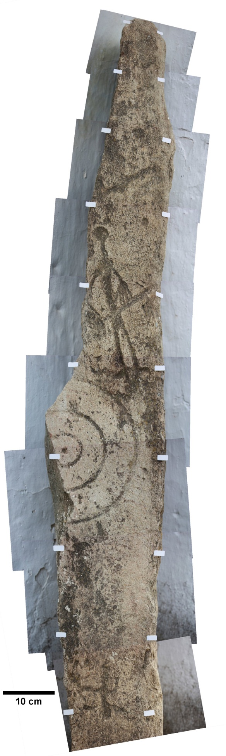

Figure 2. Scaled ortophotomosaic of Mirasiviene “warrior stele”.

Table 1. Correlation of the different bands of a set of images.

Red-Blue |  | Red-Green |  | Green-Blue
$\overline{x}$* | 0,93481112 | $\overline{x}$* | 0,97601569 | $\overline{x}$* | 0,98436587
σ* | 0,018435176 | σ* | 0,00591868 | σ* | 0,00462954
2σ | 0,036870352 | 2σ | 0,01183736 | 2σ | 0,00925908
*N=8

Table 2. Percentage of the total variance resumed by the bands obtained by Principal Components Analysis of three of the images studied in this work.

Id. Image | Band | Eigenvalue | Explained variance (%)
1451 | 1 | 5889,037 | 97,6425499
1451 | 2 | 132,624 | 2,19895809
1451 | 3 | 9,559 | 0,15849198
1455 | 1 | 5077,457 | 97,5332101
1455 | 2 | 119,347 | 2,29254448
1455 | 3 | 9,071 | 0,17424544
1457 | 1 | 8104,425 | 97,8248865
1457 | 2 | 173,099 | 2,08940055
1457 | 3 | 7,101 | 0,08571299

From a purely photo-interpretive point of view, the bands corresponding to the third Principal component showed the presence of black points over a graysh general background, with some whiter areas (Figure 3), not assignable to any recognizable pattern identifiable as a pictorial decorative motif.

Figure 3 is significant respect to the rest of the obtained images. The only visible coverages in the third Principal component band are those black stains and whitish areas already mentioned (figure 3B). These last ones, coincide with areas with a diffuse reddish pigmentation, corresponding with natural concentrations of iron oxides on the surface of the supporting rock. The dendritic aspect of the black stains, and the fact that they appear inside the engraved areas (i.e., the areas maintaining higher relative humidity for a prolonged time) leads to identifying them as biologically-originated coverages, with a high probability of being lichens. The rock is also profusely colonised by cyanobacteria, darkening the natural tone of the supporting rock (Figure 3A).

In general terms, false color images obtained using the three PCA bands (Figure 3C) seems to describe the general aspect of the rock in reddish tones, cyanobacterial epilithic biofilms in bluish tones, other biological coverages in greenish tones and the stains of iron oxides (hydroxides) in whitish tones.

Definitely, none of the studied images allowed us obtaining data leading to consider that Mirasiviene stele has never been applied a surface treatment implying the intentional application of pigments.

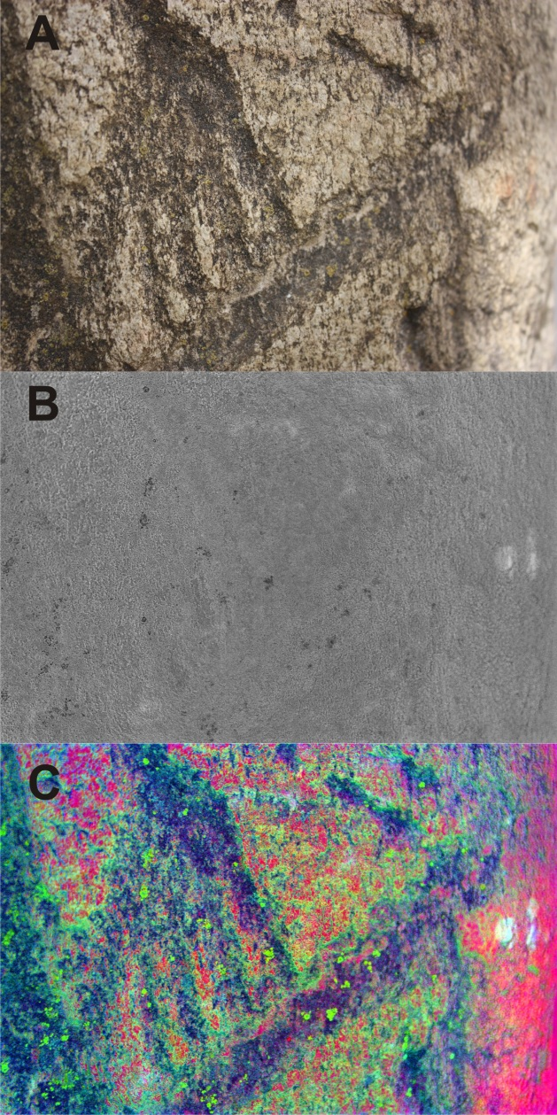

Figure 3. Photograph 1479; A) conventional RGB image; B) third PC band; C) false color image elaborated with the three PCA bands.

Sevilla, 16 de noviembre de 2012

References

Díaz‐Guardamino, M. 2012. La estela 'de guerrero' de Mirasiviene y su contexto arqueológico (Lora del Río, Sevilla): Documentación gráfica, caracterización petrológica y prospección de superficie. Propuesta de intervención arqueológica puntual. Entregado en Delegación provincial de Sevilla de la Consejería de Cultura de la Junta de Andalucía.
Pazak, R.S. 2012. HyperCube Pictorial User’s Guide. [on line] http://www.tec.army.mil/hypercube/pub/HyperCube.pdf, consulta: 24/10/2012.
Rogerio-Candelera, M.A., Vanhaecke, F., Resano, M., Marzo, P., Porca, E., Alloza Izquierdo, R. y Sáiz-Jiménez, C. 2009. Combinación de análisis de imagen y técnicas analíticas para la distinción de diferentes fases en un panel rupestre (La Coquinera II, Obón, Teruel). In López Mira, J.A., Martínez Valle, R. y Matamoros de Villa, C. (eds.) El Arte Rupestre del Arco Mediterráneo de la Península Ibérica. 10 años en la lista del Patrimonio Mundial de la Unesco. Actas del IV Congreso. Valencia, 3, 4 y 5 de diciembre de 2008: 327-334. Valencia: Generalitat Valenciana.

Rogerio-Candelera, M.A., Jurado, V., Laiz, L. y Saiz-Jimenez, C. 2011. Laboratory and in situ assays of digital image analysis based protocols for biodeteriorated rock and mural paintings recording. Journal of Archaeological Science 38: 2571-2578.

