First Style  ("incrustation") | System reproducing, with paint and stucco, a facing of marble orthostats. (2nd century BC). | 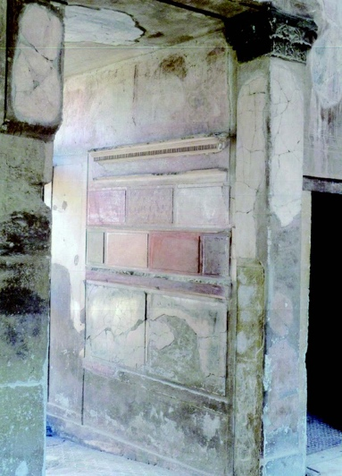
Second Style (“architectural-illusionistic”) | System reproducing architectural structures in perspective, distributed over the entire wall, with increasing illusionary breakthrough effect (100-30 BC) | 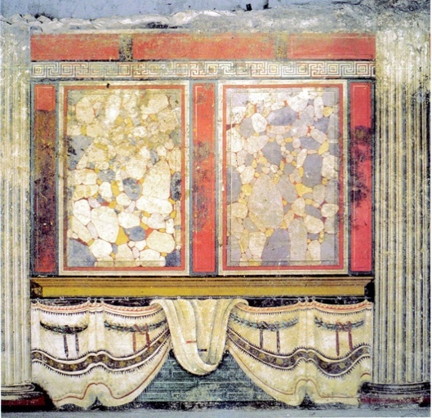
Third Style  ("ornamental") | System of monochrome panels separated by candelabra or vegetal elements (with a miniature rendering), and highly stylised architecture. The central panel often predominates and includes a figurative painting (between the end of the 1st century BC and the first half of the 1st century AD). | 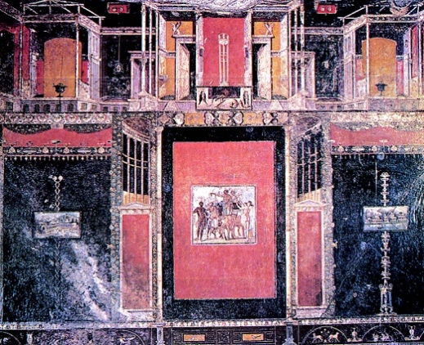
Fourth Style (“Intricate”) | System alternating unreal architectural views, often populated by small figures, with continuous panels  (from the middle of the first century AD). | 