Emphasising the community: demographic composition of an exceptional tomb – the Chalcolithic burial site of Camino del Molino, Caravaca de la Cruz, Murcia.
Sonia Díaz-Navarro; María Haber Uriarte; Cristina Tejedor-Rodríguez;
Joaquín Lomba Maurandi.

Supplementary Information
S.1. Radiocarbon dating and Bayesian analysis.
Some trends in the radiometric series can be observed in the general graph (Fig. S1). On the one hand, it seems quite evident that the temporality of this tomb covers almost the entirety of the 3rd millennium cal. BC. However, it must be considered that both the uncertainty intervals of the radiocarbon dates and the lack of precision of the calibration curve in these chronological ranges make the time sequences visually much broader than they really were. In addition, the oldest (CMOL-133) and most recent (CMOL-79) dates extend the time limits of the radiometric series, distorting their visualisation, making it necessary to adjust them as far as possible.
A probability summation tool has been implemented to determine the temporality of this deposit and to identify possible discontinuities (Fig. S2). Unlike modelling, this type of analysis does not reduce the uncertainty of the probability distribution of each dating, so it is not useful for analysing durations or temporal limits. However, it does allow us to observe possible continuities and discontinuities in the sequence, as well as to estimate the temporal probability of different archaeological events (Williams 2012).
As in the case of the joint standard calibration, this analysis does not show a clear discontinuity in the radiocarbon sequence, although a tendency towards the concentration of the dates in two clear groups is discernible. It is also noticeable how the time span covers practically the whole of the 3rd millennium cal. BC (from 3000 cal. BC to 2150 years cal. BC). The earliest and latest dating apparently prolongs the sequence at both ends. In any case, the result of the probabilistic summation must be taken with caution (Lozano and Capuzzo 2020: 325).
In order to define more precisely the phases of use and to estimate their time limits with a high percentage of probability, other analytical chronometric methods from Bayesian inferential statistics have been implemented:
-Bayesian modelling and Phase analysis
This model assumes that the entire dating assemblage is part of a single episode with no pre-established temporal order (Bayliss and Bronk Ramsey 2004: 35-36). Its aim is to define the temporal limits of the CMOL funerary use, without assuming the possible existence of distinct phases within it. The results point to a chronology estimated to begin around 2923-2712 (2σ) and to end around 2386-2226 (2σ), with an approximate duration of between 407-547 years (1σ), at most 605 years (2σ) (Fig. S3). Although the resulting model shows an acceptable agreement index (Amodel: 87.6), it is significantly lower than the multi-phase analyses. Therefore, the hypothesis of the existence of two funerary phases seems to be more solid.
Based on these premises, the association of each sample to a stratigraphic unit and phase of use has been introduced as aprioristic information, assuming that the individuals from lower SUU are older. Subsequently, two different Phase analyses have been applied (Bayliss and Bronk Ramsey 2004).
In both cases, the Span command has been applied to calculate the difference between the oldest and the most recent event in a set of radiocarbon dates (Bronk Ramsey 2009). The Interval command performs this calculation by including events that are not directly dated (Lozano and Capuzzo 2020: 324).
-Overlapping phases model
This is a chronometric analysis of multiple phases in which the phases are considered independent of each other, assuming the possibility of overlapping. The purpose of this model is to estimate their time boundaries (Fig. S4).
The results of this analysis (Table S1) mark the start of funerary use at the beginning of the 3rd millennium cal. BC (2932-2690 cal. BC 2σ), with a first phase that spanned approximately two centuries (between 0-259 cal. BC 2σ). This was followed by the second phase, which lasted until the last third of the same millennium (2457-2276 cal. BC 2σ) (Fig. S4 and S5).
-Contiguous Phases Model
Contiguous Phases Model assumes consecutive phases and attempts to estimate the transition period between them (Bayliss y Bronk Ramsey 2004). It is the most robust based on the concordance index (Amodel: 99.3) and the individual agreement indices (>60%) (Fig S6 and Table S2). Only one of the dates would not be statistically concordant with the proposed model (CMOL 133, A: 52.1), while in the rest of the models there are more discordances (Table S2).

Fig. S1 Standard calibration and summation of the radiometric series
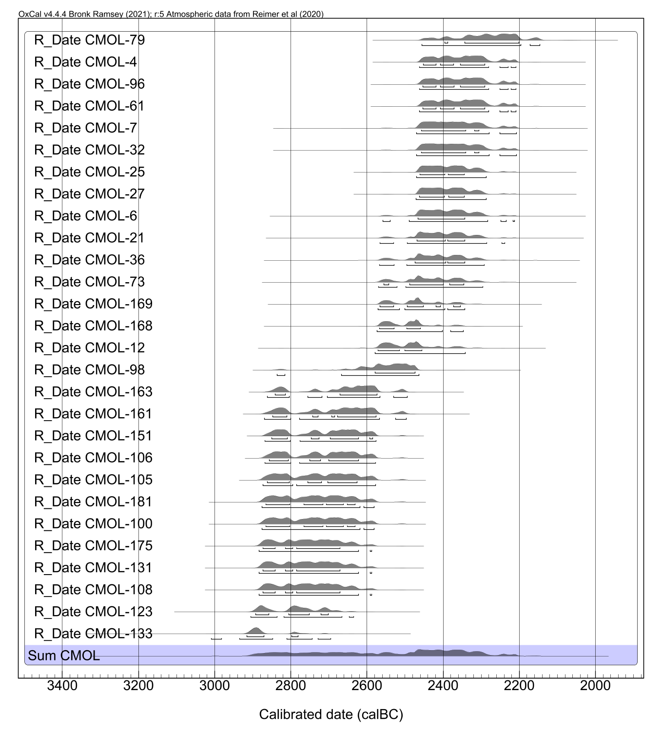

Fig. S2 Sum of probabilities of the CMOL radiocarbon dates
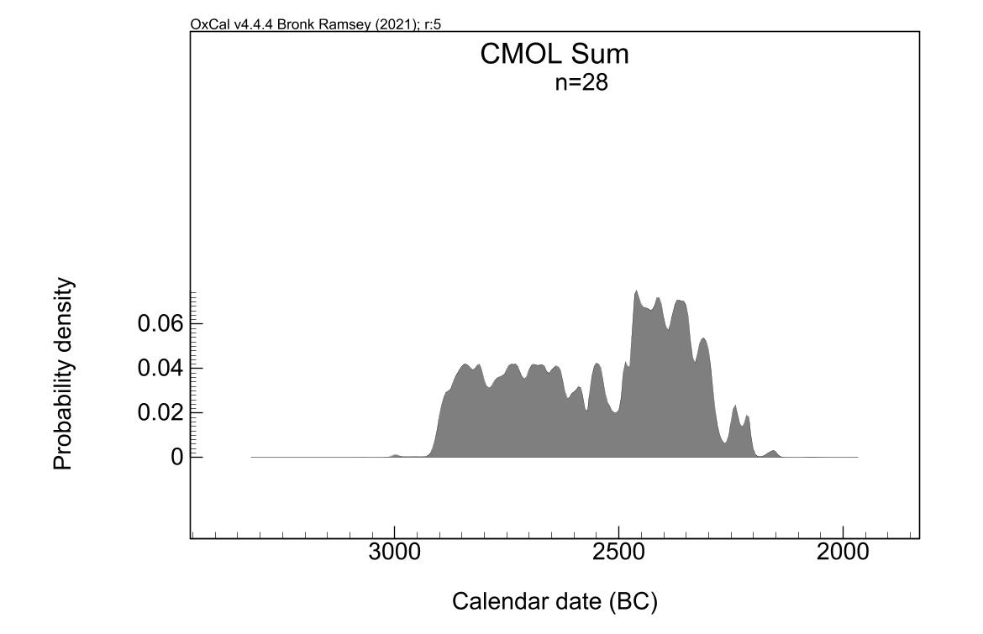
Fig. S3 Phase model, with estimated chronological intervals for the start and end limits
Fig. S4 Overlapping Phases model, with estimated chronological intervals for the start and end boundaries of each of the phases (CMOL I: blue; CMOL II: red)
Fig. S5 Graph of the estimated duration of the CMOL funerary phases based on the Overlapping Phases model

Fig. S6 Estimated duration of the two phases of CMOL funerary use and the interval between them (based on the Contiguous Phases model)

Table S1 Data corresponding to the Overlapping Phases model. The results obtained through the Span tool, which allows estimating the duration of each phase in years, have been added
CAMINO DEL MOLINO (MODELO OVERLAPPING) Amodel = 89.6/Aoverall = 84.1
 |  | 14C yr BP | MODELLED  CAL. yr BCE |  | A (individual agreement indices)
 |  |  | 1σ (68.2%) | 2σ (95.4%)
CMOL II | End CMOL II |  | 2436-2331 | 2457-2276
CMOL II | Span CMOL II (yr) |  | 0-129 | 0-220
CMOL II | R_Date CMOL 79 | 3830±40 | 2461-2384 | 2466-2316 | 57
CMOL II | R_Date CMOL 4 | 3870±32 | 2462-2393 | 2467-2330 | 100.9
CMOL II | R_Date CMOL 96 | 3871±32 | 2462-2393 | 2467-2331 | 101.6
CMOL II | R_Date CMOL 61 | 3871±32 | 2462-2393 | 2467-2331 | 101.6
CMOL II | R_Date CMOL 7 | 3890±40 | 2466-2396 | 2472-2336 | 111.8
CMOL II | R_Date CMOL 32 | 3890±40 | 2466-2396 | 2472-2335 | 111.8
CMOL II | R_Date CMOL 25 | 3900±32 | 2466-2400 | 2471-2341 | 110.7
CMOL II | R_Date CMOL 27 | 3903±32 | 2466-2401 | 2471-2341 | 111
CMOL II | R_Date CMOL 6 | 3910±40 | 2469-2367 | 2477-2338 | 115.6
CMOL II | R_Date CMOL 21 | 3920±40 | 2470-2366 | 2483-2341 | 117.9
CMOL II | R_Date CMOL 36 | 3930±40 | 2473-2403 | 2487-2344 | 120.3
CMOL II | R_Date CMOL 73 | 3940±40 | 2475-2366 | 2491-2346 | 120.4
CMOL II | R_Date CMOL 169 | 3956±32 | 2487-2366 | 2497-2347 | 105.9
CMOL II | R_Date CMOL 168 | 3967±32 | 2492-2407 | 2503-2346 | 90
CMOL II | R_Date CMOL 12 | 3970±40 | 2492-2407 | 2505-2345 | 88.7
CMOL II | R_Date CMOL 98 | 4030±40 | 2503-2457 | 2532-2351 | 68.3
CMOL II | Start CMOL II |  | 2512-2461 | 2573-2362
CMOL I | End CMOL I |  | 2797-2602 | 2843-2562
CMOL I | Span CMOL I (yr) |  | 0-149 | 0-259
CMOL I | R_Date CMOL 163 | 4089±32 | 2848-2655 | 2863-2606 | 77.5
CMOL I | R_Date CMOL 161 | 4100±40 | 2852-2662 | 2867-2619 | 93.1
CMOL I | R_Date CMOL 151 | 4117±32 | 2853-2666 | 2867-2626 | 100.1
CMOL I | R_Date CMOL 106 | 4122±32 | 2853-2669 | 2867-2629 | 102.2
CMOL I | R_Date CMOL 105 | 4130±40 | 2855-2671 | 2869-2636 | 105.7
CMOL I | R_Date CMOL 181 | 4140±40 | 2856-2672 | 2870-2640 | 107.1
CMOL I | R_Date CMOL 100 | 4140±40 | 2856-2672 | 2870-2640 | 107.1
CMOL I | R_Date CMOL 175 | 4160±40 | 2856-2675 | 2875-2641 | 106.5
CMOL I | R_Date CMOL 131 | 4160±40 | 2856-2675 | 2875-2641 | 106.5
CMOL I | R_Date CMOL 108 | 4160±40 | 2857-2675 | 2876-2641 | 106.5
CMOL I | R_Date CMOL 123 | 4210±40 | 2810-2680 | 2890-2666 | 90.9
CMOL I | R_Date CMOL 133 | 4260±40 | 2891-2699 | 2905-2672 | 39.3
CMOL I | Start CMOL I |  | 2903-2736 | 2932-2690

Table S2 Table with data for the Contiguous Phases model
CAMINO DEL MOLINO (CONTIGUOUS PHASE MODEL) Amodel = 99.3/Aoverall = 99.4
 |  | 14C yr BP | MODELLED  CAL. yr BCE |  | A (individual agreement indices)
 |  |  | 1σ (68.2%) | 2σ (95.4%)
CMOL II | End CMOL II |  | 2397-2282 | 2451-2251
CMOL II | Span CMOL II (yr) |  | 102-253 | 20-282
CMOL II | R_Date CMOL 79 | 3830±40 | 2459-2332 | 2465-2295 | 65
CMOL II | R_Date CMOL 4 | 3870±32 | 2461-2377 | 2466-2310 | 104
CMOL II | R_Date CMOL 96 | 3871±32 | 2461-2377 | 2466-2310 | 104.5
CMOL II | R_Date CMOL 61 | 3871±32 | 2461-2377 | 2466-2310 | 104.4
CMOL II | R_Date CMOL 7 | 3890±40 | 2465-2379 | 2471-2309 | 110.4
CMOL II | R_Date CMOL 32 | 3890±40 | 2465-2379 | 2471-2309 | 110.5
CMOL II | R_Date CMOL 25 | 3900±32 | 2465-2371 | 2471-2313 | 108.5
CMOL II | R_Date CMOL 27 | 3903±32 | 2466-2370 | 2471-2313 | 108.4
CMOL II | R_Date CMOL 6 | 3910±40 | 2469-2368 | 2483-2308 | 111
CMOL II | R_Date CMOL 21 | 3920±40 | 2471-2361 | 2493-2310 | 111.5
CMOL II | R_Date CMOL 36 | 3930±40 | 2474-2363 | 2557-2311 | 112.1
CMOL II | R_Date CMOL 73 | 3940±40 | 2483-2361 | 2565-2337 | 112.3
CMOL II | R_Date CMOL 169 | 3956±32 | 2495-2367 | 2566-2346 | 107.1
CMOL II | R_Date CMOL 168 | 3967±32 | 2556-2410 | 2568-2351 | 100.2
CMOL II | R_Date CMOL 12 | 3970±40 | 2556-2406 | 2567-2351 | 99.6
CMOL II | R_Date CMOL 98 | 4030±40 | 2521-2465 | 2585-2410 | 101.9
 | Transition CMOL I-II |  | 2588-2470 | 2635-2461
CMOL I | Span CMOL I (yr) |  | 176-304 | 82-377
CMOL I | R_Date CMOL 163 | 4089±32 | 2832-2576 | 2856-2501 | 102.3
CMOL I | R_Date CMOL 161 | 4100±40 | 2829-2579 | 2861-2568 | 103
CMOL I | R_Date CMOL 151 | 4117±32 | 2833-2587 | 2859-2577 | 100.9
CMOL I | R_Date CMOL 106 | 4122±32 | 2835-2621 | 2860-2578 | 100.9
CMOL I | R_Date CMOL 105 | 4130±40 | 2823-2622 | 2863-2579 | 101.5
CMOL I | R_Date CMOL 181 | 4140±40 | 2815-2627 | 2865-2584 | 101.1
CMOL I | R_Date CMOL 100 | 4140±40 | 2815-2626 | 2865-2583 | 101
CMOL I | R_Date CMOL 175 | 4160±40 | 2811-2635 | 2877-2621 | 100.2
CMOL I | R_Date CMOL 131 | 4160±40 | 2810-2635 | 2877-2588 | 100
CMOL I | R_Date CMOL 108 | 4160±40 | 2810-2635 | 2877-2589 | 100.1
CMOL I | R_Date CMOL 123 | 4210±40 | 2807-2678 | 2895-2632 | 92.5
CMOL I | R_Date CMOL 133 | 4260±40 | 2899-2702 | 2915-2671 | 52.1
CMOL I | Start CMOL I |  | 2923-2794 | 2971-2711

S.2. Osteological analysis. Sex and age estimation.
-Adult sex estimation
The conservation of 82 articulated skeleton with the skull and pelvis of both sexes and all age categories has allowed us to determine the morphological and morphometric skull traits that best discriminate between sexes (Herrmann et al. 1990; Buikstra and Ubelaker 1994). For this purpose, 12 cranial (morphology of the external occipital protuberance, mastoid processes, orbital rim, supraciliary arches, nuchal crest and supramastoid crest; height of the glabella and frontal bossing) and mandibular (morphology of the chin and gonion, angle of the mandibular ramus, mandibular muscle attachments and size of teeth) features were analysed in adult skulls, assigning each of them a sex estimation (not preserved, female, male, indeterminate). The estimates were then compared with those made from the pelvis, the results of which had been cross-checked with DNA analysis on 20 articulated skeletons.
In the cranial region, we can consider the morphology of the supraciliary arches as useful features for the sexual assignment of this population, correctly classifying 97% of the female skulls and 95% of the male skulls. Similarly, the orbital rim shows a success rate of 89% in the female estimation and 86% in the male estimation. Additionally, the height of the glabella and the inclination of the frontal bone exhibit a 97% match in female skulls compared to 86.4% in male skulls.
The presence of some morphological features that are generally useful in other anthropological samples, such as the morphology of the mastoid processes or the supramastoid crest, raises some questions in our case. In the CMOL individuals, the first indicator correctly estimates sex in 67% of the preserved female skulls. However, the remaining 33% are classified as male (16.5%) or as allophyseal (16.5%). This is due to an asymmetry affecting the volume and morphology of this region, characterized by a more massive mastoid than the one on the opposite side, affecting 83% of the right side. As for the supramastoid crest, this indicator is effective in 61% of female skulls and 94% of male skulls.
Other cranial characters such as the external occipital protuberance (inion) show a significant error in the female estimations, classifying the features of this region as male in 49% of the preserved skulls. Similarly, if we look at the morphology of the nuchal crest, we obtain an incorrect classification in 49% of the female skulls.
In the mandible, the most reliable indicators are the angle of the mandibular ramus, which correctly classifies 97% of female skulls and 80% of male skulls; the morphology of the mandibular body, with an 88% success rate in females compared to 95% in male skulls; and the size of the teeth, which correctly determines the sex of 92% of female skulls and 91% of male skulls. The rest of the indicators show higher error rates: the chin estimates sex correctly in 52% of female skulls and 100% of male individuals, the gonion in 65% of female skulls and 100% of male skulls, and the mandibular muscle attachments in 59% of females and all males.
-Age estimation
It has been possible to cross the age data from highly reliable methods –analysed in the coxal (Lovejoy et al. 1985) and costal region (Iscan et al. 1985a, 1985b)– with those obtained from the analysis of dental wear (Zoubov, 1968) in 93 articulated skeletons of adults who conserved associated dentition.
When we correlate the dental wear data (N 101) with age, as expected, a directly proportional association between the two variables is observed. Skeletons in the Infantile I (0-6 years old) age category do not show any type of dental wear. The 16.7% of Infant II (7-12 years old) age category individuals have no dental wear, 60% have grade 1 and the remaining 23.3% have grade 2. All juveniles (13-19 years old) exhibit some type of wear: 62.5% have grade 1, 25% have grade 2 and 12.5% have grade 3. On the other hand, only 2.4% of young adults (20-39 years old) show grade 1 dental wear, 36.6% grade 2, 51.2% grade 3 and the remaining 9.8% grade 4. Finally, no mature skeleton (40-59 years old) exhibits dental wear below grade 3, with 44.4% showing grade 3, 47.2% grade 4, 5.6% grade 5 and 2.8% grade 6.
Therefore, despite the fact that dental wear is considered an inaccurate tool for classifying the age of individuals from archaeological samples, the fact that we have a skeletal assemblage of the size of the CMOL sample and that we can corroborate the estimates with more reliable age determination methods in the sample of articulated skeletons allows us to use this method with a certain degree of confidence in the series of isolated skulls.
In non-adult individuals, the degree of dental eruption was analysed according to Ubelaker’s (1989) chart method as the main criteria. Where teeth were not preserved, morphometric variables of different cranial regions such as the pars basilaris, pars squama and pars lateralis (Fazekas and Kósa 1978) were analysed, as well as the degree of ossification of temporal or sphenoid bones (Scheuer and Black 2000).

References
- Bayliss A, Bronk Ramsey C (2004) Pragmatic Bayesians: a decade of integrating radiocarbon dates into chronological models. In BUCK C, MILLARD A (Eds.) Tools for constructing chronologies: tools for crossing disciplinary boundaries. London: Springer, pp. 25-41.
- Bronk Ramsey C (1995) Radiocarbon calibration and analysis of stratigraphy: The OxCal program. Radiocarbon 37(2), pp. 425–430. doi: 10.1017/S0033822200030903
- Fazekas IG, Kosa F (1978) Forensic fetal osteology. Budapest: Akadémiai Kiadó.
- Herrmann B, Grupe G and Hummel S (1990) Prähistorische Anthropologie: Leitfaden der Feld- und Labormethoden. Berlin: Springer.
- Işcan MY, Loth SR, Wrigh RK (1985a) Age estimation from the rib by phase analysis: white males. J. Forensic Sci. 29(4), pp. 1094-1104.
- Işcan MY, Loth SR, Wright RK (1985b) Age estimation from the rib by phase analysis: white females. J. Forensic Sci. 30(3), pp. 853-863.
- Lovejoy CO, Meindl RS, Pryzbeck TR and Mensforth RP (1985) Chronological metamorphosis of the auricular surface of the ilium: A new method for the determination of adult skeletal age at death. Am. J. Phys. Anthropol. 68(1), pp. 15-28. doi:10.1002/ajpa.1330680103.
- Lozano A, Capuzzo G (2020) Modelos cronométricos en OxCal. In Barceló JA, Morell B (Es.) Métodos cronométricos en Historia y Arqueología. Madrid: Dextra, pp. 315-328.
- Meindl RS, Lovejoy CO, Mensforth RP and Walker RA (1985b) A revised method of age determination using the os pubis, with a review and tests of accuracy of other current methods of pubic symphyseal aging. Am. J. Phys. Anthropol. 68(1), pp. 29-45. doi:10.1002/ajpa.1330680104.
- Scheuer L, Black S (2000). Developmental Juvenile Osteology. San Diego: Elsevier.
- Ubelaker DH (1989) The estimation of age at death from immature human bone, in Iscan MY (ed.) Age markers in the human skeleton. Springfield (USA): Charles C. Thomas, pp. 55-70.
- Williams NA (2012) The use of summed radiocarbon probability distributions in archaeology: a review of methods. J. Archaeol. Sci. 39(3), 578–589. doi: 10.1016/j.jas.2011.07.014
- Zoubov AA (1968) Odontología. Métodica de las investigaciones antropológicas. Moscú: Nauka.

