VNIR-SWIR REFLECTANCE SPECTROSCOPY AS A NON-DESTRUCTIVE TECHNIQUE FOR COMPOSITIONAL DETERMINATION OF ARCHAEOLOGICAL TALC SAMPLES WITH A MACHINE LEARNING APPROACH
M. Ferrer-Juliàª, A. Quirósª, D. Herrero-Alonsoª, E. Gonzálezª, E. García-Meléndezª,
ªResearch Group on Environmental Geology, Quaternary and Geodiversity (Q-GEO), Biological and Environmental Sciences Faculty, Universidad de León, Campus de Vegazana, sn, 24072 León, Spain
^{b}Departamento de Historia, Arte e Xeografía, Facultade de Historia, Campus Universitario As Lagoas s/n. CP: 32004, Ourense, Spain
Supplementary materials
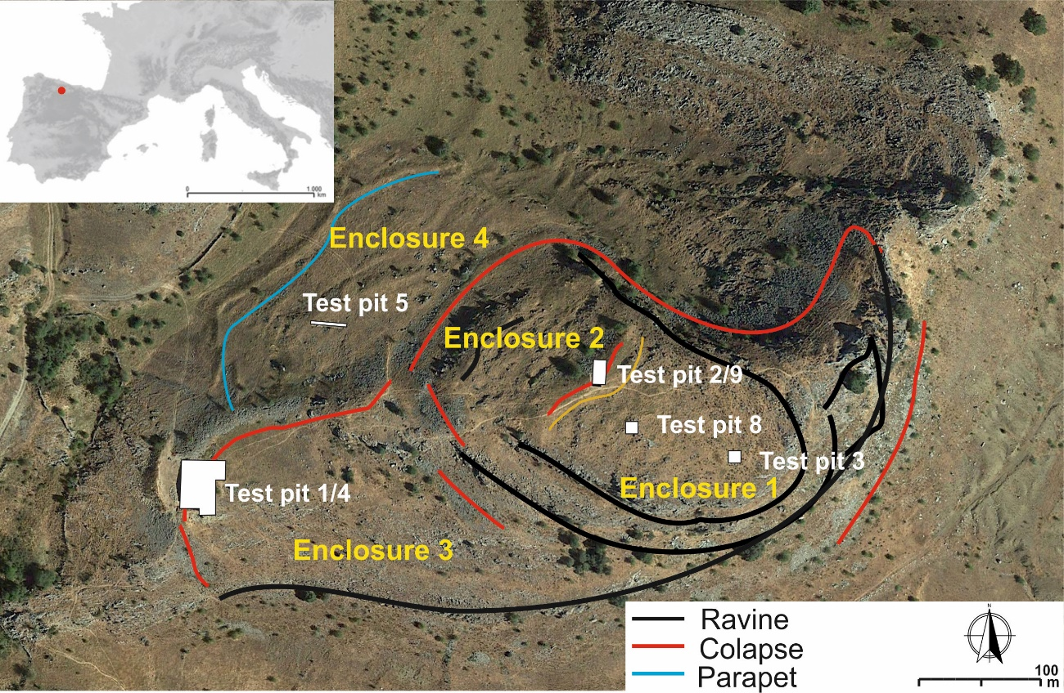
Figure S1. General planimetry of La Peña del Castro (La Ercina, León, Spain).

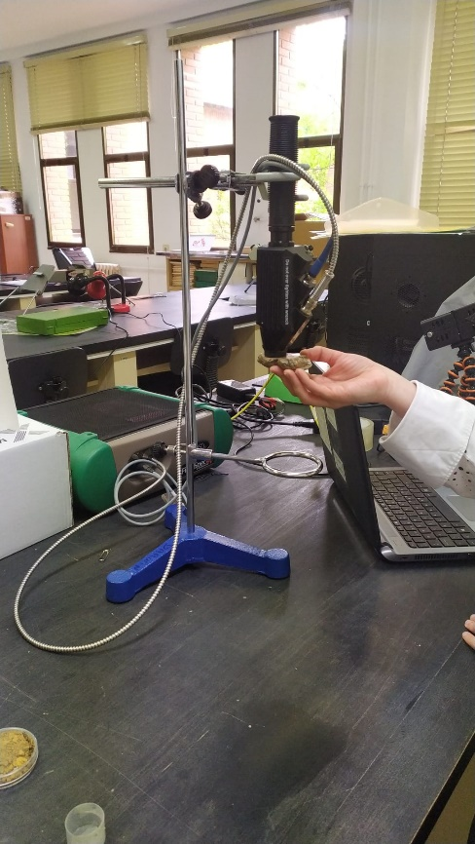
Figure S2. Contact probe of the spectroradiometer ASD FieldSpec-4 used to take measurements.

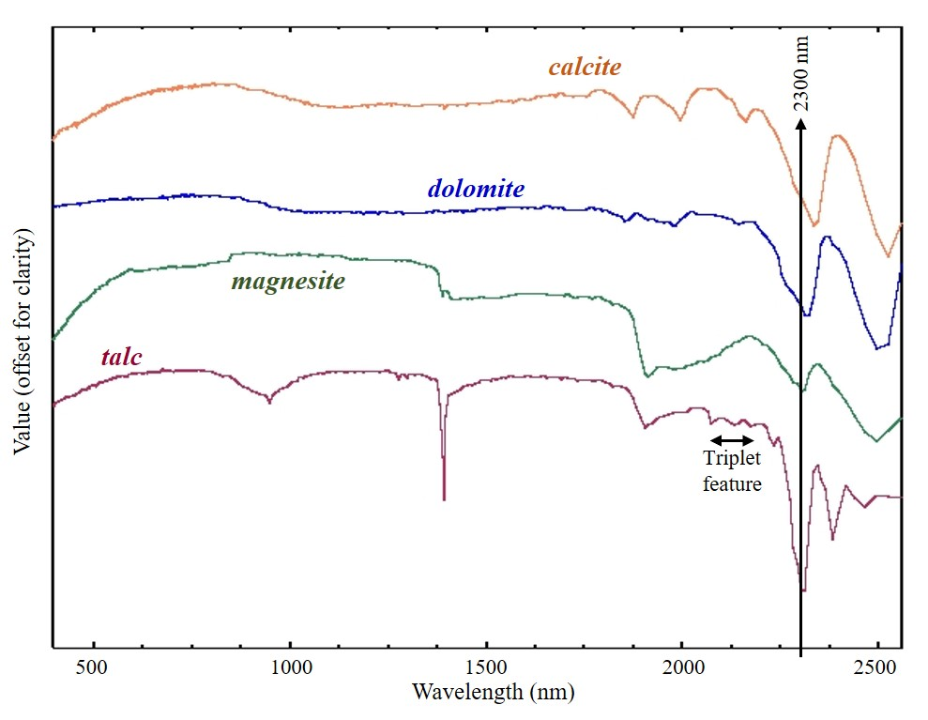
Figure S3. Examples of spectral curves of talc (Talc WS659), magnesite (HS47.3B), dolomite (HS102.3B) and calcite (HS48.3B). Data source: Clark et al. (n.d.)

Table S1. Localization of samples, related to Figure 2 of the text.

ID | Archaeological | Geological |  |  | Municipality | Province
ID | Archaeological | Bulk and powdered samples | Only powdered samples | Only bulk samples | Municipality | Province
1 |  |  |  |  | Abades | Ourense
2 |  |  |  | 1 | Benahavis | Málaga
3 |  |  | 1 | 1 | Puebla de Lillo | León
4 |  | 1 |  |  | Haro | La Rioja
5 | 2 |  |  |  | La Ercina | León
6 |  |  | 1 |  | Mallou | A Coruña
7 |  |  |  | 1 | Mijas | Málaga
8 |  | 1 | 4 | 6 | Puebla de Lillo | León
9 |  |  | 10 | 3 | Puebla de Lillo | León
10 |  |  | 1 |  | Moaldes | Pontevedra
11 |  | 3 | 1 | 7 | Boca de Huérgano | León
12 |  |  |  | 1 | Ojén | Málaga
13 |  |  | 1 |  | Riaño | León
14 |  |  |  | 1 | S.Lorenzo del Escorial | Madrid
15 |  |  | 1 |  | Sta. Mª de la Alameda | Madrid
16 |  |  |  | 1 | Sta. Olalla | Huelva
17 |  |  | 1 |  | Tirol
18 |  | 1 |  | 1 | Salas | Asturias
19 |  |  | 1 |  | Monachil | Granada
20 |  |  | 1 |  | Somontín | Almería
Total | 2 | 6 | 23 | 23

